Deepfake Detection Across Modalities: A Protocol-Separated Comparative Study of Image and Video Models with Spatial and Temporal Learning
Anson Saju George¹
¹ Division of Artificial Intelligence and Machine Learning, Karunya Institute of Technology and Sciences
Abstract
Rapid advances in generative models now make it hard to tell real media apart from the faked stuff. This raises a key issue for forensics folks: do we treat image and video deepfakes as one detection challenge or two separate ones sharing a label space? Many published studies blur this distinction. They pool images and videos, evaluate frame-level predictions while reporting video-level conclusions, or split video data without controlling for identity, and any of these choices can inflate results in ways that do not reflect genuine forensic ability. This work takes the opposite stance and treats image and video detection as separate problems under a protocol-separated evaluation framework. Image models are trained and tested only on image data with the original source train and test boundaries preserved. Video models are trained and tested only on video data with an identity-aware 70/10/20 split that prevents the same subject from appearing in more than one partition. Within this framework we run a controlled comparison of convolutional and transformer image backbones, and a systematic comparison of temporal modelling heads for video, including mean-pooled sequences, an LSTM, a temporal convolutional network, a temporal transformer, a ConvLSTM, and hybrid variants, all sharing a single ConvNeXt-Large backbone and one optimisation recipe. The strongest image model, ConvNeXt-Base, reaches a held-out test F1 of 0.9863, while the strongest video configuration reaches 0.7841 F1. Among temporal heads evaluated under matched settings, the temporal convolutional network gives the best video accuracy at 0.9102. Two findings hold across every comparison: image detection is substantially easier than raw-video detection under matched conditions, and convolutional backbones outperform the transformer backbones we evaluated. We report these conclusions as specific to the selected datasets, the fixed single-seed training configuration, and the evaluated architectures, and we discuss the absence of repeated-seed and cross-dataset analysis as explicit limitations.
Keywords: deepfake detection, protocol-separated evaluation, identity-aware splitting, temporal modelling, temporal convolutional network, ConvNeXt, multimodal forensics, benchmarking.

1. Introduction
Generative models can now produce images and videos that are hard to distinguish from real recordings, and the tools that create them are widely available. The same capability that drives legitimate media synthesis also enables disinformation, identity forgery, and fraud, so reliable automatic detection of manipulated media has become a practical need rather than an academic curiosity. The research community has produced many detection methods, but the way these methods are evaluated has not kept pace with the way they are built.
Early detectors viewed detection as a simple classification task for images. They looked for peculiarities in the way the image was formed, such as unusual textures or improper blending of faces [4], [18]. This worked great for CNNs. In videos, however, it gets complicated because while the still frame of a video may look realistic, it will become very unnatural when put in motion – unusual facial movements, unnatural expressions, and mouths that fall out of sync [20], [21].
Detection of such phenomena requires frame-by-frame analysis of the video. There exists one problem that remains constant here: scientists usually fail to draw a line between fake still images and fake videos. Some studies merge image and video data into a single training pool, some sample individual frames from videos and then report results as if the model had reasoned about the whole clip, and some split video datasets without ensuring that a given person appears in only one partition. Each of these shortcuts can produce high benchmark numbers that say more about the experimental setup than about the model's forensic ability [4], [12], [23]. When the same individual appears in both training and test data, for example, a model can score well by recognising the person rather than by detecting manipulation.
This paper argues that image-based and video-based deepfake detection should be evaluated under strictly separated protocols, and it builds a study around that principle. Rather than proposing a new architecture, we ask a narrower and more answerable question: under one controlled and identity-respecting evaluation framework, how do standard image backbones compare with one another, how do different temporal modelling strategies compare on video, and how large is the gap between the two modalities? The answers are meant to be reproducible and easy to interpret, which is why we hold the data pipeline and the optimisation recipe fixed and vary only the factor under study.

1.1 Contributions
The contributions of this work are methodological and empirical rather than architectural. They are:
- A protocol-separated evaluation framework that treats image and video detection as distinct tasks, preserves source train and test boundaries for images, and enforces identity-aware splitting for videos so that subject identity cannot leak across partitions.
- A controlled image-backbone comparison in which convolutional and transformer families are trained under one shared optimisation recipe, isolating the effect of architecture from confounding training choices.
- A temporal versus head analysis conducted on video in which the mean pooled sequential aggregation, an LSTM, a Temporal CNN, a Temporal Transformer, a ConvLSTM, and various combinations thereof are appended to one ConvNeXt-Large backbone in equal experimental conditions, thus making the temporal head the sole varying component.
- The empirical explanation for the modality gap in which it is proven that video-object detection remains much more challenging than image-object detection in equal conditions..

2. Related Work

2.1 Image-based detection with its blind-spot
Frame-based detection techniques for deepfakes rely on pattern recognition. Since synthetically generated images contain certain artifacts specific to the process used to create them, convolutional networks become the first choice and still perform well with plenty of training data available [4], [18]. Transformers are also applied because they can effectively relate non-contiguous sections of an image; that is quite useful in cases where manipulation needs to be spread over an entire picture [7], [12]. Another path involves using multimodal or large foundation models to increase the level of precision while adding an explanation for each decision [3], [13]. Models trained with multiple generator outputs for better resilience toward new inputs are yet another option [15]. However, no matter how complex the algorithm is, they all share the common problem of having a frame-based architecture. Consequently, there is no way to incorporate any temporal information such as motion. Therefore, achieving high accuracy on a still image benchmark does not mean it will be equally high on video material.

2.2 Video-based detection with evaluation inconsistency
Video detection can be considered image detection with an additional time dimension; however, this extra component turns out to be a lot more complicated than one would expect. People initially tried to ignore the temporal aspect by sampling frames and applying an image classifier to them [20], [21]. Some researchers turned to modeling the evolution of frames by taking into account factors like motion or stability of facial dynamics [20], [21]. Even approaches based on evaluating whether identities and their behaviors remain consistent during the entire clip were developed [5]. However, the crux of the matter lies in neither modeling nor the lack thereof; rather, it concerns the manner in which conclusions are drawn from results [20], [21]. There is too much discussion of predictions being evaluated on a per-frame level and generalization on the video level being made, completely ignoring the difference between these distinct units of analysis. Another problem, and a crucial one, is called identity leakage [23]. This phenomenon refers to the same identities appearing in both the training and the test set, resulting in impressive performance scores but no actual learning [23].

2.3 Temporal modelling
Temporal modeling is based on the interconnections of frames rather than their content in isolation. Typically, such modeling involves recurrent neural networks, temporal convolution, and attending to the order of frames. Such methods rest upon various assumptions about when a piece of forensic evidence occurs in time. One positive aspect here is that alterations invisible in a static image can manifest themselves during motion. Yet, the downside is the significantly greater requirements in terms of memory and computation, as well as a heavy dependence of the performance on which particular frames have been used. Temporal approaches are only useful when manipulations leave a mark visible in time; this is not always the case with deepfakes. Moreover, there appears to be very little research on the comparative benefits of temporal modeling against some other change that could have been performed at the same time. It is difficult to establish which of the two is more effective because of lack of studies on the extent of improvement due specifically to temporal factors. That is why the specific comparison provided in Section 7 is critical.

2.4 Convolutional versus transformer architectures
The majority of modern algorithms utilize either convolutional networks or transformers. Convolutional networks excel at recognizing the local structure, which perfectly matches the small-scale features that occur in manipulated media. In contrast, transformers link all regions of the image, detecting manipulations distributed throughout the whole image. However, they require larger datasets and longer training periods to demonstrate their best performance [7], [12]. In terms of performance, the findings are mixed: while some papers show superior results of transformers, the others suggest that convolutional networks dominate. This back-and-forth remains unresolved due to varying testing conditions. This motivates the controlled setup used here, in which both families are trained with an identical recipe so that the architecture is the only thing that differs.

3. Problem Formulation and System Overview
We treat deepfake detection as binary classification. Each sample carries a label
y ∈ {0, 1}, where y = 0 denotes a real sample and y = 1 a fake sample. (1)
A model with parameters θ maps an input x to an estimated probability of being fake,
ŷ = f(x; θ), (2)
and is trained by minimising the binary cross-entropy between the prediction and the label,
L_CE = −[ y · log ŷ + (1 − y) · log(1 − ŷ) ]. (3)
Although the objective is identical for both modalities, the input x is not. For an image, x is a single frame and the model can only use spatial evidence. For a video, x is an ordered set of frames and the model can use spatial evidence within frames together with temporal evidence across them. This difference is the reason the two tasks are kept apart throughout the study, and it is also why a single binary label hides a semantic mismatch: in the image datasets a fake sample is fully synthetic, whereas in the video datasets a fake sample is a manipulated authentic recording. Two different generation processes are being labelled with the same symbol.
The end-to-end system is shown in Figure 1. Raw datasets pass through cleaning and standardisation, then a protocol splitter routes data into an image-only stream and a video-only stream that never mix. Each stream trains its own models, the outputs are scored with the same set of metrics, and the scored results feed the leaderboards and ablations reported later.
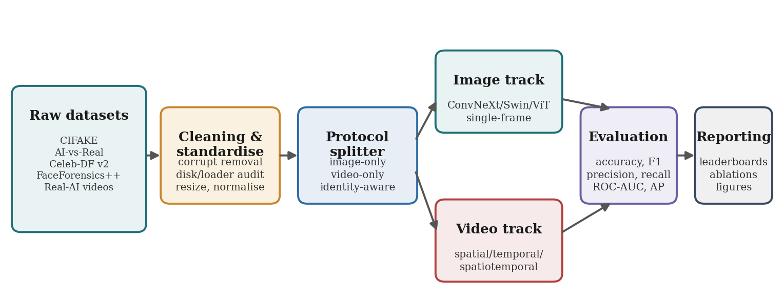
Figure 1. End-to-end detection pipeline. Raw datasets are cleaned, split by protocol into image-only and video-only streams, trained separately, then evaluated and reported under one metric set.
Figure 2 makes the protocol separation clear. For the image-only protocol, the original train and test folders are kept, and a validation set is carved out from the training part. In contrast, the video-only protocol splits content identity-wise in a 70/10/20 ratio and sets a fixed clip-sampling rule for evaluation. Under both methods lies a shared rule ensuring fair comparisons: outcomes are only compared post-protocol separation, after preprocessing and held-out testing have been strictly controlled.
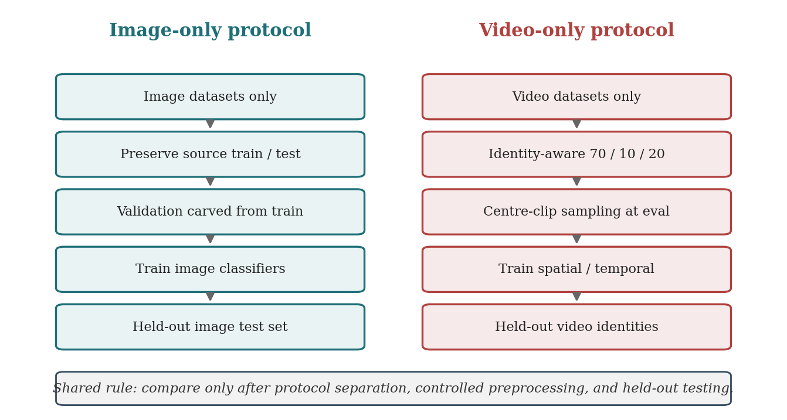
Figure 2. Protocol-separated evaluation design. Image and video models follow independent data contracts so that modality leakage and unit-of-analysis confusion cannot occur.

3.1 Spatial and temporal representations
A spatial representation summarises one frame. Writing φ for the backbone feature extractor, the spatial feature of an image or a single frame would be
z = φ(x), (4)
and z captures texture, edges, and structural inconsistencies that distinguish synthetic from authentic content. A temporal representation works on an ordered clip
X = {x₁, x₂, …, x_T}, with per-frame features z_t = φ(x_t), t = 1…T. (5)
The sequence of features {z₁,…,z_T} is then summarised by a temporal head into a single clip descriptor, and the temporal head is exactly what differs across the video models compared in Section 7. The simplest head is temporal mean pooling,
g = (1/T) Σ_t z_t, followed by p = softmax(W g + b), (6)
which discards frame order and treats the clip as a bag of frames. The recurrent head processes frames in order and keeps a hidden state,
h_t = LSTM(z_t, h_{t−1}), with the clip represented by the final state h_T. (7)
The temporal convolutional head applies a stack of dilated one-dimensional convolutions along the time axis, so that the receptive field over frames grows with depth while every output position depends only on present and past frames,
u^{(l)}_t = σ( Σ_{k=0}^{K−1} W_k^{(l)} · u^{(l−1)}_{t − d·k} ), dilation d growing across layers l. (8)
The temporal transformer head treats the T frame features as tokens and lets every frame attend to every other frame,
Attention(Q, K, V) = softmax( Q Kᵀ / √d ) V, computed over the frame tokens. (9)
The ConvLSTM head replaces the matrix multiplications inside the recurrent gates with convolutions, preserving spatial structure inside the recurrence rather than collapsing each frame to a vector first. The hybrid heads fuse a pooled spatial summary with one of the temporal heads above, so that a strong per-frame description and an explicit temporal model contribute jointly to the clip descriptor. Class-imbalanced training is handled in one of three ways that are compared directly in Section 7.4: standard cross-entropy with train-only oversampling, class-weighted cross-entropy,
L_WCE = − Σ_c w_c · [ y_c · log ŷ_c ], w_c inversely proportional to class frequency, (10)
and focal loss, which down-weights easy examples through a focusing term,
L_focal = − α (1 − ŷ)^γ · y · log ŷ − (1 − α) ŷ^γ · (1 − y) · log(1 − ŷ). (11)

4. Datasets, Cleaning, and Exploratory Analysis
The study looks at five datasets, including two image ones and three video ones, to explore various generation processes and class balance differences. There are more synthetic images than real images. As far as the videos go, they include face manipulations and AI generated videos. The overall number of images and videos according to Table 1 is 192,016.
Table 1. Datasets used for this experiment along with the number of records for each class and their balance.
Dataset | Modality | Total | Fake | Real | Balance
CIFAKE | Image | 120,000 | 60,000 | 60,000 | Balanced
AI-vs-Real | Image | 59,988 | 29,998 | 29,990 | Balanced
Celeb-DF v2 | Video | 6,533 | 5,643 | 890 | Fake-heavy
FaceForensics++ | Video | 5,429 | 4,066 | 1,363 | Fake-heavy
Real-AI Videos | Video | 66 | 33 | 33 | Balanced
The image set is huge and balanced, ensuring that there is an unbiased backdrop for comparison purposes. In contrast, the video set is much smaller and extremely biased toward fabricated images. This inherent bias is characteristic of face manipulation benchmarking systems since there are many more manipulated videos than authentic ones.

4.1 Cleaning and validation of the dataset
To ensure proper training, we took care to preprocess the corpus, discarding unreadable files and confirming that the data was correct both on the disk and through our data loader. Images were validated through attempted decoding, allowing us to detect truncated images and corrupt image streams, while videos were validated by checking their metadata and decoded frames. Twelve corrupted images were removed from the AI-vs-Real dataset and three unreadable videos had been removed earlier because of damaged container metadata, reducing the corpus from 192,028 to 192,016 valid samples. Table 2 records this history, which matters because it shows that the reported corpus is the result of an explicit cleaning step rather than whatever happened to be on disk.

Table 2. Data cleaning and validation summary.
Step | Action | Count
Initial samples | Raw dataset | 192,028
Corrupted images removed | AI-vs-Real dataset | 12
Corrupted videos removed (historical) | Video datasets | 3
Final cleaned dataset | Validated corpus | 192,016

4.2 Exploratory analysis
Aggregated across modality, the image data is almost perfectly balanced, with close to half of all samples in each class, while the video data is roughly four-fifths fake. We also examined the imbalance at the level of raw frame counts rather than file counts, because a dataset can look balanced by file while being skewed by total footage. The frame-level view added detail but did not remove the skew: Celeb-DF v2 and FaceForensics++ remain fake-dominant whether measured by file count or by total frame mass. Table 3 reports the per-dataset imbalance that drives the loss-function and balancing choices described later.
Table 3. Dataset-level class imbalance. Video benchmarks are strongly fake-heavy; image benchmarks are balanced.
Dataset | Fake share | Observation
CIFAKE | 50% | Balanced
AI-vs-Real | 50% | Balanced
Celeb-DF v2 | ~86% | Strongly fake-heavy
FaceForensics++ | ~75% | Fake-heavy
Real-AI Videos | 50% | Balanced but very small
There are two big consequences here. First, when dealing with videos, care must be taken to handle things well and to make sure it doesn't mess up final evaluations. In addition to that, the set of Real-AI Videos, which is balanced, is still extremely small in size at only 66 videos and cannot form the basis for any strong conclusion independently. So, it's only used as part of a bigger video collection and never by itself as a standalone benchmark.

5. Models and Architectural Scope
The aim of this stage is not to design a new network but to choose a set of existing architectures that lets us answer specific comparison questions. On the image side we compare a convolutional family against two transformer families. On the video side we hold one backbone fixed and vary the temporal head, which is the cleanest way to measure what temporal modelling actually contributes.

5.1 Image backbones
Three families are evaluated at base and, where relevant, large scale. ConvNeXt is a modern convolutional network whose inductive bias toward local structure suits the texture and blending artefacts of synthetic images. The Vision Transformer (ViT) processes an image as a sequence of patches and relates them through global self-attention, which tests whether long-range reasoning helps on this task. The Swin Transformer sits between the two: it is a transformer, but it computes attention within shifting local windows in a hierarchical structure, so it carries some of the locality bias of a convolutional network. All image models share identical preprocessing and a single training recipe so that any difference in score is attributable to architecture.

5.2 Video backbone and temporal heads
Every video model uses a ConvNeXt backbone to encode individual frames, and the configurations differ in how the per-frame features are combined over time. The spatial configuration ignores time and classifies a single sampled frame, serving as the baseline. The temporal configs add a head to the sequence of frame features – mean pooling, LSTM, TCN, or a temporal transformer. For spatiotemporal configs, a pooled spatial summary gets fused with a temporal head, resulting in ConvLSTM, hybrid transformer, hybrid TCN, and MaxViT-based hybrid models. By keeping the backbone, sequence length, learning rate, and loss fixed but changing just the head, this becomes a controlled study of temporal modeling, not just a bunch of random video models.
One implementation detail is stated as it impacts interpretation, so that helps too. The mean-pooled sequence configuration and the basic hybrid configuration share the same per-frame encoding followed by temporal pooling, so when both are run with the same backbone, sequence length, and learning rate they converge to the same result. We therefore do not present them as fundamentally different native-video architectures; the genuine architectural variation in the temporal comparison comes from the LSTM, TCN, transformer, and ConvLSTM heads, each of which adds a distinct temporal mechanism on top of the shared frame encoder. The measured parameter and compute cost of each head is reported in Table 6.

6. Experimental Setup

6.1 Splitting and sampling
Image datasets keep their original source train and test folders, and validation is derived from the training portion only, so no source test image is ever seen during training. Video datasets are split with an identity-aware procedure that assigns whole identities to one partition at a time. Identities are read from the source naming conventions: Celeb-DF v2 files of the form id0_id1_0000.mp4 are grouped by the subject token id0, FaceForensics++ files of the form 000_001.mp4 are grouped by the source-sequence token 000, and any file that does not match a known convention falls back to using its full path as its identity. Each video dataset is split independently into a 70/10/20 train, validation, and test partition with these identity groups kept disjoint, and the datasets are only combined after splitting. This guarantees that no subject appears in more than one partition, which is the property that prevents a model from scoring well by recognising people instead of detecting manipulation.
Class balancing is applied only after the split is fixed, and only to the training partition, through oversampling of the minority class. Validation and test partitions are left at their natural class ratios so that reported generalisation reflects the real, imbalanced distribution rather than an artificially balanced one. For video, a single frame is sampled for the spatial baseline, and a contiguous clip is sampled for the temporal configurations. During training the clip start is chosen randomly, and during evaluation a fixed centre clip is used so that each test video produces one deterministic prediction. All frames are resized to 224×224 and normalised to the pretrained backbone statistics.
Table 4 gives the exact partition sizes for every scope used in the completed experiments. The video_combined scope uses Celeb-DF v2 and FaceForensics++, while video_all additionally includes the small Real-AI Videos set. The 8,648-sample training count in the imbalance ablations reflects the natural (non-oversampled) training split used when class-weighted and focal losses are evaluated, because those settings disable oversampling by design.
Table 4. Train, validation, and test sample counts for every completed scope.
Category | Scope | Datasets | Train | Val | Test
Image | image_combined | CIFAKE, AI-vs-Real | 126,094 | 22,199 | 31,997
Spatial / temporal / ST video | video_combined | Celeb-DF v2, FF++ | 14,096 | 866 | 2,448
Temporal / ST video | video_all | Celeb-DF v2, FF++, Real-AI | 14,140 | 872 | 2,462
Video imbalance ablation | video_combined | Celeb-DF v2, FF++ (no oversample) | 8,648 | 866 | 2,448

6.2 Training configuration
Every completed model is trained with the AdamW optimiser and a cosine-annealing learning-rate schedule with a one-epoch warmup. The earlier draft of this work stated that different optimisers might be used; that is corrected here, as all completed runs use AdamW. Image models use a base learning rate of 1e-4. Larger clip-based video backbones use a reduced base learning rate of 5e-5, because at 1e-4 the heavier sequence models trained less stably; this is one of the few tuning choices we made and we report it explicitly. Weight decay is 1e-4, gradient clipping is applied at 1.0, and an exponential moving average of weights with decay 0.999 is maintained. The best checkpoint is selected by validation F1, with early stopping after three epochs without an improvement greater than 1e-4. Mixed precision is used on the GPU. Every completed run uses a single fixed random seed of 42. Table 5 summarises the configuration and the per-scope choices that differ.
Table 5. Training configuration. Settings are common unless specified otherwise.
Setting | Value
Optimiser | AdamW (all models)
LR schedule | Cosine annealing with 1-epoch warmup, min LR 1e-6
Base learning rate | 1e-4 for image models; 5e-5 for large clip-based video models
Weight decay | 1e-4
Loss | Cross Entropy (with label smoothing of 0.1 on image runs); weighted CE & focal as ablative studies
EMA / grad clip | EMA decay 0.999; gradient clip 1.0
Checkpoint / early stop | Best by validation F1; patience 3; min delta 1e-4
Epoch budget | 10 epochs configured; early stopping may end sooner
Batch size | 16-64 (image, by model size); 1-8 (video, by sequence length)
Sequence length | 1 (spatial); 4, 8, or 12 frames (temporal)
Imbalance handling | Train-only oversampling (default); class-weighted CE and focal as ablations
Random seed | 42 (single seed for all runs)
Precision | Mixed precision on CUDA
The hardware involved was a machine with a 20-core Intel CPU, 63.4 GB RAM, and an NVIDIA GeForce RTX 5080 laptop GPU with 15.9 GB RAM. In terms of the software, Python 3.12, PyTorch with CUDA, timm, and OpenCV and Pillow were used. OpenCV was used for video decoding purposes. Other options considered for video decoding included hardware-accelerated decoders; however, these could not be relied upon due to the instability with the set of mixed videos used, and they did not influence performance anyway.

6.3 Model complexity
The complexity measurements of the architectures used in the comparisons can be found in Table 6 below. These measurements were taken based on the actual implementation of the architecture, not approximations. All implementations were run on the RTX 5080 GPU, using an image sized (1, 3, 224, 224) in case of image architectures and a video sequence of four frames, (1, 4, 3, 224, 224). Because no backbone is frozen, the trainable parameter count equals the total parameter count for every model, so the table lists a single parameter column. The image side spans a wide range: ConvNeXt-Base uses 87.57 M parameters and 30.71 GFLOPs, while ViT-Large uses 303.30 M parameters and 119.29 GFLOPs, almost four times the compute for no gain in accuracy. On the video side the four-frame clip raises FLOPs to roughly 275 G for the ConvNeXt-Large models, and the temporal heads add little on top of the backbone. Moving from the mean-pooled sequence at 196.23 M parameters to the LSTM, TCN, transformer, and ConvLSTM heads raises the parameter count only to between 199 M and 213 M, with FLOPs staying near 275 to 281 G and per-sample latency clustered between 24 and 26 ms. The differences between temporal heads therefore reflect the temporal mechanism rather than any large change in capacity, which is what makes the head comparison in Section 7.3 a fair one.
Table 6. Measured model complexity for architectures used in the main comparisons. Image input (1,3,224,224); video clip input (1,4,3,224,224). Trainable parameters equal total parameters for every model (no frozen backbones).
Model | Params (M) | FLOPs (G) | MACs (G) | Latency (ms)
ConvNeXt-Base (image) | 87.57 | 30.71 | 15.35 | 5.67
Swin-Base (image) | 86.75 | 30.34 | 15.17 | 9.53
ViT-Base (image) | 85.80 | 33.70 | 16.85 | 4.73
ConvNeXt-Large (image) | 196.23 | 68.72 | 34.36 | 9.92
ViT-Large (image) | 303.30 | 119.29 | 59.65 | 13.45
ConvNeXt-Large + mean sequence (clip) | 196.23 | 274.88 | 137.44 | 26.02
ConvNeXt-Large + TCN (clip) | 199.38 | 274.90 | 137.45 | 24.62
ConvNeXt-Large + LSTM (clip) | 200.43 | 274.91 | 137.46 | 25.31
ConvNeXt-Large + Transformer (clip) | 211.98 | 274.93 | 137.47 | 24.31
ConvNeXt-Large + ConvLSTM (clip) | 212.75 | 281.35 | 140.68 | 25.67
MaxViT-Base hybrid (clip) | 118.70 | 186.74 | 93.37 | 31.02
Evaluation used the standard set of classification metrics: accuracy, F1, precision, recall, ROC-AUC, and average precision, together with confusion matrices. Held-out test F1 is treated as the primary ranking metric throughout, because F1 is more informative than accuracy on the imbalanced video test sets. All reported values come from the best checkpoint evaluated on the held-out test partition.

7. Results and Analysis
The results follow the order in which the experiments build on one another: first the image benchmark, then the video spatial baseline, then the temporal-head comparison that is the analytical core of this revision, then the loss-function ablation, and finally the cross-modality and architectural summaries. Each finding is stated once, where the evidence for it is strongest, and later sections refer back rather than repeat.

7.1 Image models
All image backbones perform well, which is expected because the image datasets are large, balanced, and contain the kind of spatial artefact that modern backbones detect easily. ConvNeXt-Base is the strongest, reaching a held-out test accuracy and F1 of 0.9863. ConvNeXt-Large and Swin-Base follow within roughly two-tenths of a percentage point of F1, and the two Vision Transformer models trail them, with ViT-Large the weakest of the five at 0.9546 F1. Figure 3 shows the validation and test F1 for each model side by side, and the small gap between validation and test indicates that none of the models is overfitting the validation split.
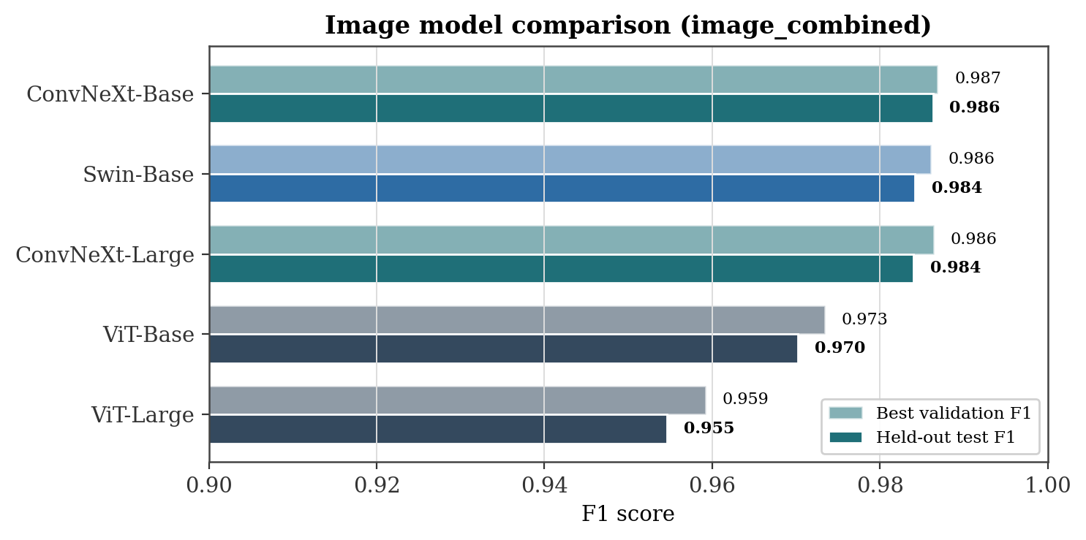
Figure 3. Image model comparison on image_combined. Held-out test F1 is the primary ranking metric; best validation F1 is shown for reference.
The full image metrics are given in Table 7. The ConvNeXt-Base error profile is shown in Figure 4 as a confusion matrix beside its test-metric scorecard. Out of nearly 32,000 test images it misclassifies only 227 real images as fake and 212 fake images as real, an error rate near 1.4% in each direction, and its ROC-AUC of 0.9968 confirms that the two classes are almost linearly separable at the score level. Swin-Base is interesting in that it has the highest ROC-AUC of any image model at 0.9987 while not having the highest F1, which means its score ranking is excellent but its default operating threshold is slightly less well placed than that of ConvNeXt-Base.
Read against the complexity figures in Table 6, the image ranking is informative. ConvNeXt-Base is the strongest image model at 87.57 M parameters and 30.71 GFLOPs, yet ViT-Large, which is roughly three and a half times larger at 303.30 M parameters and uses almost four times the compute at 119.29 GFLOPs, is the weakest of the five. Capacity was therefore not the limiting factor on this task: the extra parameters and operations of the large transformer bought no accuracy, and the smaller convolutional model both ran faster and detected the spatial artefacts more reliably.
Table 7. Image model results on the held-out image test set (image_combined).
Model | Acc | F1 | Prec | Rec | ROC-AUC | Avg. prec
ConvNeXt-Base (IMG-EXP-04) | 0.9863 | 0.9863 | 0.9867 | 0.9858 | 0.9968 | 0.9956
Swin-Base (IMG-EXP-07) | 0.9842 | 0.9842 | 0.9860 | 0.9823 | 0.9987 | 0.9986
ConvNeXt-Large (IMG-EXP-05) | 0.9840 | 0.9840 | 0.9831 | 0.9849 | 0.9966 | 0.9966
ViT-Base (IMG-EXP-01) | 0.9703 | 0.9702 | 0.9734 | 0.9670 | 0.9939 | 0.9931
ViT-Large (IMG-EXP-02) | 0.9548 | 0.9546 | 0.9588 | 0.9504 | 0.9899 | 0.9893
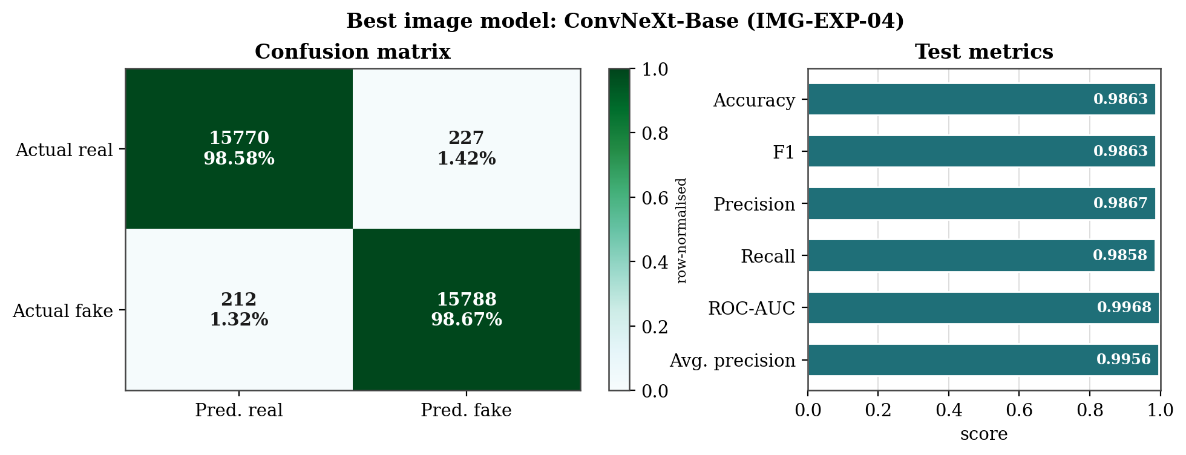
Figure 4. Best image model (ConvNeXt-Base). Left: row-normalised confusion matrix over the image test set. Right: held-out test metrics.

7.2 Video spatial baseline
The spatial baseline classifies a single frame and so establishes how far one can get on video without any temporal reasoning. The strongest spatial result is ConvNeXt-Base with a test F1 of 0.7023 at 0.8566 accuracy, and a Swin-based spatial model is markedly weaker at 0.5253 F1. The gap between accuracy and F1 here is the signature of the imbalanced test set: a model can reach high accuracy by leaning toward the majority fake class while still missing many real videos, which is exactly why F1 rather than accuracy is used to rank video models. The confusion matrix of the spatial baseline where 414 of the 463 genuine videos were detected and 302 fabricated videos were missed indicates a recall-centric operational point, which the temporal model surpasses.

7.3 Temporal-head comparison
This section of the experiment highlights how temporal modeling helps. This is due to the fact that the backbone, dataset scope, length of the sequence, learning rate, and loss remain the same while the only factor that changes is the temporal head. Figure 5 presents the six temporal heads under consideration for the video_all scope, with the ConvNeXt-Large backbone, sequence length four, learning rate of 5e-5, and loss. The temporal convolutional network is the strongest, at 0.9102 accuracy and 0.7831 F1. The hybrid TCN and the hybrid transformer follow, then the ConvLSTM and the plain LSTM, and the temporal transformer is the weakest of the six. The ordering is consistent between accuracy and F1, which gives some confidence that it is not an artefact of one metric.
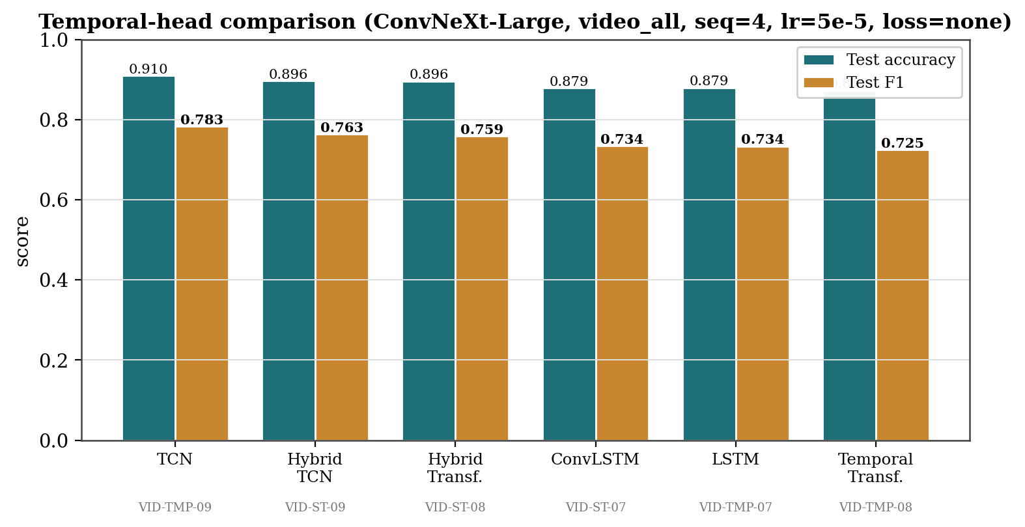
Figure 5. Temporal-head comparison under matched settings (ConvNeXt-Large, video_all, sequence length 4, lr 5e-5, standard loss). Only the temporal head varies. The TCN head is strongest on both accuracy and F1.
In Table 8, we see this sweep broken down numerically. Each row uses the same setup – ConvNeXt-Large backbone, video_all scope, sequence length of four frames, a learning rate of 5e-5, and standard loss – but switches up the temporal head. From there, the temporal CNN pulls ahead on both metrics, followed by the two hybrid heads. The recurrent and attention heads lag behind, just like what you'd spot in Figure 5.
However, when considering the values in Table 6, it becomes clear that comparing these heads goes beyond simply ranking them. All six are pretty similar in terms of cost. The backbone stays consistent, clocking in at around 196 M parameters and 275 GFLOPs. Adding just a few million parameters and a handful of gigaflops for each of the different heads doesn’t make much of a dent in the overall resource requirements. The TCN head, which wins the sweep, is among the lighter additions at 199.38 M parameters and the lowest per-sample latency in the group at 24.62 ms, below the heavier transformer and ConvLSTM heads and below the plain mean-pooled sequence at 26.02 ms. The best temporal result is therefore not the most expensive one. The TCN reaches the top of the sweep without requiring the largest model, which makes it the most attractive temporal head once compute is taken into account.
Table 8. Controlled temporal-head comparison. All rows share ConvNeXt-Large, video_all, seq 4, lr 5e-5, standard loss; only the head varies.
Temporal head | Experiment | Accuracy | F1
Temporal convolutional network (TCN) | VID-TMP-09 | 0.9102 | 0.7831
Hybrid TCN | VID-ST-09 | 0.8964 | 0.7632
Hybrid transformer | VID-ST-08 | 0.8956 | 0.7591
ConvLSTM | VID-ST-07 | 0.8786 | 0.7342
LSTM | VID-TMP-07 | 0.8794 | 0.7336
Temporal transformer | VID-TMP-08 | 0.8733 | 0.7249
Table 9 collects the main video results across all three categories, spatial, temporal, and spatiotemporal, now with the full metric set available for every completed run. Two rows deserve comment. First, the highest video F1 overall, 0.7841, is reached by the ConvNeXt-Large mean-pooled sequence model on the video_combined scope, and the ConvNeXt-Large hybrid run on the same scope reaches an identical number. As explained in Section 5.2, these two configurations share the same per-frame encoding and temporal pooling, so their convergence is expected rather than coincidental, and they should be read as one result rather than two. Second, the TCN head reaches its 0.7831 F1 and best-in-class 0.9102 accuracy on the larger video_all scope, which includes the extra Real-AI clips, so the small difference between the TCN on video_all and the mean-pooled sequence on video_combined is partly a difference of evaluation set rather than purely of head. The honest summary is that the TCN is the strongest genuine temporal head under the controlled video_all sweep, while a simple mean-pooled clip on video_combined reaches a marginally higher F1 on a different and slightly easier test pool.
Table 9. Main video results across categories on the held-out test partition.
Experiment | Category | Head / model | Scope | Acc | F1 | Prec | Rec | AUC
VID-SPA-02 | Spatial | ConvNeXt-B | v_comb | 0.8566 | 0.7023 | 0.578 | 0.894 | 0.950
VID-SPA-06 | Spatial | Swin-B | v_comb | 0.7504 | 0.5253 | 0.410 | 0.730 | 0.815
VID-TMP-01 | Temporal | ConvNeXt-B seq | v_comb | 0.8652 | 0.7090 | 0.599 | 0.868 | 0.941
VID-TMP-02 | Temporal | ConvNeXt-L seq | v_comb | 0.9089 | 0.7841 | 0.711 | 0.875 | 0.959
VID-TMP-07 | Temporal | ConvNeXt-L LSTM | v_all | 0.8794 | 0.7336 | 0.634 | 0.870 | 0.955
VID-TMP-08 | Temporal | ConvNeXt-L Transf. | v_all | 0.8733 | 0.7249 | 0.619 | 0.875 | 0.936
VID-TMP-09 | Temporal | ConvNeXt-L TCN | v_all | 0.9102 | 0.7831 | 0.727 | 0.849 | 0.938
VID-ST-02 | Spatiotemp. | ConvNeXt-B hybrid | v_comb | 0.7663 | 0.5744 | 0.438 | 0.834 | 0.859
VID-ST-03 | Spatiotemp. | ConvNeXt-L hybrid | v_comb | 0.9089 | 0.7841 | 0.711 | 0.875 | 0.959
VID-ST-05 | Spatiotemp. | MaxViT hybrid | v_comb | 0.8186 | 0.6414 | 0.512 | 0.858 | 0.916
VID-ST-07 | Spatiotemp. | ConvNeXt-L ConvLSTM | v_all | 0.8786 | 0.7342 | 0.631 | 0.879 | 0.944
VID-ST-08 | Spatiotemp. | ConvNeXt-L hyb-Transf. | v_all | 0.8956 | 0.7591 | 0.678 | 0.862 | 0.952
VID-ST-09 | Spatiotemp. | ConvNeXt-L hyb-TCN | v_all | 0.8964 | 0.7632 | 0.677 | 0.875 | 0.957
The error profile of the best video configuration is shown in Figure 7. Compared with the image confusion matrix in Figure 4, the misclassification rates are an order of magnitude higher: about one in eight real videos is called fake and roughly the same fraction of fake videos slips through, and the ROC-AUC of 0.9594, while respectable, is well below the image figure of 0.9968. The model is clearly using real forensic signal, but the separation between real and fake videos is looser than between real and fake images.
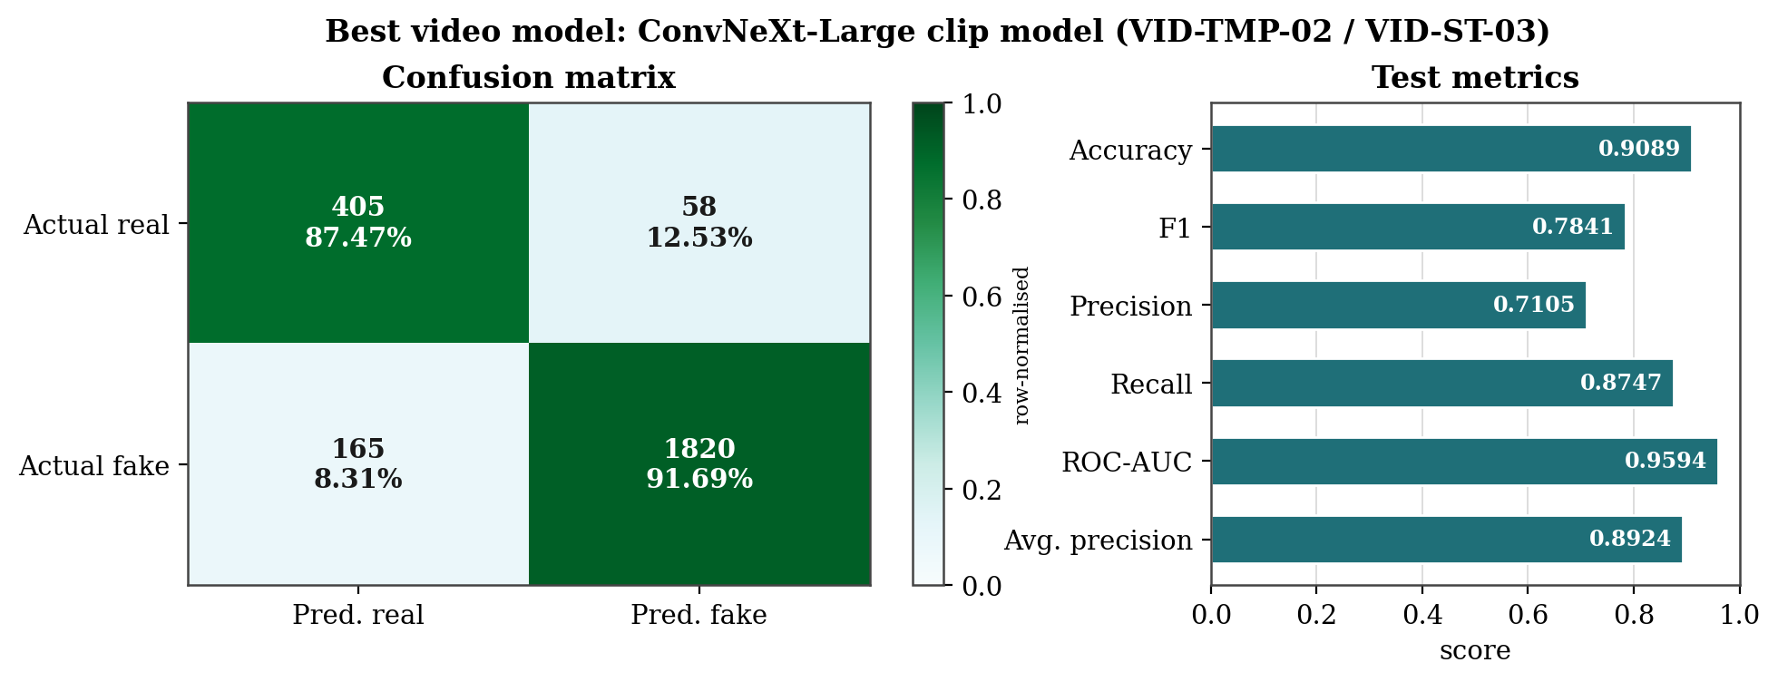
Figure 7. Best video model (ConvNeXt-Large clip model, VID-TMP-02 / VID-ST-03). Left: row-normalised confusion matrix over the video test set. Right: held-out test metrics.

7.4 Loss-function ablation
Because the video data is imbalanced, the choice of loss could in principle matter as much as the choice of architecture. Figure 6 compares standard cross-entropy with train-only oversampling against class-weighted cross-entropy and focal loss, for the spatial and temporal ConvNeXt-Base models on video_combined. For the spatial model, weighted cross-entropy raises accuracy slightly while lowering F1, trading recall for precision, and focal loss is clearly harmful, dropping F1 from 0.7023 to 0.4744. For the temporal model, weighted cross-entropy and standard loss are almost indistinguishable in F1. The practical conclusion is that the simple recipe, standard cross-entropy with train-only oversampling, is the most reliable of the three, and that the more elaborate focal objective hurts rather than helps on this data. Table 10 lists the values.
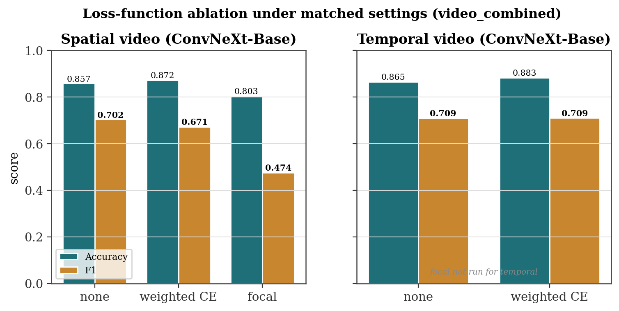
Figure 6. Loss-function ablation under matched settings on video_combined. Standard loss with oversampling is the most reliable; focal loss degrades the spatial model substantially.
Table 10. Loss-function ablation for ConvNeXt-Base video models (video_combined).
Configuration | Loss | Accuracy | F1
Spatial (VID-SPA-02) | none + oversample | 0.8566 | 0.7023
Spatial (VID-SPA-02) | weighted CE | 0.8717 | 0.6709
Spatial (VID-SPA-02) | focal | 0.8027 | 0.4744
Temporal (VID-TMP-01) | none + oversample | 0.8652 | 0.7090
Temporal (VID-TMP-01) | weighted CE | 0.8828 | 0.7092

7.5 The cross-modality gap
Bringing the modalities together, Figure 8 shows the best and mean test F1 for each category. The image category sits far above the rest, with a best F1 of 0.9863 and a category mean near 0.976. The temporal and spatiotemporal video categories reach a best F1 of 0.7841, the spatial baseline trails at 0.7023, and every video category has a substantially lower mean than the image category. The gap between the best image model and the best video model is roughly twenty F1 points. This is the single most important quantitative result in the study, and it holds regardless of which video category is used for the comparison, which is what justifies treating image and video detection as different problems rather than one problem at two resolutions.
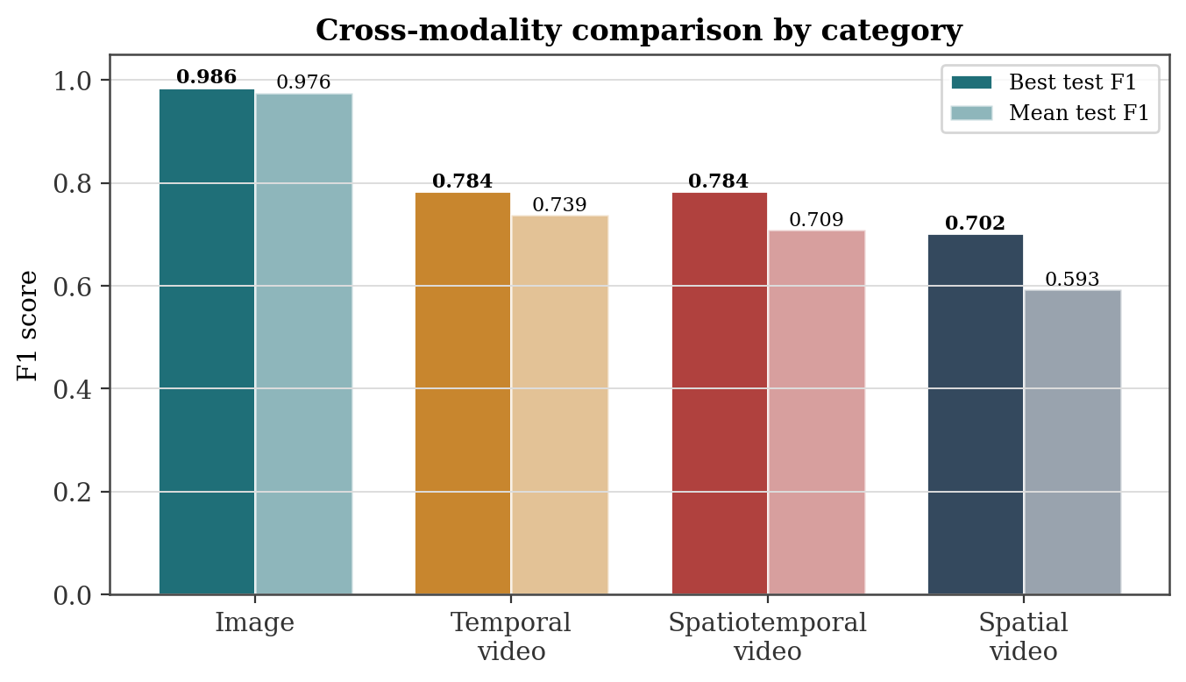
Figure 8. Cross-modality comparison by category. Image detection sits far above every video category in both best and mean held-out F1.

7.6 Convolutional versus transformer backbones
Figure 9 groups every completed run by backbone family. On the image side the convolutional and transformer means are close, because the task is nearly saturated, but the single best image model is convolutional and the weakest two are the plain Vision Transformers. For videos, the divide is obvious. The ConvNeXt, a convolutional backbone, tops mean scores and the charts for best individual results. The ViT, Swin spatial model and MaxViT hybrid, relying on attention and being hybrid designs, fall behind. So, within tested conditions, a convolutional backbone seems safest, backing the thought that local artifact detection favors this type of bias. We are careful not to overstate this: it is a statement about these architectures, this data, and this training budget, not a universal ranking of convolution against attention.
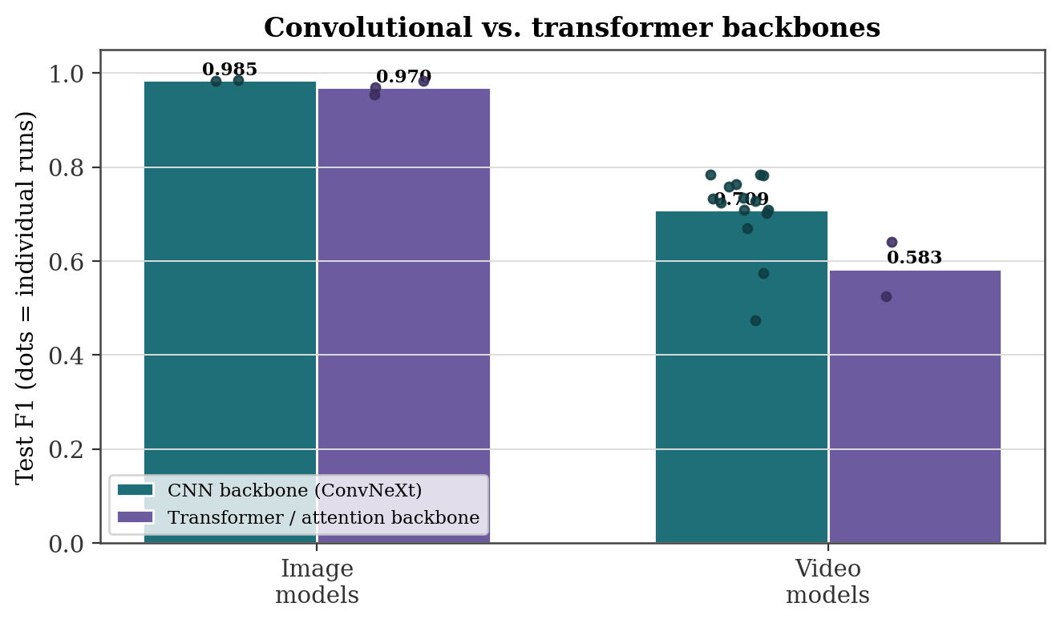
Figure 9. Convolutional versus transformer backbones. Bars are family means; dots are individual runs. The convolutional backbone is stronger on video and provides the best image result.

7.7 Overall leaderboard
Figure 10 ranks all twenty-two completed runs by held-out test F1. The ordering is unambiguous: the five image runs occupy the top of the table, separated from the video runs by a clear margin, and within the video block the ConvNeXt-Large clip and TCN configurations lead, the ConvNeXt-Base spatial and temporal runs sit in the middle, and the focal-loss spatial run sits at the bottom. The leaderboard summarises in one view the three findings developed above: image detection is easier than video detection, ConvNeXt is the strongest backbone in both modalities, and among genuine temporal heads the TCN is the best performer.
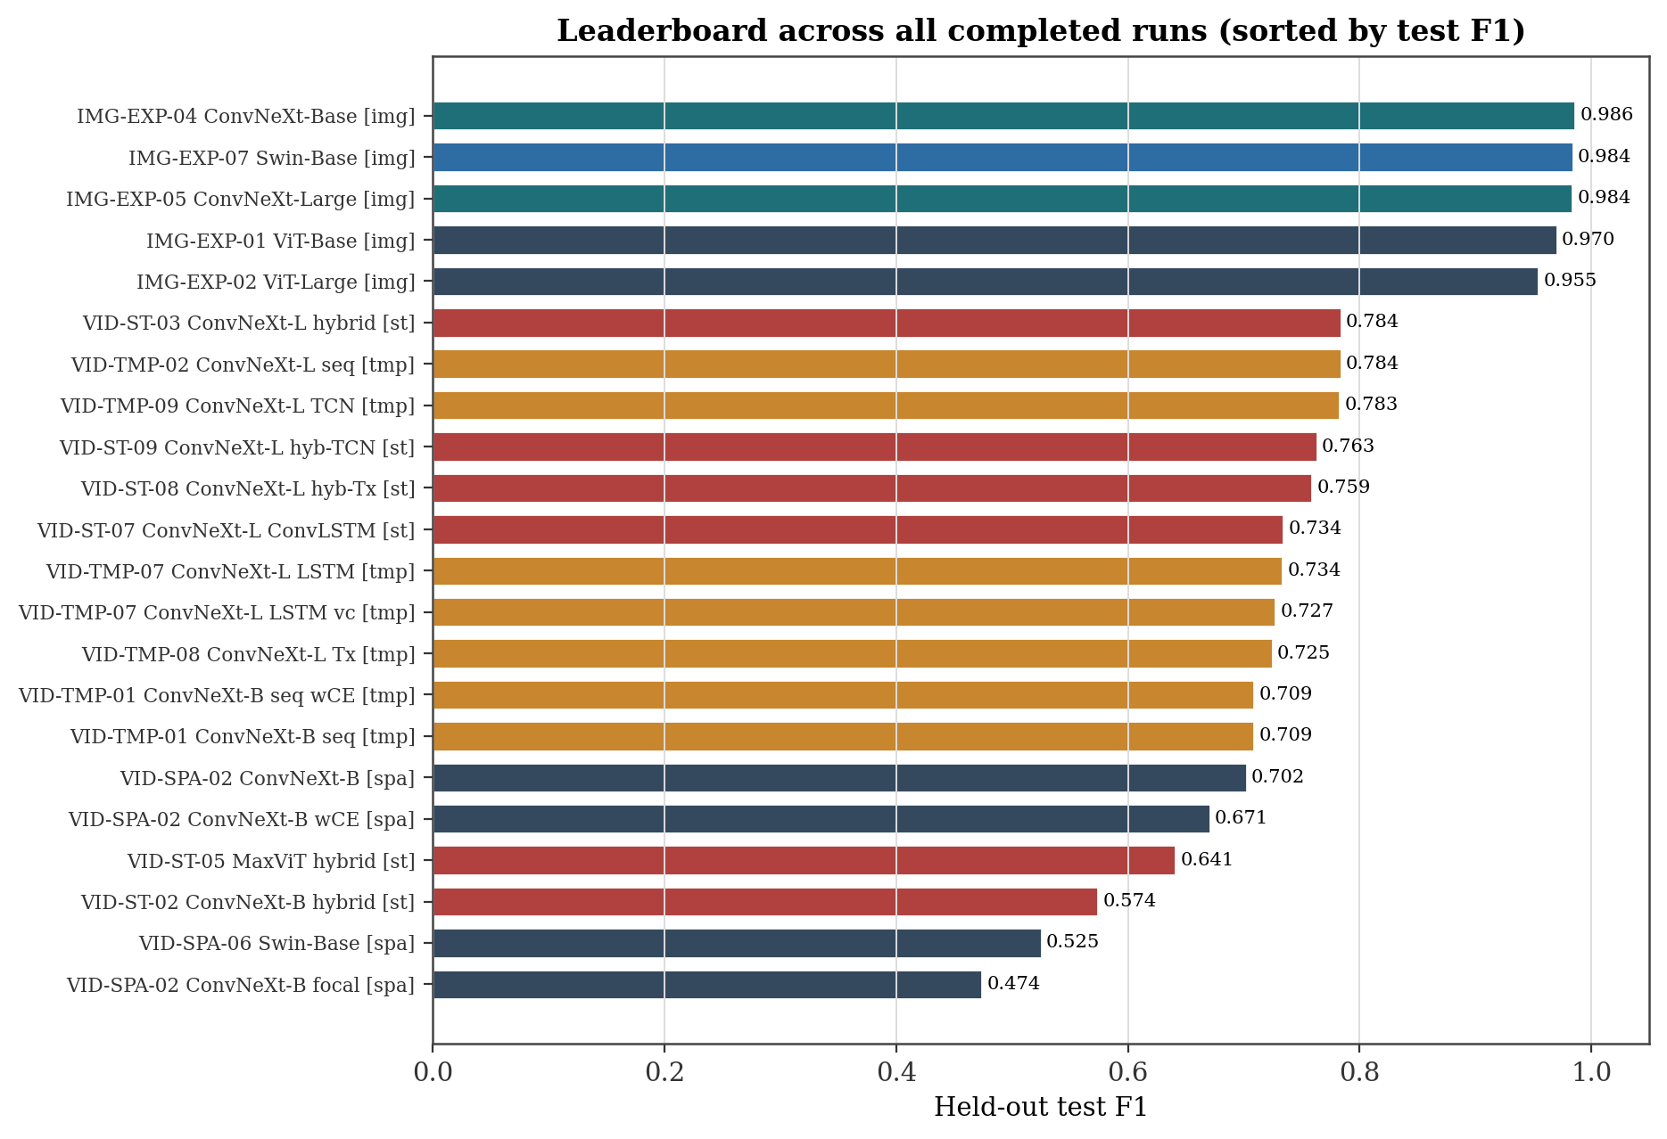
Figure 10. Leaderboard across all completed runs, sorted by held-out test F1. Colour encodes training category. Image runs occupy the top; video runs follow.

8. Discussion
Three findings emerge from the experiments, and it is worth stating once why each one looks the way it does. The first is that image detection is far easier than raw-video detection under matched conditions. The likely reason is that the image datasets contain fully synthetic content whose generation leaves consistent, frame-local artefacts, and a backbone with a local inductive bias picks these up readily on a large balanced corpus. The video datasets, by contrast, contain manipulated authentic recordings in which only part of the frame is altered, the manipulated region varies from clip to clip, and the useful signal is partly temporal. The model has to find a smaller, less consistent cue in a smaller and imbalanced dataset, so a twenty-point F1 gap is a reasonable outcome rather than a surprising one.
The second finding is that temporal modelling helps, but modestly, and that the temporal convolutional network is the best of the heads we compared. Moving from the spatial baseline at 0.7023 F1 to the best temporal configuration at 0.7841 is a real gain, which shows that frame sequences carry information that a single frame does not. The gain is bounded, though, and the controlled sweep in Figure 5 suggests why the TCN leads: its dilated causal convolutions give it a growing temporal receptive field while keeping the parameter count and the optimisation simple, so it captures short-range inconsistencies between adjacent frames without the training fragility of the recurrent and attention heads on a small dataset. The LSTM and the temporal transformer improve temporal reasoning over a naive baseline but do not surpass the TCN, which is consistent with the general observation that recurrent and attention models need more data than was available here to express their advantages.
The third finding is that convolutional backbones outperform the transformer backbones we evaluated, in both modalities and most clearly on video. The explanation is the same inductive-bias argument: deepfake cues are often subtle, local texture and blending defects, and convolution is built to detect exactly that, whereas a pure attention model spreads its capacity across global relationships that are less useful here and is harder to train well on limited data. Two secondary observations support the same picture. Focal loss, which is designed to emphasise hard examples, actually degraded the spatial video model, which indicates that the difficulty on this data is not a few hard examples that need up-weighting but a broadly noisy signal that elaborate loss shaping cannot fix. And the simple recipe of standard cross-entropy with train-only oversampling matched or beat the more complex imbalance strategies, which reinforces that careful data handling mattered more than loss engineering in this setting. Underlying all of it, the protocol separation and the identity-aware split are what let these comparisons be read as forensic results rather than as artefacts of leakage, since a model could not inflate its video score by memorising subjects who also appear in the test set.

8.1 Performance versus computational cost
The complexity profiling also adds another angle to these findings, and it shows the same trend as the accuracy results, too. So, both point in the same direction. Larger models were not better. ViT-Large carries roughly three and a half times the parameters of ConvNeXt-Base and close to four times its FLOPs, yet it is the weakest image model, while the compact ConvNeXt-Base is both the fastest of the larger-capacity options and the most accurate. The reason is the inductive-bias argument applied to budget: on a task whose evidence is local texture and blending artefacts, the convolutional model spends its capacity where the signal is, so it does not need the extra parameters that the global attention model uses to cover relationships that do not help here. For video the picture is consistent. The temporal heads are cheap relative to the ConvNeXt-Large backbone, differing by only a few million parameters and a few gigaflops, so the choice of head is close to free in compute terms and the comparison turns on the temporal mechanism rather than on capacity. Within that narrow cost band the TCN is the most attractive option, because it reaches the best temporal accuracy and F1 while being one of the lighter and faster heads, below the transformer, the ConvLSTM, and even the plain mean-pooled sequence in latency. Its dilated causal convolutions give it a useful temporal receptive field at low cost and without the optimisation fragility that the recurrent and attention heads showed on a small dataset. Taken together, the results favour matching the inductive bias to the signal over scaling capacity, and they make ConvNeXt with a TCN head a sensible default when both accuracy and efficiency matter.

9. Limitations
The conclusions above are bounded by several constraints that are stated plainly so that readers can judge how far the results travel.
Single-seed training. Every completed run used a single fixed random seed of 42. We therefore report deterministic single-run results from the best checkpoint of each experiment, and we do not report a mean or a spread across seeds.
No repeated-seed or significance analysis. Because only one seed was run per configuration, we cannot report mean and standard deviation across repeated runs, nor paired significance tests such as a t-test or a Wilcoxon signed-rank test. Small differences between models, for example the difference between the TCN on video_all and the mean-pooled sequence on video_combined, should be read as suggestive rather than as established at a stated confidence level.
No cross-dataset or unseen-generator evaluation. All models were trained and tested within the same dataset scope. We did not train on one dataset and test on another, did not evaluate against generators unseen during training, and did not measure robustness to compression or other perturbations. Generalisation to new sources is therefore untested here and is an open question.
Fixed centre-clip sampling. Each test video was summarised by a single fixed centre clip. We did not ablate the sampling position, so we cannot rule out that a manipulated region falling outside the centre clip biases some predictions, nor measure how sensitive the video results are to clip choice.
Single-platform complexity measurements. Complexity measurements were collected on a single hardware platform and should be interpreted as relative comparisons rather than universal deployment benchmarks. Latency and throughput in particular depend on the device, the software stack, and the batch size, so the figures here rank the models against one another on one GPU rather than predicting absolute speed elsewhere.
Shared rather than per-model tuning. One optimisation recipe was applied to every model so that architecture could be compared cleanly. This is the right choice for a controlled comparison, but it means no single model was tuned to its own best configuration, so the absolute numbers are likely conservative for some architectures.
Convergence of two video configurations and a small balanced set. The mean-pooled sequence and basic hybrid configurations share an implementation and converge to the same result, so they are not independent evidence. The only class-balanced video set, Real-AI Videos, is very small at 66 clips and cannot support standalone conclusions. The label “fake” also covers two different processes, fully synthetic images and manipulated videos, which is a further reason the two modalities are reported separately.
Computational constraints. Experiments ran on a single laptop-class GPU with limited memory, which capped the batch sizes, sequence lengths, and the number of configurations that could be explored, and which contributed to the reduced learning rate needed to train the larger clip models stably.

10. Future Work
The limitations point directly to the next steps. The most valuable additions would be repeated-seed runs with reported mean and spread and paired significance testing, which would turn the current rankings into statistically supported claims. Cross-dataset and unseen-generator evaluation, together with robustness tests under compression and perturbation, would establish whether the models generalise beyond the datasets used here, which is the property that matters most for deployment. On the video side, ablating the clip-sampling position and the sequence length, and moving beyond mean pooling toward sampling strategies that target likely manipulation, would clarify how much further temporal modelling can be pushed. A larger and better-balanced collection of real videos would reduce the dependence on imbalance handling. Finally, allowing each architecture to be tuned individually, and extending the complexity profiling to additional hardware, would give a fuller account of the accuracy-versus-cost trade-off across the model families.

11. Conclusion
This study examined deepfake detection as two separate problems under a protocol-separated evaluation framework, with image and video data kept apart and with an identity-aware split protecting the video evaluation from subject leakage. Within this framework, a controlled comparison of image backbones and a systematic comparison of temporal heads on video produced a consistent picture. Image detection was substantially easier than raw-video detection under matched conditions, with the best image model reaching a held-out test F1 of 0.9863 against 0.7841 for the best video configuration. Temporal modelling improved video detection over a spatial baseline, and among the temporal heads compared under matched settings the temporal convolutional network was the strongest, reaching the best video accuracy of 0.9102. Convolutional backbones outperformed the transformer backbones across both modalities. These results are reported as specific to the selected datasets, the fixed single-seed training configuration, and the evaluated architectures. They are not claims about deepfake detection in general, and the absence of repeated-seed, cross-dataset, and robustness analysis marks the boundary of what the present evidence supports. The contribution of the work is a clean and reproducible way to compare models across modalities, and a clear measurement of how far apart image and video detection currently stand.

Data and Code Availability
The curated image and video datasets used for training are available on Hugging Face [31]. The full implementation, including training and evaluation procedures, is available on GitHub [32]. A live demonstration of the detection system is available on the web [39]. The source datasets are additionally available from their original providers [33], [34], [35], [36], [37], [38].

References
[1] M. Li, Y. Ahmadiadli, and X. P. Zhang, “A survey on speech deepfake detection,” ACM Computing Surveys, vol. 57, no. 7, pp. 1–38, 2025.
[2] K. Somoray, D. J. Miller, and M. Holmes, “Human performance in deepfake detection: a systematic review,” Human Behavior and Emerging Technologies, vol. 2025, no. 1, 2025.
[3] Z. Huang, J. Hu, X. Li, Y. He, X. Zhao, B. Peng, et al., “SIDA: Social media image deepfake detection, localization and explanation with large multimodal model,” in Proc. CVPR, 2025, pp. 28831–28841.
[4] Y. Zhang, Z. Pang, S. Huang, C. Wang, and X. Zhou, “Unmasking AI-created visual content: a review of generated images and deepfake detection technologies,” Journal of King Saud University Computer and Information Sciences, vol. 37, no. 6, 2025.
[5] S. K. Datta, T. Ranga, C. Sun, and S. Lyu, “PIA: Deepfake detection using phoneme-temporal and identity-dynamic analysis,” in Proc. ICCV, 2025, pp. 1596–1606.
[6] Y. El Kheir, Y. Samih, S. Maharjan, T. Polzehl, and S. Möller, “Comprehensive layer-wise analysis of SSL models for audio deepfake detection,” in Findings of NAACL, 2025, pp. 4070–4082.
[7] Y. Wang, Y. Deng, Y. Zheng, P. Chattopadhyay, and L. Wang, “Vision transformers for image classification: a comparative survey,” Technologies, vol. 13, no. 1, 2025.
[8] A. Hatamizadeh and J. Kautz, “MambaVision: A hybrid Mamba-transformer vision backbone,” in Proc. CVPR, 2025, pp. 25261–25270.
[9] Z. Wang, X. Xia, R. Chen, D. Yu, C. Wang, M. Gong, and T. Liu, “LAVIN-DiT: Large vision diffusion transformer,” in Proc. CVPR, 2025, pp. 20060–20070.
[10] B. N. Patro, V. P. Namboodiri, and V. S. Agneeswaran, “SpectFormer: Frequency and attention is what you need in a vision transformer,” in Proc. WACV, 2025.
[11] Y. Li, D. Chen, T. Tang, and X. Shen, “HTR-VT: Handwritten text recognition with vision transformer,” Pattern Recognition, vol. 158, 2025.
[12] V. Hassija, B. Palanisamy, A. Chatterjee, A. Mandal, D. Chakraborty, A. Pandey, et al., “Transformers for vision: A survey on innovative methods for computer vision,” IEEE Access, 2025.
[13] Y. Li, Y. Tian, Y. Huang, W. Lu, S. Wang, W. Lin, and A. Rocha, “FakeScope: Large multimodal expert model for transparent AI-generated image forensics,” arXiv, 2025.
[14] P. Dahiwal and V. Khare, “Strengthening security in clouds through cloud computing authentication using facial image forensics,” Journal of Computational and Cognitive Engineering, vol. 4, no. 2, 2025.
[15] J. Park and A. Owens, “Community forensics: Using thousands of generators to train fake image detectors,” in Proc. CVPR, 2025.
[16] S. Thotakuri, B. Naresh, and P. Premalatha, “Leveraging image forensics for effective copy-move forgery identification.”
[17] Z. Yan, J. Ye, W. Li, Z. Huang, S. Yuan, X. He, et al., “GPT-ImgEval: A comprehensive benchmark for diagnosing GPT-4o in image generation,” arXiv, 2025.
[18] Y. Chen, W. Yin, A. Luo, J. Yang, and J. Wang, “Improving the generalization and robustness of computer-generated image detection based on contrastive learning,” International Journal of Intelligent Systems, 2025.
[19] Y. Li, D. Zhu, X. Cui, and S. Lyu, “Celeb-DF++: A large-scale challenging video deepfake benchmark,” arXiv, 2025.
[20] T. D. Nguyen and M. C. Stamm, “MVFNet: Multipurpose video forensics network using multiple forms of forensic evidence,” in Proc. WACV, 2025.
[21] R. Corvi, D. Cozzolino, E. Prashnani, S. De Mello, K. Nagano, and L. Verdoliva, “Seeing what matters: Generalizable AI-generated video detection with forensic-oriented augmentation,” arXiv, 2025.
[22] B. C. Hosler, “Video forensics: A study of multimedia forensics with emphasis on modern video,” PhD thesis, Drexel University, 2025.
[23] M. M. Ali, N. I. Ghali, H. M. Hamza, K. M. Hosny, E. Vrochidou, and G. A. Papakostas, “Interframe forgery video detection: Datasets, methods, challenges, and search directions,” Electronics, vol. 14, no. 13, 2025.
[24] P. Michael, Z. Hao, S. Belongie, and A. Davis, “Noise-coded illumination for forensic and photometric video analysis,” ACM Transactions on Graphics, vol. 44, no. 5, 2025.
[25] O. Shobayo and R. Saatchi, “Developments in deep learning artificial neural network techniques for medical image analysis,” Diagnostics, vol. 15, no. 9, 2025.
[26] S. Iqbal, T. M. Khan, S. S. Naqvi, A. Naveed, and E. Meijering, “TBConvL-Net: A hybrid deep learning architecture for robust medical image segmentation,” Pattern Recognition, vol. 158, 2025.
[27] M. Trigka and E. Dritsas, “A comprehensive survey of deep learning approaches in image processing,” Sensors, vol. 25, no. 2, 2025.
[28] J. Wang, S. Wang, and Y. Zhang, “Deep learning on medical image analysis,” CAAI Transactions on Intelligence Technology, vol. 10, no. 1, 2025.
[29] A. Chaddad, Y. Hu, Y. Wu, B. Wen, and R. Kateb, “Generalizable and explainable deep learning for medical image computing,” Current Opinion in Biomedical Engineering, 2025.
[30] M. T. Ahmed, O. Monjur, A. Khaliduzzaman, and M. Kamruzzaman, “A comprehensive review of deep learning-based hyperspectral image reconstruction,” Artificial Intelligence Review, vol. 58, no. 4, 2025.
[31] A. S. George, “Deepfake datasets (image and video repository),” Hugging Face. Available: https://huggingface.co/datasets/Anson-Saju-George/deepfake_datasets (accessed Apr. 23, 2026).
[32] A. S. George, “Deepfake engine research repository,” GitHub. Available: https://github.com/Anson-Saju-George/Deepfake-Engine-Research (accessed Apr. 23, 2026).
[33] T. Zhang, “AI-generated images vs real images dataset,” Kaggle. Available: https://www.kaggle.com/datasets/tristanzhang32/ai-generated-images-vs-real-images (accessed Apr. 23, 2026).
[34] H. Duy, “CIFAKE dataset,” Kaggle. Available: https://www.kaggle.com/datasets/hunhduyng/cifake (accessed Apr. 23, 2026).
[35] R. Suju, “Celeb-DF-v2 dataset,” Kaggle. Available: https://www.kaggle.com/datasets/reubensuju/celeb-df-v2 (accessed Apr. 23, 2026).
[36] A. Rössler et al., “FaceForensics dataset,” GitHub. Available: https://github.com/ondyari/FaceForensics (accessed Apr. 23, 2026).
[37] J. Thies et al., “FaceForensics++,” Project Page. Available: https://justusthies.github.io/posts/faceforensics++/ (accessed Apr. 23, 2026).
[38] Kanzeus, “Real vs AI generated video dataset,” Kaggle. Available: https://www.kaggle.com/datasets/kanzeus/realai-video-dataset (accessed Apr. 23, 2026).
[39] A. S. George, “Deepfake detection web application,” 2026. Available: https://ansonsajugeorge.online/deepfake/ (accessed Apr. 23, 2026).

