Part1:

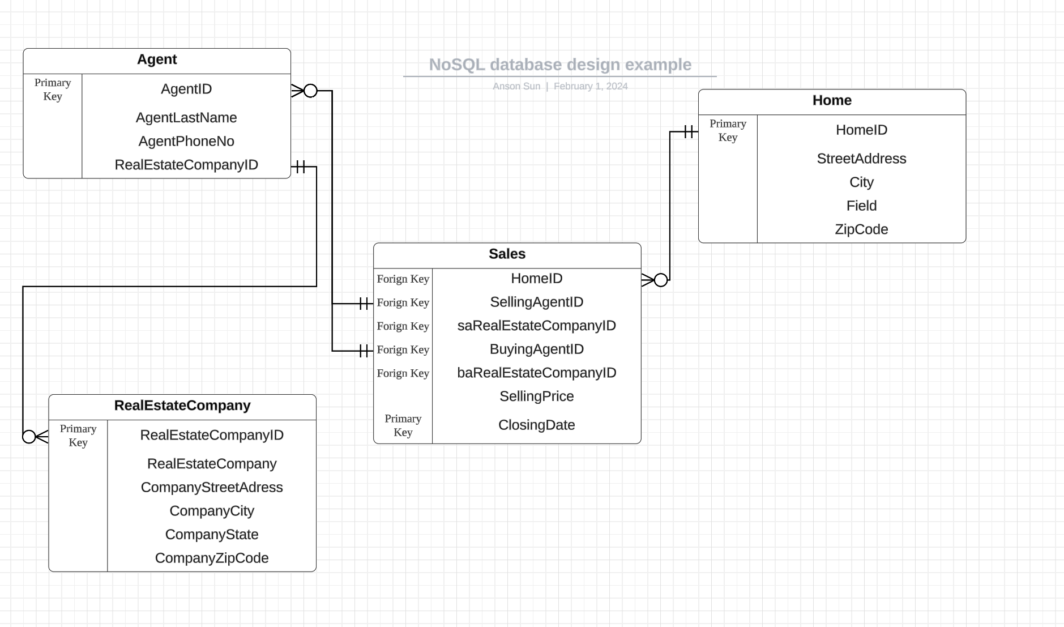

Our data usage pattern is to find the average quarterly sold quantity of a color. Use the embedding design technique and the provided data to design a MongoDB database. Create the database on MongoDB Atlas that includes document(s) reflecting the data contained in the attached file. (50% of grade)

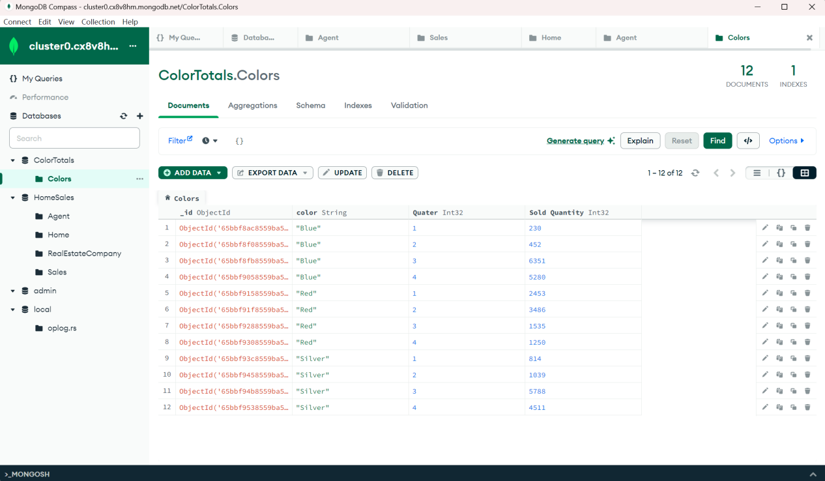

Then use the MongoDB Compass, JavaScripts and MongoDB Aggregation Pipeline to calculate the average quarterly sold quantity of the blue color. (50% of grade)

The the average quarterly sold quantity of the blue color is 3078.25

