### TwoSumWithCalipers

I used a double for circular to traverse the array. One is i who traversed from 0 to a.length, and another is j who traversed from i+1 to a.length.

For every pairs , if a[i]+a[j]=0, the pair will be added into the arraylist.

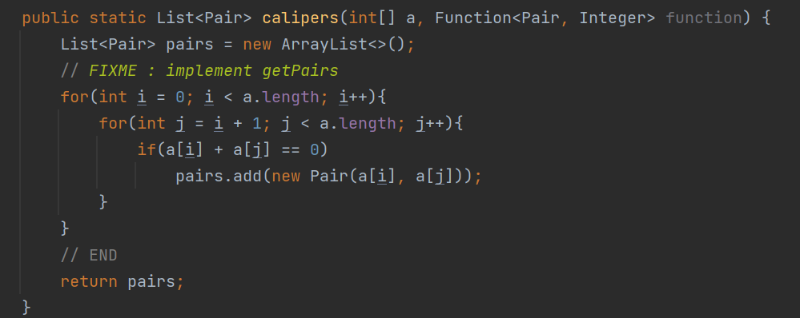

This is the result of tests:

### 

### Three sum quadratic:

I used a double for circular to traverse the array. One is x who traversed from 0 to j, and another is y who traversed from a.length to j, like digging a tunnel.

For every triples , if a[x]+a[j]+a[y]=0, the triple will be added into the arraylist.

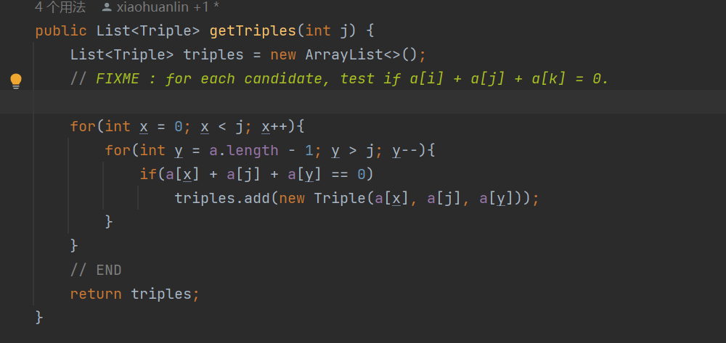

### ThreeSumQuadraticWithCalipers

Just like what I did before, I used a double for circular to traverse the array. One is x who traversed from 0 to j, and another is y who traversed from a.length to j, like digging a tunnel.

For every triples , if a[x]+a[j]+a[y]=0, the triple will be added into the arraylist.

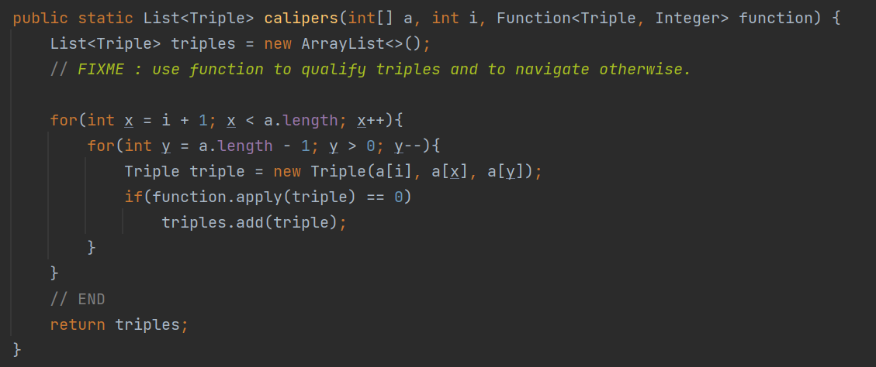

### Test Result

I think there should be no problem, but I didn’t pass all of the tests when testing “Three Sum Quadratic With Calipers”, I don’t know why. The result is very close to the correct one, but it seemed that I’ve missed some of the triples.



