Part2:

I think my method of sorting is correct, but the result of the test is strange.



Part3:

I generated 4 arrays whose length are all 100000.

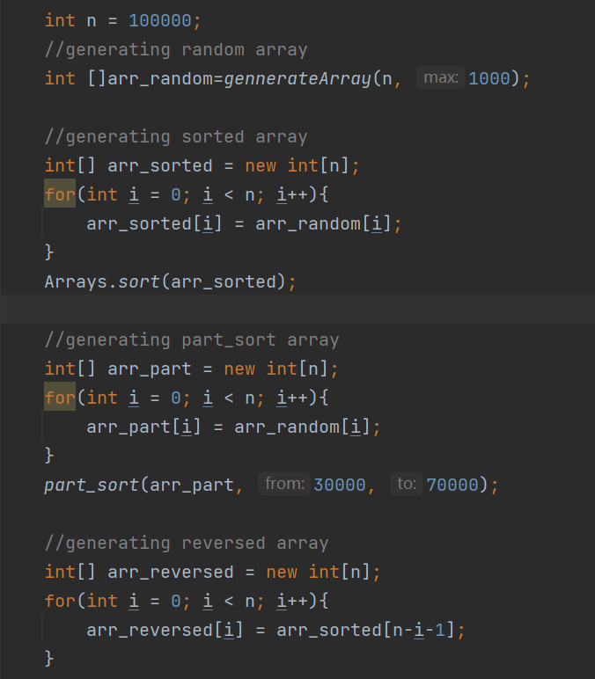

I sorted it by using insertion sort.

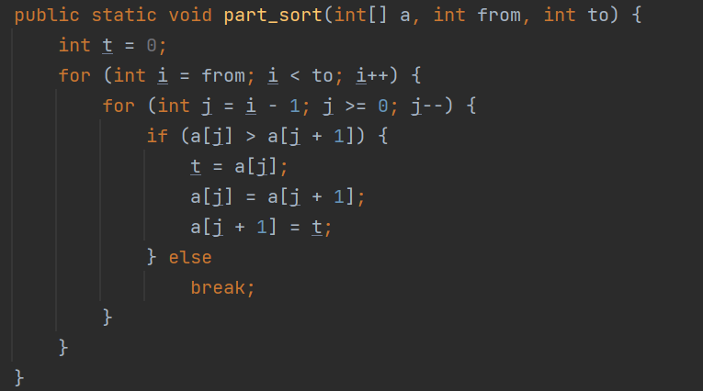

Running result for the 4 kinds of arrays:

