Step1:

I got some problem in this step. If I check if (root != parent[root]) in this way:

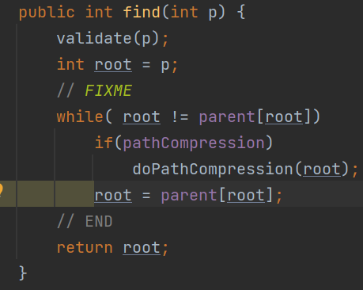

The test stuck in testIsConnected03 and keep running for very long time, I cannot find out if I passed the test or not.

In order to make sure the program is able to run, I assigned root as parent[root] without checking anything:

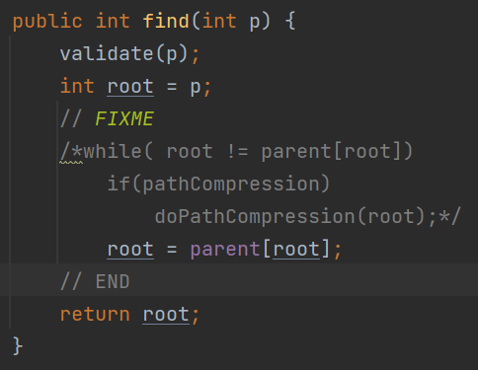

And of course, it costs:

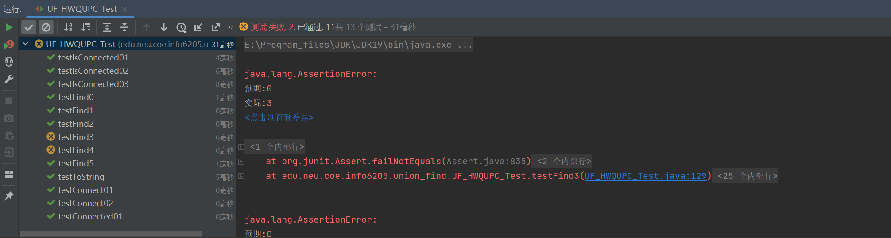

Step2:

This step based on the way I modified the program.

I wrote a counter and main method in Solution.java to call the union function:

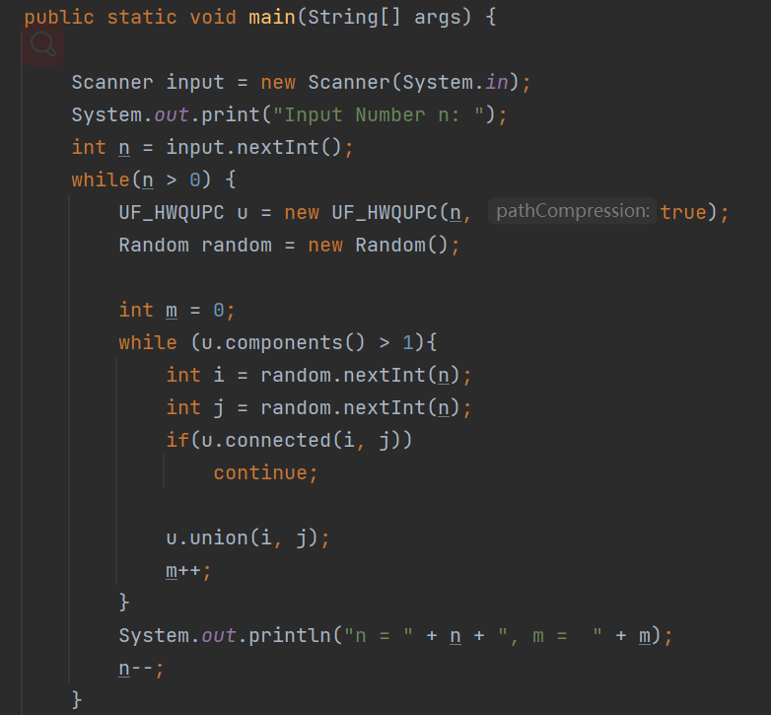

When I entered n as 100:

This is the result:

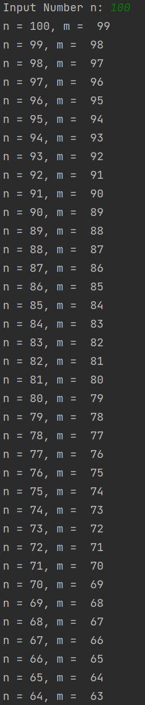 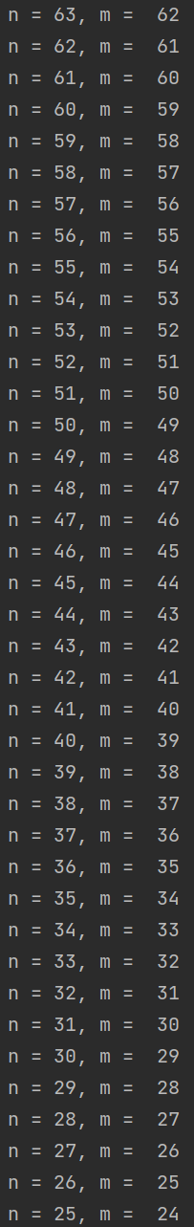 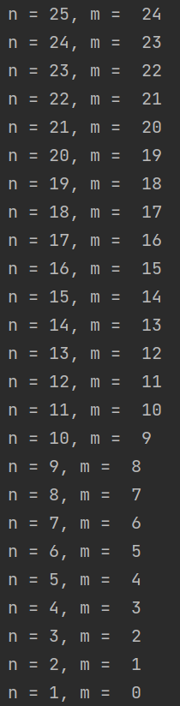

Step 3:

I guess the relationship between n and m is:

M = N - 1