## Assignment 5

I created my own thread pool and created pool numbers as :1, 2, 5, 10, 20, 100, 200, 500:

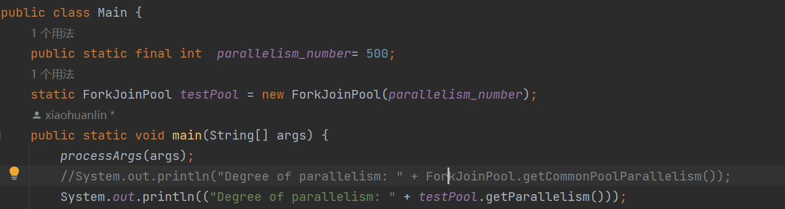

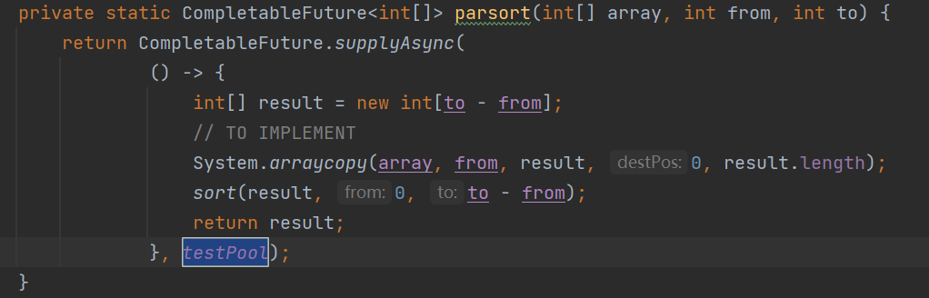

The time of parallel sorting is in the excel table:

|  |  |  |  |  |  |  |  |  |  |  |
| --- | --- | --- | --- | --- | --- | --- | --- | --- | --- | --- |
| cutoff | 19(default) | 1 | 2 | 5 | 10 | 20 | 50 | 100 | 200 | 500 |
| 510000 | 940 | 1636 | 1307 | 1125 | 939 | 900 | 947 | 956 | 826 | 804 |
| 520000 | 638 | 1274 | 1121 | 856 | 649 | 634 | 680 | 666 | 658 | 654 |
| 530000 | 655 | 1272 | 1124 | 860 | 609 | 639 | 664 | 669 | 609 | 625 |
| 540000 | 616 | 1349 | 1122 | 881 | 613 | 610 | 616 | 644 | 605 | 603 |
| 550000 | 609 | 1242 | 1129 | 852 | 606 | 611 | 634 | 638 | 593 | 613 |
| 560000 | 608 | 1419 | 1115 | 847 | 600 | 629 | 624 | 644 | 611 | 615 |
| 570000 | 605 | 1370 | 1122 | 846 | 607 | 616 | 614 | 643 | 621 | 615 |
| 580000 | 612 | 1303 | 1118 | 846 | 604 | 603 | 623 | 673 | 610 | 599 |
| 590000 | 614 | 1267 | 1110 | 843 | 649 | 600 | 613 | 687 | 654 | 608 |
| 600000 | 692 | 1337 | 1161 | 844 | 630 | 623 | 604 | 636 | 641 | 612 |
| 610000 | 660 | 1287 | 1156 | 844 | 607 | 656 | 655 | 634 | 599 | 611 |
| 620000 | 667 | 1297 | 1144 | 840 | 596 | 623 | 615 | 634 | 601 | 605 |
| 630000 | 610 | 1365 | 1132 | 846 | 605 | 606 | 626 | 626 | 605 | 608 |
| 640000 | 613 | 1287 | 1148 | 849 | 595 | 612 | 637 | 630 | 604 | 620 |
| 650000 | 624 | 1307 | 1138 | 840 | 596 | 614 | 654 | 627 | 611 | 605 |
| 660000 | 630 | 1342 | 1123 | 852 | 589 | 606 | 633 | 646 | 626 | 605 |
| 670000 | 648 | 1414 | 1125 | 920 | 593 | 607 | 613 | 635 | 610 | 647 |
| 680000 | 634 | 1231 | 1150 | 1038 | 586 | 602 | 612 | 642 | 667 | 609 |
| 690000 | 611 | 1361 | 1133 | 1098 | 595 | 617 | 602 | 636 | 688 | 613 |
| 700000 | 611 | 1180 | 1139 | 961 | 599 | 606 | 620 | 641 | 675 | 641 |
| 710000 | 609 | 1259 | 1120 | 912 | 597 | 605 | 625 | 642 | 634 | 656 |
| 720000 | 620 | 1244 | 1109 | 873 | 609 | 604 | 623 | 640 | 614 | 611 |
| 730000 | 600 | 1257 | 1149 | 905 | 593 | 617 | 609 | 638 | 628 | 610 |
| 740000 | 604 | 1325 | 1115 | 910 | 599 | 604 | 612 | 627 | 640 | 600 |
| 750000 | 600 | 1236 | 1114 | 997 | 594 | 604 | 614 | 627 | 623 | 602 |
| 760000 | 603 | 1266 | 1146 | 892 | 602 | 607 | 618 | 630 | 633 | 610 |
| 770000 | 607 | 1274 | 1120 | 870 | 595 | 603 | 601 | 635 | 633 | 609 |
| 780000 | 603 | 1284 | 1114 | 838 | 595 | 609 | 602 | 639 | 648 | 607 |
| 790000 | 596 | 1284 | 1109 | 853 | 600 | 610 | 597 | 644 | 627 | 599 |
| 800000 | 609 | 1334 | 1112 | 864 | 601 | 596 | 610 | 651 | 613 | 597 |
| 810000 | 612 | 1246 | 1119 | 845 | 596 | 614 | 625 | 622 | 615 | 604 |
| 820000 | 603 | 1259 | 1131 | 847 | 606 | 605 | 607 | 651 | 618 | 602 |
| 830000 | 618 | 1291 | 1121 | 870 | 593 | 602 | 601 | 625 | 632 | 605 |
| 840000 | 620 | 1325 | 1114 | 840 | 589 | 606 | 604 | 631 | 637 | 615 |
| 850000 | 601 | 1278 | 1118 | 856 | 591 | 606 | 614 | 636 | 634 | 612 |
| 860000 | 617 | 1237 | 1112 | 843 | 596 | 600 | 610 | 637 | 633 | 614 |
| 870000 | 602 | 1213 | 1125 | 886 | 599 | 604 | 612 | 637 | 604 | 620 |
| 880000 | 602 | 1286 | 1110 | 847 | 613 | 596 | 622 | 630 | 603 | 617 |
| 890000 | 628 | 1284 | 1111 | 840 | 624 | 601 | 619 | 636 | 610 | 624 |
| 900000 | 613 | 1313 | 1116 | 841 | 608 | 621 | 623 | 646 | 604 | 618 |
| 910000 | 607 | 1190 | 1123 | 841 | 614 | 599 | 630 | 635 | 600 | 618 |
| 920000 | 612 | 1287 | 1111 | 843 | 606 | 606 | 631 | 642 | 604 | 612 |
| 930000 | 598 | 1227 | 1112 | 834 | 595 | 608 | 609 | 639 | 599 | 606 |
| 940000 | 603 | 1262 | 1168 | 843 | 587 | 616 | 609 | 623 | 613 | 595 |
| 950000 | 612 | 1288 | 1145 | 838 | 595 | 602 | 610 | 623 | 608 | 606 |
| 960000 | 622 | 1278 | 1122 | 840 | 592 | 610 | 636 | 654 | 602 | 608 |
| 970000 | 626 | 1268 | 1107 | 843 | 600 | 606 | 616 | 640 | 604 | 609 |
| 980000 | 632 | 1210 | 1124 | 837 | 592 | 617 | 627 | 651 | 606 | 610 |
| 990000 | 623 | 1308 | 1111 | 851 | 596 | 615 | 611 | 634 | 621 | 599 |
| 1000000 | 617 | 1187 | 1125 | 867 | 609 | 605 | 624 | 625 | 602 | 608 |
| average | 624.32 | 1290.8 | 1129 | 875.08 | 609.06 | 616.24 | 626.74 | 645.94 | 625.12 | 616.3 |

As we can see in the 2 line graph below, the time of parallel sorting decreases as the number of thread pool increases. But if there are too many threads, the effect of acceleration is not remarkable anymore.

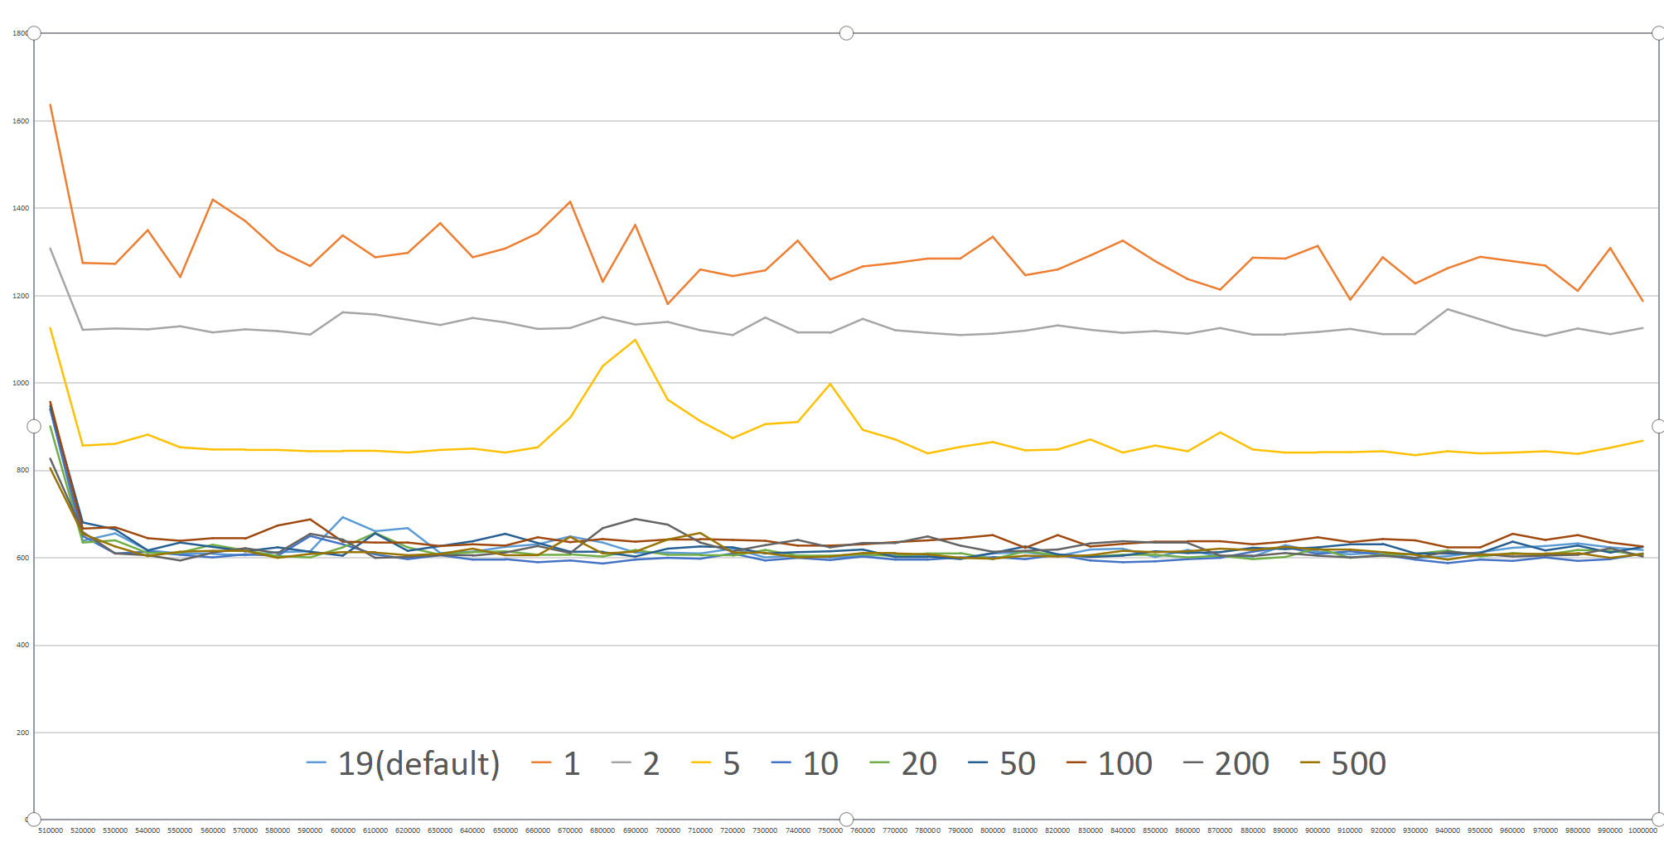

Graph-1 Sorting Time

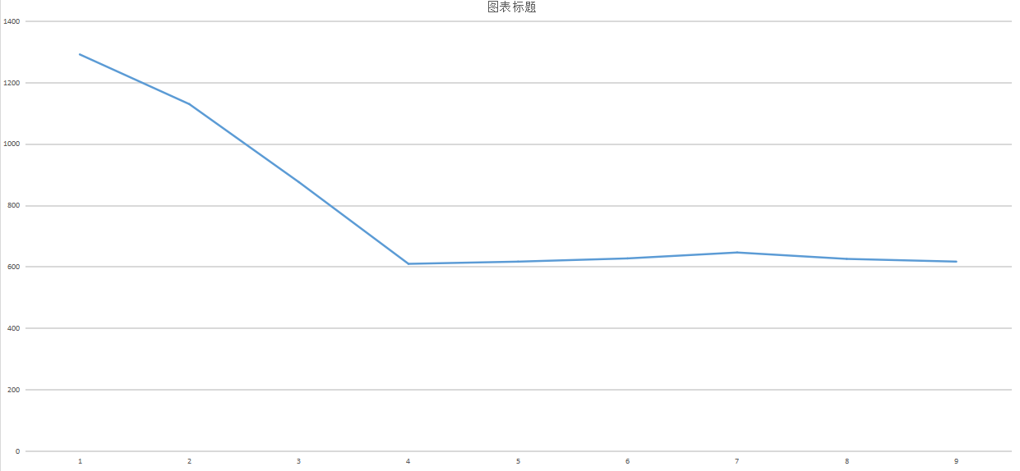

Graph-2 Average of the Sorting Time