VegClassify User Tutorial

Introduction
VegClassify is designed specifically for NAIP (National Agriculture Imagery Program) imagery that contains four spectral bands: Red, Green, Blue (RGB), and Near-Infrared (NIR). The tool has been extensively tested using NAIP datasets from all 48 contiguous U.S. states, ensuring broad geographic robustness and stable performance across different landscapes.
While VegClassify is optimized for NAIP imagery, it can also be applied to other high-resolution datasets as long as the input imagery is pre-processed to include the same four bands (RGB + NIR). In principle, any imagery that provides these four channels in the correct order should be compatible with VegClassify and produce reliable greenspace classification results. For academic use, we kindly ask users to cite VegClassify using the references listed at the end of this document.
- Launching the Software

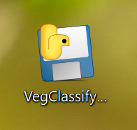
Double-click the VegClassify.exe icon to start the program. No installation is required.
Please note that the software may take up to one minute to fully load all necessary resources.
If you are unsure whether the program has started, open Task Manager and search for “veg” in the search bar. If a related process appears, the software is running in the background—please allow it some time to finish loading.
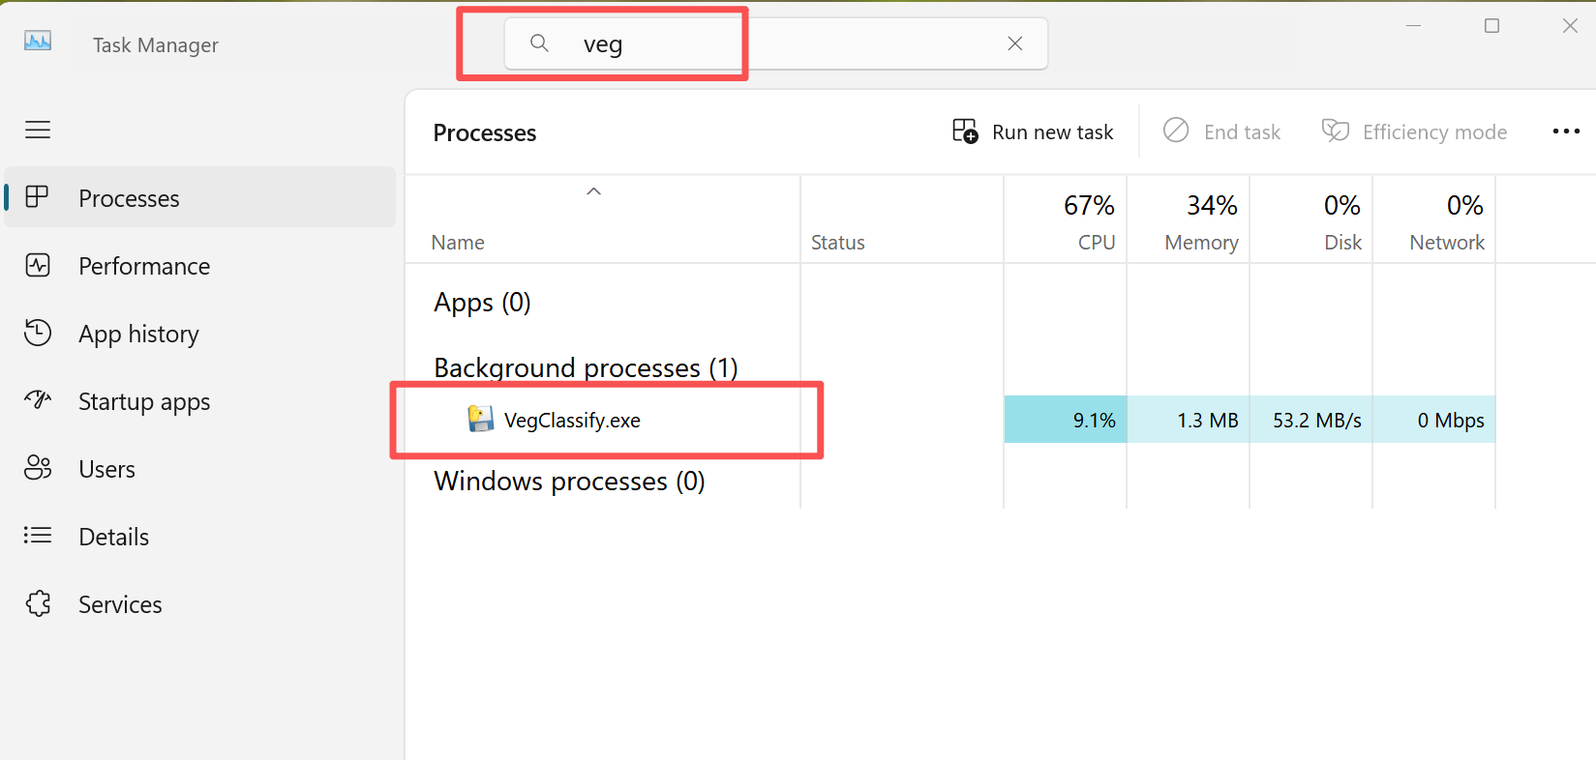
- Initializing the Workspace
Upon launch, you will see a pop-up message:
“Workspace not initialized. Run it now?”
The Workspace is the directory where all output imagery will be saved.
- Click Yes if you are comfortable using the default directory.
- Click No if you'd like to specify your own directory.
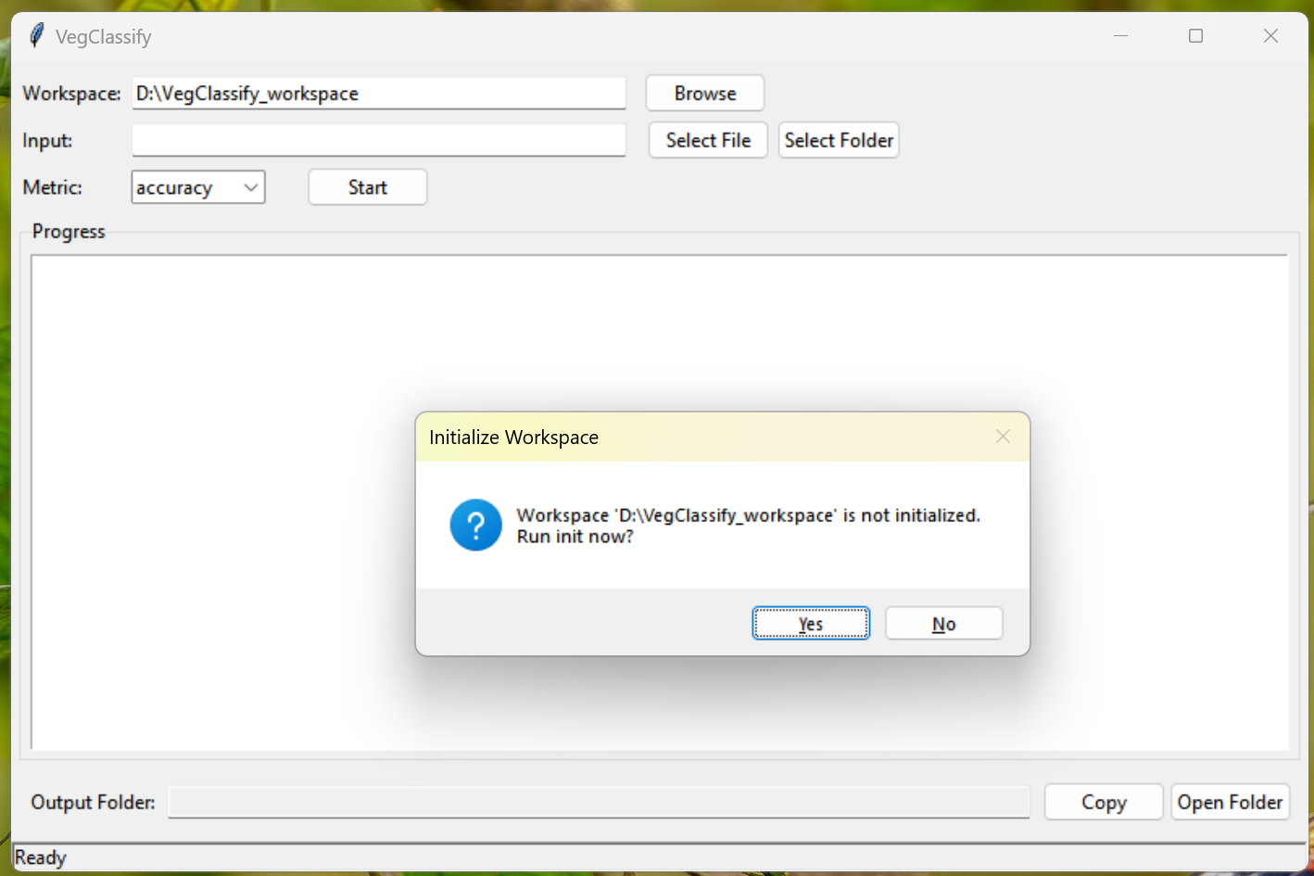
If you select No, click Browse and choose any folder you prefer as the Workspace.
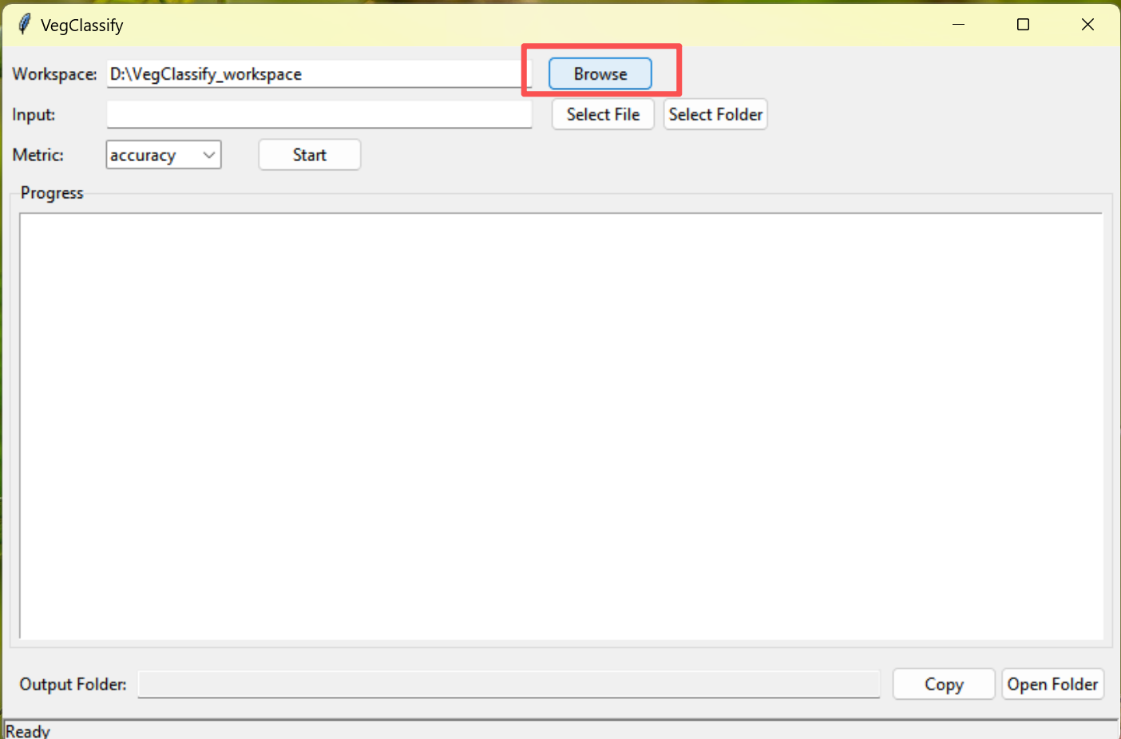
The software will then ask if you want to initialize the Workspace. Click Yes.
Once you see “Workspace initialized successfully,” click OK to continue.
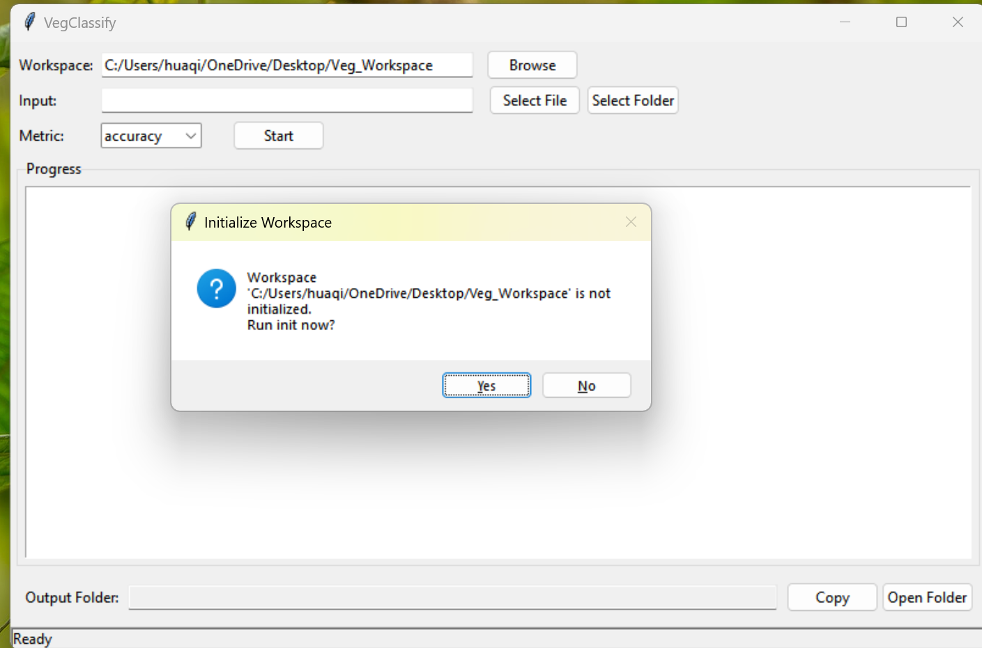
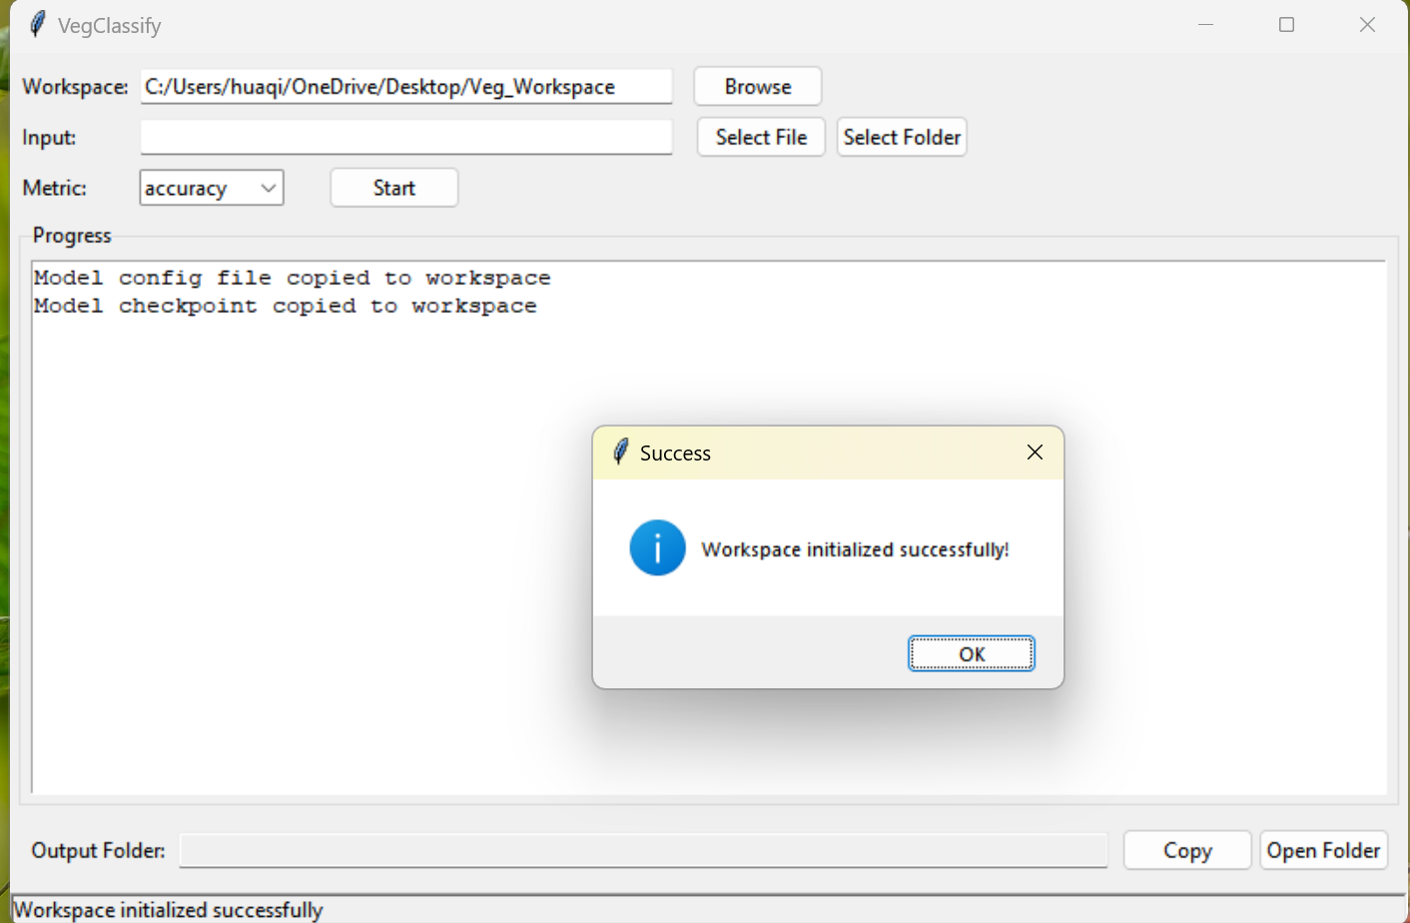

Selecting Input Imagery
On the main interface, choose one of the following options:
- Select File — Use this option if you want to classify a single image.
- Select Folder — Use this option if you want to batch process multiple images stored in the same folder.

Selecting the Classification Method and Starting the Process
You can choose between Optimal Kappa and Optimal Accuracy as the classification methods.
- Optimal Kappa:
Based on our testing, the Kappa-based optimization generally provides more stable and consistent results across most high-resolution imagery.
- Optimal Accuracy:
For certain imagery, we found that the accuracy-based optimization may occasionally outperform Optimal Kappa, although this behavior is less consistent.
Recommendation:
If you are unsure which method to choose, we recommend using Kappa as the default option, as it typically yields the most reliable performance.
After selecting the method, click Start to begin processing. The classification may take some time depending on dataset size, so please allow the process to complete.
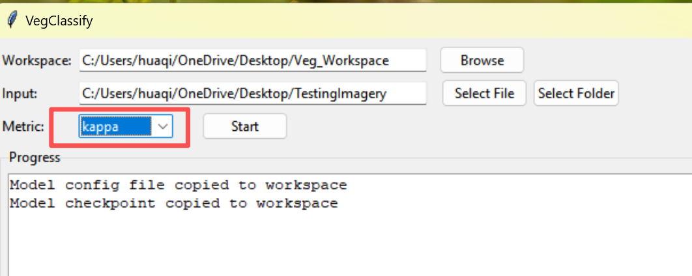

Viewing Output Results
Once processing is complete, click Open Folder to access the output directory.
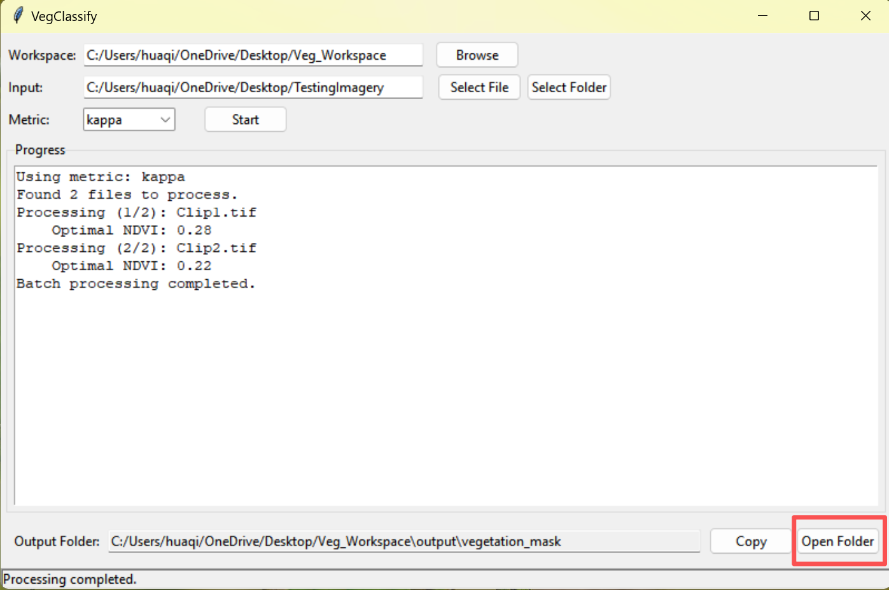
You will find classified raster images in the output folder.
If the previews appear solid black, this is normal—simply adjust the symbology in your GIS software. The classified imagery by defaults comes with pixel values:
- greenspace = 1
- nongreenspace = 0
After adjusting the display settings, the classified green space and non-green space pixels will be shown correctly.

References
We are offering this software free of charge. If you use VegClassify in your research, publications, or presentations, please cite the following works:
Wang, H., Zhao, X., Gholami, S., McGinty, C., Chamberlain, B., & Qi, X. (2026). A Hybrid Deep Learning and NDVI Threshold Approach for High-Resolution Urban Greenspace Classification. Urban Forestry & Urban Greening, 129332. https://doi.org/10.1016/j.ufug.2026.129332
Wang, H., Zhang, Y., & Fu, J. (2026). VegClassify: A Hybrid Deep Learning–NDVI Greenspace Classification Tool and GUI. Utah State University. https://doi.org/10.26078/X0GG-0969

