TECHNICAL UNIVERSITY - SOFIA
FACULTY OF COMPUTER SYSTEMS AND TECHNOLOGIES

BACHELOR THESIS ON TOPIC OF
DESIGN AND IMPLEMENTATION OF A MULTI-AGENT TASK SCHEDULING AND EXECUTION SYSTEM

ANSOR TAGHOEV
2026
FACULTY NUMBER 273222034

2026

Table of Contents
1. INTRODUCTION 3
2. PROBLEM DESCRIPTION 4
3. MULTI-AGENT SYSTEM DESIGN 6
3.1. AGENTS AND RESPONSIBILITIES 7
3.2. AGENT COMMUNICATION 8
3.3. TASK SCHEDULING STRATEGY 8
3.4. TASK LIFECYCLE AND STATE MANAGEMENT 10
SOURCES 13
APPENDIX 14

1. INTRODUCTION
Modern software systems often consist of multiple interacting components that must coordinate their activities while operating with limited direct supervision. The agent-oriented approach models such components as autonomous software entities. Wooldridge and Jennings identify autonomy, social ability, reactivity, and proactiveness as central characteristics of intelligent agents [1]. When multiple agents interact within a shared environment, their coordination can be organized as a multi-agent system.
Multi-agent systems provide an approach for designing complex applications as organizations of interacting autonomous agents. This introduces abstractions such as agents, roles, responsibilities, interactions, and organizational structures [2]. By assigning separate responsibilities to different agents, a system can distribute control and allow individual components to react independently to changes in their environment.
Task scheduling and load balancing are important concerns in distributed systems. Task scheduling determines when and where work should be executed, while load balancing attempts to distribute work among the available processing resources. Poor scheduling decisions can leave some resources overloaded while others remain underused [3]. Scheduling strategies must therefore consider both the order in which tasks are processed and the selection of an appropriate execution resource.
This thesis presents the design and implementation of a multi-agent task scheduling and execution system. The proposed system separates scheduling and execution responsibilities between two agent roles. A coordinator agent retrieves pending tasks, prioritizes them, and assigns them to executor agents. Executor agents receive assignments and perform the requested work. Tasks and their lifecycle states are stored in PostgreSQL, which provides transactional operations for applying state changes as complete units [4].
The agent layer is implemented using the Java Agent DEvelopment Framework (JADE). JADE is an open-source middleware platform intended to simplify the development of interoperable multi-agent systems while complying with Foundation for Intelligent Physical Agents specifications [5]. It provides agent lifecycle management, behaviour abstractions, and communication through Agent Communication Language messages. These features make it suitable for demonstrating coordination and message exchange between the agents implemented in this project.
The principal objective of the thesis is to demonstrate how multi-agent concepts can be applied to task scheduling and execution. The developed system aims to:
- schedule pending tasks according to their priority;
- distribute tasks according to the current executor workload;
- support task execution through both Java and Python modules;
- maintain a persistent and traceable task lifecycle;
- handle unsuccessful execution through finite retries;
- recover tasks left in stale active states;
- demonstrate communication between cooperating JADE agents.
The remainder of the thesis describes the addressed scheduling problem, the design of the multi-agent architecture, its implementation with JADE, and the resulting system behaviour. It concludes with a discussion of the system’s strengths, limitations, and possible future improvements.

2. PROBLEM DESCRIPTION
Distributed software systems often need to execute multiple tasks over a set of available processing resources. In such systems, scheduling is the decision-making process that determines the order in which tasks are executed and the resources on which they run. Bittencourt et al. describe scheduling as a resource-sharing decision process that determines the execution order of activities over available resources [6]. Casavant and Kuhl also identify distributed scheduling as part of the broader resource management problem in distributed computing systems [7].
The problem addressed in this thesis is the scheduling and execution of independent tasks by a group of cooperating software agents. Each task has a type, input data, priority, lifecycle status, and execution result. A task must be selected from the pending queue, assigned to an available executor, executed, and then marked as completed or failed. This creates two connected problems: choosing which task should be processed next, and choosing which executor should receive it.
The current implementation focuses on independent tasks. This means that one task does not depend on the output or completion of another task. Such workloads are close to what distributed-systems literature often calls “bag-of-tasks” applications, where individual tasks can be executed independently and do not require a strict dependency order [8]. This assumption keeps the project scope clear and allows the thesis to focus on task prioritization, executor selection, message exchange, lifecycle persistence, and recovery.
A simple centralized execution model would place both scheduling and execution responsibility in one component. While this is easier to implement, it limits the demonstration of cooperation between autonomous components and makes the system less representative of a multi-agent architecture. In contrast, the proposed system separates responsibilities between a coordinator agent and executor agents. The coordinator is responsible for selecting and assigning work, while executor agents are responsible for carrying out assigned tasks.
The scheduling strategy must also avoid inefficient workload distribution. If tasks are repeatedly assigned to the same executor while another executor remains idle, the system does not use its available resources effectively. For this reason, the project uses a least-loaded selection strategy: the coordinator checks how many active tasks are currently assigned to each executor and chooses the executor with the lowest active load. This strategy is intentionally simple, but it is suitable for demonstrating basic load-aware scheduling.
Another important part of the problem is reliable task state management. A task may be pending, assigned, running, completed, failed, or cancelled. These states must be stored persistently so that the system can be inspected and recovered after interruptions. PostgreSQL transactions are relevant here because they group database operations into all-or-nothing units and prevent incomplete intermediate states from becoming visible as final results [4].
The project must therefore solve the following practical requirements:
- store tasks persistently with their type, input data, priority, status, assigned executor, result, error, and timestamps;
- select pending tasks according to priority;
- assign tasks to executor agents according to current executor load;
- send task assignments through JADE agent messages;
- execute supported Java and Python task types;
- record successful completion and execution errors;
- retry failed tasks only while attempt limits allow it;
- recover stale assigned or running tasks after interrupted execution.
The scope of the thesis is limited to a local demonstration of a multi-agent scheduler. The system does not attempt to solve every form of distributed scheduling. It does not currently support task dependencies, deadlines, executor capability matching, distributed JADE containers on multiple physical machines, or dynamic executor discovery through the JADE Directory Facilitator. These features are left as possible future improvements. The goal of the project is to demonstrate a complete and understandable multi-agent scheduling system with persistent state, message-based coordination, and traceable task execution.

3. MULTI-AGENT SYSTEM DESIGN
The proposed system is designed as a small multi-agent architecture in which task scheduling and task execution are separated into different agent roles. This separation follows the agent-oriented idea of organizing a system around agents, roles, responsibilities, and interactions [2]. In the context of this thesis, the agents do not attempt to model complex reasoning or negotiation. Instead, they cooperate through clearly defined responsibilities and a simple message-based protocol.
The system contains two main agent roles: a coordinator agent and executor agents. The coordinator is responsible for observing pending tasks, selecting the next task to process, choosing an executor, and sending the assignment. Executor agents are responsible for receiving assignments, starting the assigned task, executing the corresponding task logic, and recording the result. PostgreSQL is used as the persistent shared state between the agents, while JADE provides the agent runtime and communication mechanism [5].
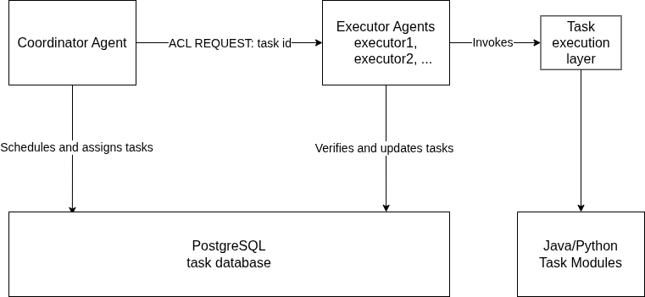Figure 1: Architecture Diagram

3.1. AGENTS AND RESPONSIBILITIES
The coordinator agent represents the scheduling part of the system. Its responsibility is to periodically inspect the task queue and assign eligible work to an executor. On startup, it first performs stale-task recovery so that tasks left in active states from a previous interrupted run can be returned to a valid state. After that, it performs an immediate scheduling attempt and then continues scheduling at a fixed interval.
The executor agent represents the execution part of the system. Each executor waits for task assignment messages. When an assignment is received, the executor verifies through the database that the task is assigned to its own agent name. If the task can be started, it is marked as running and passed to the task execution layer. After execution, the executor records either a successful result or a failure state.
The database is not an agent, but it is a central part of the design. It stores task data, lifecycle status, assigned executor, attempt counters, results, errors, and timestamps. This makes the state of the system persistent and inspectable. It also prevents the message protocol from carrying all task data, because the message only needs to contain the task identifier.

Component | Responsibility
Coordinator agent | Finds pending tasks, selects executor, assigns work
Executor agent | Receives assignment, runs task, records result
PostgreSQL database | Stores task state and lifecycle history
Task execution layer | Executes Java or Python task logic

3.2. AGENT COMMUNICATION
Communication between agents is performed through JADE ACL messages. JADE provides support for the FIPA Agent Communication Language through the jade.lang.acl package, including the ACLMessage class [9]. In the implemented protocol, the coordinator sends an ACL message with the REQUEST performative to the selected executor. The message content contains the task identifier.
The message uses the conversation id task-assignment. This field separates task assignment messages from any other possible messages that an executor might receive in the future. If an executor receives a message with a different conversation id, it ignores the message. This keeps the current protocol simple while leaving room for future extensions.
The database remains the source of truth for task ownership. The coordinator first assigns the task in PostgreSQL and only then sends the JADE message. The executor does not trust the message alone; it attempts to mark the task as running only if the database confirms that the task is assigned to that executor. This protects the lifecycle from incorrect or duplicated execution.

3.3. TASK SCHEDULING STRATEGY
The scheduling strategy has two decisions: which task should be processed next, and which executor should receive it. The coordinator reads pending tasks from PostgreSQL and relies on repository ordering to prioritize them. Pending tasks are ordered by priority in descending order and then by creation time in ascending order. This means that higher-priority tasks are preferred, while tasks with the same priority are processed in the order in which they were created.
After selecting the next pending task, the coordinator chooses an executor using a least-loaded strategy. For each configured executor name, it counts active tasks in the ASSIGNED and RUNNING states. The executor with the lowest active count is selected. This is a simple load-aware strategy: it does not estimate task duration or executor performance, but it prevents the coordinator from assigning all work to the same executor while another configured executor is idle.
The assignment itself is performed through a conditional database update. A task can be assigned only if it is still in the PENDING state and has remaining attempts. If the task has already been changed by another process, the assignment returns no task and no message is sent. This design keeps the scheduling decision simple while still protecting the task lifecycle against duplicate assignment.
The strategy can be summarized as follows:
1. Read up to 10 pending tasks.
2. If no pending task exists, do nothing.
3. Select the first task from priority-ordered results.
4. Count active tasks for each configured executor.
5. Select the executor with the lowest active count.
6. Atomically assign the task in PostgreSQL.
7. Send a JADE REQUEST message containing the task id.
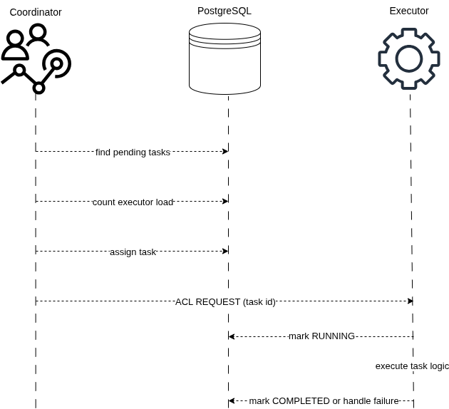Figure 2: Task assignment and execution sequence.
This scheduling strategy is appropriate for the scope of the thesis because it is understandable, deterministic, and directly demonstrable. More advanced strategies, such as task-duration estimation, deadline-aware scheduling, executor capability matching, or dynamic discovery through the JADE Directory Facilitator, are left for future work.

3.4. TASK LIFECYCLE AND STATE MANAGEMENT
The task lifecycle defines the valid states through which a task can move from its creation to its final result. PostgreSQL acts as the source of truth for this lifecycle. Each task record contains its current status, assigned executor, attempt counters, result or error information, and timestamps corresponding to important lifecycle transitions.
A newly created task begins in the PENDING state. In this state, it is eligible for scheduling while its attempt_count remains lower than its configured max_attempts. When the coordinator selects the task and successfully assigns it to an executor, the task moves to ASSIGNED. The assigned executor then verifies its ownership through the database before changing the task to RUNNING. The attempt counter is incremented only when execution begins.
The normal successful lifecycle is:
PENDING -> ASSIGNED -> RUNNING -> COMPLETED
When execution completes successfully, the executor stores the result, changes the status to COMPLETED, and records the completion time. COMPLETED is a terminal state, meaning that the task is no longer eligible for scheduling or execution.
Execution failures follow a finite retry policy. If an execution attempt fails while additional attempts remain, the task returns from RUNNING to PENDING. Its assignment and start timestamps are cleared, allowing the coordinator to schedule another attempt. If the task has reached its maximum number of attempts, it instead moves to the terminal FAILED state and stores the corresponding error message.
RUNNING -- failure, attempts remain --> PENDING
RUNNING -- failure or stale, no attempts remain --> FAILED
The system also supports recovery of stale tasks. A task is considered stale when it remains in the ASSIGNED or RUNNING state beyond the configured recovery threshold. During coordinator startup, stale tasks with remaining attempts are returned to PENDING. Tasks that have exhausted their available attempts are changed to FAILED. This prevents interrupted assignments or executions from remaining permanently active.
The CANCELLED status is another terminal state. It is intended for tasks that are deliberately archived or excluded from execution. Unlike COMPLETED and FAILED, cancellation is currently performed through maintenance tools rather than through the normal agent workflow.
Note: Repeated state boxes represent the same lifecycle states and are shown only to keep the transition arrows readable.
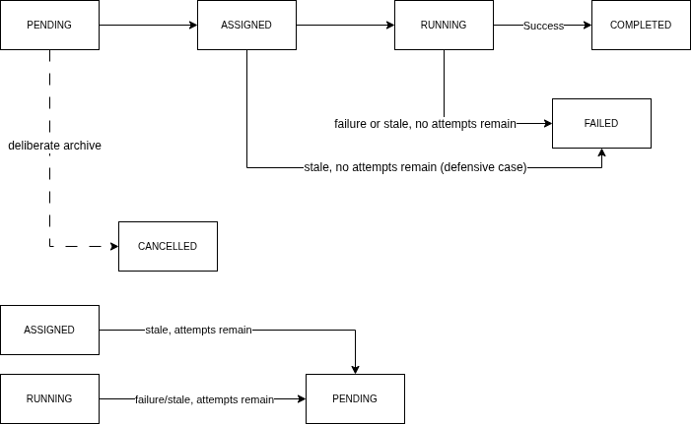Figure 3: Task Lifecycle Diagram

Task state transitions are implemented as conditional PostgreSQL updates. Each operation verifies the expected current status and, where necessary, the assigned executor. If those conditions no longer match, the update does not modify the task. This prevents an executor from starting a task assigned to another agent and reduces the risk of invalid or duplicated transitions. PostgreSQL transactions ensure that related database operations are treated as complete units [4].
The system additionally maintains a structured lifecycle history in the task_events table. A PostgreSQL trigger records task creation and each status transition, including assignment, execution start, completion, failure, retry scheduling, recovery, and cancellation. PostgreSQL triggers execute as part of the same transaction as the statement that activated them, meaning that the task update and its corresponding event are committed or rolled back together [10]. This event history makes task execution traceable and supports monitoring and later analysis.

SOURCES
[1] M. Wooldridge and N. R. Jennings, “Intelligent Agents: Theory and Practice,” The Knowledge Engineering Review, vol. 10, no. 2, pp. 115–152, 1995. DOI: 10.1017/S0269888900008122
[2] F. Zambonelli, N. R. Jennings, and M. Wooldridge, “Developing Multiagent Systems: The Gaia Methodology,” ACM Transactions on Software Engineering and Methodology, vol. 12, no. 3, pp. 317–370, 2003. DOI: 10.1145/958961.958963
[3] A. Y. Zomaya and Y.-H. Teh, “Observations on Using Genetic Algorithms for Dynamic Load-Balancing,” IEEE Transactions on Parallel and Distributed Systems, vol. 12, no. 9, pp. 899–911, 2001. DOI: 10.1109/71.954632
[4] PostgreSQL Global Development Group, “Transactions,” PostgreSQL 16 Documentation. [Online]. Available: https://www.postgresql.org/docs/16/tutorial-transactions.html. Accessed: June 5, 2026.
[5] F. Bellifemine, G. Caire, A. Poggi, and G. Rimassa, “JADE: A Software Framework for Developing Multi-Agent Applications—Lessons Learned,” Information and Software Technology, vol. 50, no. 1–2, pp. 10–21, 2008. DOI: 10.1016/j.infsof.2007.10.008
[6] L. F. Bittencourt, A. Goldman, E. R. M. Madeira, N. L. S. da Fonseca, and R. Sakellariou, “Scheduling in distributed systems: A cloud computing perspective,” Computer Science Review, vol. 30, pp. 31–54, 2018. DOI: 10.1016/j.cosrev.2018.08.002
[7] T. L. Casavant and J. G. Kuhl, “A taxonomy of scheduling in general-purpose distributed computing systems,” IEEE Transactions on Software Engineering, vol. 14, no. 2, pp. 141–154, 1988. DOI: 10.1109/32.4634
[8] O. Beaumont, L. Carter, J. Ferrante, A. Legrand, L. Marchal, and Y. Robert, “Centralized versus Distributed Schedulers for Bag-of-Tasks Applications,” IEEE Transactions on Parallel and Distributed Systems, vol. 19, no. 5, pp. 698–709, 2008. DOI: 10.1109/TPDS.2007.70747
[9] Telecom Italia / JADE, “Package jade.lang.acl,” JADE API Documentation. [Online]. Available: https://jade.tilab.com/doc/api/jade/lang/acl/package-summary.html. Accessed: June 5, 2026.
[10] PostgreSQL Global Development Group, “Overview of Trigger Behavior,” PostgreSQL 16 Documentation. [Online]. Available: https://www.postgresql.org/docs/16/trigger-definition.html. Accessed: June 5, 2026.

APPENDIX
- Source code - https://github.com/AnsorTag/DiplomaProject.git

