

FALCULTY OF INFORMATION AND COMMUNICATION TECNOLOGY
PRINCIPLES OF PROGRAMMING & LOGIC DESIGN(PROG101)

Title : Designing Logical Solutions for Sierra Leone community challenges
Issue Date : WEEK 4
Due Date : WEEK 6
Lecturer/Examiner : Mr. Laggah
Name of Student : Ansu Tucker Student ID No. : 905006550
Class : BIT1101F
Semester/Year : 1
I hereby attest that contents of this attachment are my own work. Referenced works, articles, art, programs, papers or parts thereof are acknowledged at the end of this paper. This includes data excerpted from CD-ROMs, the Internet, other private networks, and other people’s disk of the computer system.

Student’s Signature : Date:

LECTURER’S COMMMENTS/GRADE: | for office use only upon receive  Remark  DATE :  TIME :  RECEIVER’S NAME :
TABLE OF CONTENTS
1. Introduction
2. Problem Analysis
2.1 Problem Description
2.2 Background
2.3 Community Impact
2.4 Proposed Solution, Scope and Limitations
2.5 Computational Thinking Process
2.6 SDG Alignment
2.7 Open-Source Justification
2.8 Digital Public Goods Justification
3. Step-by-Step Algorithm
4. Pseudocode
5. Flowchart
6. Functional Modules and Functions
7. Expected Outputs and Test Scenarios
8. Variables, Constants, Data Types and Boolean Logic
9. GitHub Evidence
10. Conclusion
11. References

INTRODUCTION
Education is important for the development of individuals and communities. School attendance gives students the opportunity to participate in lessons, complete class activities and make progress in their studies. However, when students miss school repeatedly, they may miss important learning and may need additional attention from teachers and school administrators.
This assignment presents the Student Attendance Support System (SASS), a simple logical design for helping a teacher or school clerk review students’ monthly attendance. The user enters a student name and monthly attendance percentage. The system then compares the percentage with a select minimum threshold of 80%. If the percentage is below 80% it displays “Needs attendance support”. If the percentage is 80% or above, it displays “Attendance is good’.
The system uses input, processing, output, variables, a decision structure and a repetition structure. A loop allows the user to check several learners during one session.

Project objectives
- Provide a simple way to check a learner's monthly attendance percentage.
- Display a clear attendance result for each learner.
- Reject attendance values outside the range 0–100.
- Allow the user to check more than one learner without restarting the program.
- Demonstrate functions and modular design through reusable operations.

Problem Description
The community problem in Sierra Leone I have chosen for this project is irregular school attendance and the struggles of noticing when a student may need additional support. For example, Many places in Sierra Leone such as Bombali District, Pujehun Districit, Falaba District in Sierra Leone have the lowest rate of school attendance in the whole country. When students miss lessons, they can miss important explanations, exercises, assessments and other classroom activities that could affect their performance. A continuous repeated absence may contribute to learning gaps and can make it harder for a student to keep up with the class.
Schools do record attendance in paper registers or other records. These records are useful, but reviewing attendance information for many students can be a hassle and takes time. A simple checking process can help make it easier for a teacher or school clerk identify a learner whose monthly attendance percentage is below a chosen level.
Background
There can be different reasons why students miss school. For example, some students may face illness, transportation problems, family responsibilities or long distances between home and school. These are possible reasons for absence, although the situation can be different for each student. This means that schools should not assume that every student with low attendance has the same problem.
Keeping track of attendance can help teachers notice when a student may need additional support. However, identifying the students who need attention is only one part of addressing the problem. Teachers and school administrators also need to understand the reasons behind the absences and consider what help may be appropriate.
This is why I chose to design the Student Attendance Support System (SASS). The system provides a simple way to check a student's monthly attendance percentage and identify when it falls below the selected 80% threshold. It does not solve the reasons why students miss school, but it could help make the initial checking process more organized.

Community Impact
Poor school attendance can affect more than just the student who is missing classes. In many schools, when students keep missing school, they can fall behind in their lessons and struggle to perform well in exams. For example, a student who misses mathematics lessons regularly may find it difficult to understand new topics because they have missed the explanations from their teacher.
It can also affect parents and guardians because they want their children to get a good education and have better opportunities in the future. Some parents already struggle to pay for transport, uniforms and other school needs, so it can be frustrating when their children are not attending school regularly.
Schools are also affected because teachers may have to spend extra time helping students catch up with work they missed. When several students are absent, it can make teaching and completing the school syllabus more difficult.
In the long run, this problem can affect the community and Sierra Leone as a whole. Education helps young people develop skills that they can use to find jobs and contribute to society. If students continue missing school and falling behind, they may have fewer opportunities in the future. This is why I believe schools should try to identify attendance problems early and find ways to support students before the situation becomes worse.

Proposed Solution
My proposed solution to this problem is to create a Student Attendance Support System (SASS). The main idea of this is to make it easier and more efficient for teachers and school staff to identify students who are missing school regularly.
The system will allow a teacher to enter a student's name and their monthly attendance percentage. After entering the information, the system will check the percentage and show whether the student's attendance is good or whether they need attendance support. For this project, I decided to use 80% as the attendance level threshold. Any student with a percentage below 80% will be marked as needing attendance support.
For example, if a student has 65% attendance, the system will display "Needs attendance support". This will help the teacher notice that the student may have an attendance problem. The teacher can then speak with the student or their parents to understand why they have been missing school. There could be different reasons, such as transport difficulties, family responsibilities or illness.
I understand that this system cannot stop students from missing school or solve every problem they face. However, I believe it can make it easier for schools to notice attendance problems earlier instead of waiting until the student has missed too many lessons. My aim is to create a simple system that can help teachers make better decisions and give students the support they need to attend school more regularly.

Scope
Reviewing a learner's monthly attendance percentage.
Identifying values below the project's 80% threshold for further attention.
Validating that attendance is between 0 and 100 inclusive.
Checking multiple learners in one program session.
Demonstrating programming logic through an algorithm, pseudocode, flowchart and functions.

Limitations
The system depends on the user entering accurate information.
It does not record daily attendance or calculate the monthly percentage from daily records.
It cannot determine why a learner was absent.
It has no permanent database; entered information is not saved after the session.

Computational Thinking Process
Decomposition
The problem is divided into smaller tasks: welcome the user, collect a student’s name, collect a valid attendance percentage, determine the attendance status, display the result and ask whether another learner should be checked. Separate functions handle attendance validation and status determination.
Pattern Recognition
The same sequence is used for each learner: enter a name, enter a percentage, validate it, compare it with 80% and display a result. The repetition loop allows this pattern to be reused.
Abstraction
The design focuses on the learner's name and monthly attendance percentage. It does not collect unrelated personal details or attempt to infer reasons for absence.
Algorithm Design
The steps are arranged in a clear order and use input, validation, function calls, a decision and repetition to produce the result.
SDG Alignment
SASS aligns most directly with United Nations Sustainable Development Goal 4 (Quality Education), which focuses on inclusive and equitable quality education and learning opportunities. The connection is limited but relevant: attendance monitoring may help a school notice students who are missing lessons and consider whether follow-up support is needed.

Open-Source Justification
If SASS were developed beyond this assignment, it could be released under a recognised open-source licence with its documentation and source files available for inspection and improvement. Local developers, IT students and schools could review the logic, report errors and suggest changes. Any public release should avoid confidential learner records.
Benefits and potential community contributions
Local developers and IT students could review the logic, report errors and contribute improvements.
Teachers could give feedback about whether the prompts and result messages are clear and useful.
Schools could help translate instructions into languages used by their communities, if needed.
Community organizations could help test accessibility and provide guidance on responsible use.
Open development may reduce dependence on one provider, but it does not mean that hosting, training, maintenance or support are automatically free.

Digital Public Goods Justification
SASS is a proposed logical design and is not currently a recognised Digital Public Good. It could move toward public benefit if it were developed, documented, openly licensed, accessible and maintained with appropriate privacy safeguards. A public GitHub repository alone would not automatically make it a Digital Public Good.
Accessibility and sustainability would require clear instructions, modest technology requirements, possible offline use, training, maintenance, privacy protection and school oversight. A low attendance result should prompt human review and support, not automatic punishment.
Accessibility, openness and public benefit
To be more accessible, a future version should use clear language, readable screens and modest hardware requirements. It should not assume that every school has reliable internet access; an offline option may be useful. The design should minimize personal information, restrict access to real pupil records and explain that low attendance should trigger human review rather than automatic punishment. Public benefit would come from responsible use by schools, transparent logic and ongoing maintenance.
Sierra Leone community impact and sustainability
The intended beneficiaries are learners, teachers, school administrators and, indirectly, parents or guardians. In the long term, sustainability would depend on a school or community organization taking responsibility for maintenance, training users, reviewing the attendance threshold, protecting data and checking whether the tool is actually useful. A simple design is easier to understand, but real-world adoption would still require testing, support and resources.

STEP-BY-STEP ALGORITHM
1. Start.
2. Display the welcome message.
3. Set MinAttendance to 80.
4. Set continueChecking to "YES".
5. While continueChecking, equals "YES" OR continuChecking equals “yes”:
a. Ask for the student's name.
b. input name
c. Call GetValidAttendance to obtain a valid monthly attendance percentage.
d. Call GetAttendanceStatus using the attendance and MinAttendance values.
e. Display the student's name, attendance percentage and returned status.
f. Ask whether the user wants to check another student.
g. While the answer, is neither "YES" nor "NO":
i. Display "Please enter YES or NO".
ii. the response YES or NO stored continueChecking
iii. Ask for the answer again.
6. When the answer is "NO", leave the repetition loop.
7. Display the goodbye message.
8. End.
FUNCTION: GetValidAttendance
1. Ask the user to enter a monthly attendance percentage from 0 to 100.
2. Input attendance.
3. While attendance is less than 0 OR attendance is greater than 100:
a. Display an invalid percentage message.
b. Ask for attendance again.
c. input attendance.
4. Return the valid attendance value.
FUNCTION: GetAttendanceStatus(attendance, MinAttendance)
1. If attendance is less than MinAttendance, return "Needs attendance support".
2. Otherwise, return "Attendance is good".

Pseudcode
Function Main
Declare String name
Declare String continueChecking
Declare String status
Declare Integer attendance
Declare Integer MinAttendance
Assign MinAttendance = 80
Assign continueChecking = "YES"
Output "Welcome to Student Attendance Support System"
While continueChecking = "YES" OR continueChecking=”yes”
Output "Enter student name:"
Input name
Assign attendance = GetValidAttendance()
Assign status = GetAttendanceStatus(attendance, MinAttendance)
Output “Student:”&name & " Attendance: " & attendance & %"”
Output "Status: " & status
Output "Do you want to check another student? (YES/NO)"
Input continueChecking
While continueChecking <> "YES" AND continueChecking<>”yes”
AND continueChecking <> "NO" AND continueChecking<>”no”
Output "Invalid response. Please enter YES or NO."
Input continueChecking
End While
End While
Output "Thank you for using the system. Goodbye."
End Function
Function GetValidAttendance() Returns Integer
Declare Integer attendance
Output "Enter monthly attendance percentage (0-100):"
Input attendance
While attendance < 0 OR attendance > 100
Output "Invalid percentage. Enter a value from 0 to 100:"
Input attendance
End While
Return attendance
End Function
Function GetAttendanceStatus(Integer attendance,
Integer MinAttendance) Returns String
If attendance < MinAttendance Then
Return "Needs attendance support"
Else
Return "Attendance is good"
End If
End Function

FLOWCHART

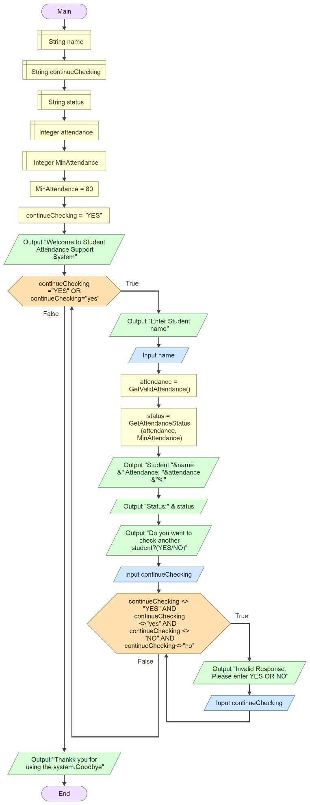

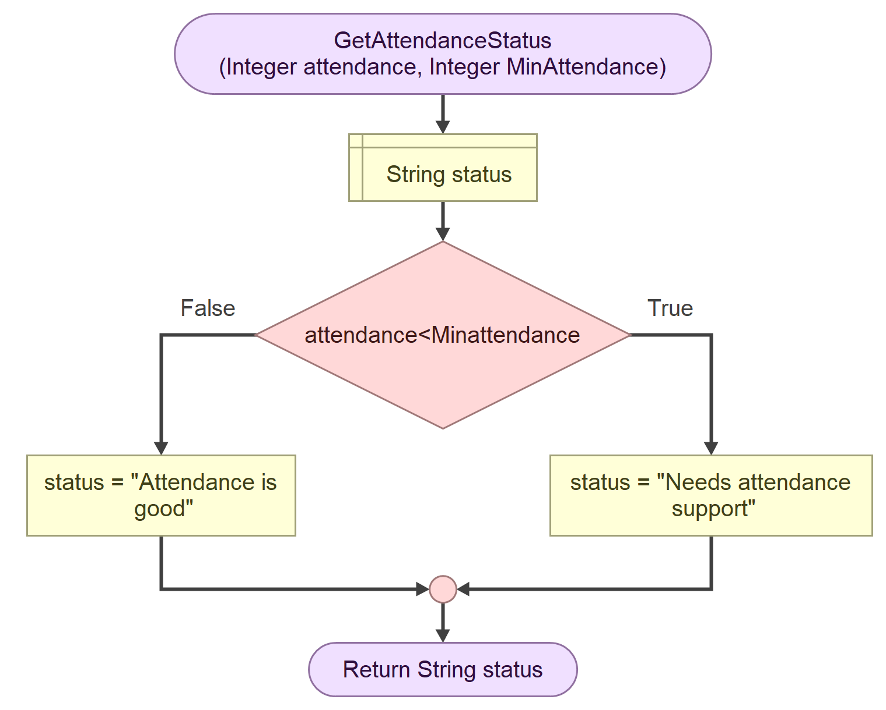

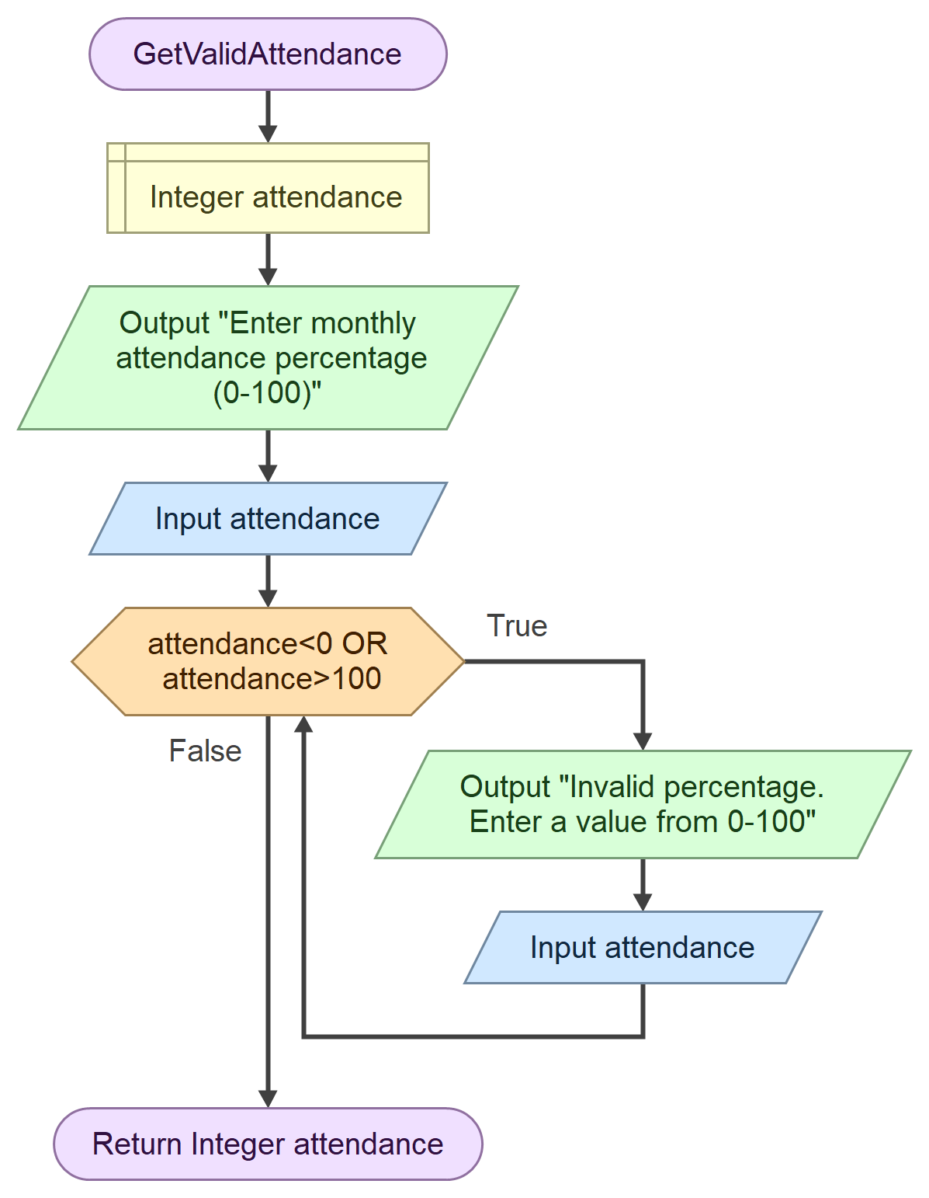

Flowchart elements and purpose

Element | Purpose
Start/End | Shows where the program begins and finishes.
Input | Receives the learner’s name, attendance and continuation response.
Output | Displays prompts, validation messages and the result.
Assignment | Sets MinAttendance to 80 and stores returned function values.
Decision | Compares attendance with the threshold and validates input.
While loop | Repeats attendance validation and learner checking.
Function call | Uses reusable functions to validate attendance and determine status.

FUNCTIONAL MODULES AND FUNCTIONS
The SASS design is divided into modules. The validation and decision responsibilities are implemented as separately defined functions, while Main coordinates the complete process.
1. Main Control Function — Main
Controls the program. It displays the welcome message, sets the 80% threshold, calls the other functions, displays each result, validates the YES/NO response and ends with a goodbye message.
2. Attendance Input and Validation Function — GetValidAttendance
Prompts for the monthly attendance percentage. It repeats the input request while the value is below 0 or above 100, then returns the valid integer to Main.
3. Attendance Decision Function — GetAttendanceStatus
Receives attendance and MinAttendance as parameters. It returns “Needs attendance support” when attendance is below the threshold; otherwise it returns “Attendance is good”.
4. Output responsibility
Main displays the learner's name, percentage and status returned by the decision function, along with the welcome, error and goodbye messages.
The functions are called by Main. GetValidAttendance returns an Integer. GetAttendanceStatus accepts two Integer parameters and returns a String. This makes the modular structure visible in both the pseudocode and the Flowgorithm file.

EXPECTED OUTPUTS AND TEST SCENARIOS

Learner / Test | Attendance / Input | Expected result
Fatmata Kamara | 65% | Needs attendance support
Ibrahim Sesay | 92% | Attendance is good
Mariama Bangura | 80% | Attendance is good
Mohamed Koroma | 0% | Needs attendance support
Sample learner | 100% | Attendance is good
Invalid test | -1% | Reject and request another value
Invalid test | 101% | Reject and request another value
Continuation | YES | Repeat for another learner
Continuation | NO | Exit and display goodbye
Continuation | MAYBE | Reject and request YES or NO

Example of repetition
Welcome to Student Attendance Support System
Enter student name: Madi
Enter monthly attendance percentage: 86
Madi - Attendance: 86%
Status: Attendance is good
Do you want to check another student? YES
Enter student name: John
Enter monthly attendance percentage: 65
John - Attendance: 65%
Status: Needs attendance support
Do you want to check another student? NO
Thank you for using the system. Goodbye.
VARIABLES, CONSTANTS, DATA TYPES AND BOOLEAN LOGIC
Name | Data type | Purpose
name | String | Stores the learner's name.
attendance | Integer | Stores the monthly attendance percentage from 0 to 100.
continueChecking | String | Stores YES or NO and controls repetition.
MinAttendance | Integer constant/design constant | Stores the selected threshold of 80.
status | String | Stores the status returned by GetAttendanceStatus.
Boolean logic
The condition attendance < MinAttendance produces TRUE or FALSE. If TRUE, the system returns “Needs attendance support”. Otherwise, it returns “Attendance is good”. The attendance validation condition attendance < 0 OR attendance > 100 is TRUE only when the value is outside the permitted range. The continuation validation condition checks that the response is neither YES nor NO .
Input, processing and output
Inputs: learner name, monthly attendance percentage and continuation response. Processing: validate attendance, call the decision function and compare the value with the threshold. Outputs: validation message, learner attendance result, continuation prompt and goodbye message.

GITHUB EVIDENCE
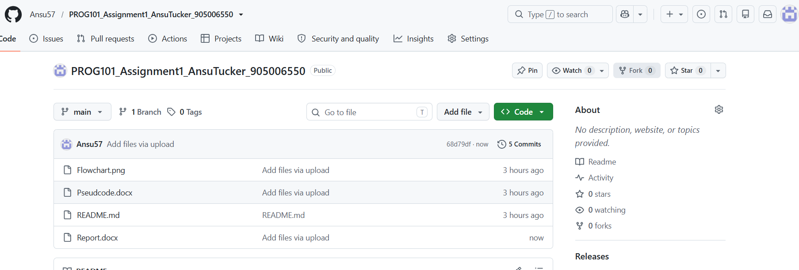
Link: https://github.com/Ansu57/PROG101_Assignment1_AnsuTucker_905006550.git

CONCLUSION
Working on the Student Attendance Support System has helped me understand how programming logic can be used to address a problem that affects learners and schools. SASS accepts a learner's name and monthly attendance percentage, validates the percentage, compares it with the project's selected 80% threshold and displays a clear result. It also allows multiple learners to be checked in one session.
The updated design demonstrates decomposition, algorithm design, pseudocode, flowchart logic, variables, constants, Boolean conditions, decisions, repetition and separately defined functions. The system is only an initial checking aid. A teacher or school administrator would still need to understand the reasons behind absence and decide what support is appropriate.

REFERENCES
United Nations. (n.d.). Goal 4: Quality Education. https://sdgs.un.org/goals/goal4
Digital Public Goods Alliance. (n.d.). Digital Public Goods Standard. https://digitalpublicgoods.net/standard/
Open Source Initiative. (n.d.). The Open Source Definition. https://opensource.org/osd
Ministry of Basic and Senior Secondary Education(MBSSE)

