Title: Reading Hexadecimal Number from SD Card and Displaying on OLED using ESP32
Components Used:
- Hardware Used:
  - ESP32
  - SD Card
  - OLED Display (SSD1306)
- Software Used:
  - Arduino IDE
  - ESP32 Libraries (SD, Wire, Adafruit_SSD1306)
Introduction:
This experiment involves reading a hexadecimal number from a text file on an SD card using an ESP32 and displaying it on an OLED display.
Block Diagram:

OLED display

ESP32
SD Card

Libraries Used
- Wire.h:
  - Provides the functionality to communicate with I2C devices. Used here to interface with the OLED display.
- Adafruit_GFX.h:
  - A graphics library that provides common graphics primitives (e.g., points, lines, circles). Used as a base for the Adafruit SSD1306 library to display text and graphics on the OLED display.
- Adafruit_SSD1306.h:
  - A library for controlling SSD1306-based OLED displays. It uses the Adafruit GFX library for rendering text and graphics on the display.
- SD.h:
  - Provides the functionality to read from and write to SD cards using the SD card slot on the ESP32 or an SD card module.
- SPI.h:
  - Provides the functionality to communicate with devices using the SPI protocol. Used here to interface with the SD card module.

Protocols Used
- I2C (Inter-Integrated Circuit):
  - A serial communication protocol used for interfacing low-speed peripherals. In this code, the I2C protocol is used to communicate with the OLED display. The Wire.h library facilitates this communication.
- SPI (Serial Peripheral Interface):
  - A high-speed serial communication protocol used for interfacing devices like SD cards, sensors, and displays. In this code, the SPI protocol is used to communicate with the SD card module. The SPI.h library provides the necessary functions for this communication.

Brief Overview of the Protocols
- I2C (Inter-Integrated Circuit):
  - I2C is a two-wire communication protocol consisting of a data line (SDA) and a clock line (SCL).
  - It allows multiple slave devices to be connected to a single master device on the same bus.
- SPI (Serial Peripheral Interface):
  - SPI is a four-wire communication protocol consisting of MOSI (Master Out Slave In), MISO (Master In Slave Out), SCK (Serial Clock), and SS (Slave Select).
  - It allows full-duplex communication between a master and one or more slave devices.
  - The master device controls the clock signal, and data is exchanged simultaneously between the master and the slave device.
Circuit Diagram:
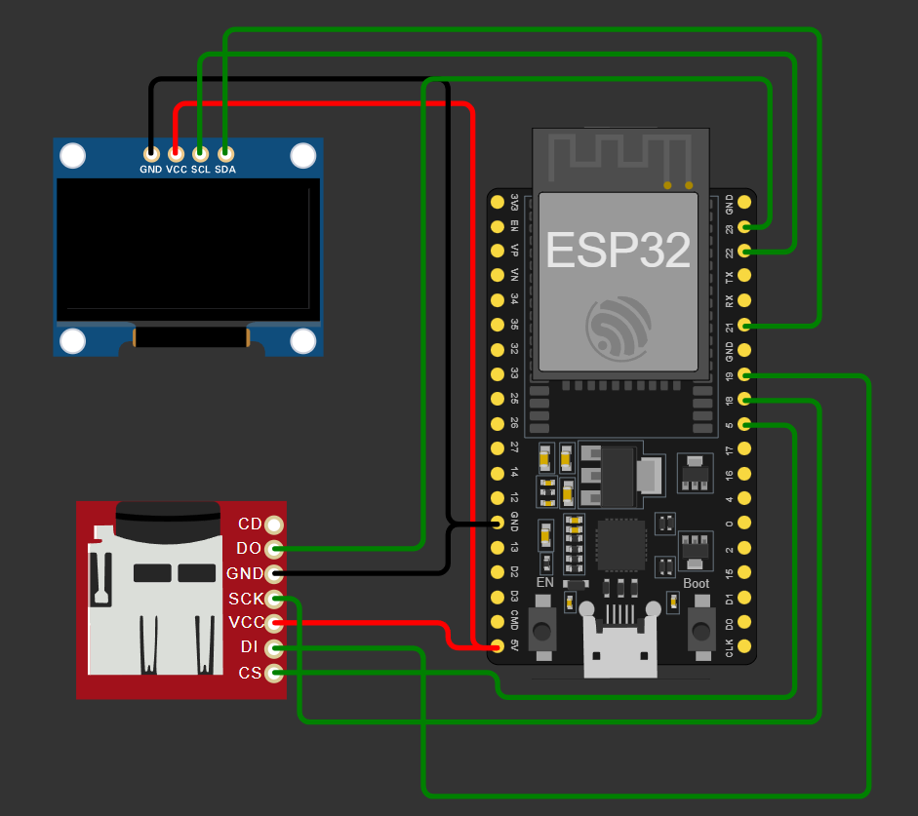
Flow Chart:
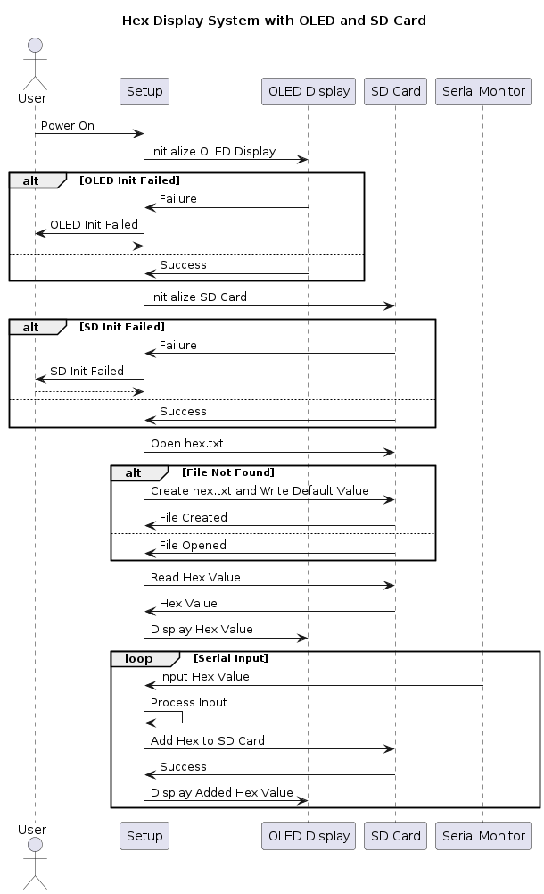
Pin Connections Table:
ESP32 Pin | OLED Pin | SD Card Pin
GPIO 21 | SDA
GPIO 22 | SCL
GPIO 4 |  | CS
GPIO 18 |  | CLK
GPIO 23 |  | MOSI
GPIO 19 |  | MISO
3.3V | VCC | VCC
GND | GND | GND
Procedure:
- Connect the SD card module and OLED display to the ESP32 as per the pin diagram.
- Install the required libraries in the Arduino IDE:
  - SD
  - Wire
  - Adafruit_SSD1306
- Create an Arduino sketch to read the hexadecimal number from the SD card and display it on the OLED display.

Code:
#include <Wire.h>
#include <Adafruit_GFX.h>
#include <Adafruit_SSD1306.h>
#include <SD.h>
#include <SPI.h>

#define SCREEN_WIDTH 128
#define SCREEN_HEIGHT 64
#define OLED_RESET -1
#define SCREEN_ADDRESS 0x3C
#define CS_PIN 4

Adafruit_SSD1306 display(SCREEN_WIDTH, SCREEN_HEIGHT, &Wire, OLED_RESET);

void setup() {
Serial.begin(115200);

if(!display.begin(SSD1306_SWITCHCAPVCC, SCREEN_ADDRESS)) {
Serial.println(F("SSD1306 allocation failed"));
for(;;);
}
display.display();
delay(2000);
display.clearDisplay();

if (!SD.begin(CS_PIN)) {
Serial.println("SD card initialization failed!");
return;
}
Serial.println("SD card initialized.");

display.setTextSize(2);
display.setTextColor(SSD1306_WHITE);
display.setCursor(0, 0);
display.println("Reading Hex");
display.display();
delay(1000);

File myFile = SD.open("/hex.txt");
if (!myFile) {
// File does not exist, create and write to it
Serial.println("hex.txt not found. Creating file.");
myFile = SD.open("/hex.txt", FILE_WRITE);
if (myFile) {
myFile.println("0x1A2B3C4D");
myFile.close();
Serial.println("File created and data written.");
} else {
Serial.println("Failed to create file.");
return;
}
}

// Reopen the file to read from it
myFile = SD.open("/hex.txt");
if (myFile) {
String hexNumber = "";
while (myFile.available()) {
hexNumber += (char)myFile.read();
}
myFile.close();
display.clearDisplay();
display.setCursor(0, 0);
display.print("Hex: ");
display.println(hexNumber);
display.display();
} else {
Serial.println("Failed to open file.");
}
}

void loop() {
if (Serial.available() > 0) {
String input = Serial.readStringUntil('\n');
input.trim(); // Remove any leading or trailing whitespace
if (input.length() > 0) {
addHexToSD(input);
}
}
}

void addHexToSD(String hexNumber) {
File myFile = SD.open("/hex.txt", FILE_WRITE);
if (myFile) {
myFile.println(hexNumber);
myFile.close();
Serial.println("Hex number added to file: " + hexNumber);

display.clearDisplay();
display.setCursor(0, 0);
display.print("Added Hex: ");
display.println(hexNumber);
display.display();
} else {
Serial.println("Failed to open file for writing.");
}
}


Explanation of the Code
The provided code initializes an OLED display and an SD card, reads a hex value from an SD card file, displays it on the OLED screen, and allows for new hex values to be entered via the serial monitor and saved to the SD card.
- Libraries and Constants:
  - Includes necessary libraries for handling the OLED display and SD card.
  - Defines constants for the OLED display's dimensions, reset pin, I2C address, and SD card chip select pin.
- Global Objects:
  - Creates an Adafruit_SSD1306 display object.
- Setup Function:
  - Initializes serial communication.
  - Initializes the OLED display and clears it.
  - Initializes the SD card.
  - Attempts to open hex.txt. If the file doesn't exist, it creates and writes a default hex value.
  - Reads the hex value from hex.txt and displays it on the OLED.
- Loop Function:
  - Continuously checks for input from the serial monitor.
  - If input is received, it is processed and added to hex.txt using the addHexToSD function.
- addHexToSD Function:
  - Appends the new hex value to hex.txt.
  - Displays the added hex value on the OLED.

How to Operate the Code:
- Setup:
  - Open the Arduino IDE.
  - Install the required libraries: SD, Wire, Adafruit_SSD1306.
  - Connect the ESP32, SD card module, and OLED display as per the pin diagram.
- Upload the Code:
  - Copy the provided Arduino sketch into the Arduino IDE.
  - Upload the code to the ESP32.
- Prepare SD Card:
  - Create a text file named hex.txt on the SD card.
  - Write a hexadecimal number (e.g., 0x1A2B3C) into the file and save it.
- Insert SD Card:
  - Insert the SD card into the SD card module connected to the ESP32.
- View on OLED Display:
  - After uploading, the hexadecimal number from the SD card will be displayed on the OLED screen.
Output: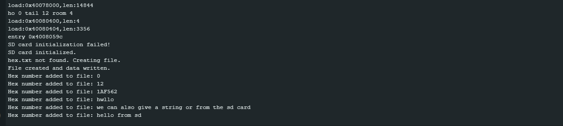
Fig .The hexadecimal number read from the SD card / Created if not present.
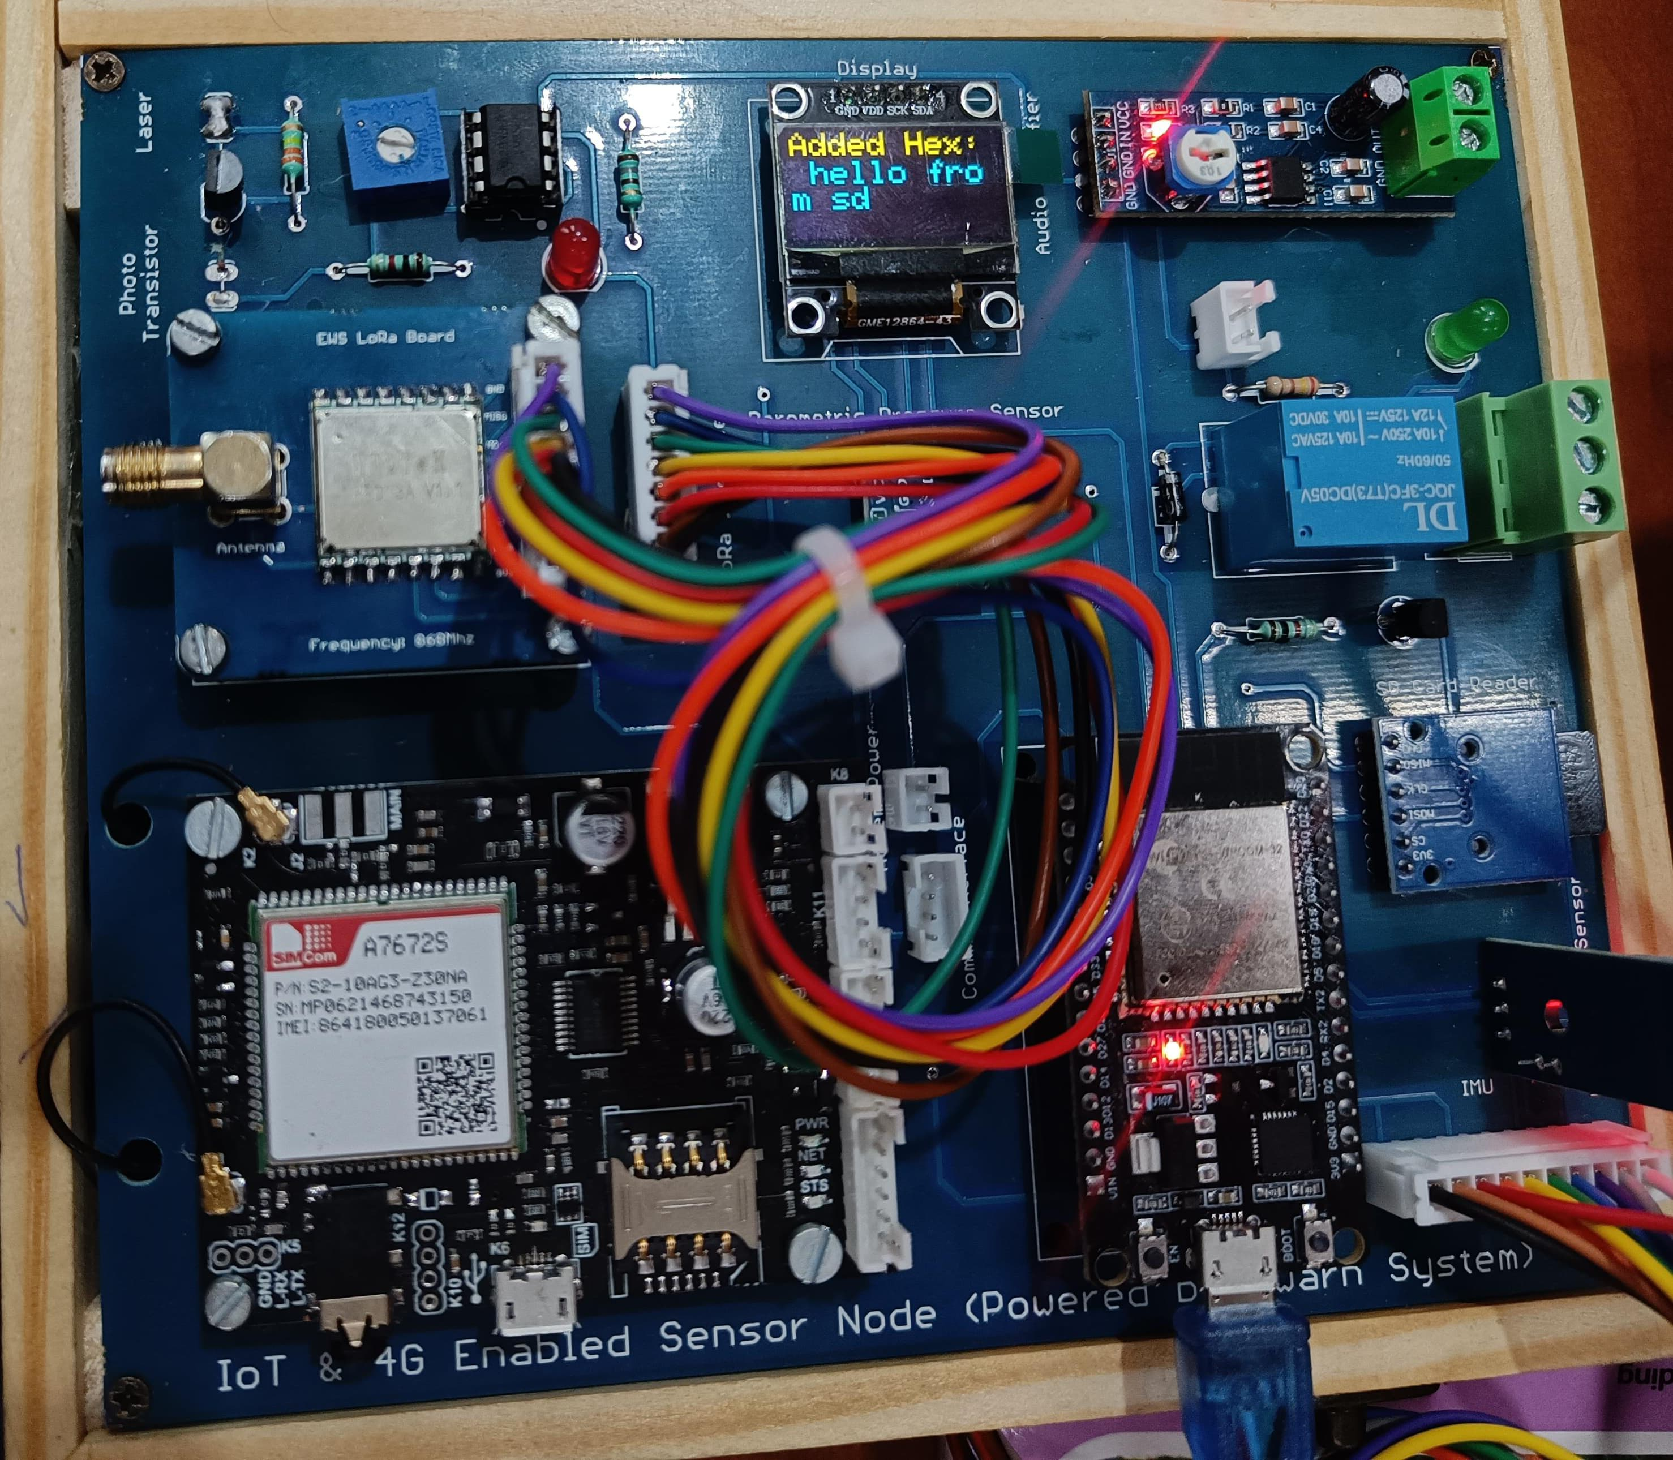
Fig. Displaying text from serial monitor which is written into SD Card then read and printed in OLED

Conclusion:
The experiment demonstrates reading a hexadecimal number from an SD card and displaying it on an OLED display using an ESP32.
Applications:
- Displaying diagnostic or configuration data stored in hexadecimal format.
- To display the reading of sensor data on OLED.

