Date: 30/05/2024
Day: Thursday
Experiment no: 15
- Title – Measurement of Temperature using DHT11 sensor using IoT development kit.
- Introduction-
In this project, we explore data transmission using Free Space Optics (FSO) with an ESP32 microcontroller. FSO technology allows for the wireless transfer of data through light, utilizing a laser and a light-dependent resistor (LDR) for sending and receiving signals. By employing the DOIT ESP32 DevKit V1, a powerful microcontroller board based on the ESP32 System-on-Chip (SoC), we can implement a reliable FSO communication system. This report details the setup, implementation, and results of using the ESP32 for transmitting binary data via a laser and receiving it with an LDR, demonstrating the capabilities and practical applications of FSO technology.

- Software used:
  - Arduino IDE

- Hardware used:
  - Transmitter side:
    - ESP 32
    - Photo Diode
  - Receiver side:
    - ESP 32
    - LDR
    - 1kΩ Resistor
Component | Specification
Transistor | N-channel MOSFET (likely 2N7000)
Resistor | 330 kΩ resistor
Laser | Laser diode (likely 1C2A)
Table 1.1 Components and its specifications of Transmitter side

Component | Specification
LDR Symbol | Light-dependent resistor (LDR)
Resistor | 1kΩ
Table 1.2 Components and its specifications of Receiver side

ESP 32 WROOM Feature | Specification
Microprocessor | Tensilica Xtensa LX6
Cores | Dual Core
Clock Frequency | 160 MHz (adjustable to 240 MHz)
Memory | * SRAM: 512 KB * Flash: Varies depending on module
Wireless Connectivity | Wi-Fi 802.11 b/g/n
Bluetooth | Yes (4.2 and Low Energy)
Operating System | Bare-metal, RTOS (Real-Time Operating System)
Security Features | WPA/WPA2 encryption, Secure Boot
Power Supply | 3.3V
Current Consumption | Higher (down to 20uA deep sleep)
Operating Temperature | -40°C to +125°C
Dimensions | Varies depending on module (typically larger than ESP8266 module)
Interfaces | SPI, I2C, UART, ADC, DAC, PWM, High-speed SPI, Touch Sensor (may vary)

Table 1.3 Specifications of ESP 32 WROOM Module.

- Circuit Diagram:
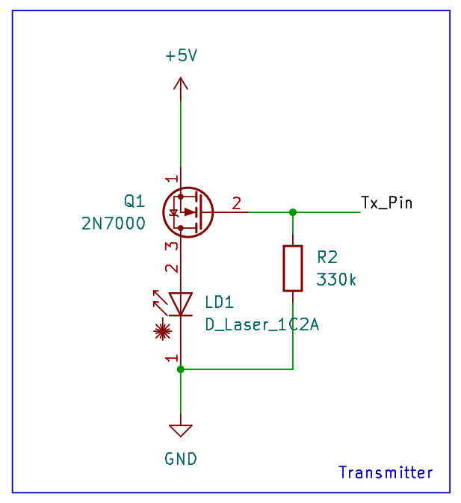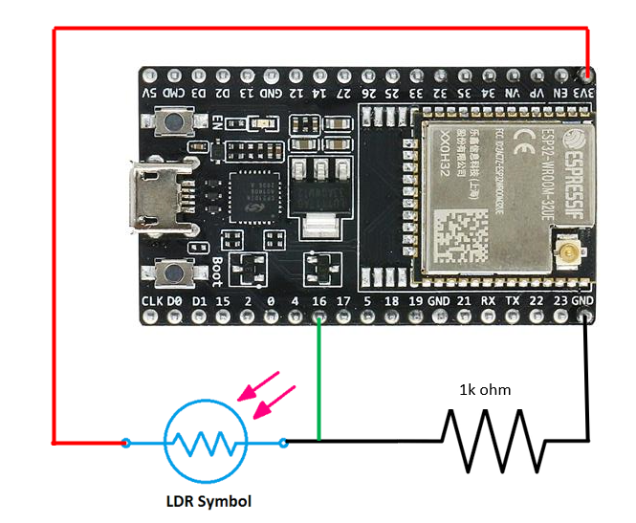
Figure 1.2 Receiver of FSO
Figure 1.1 Transmitter of FSO

Component | ESP32 Pin | Description
Transmitter
Laser Diode | Any GPIO pin (e.g., 25) | Connects the positive (+) lead of the laser diode to the ESP32 pin. A current-limiting resistor (typically 100 ohms to 470 ohms) is recommended in series with the laser to prevent damage.
Ground | GND | Connects the negative (-) lead of the laser diode and the current-limiting resistor (if used) to the ESP32 ground pin.
Receiver
Phototransistor (LDR) | Any analog input pin (e.g., 34) | Connects the signal pin of the LDR to the ESP32 analog input pin.
Resistor (optional) | Any GPIO pin (e.g., 26) | A pull-up resistor (typically 10k ohms to 47k ohms) can be connected between the LDR signal pin and the ESP32 power pin (3.3V) to improve signal stability (optional).
Ground | GND | Connects the ground pin of the LDR to the ESP32 ground pin.
Table 2. Pin connections at transmitter and receiver side

- Block Diagram:
ESP 32
+
LDR
ESP 32
+
Photodiode

Figure 2. Block Diagram of the FSO Data Transmission.

- Flowchart
  - Transmitter:

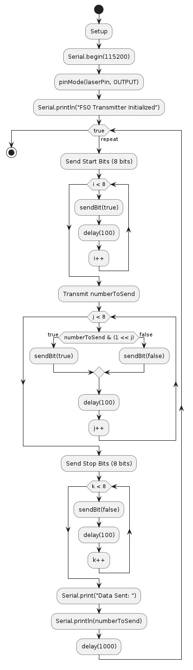
  - Receiver:
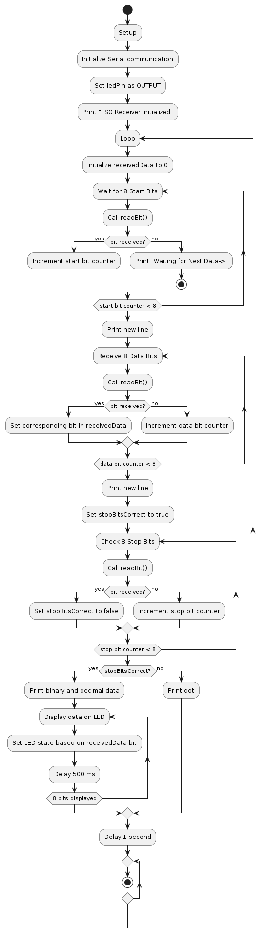
- Source Code:
- Transmitter code:
#include <Arduino.h>

const int laserPin = 17; // GPIO pin for Laser Diode
int numberToSend = 54; // The number you want to send

void setup() {
Serial.begin(115200);
pinMode(laserPin, OUTPUT);
Serial.println("FSO Transmitter Initialized");
}

void sendBit(bool bit) {
digitalWrite(laserPin, bit ? HIGH : LOW);
delay(100); // Delay to separate bits
}

void loop() {
// Send start bits
for (int i = 0; i < 8; i++) {
sendBit(true);
}

// Transmit numberToSend value
for (int i = 0; i < 8; i++) {
sendBit(numberToSend & (1 << i));
}

// Send stop bits
for (int i = 0; i < 8; i++) {
sendBit(false);
}

Serial.print("Data Sent: ");
Serial.println(numberToSend);

delay(1000); // Delay for 1 second before sending again
}

- Receiver code:
#include <Arduino.h>

const int phototransistorPin = 34; // GPIO pin for Phototransistor
const int ledPin = 4; // GPIO pin for LED
const int threshold = 900; // Threshold for analog reading

void setup() {
Serial.begin(115200);
pinMode(ledPin, OUTPUT);
Serial.println("FSO Receiver Initialized");
}

bool readBit() {
int value = analogRead(phototransistorPin);
bool bitValue = value > threshold;
delay(100); // Delay to synchronize with transmitter
return bitValue;
}

void loop() {
int receivedData = 0;

// Wait for start bits
for (int i = 0; i < 8; i++) {
if (!readBit()) {
Serial.println("Waiting for Next Data->");
return;
}
}

Serial.println(); // New line after start bits

// Receive 8 data bits
for (int i = 0; i < 8; i++) {
if (readBit()) {
receivedData |= (1 << i);
}
}

Serial.println(); // New line after data bits

// Check stop bits
bool stopBitsCorrect = true;
for (int i = 0; i < 8; i++) {
if (readBit()) {
stopBitsCorrect = false;
break;
}
}

if (stopBitsCorrect) {
Serial.print("Binary Data Received: ");
Serial.println(receivedData, BIN);
Serial.print("Decimal Data Received: ");
Serial.println(receivedData);

// Display received data on LED
for (int i = 0; i < 8; i++) {
digitalWrite(ledPin, (receivedData & (1 << i)) ? HIGH : LOW);
delay(500); // Display each bit for 500 ms
}
} else {
Serial.print(".");
}

delay(1000); // Delay for 1 second before the next reception
}

- Output:

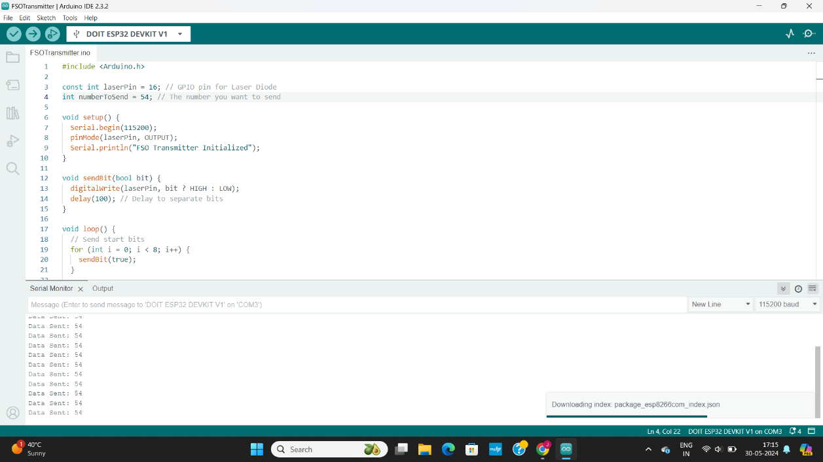
Figure 3.1 Transmitter output
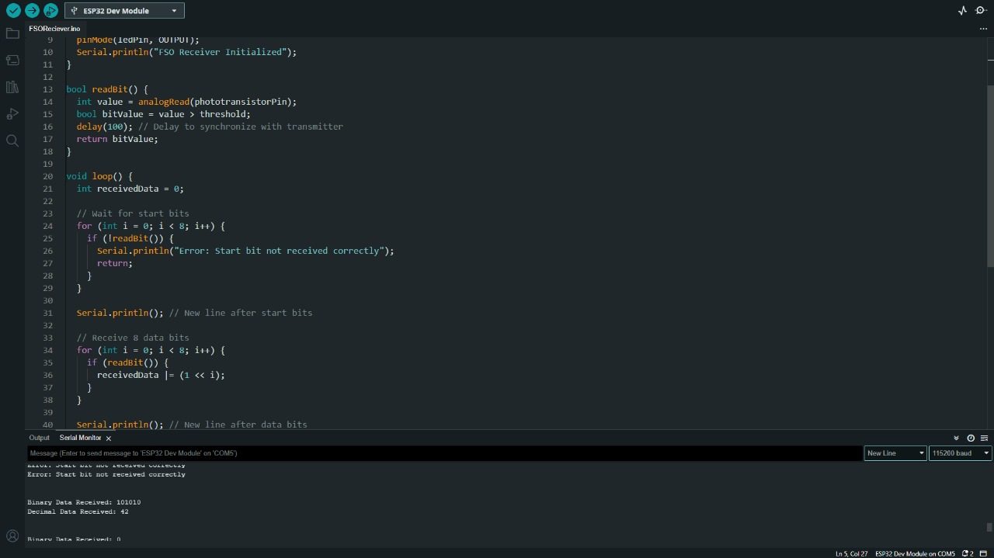
Figure 3.2 Receiver output

- Applications:
- Short-Range Data Transfer
- Infrared Remote Controls
- Learning Optoelectronics
- Digital Communication Protocols
- Wireless Sensor Networks
- Internet of Things (IoT)
- Secure Communication
- Remote Monitoring and Control
- Prototype Development
- Performance Testing
- Temporary Networks
- Peripheral Communication

