Title :IMU Data Monitoring using Arduino, HTML, and Node.js
Introduction :
This project demonstrates a system for monitoring Inertial Measurement Unit (IMU) data using an MPU9250 sensor connected to an Arduino. The data is sent to a local server and displayed on a web page. Additionally, the data is also sent to ThingSpeak for remote monitoring. The system uses Arduino for data collection, a Node.js server for data handling, and an HTML page for displaying the data.
Theory:
The MPU9250 sensor is an IMU that measures acceleration, gyroscopic rotation, and magnetic field in three axes. The data from this sensor can be used in various applications such as motion tracking, gesture detection, and orientation measurement. Arduino is used to interface with the MPU9250 and send the data to a server. The server, built with Node.js, handles the data and makes it available for visualization on a web page. ThingSpeak is used for remote monitoring and data storage.
Components Required:
Arduino board
MPU9250 sensor
Wi-Fi module (if not integrated with the Arduino)
Laptop/PC for running the server
Internet connection
Circuit Diagram
Pins:
MPU9250 Connections:
VCC -> 3.3V on Arduino
GND -> GND on Arduino
SDA -> A4 on Arduino
SCL -> A5 on Arduino
Libraries Included and Downloaded:
Arduino Code-
Wire.h: Enables communication with I2C / TWI devices.
MPU9250_asukiaaa.h: Facilitates interfacing with the MPU9250 sensor.
WiFi.h: Allows connection to a Wi-Fi network.
HTTPClient.h: Provides functions for sending HTTP requests.
Libraries Downloaded:
Libraries such as MPU9250_asukiaaa, WiFi, and HTTPClient would typically be downloaded from the Arduino Library Manager or external sources like GitHub. They are then included in the Arduino IDE for use in the project.
Node.js Code-
express: A web framework for Node.js, used for building web applications and APIs.
body-parser: Middleware for parsing incoming request bodies before handling them.
axios: A promise-based HTTP client for Node.js, used for making HTTP requests from the server.
Libraries Downloaded:
Libraries like express, body-parser, axios , body-parser axios ws , npm install ws are installed using npm (Node Package Manager) by running commands such as npm install express body-parser axios in the project directory.
Hardware Implementation:
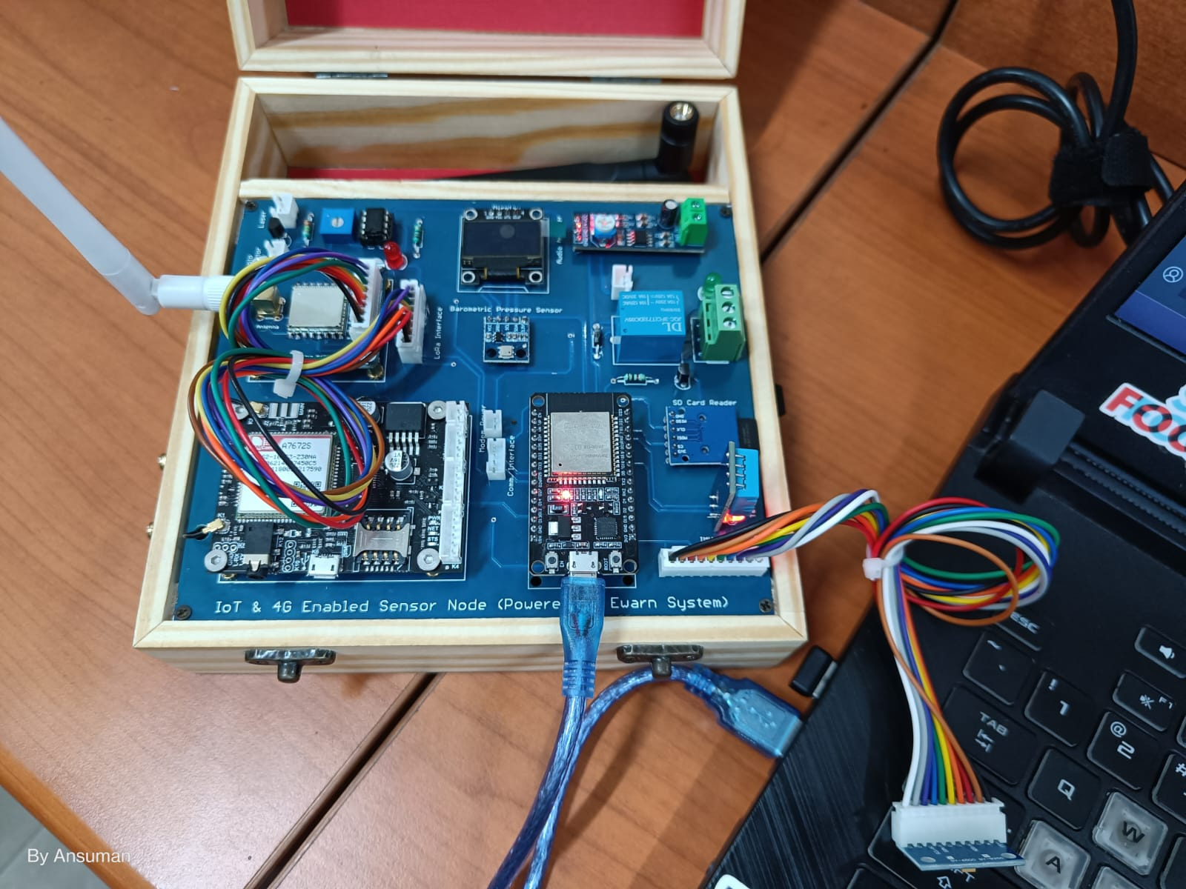
Figure 1. Hardware implementation using All in one IOT Devkit
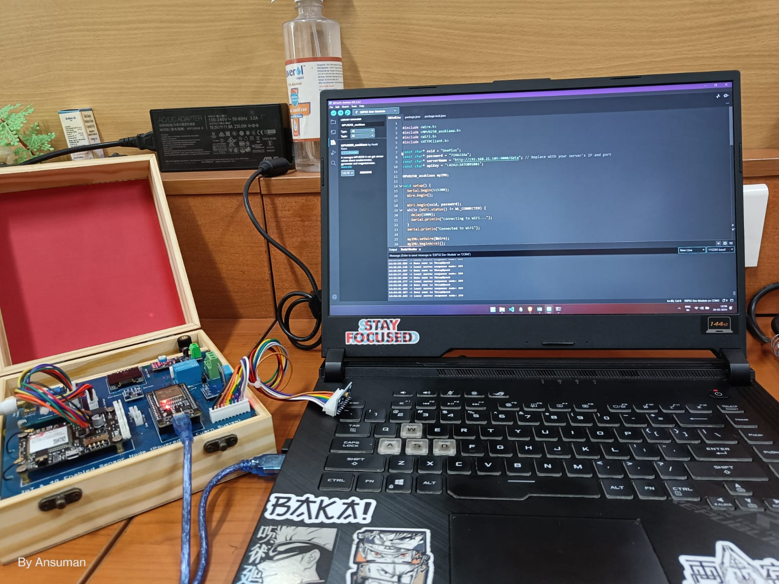
Figure 2. Hardware & Software implementation Using Arduino IDE & Devkit
Software Implementation:
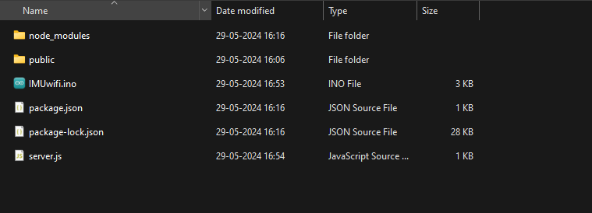
Figure 3.a Arrangement of server.js file to start the server.
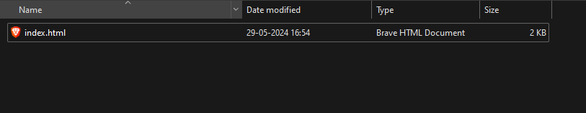
Figure 3.b Arrangement of index.html
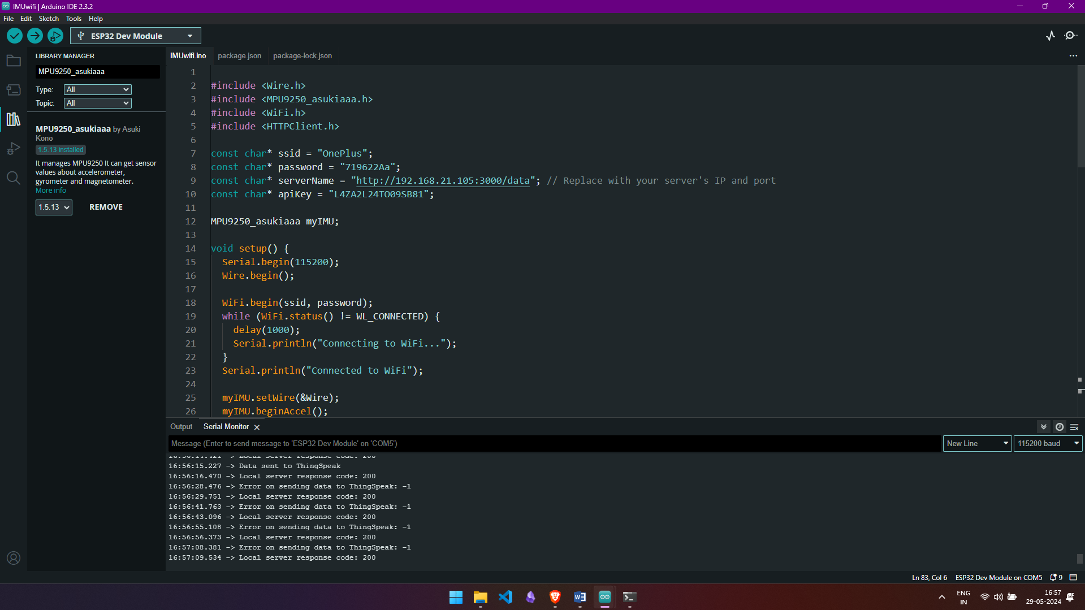
Figure 4. Software Implementation using Arduino IDE 2.3.2

Procedure:
- Set up your project directory structure: Fig 3.a
your-project/
├── public/
│ └── index.html
└── server.js
- Install necessary npm packages:
npm init -y
npm install express body-parser axios
body-parser axios ws
npm install ws
- Place the updated HTML file into the public directory. Fig3.b
- Run the server: In the folder right click and open terminal then type -
node server.js
- Access the HTML page by navigating to http://localhost:3000 in your web browser.

Block Diagram:
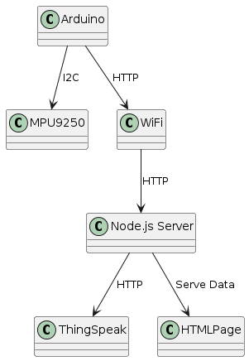
Figure 5. Block diagram of System of connections used in the code.
Flowchart: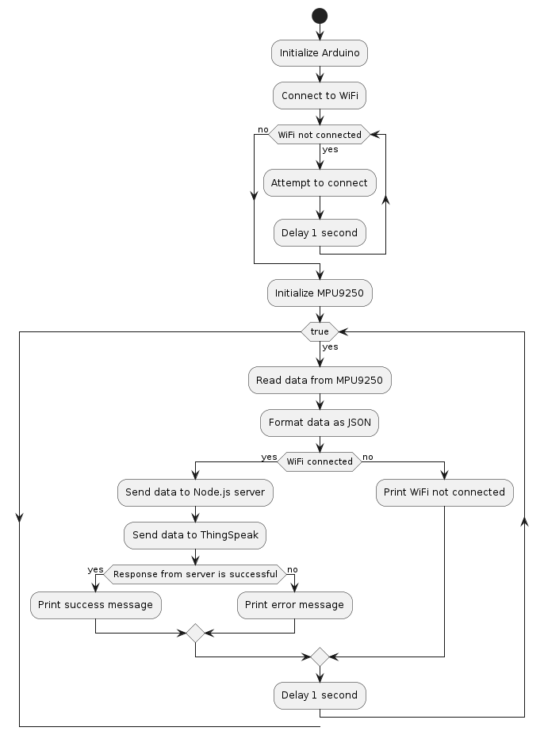
Figure 6. Flowchart of the code to measure and send data to the local host server and ThingSpeak

Arduino Code:
#include <Wire.h>
#include <MPU9250_asukiaaa.h>
#include <WiFi.h>
#include <HTTPClient.h>

const char* ssid = "OnePlus";
const char* password = "719622Aa";
const char* serverName = "http://192.168.21.105:3000/data"; // Replace with your server's IP and port
const char* apiKey = "L4ZA2L24TO09SB81";

MPU9250_asukiaaa myIMU;

void setup() {
Serial.begin(115200);
Wire.begin();

WiFi.begin(ssid, password);
while (WiFi.status() != WL_CONNECTED) {
delay(1000);
Serial.println("Connecting to WiFi...");
}
Serial.println("Connected to WiFi");

myIMU.setWire(&Wire);
myIMU.beginAccel();
myIMU.beginGyro();
myIMU.beginMag();
}

void loop() {
myIMU.accelUpdate();
myIMU.gyroUpdate();
myIMU.magUpdate();

float accelX = myIMU.accelX();
float accelY = myIMU.accelY();
float accelZ = myIMU.accelZ();

float gyroX = myIMU.gyroX();
float gyroY = myIMU.gyroY();
float gyroZ = myIMU.gyroZ();

// Send data to local server
String postDataLocal = "{\"accelX\":" + String(accelX) + ",\"accelY\":" + String(accelY) + ",\"accelZ\":" + String(accelZ) +
",\"gyroX\":" + String(gyroX) + ",\"gyroY\":" + String(gyroY) + ",\"gyroZ\":" + String(gyroZ) + "}";

if (WiFi.status() == WL_CONNECTED) {
HTTPClient httpLocal;
httpLocal.begin(serverName);
httpLocal.addHeader("Content-Type", "application/json");
int httpResponseCodeLocal = httpLocal.POST(postDataLocal);

if (httpResponseCodeLocal > 0) {
Serial.print("Local server response code: ");
Serial.println(httpResponseCodeLocal);
} else {
Serial.print("Error on sending data to local server: ");
Serial.println(httpResponseCodeLocal);
}
httpLocal.end();
} else {
Serial.println("WiFi not connected");
}

// Send data to ThingSpeak
if (WiFi.status() == WL_CONNECTED) {
HTTPClient httpThingSpeak;
String url = "http://api.thingspeak.com/update?api_key=" + String(apiKey) +
"&field1=" + String(accelX) + "&field2=" + String(accelY) + "&field3=" + String(accelZ) +
"&field4=" + String(gyroX) + "&field5=" + String(gyroY) + "&field6=" + String(gyroZ);

httpThingSpeak.begin(url);
int httpResponseCodeThingSpeak = httpThingSpeak.GET();

if (httpResponseCodeThingSpeak == 200) {
Serial.println("Data sent to ThingSpeak");
} else {
Serial.print("Error on sending data to ThingSpeak: ");
Serial.println(httpResponseCodeThingSpeak);
}
httpThingSpeak.end();
}

delay(100);
}
HTML Code:
<!DOCTYPE html>
<html lang="en">
<head>
<meta charset="UTF-8">
<meta name="viewport" content="width=device-width, initial-scale=1.0">
<title>Sensor Data</title>
<script>
document.addEventListener('DOMContentLoaded', () => {
const ws = new WebSocket('ws://localhost:3000');

ws.onmessage = event => {
const data = JSON.parse(event.data);

document.getElementById('accelX').innerText = data.accelX;
document.getElementById('accelY').innerText = data.accelY;
document.getElementById('accelZ').innerText = data.accelZ;
document.getElementById('gyroX').innerText = data.gyroX;
document.getElementById('gyroY').innerText = data.gyroY;
document.getElementById('gyroZ').innerText = data.gyroZ;
};

ws.onopen = () => {
console.log('WebSocket connection opened');
};

ws.onclose = () => {
console.log('WebSocket connection closed');
};

ws.onerror = error => {
console.error('WebSocket error:', error);
};
});
</script>
</head>
<body>
<h1>Sensor Data</h1>
<div>
<p>Accel X: <span id="accelX"></span></p>
<p>Accel Y: <span id="accelY"></span></p>
<p>Accel Z: <span id="accelZ"></span></p>
<p>Gyro X: <span id="gyroX"></span></p>
<p>Gyro Y: <span id="gyroY"></span></p>
<p>Gyro Z: <span id="gyroZ"></span></p>
</div>
</body>
</html>
Node.js Code:
const express = require('express');
const bodyParser = require('body-parser');
const path = require('path');
const axios = require('axios');
const http = require('http');
const WebSocket = require('ws');

const app = express();
const port = 3000;

// ThingSpeak API information
const apiKey = 'L4ZA2L24TO09SB81';
const thingSpeakUrl = `http://api.thingspeak.com/update?api_key=${apiKey}`;

// Middleware to parse JSON data
app.use(bodyParser.json());

// Serve the static HTML file
app.use(express.static(path.join(__dirname, 'public')));

let sensorData = {};

// Create an HTTP server
const server = http.createServer(app);

// Create a WebSocket server
const wss = new WebSocket.Server({ server });

// WebSocket connection
wss.on('connection', ws => {
console.log('Client connected');

ws.on('close', () => {
console.log('Client disconnected');
});
});

// Function to broadcast data to all connected clients
const broadcastData = data => {
wss.clients.forEach(client => {
if (client.readyState === WebSocket.OPEN) {
client.send(JSON.stringify(data));
}
});
};
// Endpoint to receive data from the Arduino
app.post('/data', async (req, res) => {
sensorData = req.body;
console.log('Received data:', sensorData);

// Send data to ThingSpeak
try {
const response = await axios.get(thingSpeakUrl, {
params: {
field1: sensorData.accelX,
field2: sensorData.accelY,
field3: sensorData.accelZ,
field4: sensorData.gyroX,
field5: sensorData.gyroY,
field6: sensorData.gyroZ,
}
});
console.log('Data sent to ThingSpeak:', response.data);
} catch (error) {
console.error('Error sending data to ThingSpeak:', error);
}
// Broadcast the received data to all WebSocket clients
broadcastData(sensorData);
res.sendStatus(200);
});

// Endpoint to serve sensor data to the client
app.get('/sensorData', (req, res) => {
res.json(sensorData);
});
// Start the server
server.listen(port, () => {
console.log(`Server is running on http://localhost:${port}`);
});

Protocols Used:
I2C (Inter-Integrated Circuit): I2C is a synchronous, multi-master, multi-slave, packet-switched, single-ended, serial communication bus. In this project, I2C is used for communication between the Arduino and the MPU9250 sensor. The Arduino uses the I2C protocol to read data from the sensor by sending and receiving data packets over two lines: SDA (data line) and SCL (clock line).
HTTP (HyperText Transfer Protocol): HTTP is an application protocol for distributed, collaborative, hypermedia information systems. It is the foundation of data communication on the World Wide Web. In this project, HTTP is used to send IMU data from the Arduino to the local server and to ThingSpeak. The data is formatted as JSON and transmitted via HTTP POST requests.
JSON (JavaScript Object Notation): JSON is an open standard file format and data interchange format that uses human-readable text to store and transmit data objects consisting of attribute–value pairs and arrays (or other serializable values). In this project, JSON is used to format the IMU data for transmission between the Arduino and the server, and between the server and ThingSpeak.

Result:
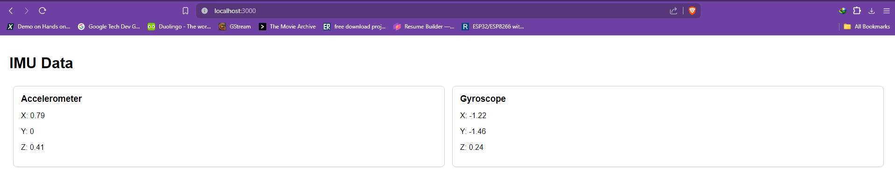
Figure 7. Server Showing realtime data and updating every 1000ms or 1 seconds

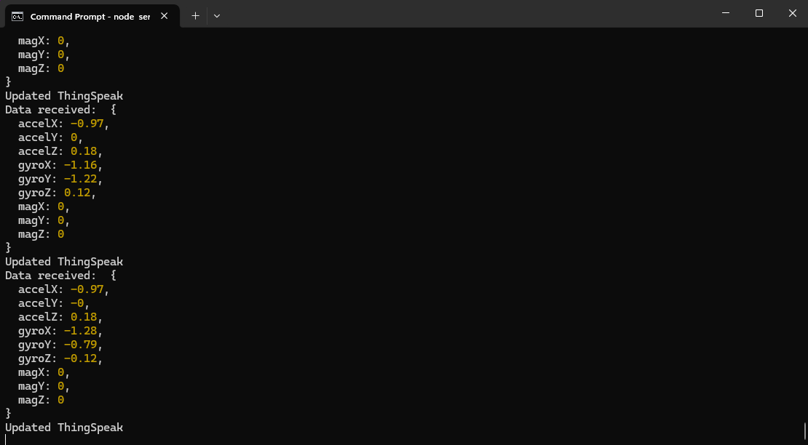
Figure 8. Node.js server started and values are being updated and displayed

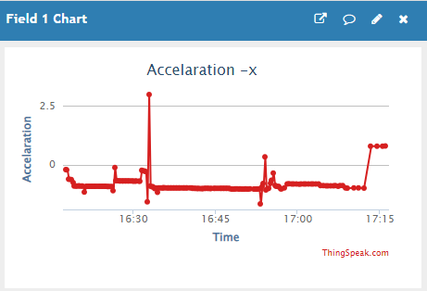
Figure 9.a Acceleration x-axis field in ThingSpeak
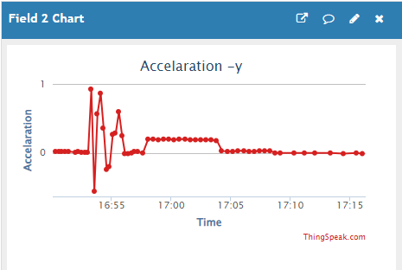
Figure 9.b Acceleration y-axis field in ThingSpeak
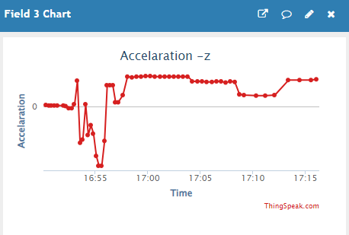
Figure 9.c Acceleration z-axis field in ThingSpeak

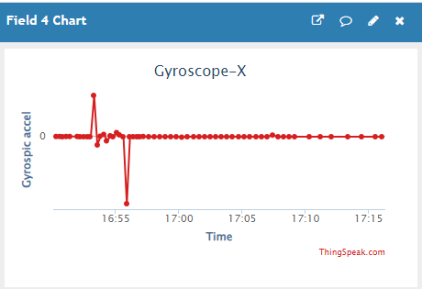
Figure 10.a Gyroscopic Acceleration x-axis field in ThingSpeak

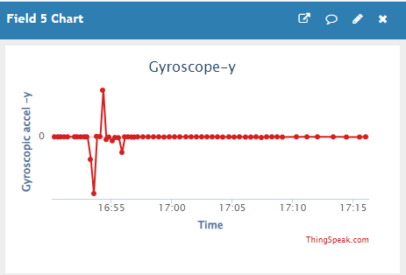
Figure 10.b Gyroscopic Acceleration y-axis field in ThingSpeak

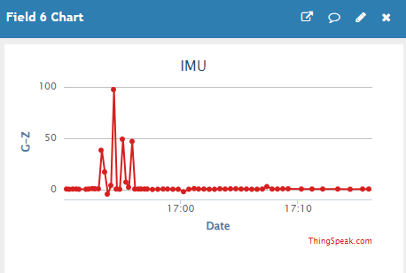
Figure 10.c Gyroscopic Acceleration z-axis field in ThingSpeak

- Figures 7 and 8 showing the server displaying real-time data and updating every 1000ms (1 second)
- Figures 9.a to 9.c showing the acceleration data fields (x, y, z) in ThingSpeak
- Figures 10.a to 10.c showing the gyroscopic data fields (x, y, z) in ThingSpeak

Conclusion:
This project successfully demonstrates how to monitor IMU data using an Arduino, a local Node.js server, and an HTML interface. The data is also sent to ThingSpeak for remote monitoring. This system can be used in various applications requiring real-time motion tracking and environmental monitoring.

References:
MPU9250 Datasheet: MPU9250 Datasheet
Arduino I2C Library: I2C LIbrary
ThingSpeak API: ThinkSpeak API
Express.js Documentation: Espress.js
Node.js Documentation: Node.js

