Amiri Decision No. (45) of 2022 on
The Organizational Structure of the Ministry of Sports and Youth
______________________________________________________________________________________

We,
Tamim Bin Hamad Al Thani, Amir of the State of Qatar,

After having perused the Constitution,
Law No. (15) of 2016 on Civil Human Resources, as amended by Law No. (23) of 2022,
Amiri Decision No. (57) of 2021 on the Assignment of the Ministries’ Competencies, and
The proposal of the Council of Ministers,

Have decided the following:
Article (1)
The organizational structure of the Ministry of Sports and Youth shall consist of the administrative units outlined in the organizational chart attached to this Decision, as follows:
First: Administrative Units Under the Minister's Supervision:
- Minister Office
- Technical Office
- Internal Audit Department
- Department of Planning, Quality, and Innovation
- Legal Affairs Department
Second: Administrative Units Under the Undersecretary's Supervision:
- Undersecretary Office
- Public Relations and Communications Department
- Sports Affairs Department
- Youth Affairs Department
- Assets and Projects Department
- Human Resources Department
- Financial and Administrative Affairs Department
- Information Systems Department
Article (2)
The Technical Office shall be responsible for the following:
- Providing technical opinions on matters referred thereto by the Minister.
- Studying and evaluating reports, projects, and programs related to the Ministry's activities, as assigned by the Minister.
- Reviewing, studying, and following up on issues referred thereto by the Minister, in coordination with the relevant administrative units.
- Preparing summaries of topics, reports, and studies that need to be presented to the Minister, and providing recommendations on them.
Article (3)
The Internal Audit Department shall be responsible for the following:
- Preparing a draft annual risk-based audit plan for the Ministry, submitting it to the Minister for approval, and preparing reports on audit results.
- Monitoring compliance with the laws, regulations, and decisions governing the work.
- Reviewing financial instructions, recommending necessary amendments, and monitoring their implementation.
- Overseeing administrative activities, including employee appointments, leaves, promotions, and other personnel matters, ensuring adherence to the applicable laws and regulations.
- Monitoring financial and accounting activities, payment vouchers, and accounting entries, and ensuring the correct application of approved rules.
- Assessing financial and administrative audit risks and proposing measures to mitigate them.
- Following up on corrective actions required from relevant administrative units based on audit results and preparing periodic reports on them.
- Ensuring the integrity of funds, assets, furniture, equipment, buildings, and other properties owned or supervised by the Ministry.
- Participating in regular and surprise inventory' audits of stores and assets, ensuring accuracy of records and validity of procedures.
- Monitoring the outcomes of reports from oversight bodies and providing appropriate recommendations regarding them.
Article (4)
The Department of Planning, Quality, and Innovation shall be responsible for the following:
- Preparing the Ministry's strategic plan in coordination with the competent authorities and relevant administrative units, and overseeing its approval.
- Identing current challenges, assessing potential institutional risks that could impact the Ministry goals, and providing proposals to address them, in coordination with relevant units.
- Managing and developing contingency plans to ensure business continuity during emergencies and crises, in coordination with the respective units.
- Submitting executive plans, projects, and programs from various administrative units to the Minister for approval.
- Monitoring the implementation of the Ministry’s activity plans, evaluating outcomes, and submitting periodic reports.
- Analyzing challenges and obstacles in implementing the strategic and operational plans, and proposing suitable solutions.
- Evaluating the quality of services provided by administrative units, in coordination with the competent authority.
- Reviewing and assessing performance quality at the administrative unit level, and proposing recommendations to enhance overall efficiency.
- Ensuring that work systems and methods align with the Ministry's goals and responsibilities, and proposing plans to develop these systems and simplify the procedures, in coordination with the relevant units and the competent authority.
- Studying work-related issues and challenges within the Ministry, investigating their causes, and recommending appropriate solutions.
- Receiving and reviewing initiatives, proposals, and creative ideas, in coordination with relevant administrative units and the competent authority.
- Monitoring, collecting, and analyzing statistical data related to the Ministry s activities, and coordinating with the concerned units regarding statistical reports required by the Ministry.
- Coordinating with the relevant administrative units and the competent authority on international indicators related to the Ministry activities and responsibilities.
Article (5)
The Legal Affairs Department shall be responsible for:
- Reviewing, studying, and following up on legal matters related to the Ministry's activities, in coordination with the concerned administrative units.
- Drafting legislative instruments related to the Ministry and providing legal opinions on draft laws referred to the department
- Expressing legal opinions on matters submitted to the department.
- Preparing drafts of contracts, agreements, and memoranda of understanding relevant to the Ministry’s functions, in collaboration with the relevant units.
- Investigating incidents and violations attributed to Ministry staff, preparing detailed reports with legal opinions and recommendations, submitting them to the competent authority, and following up on the implementation of decisions made in this regard.
- Monitoring disputes and legal cases involving the Ministry, in coordination with the competent authorities.
Article (6)
The Public Relations and Communications Department shall be responsible for:
- Publishing bulletins and media programs aimed at promoting awareness of the Ministry’s role, activities, and responsibilities, in coordination with relevant units.
- Monitoring and tracking what is published in newspapers, media outlets, and on social media platforms regarding the Ministry and presenting these matters to the decision-makers, and preparing appropriate responses, in coordination with the concerned units and the competent authorities.
- Coordinating with the relevant units to prepare awareness and education programs and implementing them through events and various activities, in collaboration with the concerned entities.
- Receiving public inquiries and complaints, forwarding them to the appropriate units, and responding to queries.
- Arranging travel, hospitality, and accommodation for the Ministry’s guests and for visiting and departing delegations, in coordination with the relevant administrative units.
- Organizing cultural, social, and sports events for Ministry staff and overseeing celebrations held or participated in by the Ministry.
- Organizing conferences, seminars, and exhibitions hosted by the Ministry, and preparing the necessary budgets in coordination with the relevant departments and authorities.
- Preparing working papers for local, regional, and international conferences, seminars, and meetings related to the Ministry’s activities, in coordination with the relevant units and the competent authorities.
- Preparing reports and responses requested by regional and international organizations concerning the Ministry’s activities, coordinating with relevant units, and following up on recommendations issued by these bodies.
- Preparing reports evaluating the efficiency and effectiveness of international cooperation with regional and international organizations related to the Ministry's scope of work.
- Receiving and facilitating the requests of senior citizens and persons with disabilities, in coordination with the relevant units, to ensure smooth processing of their transactions and overcome any difficulties they may face.
Article (7)
The Spots Affairs Department shall be responsible for:
- Implementing the provisions of the law regulating sports clubs.
- Proposing legislation, decisions, regulations, policies, and development plans concerning sports activities and entities, and following up on their implementation once approved.
- Issuing licenses and approvals related to sports activities.
- Monitoring the compliance of sports entities with licensing requirements as provided for by the law.
- Developing establishing standards and conditions for the creation, registration, and official recognition of sports clubs, centers, committees, and associations, in accordance with the governing laws and relevant international standards.
- Setting conditions and procedures for allowing sports entities to invest in public facilities and issuing licenses accordingly.
- Following up on the country’s obligations regarding the promotion of transparency, the protection of integrity in sports, and adherence to international codes of conduct and sports regulations.
- Supervising and monitoring compliance of national athletes with international sports regulations and standards.
- Overseeing the performance of sports-related entities, monitoring their activities, and
- Supporting initiatives aimed at increasing community participation in sports and monitoring their implementation.
- Supervising and evaluating sports events and activities at the national level.
- Participating in the organization of national sports events and occasions.
- Reviewing, evaluating, and developing the work of sports entities and preparing periodic reports on their performance.
- Elevating the overall level of sports in the country to achieve excellence.
- Promoting sports as an integral part of a healthy lifestyle in the community.
Article (8)
The Youth Affairs Department shall be responsible for:
- Implementing the legislation and regulations governing youth centers.
- Empowering youth, developing their skills, and highlighting their role in contributing to national responsibilities.
- Proposing standards and conditions for establishing youth centers, committees, and associations, issuing licenses, and monitoring their activities.
- Proposing laws, regulations, decisions, policies, and development plans related to youth activities and following up on their implementation upon approval.
- Issuing licenses and approvals related to youth work.
- Monitoring youth entities' compliance with licensing conditions as per the law.
- Recommending the dissolution or merger of youth centers and entities.
- Defining conditions and standards for practicing youth activities and issuing the corresponding licenses.
- Supervising and supporting youth centers and related entities, coordinating their work, and monitoring their performance.
- Supporting plans and initiatives aimed at broadening youth participation and tracking their progress.
- Ensuring the provision of resources, facilities, and capabilities needed for youth activities and events.
- Overseeing internal and external youth events and participations, evaluating their execution, and tracking outcomes.
- Participating in organizing national youth events and celebrations.
- Reviewing, assessing, and improving the performance of youth centers, entities, seasonal programs, and activities, and preparing periodic reports.
- Organizing youth participation in conferences, training programs, competitions, camps, and festivals at the local, Arab, and international levels, and supporting talented and high-achieving youth by working on nurturing their skills.
- Approving the annual budget of affiliated youth entities based on approved work plans.
Article (9)
The Assets and Projects Department shall be responsible for:
- Identifying and assessing the needs for sports and youth-related projects and facilities, in coordination with the relevant authorities, and establishing implementation priorities.
- Developing and maintaining a comprehensive database of the Ministry’s assets and facilities, and managing related records.
- Monitoring the design and construction of sports and youth facilities in collaboration with concerned authorities, and preparing related reports.
- Preparing the annual maintenance and operations plan for the Ministry's facilities, coordinating with relevant authorities, and overseeing its implementation.
- Preparing maintenance requests and facility needs based on the annual plan and defining technical specifications for contracting.
- Following up on the implementation of maintenance and operational contracts for facilities.
- Ensuring the provision of all operational services required by the Ministry’s facilities.
- Taking the necessary measures to prepare and set up events and activities organized or overseen by the Ministry, in coordination with the relevant authorities and administrative units.
Article (10)
The Human Resources Department shall be responsible for:
- Implementing laws, regulations, and systems related to personnel affairs.
- Conducting studies on human resources planning within the Ministry and specifying staffing needs in coordination with the relevant authority and administrative units.
- Preparing job descriptions, classifications, and grading proposals, and monitoring the implementation and development thereof.
- Preparing the draft budget for Chapter One (Salaries and Wages), in coordination with relevant departments.
- Administering employee performance evaluations.
- Managing recruitment, transfers, secondments, and delegations.
- Reviewing employee eligibility for leaves, in accordance with the applicable laws.
- Conducting organizational structure studies and proposing necessary improvements to enhance administrative organization.
- Identifying training needs for Ministry staff in coordination with all departments, monitoring training execution, and evaluating its effectiveness.
- Handling procedures related to the allocation of government housing and disbursement of furniture allowances for Ministry employees, in coordination with the competent authorities.
- Establishing and regularly updating the Ministry’s employee databases.
Article (11)
The Financial and Administrative Affairs Department shall be responsible for:
- Enforcing financial and administrative laws, regulations, and systems relevant to the Ministry’s operations.
- Preparing the Ministry's annual budget and final account, in coordination with relevant departments.
- Providing the Ministry and its various departments with the necessary supplies and equipment to support their operations, in coordination with relevant units.
- Managing procurement, tenders, and auctions, in accordance with the applicable laws and regulations in the State.
- Overseeing the execution of budget allocations and auditing revenue and expenditure accounts.
- Handling the receipt, delivery, classification, and registration of incoming and outgoing mail.
- Organizing the Ministry’s archive and document storage according to modern best practices.
- Preparing payment vouchers and processing all other financial transactions.
- Collecting fees and charges for services rendered by the Ministry.
- Managing all administrative support services.
- Overseeing the Ministry’s warehouses.
Article (12)
The Information Systems Department shall be responsible for:
- Developing plans and policies for the use of computer systems across the Ministry’s operations and overseeing their implementation.
- Programming, storing, retrieving, and enhancing information systems and databases required for the Ministry’s activities.
- Securing systems, software, networks, and IT infrastructure against cyber threats and digital incidents.
- Preparing disaster recovery plans to mitigate the impact of cyber incidents, reduce their occurrence or escalation, and ensure compliance with information security policies and guidelines, in coordination with the competent authority.
- Providing and maintaining the electronic devices, software, and networks necessary for the Ministry’s automated systems, in coordination with the relevant departments.
- Designing, operating, and managing databases and information systems in all their forms.
- Offering technical support to users of the Ministry’s electronic networks and training them on how to use systems, software, computers, and related tools.
- Creating, maintaining, and regularly updating the Ministry’s official website on the internet.
Article (13)
The specific responsibilities of both the Minister's Office and the Undersecretary Office shall be specified by a decision issued by the Minister.
Article (14)
The Council of Ministers may, upon the Minister's proposal, approve amendments to the organizational structure of the Ministry by adding, removing, or merging administrative units, as well as specifying or modifying their responsibilities.
Article (15)
The Minister may, in the interest of public service, establish, abolish, or merge departments within the Ministry’s administrative units and assign or amend their responsibilities. However, such decisions shall only take effect after being approved by the Council of Ministers.
Article (16)
All relevant entities, each within its jurisdiction, shall implement this Decision. It shall come into force from the date of its issuance and it shall be published in the Official Gazette.

Tamim Bin Hamad Al Thani
Amir of the State of Qatar

Issued at the Amiri Diwan on: 28/03/1444 (H)
Corresponding to: 24/10/2022 (AD)

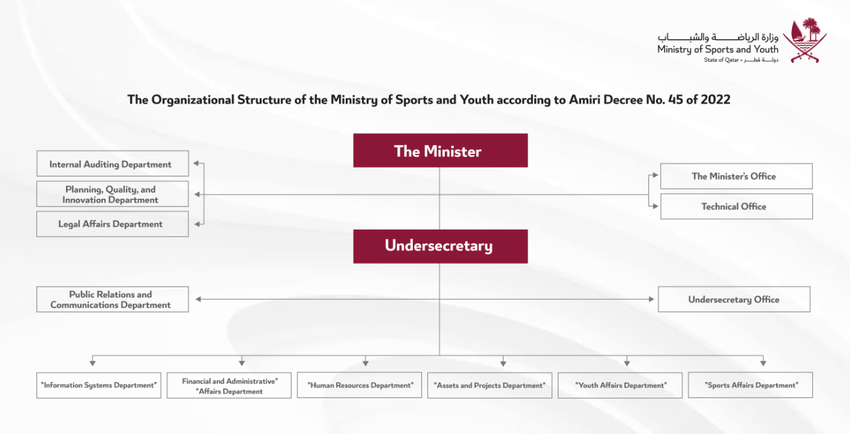

The Official Gazette, Issue No. (12) of 2022.

