1. Run a command to find your current location on the server

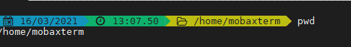

1. Change directory from your current location to /var/log

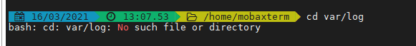

1. Go back up a directory

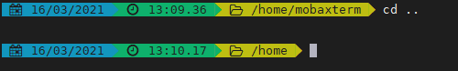

1. Find your current location again

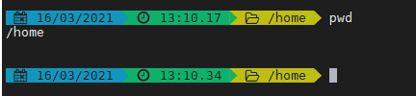

1. List all the files in the current directory

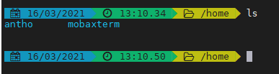

1. Now list all the files with the long listing

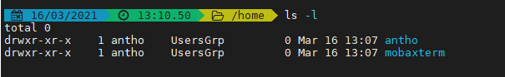

1. Now list all the files with the long listing in reverse order, with the newest appearing at the bottom of your screen

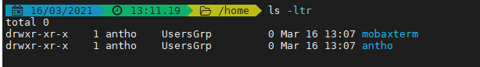

1. Change to root directory

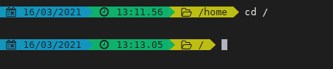

1. Change back to your home directory

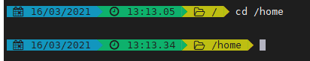

1. Go up a level in directory structure

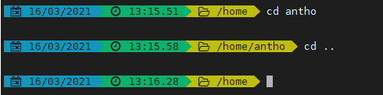

1. Find out more information about the ls command

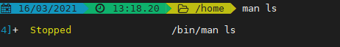

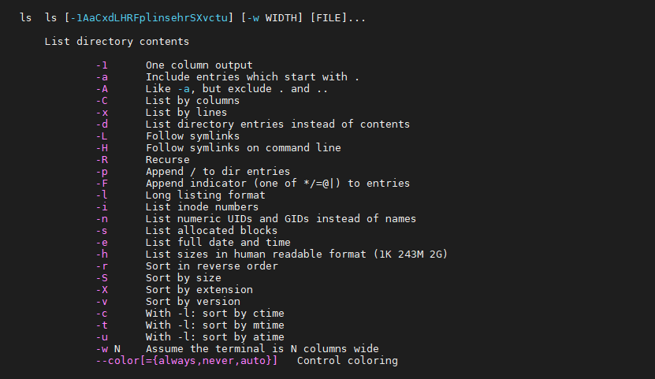

1. Go back to /var

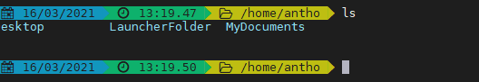

1. Show the contents of this directory with details reverse sorted by size (you may have to use man to help)

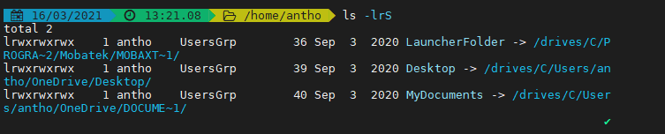

1. Find out the hardware version you are running

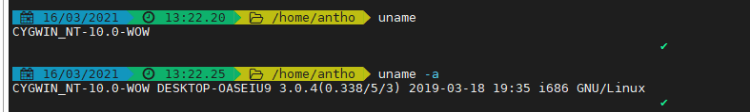

1. Run the following command to store your results in the directory that the trainer has provided – substitute your name and the date in your file

