Proof of Concept: Controlled Natural Language Logic For Knowledge Engineering At 1Spatial
Anthony Beck
Distribution list:
- Mike Sanderson
- Matt Beare
- Alan Howie
- Bob Chell
- Stephen Stanley
A version of this document needs sending to UU
- John Daniels
- Lee Mooney (lee.mooney@uuplc.co.uk)

Rules, Ontologies and the 1Spatial consultancy model
The ability to express rules and logic in syntactically simple phrases is becoming increasingly important to how we develop an understanding of clients business needs and then effectively communicating this understanding to our clients. This is particularly important when identifying the difference between a client's pre-conceived need and their actual need (as reflected in the data and the surrounding business processes). To facilitate this 1Spatial use RuleSpeak to both capture and communicate business rules. RuleSpeak is an example of a Controlled Natural Language (CNL). Whilst Rulespeak reduces or removes ambiguity it is only understandable by a human reader. There are other CNLs which have been developed in the Knowledge Engineering community which focus on developing Formal Ontologies. This extends the utility of the rules by ensuring they are human and computer readable.
Ontologies have been proposed and studied in the last couple of decades as a way to capture and share people’s knowledge about the world in a way that is computer readable. This allows inference engines to test the validity of facts/statements and to infer new knowledge. Ontologies have the potential to serve as a bridge between the human conceptual understanding of the world and the abstracted view of the world stored in computer systems.
One of the main reasons for the lack of widespread adoption of ontologies is the steep learning curve for authoring them: most people find it too difficult to learn the syntax and formal semantics of ontology languages. If CNL can be used to develop ontologies then we can produce a more formal and rigorous method of modelling data, conceptual and business processes and sharing these models in meaningful ways with our business partners. For 1Spatial this has the added benefit of accruing a knowledge base.
From a consultancy perspective 1Spatial is employed because the added business value to the client is greater than the cost of adding the value. Quality and knowledge is our business.
During consultation we need to rapidly determine a number of things:
- the actual nature of the data (a data profiling exercise)
- the expected nature of the data (an 'as-design' conceptual modelling exercise)
- the business problems which the data is expected to help solve (a business requirements exercise)
- the business operational processes (an 'as-built' business modelling exercise)
1Spatial has generic skills in data and spatial data quality enhancement but also has expert knowledge in different operational sectors (National Mapping Agencies, Utilities, Defense, Transport etc.). However, we are poor at re-using this knowledge. Being able to effectively re-use our knowledge base provides 1Spatial with a significant competitive advantage. 1Spatial can capitilise on the knowledge gained from each project more effectively. When working in in different organisations which refelct our domains of expertise there already exists a domain rich model which can be re-used in different business environments (i.e. we already know how utility A models water assets.... can this be used to help solve problems for utility B?). This knowledge can also be used to identify new market opportunities: for example, the impacts of a new policy initiative (or policy change) can be modelled and inform products and services which can be pitched across the different sectors in a timely manner.
The ability to rapidly generate formal models and build these into a corporate knowledge base represents a significant opportunity for 1Spatial to transform and improve how it operates. This document outlines a proof of concept approach for generating such models.

Controlled Natural Language systems for Ontology engineering

Ontology creation
Ontology development requires at least two types of people:
- A knowledge engineer - who can structure the underlying logic that supports the knowledge model
- A domain expert - who has in depth understanding and experience of the phenomena to be modelled
The mathematical nature of description logic has meant that domain experts find them hard to understand. This forms a significant impediment to the creation and adoption of ontologies. Ontology focussed Controlled Natural Language systems constrain language syntax and allow statements to be translated into the Web Ontology Language (OWL) with the aim of achieving both comprehension by domain experts and computational preciseness.

The benefit of CNLs for ontology creation
The fundamental principles underlying the use of CNLs for Ontology engineering are (after @denaux_intuitive_2013):
- To allow the domain expert, with the aid of a knowledge engineer and tool support, to express their knowledge as easily and simply as possible and in as much detail as necessary.
- To have a well defined grammar and be sufficiently formal to enable those aspects that can be expressed as OWL to be systematically translatable.
- To be comprehensible by domain experts with little or no knowledge of OWL.
- To be independent of any specific domain.
These principles can be achieved - at least in part. One such example is the use of the Rabbit CNL developed by Ordnance Survey (@hart_rabbit:_2008):
The original intention was for Rabbit to enable domain experts alone to author ontologies. However, practice showed that whilst domain experts could build ontologies, these ontologies often contained many modelling errors not related to the language but the modelling processes. None-the-less Rabbit still enables the domain expert to take the lead and to author ontologies with guidance in modelling techniques from a knowledge engineer. Rabbit also enables other domain experts to verify the ontology.

Candidate systems
Two candidate systems were considered:
- ROO and Rabbit [@denaux_intuitive_2013, @hart_rabbit:_2008]
- APE and ACE [@_attempto_2014]
ROO and Rabbit are not as actively developed as APE and ACE. For this reason the proof of concept was undertaken using APE and ACE. Both languages have limitations and a more rigorous review of CNLs and CNL ontology modelling would need to be undertaken if these approaches are implemented by 1Spatial.
Other systems should be reviewed including Fluent Editor which includes CNL for SWRL rule authoring.

Ontology CNLs compared to formal language
CNLs should contain a number of language element. Those used to
- express axioms
- introduce (or declare) concepts, relationships and individuals
- define relationships between concepts
- define properties of concepts and individuals
The table below contrasts the ACE representation with a "formal language" representation that is normally used in such ontologies. This is intended to show that natural language, if carefully controlled, provides a more readable and writable ontology representation, without a loss in generality and expressive power.
ACE notation | Formal logic notation
Every man is a human. | man human
Every human is a male or is a female. | human male female
John is a student and Mary is a student. | {John, Mary} student
No dog is a cat. | dog cat
Every driver owns a car. | driver own car
Everything that a goat eats is some grass. | goat eat grass
John likes Mary. | <John, Mary> like
Everybody who loves somebody likes him/her. | love(X, Y) $\implies$ like(X, Y)
example statements represented in ACE and formal logic notation

Ontology CNLs compared to RuleSpeak
The conclusion of this section should be that Ontology CNLs are no harder to construct than RuleSpeak but provide greater value. However, it is likely that, at least in the short term, RuleSpeak provides more flexibility (i.e. not all concepts may be directly tractable/mappable to OWL ontologies).

Why ontologies (reasoning and generalisation)
An ontology is a logic framework which provides powerful functionality. The rich model that describes the relationships between and properties of concepts and individuals can be used to generalise data and infer new knowledge. The geographical potential of such approaches are described in detail in @hart_linked_2013.
For example Figure describes the relationship between the different levels of the Corine land-cover classification hierarchy expressed within an OWL ontology. This encoding can be used to collapse the groupings and generalise the data based upon properties and relations within the ontology. Hence, individual instances can be generalised up the hierarchy.
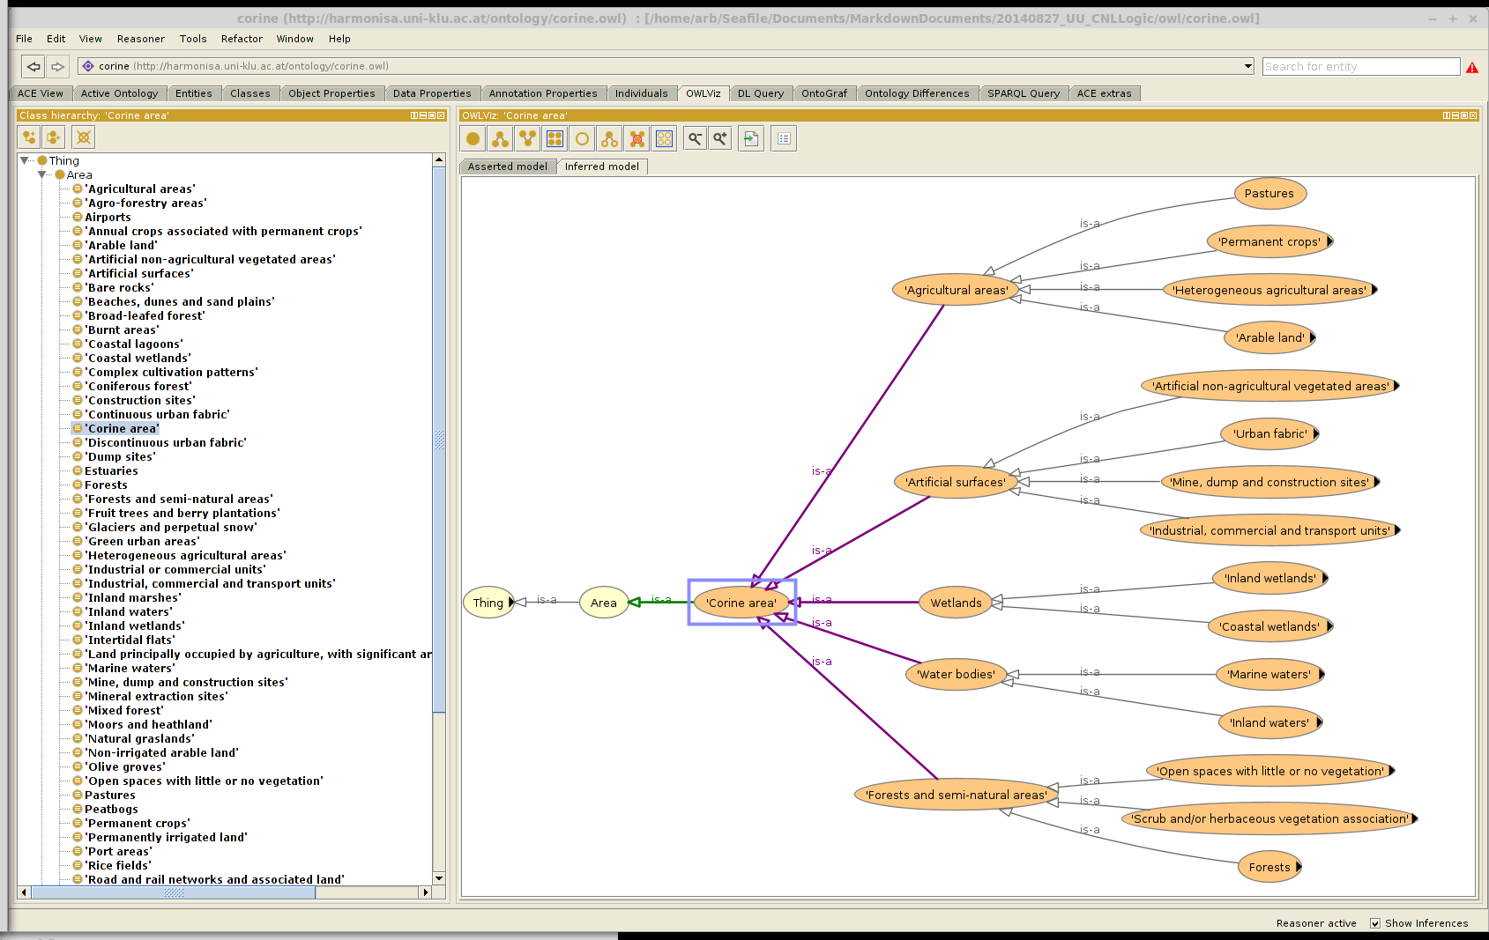
This kind of functionality is important to projects like ELF. Inspire is also transitioning into an ontology led framework employing Linked Open Data (LOD).
The reasoning and inference capabilities are powerful. Assertions can be tested for logical validity. Statements can be tested for their validity based upon rules:
- Rule
  - No man is a woman.
- Statements
  - John is a woman.
  - John is a man.
the reasoner will find an inconsistency because John has been asserted as a man and men have been described as disjoint from women. This is shown in Figure . This complements the rules which can be expressed within 1Integrate.
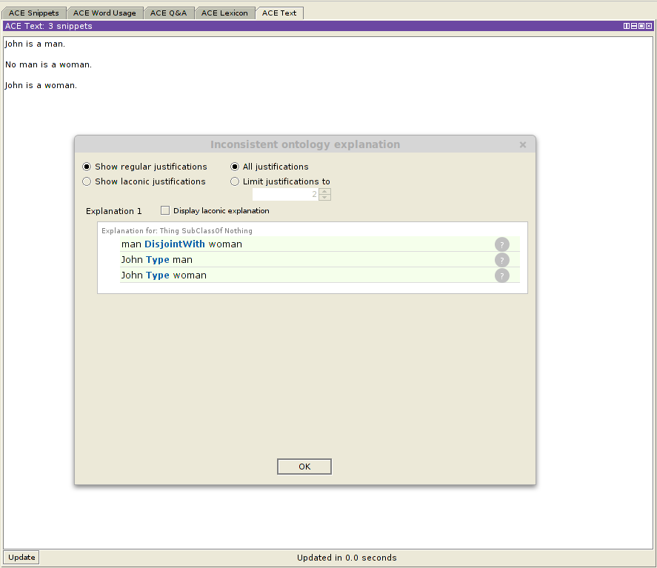
Reasoning about transitivity and HasValue will find the following text inconsistent (see Figure ).
- If something X follows something that follows something Y then X follows Y.
- John follows Mary who follows Bill who follows John.
- No manager follows Mary.
- Bill is a manager.
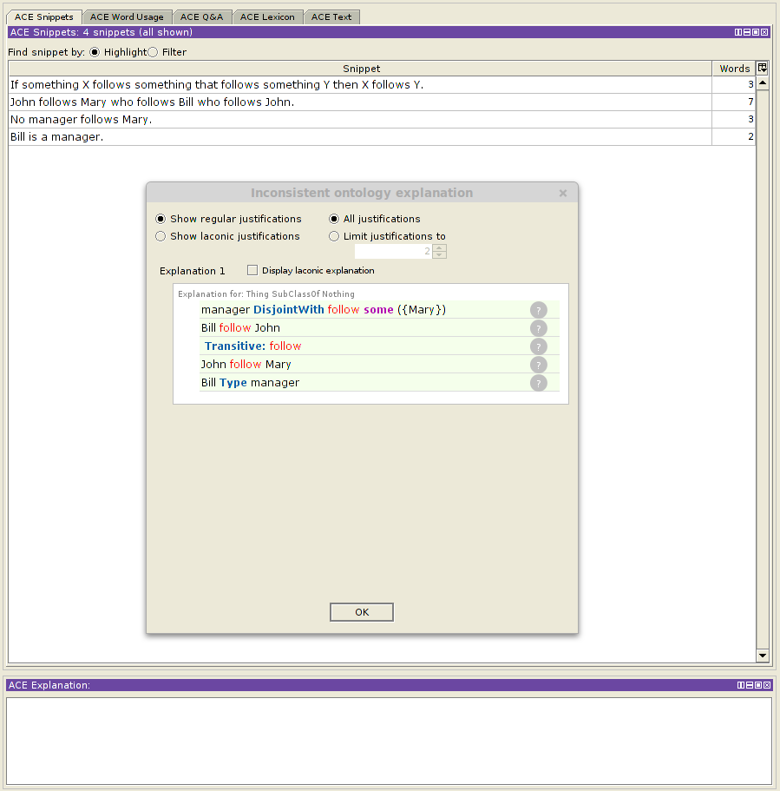

Proof of concept problem - The impact of Open Water

United Utilities
United Utilities (UU) provides both water and wastewater services. The location of the termination point of a United Utilities wholesale service asset to a customer is called a service point. These service points may be for water supply, sewerage services, metering, trade effluent and any other service within the wholesale service catalogue. A service point is a sub-set of the UU wholesale assets which is uniquely billable and has a geographical location. This locational geography needs to adequately represent billing and operational activities.
The Address Management System (AMS) fulfills parts of this need. AMS is a bespoke data repository holding Service Point Addresses for water, wastewater and electricity (now deprecated) domains. AMS is not an address gazetteer. Figure provides an overview of AMS.
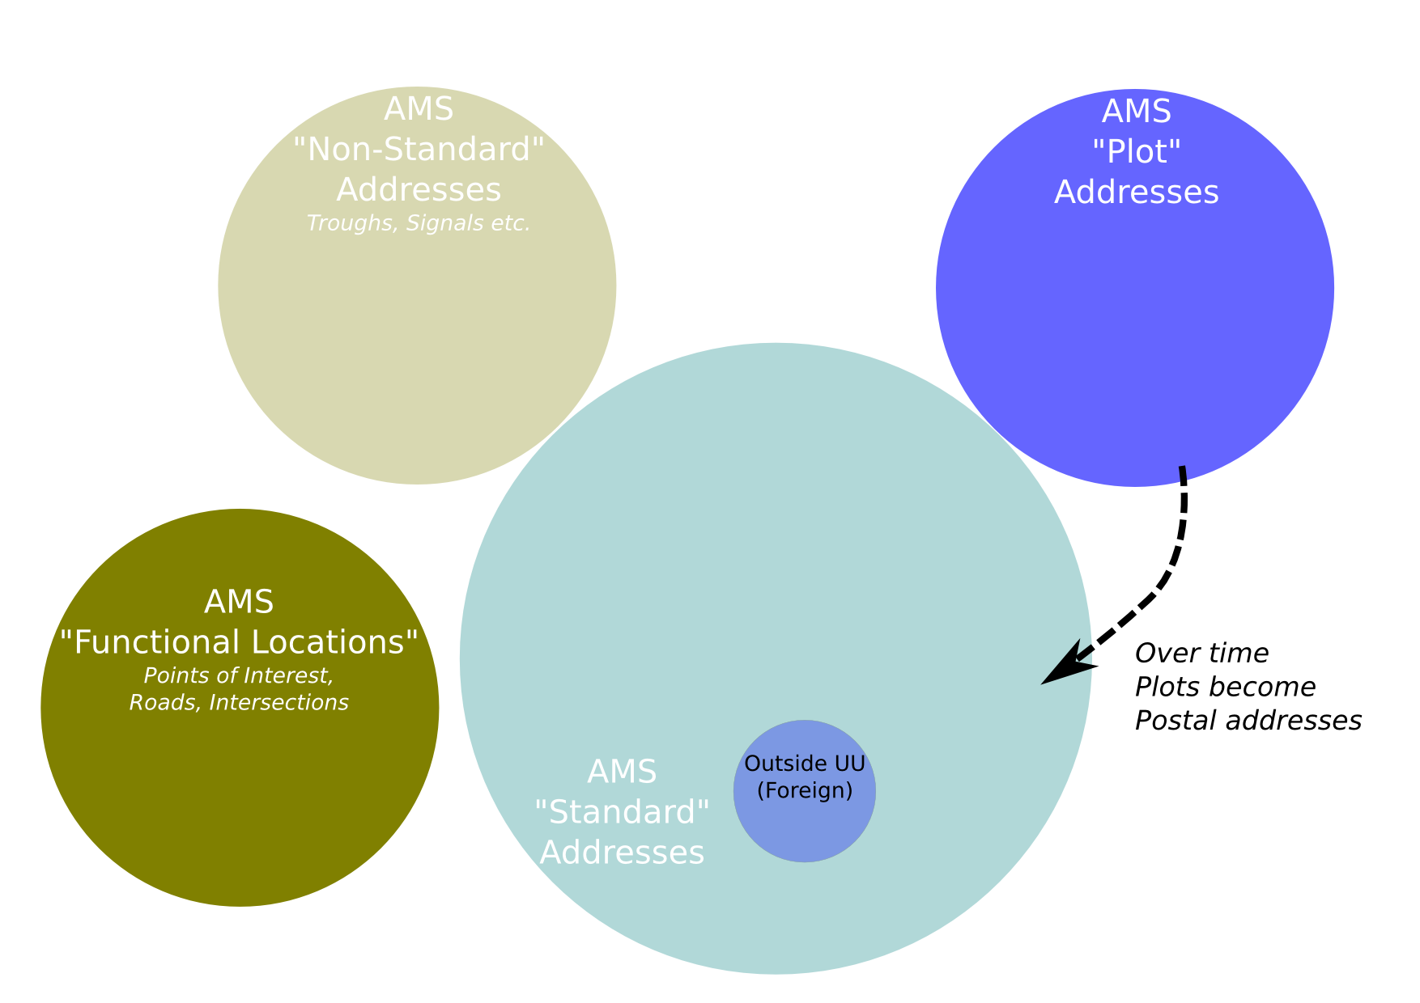
AMS records are related to a service point:
- In most cases these service points are at an addressable property (or a standard address) such as a house or office. These have an address_type of postal (PO).
  - There are also some legacy records that refer to postal addresses outside the UU operational area. These have an address_type of foreign (FO).
- Some AMS records are related to potential future service points which will be constructed. These represent plot addresses. These have an address_type of plot (PL).
- The AMS record might refer to a service point feeding a cattle trough or a railway signalling box. These represent non-standard addresses. These have an address_type of locational (LO).

Open Water
At present UU only provides wholesale services. When the Open Water initiative is enacted UU will be split into a wholesale and retail business. The wholesale part of UU will sell services to a small number of elegible third parties (including the retail part of UU) who will act as retail agents. These elegible retail agents will sell services to individual consumers. The wholesale business will provide transparent systems to all eligible retail businesses. Key to this will be the interoperable exchange of service point information. This implies that after Open Water has been enacted there will be both Retail Service Points and Wholesale Service Points. UU has recognised the important and potentially disruptive impact of Open Water. This recognition underpins the Service Point Address (SPA) project:
In the coming competitive environment, the importance of the service point address will increase. On 2nd January 2014, the OpenWater Group published documentation on how it sees the competitive market operating. A fundamental requirement for market operation is “for registration and switching, a centrally held record of premises, service points, and associated meters and market participants”. The ability of suppliers to interact and automatically match to this data will be critical in running an efficient business.
The current addressing system suffers from poor integration with existing systems including Alto and IWM, poor data quality and is based on an end of life, custom application.
Service point address (SPA) will provide a single version of the truth for property addresses and service point locations within the strategic UUGIS (LAM) application and integrate to other key enterprise applications (IWM, Alto). Our critical success will be ensuring that when dealing with a property which receives a UU service, all of our teams are presented with consistent, accurate information about the property address and location.
The Open Water policy initiative will be very disruptive to the Water domain. Other utility companies in the water domain will be responding to this policy initiative.

The CNL developed for Open Water based on UU views of its assets
On 17th July there was a meeting at UU as part of the SPA project which discussed the forthcoming Open Water initiative in significant detail. It became apparent that the impact of Open Water was unclear. This was not helped by semantic and conceptual issues. For example the terminology had multiple interpretations that could be construed differently depending upon the mental models employed. Based upon this experience it was determined that a better way of sharing this information was required.
This meeting resulted in Figure : a conceptual model that identifies the nature of Service Points and connectivity of the physical assets in relation to Open Water. These relationships have been encoded as CNL as detailed below
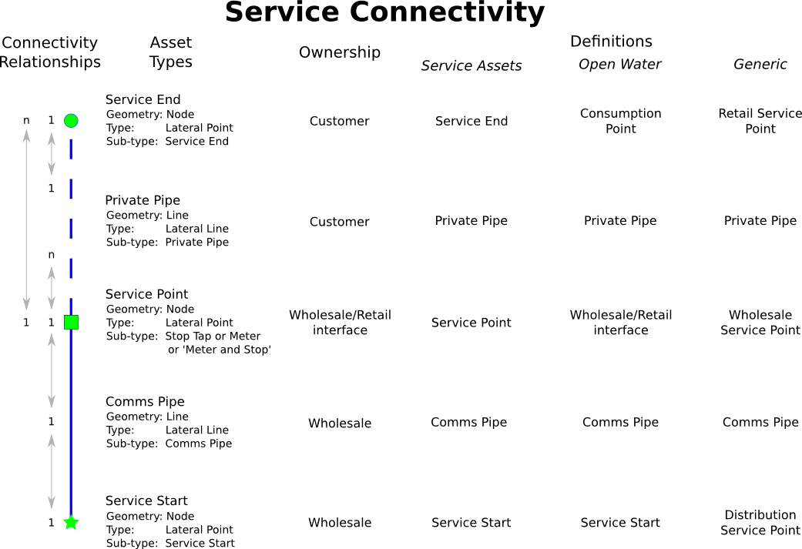

Classes and properties
A series of simple statements that define classes and properties. The validity of these statements can be easily tested by domain experts in the business. It is important to ensure that edge cases are detected
Every lateralPoint is an asset .
Every lateralPoint hasGeometry node .
Every lateralLine is an asset .
Every lateralLine hasGeometry line .
Every main is a lateralLine .
Every main is a wholesaleAsset .
Every commsPipe is a lateralLine .
Every commsPipe is a wholesaleAsset .
Every privatePipe is a lateralLine .
Every privatePipe is a retailAsset .
Every ferrule is a lateralPoint .
Every meter is a lateralPoint .
Every stopTap is a lateralPoint .
Every meterAndStop is a lateralPoint .
Every serviceStart is a lateralPoint .
Every serviceStart is a ferrule .
Every serviceStart is a wholesaleAsset .
Every distributionServicePoint is a serviceStart .
Every servicePoint is a lateralPoint .
Every servicePoint is a wholesaleAsset and is a retailAsset.
Every wholesaleServicePoint is a servicePoint .
Every serviceEnd is a lateralPoint .
Every serviceEnd is a retailAsset .

General constraints
Constraints have been given to the classes (and by extension their instances) which are defined above.
Every serviceStart is physicallyConnected to 1 main and 1 commsPipe .
Every servicePoint is a stopTap or is a meter or is a meterAndStop .
Every servicePoint is physicallyConnected to 1 main and at least 1 commsPipe .
Every serviceEnd is physicallyConnected to 1 commsPipe .

Transitivity rules
Some transitivity rules are detailed below. That explain that if A is physicallyConnected to B and B physicallyConnected to C then A is part of the same network as C. There is also an inverse statement so that connections can be identified irrespective of direction.
If something X follows something that follows something Y then X follows Y.
If something X physicallyConnected something that physicallyConnected something Y then X networkConnected Y.
If something X physicallyConnected something Y then something Y physicallyConnected X.
If something X physicallyConnected something Y then something X networkConnected Y.
If something X networkConnected something Y then something Y networkConnected X.
If something X is taller than something Y and Y is taller than something Z then X is taller than Z.
If something X is physicallyConnected something Y and Y is physicallyConnected something Z then X is networkConnected Z.

Individuals
Some individuals have been created. These can be used to test the validity of statements about concepts and to test connectivity. A physicallyConnected network has been generated.
ID_12345 is a ferrule .
ID_12345 is a serviceStart .
ID_12345 physicallyConnected ID_45678 .
ID_45678 physicallyConnected ID_99999 .
ID_99999 physicallyConnected ID_99998 .
Every retailServicePoint is a serviceEnd .

Questions for the reasoner to answer
Some questions have been stated for the reasoner to answer:
What is a ferrule ?
What is ID_12345 ?
What is an asset ?
What is a wholesaleAsset ?
Is ID_99998 networkConnected ID_12345 ?

Entailment (what does this imply)
To support this section a 4 minute video has been created that shows how the ACE/APE CNL statements can be loaded into the Protege ontology editor. There are two versions of this video:
- Original webm
- Converted wmv (for windows users who do not have the appropriate codecs)
Create some stories around the models in protege and the questions which have been asked.
Also be honest that this (the CNL) currently has holes and needs some other things to support it (like the concepts in the supporting OWL). In this example the network connected relationships have not come through (because I need to hand crank the logic directly in Protege as it's not accepted in the statements)
Relationships between the statements can be quickly visualised in Protege as shown in Figure . This facility alone is an enhancement to that offered by RuleSpeak.
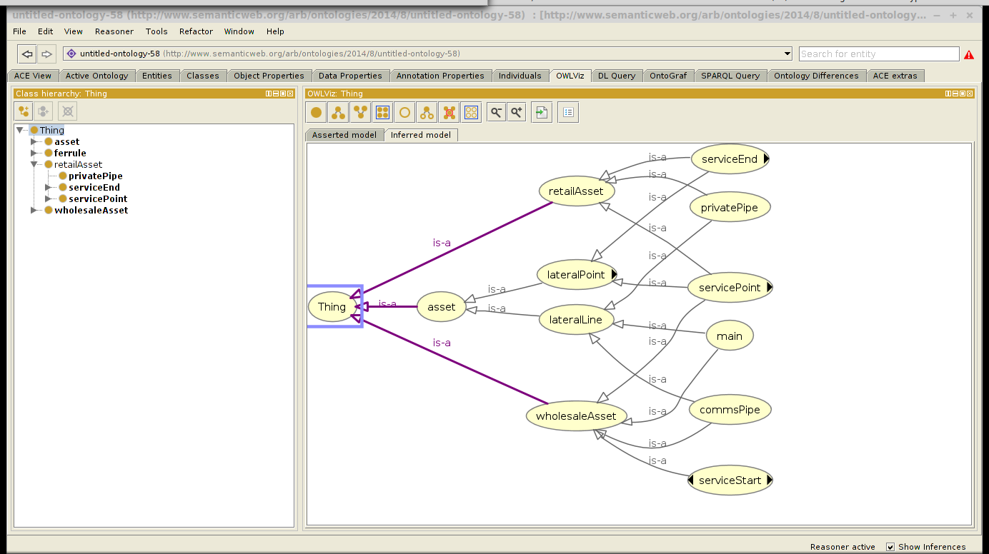
As explained in the videos a number of different visualizations, views and facts can be seen using the built in tools in Protege. In addition we have used ACE/APE to ask a number of questions of the ontology as detailed in the figures below:
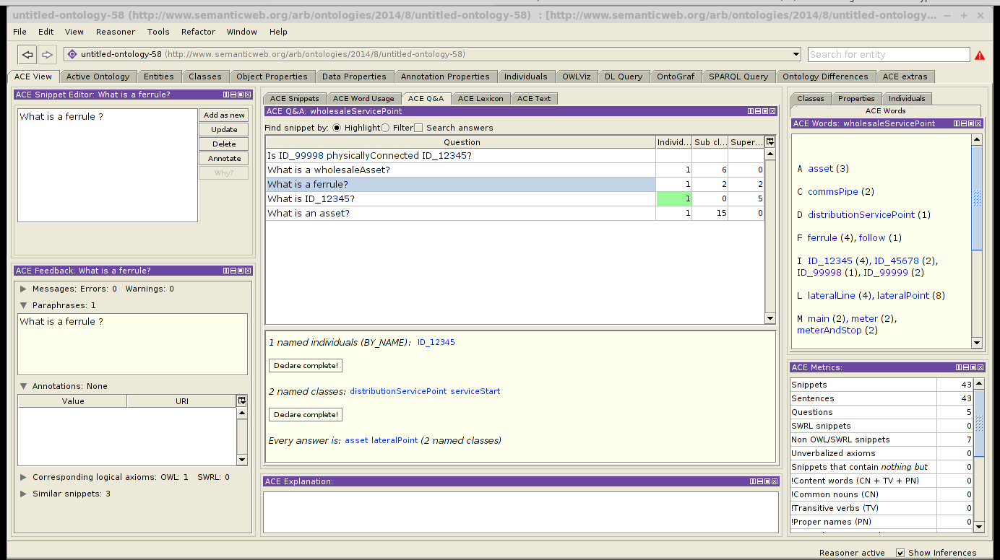
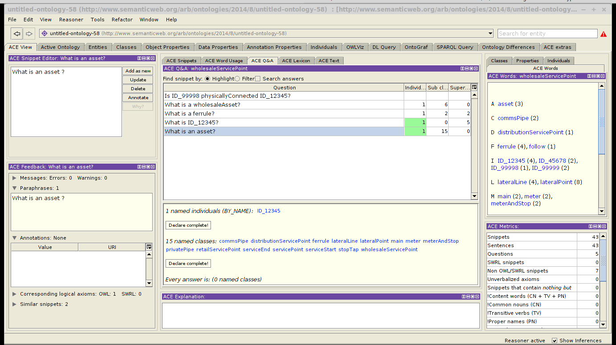
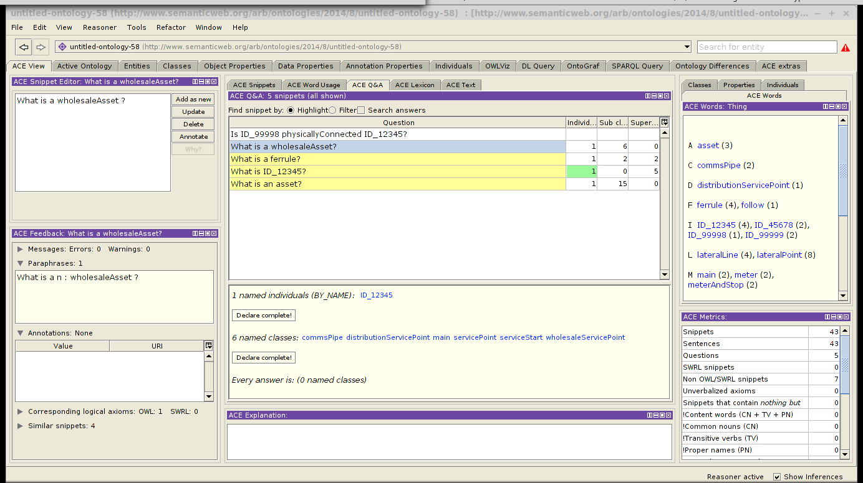
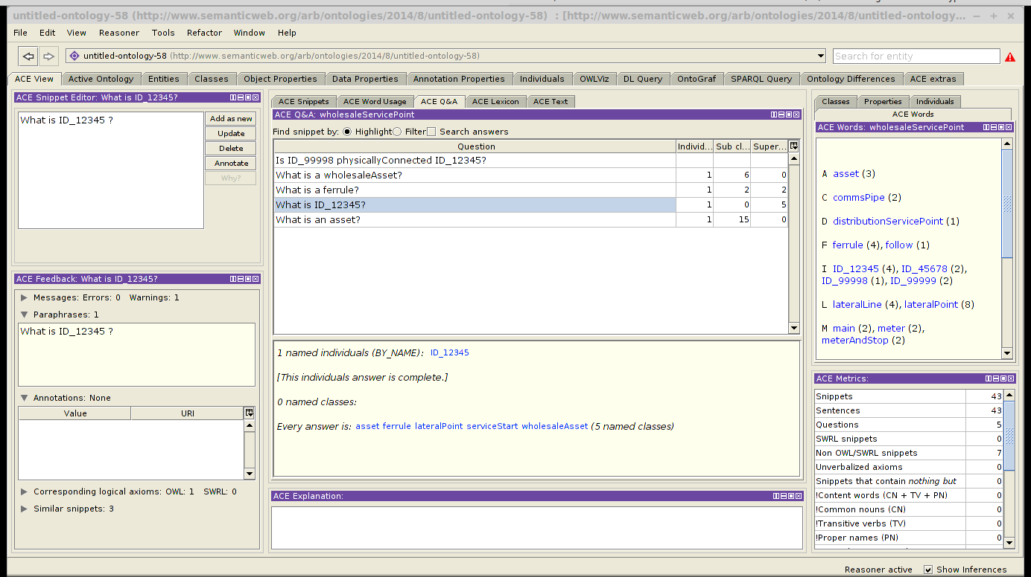

The CNL developed for Open Water based on the Systems Architecture and Data Model document
Open Water have produced a number of consultation documents. This architectural overview has been taken from @open_water_systems_2014 and @open_water_systems_2014-1.
This was partially modelled to create the following CNL.

Classes

Nature of the operators
Every wholesaleOperator is a marketParticipant .
Every retailOperator is a marketParticipant .
Every marketOperator is a marketParticipant .
marketOperator is at most one thing .
Every wholesaleOperator is a waSC or is a wOC or is a nAV .
Every retailOperator is a waSC or is a wOC or is a nAV .

IT requirements
Every registrationDatabase is a database .
Every registrationDatabase holdsInformation sites .
Every registrationDatabase holdsInformation parties .
Every registrationDatabase provides registrationServices .
Every registrationDatabase provides switchingServices .
Every switchingService is a service .
Every registrationService is a service .
Every financialDatabase is a database .
Every financialDatabase holdsInformation meterReadings .
Every financialDatabase provides financialServices .
Every financialDatabase provides settlementServices .
Every settlementService is a financialService .
Every settlementService requires a calculationSystem and a meterReading and a wholesaleOperator and a retailOperator .
Every financialService is a service .

PROPERTIES
Every servicePoint hasCustomerUPRN a UPRN.
Every servicePoint hasCustomerUPRN at most one thing .
Every servicePoint hasRetailer a retailOperator
Every servicePoint hasRetailer exactly one thing .
Every servicePoint hasWholesaler a wholesaleOperator.
Every servicePoint hasWholesaler exactly one thing .
Every meter hasServicePoint a servicePoint.
Every meter hasServicePoint at least one thing .
Every meter hasMeterType a meterType.
Every meter hasMeterType exactly one thing .
Every meter hasSerialNumber a serialNumber .
Every meter hasSerialNumber exactly one thing .
Every meter hasInstallDate a installDate .
Every meter hasInstallDate exactly one thing .
Every meter hasUseStatus a useStatus .
Every meter hasUseStatus exactly one thing .
Every meter hasMeterReading a meterReading .
Every meter hasMeterReading at least one thing .

NOT DEALT WITH
a conceptual model for registration data; a conceptual model for service request data; a conceptual data model for consumption and financial settlement data; and indicative event and data volumes.

Individuals
UU is a waSC .
UU is a wholesaleOperator .
UU is a wholesaleOperator .
UU is not a marketOperator .

Entailment
Figure is a visualization of the Systems Architecture and Data Modelconcepts described in CNL and turned into an OWL ontology.
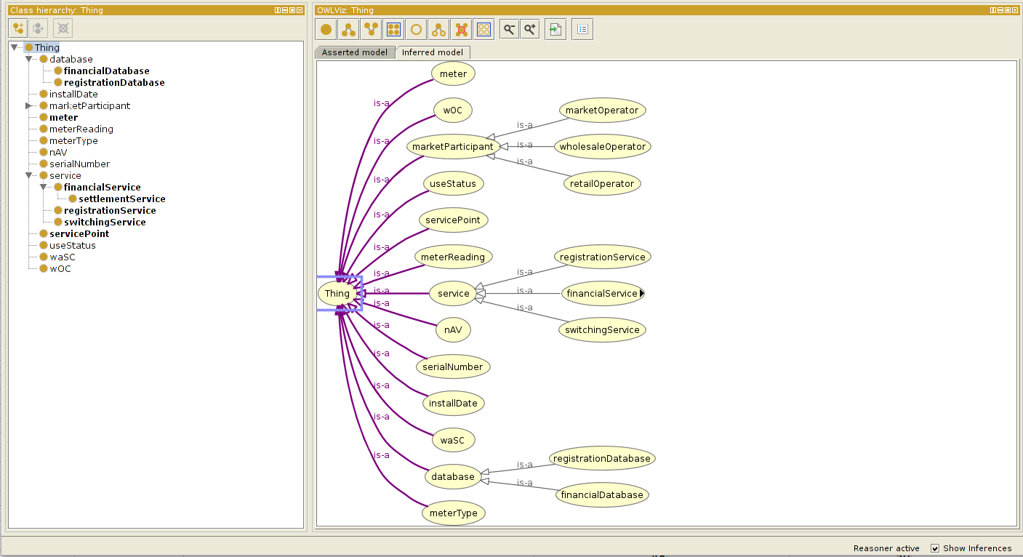

Summary and discussion
- Rapidly understand systems
- Rapidly visualize relationships and frameworks
- Be able to undertake quality improvement from Top down (conceptual) and bottom up (how the data has been physically modelled)
- Transfer knowledge and re-use within new environments
- Communicate knowledge more effectively within teams and to clients
- Store knowledge so it can be re-used in downstream projects and products
- Sell services based upon the knowledge model

Appendices

Writing OWL ontologies in ACE
The following text is structured to separately discuss the three main building blocks of ontologies as used in OWL: individuals, classes and properties.

Individuals
One can talk about individuals, classify them and describe relations between them. For example,
- There is a man. The man is John.
- His age is 31 and he likes Mary.
- Mary loves herself.
- Bill sees something.
- John is not Bill.
The following graph visualizes the model described by the story, with individuals (denoted by ellipses), their belonging to classes (boxes with labels), properties (solid arrows with labels), equality (dashed line) and difference (red line). Data-values are in a box with dotted border. In case the name of an individual is know then it is written into the ellips.
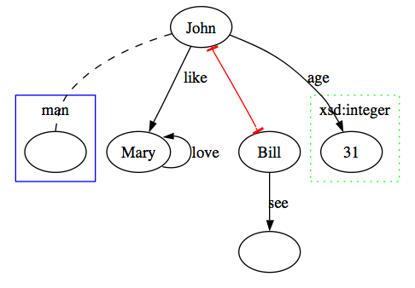
The following should be noted about the above statements:
- Individuals are proper nouns that all start with a capital letter
  - I should discuss conventions (i.e Multiple Lettered Things and camelCase)
  - I should also say that common nouns can represent the base level of class membership
OWL does not make a unique name assumption, i.e. an individual can have different names and one has to explicitly state the equivalence or difference of two differently named individuals. Therefore, whether Mary is John or is Bill or is different from both of them, is still open, we only know that John is not Bill. The fact that John belongs to the class man is not explicit in the picture, but can be derived by simple reasoning. Note also that John, Mary, Bill and the thing that Bill sees, all belong to the topmost class owl:Thing.
One can also classify the individuals by complex class descriptions, e.g.
- John is not a woman. (i.e. John belongs to the complement of the class woman)
- John is a programmer or is a manager. (i.e. John belongs to the union of classes programmer and manager)

Classes
One can describe classes by specifying relations to other classes. Such relations can be a simple inheritance from a named class ("Every man is a human.") or more complex property restrictions ("Every driver owns a car."). Remember that the concepts are common nouns in lower case. In OWL, the classes do not need names, they can be abstract descriptions, e.g. "(Every) man who owns a dog ...". Such descriptions can be made arbitrarily complex by negation (no, is not, does not), disjunction (or, or that) and conjunction (and, that, and that).
Both the every-sentences ("Every man who has a driving-license drives a car.") and the if-then sentences ("If a man has a driving-license then he drives a car.") can be used. The if-then sentences are more flexible in the way the verbs can refer to existing nouns. However, it is a good idea to only use every-sentences
- Every man is a human. (man human)
- If there is a man then the man is a human. (man human)
- Every professor is a scientist and is a teacher. (professor scientist teacher)
- Everybody who is not a child is an adult. (owl:Thing child adult)
Equality of classes has to be explicitly defined, there is no shorthand construction like OWL's EquivalentClasses.
- Every carnivore is a meat-eater and every meat-eater is a carnivore.
Disjointness of classes can be expressed via ACE's negation which maps to OWL's ComplementOf.
- Every man is not a woman. (man woman)
- No man is a woman. (man woman)
- Nothing is a man and is a woman. (owl:Thing (man woman))
Classes can also be described in terms of a property and its cardinality. (Note that the plural of `thing' will be mapped to owl:Thing.)
- Every pipe connects at least 2 fittings. (pipe >= 2 connect fittings)
Reflexive pronouns (`itself', `himself', `herself') can be used to describe (ir)reflexivity.
- Every narcissist likes himself.
- No river flows-into itself.
- No pipe connects itself.
Classes can also be described in terms of a property and its value that is either an individual or data-value.
- Every man knows John. (man know {John})
- There is a woman who everybody likes. (w woman; owl:Thing like {w})
- John likes every dog. (dog inv(like) {John})
- Every dog is liked by John. # the same using passive
- Everybody whose age is 32 is a grown-up.
- If there is a man who lives-in Paris then the man's address is "Paris".
- For all water it is false that the temperature of the water is -1.
where the construction is expressed by `whose', `man's', `of the water', the property is expressed by `age', `address', `temperature', and the data-value is `32', `"Paris"' and `-1'.

Properties
OWL properties correspond to ACE's verbs and transitive adjectives (e.g. `taller than').
A superproperty for a given property can be defined as:
- Everybody who loves somebody likes him/her.
or in a more verbose manner:
- If there is somebody X and X loves somebody Y then X likes Y.
Disjointness of properties can be declared by using negation.
- Nobody who likes somebody hates him/her.
or more verbosely:
- If somebody X likes somebody Y then it is false that X hates Y.
Property chaining is a complex mathematical concept that does not have a simple verbalization in natural language. E.g. the transitivity of a property is formulated in ACE in the following ways (different levels of syntactic compactness are provided):
- If something X is taller than something Y and Y is taller than something Z then X is taller than Z.
- If something X is taller than something that is taller than something Y then X is taller than Y.
To declare an inverse property of a property, two sentences are needed.
- If something X is taller than something Y then Y is shorter than X.
- If something X is shorter than something Y then Y is taller than X.
The rest of the syntax that OWL provides for describing properties is just syntactic sugar, one can use the already described class relations, cardinality constraints and inverse properties instead.
Properties can have a domain and a range. The domain of a property can be expressed e.g. by
- Everybody who writes something is a human.
The range of a property can be expressed by:
- Everything that somebody writes is a book or is a paper.
- Everything that is written by somebody is a book or is a paper. # the same using passive
Properties can be functional and inverse functional. Functionality means that for a given subject, the object of the property (verb) is always the same. Inverse functionality means that for a given object the subject must always be the same. For functionality, one has to restrict the class owl:Thing to have at most one value for a given property (it is OK to have no values at all).
- Everybody orders at most one thing. (owl:Thing <= 1 order owl:Thing)
Inverse functional properties are expressed by switching the subject and the object of the verb.
- Everything is something that at most one thing orders. (owl:Thing <= 1 inv(order) owl:Thing)
- Everything is ordered by at most one thing. # using passive
Symmetric property is its own inverse. The various ACE syntaxes to express this are:
- If somebody X loves somebody Y then Y loves X.
- Everybody who is loved by somebody loves him/her.
- Everybody who somebody loves loves him/her.
Equivalent properties are expressed by declaring the two properties to be superproperties of each other.
- Everybody who hates somebody despises him/her.
- Everybody who despises somebody hates him/her.

Reasoning
User acceptance of the reasoning results obtained on the OWL level and perceived on the ACE level provides the basis for proving that the mapping from ACE to OWL is useful. Given the ACE text
- John is a man.
- No man is a woman.
- John is a woman.
the reasoner will find an inconsistency because John has been asserted as a man and men have been described as disjoint from women.
Here is another example.
- Every child is a man or is a woman.
- No child is a man.
- No child is a woman.
This text may seem strange, but it is not inconsistent, as far as OWL is concerned. All we have done, is constructed an empty class child, which is perfectly legal (one can say, though, that the class child is unsatisfiable). Only when we claim that there are elements (individuals) in this class, for instance by stating
- John sees a child.
do we end up being inconsistent.
Reasoning about property restrictions finds inconsistency in:
- Every man sees a dog.
- Nothing is a dog.
- John is a man.
Reasoning about properties of properties. The following text is consistent.
- No dog likes a cat.
- Fido is a dog.
- It loves a cat.
But it becomes inconsistent if we add information about the relation between `like' and `love':
- Everything that loves something likes it.
We can also reason about the domain and range of properties.
- Everything that somebody writes is a book.
- Everybody that writes something is a human.
- John who is a man writes a paper.
- Every man is a human.
Inconsistency is caused when we now claim that:
- No paper is a book.
Reasoning about cardinality, e.g. functional properties. Imagine a library policy saying that everybody can order only one item from the library, and that John places two orders.
- Everybody orders at most one thing.
- John orders a book X and orders a book Y.
This text is consistent, namely because the reasoner sees nothing strange about taking X and Y to denote the same item (individual). Only when we state that:
- X is not Y.
would it become inconsistent.
Reasoning about inverse functional properties is similar.
- Everything is ordered by at most one thing.
- Mary orders a book X.
- Bill orders the book X.
- Mary is not Bill.
Reasoning about transitivity and HasValue will find the following text inconsistent.
- If something X follows something that follows something Y then X follows Y.
- John follows Mary who follows Bill who follows John.
- No manager follows Mary.
- Bill is a manager.
Reasoning about inverse properties. In ACE, in many cases, one does not have to explicitly assert a named inverse property of a given property. One can simply use a passive verb to create an (unnamed) inverse property. An inconsistent text, containing an inverse property, can be constructed like this:
- John likes Mary.
- Nobody is liked by John.
This statement would be redundant:
- If somebody X likes somebody Y then Y is liked by X.
Reasoning about nominals (i.e. OWL's OneOf construct). The following text is inconsistent.
- Every student is somebody who is John or who is Mary.
- Bill is a student who is not John and who is not Mary.

Bibliography

Speak to Alan about this
I don't know of a RuleSpeak Natural Language Processing (NLP) parser
this cost is not always calculated financially: improving business value may be mandated by changes in policy terms with metrics that are not calculated financially but where failure to achieve such metrics does incur a financial penalty
Not completely happy with this
each with different but complementary views over the same domain
This is precisely the case for the clean and waste water sector of the utility market where the Open Water initiative represents a significant business opportunity for 1Spatial
Alan: would appreciate your perspective on this
Speak to Stephen Stanley about this
this is an important point: the benefits described here are not primarily about the moelling and inferencing capabilities of an ontology but in providing a team with clear and unambiguous representations
for example - whilst the statement holds for most things it doesn't work when X or Y
this is a bold statement - ensure this is run past Stephen Stanley first (and at an early stage)
This is where I got up to. It's not finished and I haven't articulated everything
the common noun 'publicHouse' is the class whilst the proper noun'CoachAndHorses' is an individual

