


645 bis allée du bois fleuri 78830 Bullion, France
+33 6 75 05 35 32

Antoine CHEDEBOIS

Lead Developer / Senior Full Stack Web Dev
Pre-sale skill


married, born the 26/12/76

antoinechedebois@gmail.com

ABOUT ME
I'm a Web Developer passionate about new technologies since 2001. I can occupy functions ranging from Lead Dev JS/PHP, senior Full Stack Web dev and Scrum Master. With more than 18 years of experience, I am able to conduct complex Front / Back projects and also hybrid mobile applications or PWA in Agile/SCRUM.

PROFESSIONAL EXPERIENCE
Amazon – Bretigny-sur-orge
2020 - … Senior Developer
Missions: Technical leader of a 5 engineer’s team specialized in Web Dev. Development of heavy traffic web apps deployed Worldwide using the AWS Services.
Technology Stack:
- Angular, React, Flask, Python, Bootstrap 5, LESS, PostgreSQL, TypeScript, Photoshop
- Git, AWS CloudWatch, Lambda, API Gateway, Athena, QuickSight, SES...

Ministry of the Armed Forces – Paris
2017 - 2020 Lead Developer
Missions: Technical leader of a 5 engineer’s team specialized in Web Dev. Development of complex Web applications: Translation of the customer needs in wireframes, HTML design and integration, Front development using Angular and Back development (RestFul API) with Symfony.
Technology Stack:
- Angular, Symfony, Bootstrap, LESS, MySQL, Redis, TypeScript, PHP Object Oriented, Gimp
- Git, GitLab, Artifactory, Jira, Confluence, PHP Storm, Web Storm, Debian, Docker, Nginx...

Essonne County Council – Evry Territorial collectivity – IT Department
2016- 2017 Senior Web Developer / Lead dev
Missions: Development of Web applications for agents and users of the Council. Lead dev of a small team of 3 people.
Technology Stack: Node.js, jQuery, ElasticSearch, CakePHP, PostGreSQL, Bootstrap, SASS, RestFul API, Oracle, CentOS, Photoshop, Git...

BelAir Informatique – Les Ulis
Software publisher for insurance brokers

2012-2016 Senior Web Developer
Missions: Web development, technical writing, small project leading
Technology Stack: HTML5 / CSS3 / jQuery / Ajax / PHP5 Object Oriented / MVC design pattern / MySQL 5 / Apache / Bootstrap / SASS / Ubuntu / Photoshop...
Achievements:
- Website company: www.belair-info.fr
- Extranet company: AJAX navigation with Rest API
- Customer’s Extranets (collect needs, integration and development: Photoshop / Bootstrap / PHP OO / SASS…)
- Customer’s Web app connected to main software solution (jQuery mobile/Rest API)

COTEP – Paris
Company specializing in digital signage

2009-2012 Web Developer / Project Manager
Missions: Studies / design and development of a Web application allowing the real-time supervision of 1500 LCD displays via GPRS/3G (PHP5/MS SQL/AJAX/JavaScript/C#) dispatch in hundreds of French train station.

2001 -2009 Web Developer / Webmaster
Missions:
- Evolution and maintenance of Internet/Intranet/Extranet websites of the company (HTML4/5/CSS2/PHP5/MySQL/JavaScript/AJAX)
- Analysis, design and monitoring of the development of an airport resource management software (UML/C#/SQL Server), a WEB dynamic signage server and the Intranet company (Apache/PHP/MySQL)

Pre-sale engineer
Missions: Response to national and international tenders. Analysis, study and design of technical and economic responses


EDUCATION & TRAINING

2019 AWS Certified Developer & AWS Cloud Practitioner certifications
Amazon Web services




2018 Symfony 3/4 (hack and extend the Symfony Framework)
5 days- Sensiolabs - Paris

2018 Advanced PHP (PHP object, pattern MVC, Doctrine, Symfony)
4 days - M2I - Paris

2017 ETL Talend Open Studio
5 days – getting started and various practical works - Evry

2015 Develop websites with Symfony – final note: 94/100
5 weeks training via the MOOC OpenClassrooms - sensiolabs

2001 DEA Virtual Reality and Mastery of Complex Systems (Master degree)
National Institute of nuclear science and technology – INSTN - CEA Saclay

2000 DESS Engineering of industrial systems (Master degree)
Professional University Institute – IUP - Evry

IT SKILLS
Languages: HTML5 / CSS3 / JavaScript / TypeScript / PHP / Python / Yaml / Twig

JS Frameworks / Lib: Angular / Node.js / React / jQuery / jQuery Mobile / jQuery UI

CSS Frameworks: Bootstrap / Material / OnSen UI / Ionic (Cordova)

PHP frameworks: Symfony / CakePHP

Python frameworks: Django / Flask

DB: MySQL / PostgreSQL / REDIS / Elasticsearch / SQL Server / Oracle / Sybase

Technologies: Ajax / SASS & LESS / ORM Doctrine / MVC pattern

OS: Linux Debian, Ubuntu, CentOS - Microsoft Windows 10 to XP/Server

Web Services: API REST / RESTful / SOAP / XML / JSON

IDE: Php Storm, Web Storm, IntelliJ, Sublime Text

Software: Photoshop / Gimp / Grunt / MySQL Workbench / Apache JMeter...
Docker / Git / Gitlab / SVN / Jira / Confluence...

CMS: WordPress / PrestaShop / Joomla / SPIP

Reporting / marketing: Google Analytics / AdSense / AdWords

Analysis and design methodologies: UML / merise / SART / BPMN

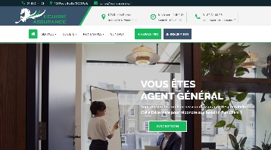
FEW PERSONAL ACHIEVEMENTS
2020 – Ecurie Assurance: Web site and Extranet Customers for insurance Brokers. Stack: Symfony PHP / Boostrap

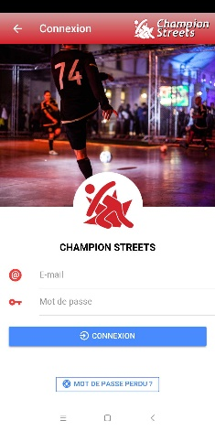

2019 – Champion streets: Mobile app for connecting sportsmen and women practicing urban football. Stack: Cordova – Ionic – Angular – Rest API with Symfony – Available on the Play Store and Apple Store



2017 – ShaLis: Android app available on the PlayStore. Stack: Ubuntu, Apache Cordova – OnSen UI – VanillaJS – API Rest PHP7

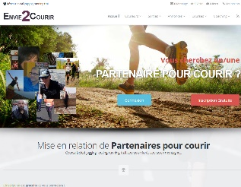
2015 – Envie2courir: Social network for runners – development from scratch with SEO optimization. More than 10 000 members.
http://www.envie2courir.fr/
Also declined in Envie2danser https://www.envie2danser.fr/



2014 – Configurator watches: Iframe allowing the configuration of a custom watch for several websites and its back office for managing the elements: photos/price/stock/payment system...
http://www.atelierpremium.fr/visu.php

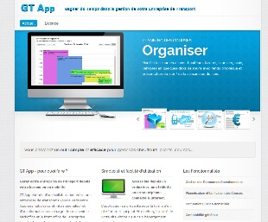
2013 – Priority Courses: Front & backoffice of an express transport company. 4000 races per year – graphic planning of steeds – automatic customer’s billing – accounting - statistics... Made from scratch.
http://www.prioritycourses.com/

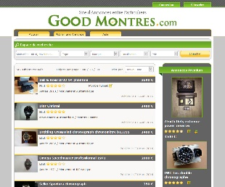

2012 – Good Montres: Classifieds site specializing in luxury watches.
http://www.goodmontres.com/

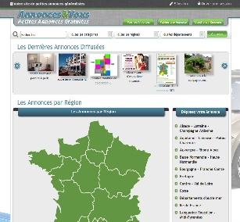

2010 – Annoncez vous: generic Classifieds Script easily adaptable to customer needs. Sold to many customers. Made from scratch.
http://annoncez-vous.com/

COMMERCIAL PROFESSIONAL ACHIEVEMENTS

« I learned to listen and understand customer needs, formalize them and turn them into finished products »

2009 SNCF Technical and commercial writer of the winning offer (7M€) concerning the supply of approximately 1500 LCD displays for passenger information in the French railway stations. Park of screens remotely supervised via GSM by a supervision web server - Project Manager on the realization of the server. Monitoring of the approval and the recipe of the complete system.

2007 SNCF Technical and commercial writer of the winning offer concerning the supply of about 5000 LCD displays for information passengers in railway stations (15 / 20M€ on several years) - monitoring of the approval of the screens (tests, recipe…)

2004-2012 More than 25 tenders won in the fields of Railway (500 interactive LCD displays in SNCF sales area...), Airport (Toulouse, Pointe-a-Pitre, Lille, Ajaccio, Figari...) and generic (Annecy court, Tourist Office of Pézenas...)

ADDITIONAL INFORMATION

Language English (read/write)

Sports Swimming, running, mountain biking. Occasional: squash & climbing

Hobbies Keeping in touch with news Web technologies. Always in training, actually Python / Flask.
Like to build structures (after a terrace, a parking for cars, a garden shelter in wood, my next project in a swimming pool)

Permits Car & Motorbike

