**HW4 ReadMe**

To build the code:

* Open the console
* Go to the project file
* Type make

This will compile and link file and execute the output.

I made a drive file inside main.cpp that tests all the functions that are wanted from us. When you run the code Drive File writes the console which function is used so it is easy to verify read the Homework for TA.

I created 5 HEX objects inside main.cpp and put them inside a vector data structure so we can switch any game we want. I don’t have a functionality for creating game while playing the game. But it is not asked from us. So I didn’t implemented it.

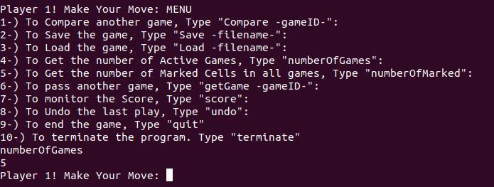

We can reach the Main Menu inside the game by Typing MENU.

After that we can choose a command in that Main Menu. For example:

If we want to Compare two games. Type “Compare 2”.

If we want to pass to another game. Type “getGame 3”.

If we want to undo the game. Type “undo”.

If you Type “quit” then it ends the game which is active right now. Then if there are any unfinished game pass to that game automatically.

If you Type “terminate” it ends all the games and finishes the program.

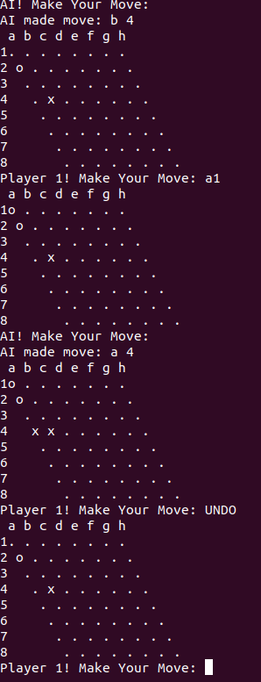

You can also use UNDO command directly on the console while you are in the game.