**HW5 ReadMe**

To build the code:

* Open the console
* Go to the project file
* Type make

This will compile and link file and execute the output.

I made a drive file inside main.cpp that tests all the functions that are wanted from us. When you run the code Drive File writes the console which function is used so it is easy to verify read the Homework for TA.

I created 5 AbstractHex pointer inside main.cpp and put them inside an AbstractHex pointer array with size 5 so we can pass the games to isValid() global function. I don’t have a functionality for creating game while playing the game. But it is not asked from us. So I didn’t implemented it. I also removed MENU for this Homework. Because I wanted to discard every feature that doesn’t asked for this Homework as soon as I can.

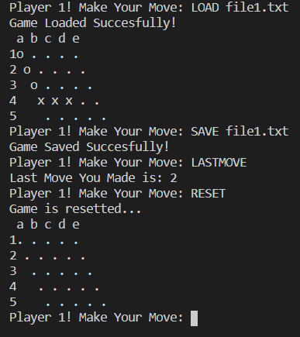

I created 4 terminal commands for this game as You can see in the screen shot. Which is defined like this:

* LOAD -filename- : Loads the game from a specific file.
* SAVE -filename- : Saves the specific game to a given file.
* LASTMOVE : Prints the last move you made.
* RESET : Resets the game and empties the board.

All of the functions that I implemented is tested inside Drive file. I created a makefile that explains what I did, What I tested and gives you the results accordingly.

**NAME = Kamil Kaya**

**NUMBER = 1801042082**