## **Team 2:** Bao Nguyen, Antoine Vo, Kyle Domen, Ivana Chen, Henri Wood, Sai Avadhanam

**Scrum Leader:** Antoine Vo

## **Topic:** Big Data and Analytics

## Feature Brainstorm

* Social media integration
* Specialization Filtering - (specific kinds of “big data” topics, particular languages, etc.)
* Learning Modules - Video, Quizzes, and Text contents
* Visual data Interactive modules - in-browser editor and dynamic elements
* Language Support - Localization
* Integrated payments to pay for course
* Gamification of the Course - Experience points and progress marker

## Feature 1: Social media integration

- What is it and how it relates to which core requirement(s)?

Achieve online learning objectives. Ability to connect the user’s account to their desired social media platforms to showcase their own learning and progress while encouraging collaboration among friends in the field.

- Why is it innovative and useful to users?

It will be innovative and useful to users because it will enable users to connect with like-minded learners and create a sense of community within their learning journey. Peers could offer potential solutions and discuss various topics within big data.

- Provide a reference site URL and snapshot

URL: https://www.udemy.com/

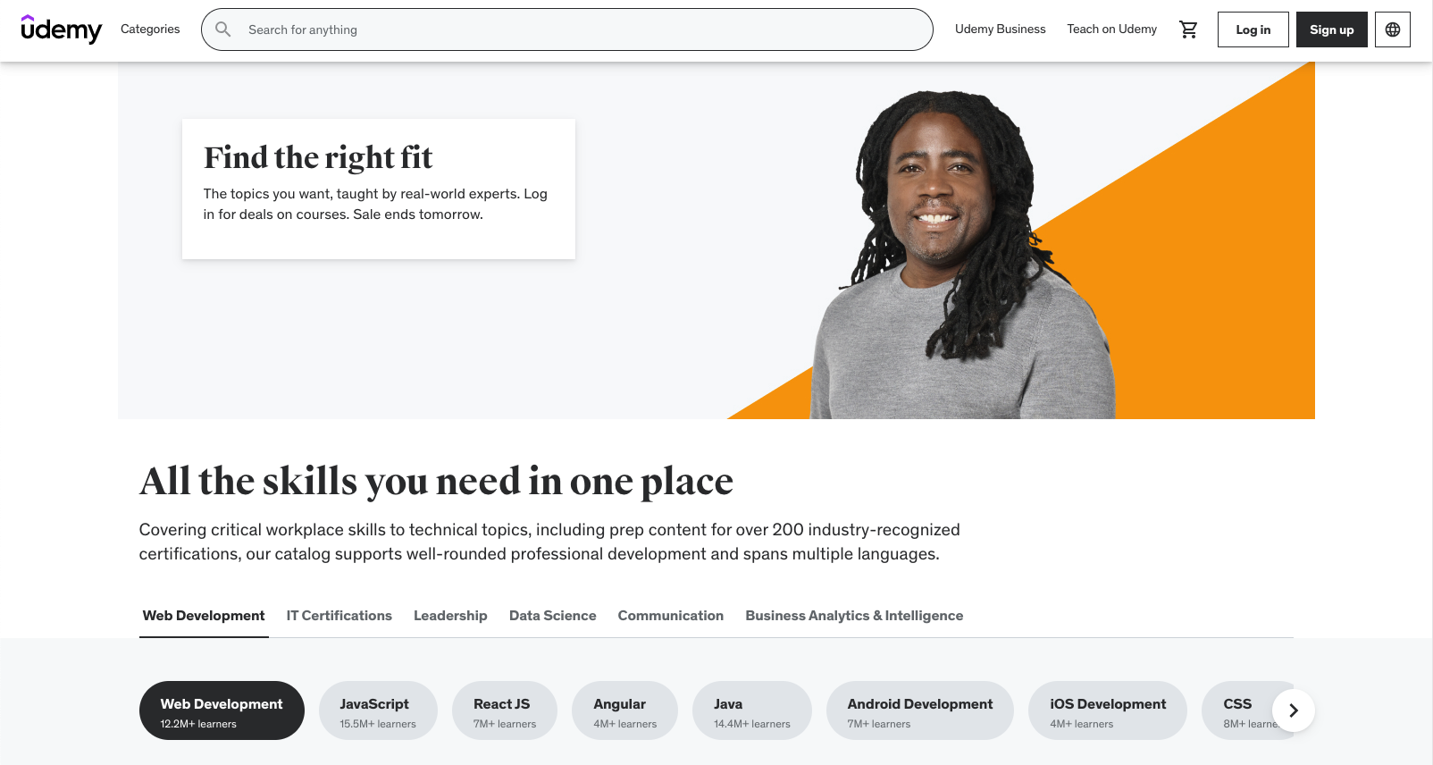

-Do you see any conflict or overlap with other features?

(Suggest how it can be dealt with)

No.

## Feature 2: Specialization Filtering

- What is it and how it relates to which core requirement(s)?

Users can utilize specialization filtering to focus the course catalog on their most relevant interests. Giving users a user-centered and individualized learning experience is strongly related to core requirements.

- Why is it innovative and useful to users?

Because users may easily identify courses that suit their specific learning objectives without having to go through a large course library.

- Provide a reference site URL and snapshot

URL: <https://www.linkedin.com/jobs/search/>

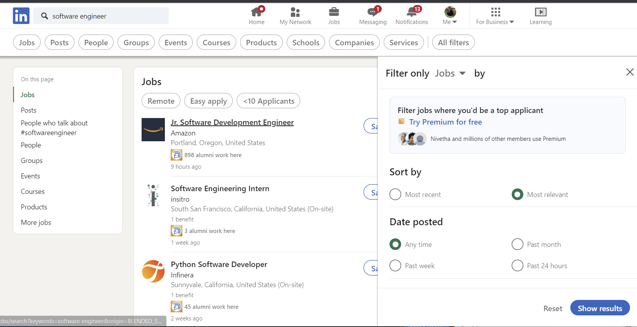

-Do you see any conflict or overlap with other features?

(Suggest how it can be dealt with)

No.

## Feature 3: Learning modules

- What is it and how it relates to which

core requirement(s)?

Learning modules provide the core contents of the site and a structured way to view course contents, similar to modules in Canvas. The core modules will be:

* Intro to Big data and Analytics
* Data Collection and Processing
* Data and Technology Stack
* Data Visualization and Reporting
* Advanced Topics in Big Data and Analytics

- Why is it innovative and useful to users?

It will be innovative and useful to users because it will give an informational summary as well as the general feel to the website. For example, it w

- Provide a reference site URL and snapshot

URL: <https://www.udemy.com>

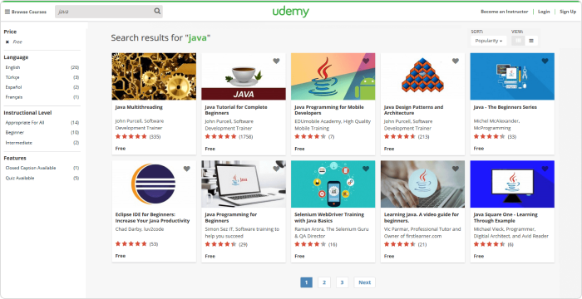

-Do you see any conflict or overlap with other features?

(Suggest how it can be dealt with)

No.

## Feature 4: Visual data Interactive modules

- What is it and how it relates to which

core requirement(s)?

Dynamic course contents such as inline code editors, interactive data visualizations, multimedia contents such as videos to provide a more interactive learning experience.

Why is it innovative and useful to users?

Due to the nature of the course content, interactive visuals and multimedia learning content will provide a more interactive learning experience to users in a way that traditional textbooks or lectures do not.

- Provide a reference site URL and snapshot

Url: <https://www.datacamp.com/>

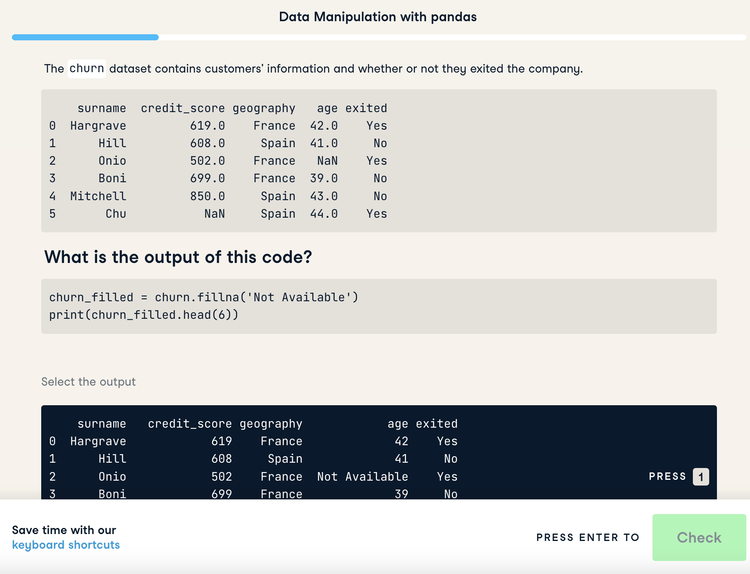

- Do you see any conflict or overlap with other features?

No

## Feature 5: Integrated payment system

- What is it and how it relates to which

core requirement(s)?

Integrated payment system is a seamless way to provide secure transactions.

- Why is it innovative and useful to users?

It is innovative and useful to users because it allows a convenient and flexible experience for users. Users would save time and not have to worry about switching between different systems.

- Provide a reference site URL and snapshot

<https://www.udemy.com/cart/>

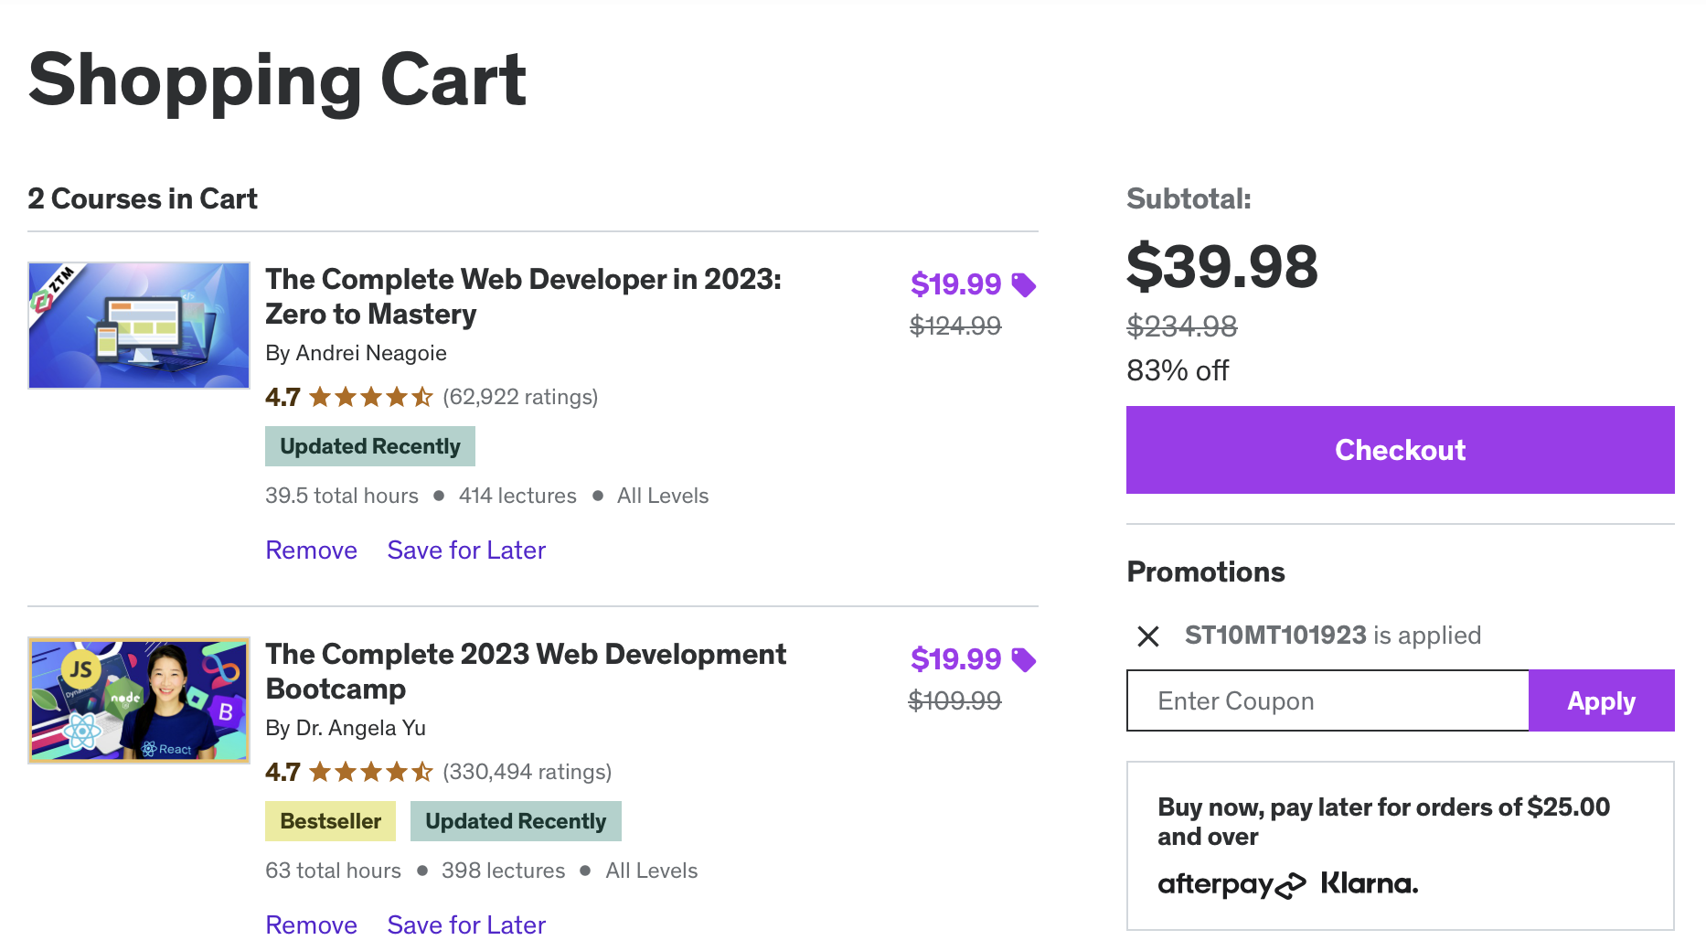

- Do you see any conflict or overlap with other features?

No.

## Feature 6: Gamification and Progress Rewards

- What is it and how does it relates to which core requirement(s)?

Gamify progress as users progress through the course contents by providing progress rewards, progress bar, experience points, and rewards.

- Why is it innovative and useful to users?

This encourages users to use progress and learn content through positive-reinforcement and makes learning more fun.

- Provide a reference site URL and snapshot

Url: <https://www.datacamp.com/courses/understanding-data-science>

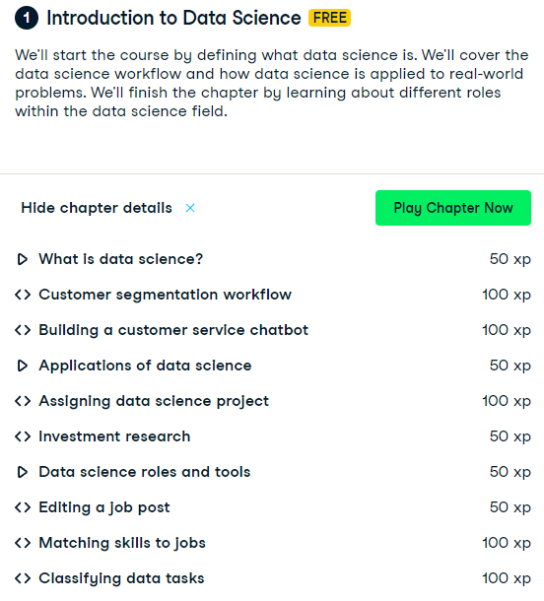

-Do you see any conflict or overlap with other features?  
No

## Assignments

The assignments below will cover who is working on the use cases, use case diagrams, and site map flow for each individual feature. Features will be assigned to member and they will be responsible for completion of that feature.

Feature 1 - Learning modules - Antoine Vo

Feature 2 - Specialization Filtering - Bao Nguyen

Feature 3 - Visual data interactive - Kyle Domen

Feature 4 - Gamification and Progress Rewards - Antoine Vo

Feature 5 - Social media integration - Kyle Domen

Feature 6 - Integrated Payments - Ivana Chen

Gamification is a powerful tool to enhance user engagement and motivation. By implementing a merit point rating system, badges, leaderboards, and rewards, bigdata.io creates a dynamic and interactive learning environment. Users can track their progress, compete with others, and earn recognition for their achievements. This not only makes learning more enjoyable but also promotes a sense of accomplishment, which is crucial for user retention and long-term learning success.

Furthermore, offering rewards and discounts for active and engaged users can provide a tangible benefit for their commitment to learning. This innovative approach adds a layer of excitement and competition to the learning process, making it more appealing and enjoyable for a wide range of users.