DEVOPS PROJECT PORTFOLIO
Project evidence and implementation overview

Purpose
This portfolio is prepared to present DevOps and cloud implementation projects to prospective clients. Each case study summarizes the objective, technologies, implementation approach, and available screenshot evidence so a client can understand the work demonstrated. Project outcomes are stated only to the extent supported by the supplied evidence.
Presentation note: label projects from employment environments as real-time project experience only when they genuinely are workplace projects and sharing is permitted. Label training assignments and capstones as hands-on/capstone projects; do not represent them as paid client engagements.

Terraform Infrastructure Provisioning
Purpose: Present infrastructure-as-code work using Terraform to define and provision cloud resources.
Technologies: Terraform, AWS (resource names to be confirmed against each screenshot)

Implementation overview
The screenshots in this section are taken only from the Terraform case-study document. They include Terraform configuration and execution evidence, along with AWS console views of the provisioned resources. The terminal output shows an apply summary of 7 added, 0 changed, and 0 destroyed.

Outcome / validation
The visible apply summary supports the claim that Terraform reported 7 resources added in that run. This should be described as a lab/capstone result unless the user confirms it came from a permitted real-world project.

Screenshots from this project document
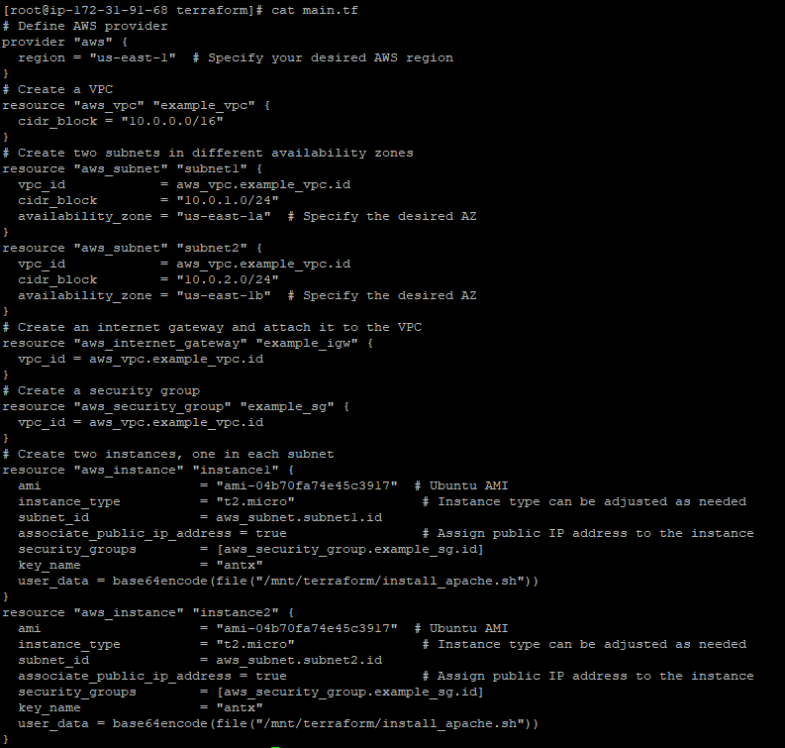
Figure 1 — Screenshot extracted from the source document for Terraform Infrastructure Provisioning.
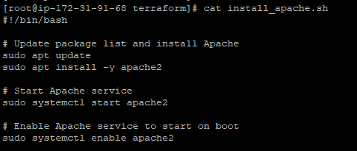
Figure 2 — Screenshot extracted from the source document for Terraform Infrastructure Provisioning.
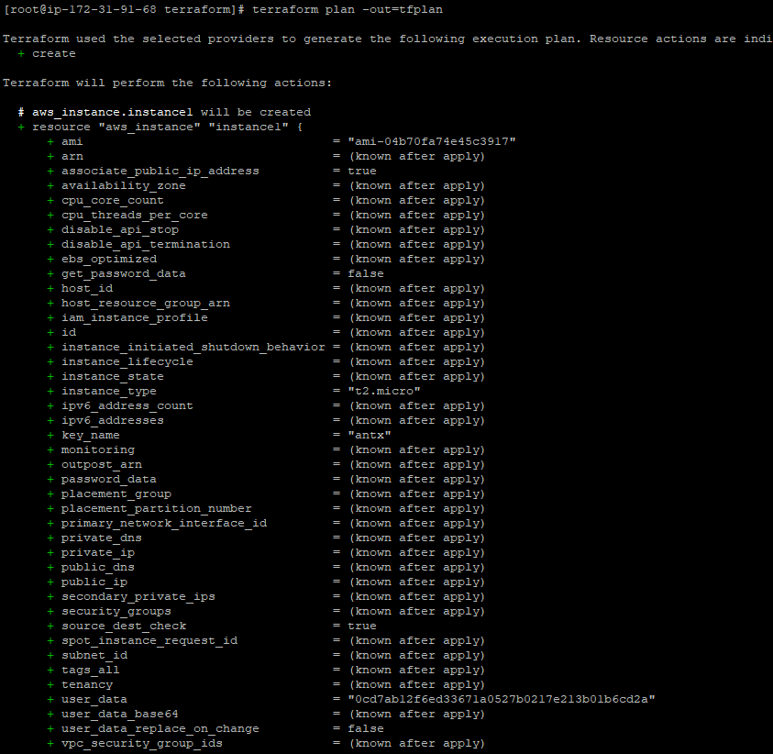
Figure 3 — Screenshot extracted from the source document for Terraform Infrastructure Provisioning.
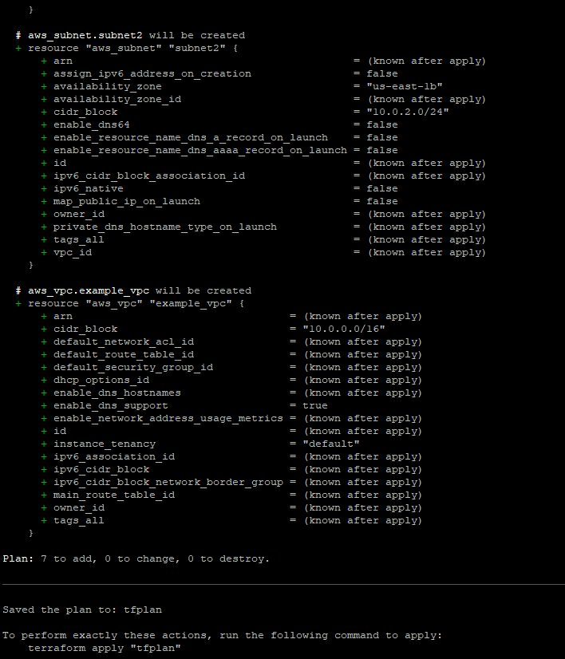
Figure 4 — Screenshot extracted from the source document for Terraform Infrastructure Provisioning.
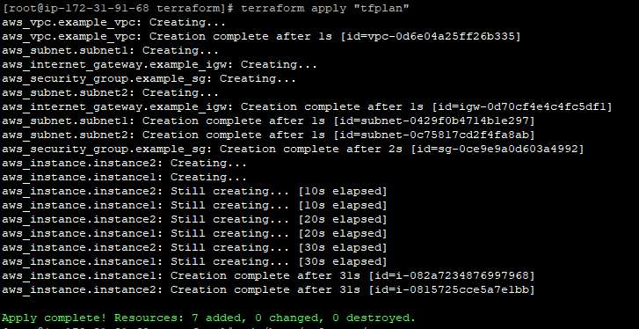
Figure 5 — Screenshot extracted from the source document for Terraform Infrastructure Provisioning.
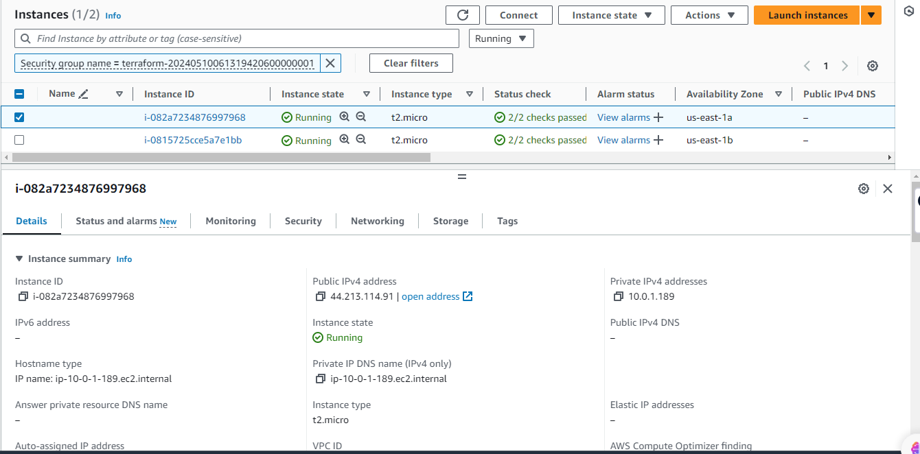
Figure 6 — Screenshot extracted from the source document for Terraform Infrastructure Provisioning.
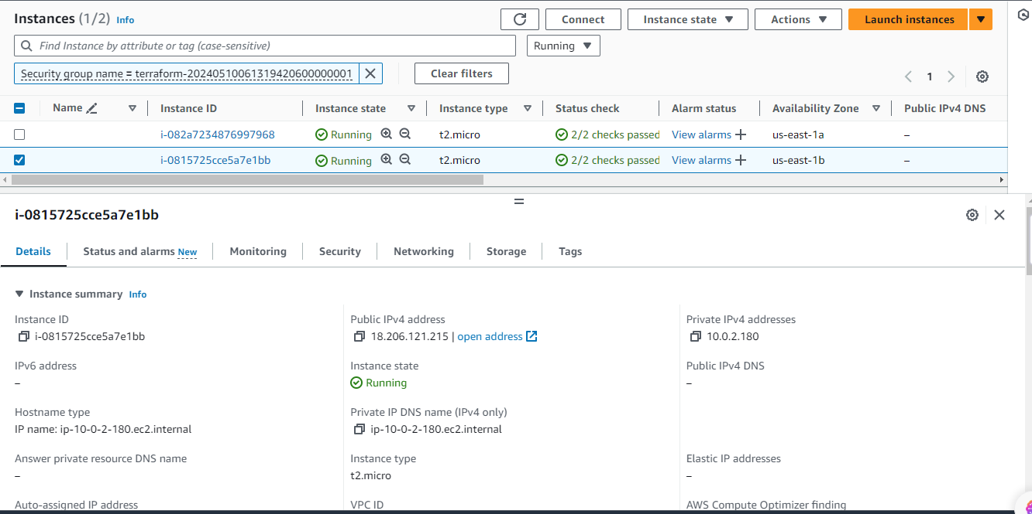
Figure 7 — Screenshot extracted from the source document for Terraform Infrastructure Provisioning.
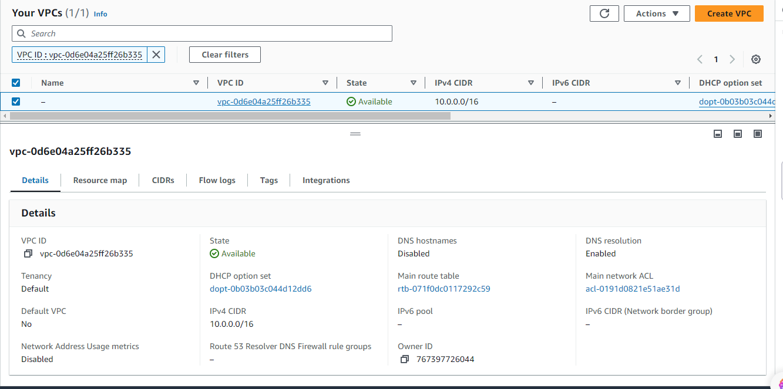
Figure 8 — Screenshot extracted from the source document for Terraform Infrastructure Provisioning.
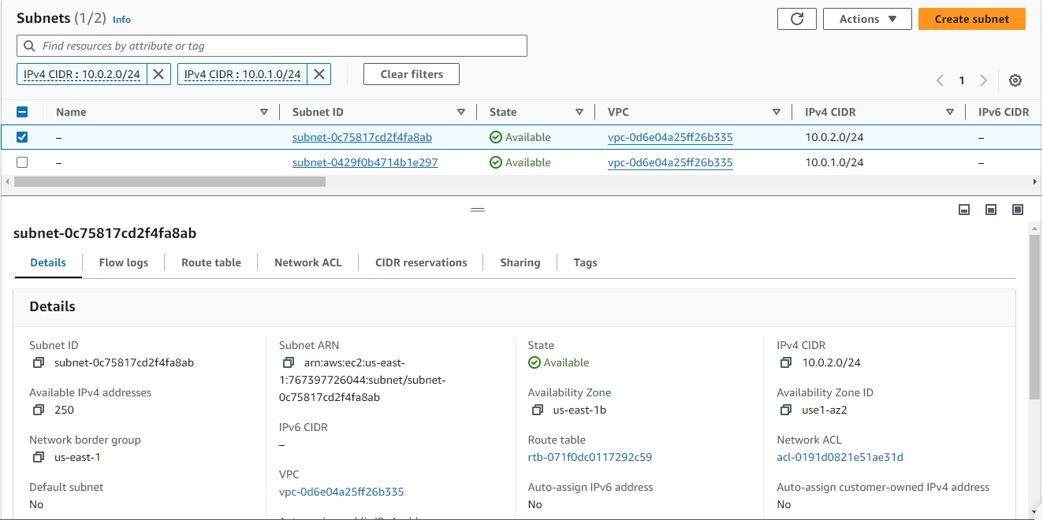
Figure 9 — Screenshot extracted from the source document for Terraform Infrastructure Provisioning.
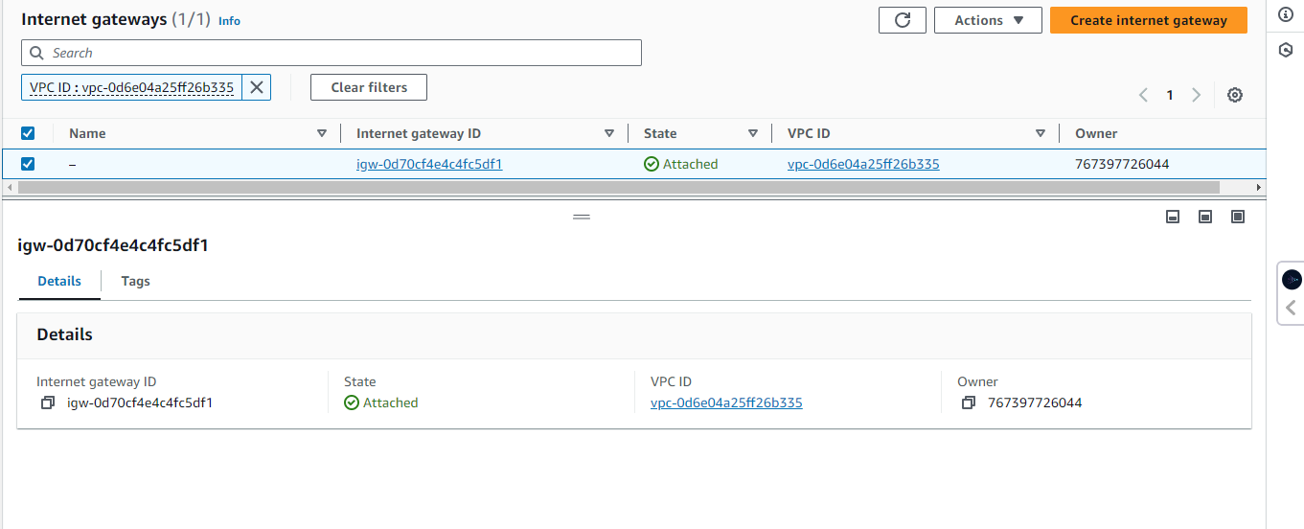
Figure 10 — Screenshot extracted from the source document for Terraform Infrastructure Provisioning.
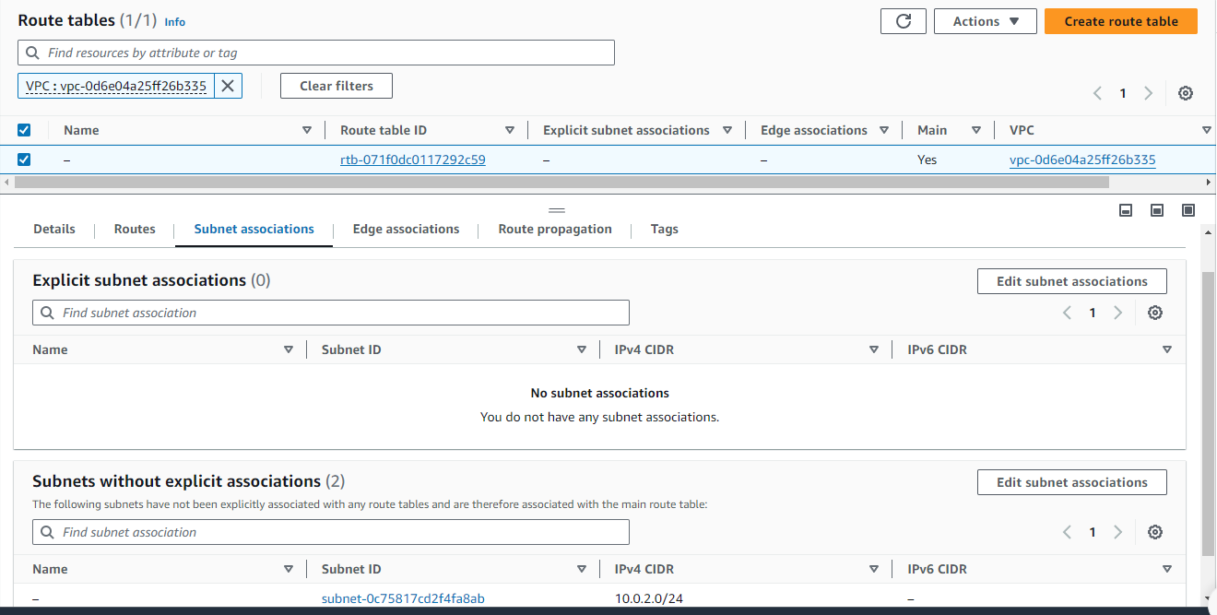
Figure 11 — Screenshot extracted from the source document for Terraform Infrastructure Provisioning.

Kubernetes Application Deployment
Purpose: Present hands-on Kubernetes configuration and application deployment evidence.
Technologies: Kubernetes, YAML, Deployment, Service (mention additional resources only when visibly shown)

Implementation overview
This section uses images extracted only from the Kubernetes case-study document. The screenshots should be read as configuration and runtime evidence; only resources and statuses visibly shown should be mentioned in the final public version.

Outcome / validation
Confirm the exact deployment and pod status from the included screenshots before claiming successful application availability.

Screenshots from this project document
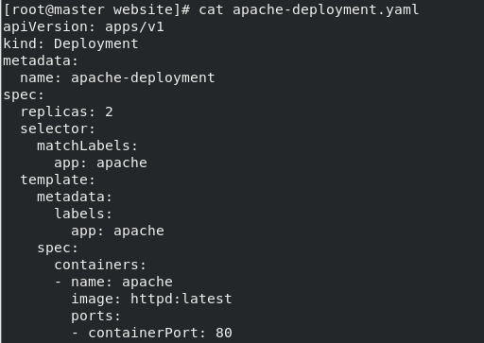
Figure 1 — Screenshot extracted from the source document for Kubernetes Application Deployment.
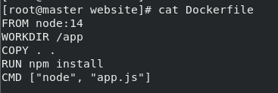
Figure 2 — Screenshot extracted from the source document for Kubernetes Application Deployment.
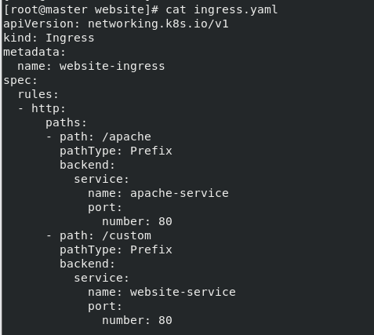
Figure 3 — Screenshot extracted from the source document for Kubernetes Application Deployment.
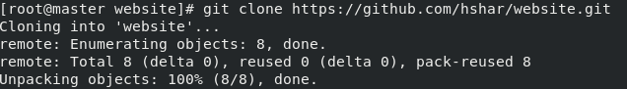
Figure 4 — Screenshot extracted from the source document for Kubernetes Application Deployment.
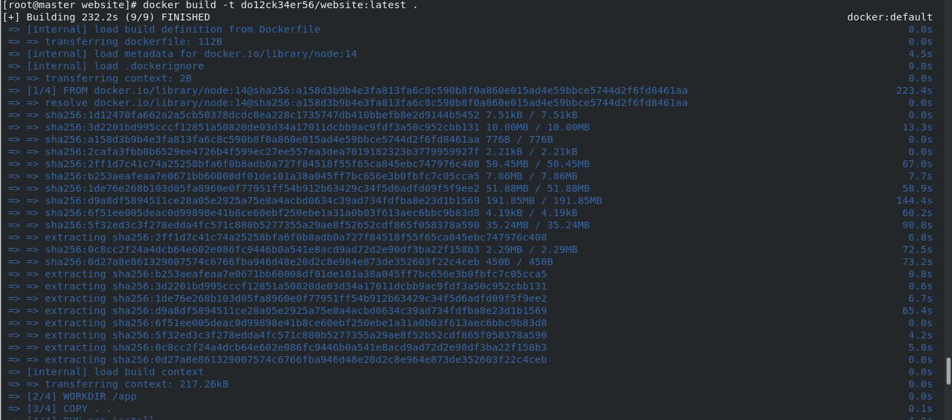
Figure 5 — Screenshot extracted from the source document for Kubernetes Application Deployment.

Jenkins Pipeline
Purpose: Present Jenkins pipeline configuration and build workflow evidence.
Technologies: Jenkins, pipeline configuration, Git (Docker only if shown)

Implementation overview
Images in this section come from the Jenkins case-study document, not from Terraform or Kubernetes documents.

Outcome / validation
A successful end-to-end pipeline should only be claimed if the relevant build/stage output is clearly visible.

Screenshots from this project document
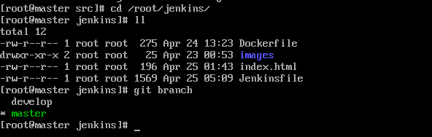
Figure 1 — Screenshot extracted from the source document for Jenkins Pipeline.
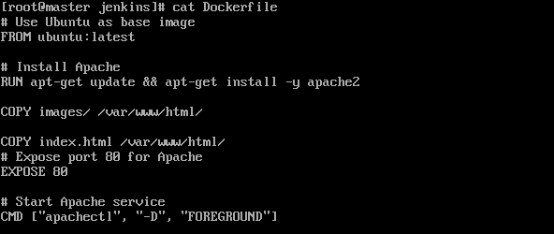
Figure 2 — Screenshot extracted from the source document for Jenkins Pipeline.
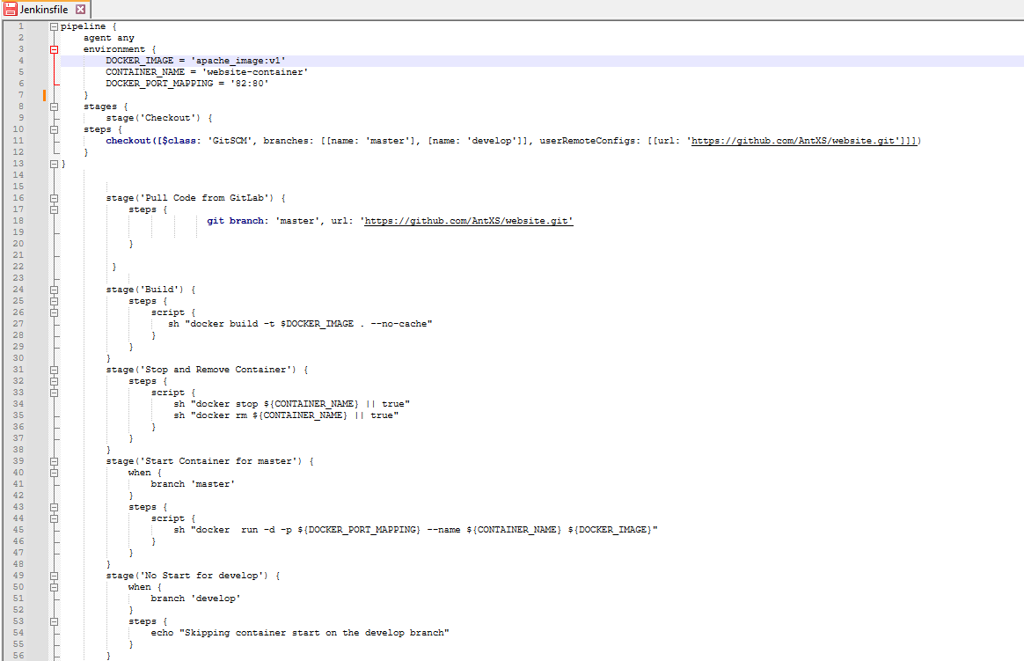
Figure 3 — Screenshot extracted from the source document for Jenkins Pipeline.
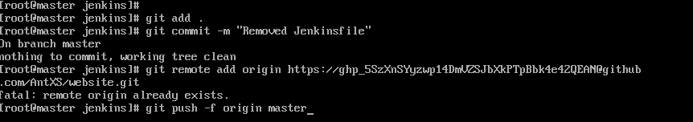
Figure 4 — Screenshot extracted from the source document for Jenkins Pipeline.
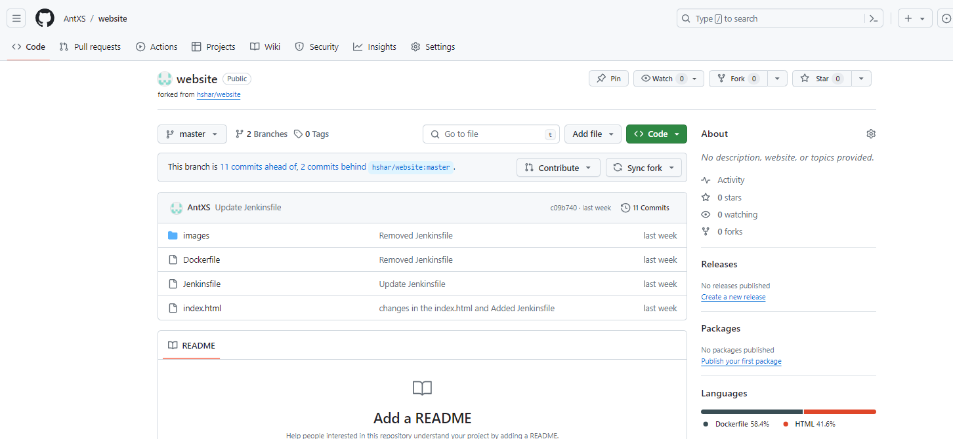
Figure 5 — Screenshot extracted from the source document for Jenkins Pipeline.
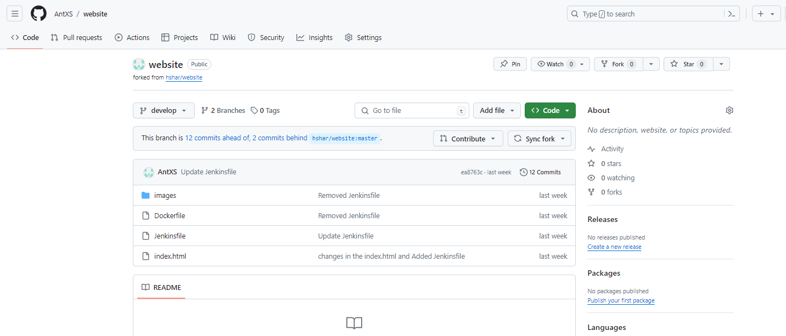
Figure 6 — Screenshot extracted from the source document for Jenkins Pipeline.
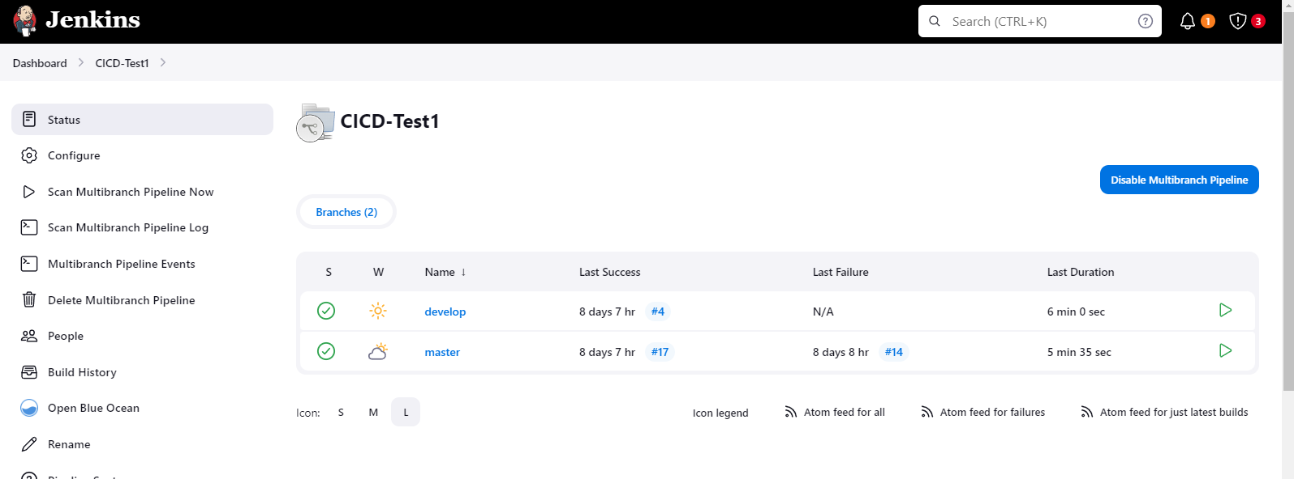
Figure 7 — Screenshot extracted from the source document for Jenkins Pipeline.
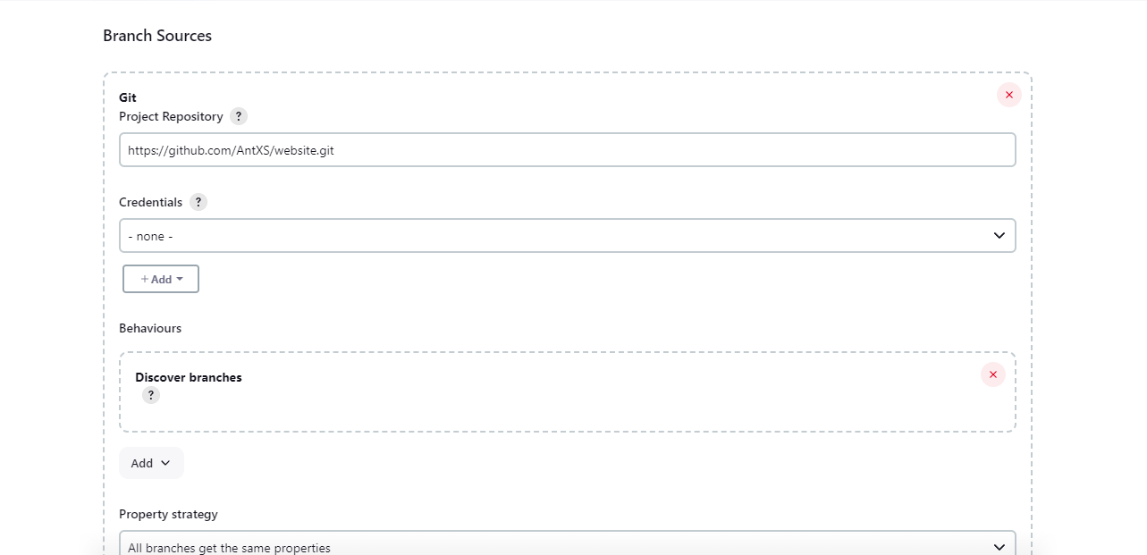
Figure 8 — Screenshot extracted from the source document for Jenkins Pipeline.

Docker Containerization
Purpose: Present practical Docker work related to container image and application configuration.
Technologies: Docker, Dockerfile, container image/runtime

Implementation overview
This section uses screenshots from the Docker case-study document. Keep only evidence that clearly shows Docker-specific configuration, commands, build output, or container status.

Outcome / validation
Verify the selected images show a successful build/run before claiming a working containerized application.

Screenshots from this project document
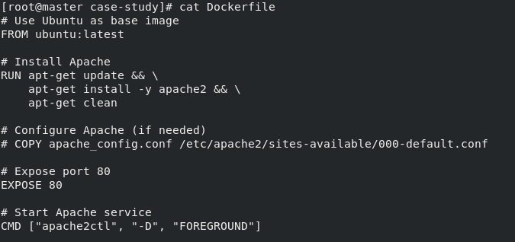
Figure 1 — Screenshot extracted from the source document for Docker Containerization.
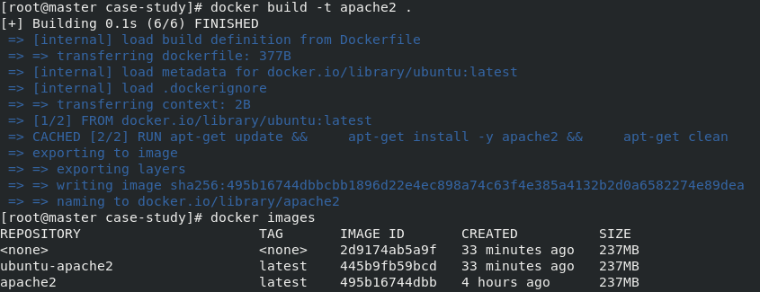
Figure 2 — Screenshot extracted from the source document for Docker Containerization.
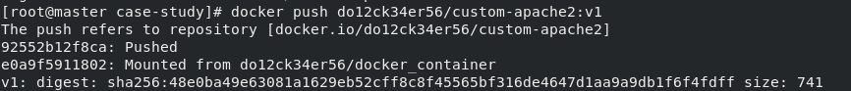
Figure 3 — Screenshot extracted from the source document for Docker Containerization.
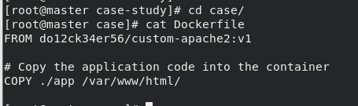
Figure 4 — Screenshot extracted from the source document for Docker Containerization.
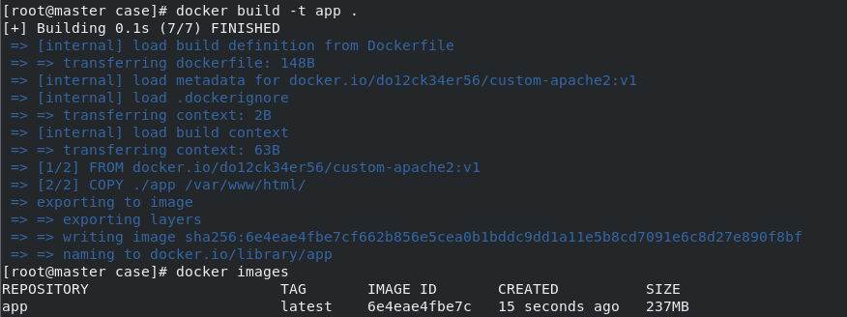
Figure 5 — Screenshot extracted from the source document for Docker Containerization.
Figure 6 — Screenshot extracted from the source document for Docker Containerization.
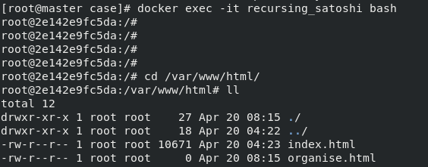
Figure 7 — Screenshot extracted from the source document for Docker Containerization.

AWS Web Application and Database
Purpose: Present an AWS-hosted web application workflow with compute, scaling configuration, and database-backed form submission.
Technologies: EC2, Auto Scaling, security groups, Apache/PHP, MySQL

Implementation overview
This section uses screenshots from the AWS capstone assignment document. The documented workflow describes a PHP application that accepts name/email details and stores them in a database.

Outcome / validation
The assignment text describes desired/minimum scaling capacity 2 and maximum 5. Confirm screenshot details before using these numbers in a public client-facing version.

Screenshots from this project document
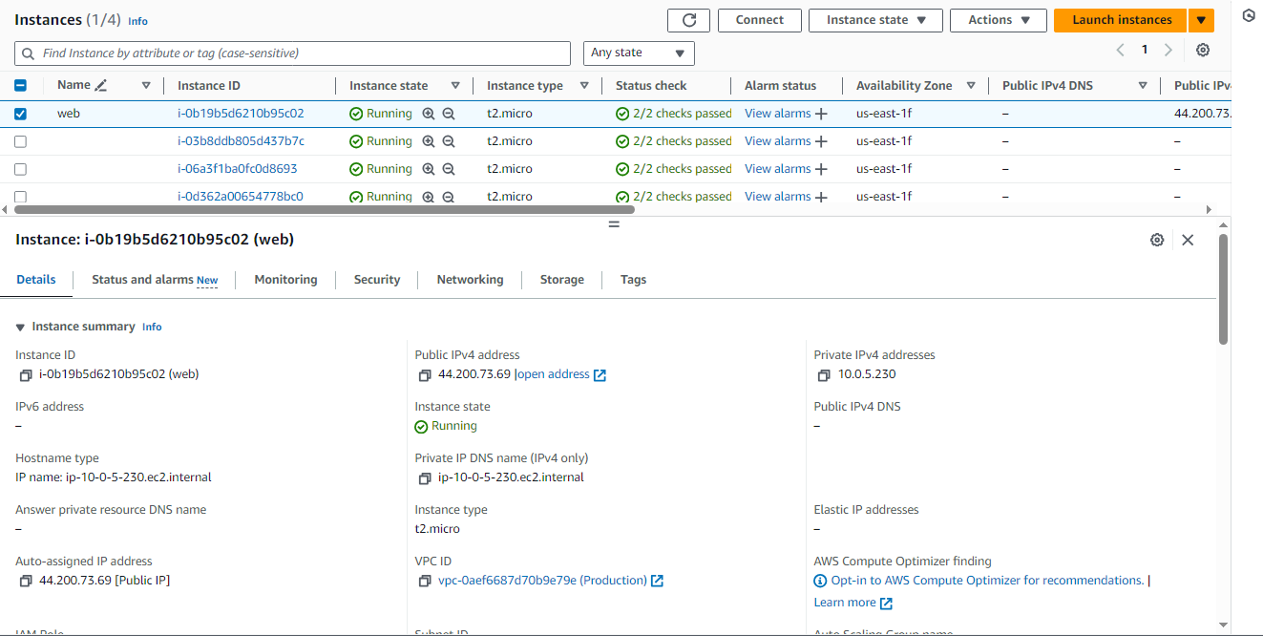
Figure 1 — Screenshot extracted from the source document for AWS Web Application and Database.
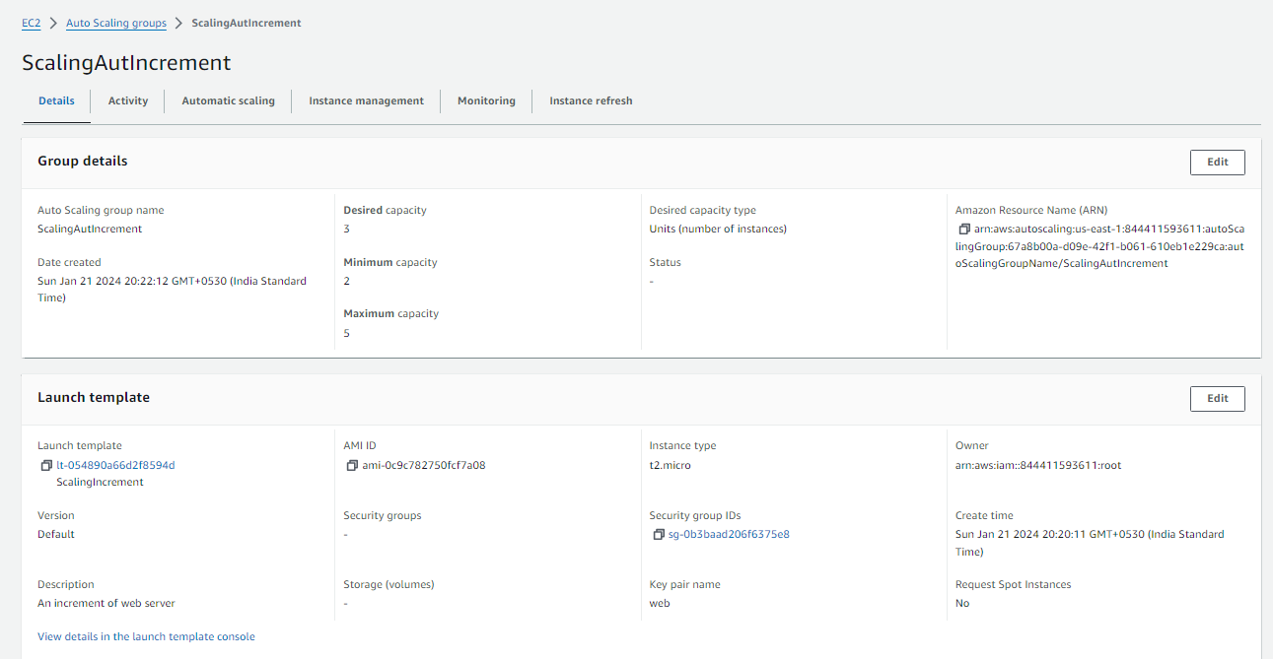
Figure 2 — Screenshot extracted from the source document for AWS Web Application and Database.
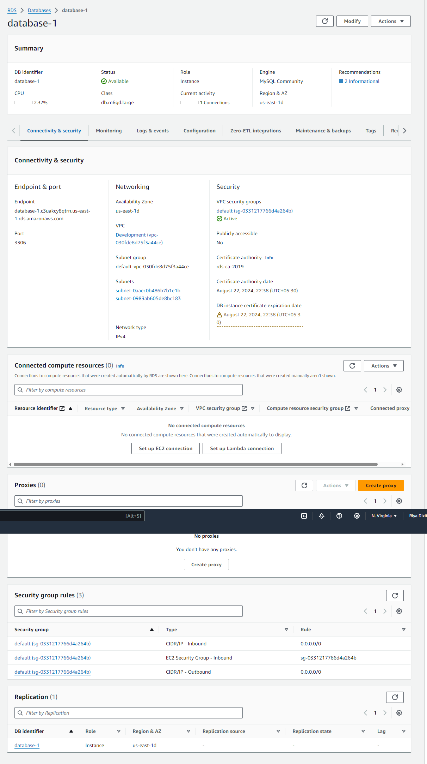
Figure 3 — Screenshot extracted from the source document for AWS Web Application and Database.
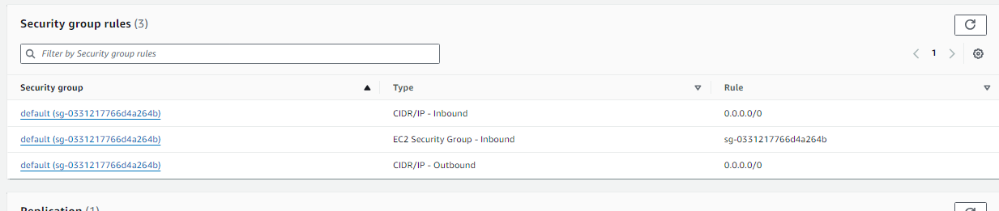
Figure 4 — Screenshot extracted from the source document for AWS Web Application and Database.
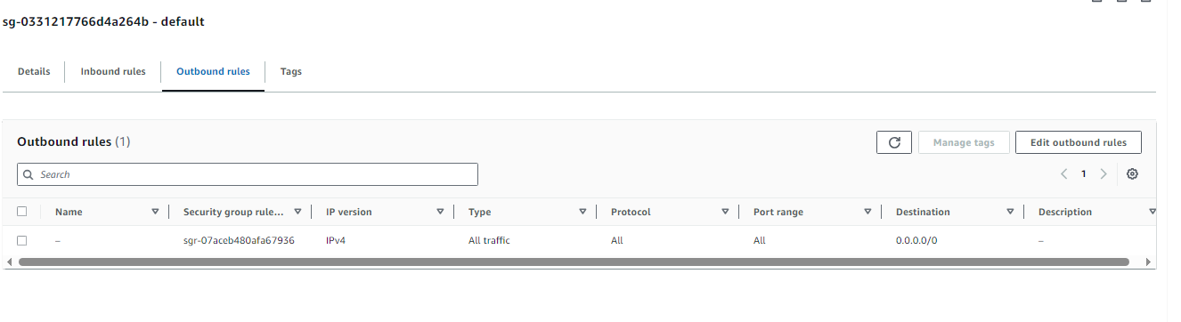
Figure 5 — Screenshot extracted from the source document for AWS Web Application and Database.
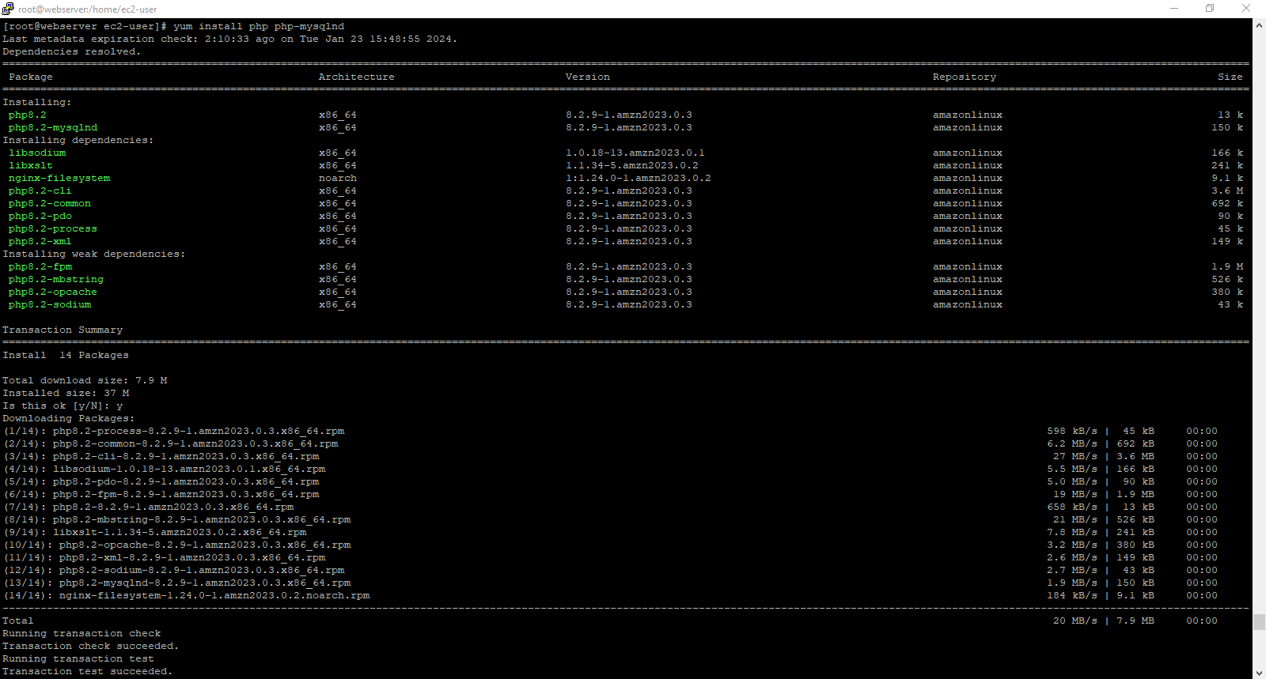
Figure 6 — Screenshot extracted from the source document for AWS Web Application and Database.
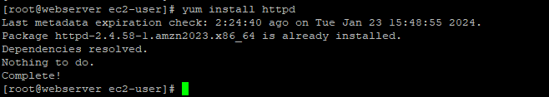
Figure 7 — Screenshot extracted from the source document for AWS Web Application and Database.
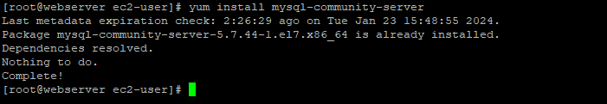
Figure 8 — Screenshot extracted from the source document for AWS Web Application and Database.

AWS IAM and CloudWatch Monitoring
Purpose: Present AWS access-control and monitoring configuration.
Technologies: IAM, IAM groups/policies/roles, CloudWatch, SNS

Implementation overview
This section is based on the IAM/CloudWatch assignment files. It should include IAM configuration and the most relevant dashboard/alarm screenshots from the matching assignments.

Outcome / validation
Assignment notes describe four users, two groups, CPU/network metrics, a billing alarm, and an EC2 CPU alarm. Verify each configuration from the screenshots before publication.

Screenshots from this project document
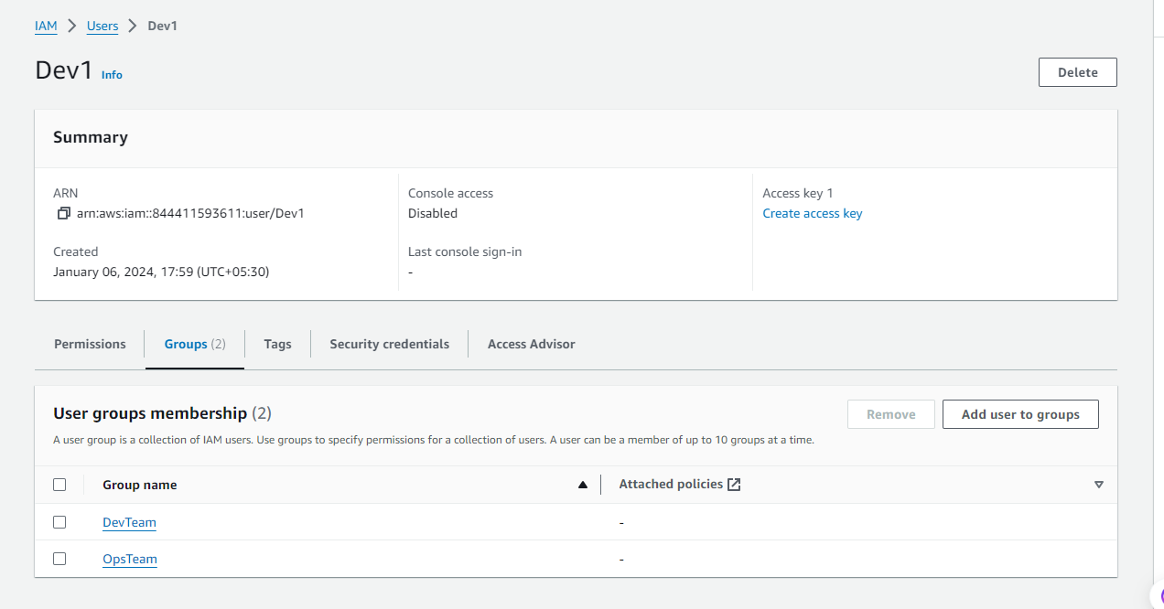
Figure 1 — Screenshot extracted from the source document for AWS IAM and CloudWatch Monitoring.
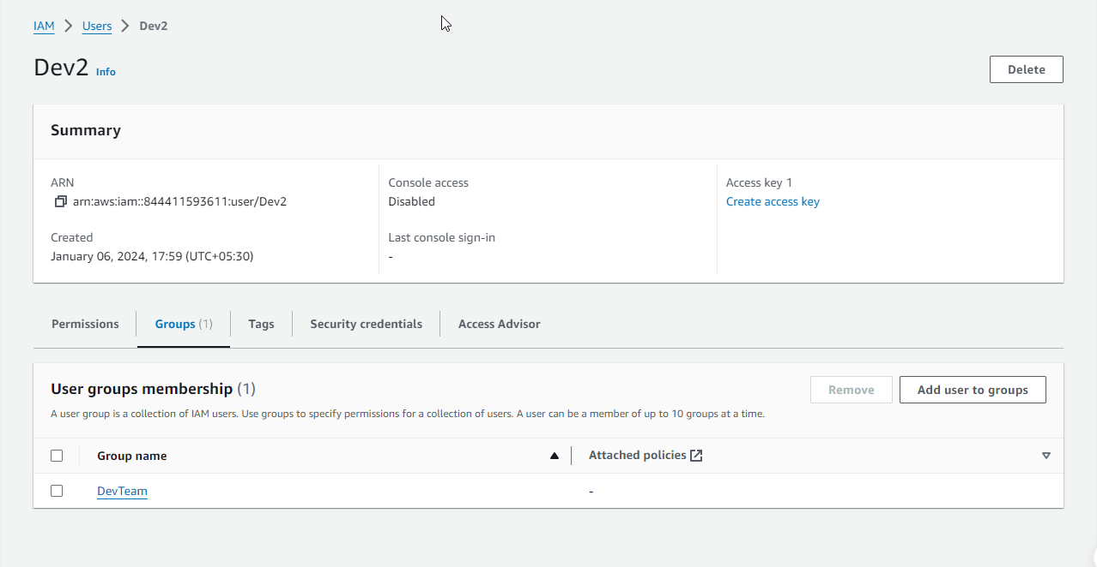
Figure 2 — Screenshot extracted from the source document for AWS IAM and CloudWatch Monitoring.
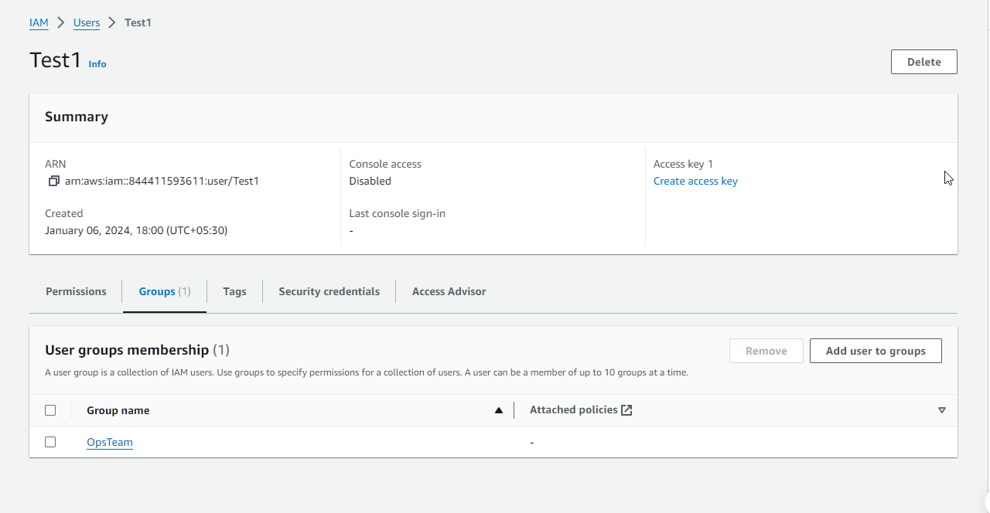
Figure 3 — Screenshot extracted from the source document for AWS IAM and CloudWatch Monitoring.
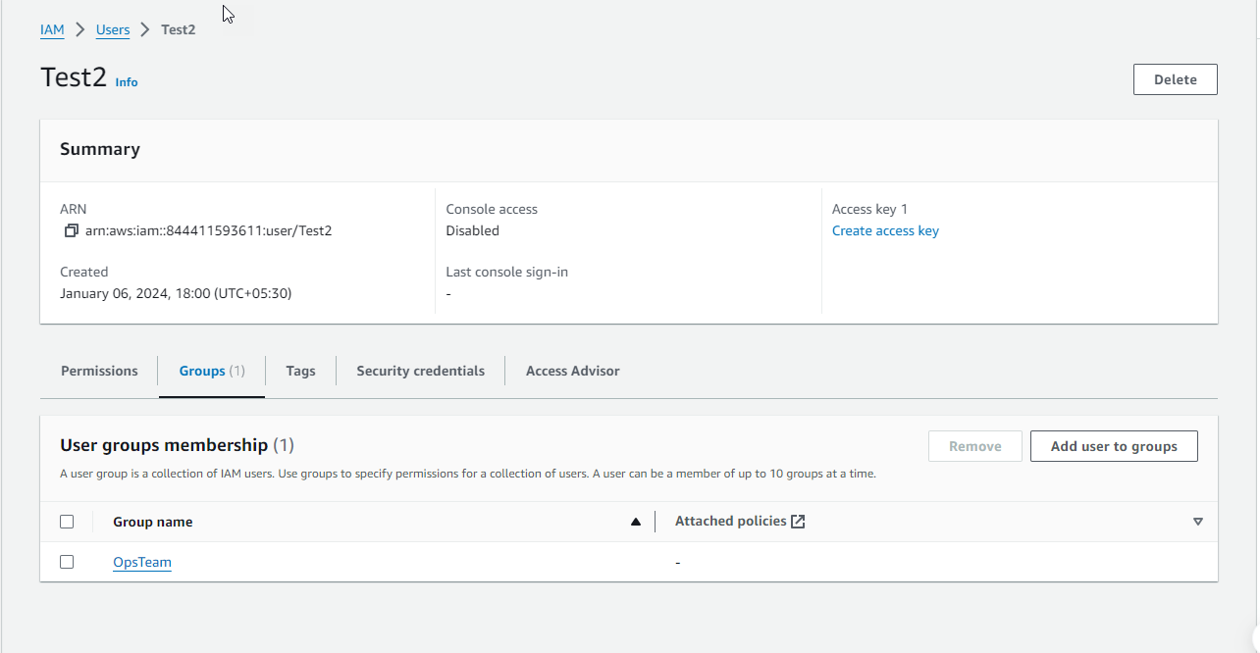
Figure 4 — Screenshot extracted from the source document for AWS IAM and CloudWatch Monitoring.

AWS Lambda with SQS
Purpose: Present an event-driven workflow using an SQS trigger to invoke an AWS Lambda function.
Technologies: AWS Lambda, SQS, Python, CloudWatch

Implementation overview
This section uses screenshots extracted from the Lambda assignment document, focused on the function, trigger, test invocation, and monitoring.

Outcome / validation
The source notes successful test invocations; make this claim only if the success output is visible in the included screenshots.

Screenshots from this project document
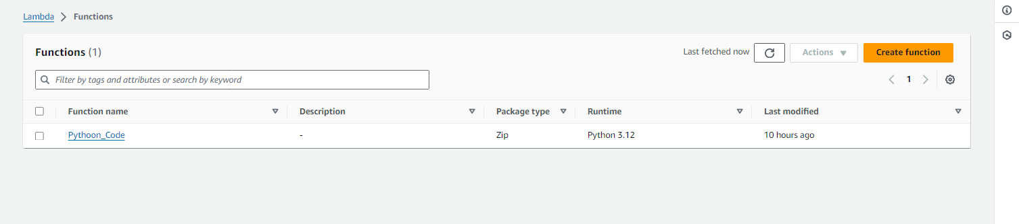
Figure 1 — Screenshot extracted from the source document for AWS Lambda with SQS.
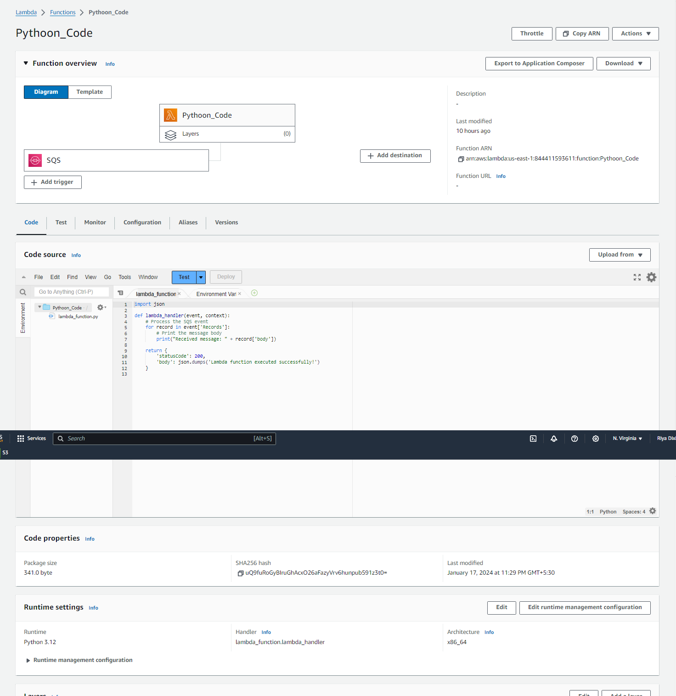
Figure 2 — Screenshot extracted from the source document for AWS Lambda with SQS.
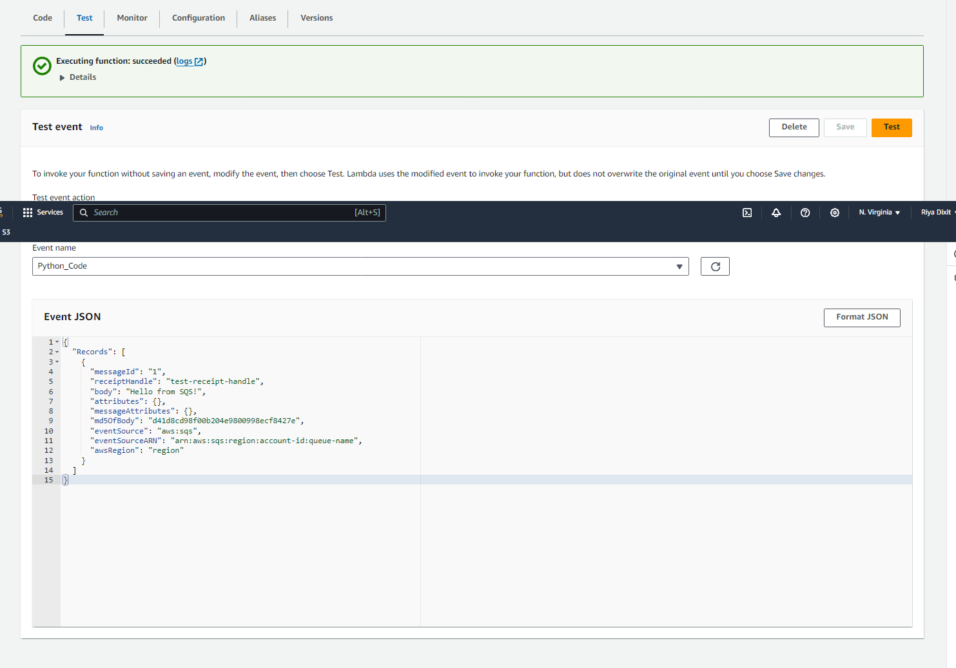
Figure 3 — Screenshot extracted from the source document for AWS Lambda with SQS.
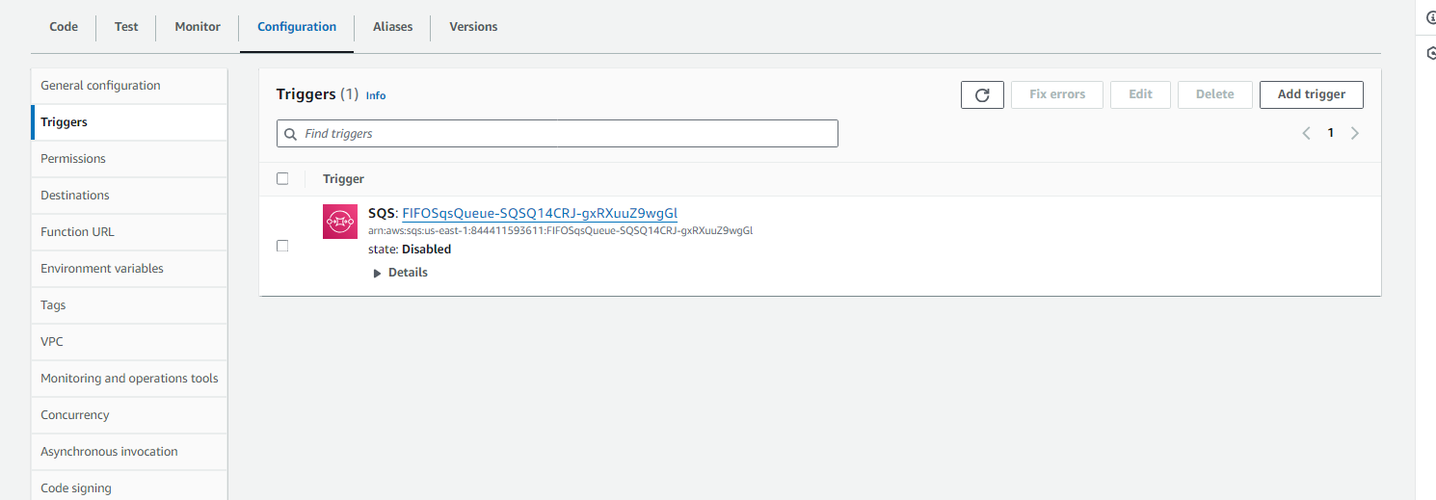
Figure 4 — Screenshot extracted from the source document for AWS Lambda with SQS.
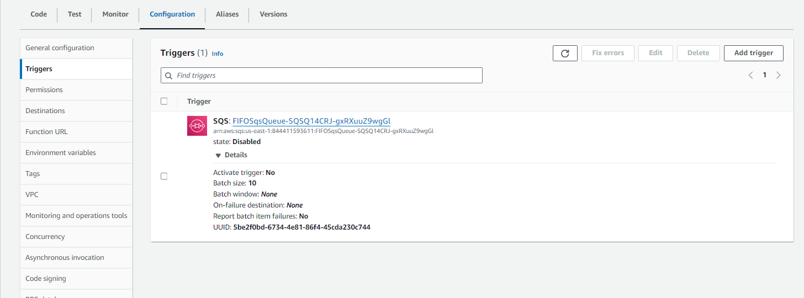
Figure 5 — Screenshot extracted from the source document for AWS Lambda with SQS.
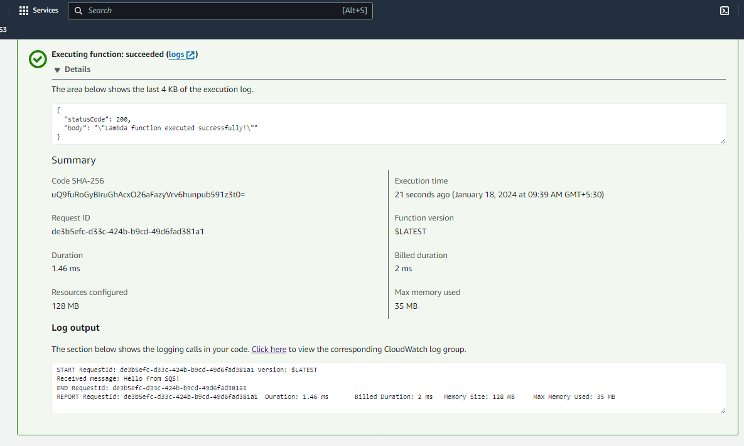
Figure 6 — Screenshot extracted from the source document for AWS Lambda with SQS.

AWS Elastic Beanstalk Deployment
Purpose: Present deployment of a sample PHP application using AWS Elastic Beanstalk.
Technologies: Elastic Beanstalk, EC2, S3, PHP

Implementation overview
This section uses screenshots from the Elastic Beanstalk assignment document only.

Outcome / validation
Verify environment health and live endpoint before claiming successful public availability.

Screenshots from this project document
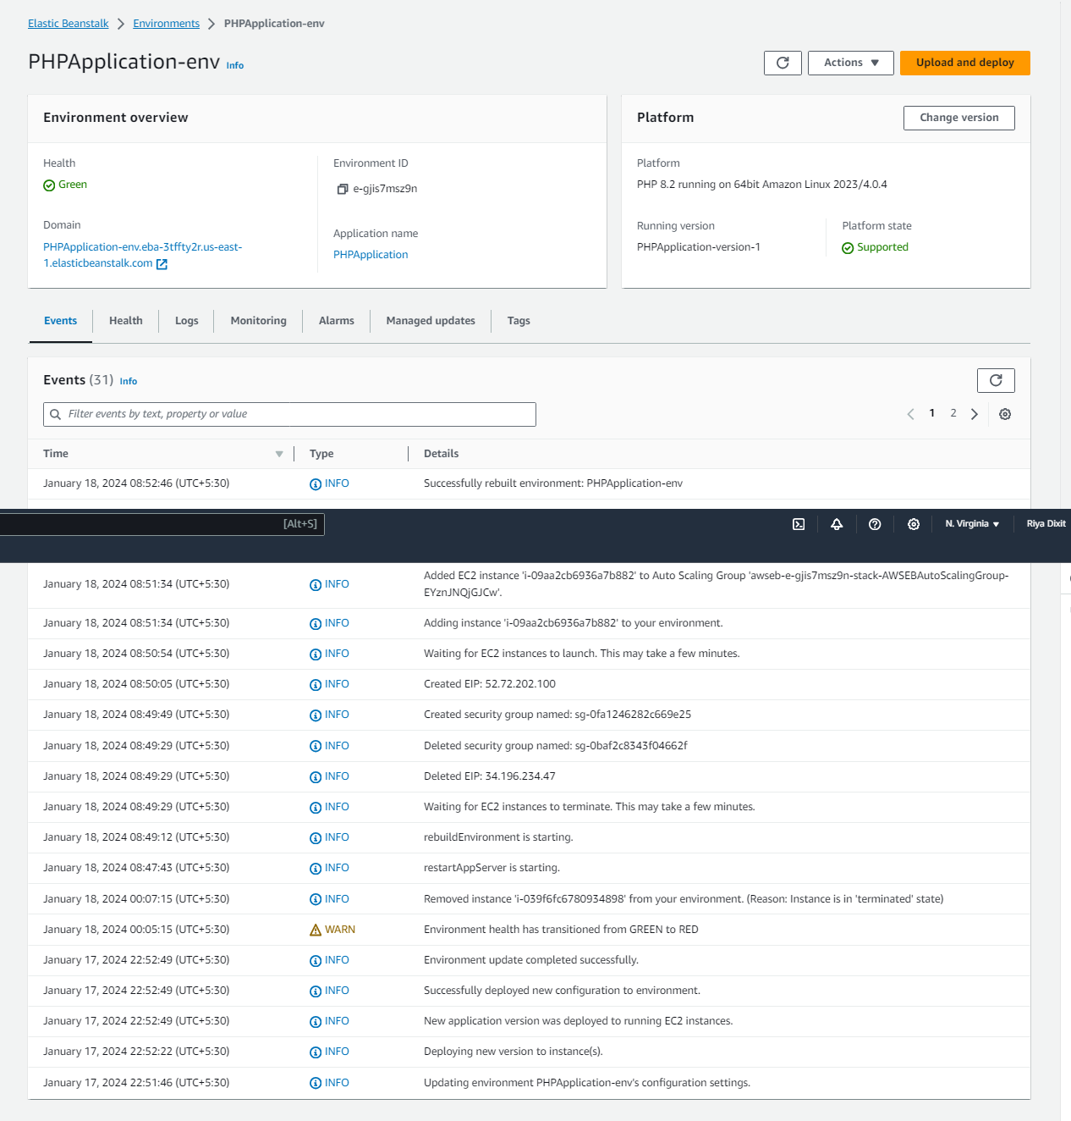
Figure 1 — Screenshot extracted from the source document for AWS Elastic Beanstalk Deployment.
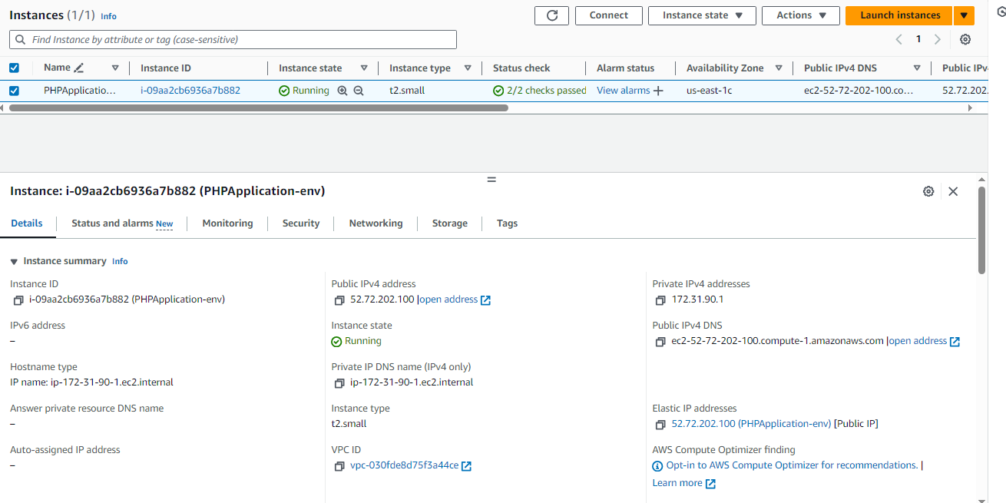
Figure 2 — Screenshot extracted from the source document for AWS Elastic Beanstalk Deployment.
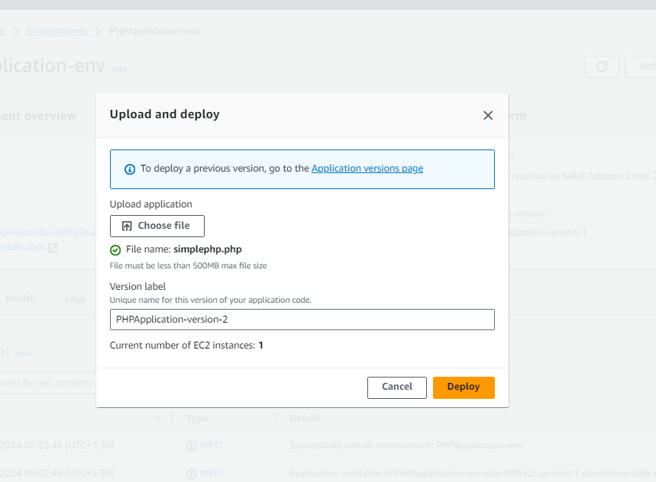
Figure 3 — Screenshot extracted from the source document for AWS Elastic Beanstalk Deployment.
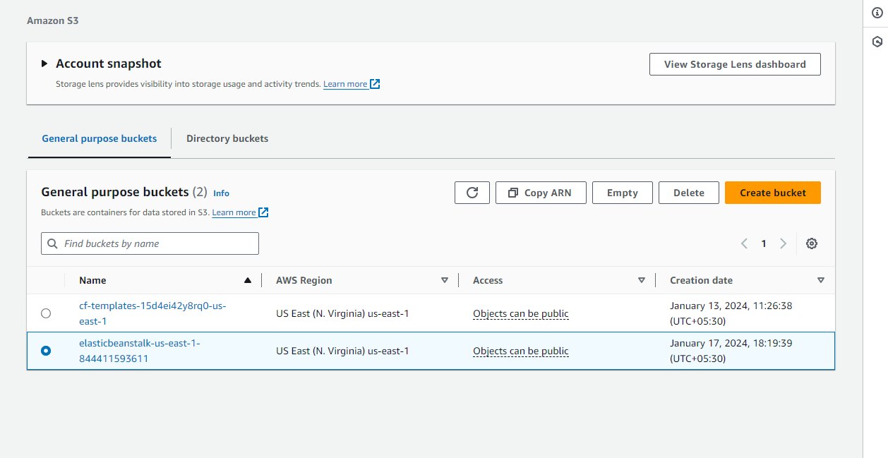
Figure 4 — Screenshot extracted from the source document for AWS Elastic Beanstalk Deployment.
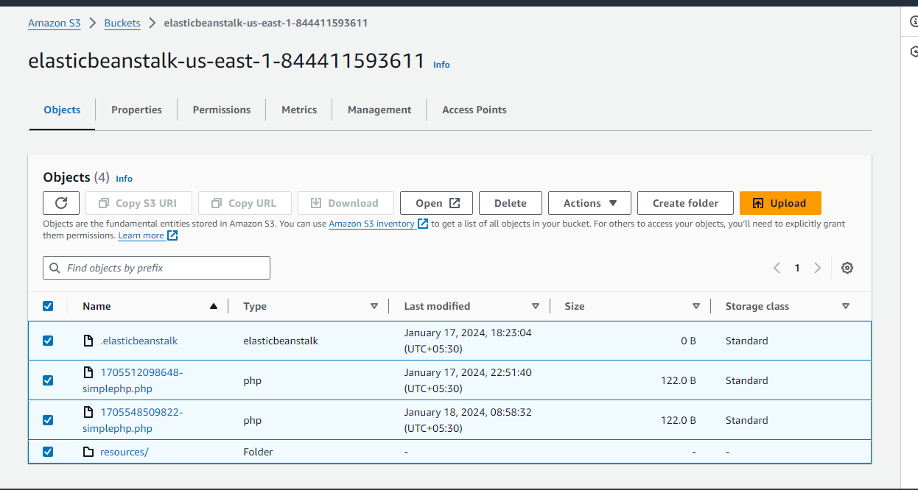
Figure 5 — Screenshot extracted from the source document for AWS Elastic Beanstalk Deployment.
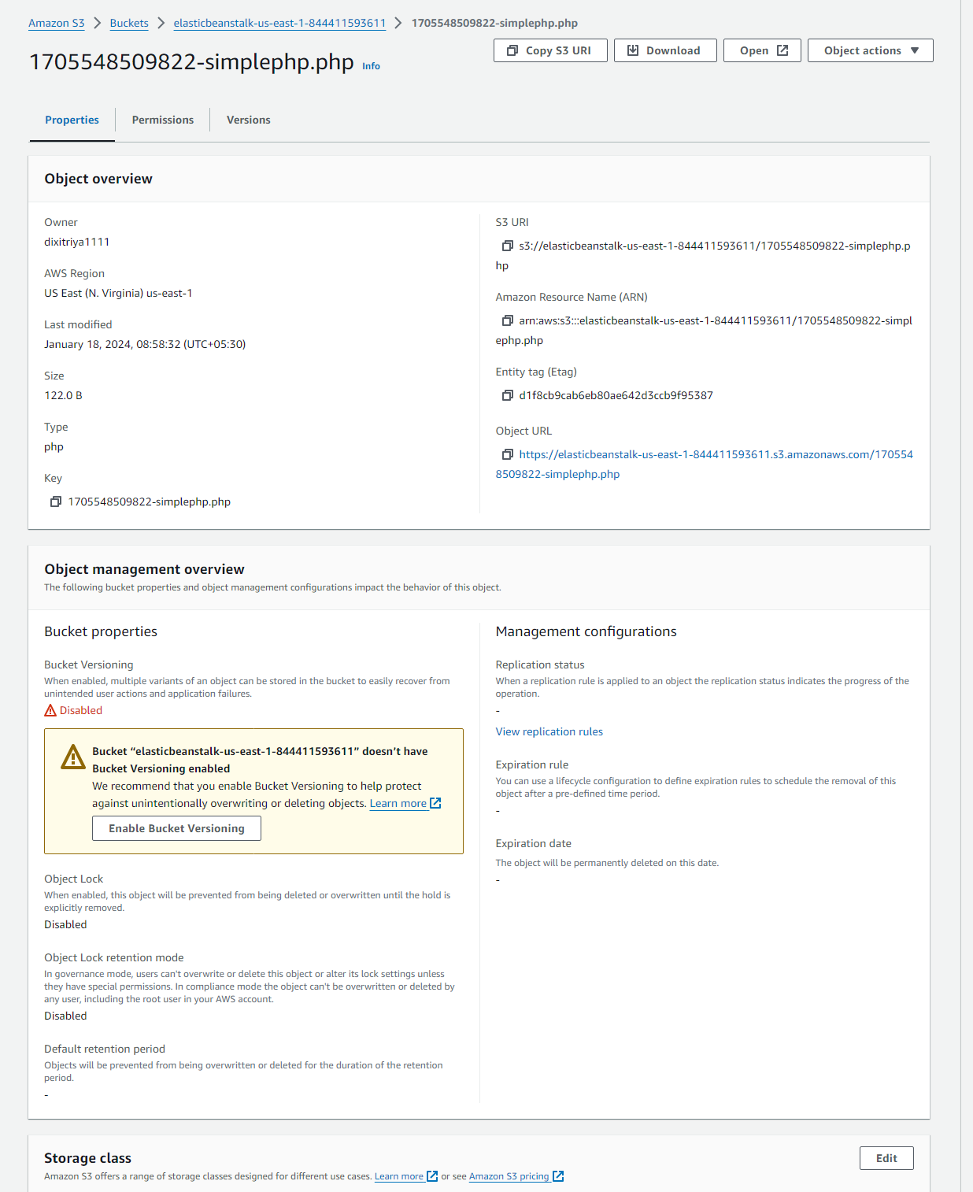
Figure 6 — Screenshot extracted from the source document for AWS Elastic Beanstalk Deployment.

Ansible Configuration Automation
Purpose: Present Linux configuration automation using Ansible inventory and playbooks.
Technologies: Ansible, Linux; Docker/Jenkins only if the specific screenshots support it

Implementation overview
This section uses screenshots extracted from Capstone Project 01. The narrative should focus on inventory, playbook logic, and execution evidence.

Outcome / validation
Claim successful automation only when playbook completion or the resulting system state is visible.

Screenshots from this project document
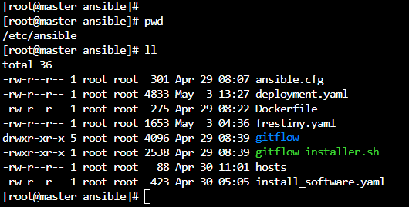
Figure 1 — Screenshot extracted from the source document for Ansible Configuration Automation.
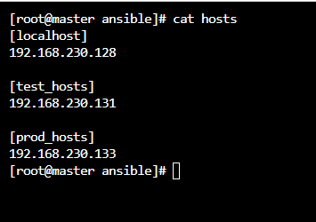
Figure 2 — Screenshot extracted from the source document for Ansible Configuration Automation.
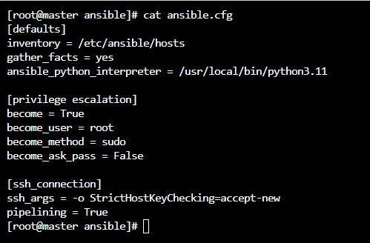
Figure 3 — Screenshot extracted from the source document for Ansible Configuration Automation.
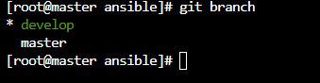
Figure 4 — Screenshot extracted from the source document for Ansible Configuration Automation.
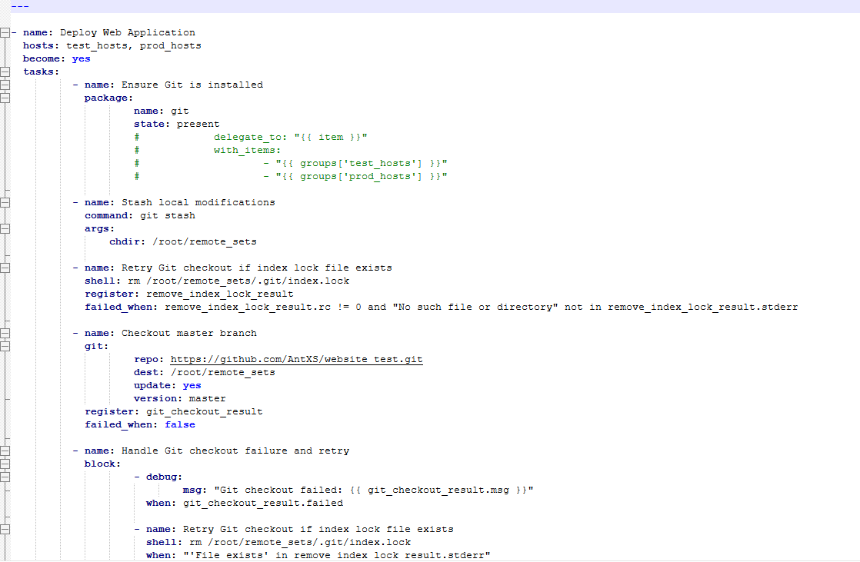
Figure 5 — Screenshot extracted from the source document for Ansible Configuration Automation.
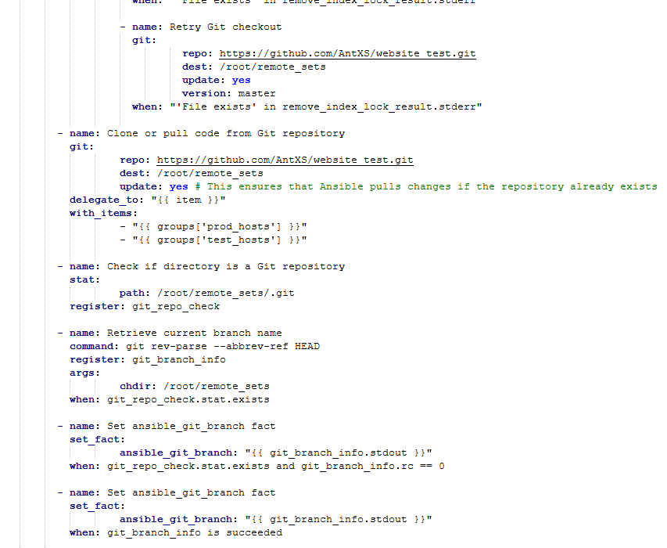
Figure 6 — Screenshot extracted from the source document for Ansible Configuration Automation.
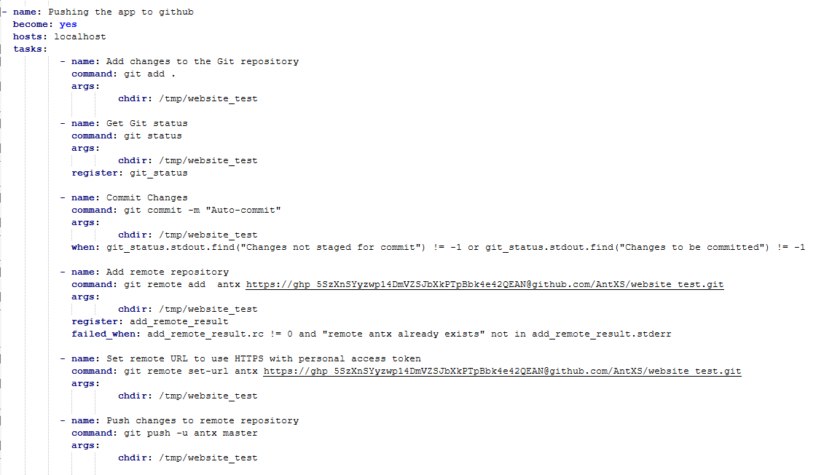
Figure 7 — Screenshot extracted from the source document for Ansible Configuration Automation.
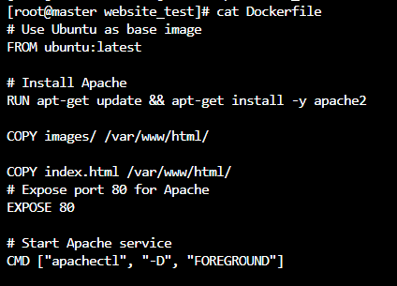
Figure 8 — Screenshot extracted from the source document for Ansible Configuration Automation.

Terraform and Ansible Workflow
Purpose: Present an infrastructure provisioning and configuration-management workflow.
Technologies: Terraform, AWS EC2, Ansible, Linux/Java installation

Implementation overview
This section uses images from the DevOps Final Project document. It is separate from the Terraform case study only if it demonstrates a distinct workflow.

Outcome / validation
Confirm Terraform apply and Ansible execution outputs before describing the workflow as fully automated end-to-end.

Screenshots from this project document
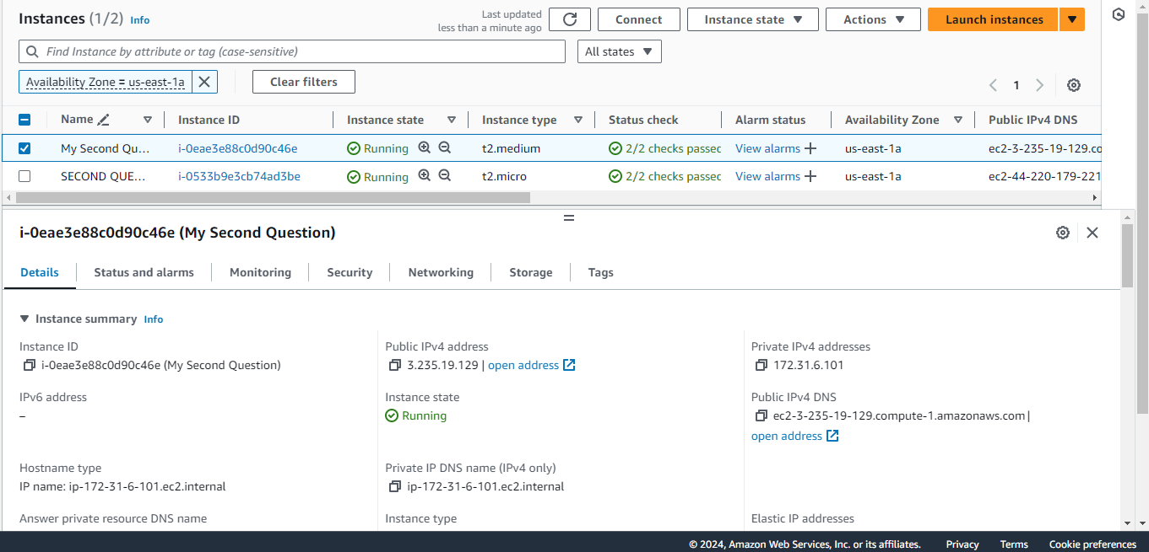
Figure 1 — Screenshot extracted from the source document for Terraform and Ansible Workflow.
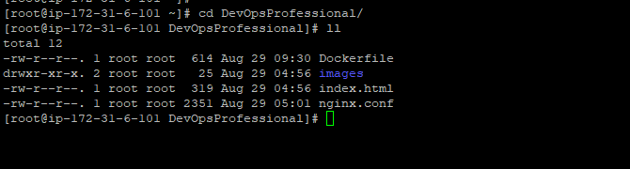
Figure 2 — Screenshot extracted from the source document for Terraform and Ansible Workflow.
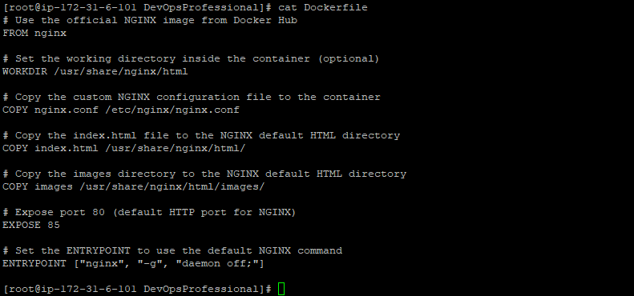
Figure 3 — Screenshot extracted from the source document for Terraform and Ansible Workflow.
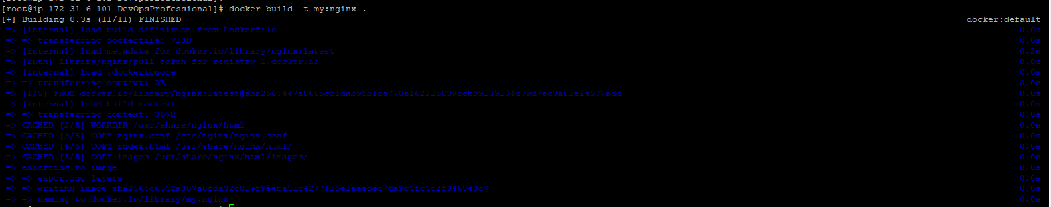
Figure 4 — Screenshot extracted from the source document for Terraform and Ansible Workflow.
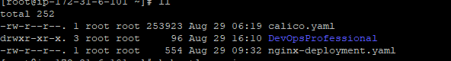
Figure 5 — Screenshot extracted from the source document for Terraform and Ansible Workflow.
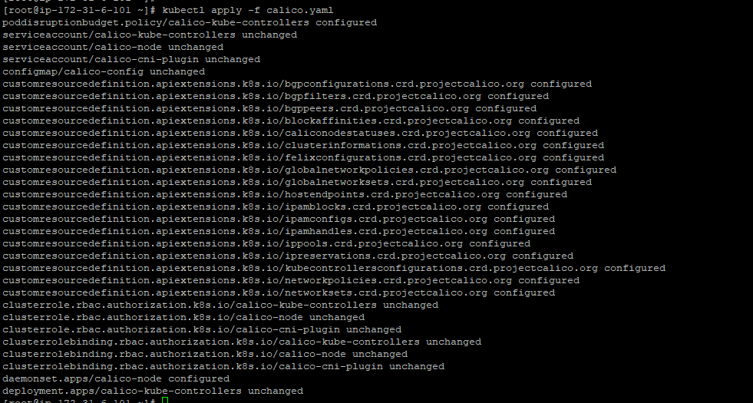
Figure 6 — Screenshot extracted from the source document for Terraform and Ansible Workflow.
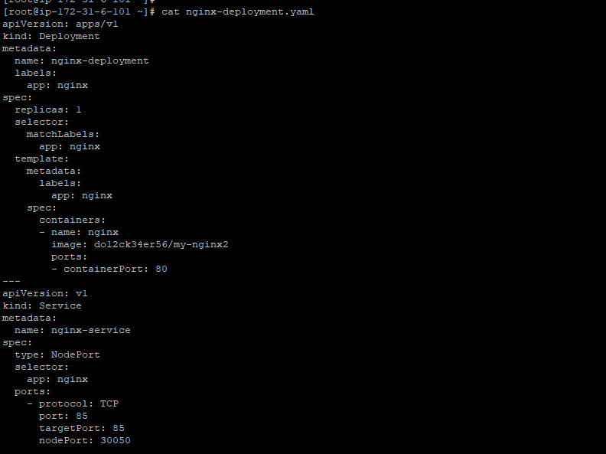
Figure 7 — Screenshot extracted from the source document for Terraform and Ansible Workflow.
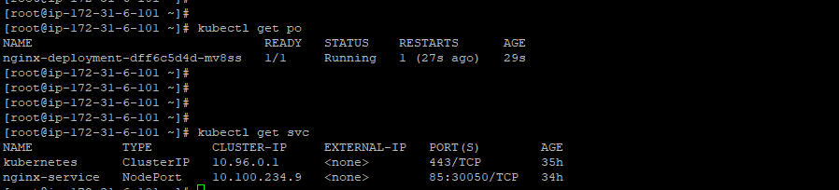
Figure 8 — Screenshot extracted from the source document for Terraform and Ansible Workflow.

Before sharing with clients
- Confirm each screenshot matches the section heading and demonstrates the stated technology.
- Redact access keys, tokens, passwords, account IDs, sensitive IPs, internal hostnames, and confidential client/employer details.
- Check employer/client permission before sharing workplace screenshots externally.
- Use only verified outcomes. Do not claim production usage, cost savings, uptime, or incident resolution without evidence.
- Keep capstone/training work clearly distinguished from real-time workplace projects.

