DEVOPS SCREENSHOT INVENTORY
Index of embedded images extracted from uploaded ZIP documents
This inventory lists screenshots by their original ZIP and Word document. Image labels are source filenames/order, not an interpretation that every image proves a successful result. Review each image before public sharing.

assignment_kubernetescasestudy.zip
Source Word document: assignment_kubernetescasestudy.docx
Embedded image count extracted: 6

Screenshot 01 — word/media/image8.png
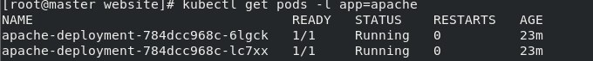
Original dimensions: 680 × 71 px

Screenshot 02 — word/media/image6.png
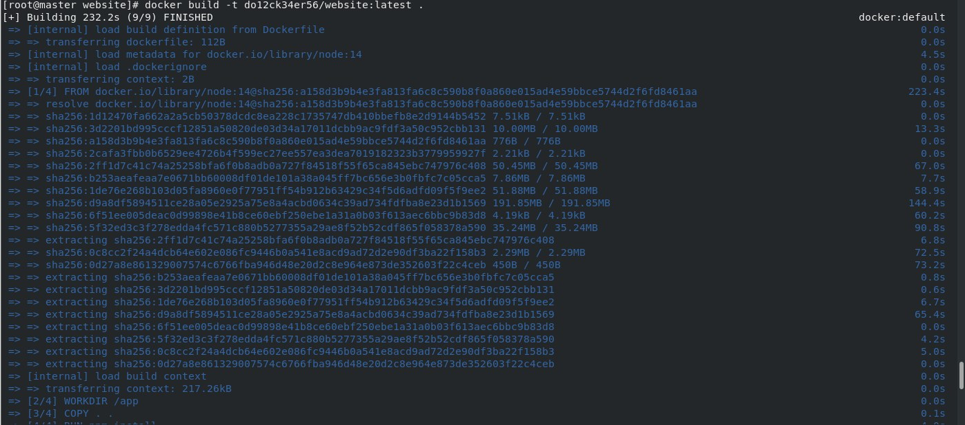
Original dimensions: 1399 × 618 px

Screenshot 03 — word/media/image5.png
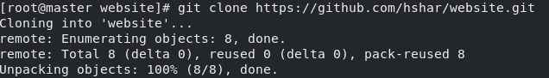
Original dimensions: 636 × 91 px

Screenshot 04 — word/media/image3.png
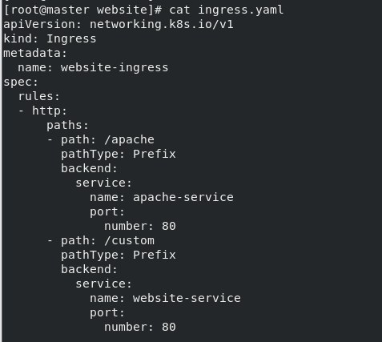
Original dimensions: 477 × 427 px

Screenshot 05 — word/media/image2.png
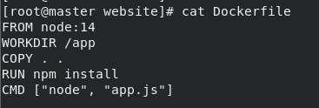
Original dimensions: 367 × 124 px

Screenshot 06 — word/media/image1.png
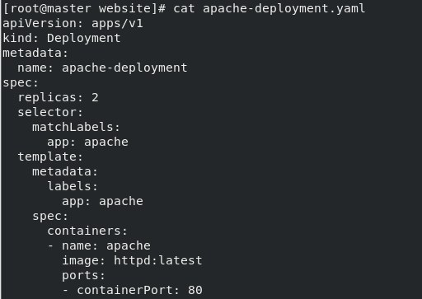
Original dimensions: 512 × 363 px

assignment-terraformcasestudy.zip
Source Word document: assignment-terraformcasestudy.docx
Embedded image count extracted: 11

Screenshot 01 — word/media/image7.png
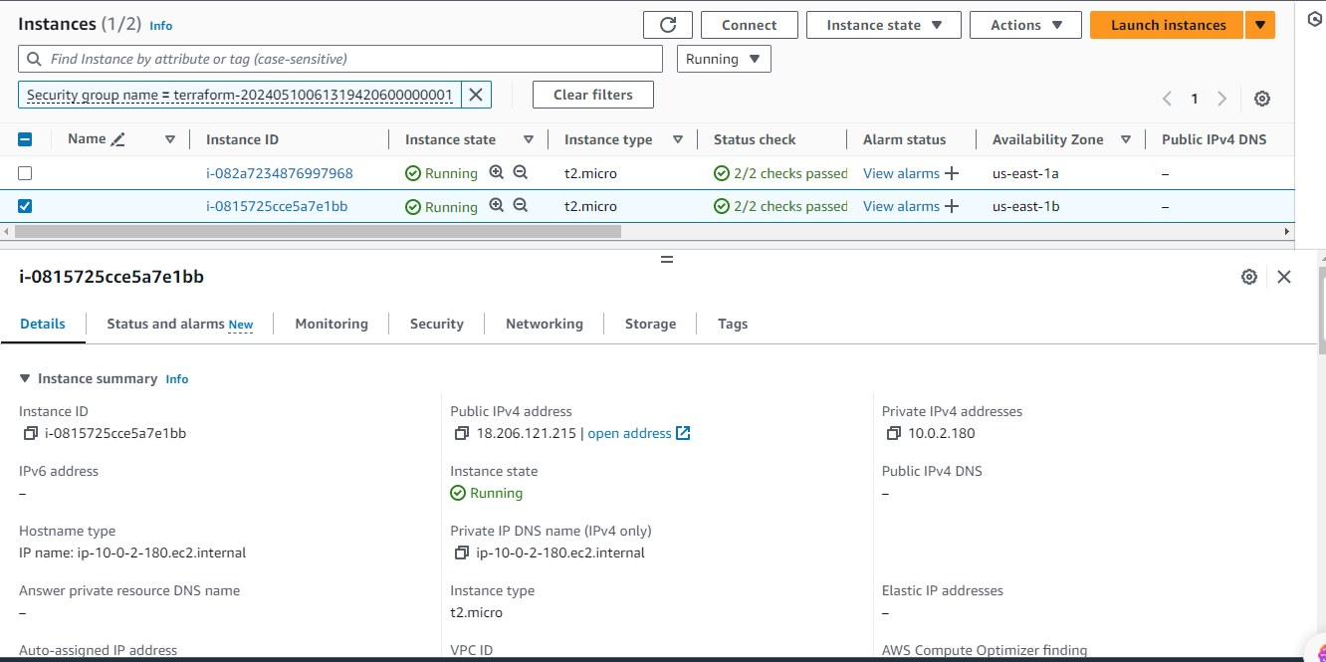
Original dimensions: 1332 × 665 px

Screenshot 02 — word/media/image8.png
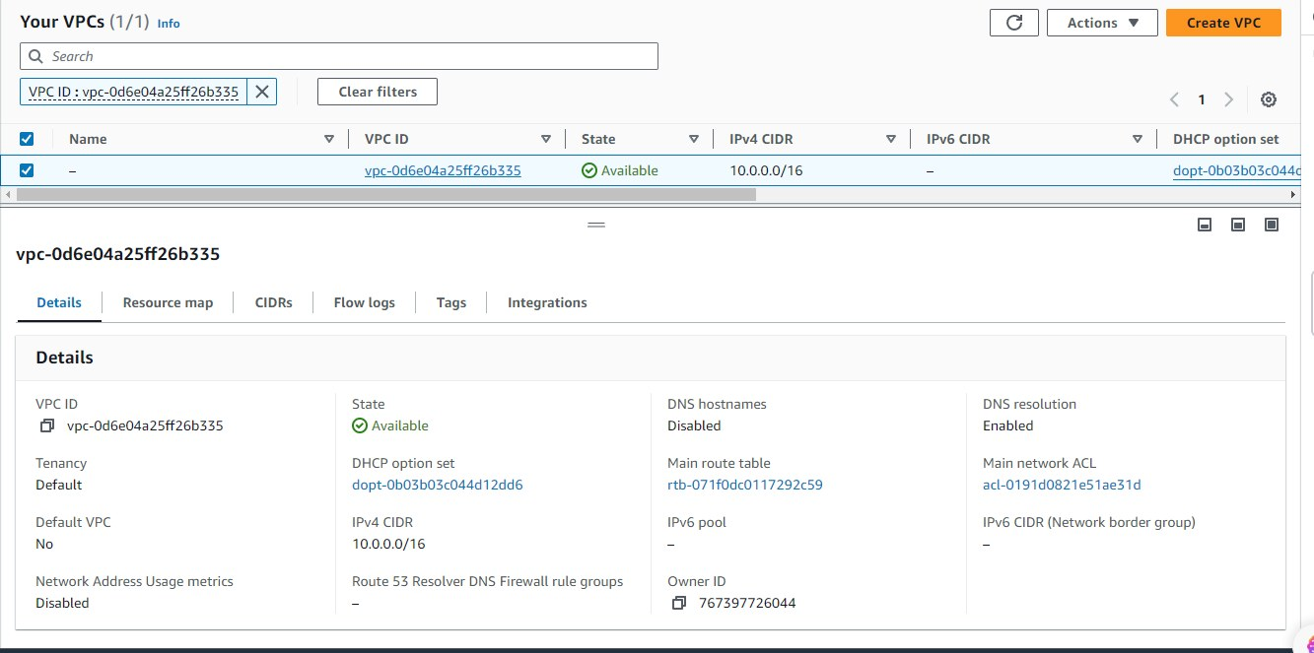
Original dimensions: 1333 × 663 px

Screenshot 03 — word/media/image9.png
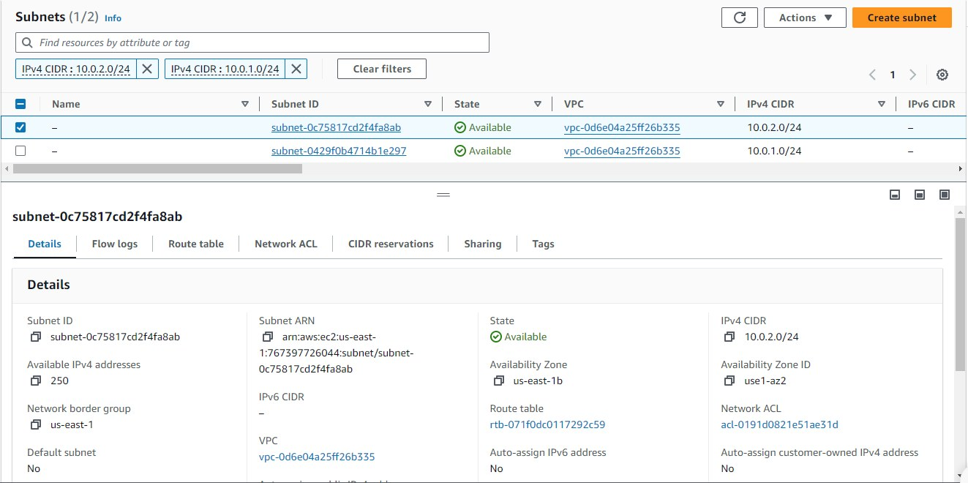
Original dimensions: 1323 × 660 px

Screenshot 04 — word/media/image10.png
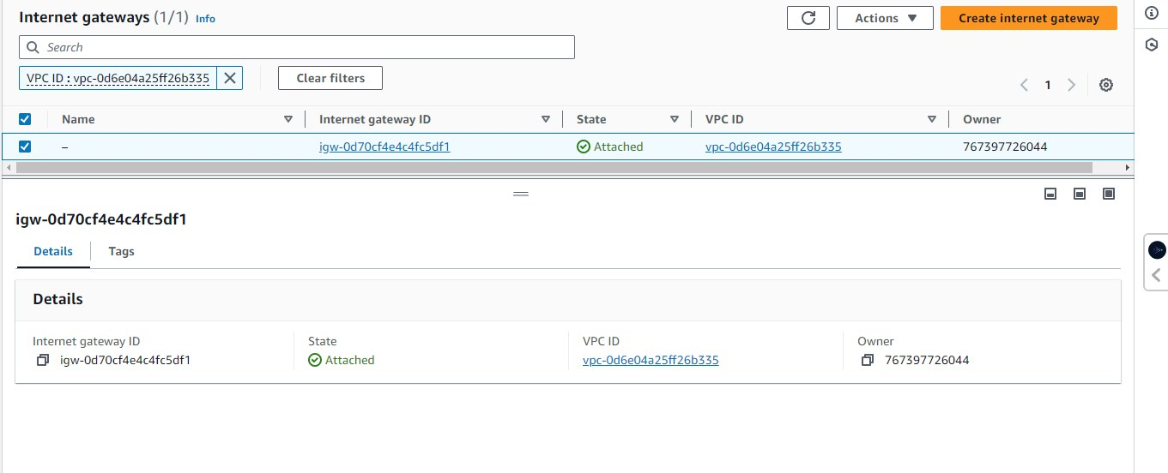
Original dimensions: 1361 × 552 px

Screenshot 05 — word/media/image6.png
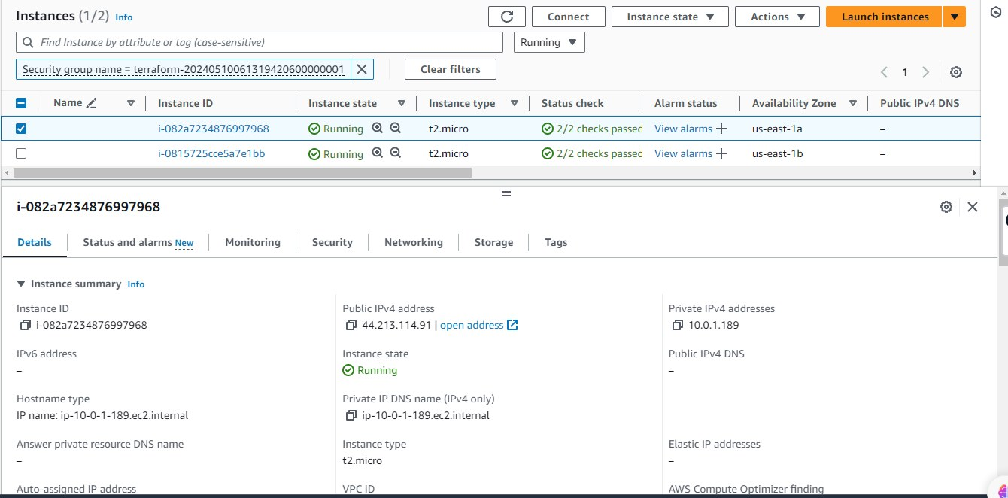
Original dimensions: 1340 × 662 px

Screenshot 06 — word/media/image5.png
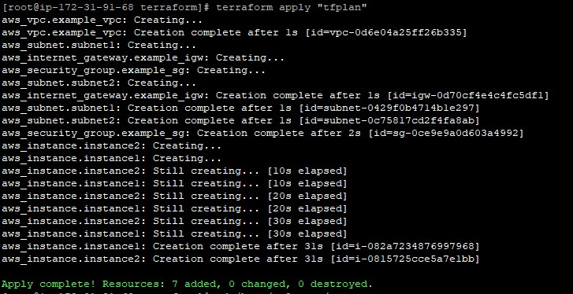
Original dimensions: 727 × 374 px

Screenshot 07 — word/media/image4.png
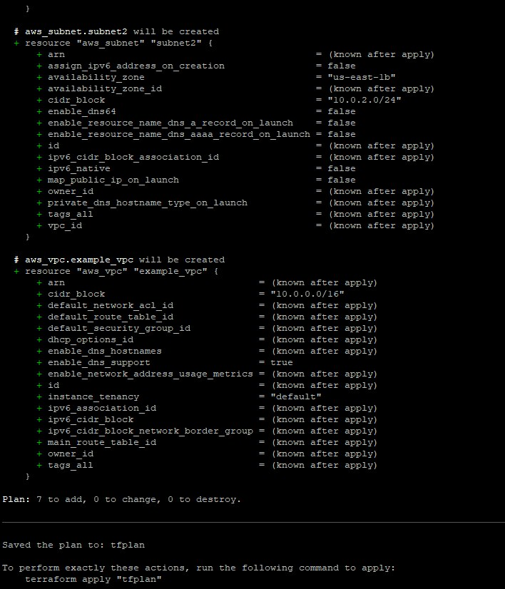
Original dimensions: 708 × 826 px

Screenshot 08 — word/media/image3.png
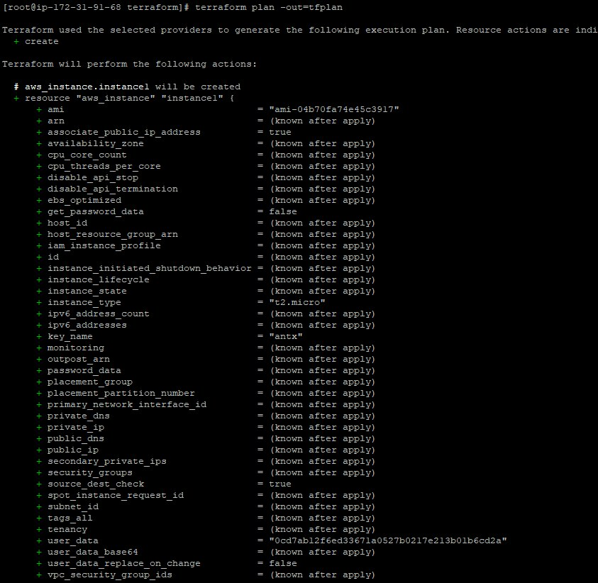
Original dimensions: 843 × 822 px

Screenshot 09 — word/media/image2.png
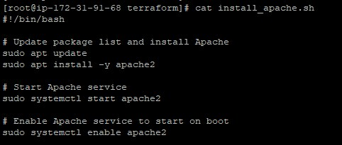
Original dimensions: 482 × 205 px

Screenshot 10 — word/media/image1.png
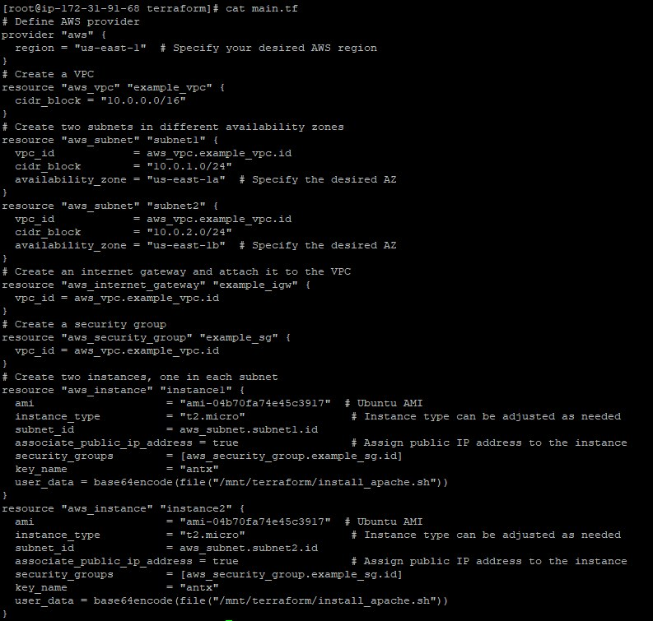
Original dimensions: 793 × 755 px

Screenshot 11 — word/media/image11.png
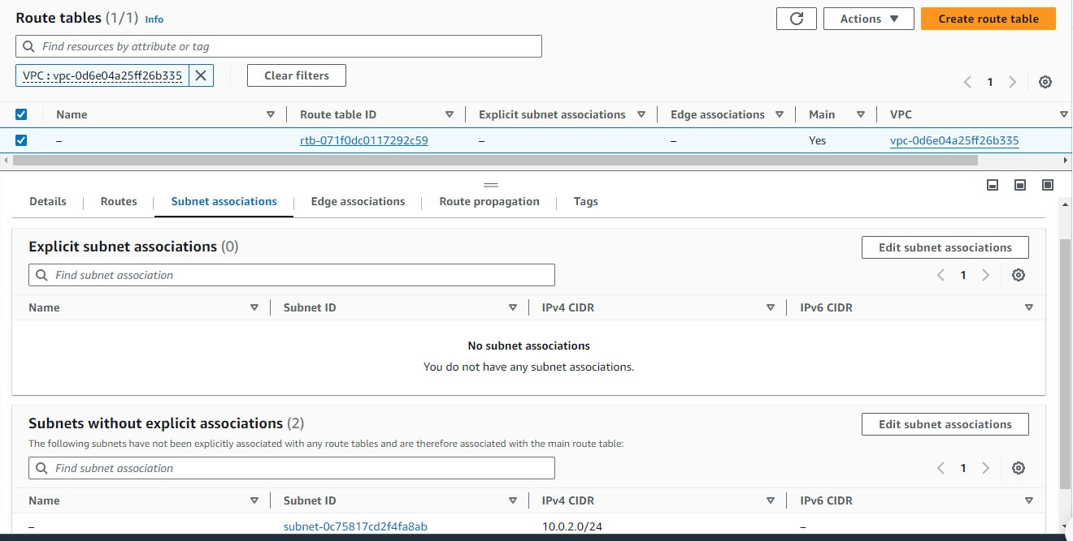
Original dimensions: 1320 × 667 px

terraform_assignment.zip
Source Word document: terraform_assignment/assignment1.docx
Embedded image count extracted: 6

Screenshot 01 — word/media/image5.png
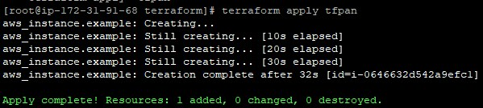
Original dimensions: 599 × 135 px

Screenshot 02 — word/media/image4.png
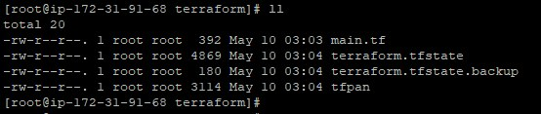
Original dimensions: 554 × 117 px

Screenshot 03 — word/media/image3.png
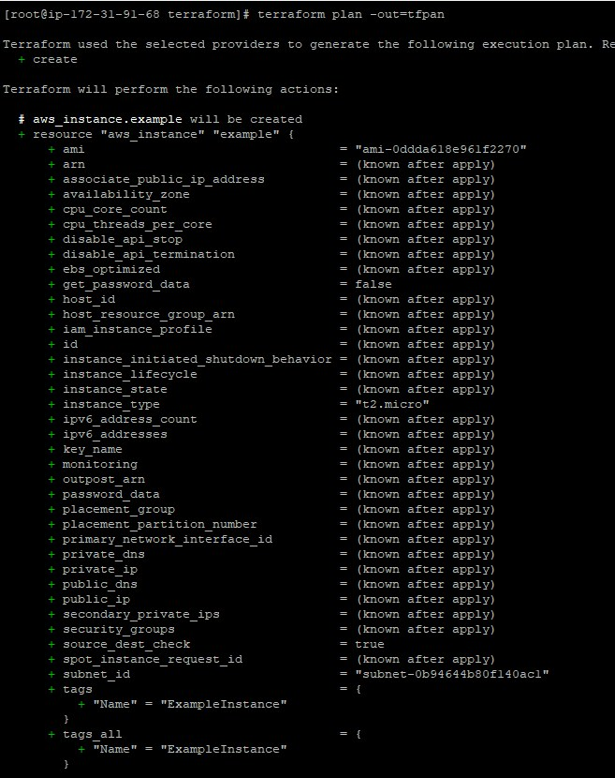
Original dimensions: 657 × 830 px

Screenshot 04 — word/media/image2.png
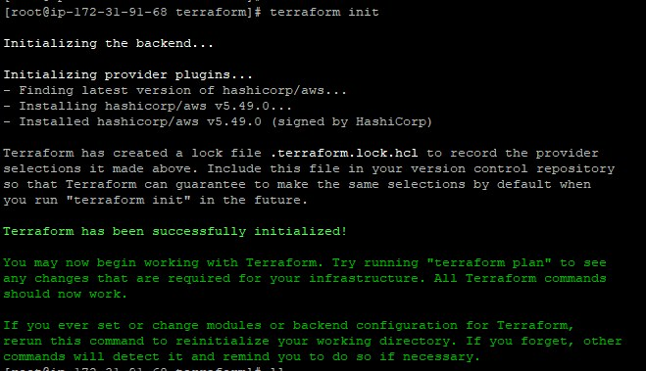
Original dimensions: 659 × 379 px

Screenshot 05 — word/media/image1.png
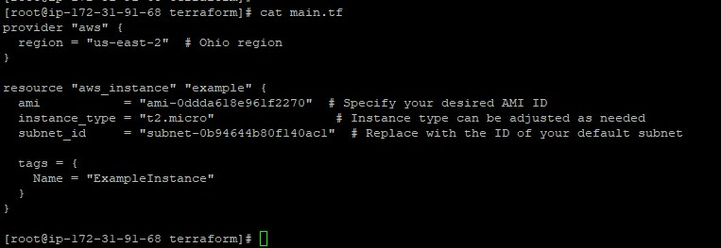
Original dimensions: 763 × 263 px

Screenshot 06 — word/media/image6.png
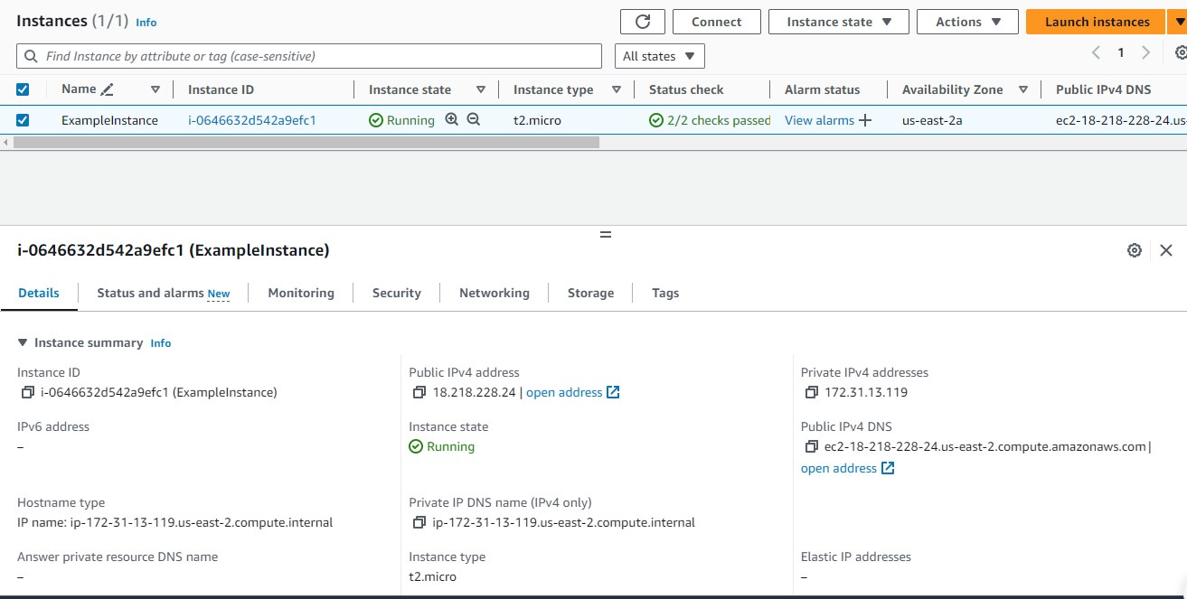
Original dimensions: 1313 × 663 px

terraform_assignment.zip
Source Word document: terraform_assignment/assignment2.docx
Embedded image count extracted: 6

Screenshot 01 — word/media/image5.png
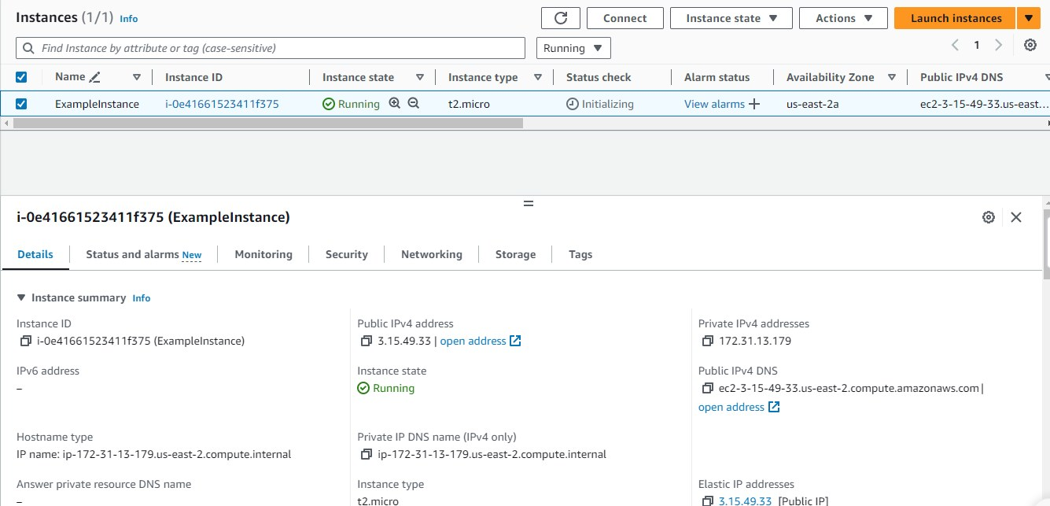
Original dimensions: 1335 × 643 px

Screenshot 02 — word/media/image4.png
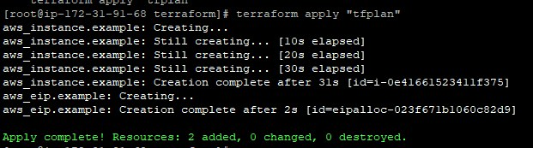
Original dimensions: 621 × 173 px

Screenshot 03 — word/media/image3.png
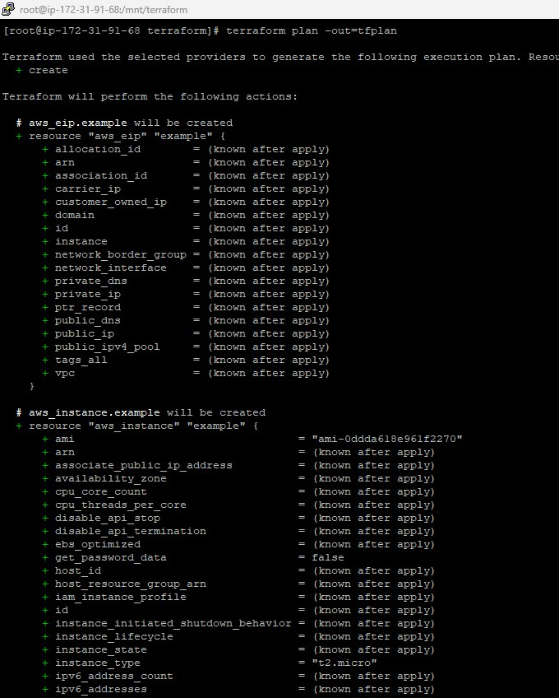
Original dimensions: 680 × 848 px

Screenshot 04 — word/media/image2.png
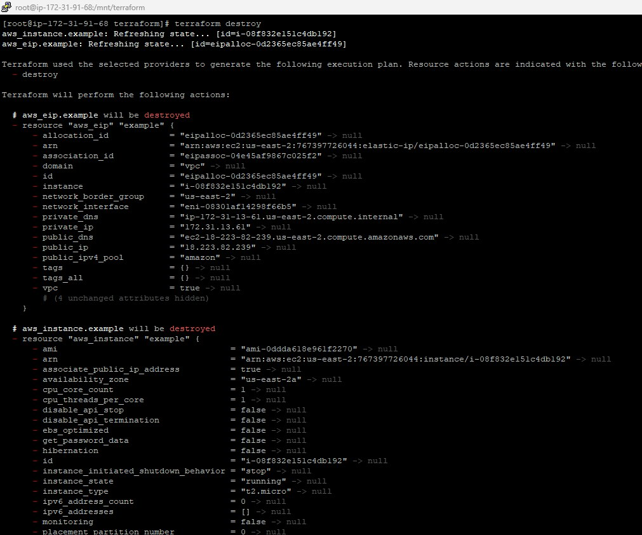
Original dimensions: 1011 × 842 px

Screenshot 05 — word/media/image1.png
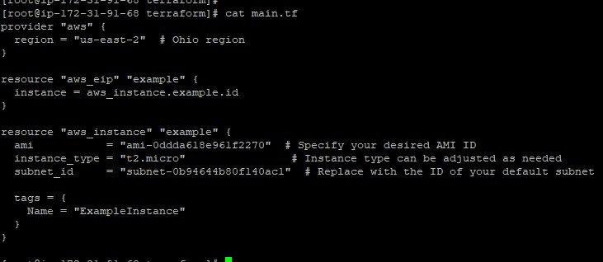
Original dimensions: 731 × 318 px

Screenshot 06 — word/media/image6.png
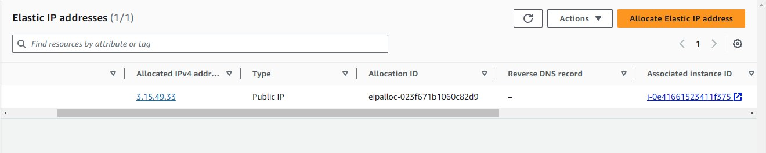
Original dimensions: 1320 × 266 px

terraform_assignment.zip
Source Word document: terraform_assignment/assignment3.docx
Embedded image count extracted: 8

Screenshot 01 — word/media/image7.png
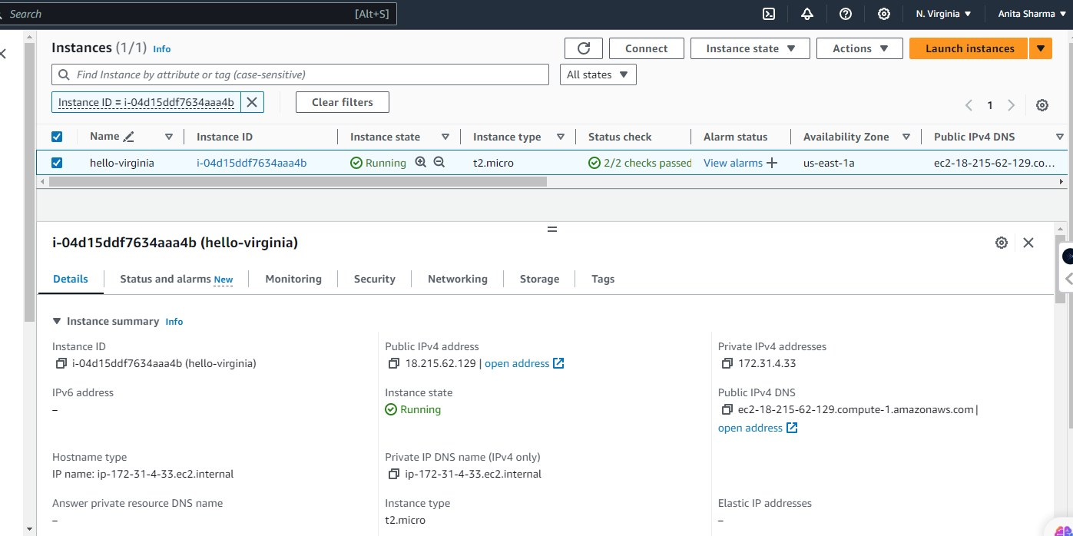
Original dimensions: 1397 × 698 px

Screenshot 02 — word/media/image6.png
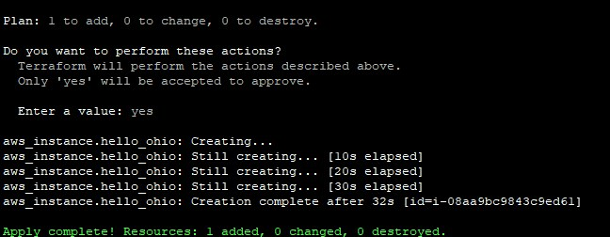
Original dimensions: 648 × 252 px

Screenshot 03 — word/media/image5.png
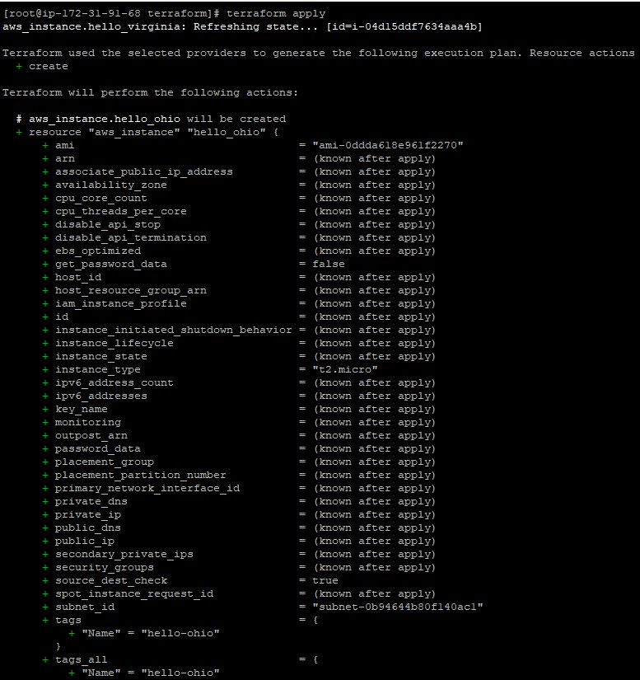
Original dimensions: 777 × 825 px

Screenshot 04 — word/media/image4.png
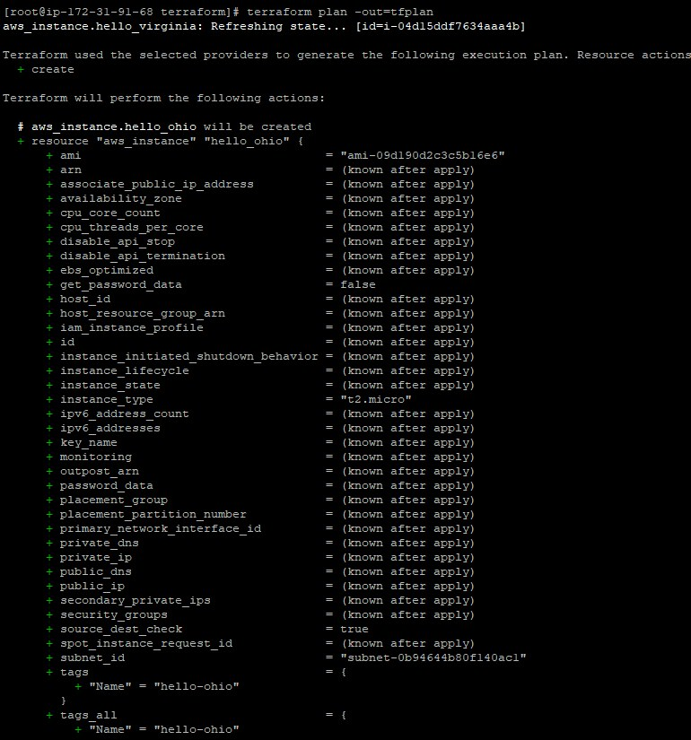
Original dimensions: 770 × 825 px

Screenshot 05 — word/media/image3.png
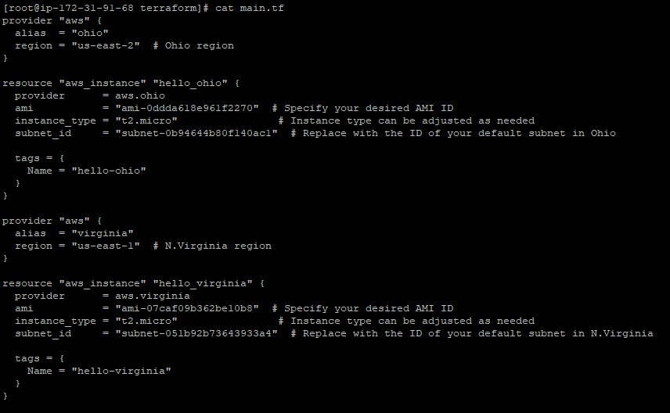
Original dimensions: 856 × 528 px

Screenshot 06 — word/media/image2.png
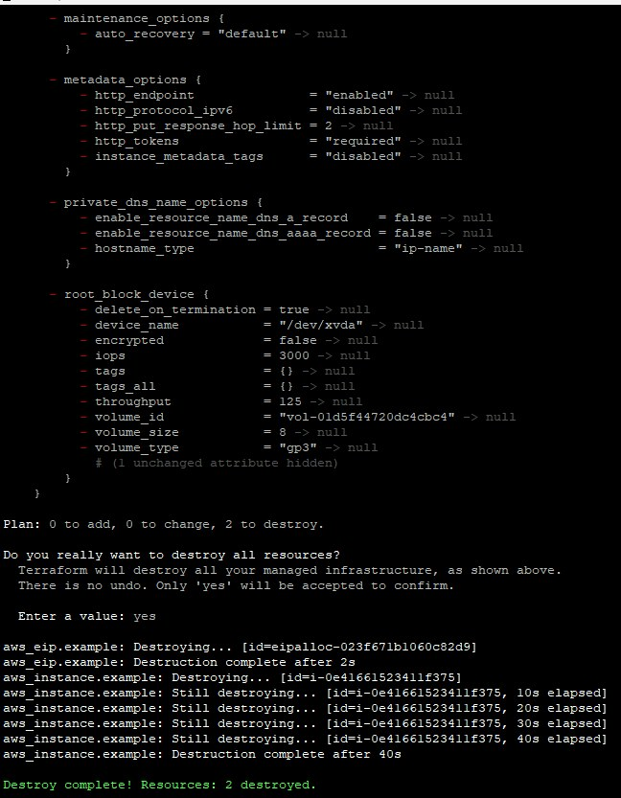
Original dimensions: 648 × 833 px

Screenshot 07 — word/media/image1.png
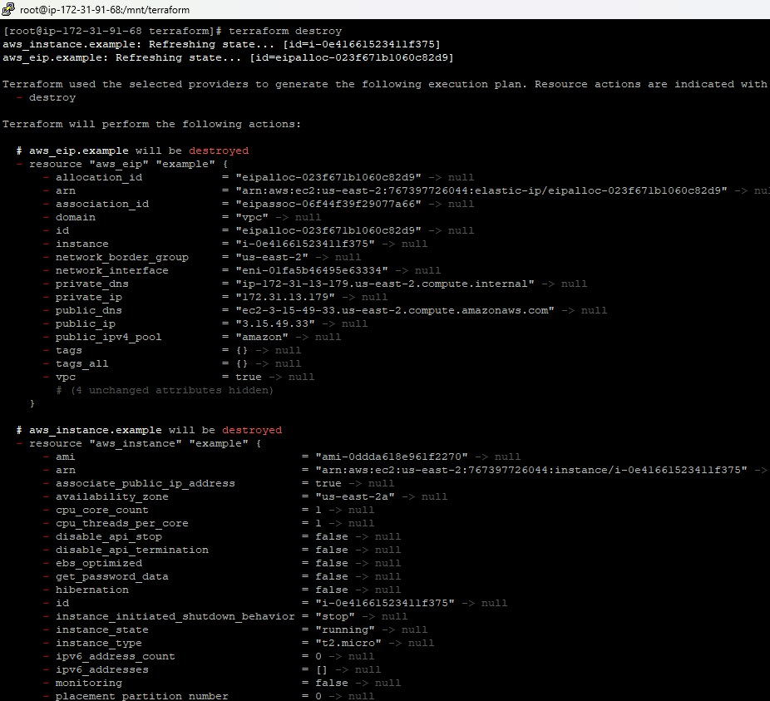
Original dimensions: 926 × 843 px

Screenshot 08 — word/media/image8.png
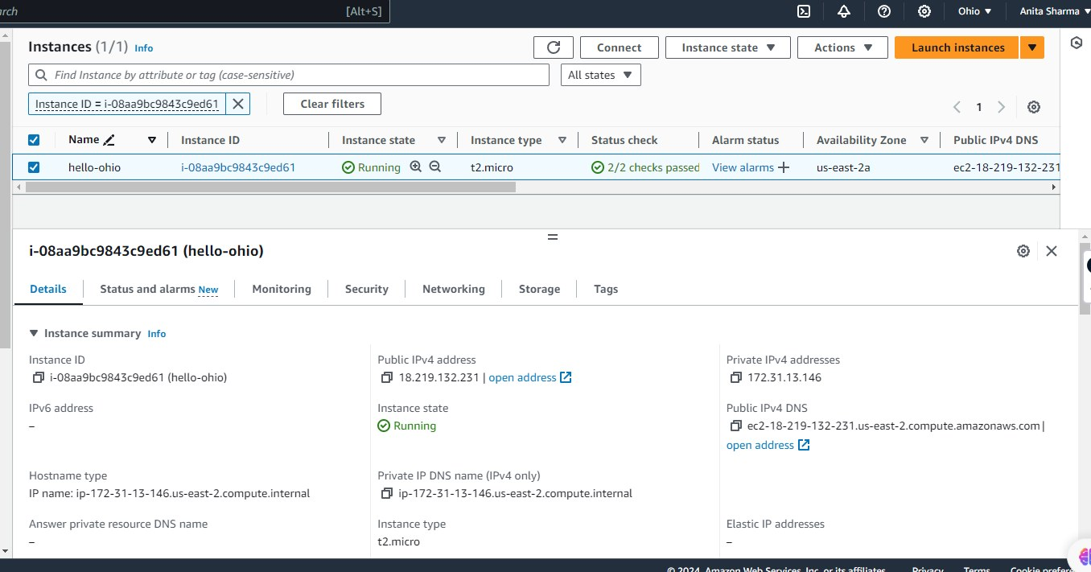
Original dimensions: 1356 × 711 px

terraform_assignment.zip
Source Word document: terraform_assignment/assignment4.docx
Embedded image count extracted: 14

Screenshot 01 — word/media/image9.png
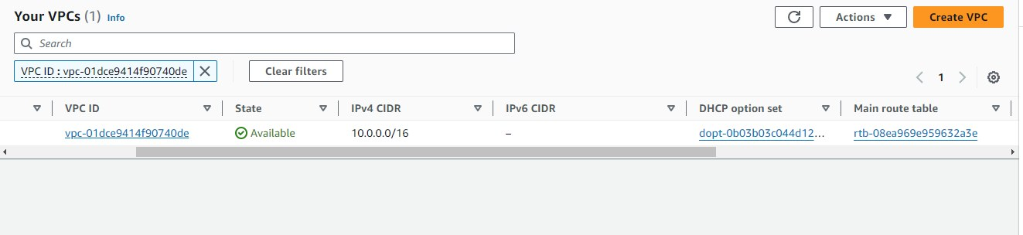
Original dimensions: 1323 × 304 px

Screenshot 02 — word/media/image10.png
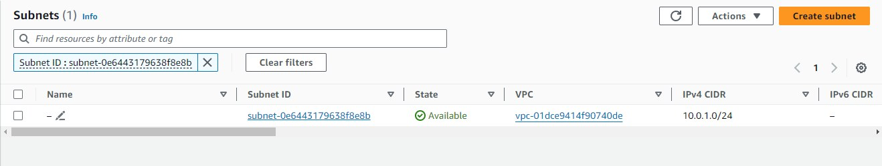
Original dimensions: 1318 × 250 px

Screenshot 03 — word/media/image11.png
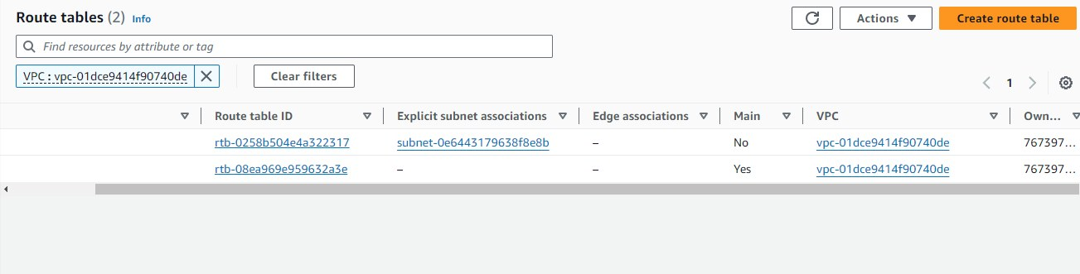
Original dimensions: 1303 × 331 px

Screenshot 04 — word/media/image12.png
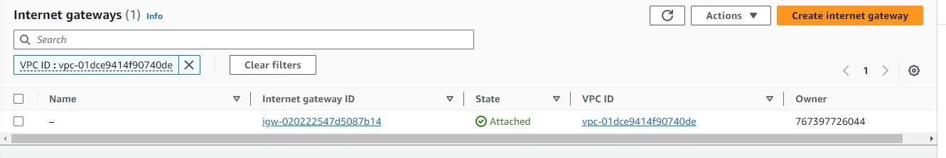
Original dimensions: 1331 × 224 px

Screenshot 05 — word/media/image13.png
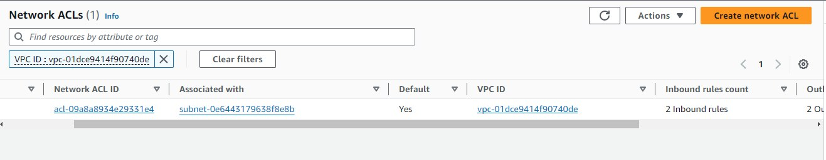
Original dimensions: 1317 × 257 px

Screenshot 06 — word/media/image8.png
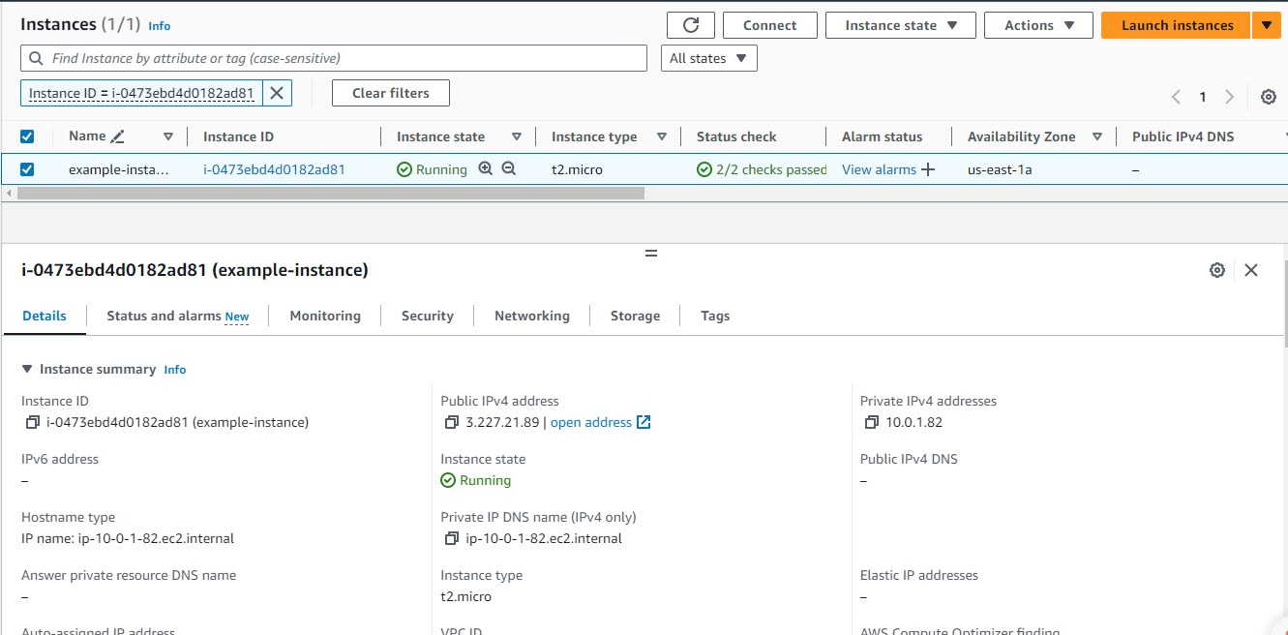
Original dimensions: 1331 × 656 px

Screenshot 07 — word/media/image7.png
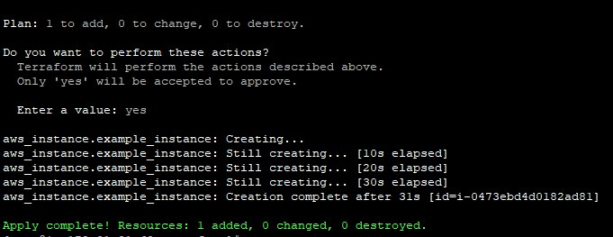
Original dimensions: 681 × 263 px

Screenshot 08 — word/media/image6.png
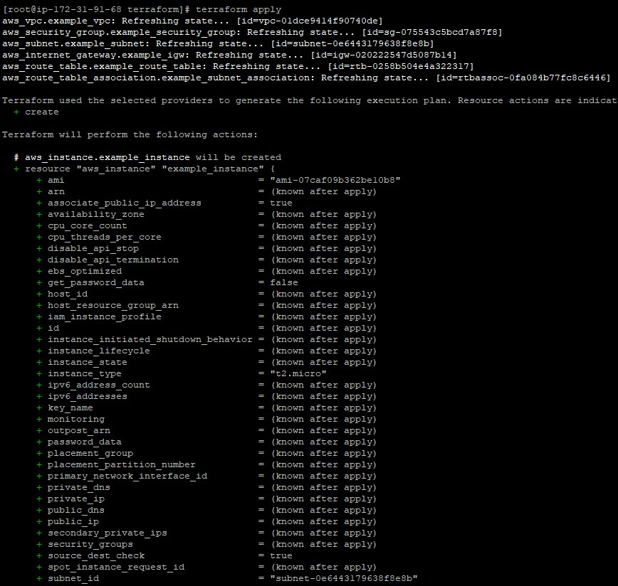
Original dimensions: 868 × 824 px

Screenshot 09 — word/media/image1.png
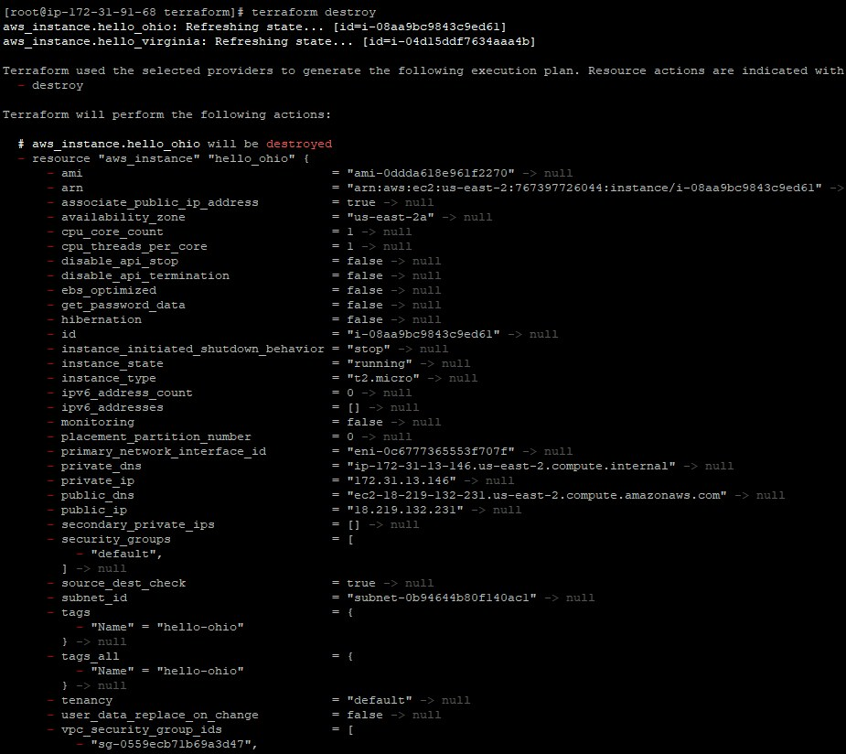
Original dimensions: 925 × 824 px

Screenshot 10 — word/media/image2.png
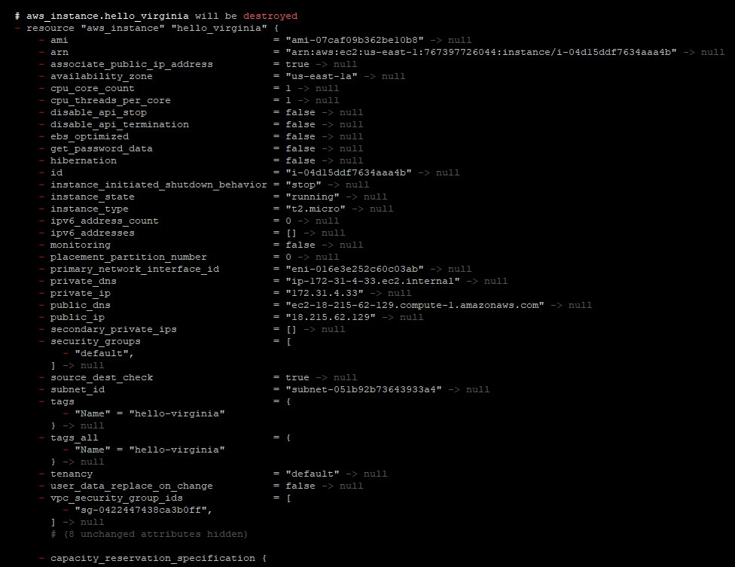
Original dimensions: 976 × 753 px

Screenshot 11 — word/media/image3.png
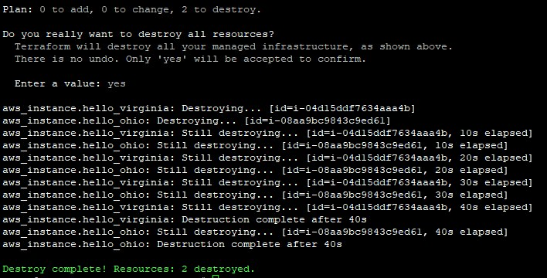
Original dimensions: 708 × 360 px

Screenshot 12 — word/media/image4.png
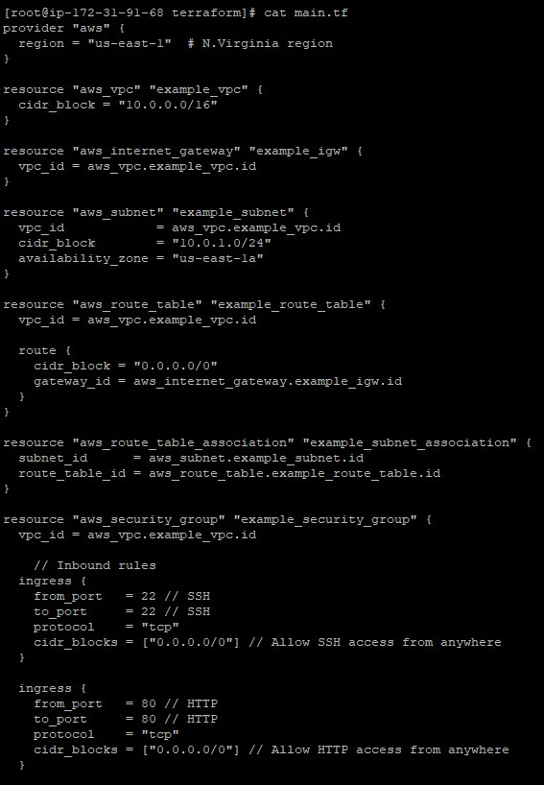
Original dimensions: 567 × 818 px

Screenshot 13 — word/media/image5.png
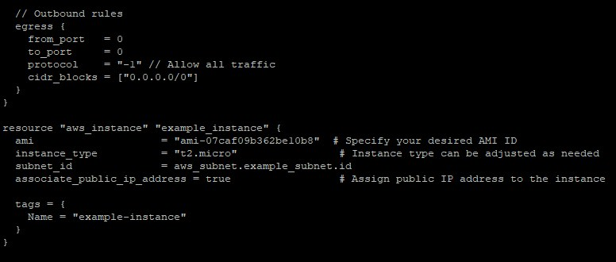
Original dimensions: 776 × 330 px

Screenshot 14 — word/media/image14.png
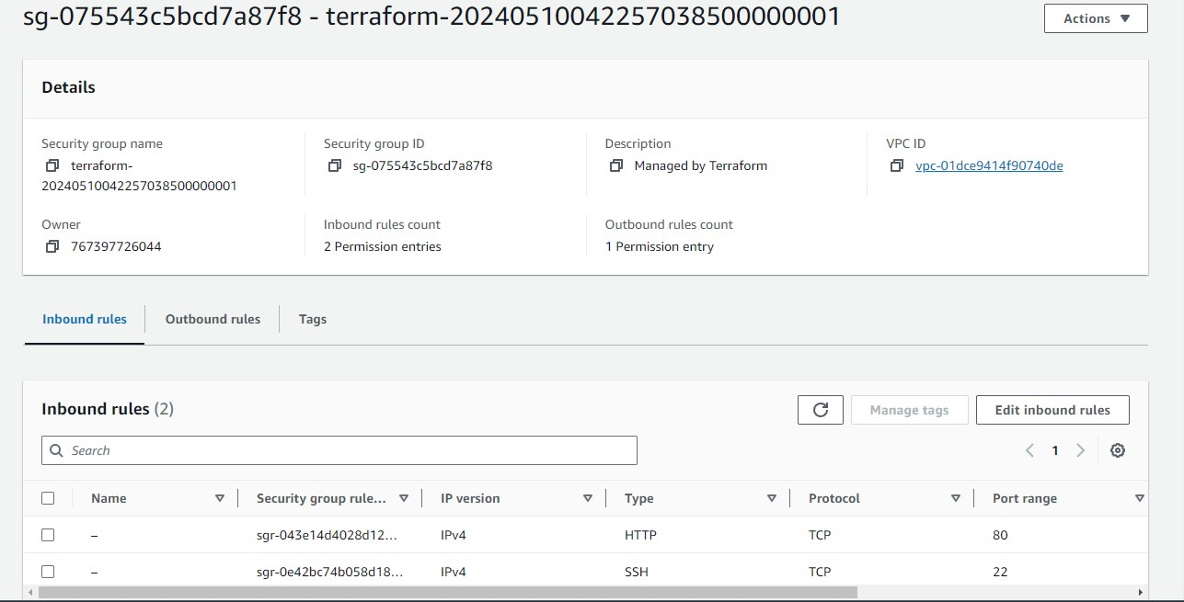
Original dimensions: 1287 × 655 px

terraform_assignment.zip
Source Word document: terraform_assignment/assignment5.docx
Embedded image count extracted: 8

Screenshot 01 — word/media/image8.png
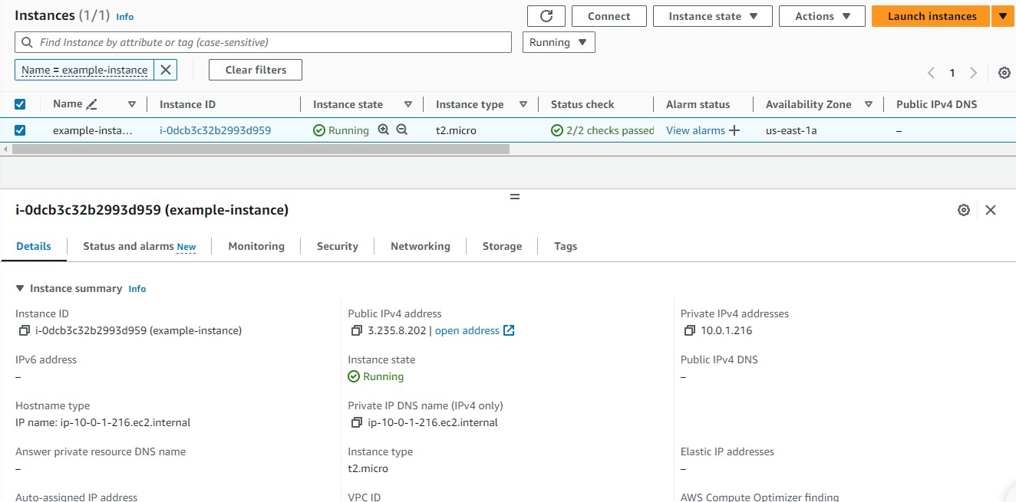
Original dimensions: 1324 × 655 px

Screenshot 02 — word/media/image7.png
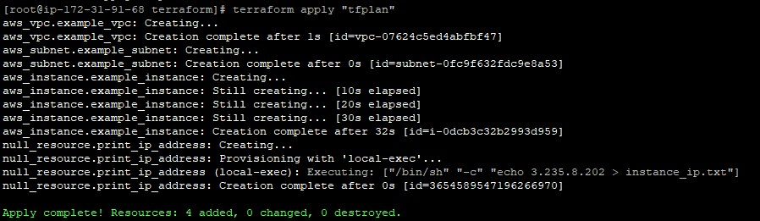
Original dimensions: 898 × 261 px

Screenshot 03 — word/media/image6.png
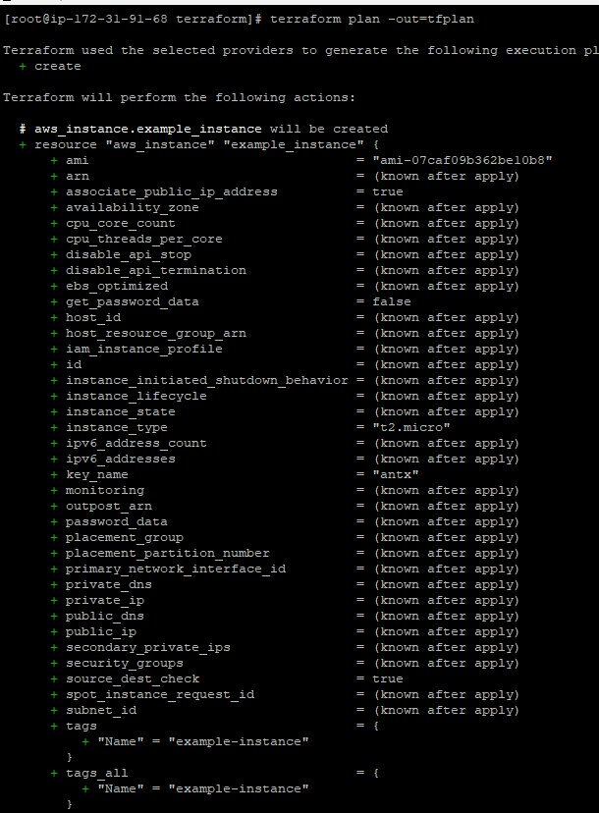
Original dimensions: 610 × 828 px

Screenshot 04 — word/media/image5.png
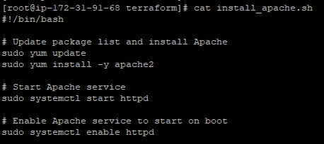
Original dimensions: 458 × 204 px

Screenshot 05 — word/media/image4.png
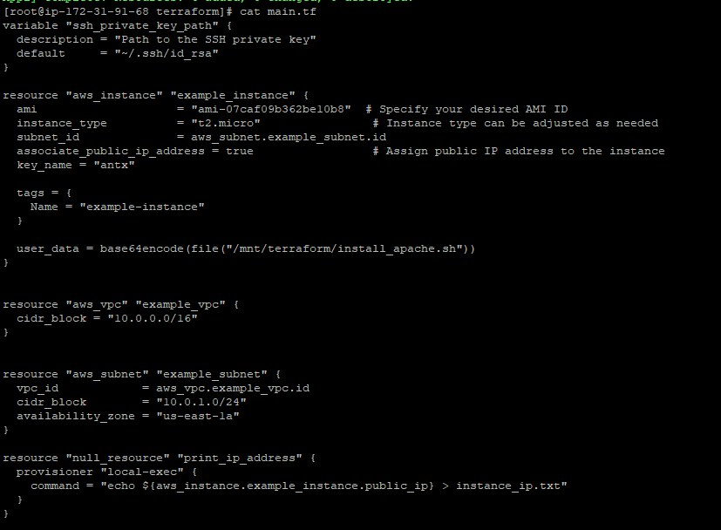
Original dimensions: 827 × 608 px

Screenshot 06 — word/media/image3.png
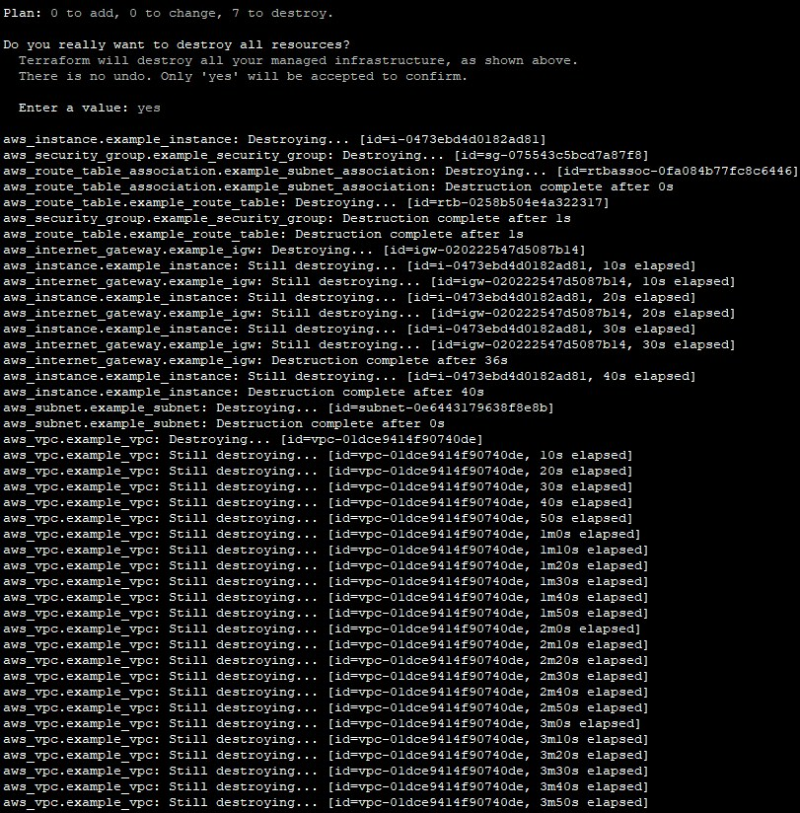
Original dimensions: 811 × 824 px

Screenshot 07 — word/media/image2.png
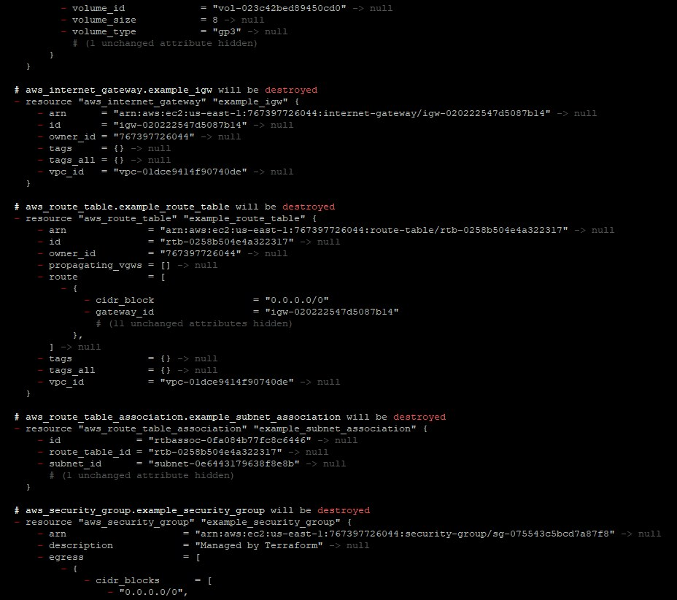
Original dimensions: 928 × 822 px

Screenshot 08 — word/media/image1.png
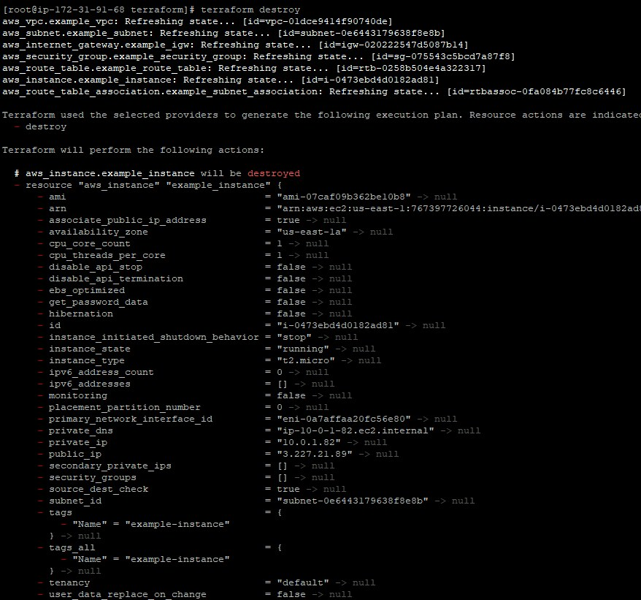
Original dimensions: 878 × 821 px

terraform_assignment.zip
Source Word document: terraform_assignment/assignment-casestudy.docx
Embedded image count extracted: 11

Screenshot 01 — word/media/image7.png
Original dimensions: 1332 × 665 px

Screenshot 02 — word/media/image8.png
Original dimensions: 1333 × 663 px

Screenshot 03 — word/media/image9.png
Original dimensions: 1323 × 660 px

Screenshot 04 — word/media/image10.png
Original dimensions: 1361 × 552 px

Screenshot 05 — word/media/image6.png
Original dimensions: 1340 × 662 px

Screenshot 06 — word/media/image5.png
Original dimensions: 727 × 374 px

Screenshot 07 — word/media/image4.png
Original dimensions: 708 × 826 px

Screenshot 08 — word/media/image3.png
Original dimensions: 843 × 822 px

Screenshot 09 — word/media/image2.png
Original dimensions: 482 × 205 px

Screenshot 10 — word/media/image1.png
Original dimensions: 793 × 755 px

Screenshot 11 — word/media/image11.png
Original dimensions: 1320 × 667 px

amazoniamandcloudwatch.zip
Source Word document: amazoniamandcloudwatch/assignment1.docx
Embedded image count extracted: 4

Screenshot 01 — word/media/image4.png
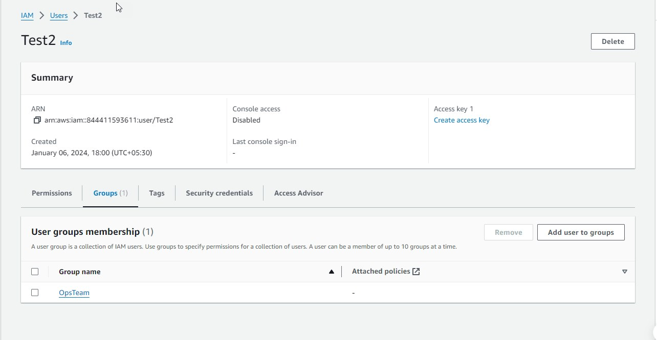
Original dimensions: 1284 × 666 px

Screenshot 02 — word/media/image1.png
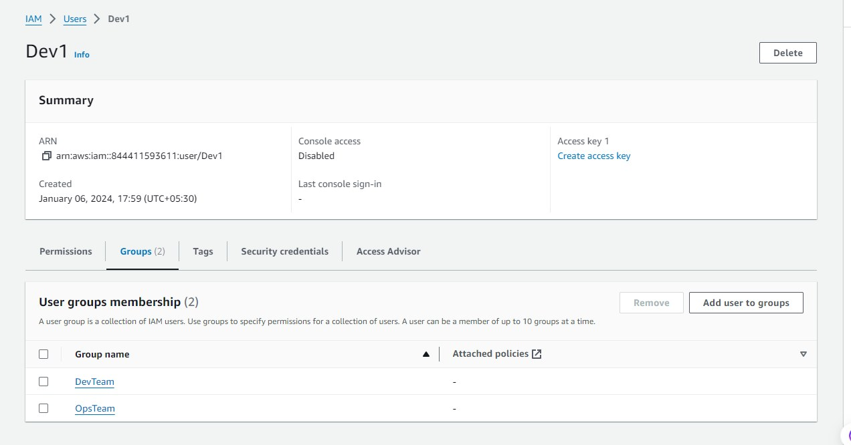
Original dimensions: 1272 × 666 px

Screenshot 03 — word/media/image2.png
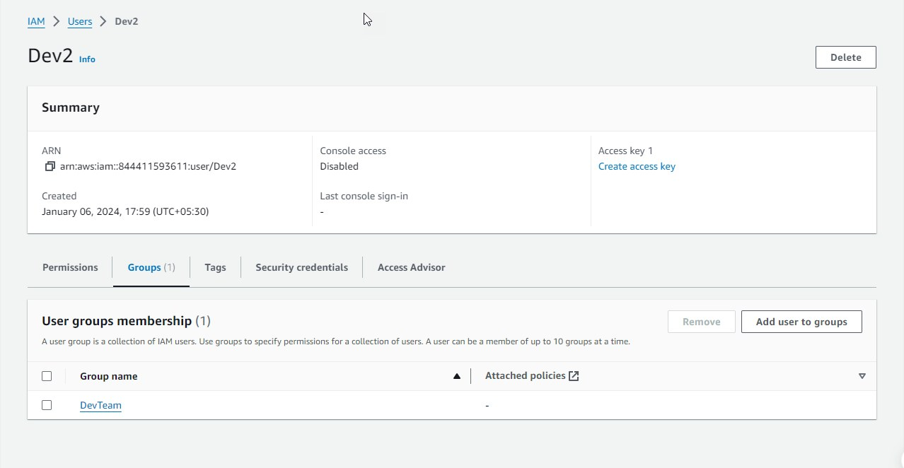
Original dimensions: 1278 × 662 px

Screenshot 04 — word/media/image3.png
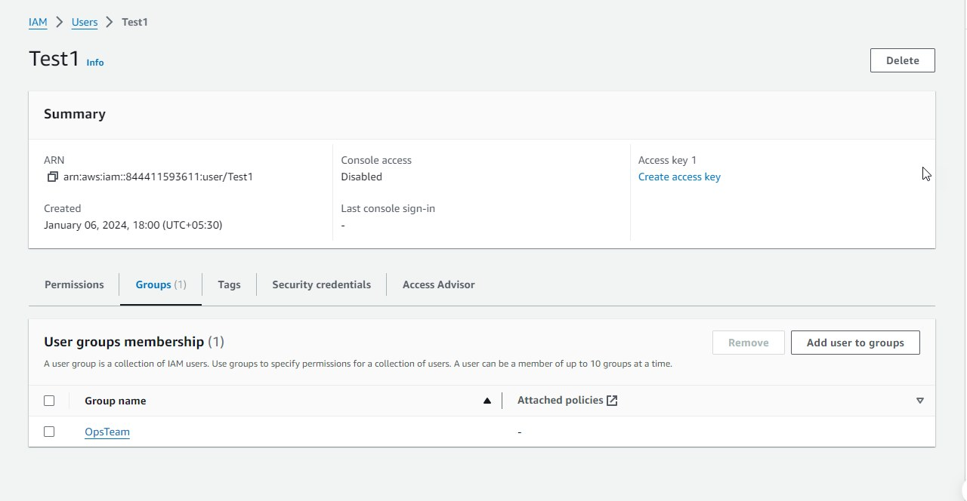
Original dimensions: 1280 × 664 px

amazoniamandcloudwatch.zip
Source Word document: amazoniamandcloudwatch/assignment2.docx
Embedded image count extracted: 4

Screenshot 01 — word/media/image4.png
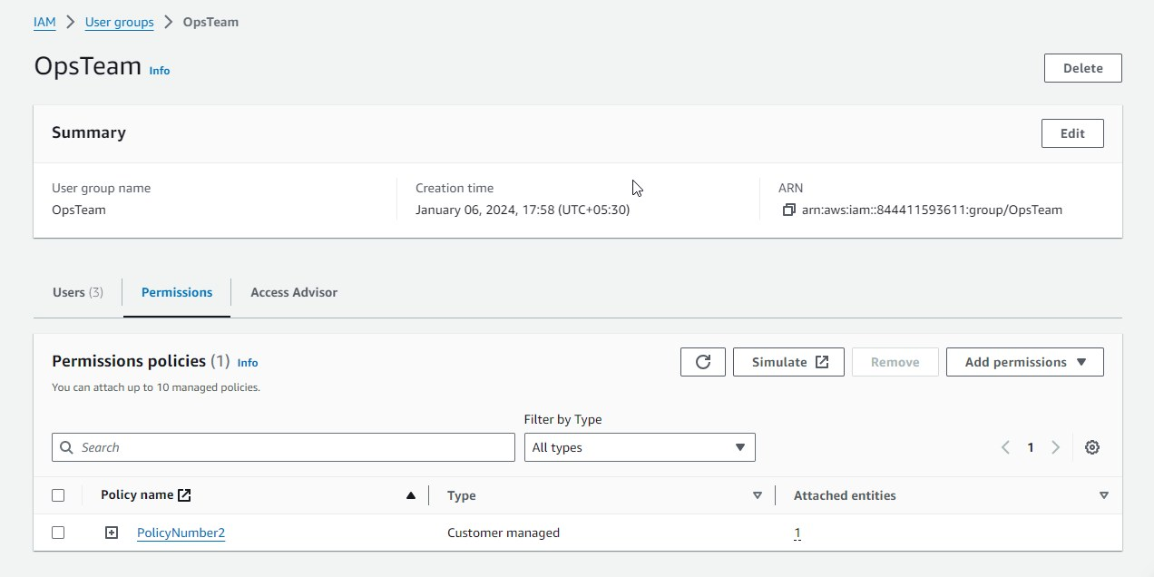
Original dimensions: 1272 × 636 px

Screenshot 02 — word/media/image1.png
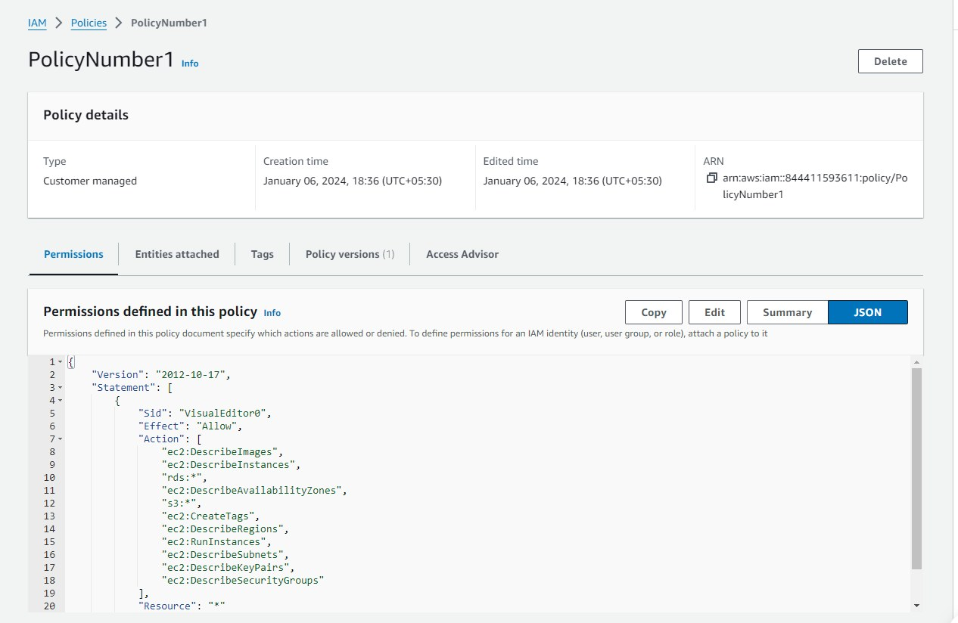
Original dimensions: 1266 × 824 px

Screenshot 03 — word/media/image2.png
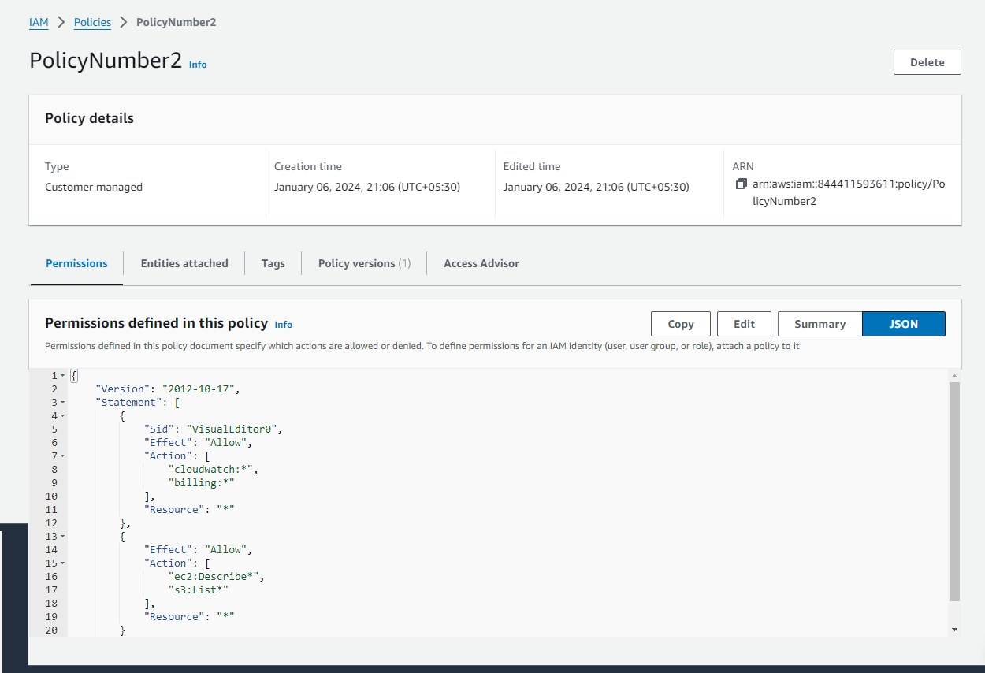
Original dimensions: 1250 × 854 px

Screenshot 04 — word/media/image3.png
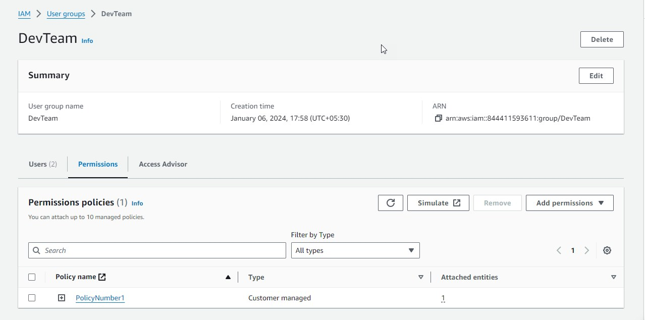
Original dimensions: 1278 × 634 px

amazoniamandcloudwatch.zip
Source Word document: amazoniamandcloudwatch/assignment3.docx
Embedded image count extracted: 9

Screenshot 01 — word/media/image9.png
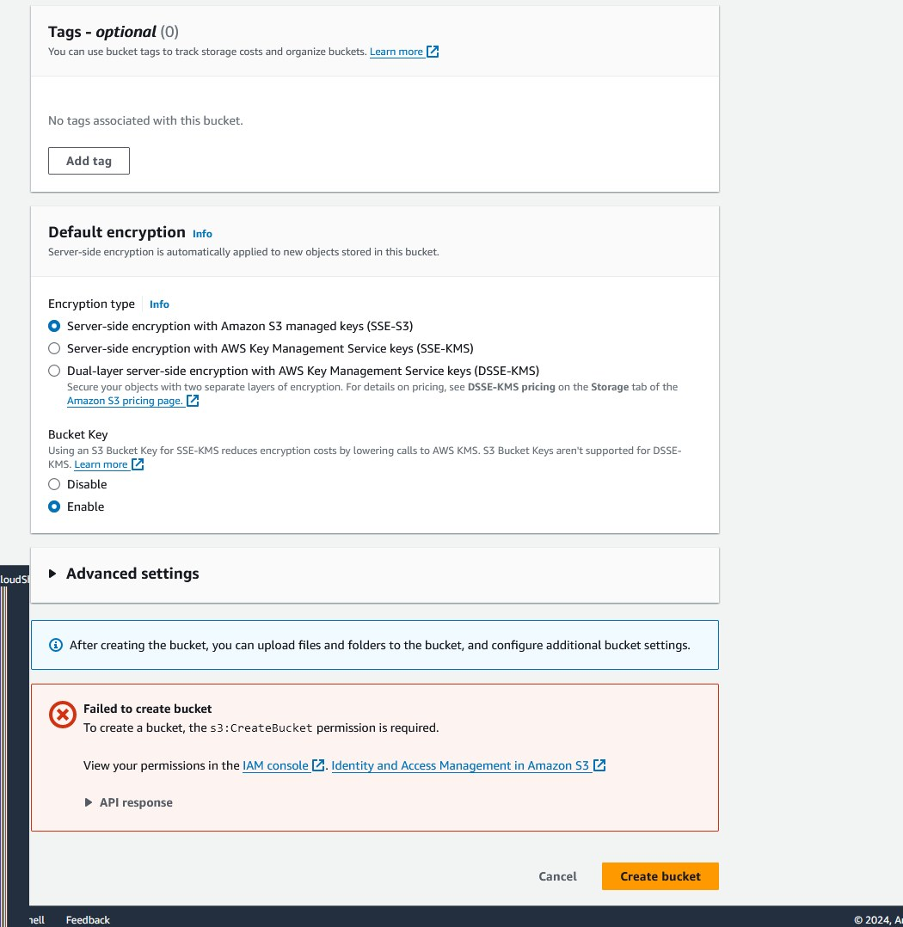
Original dimensions: 1050 × 1078 px

Screenshot 02 — word/media/image7.png
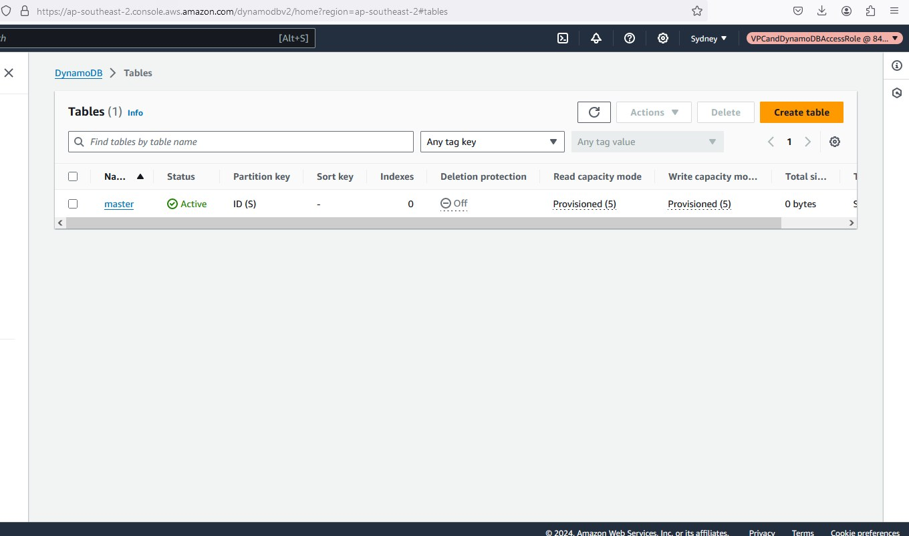
Original dimensions: 1360 × 802 px

Screenshot 03 — word/media/image6.png
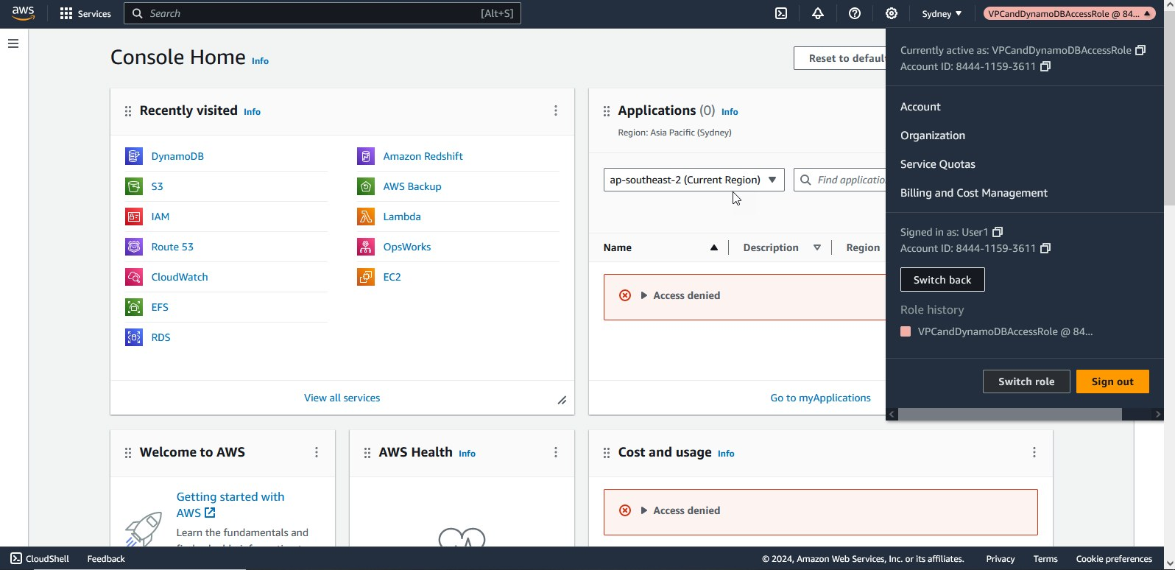
Original dimensions: 1596 × 774 px

Screenshot 04 — word/media/image5.png
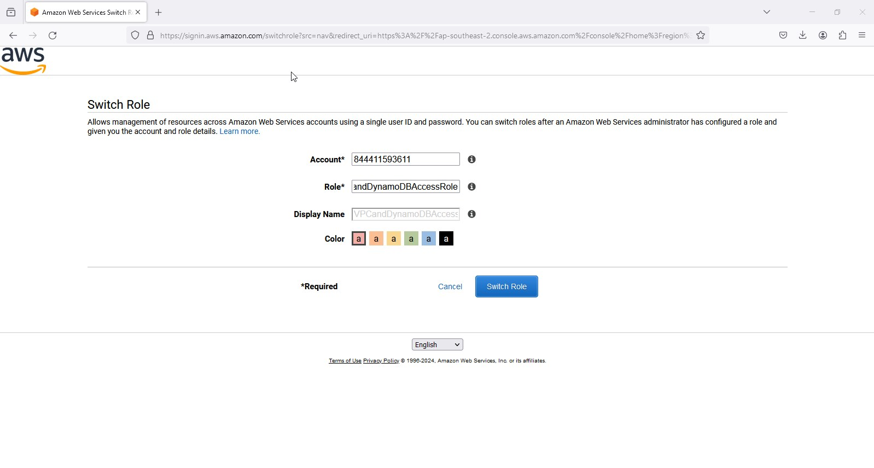
Original dimensions: 1598 × 856 px

Screenshot 05 — word/media/image4.png
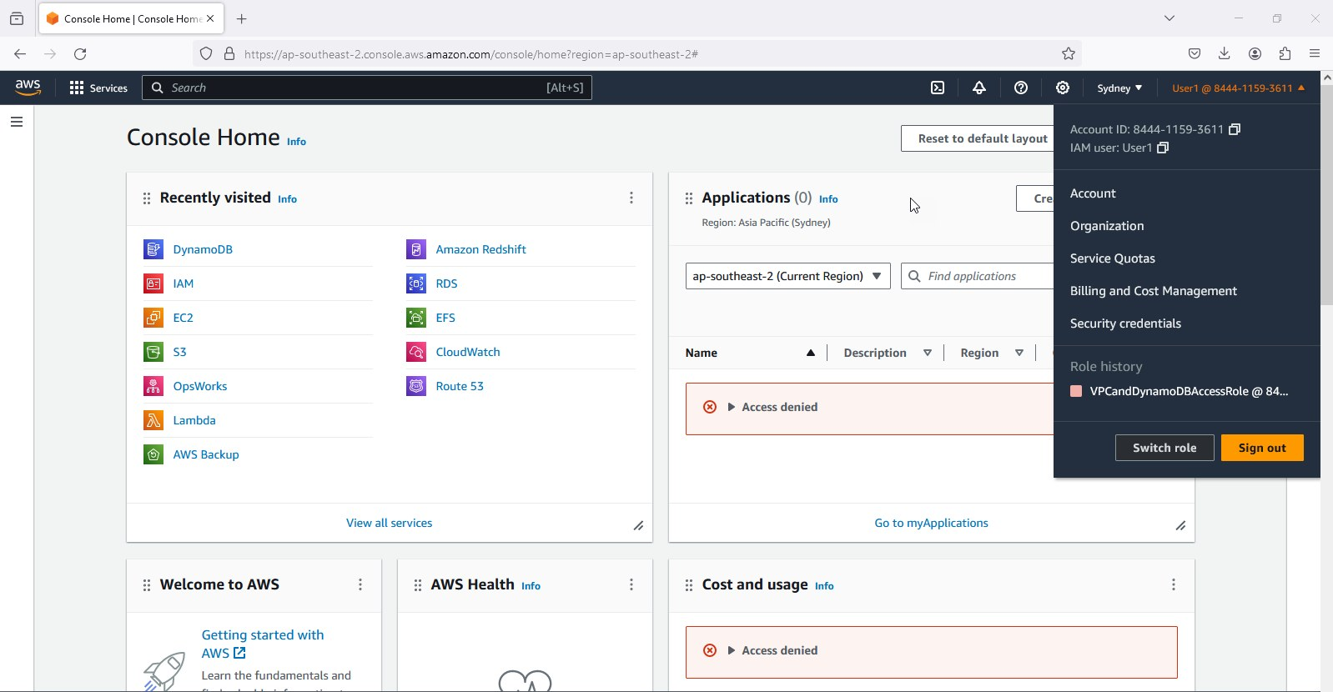
Original dimensions: 1598 × 830 px

Screenshot 06 — word/media/image3.png
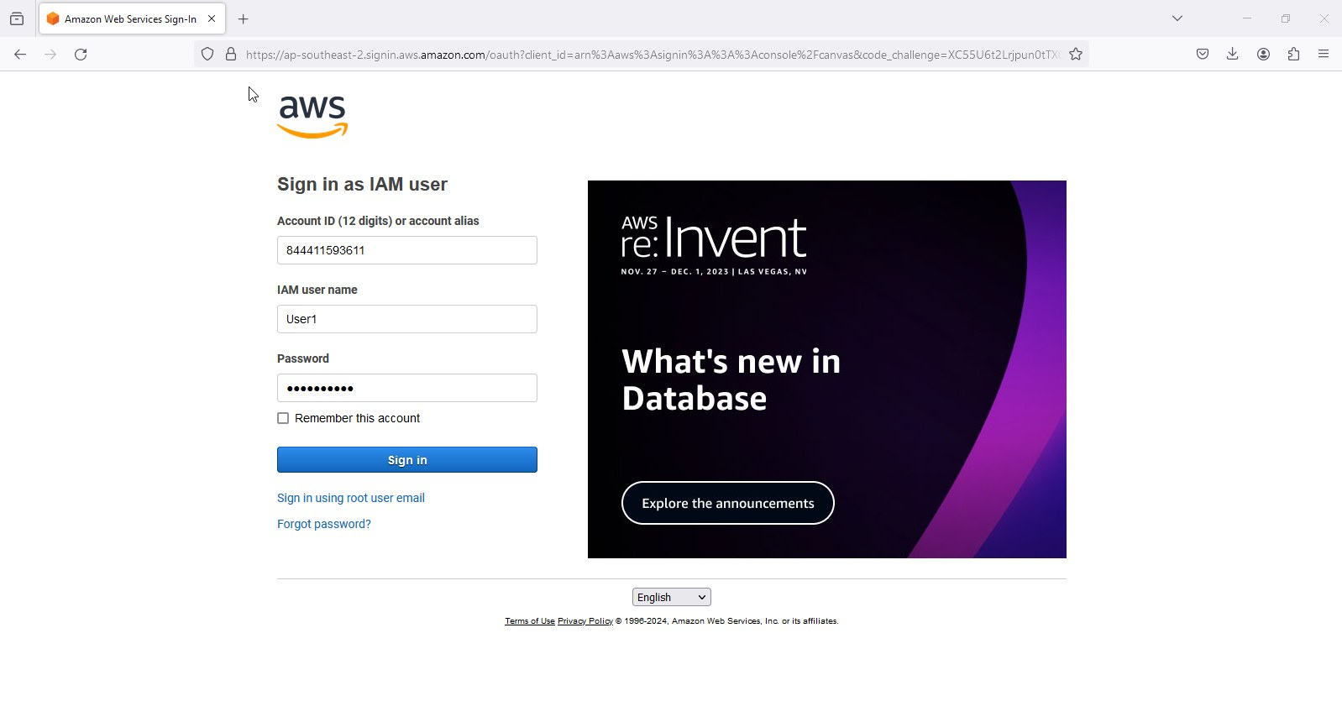
Original dimensions: 1598 × 860 px

Screenshot 07 — word/media/image2.png
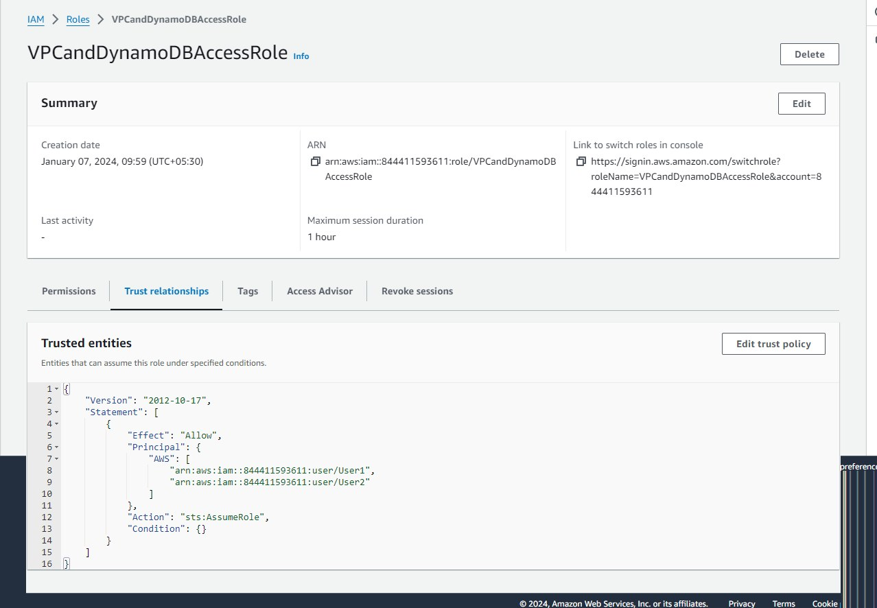
Original dimensions: 1278 × 886 px

Screenshot 08 — word/media/image1.png
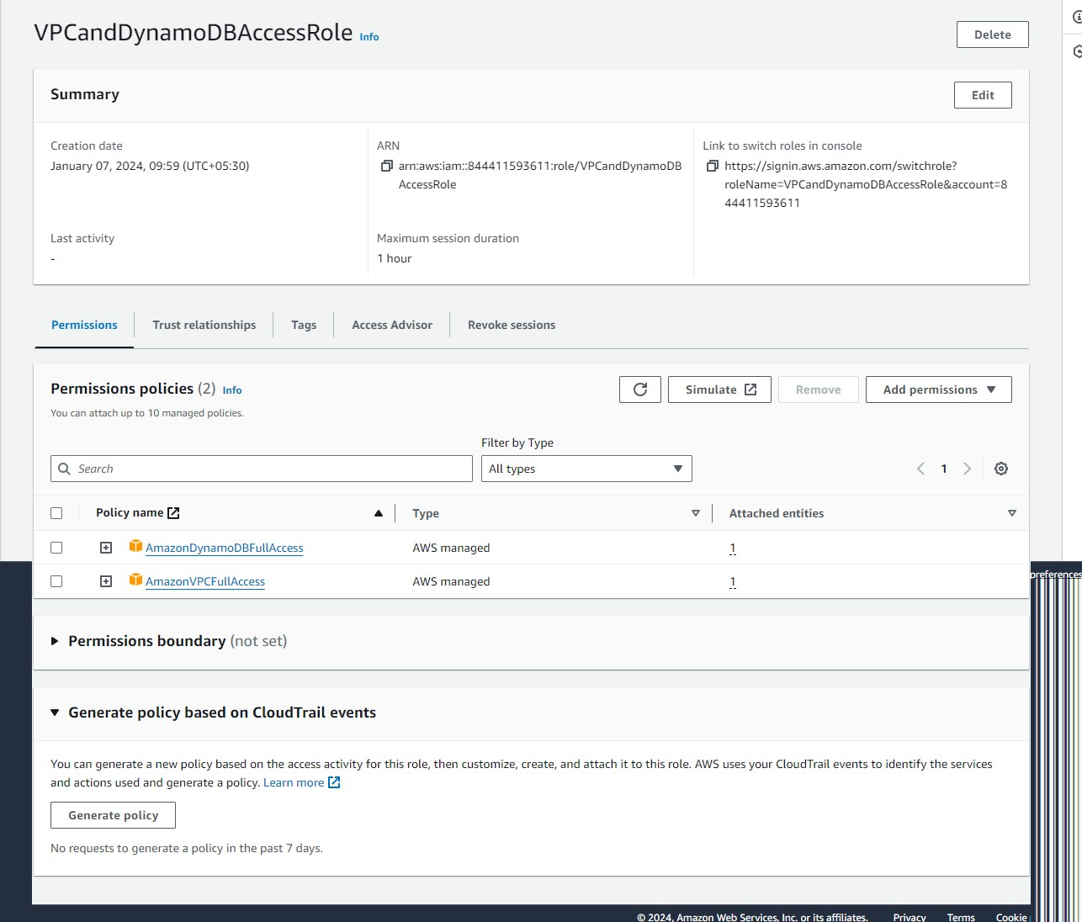
Original dimensions: 1286 × 1096 px

Screenshot 09 — word/media/image8.png
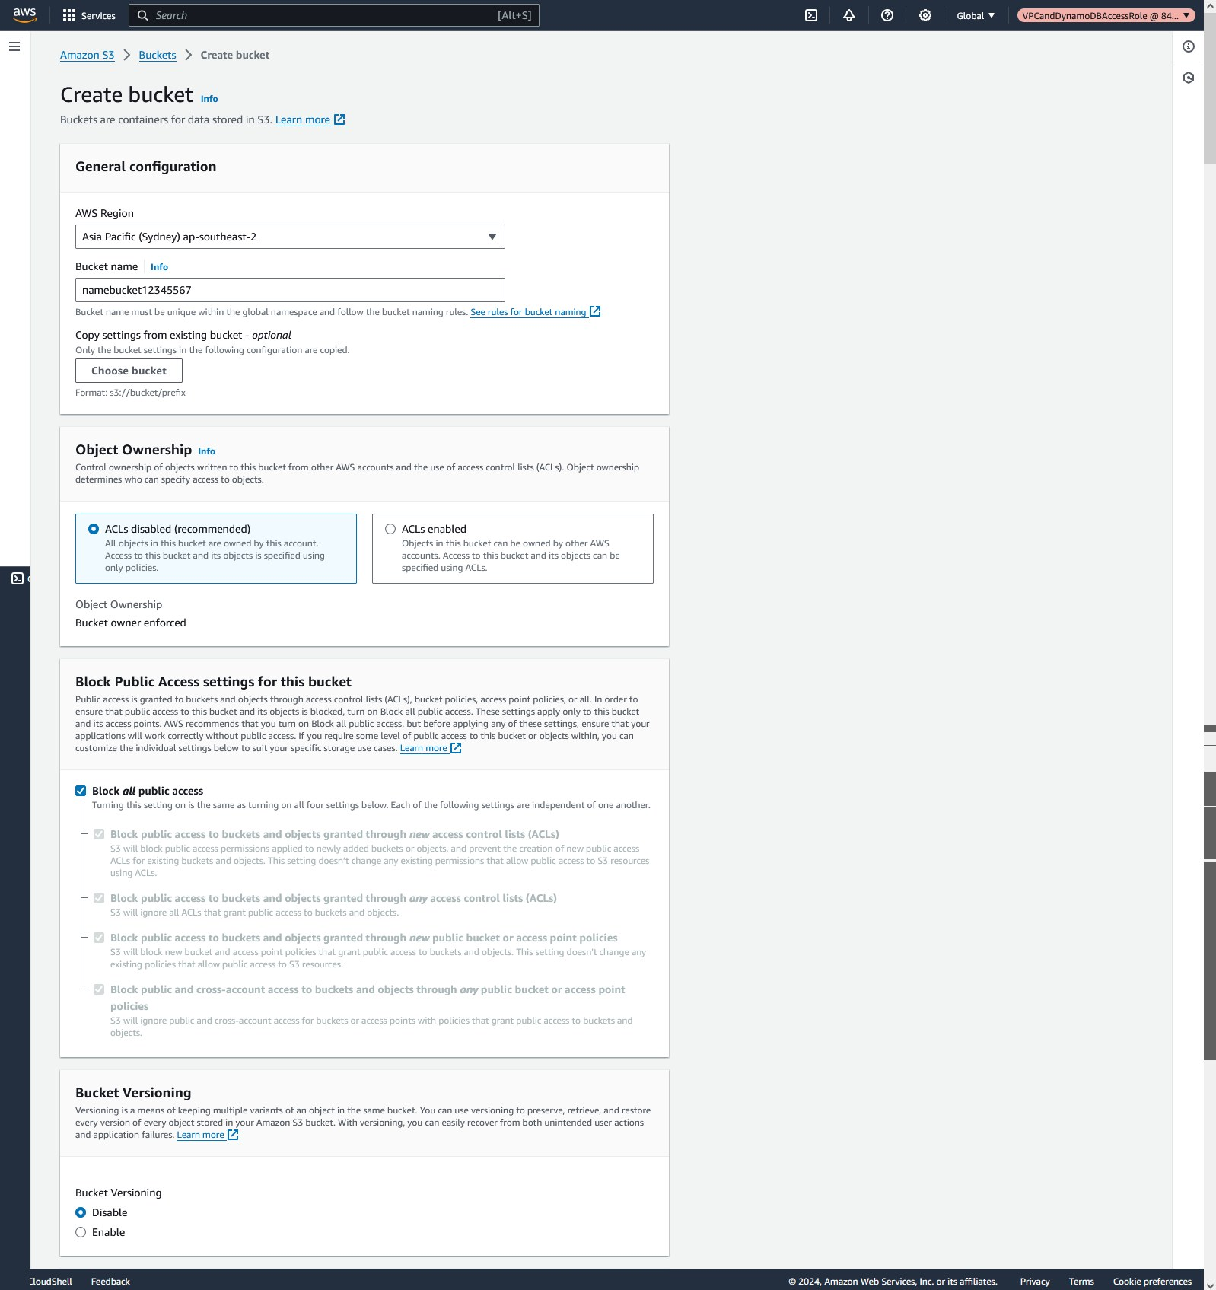
Original dimensions: 1598 × 1695 px

amazoniamandcloudwatch.zip
Source Word document: amazoniamandcloudwatch/assignment4.docx
Embedded image count extracted: 2

Screenshot 01 — word/media/image2.png
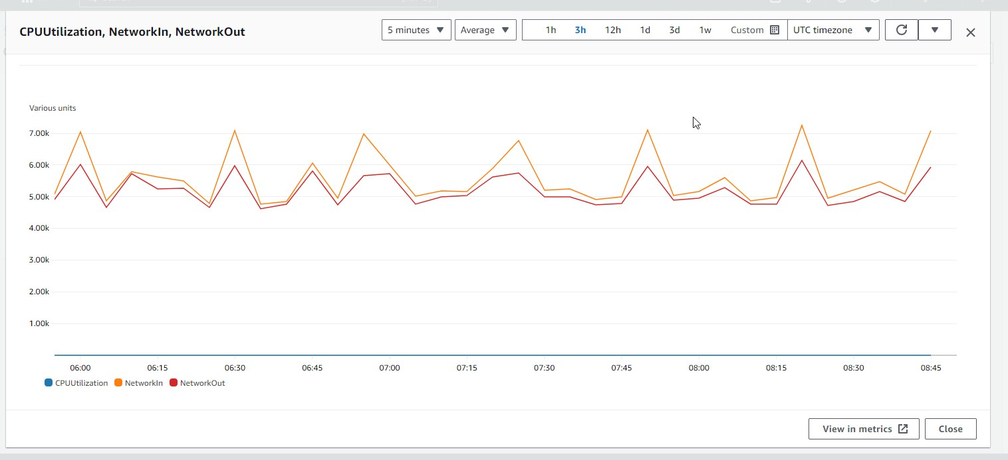
Original dimensions: 1516 × 694 px

Screenshot 02 — word/media/image1.png
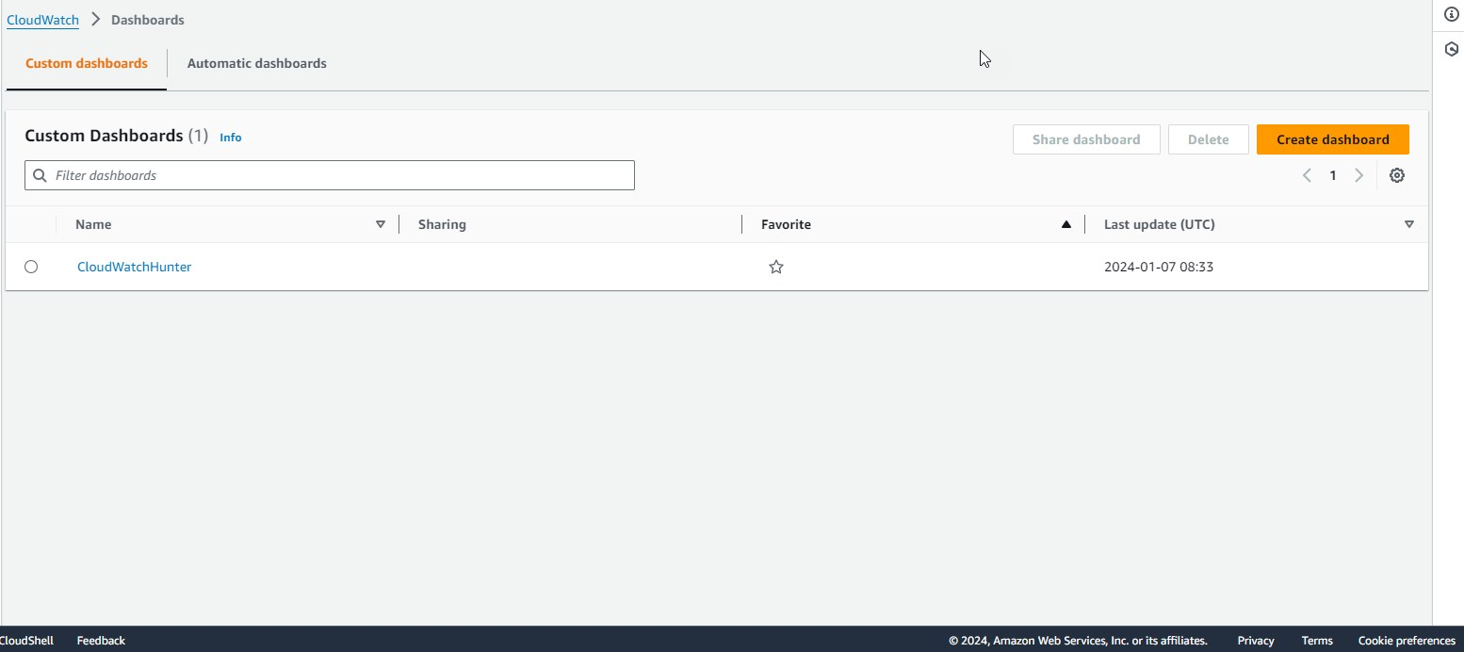
Original dimensions: 1554 × 692 px

amazoniamandcloudwatch.zip
Source Word document: amazoniamandcloudwatch/assignment5.docx
Embedded image count extracted: 2

Screenshot 01 — word/media/image2.png
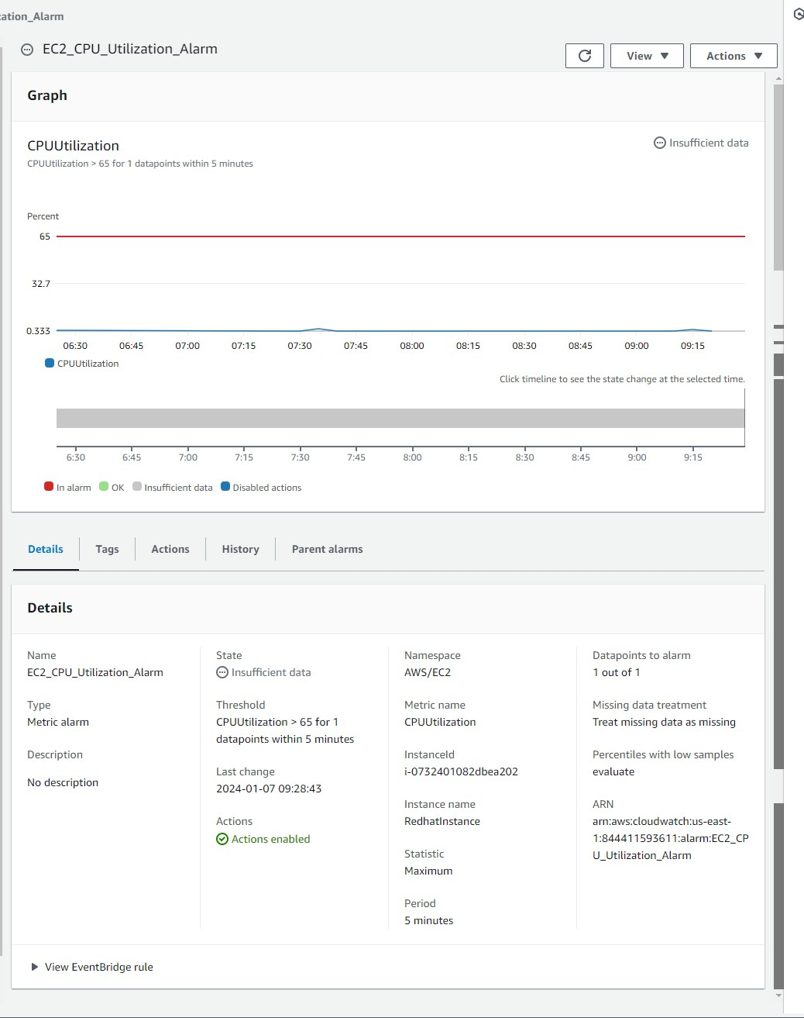
Original dimensions: 1038 × 1313 px

Screenshot 02 — word/media/image1.png
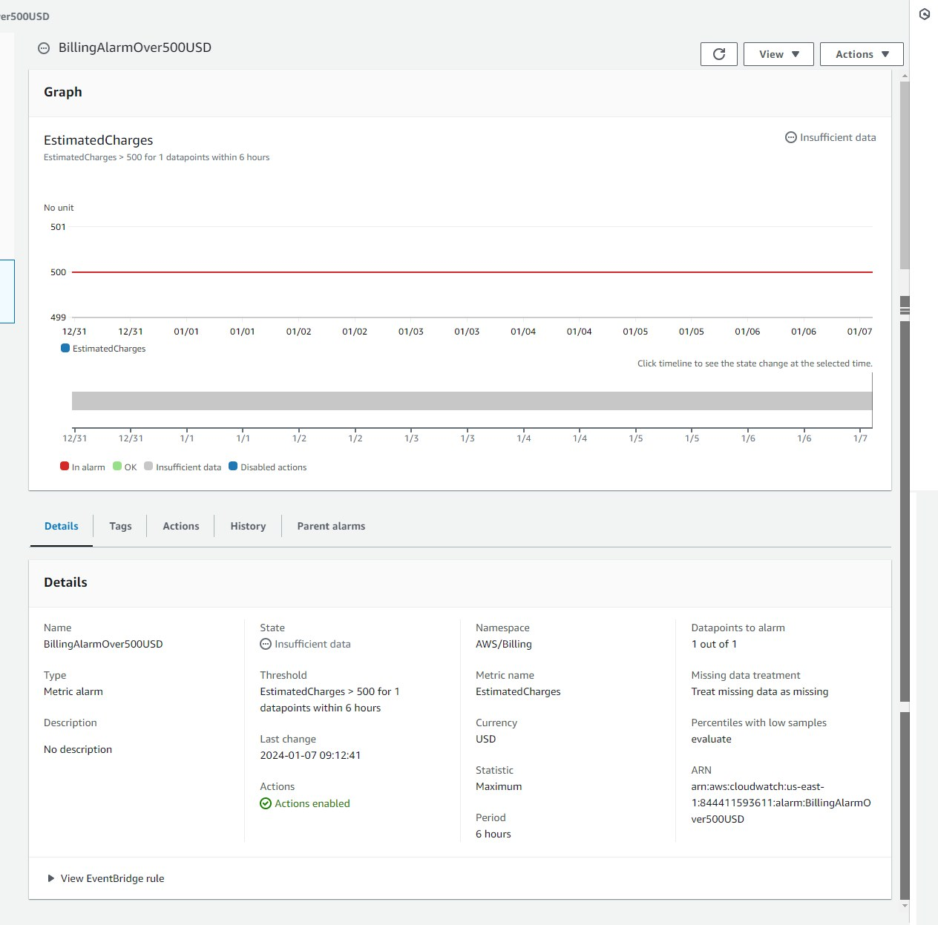
Original dimensions: 1264 × 1247 px

docker_assignment.zip
Source Word document: docker_assignment/assignment_1.docx
Embedded image count extracted: 4

Screenshot 01 — word/media/image5.png
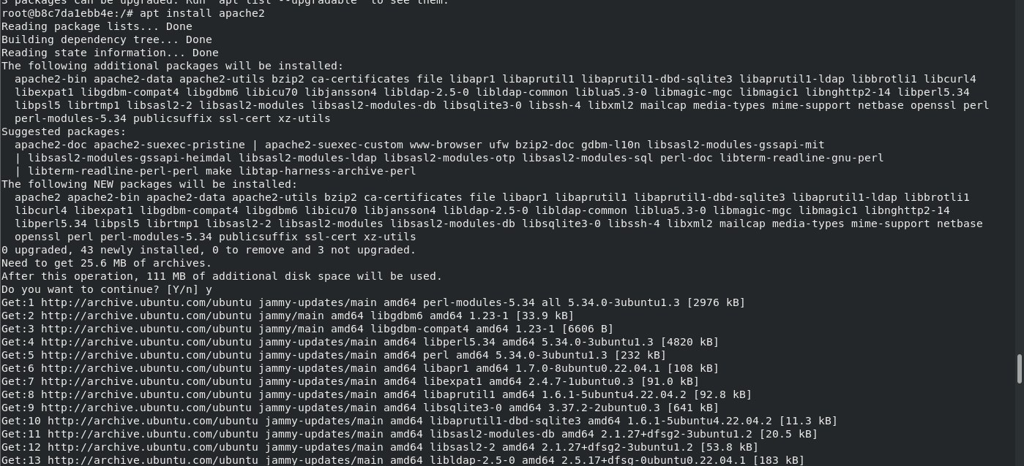
Original dimensions: 1399 × 638 px

Screenshot 02 — word/media/image4.png
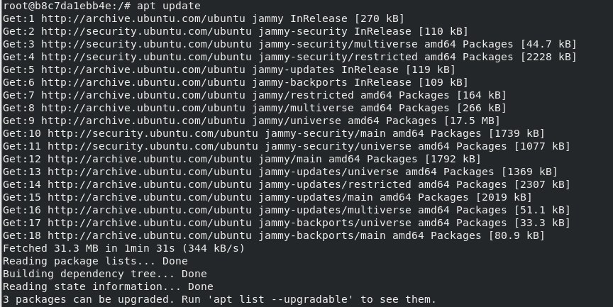
Original dimensions: 864 × 433 px

Screenshot 03 — word/media/image1.png
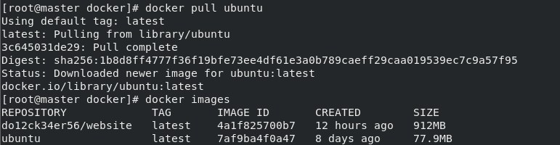
Original dimensions: 771 × 200 px

Screenshot 04 — word/media/image6.png
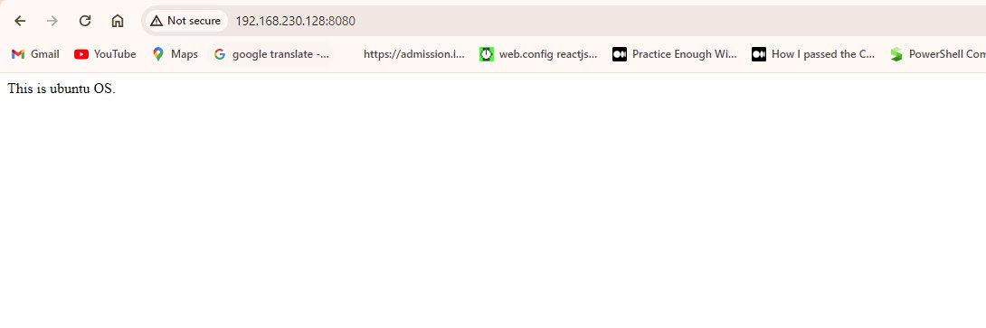
Original dimensions: 1090 × 363 px

docker_assignment.zip
Source Word document: docker_assignment/assignment_10.docx
Embedded image count extracted: 3

Screenshot 01 — word/media/image1.png
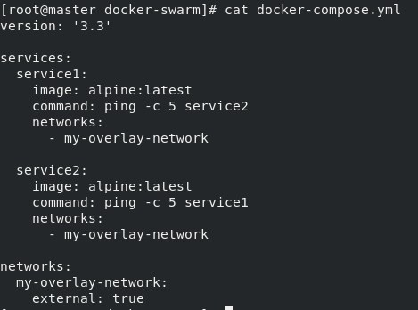
Original dimensions: 469 × 348 px

Screenshot 02 — word/media/image3.png
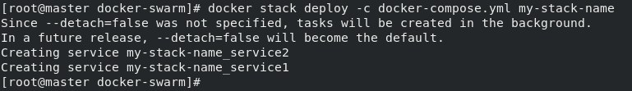
Original dimensions: 769 × 111 px

Screenshot 03 — word/media/image4.png
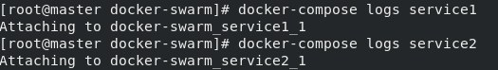
Original dimensions: 525 × 74 px

docker_assignment.zip
Source Word document: docker_assignment/assignment_2.docx
Embedded image count extracted: 6

Screenshot 01 — word/media/image7.png
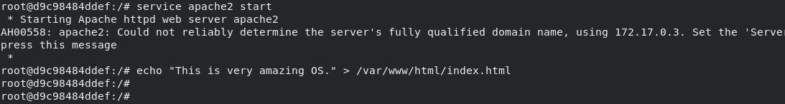
Original dimensions: 1093 × 146 px

Screenshot 02 — word/media/image6.png
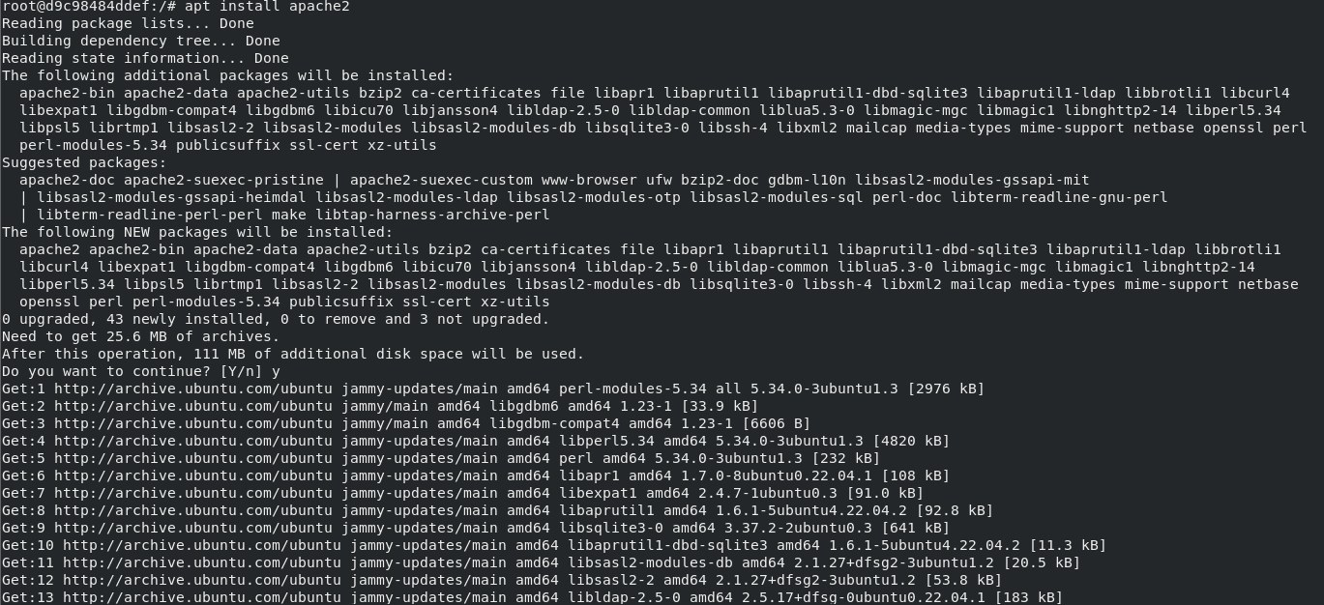
Original dimensions: 1369 × 626 px

Screenshot 03 — word/media/image5.png
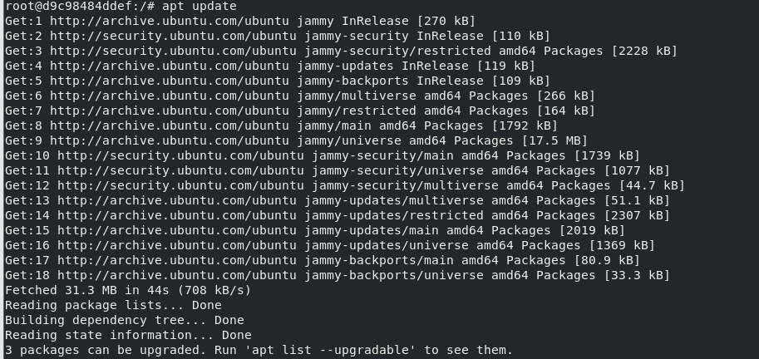
Original dimensions: 913 × 432 px

Screenshot 04 — word/media/image3.png
Original dimensions: 1212 × 74 px

Screenshot 05 — word/media/image1.png
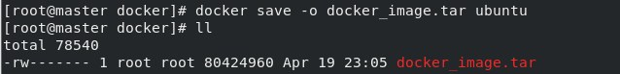
Original dimensions: 638 × 77 px

Screenshot 06 — word/media/image8.png
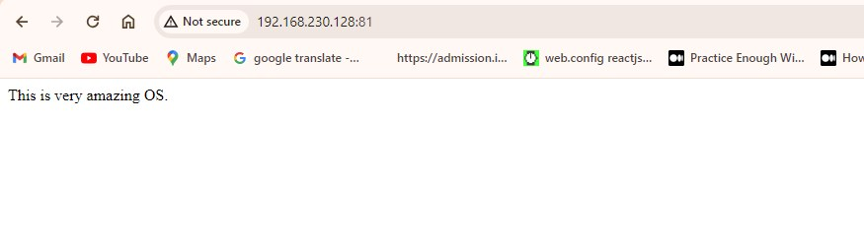
Original dimensions: 875 × 249 px

docker_assignment.zip
Source Word document: docker_assignment/assignment_3.docx
Embedded image count extracted: 6

Screenshot 01 — word/media/image9.png
Original dimensions: 1400 × 127 px

Screenshot 02 — word/media/image7.png
Original dimensions: 1398 × 94 px

Screenshot 03 — word/media/image4.png
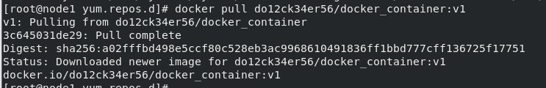
Original dimensions: 743 × 120 px

Screenshot 04 — word/media/image3.png
Original dimensions: 892 × 75 px

Screenshot 05 — word/media/image2.png
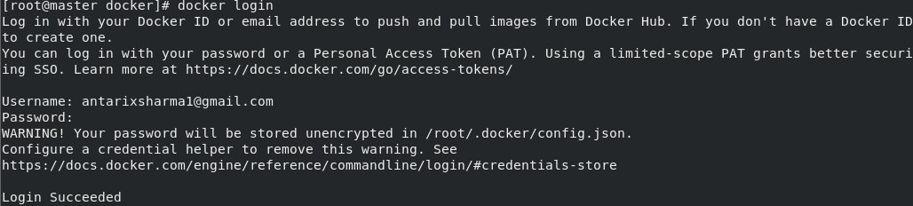
Original dimensions: 1028 × 232 px

Screenshot 06 — word/media/image10.png
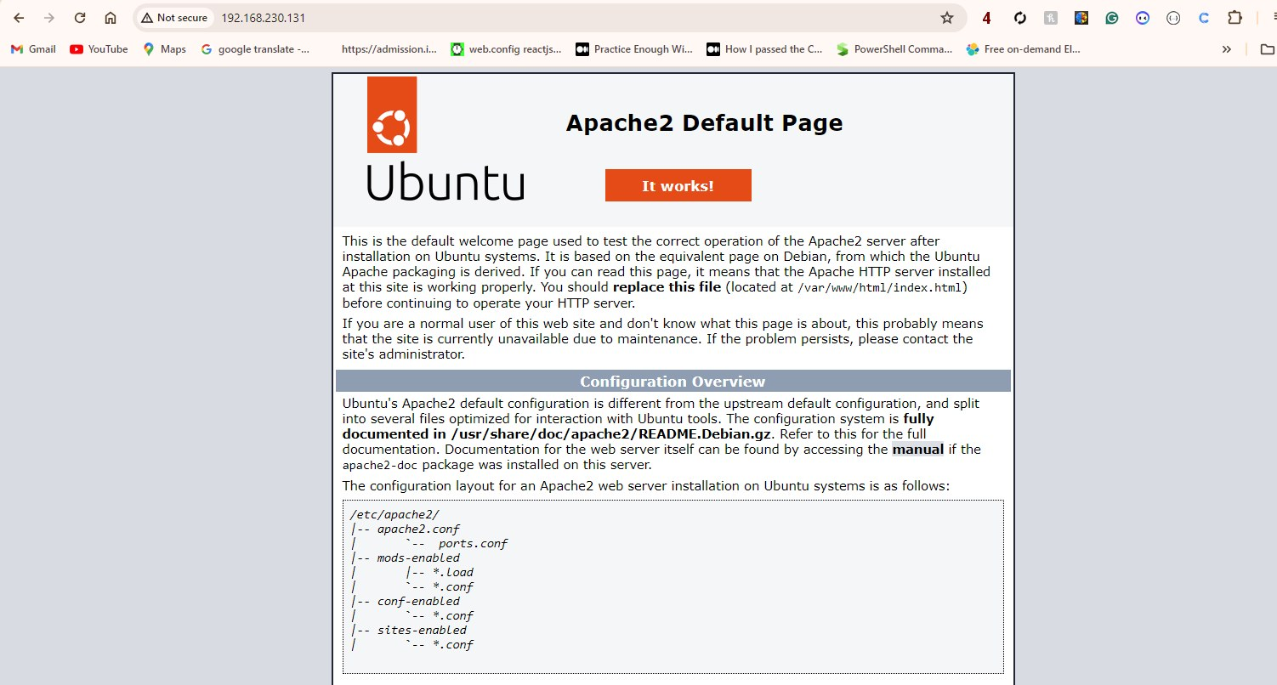
Original dimensions: 1502 × 806 px

docker_assignment.zip
Source Word document: docker_assignment/assignment_4.docx
Embedded image count extracted: 1

Screenshot 01 — word/media/image1.png
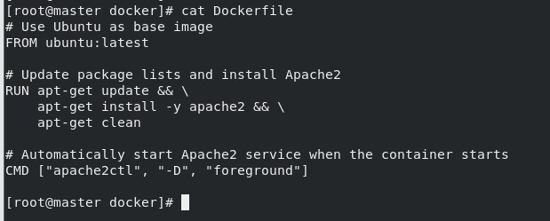
Original dimensions: 619 × 249 px

docker_assignment.zip
Source Word document: docker_assignment/assignment_5.docx
Embedded image count extracted: 5

Screenshot 01 — word/media/image5.png
Original dimensions: 1327 × 92 px

Screenshot 02 — word/media/image3.png
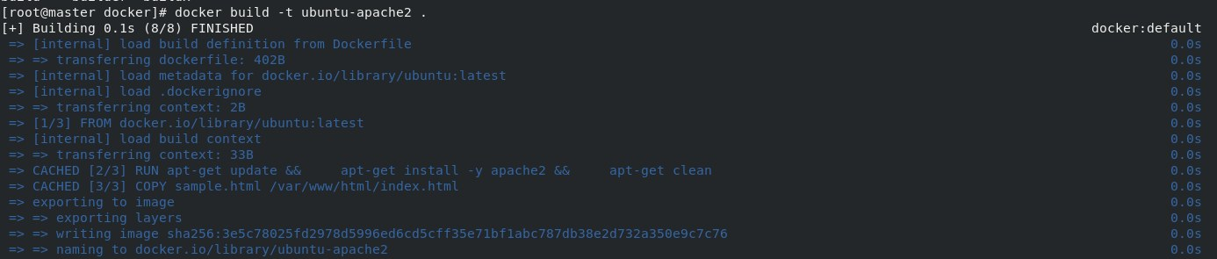
Original dimensions: 1386 × 295 px

Screenshot 03 — word/media/image2.png
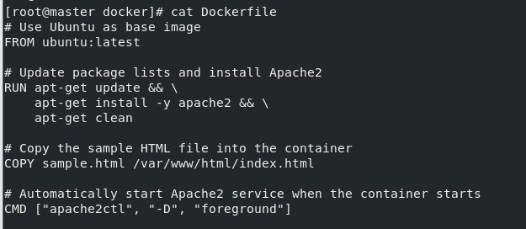
Original dimensions: 625 × 272 px

Screenshot 04 — word/media/image1.png
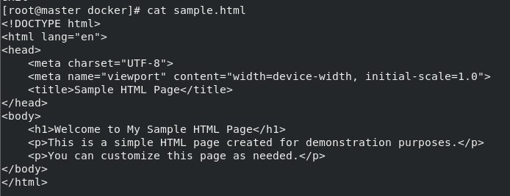
Original dimensions: 694 × 267 px

Screenshot 05 — word/media/image7.png
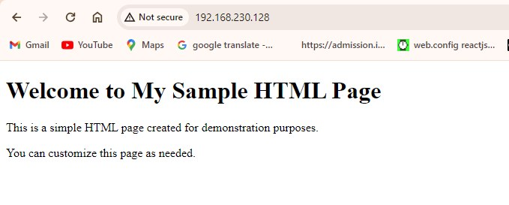
Original dimensions: 679 × 273 px

docker_assignment.zip
Source Word document: docker_assignment/assignment_6.docx
Embedded image count extracted: 3

Screenshot 01 — word/media/image4.png
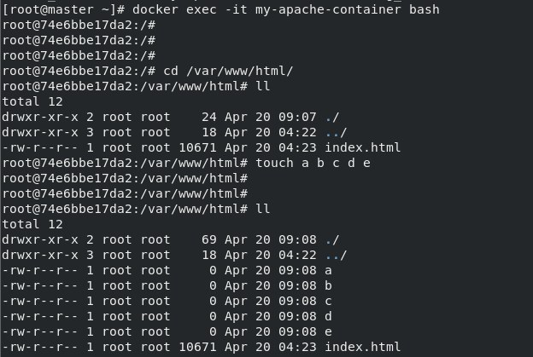
Original dimensions: 624 × 419 px

Screenshot 02 — word/media/image3.png
Original dimensions: 1387 × 90 px

Screenshot 03 — word/media/image5.png
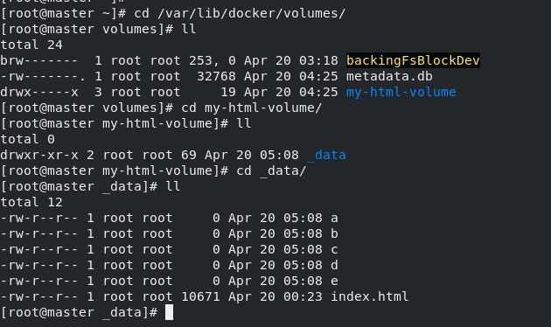
Original dimensions: 630 × 374 px

docker_assignment.zip
Source Word document: docker_assignment/assignment_7.docx
Embedded image count extracted: 3

Screenshot 01 — word/media/image2.png
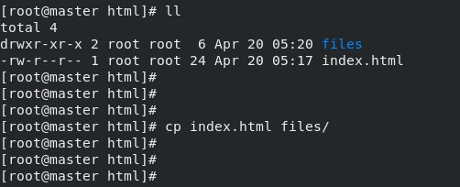
Original dimensions: 502 × 204 px

Screenshot 02 — word/media/image3.png
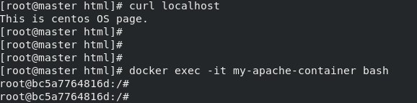
Original dimensions: 578 × 143 px

Screenshot 03 — word/media/image4.png
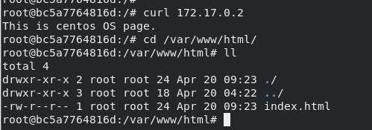
Original dimensions: 499 × 175 px

docker_assignment.zip
Source Word document: docker_assignment/assignment_8.docx
Embedded image count extracted: 5

Screenshot 01 — word/media/image4.png
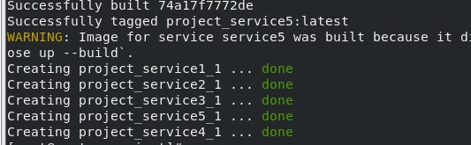
Original dimensions: 533 × 165 px

Screenshot 02 — word/media/image3.png
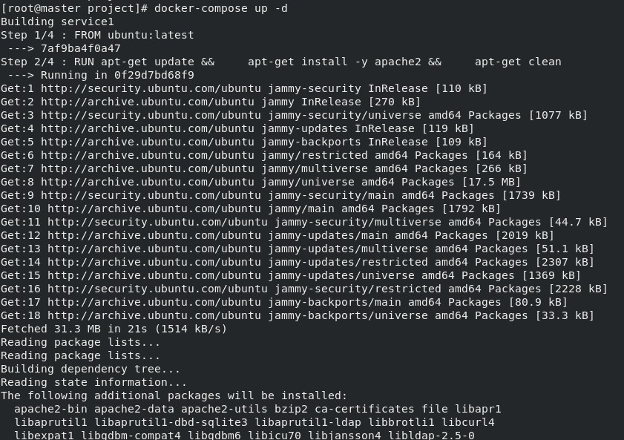
Original dimensions: 841 × 593 px

Screenshot 03 — word/media/image2.png
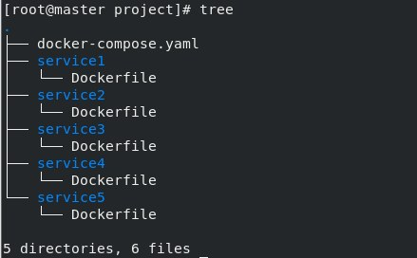
Original dimensions: 439 × 272 px

Screenshot 04 — word/media/image1.png
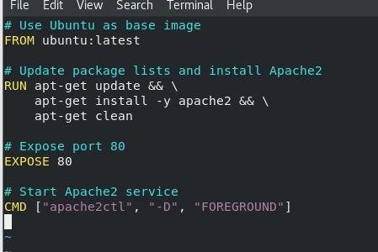
Original dimensions: 449 × 300 px

Screenshot 05 — word/media/image5.png
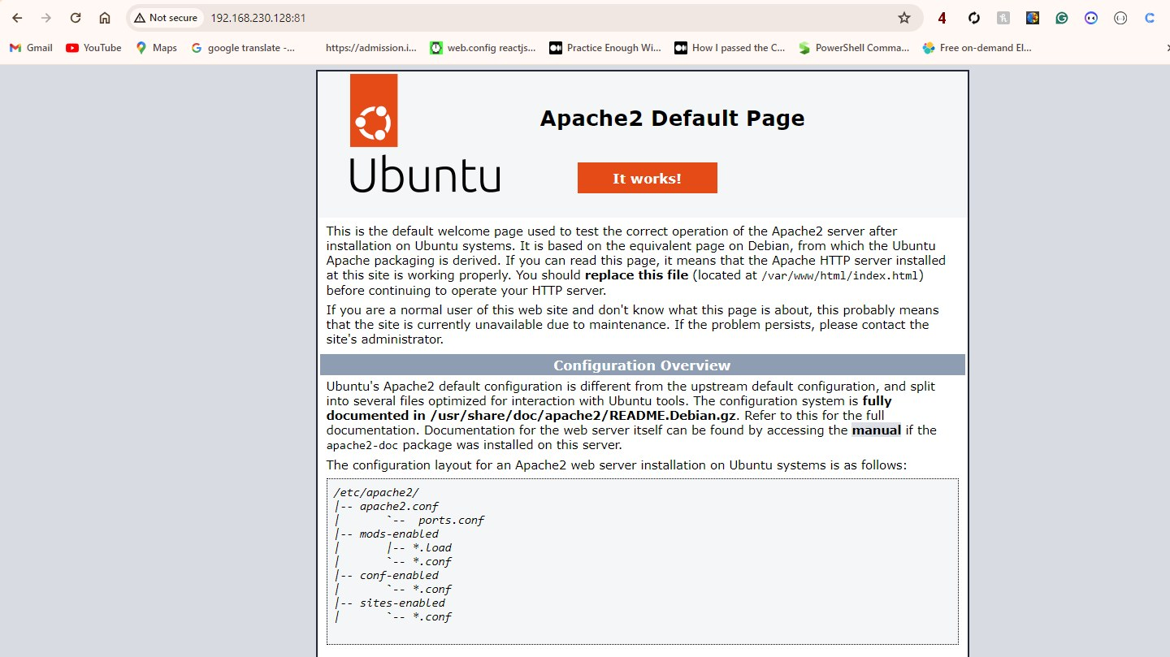
Original dimensions: 1440 × 809 px

docker_assignment.zip
Source Word document: docker_assignment/assignment_9.docx
Embedded image count extracted: 3

Screenshot 01 — word/media/image5.png
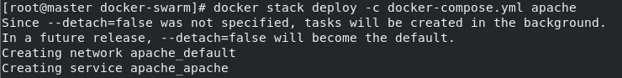
Original dimensions: 740 × 93 px

Screenshot 02 — word/media/image4.png
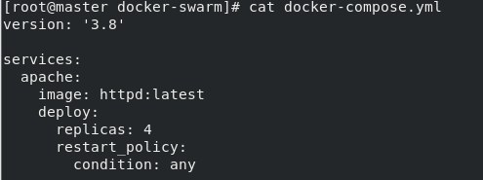
Original dimensions: 495 × 185 px

Screenshot 03 — word/media/image1.png
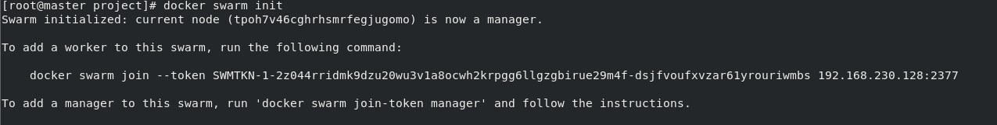
Original dimensions: 1275 × 161 px

docker_assignment.zip
Source Word document: docker_assignment/assignment_casestudy1.docx
Embedded image count extracted: 7

Screenshot 01 — word/media/image8.png
Original dimensions: 1378 × 93 px

Screenshot 02 — word/media/image7.png
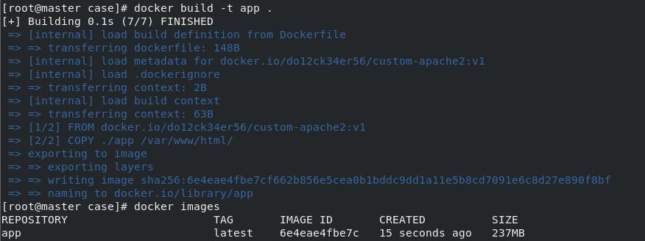
Original dimensions: 876 × 328 px

Screenshot 03 — word/media/image5.png
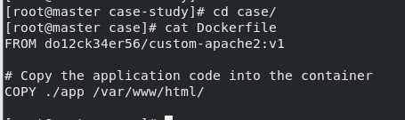
Original dimensions: 455 × 135 px

Screenshot 04 — word/media/image4.png
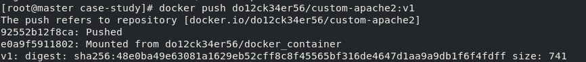
Original dimensions: 866 × 93 px

Screenshot 05 — word/media/image2.png
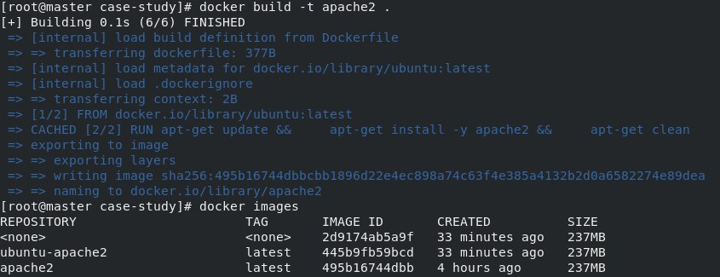
Original dimensions: 845 × 325 px

Screenshot 06 — word/media/image1.png
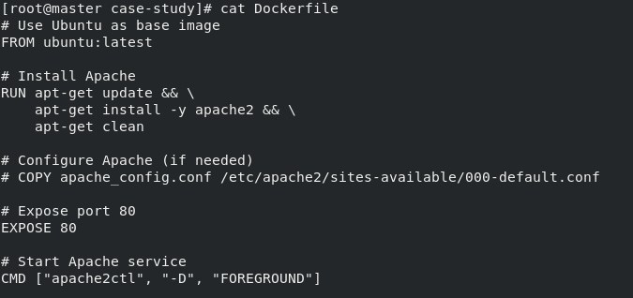
Original dimensions: 675 × 318 px

Screenshot 07 — word/media/image9.png
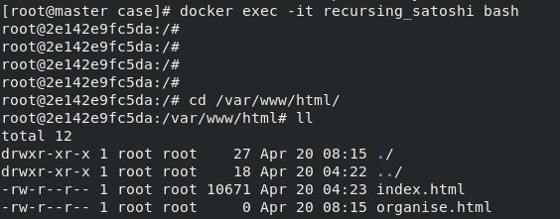
Original dimensions: 564 × 221 px

docker_assignment.zip
Source Word document: docker_assignment/assignment_casestudy2.docx
Embedded image count extracted: 7

Screenshot 01 — word/media/image8.png
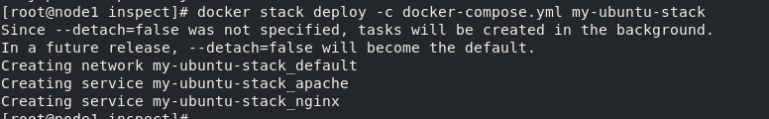
Original dimensions: 776 × 120 px

Screenshot 02 — word/media/image9.png
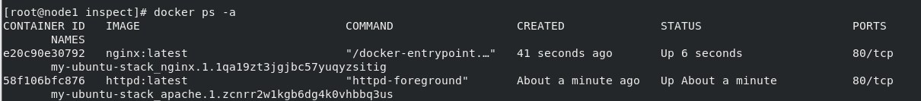
Original dimensions: 1210 × 133 px

Screenshot 03 — word/media/image6.png
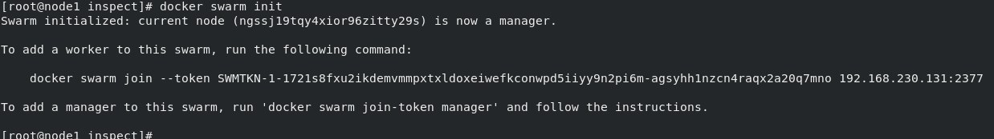
Original dimensions: 1238 × 174 px

Screenshot 04 — word/media/image5.png
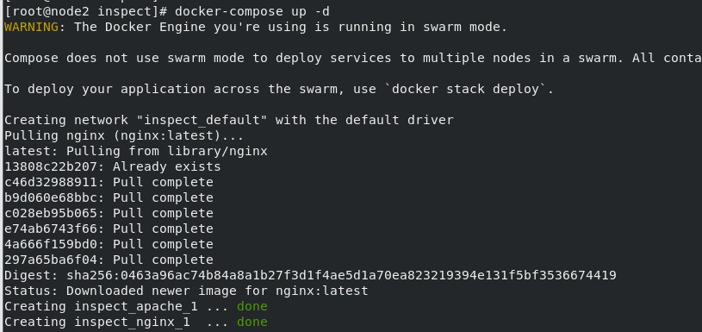
Original dimensions: 815 × 385 px

Screenshot 05 — word/media/image4.png
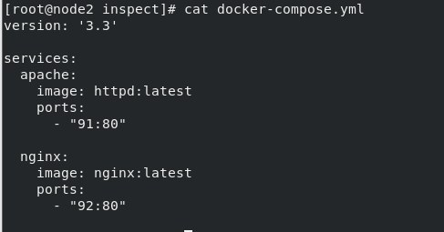
Original dimensions: 487 × 255 px

Screenshot 06 — word/media/image3.png
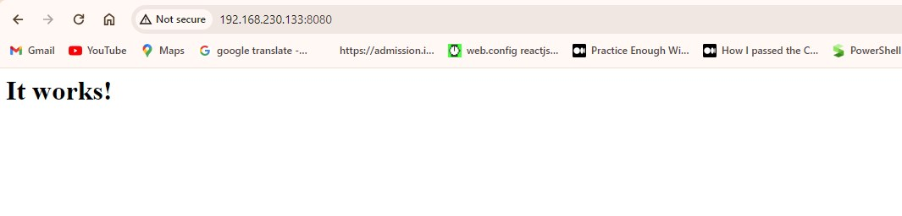
Original dimensions: 1065 × 256 px

Screenshot 07 — word/media/image11.png
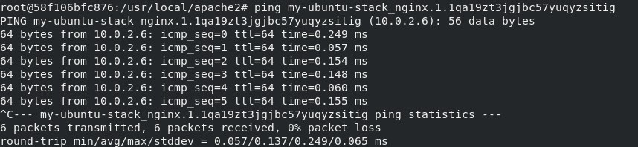
Original dimensions: 858 × 198 px

amazonelasticlambdaopsworks.zip
Source Word document: amazonelasticlambdaopsworks/assignment1.docx
Embedded image count extracted: 6

Screenshot 01 — word/media/image6.png
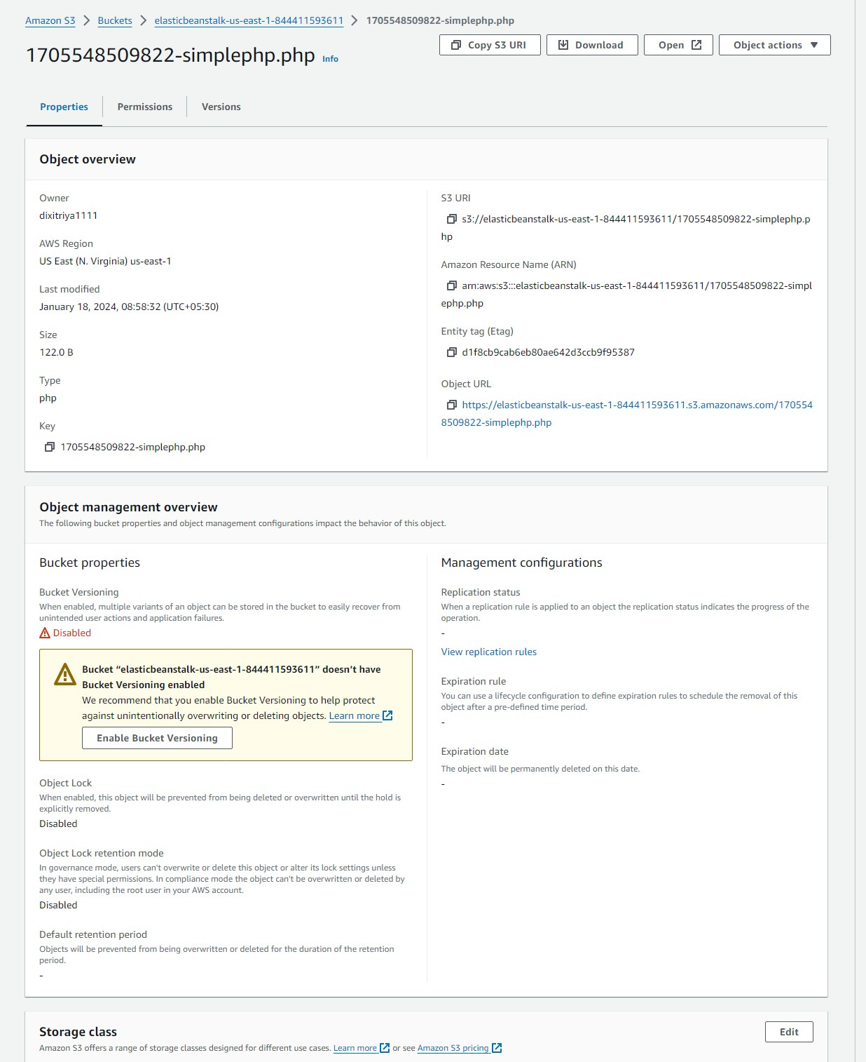
Original dimensions: 1236 × 1514 px

Screenshot 02 — word/media/image4.png
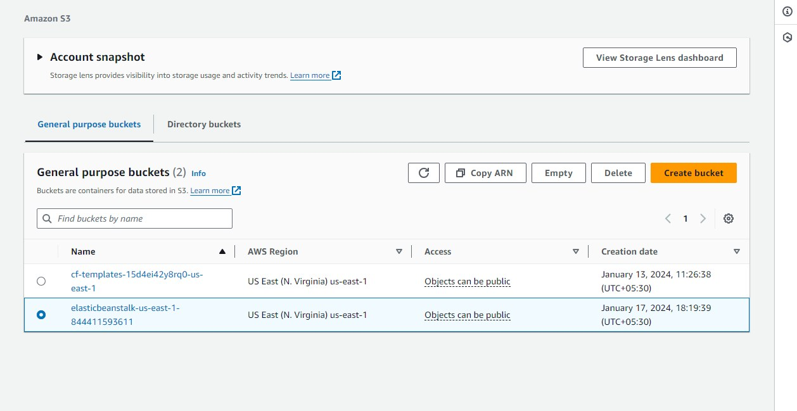
Original dimensions: 1258 × 649 px

Screenshot 03 — word/media/image3.png
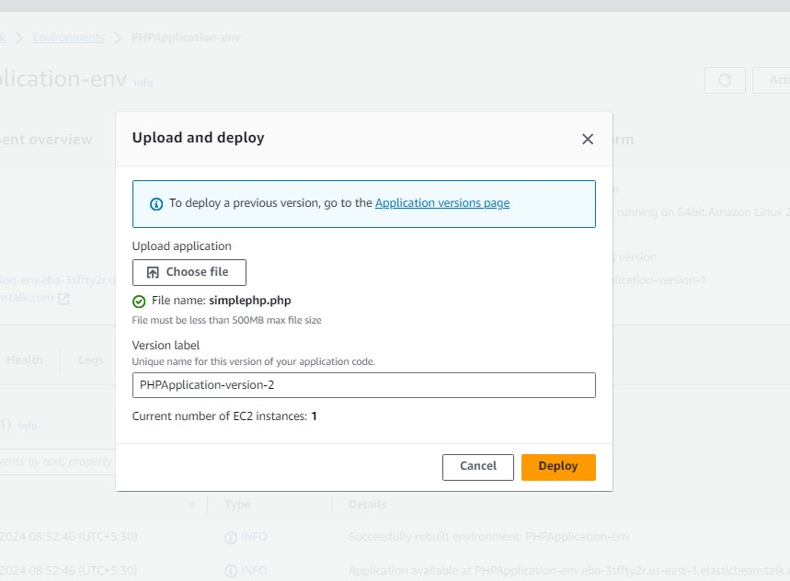
Original dimensions: 859 × 632 px

Screenshot 04 — word/media/image2.png
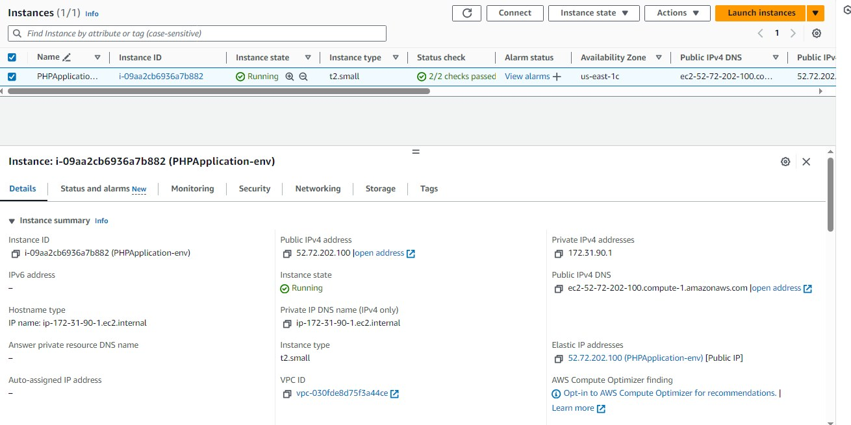
Original dimensions: 1310 × 655 px

Screenshot 05 — word/media/image1.png
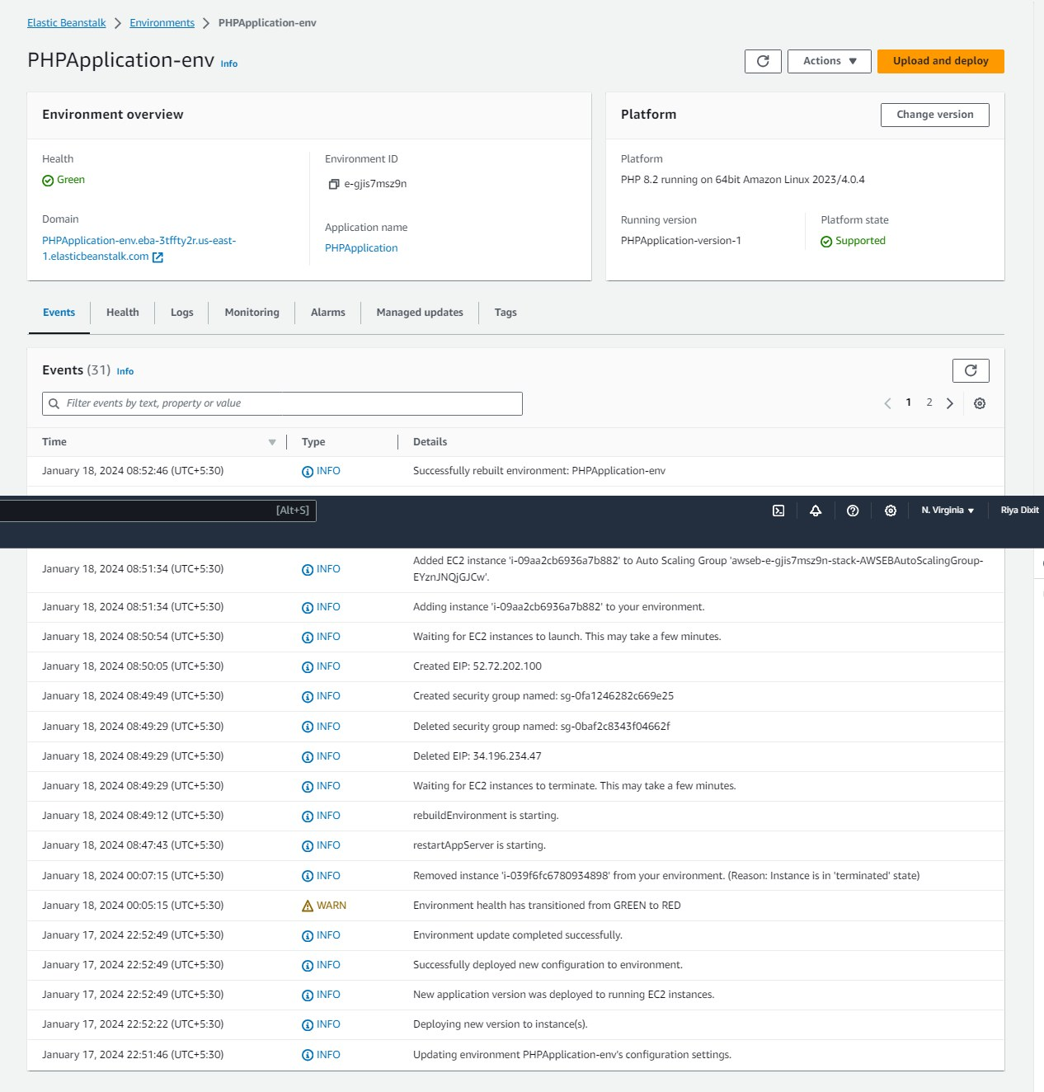
Original dimensions: 1266 × 1324 px

Screenshot 06 — word/media/image5.png
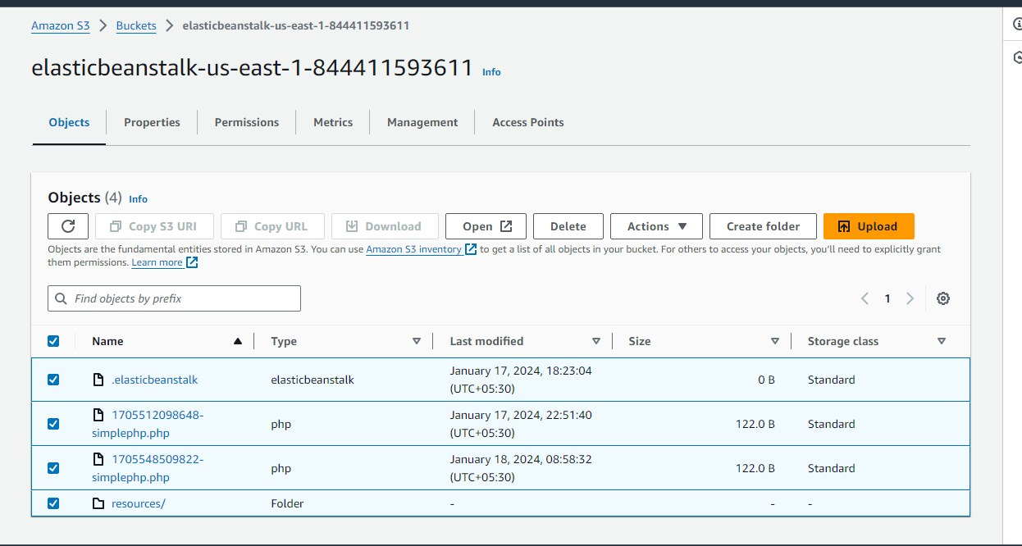
Original dimensions: 1246 × 666 px

amazonelasticlambdaopsworks.zip
Source Word document: amazonelasticlambdaopsworks/assignment2.docx
Embedded image count extracted: 8

Screenshot 01 — word/media/image8.png
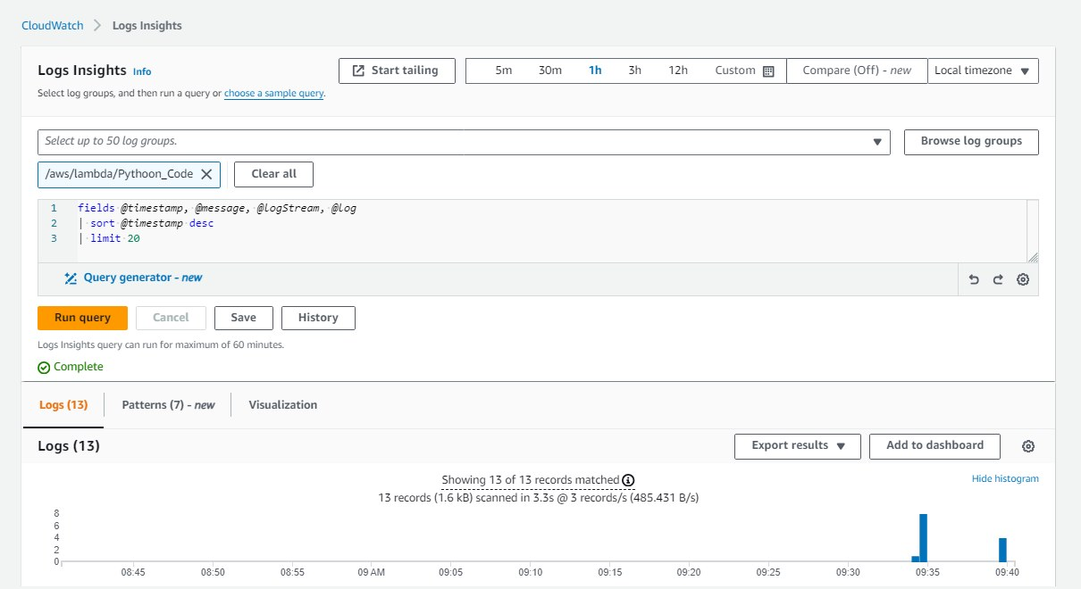
Original dimensions: 1210 × 660 px

Screenshot 02 — word/media/image6.png
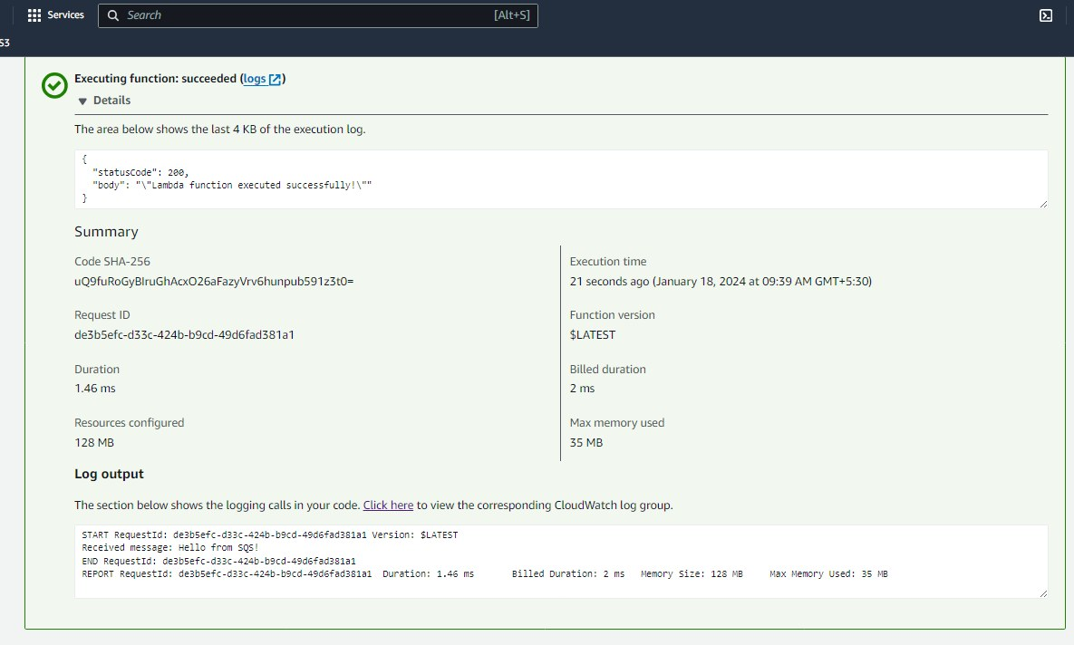
Original dimensions: 1185 × 712 px

Screenshot 03 — word/media/image5.png
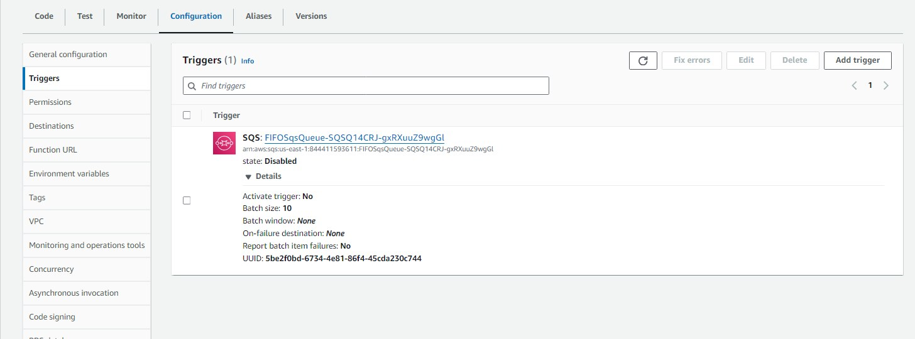
Original dimensions: 1456 × 540 px

Screenshot 04 — word/media/image4.png
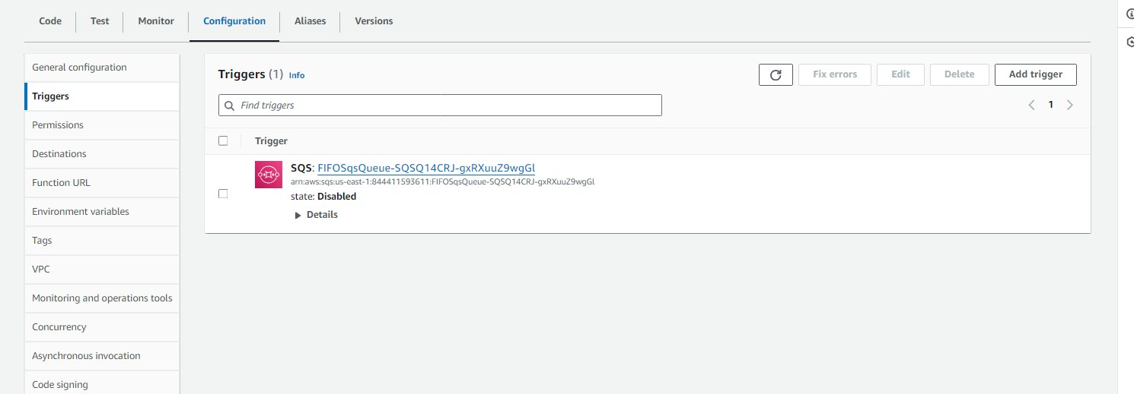
Original dimensions: 1490 × 519 px

Screenshot 05 — word/media/image3.png
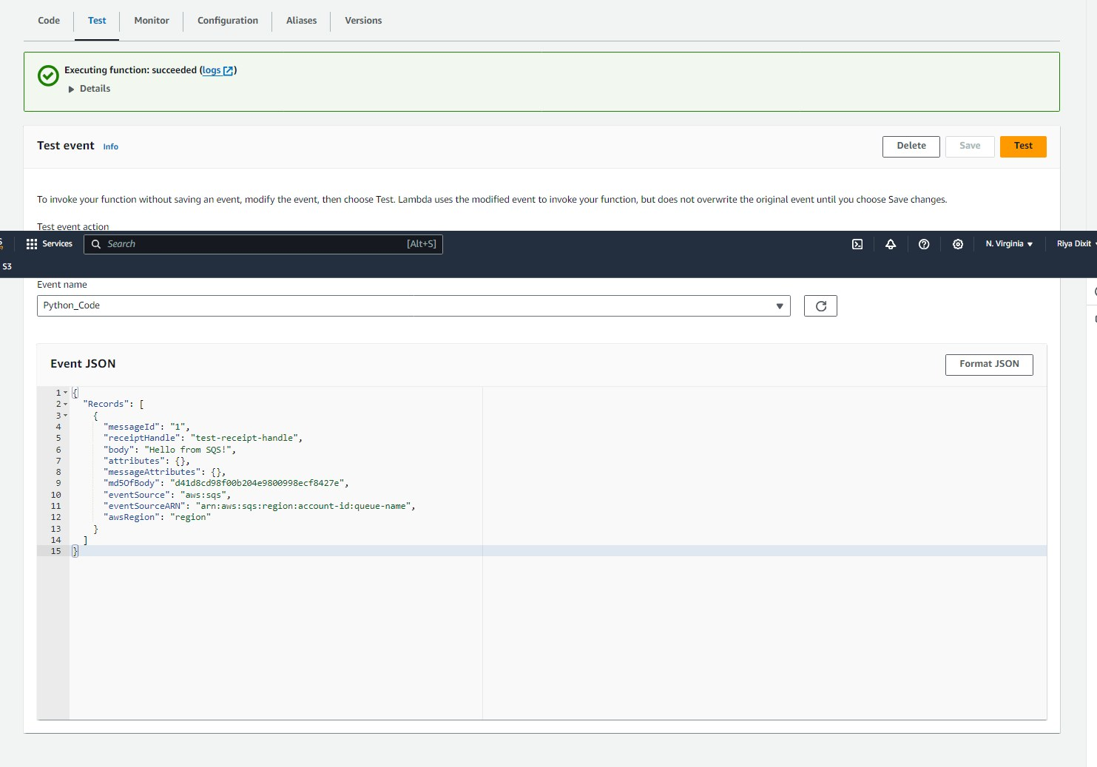
Original dimensions: 1483 × 1037 px

Screenshot 06 — word/media/image2.png
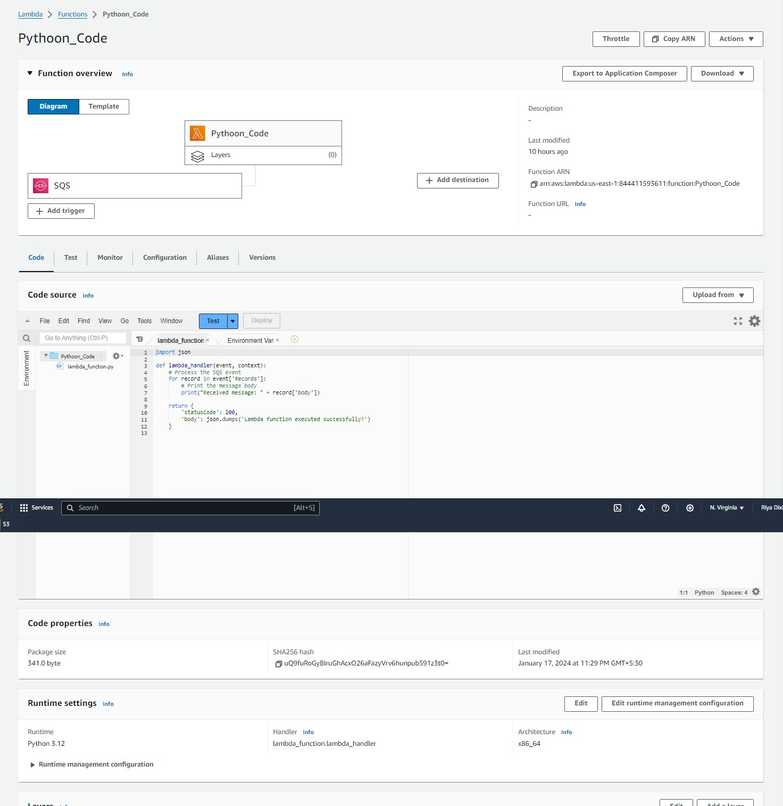
Original dimensions: 1472 × 1514 px

Screenshot 07 — word/media/image1.png
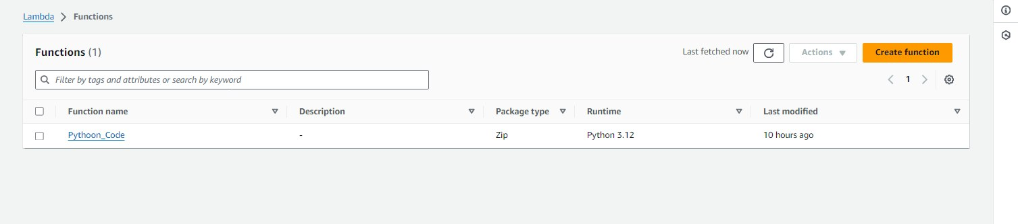
Original dimensions: 1507 × 333 px

Screenshot 08 — word/media/image7.png
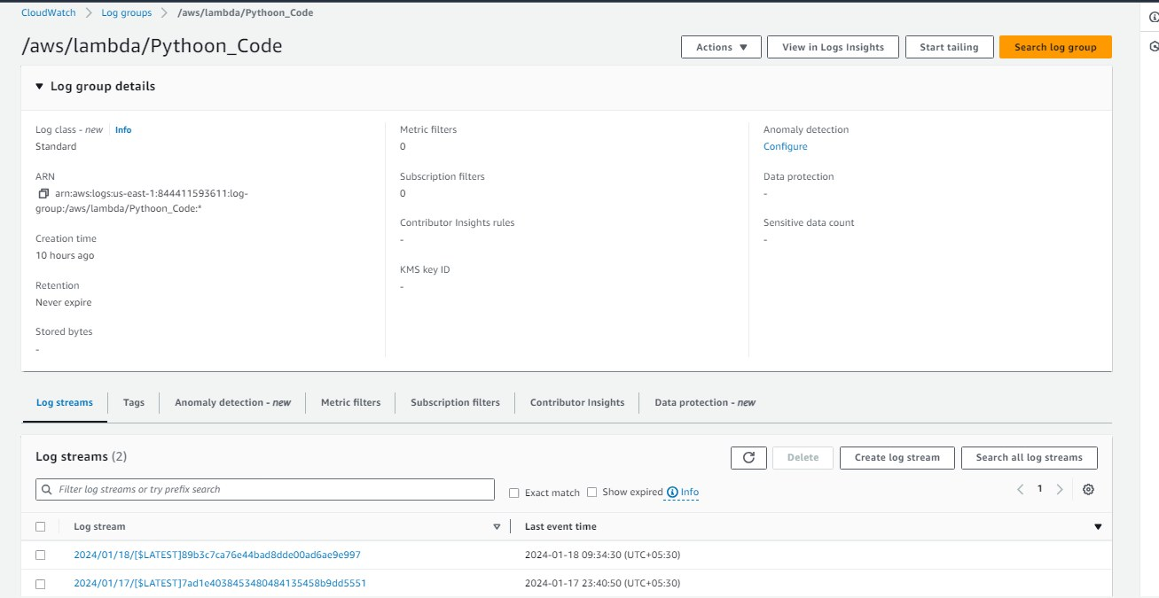
Original dimensions: 1307 × 675 px

amazonelasticlambdaopsworks.zip
Source Word document: amazonelasticlambdaopsworks/assignment3.docx
Embedded image count extracted: 3

Screenshot 01 — word/media/image3.png
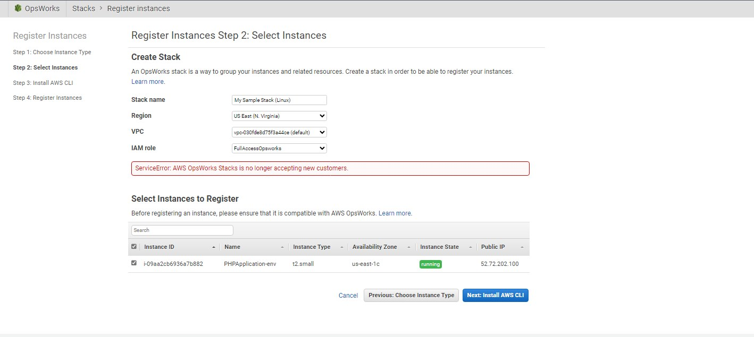
Original dimensions: 1418 × 635 px

Screenshot 02 — word/media/image1.png
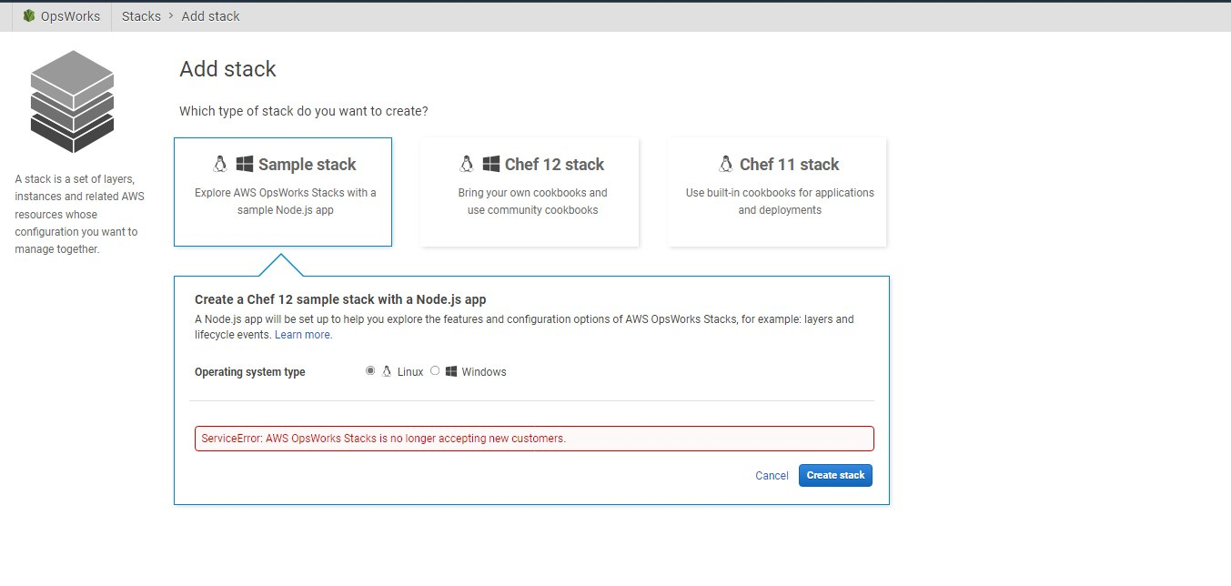
Original dimensions: 1353 × 644 px

Screenshot 03 — word/media/image2.png
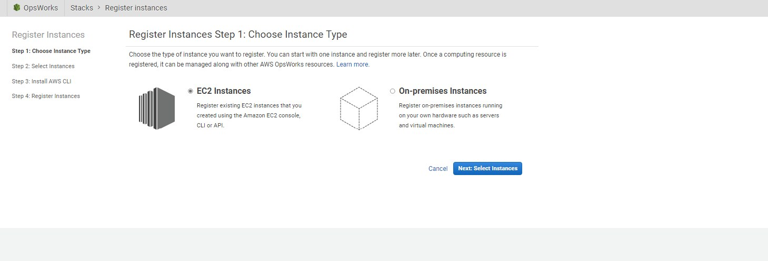
Original dimensions: 1459 × 498 px

assignment_jenkinscasestudy.zip
Source Word document: assignment_jenkinscasestudy.docx
Embedded image count extracted: 11

Screenshot 01 — word/media/image8.png
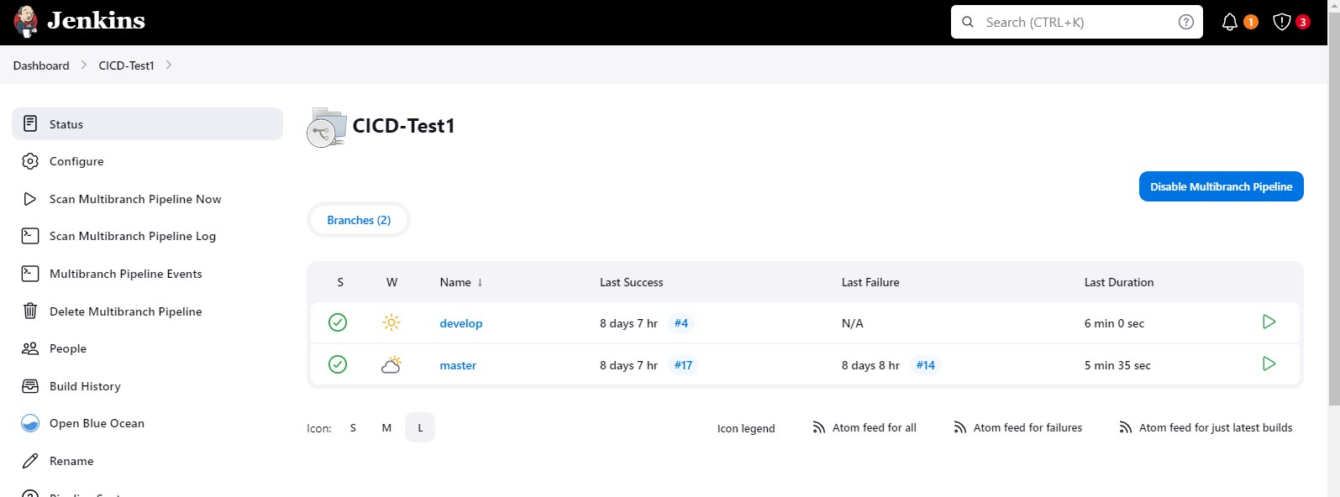
Original dimensions: 1595 × 592 px

Screenshot 02 — word/media/image9.png
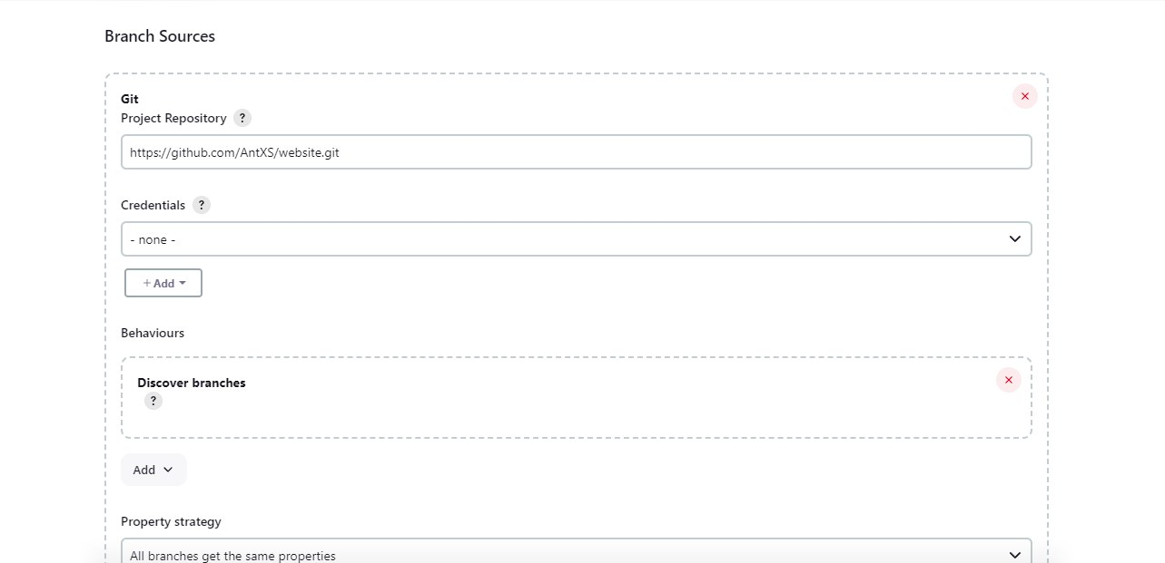
Original dimensions: 1283 × 621 px

Screenshot 03 — word/media/image10.png
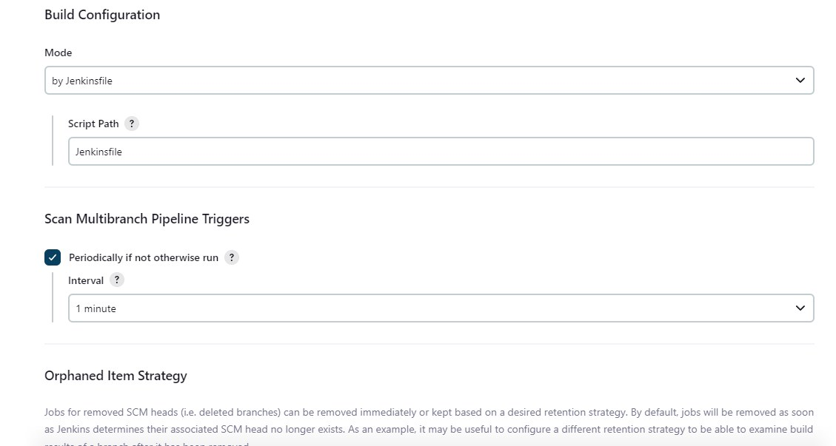
Original dimensions: 1129 × 603 px

Screenshot 04 — word/media/image11.png
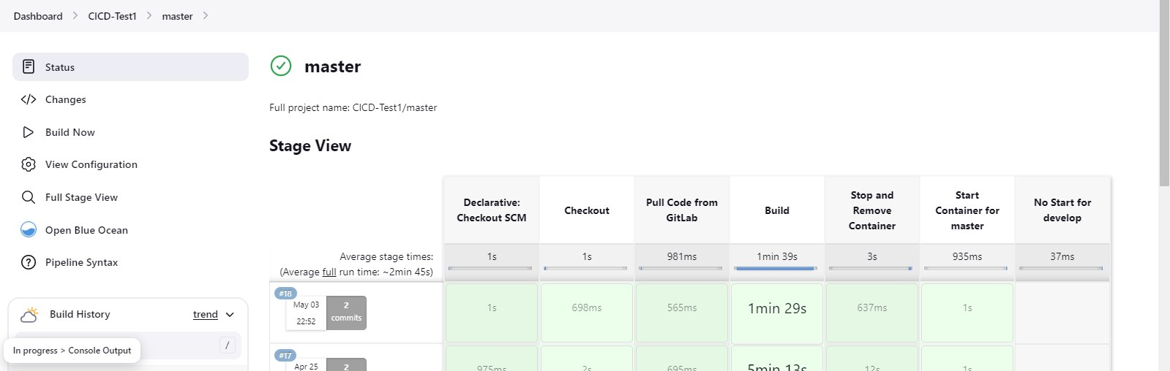
Original dimensions: 1599 × 508 px

Screenshot 05 — word/media/image6.png
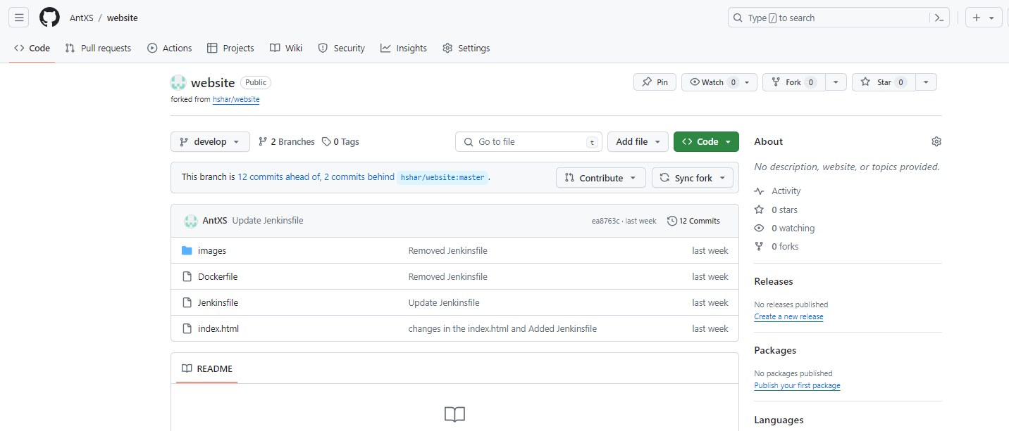
Original dimensions: 1432 × 613 px

Screenshot 06 — word/media/image5.png
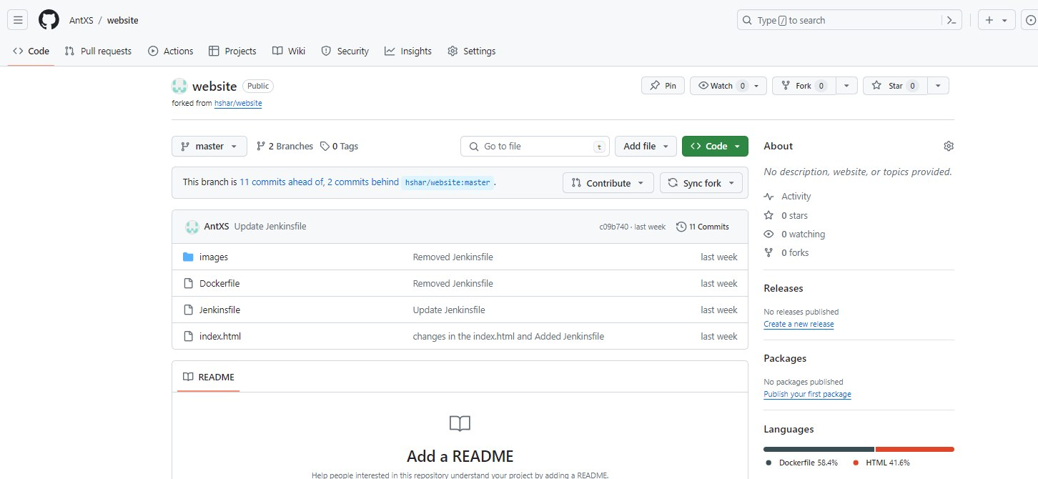
Original dimensions: 1452 × 670 px

Screenshot 07 — word/media/image1.png
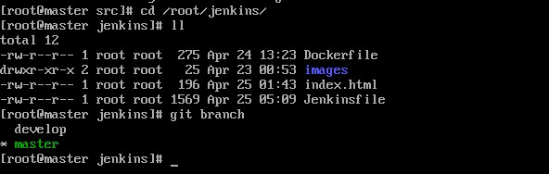
Original dimensions: 592 × 188 px

Screenshot 08 — word/media/image2.png
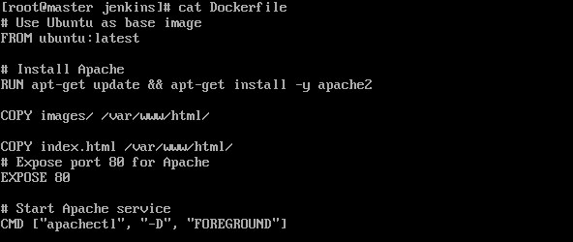
Original dimensions: 592 × 250 px

Screenshot 09 — word/media/image3.png
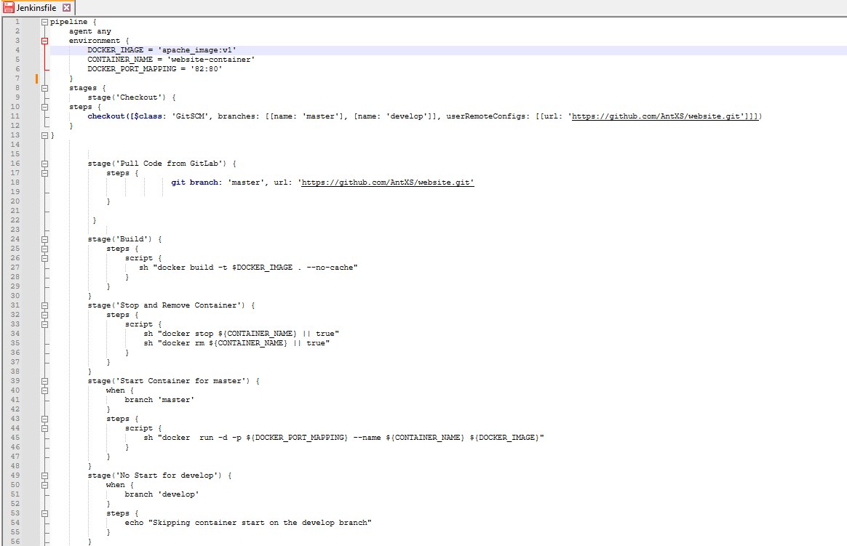
Original dimensions: 1164 × 751 px

Screenshot 10 — word/media/image4.png
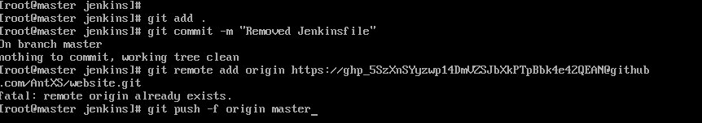
Original dimensions: 862 × 152 px

Screenshot 11 — word/media/image12.png
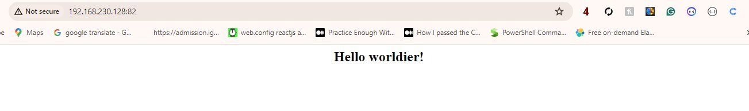
Original dimensions: 1303 × 194 px

aws capstone 1.zip
Source Word document: aws capstone 1/assignment.docx
Embedded image count extracted: 12

Screenshot 01 — word/media/image11.png
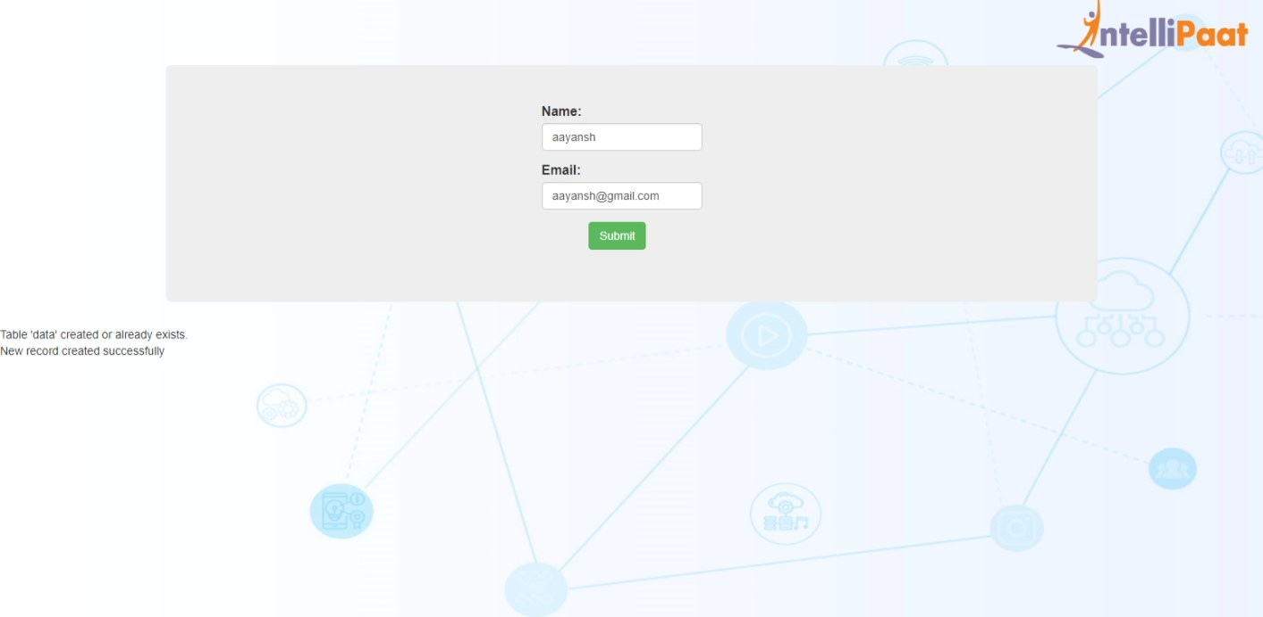
Original dimensions: 1413 × 692 px

Screenshot 02 — word/media/image6.png
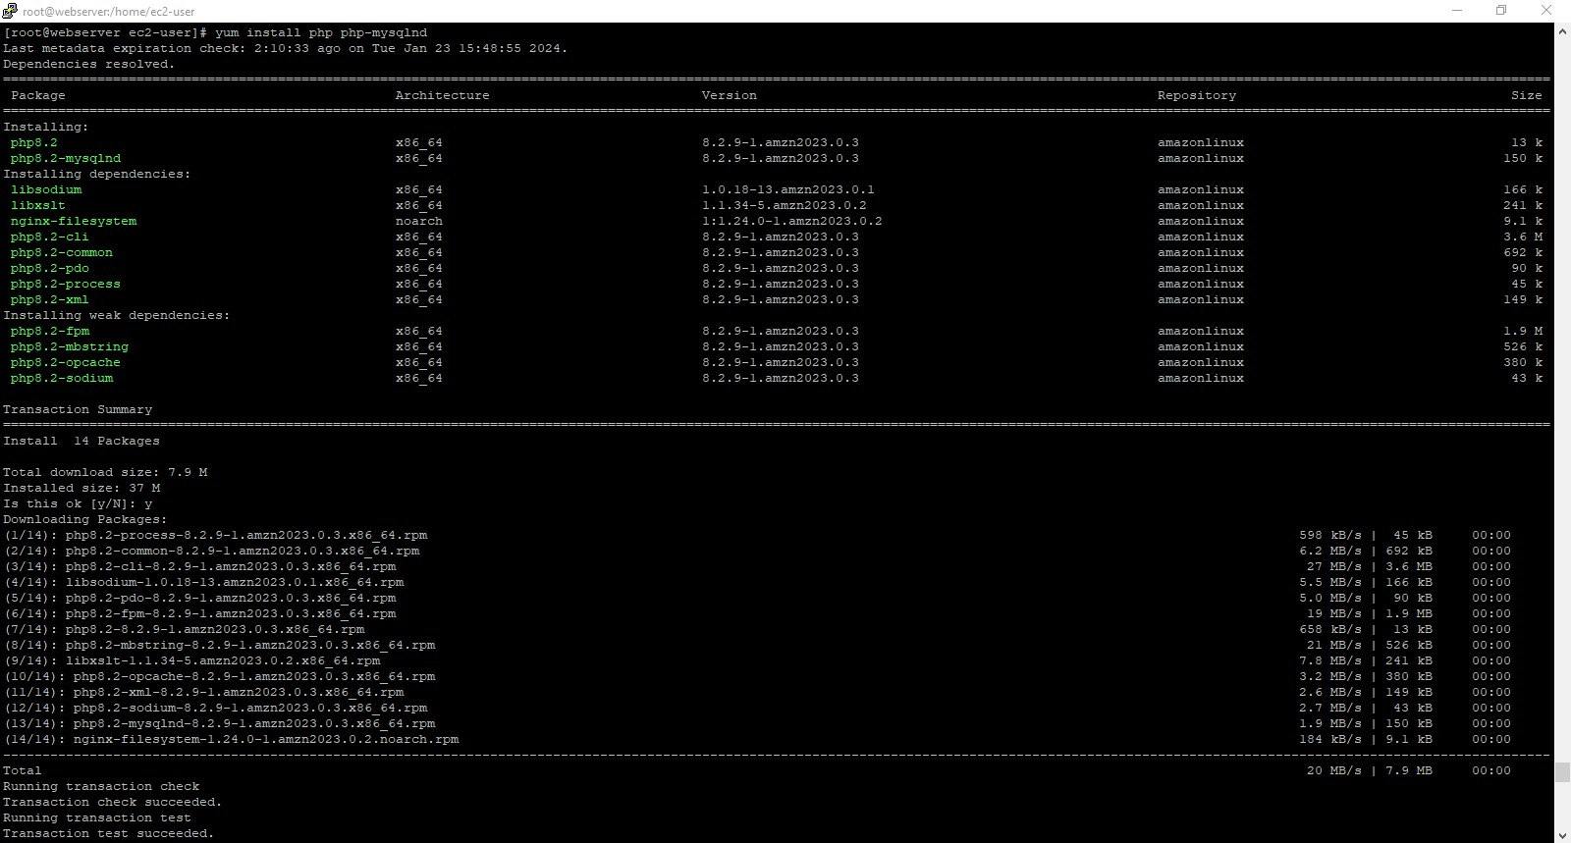
Original dimensions: 1600 × 859 px

Screenshot 03 — word/media/image7.png
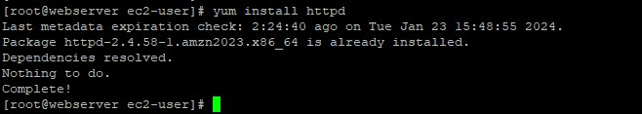
Original dimensions: 658 × 117 px

Screenshot 04 — word/media/image8.png
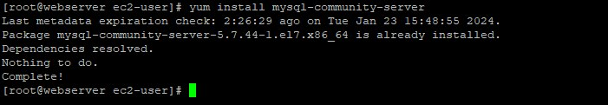
Original dimensions: 701 × 121 px

Screenshot 05 — word/media/image9.png
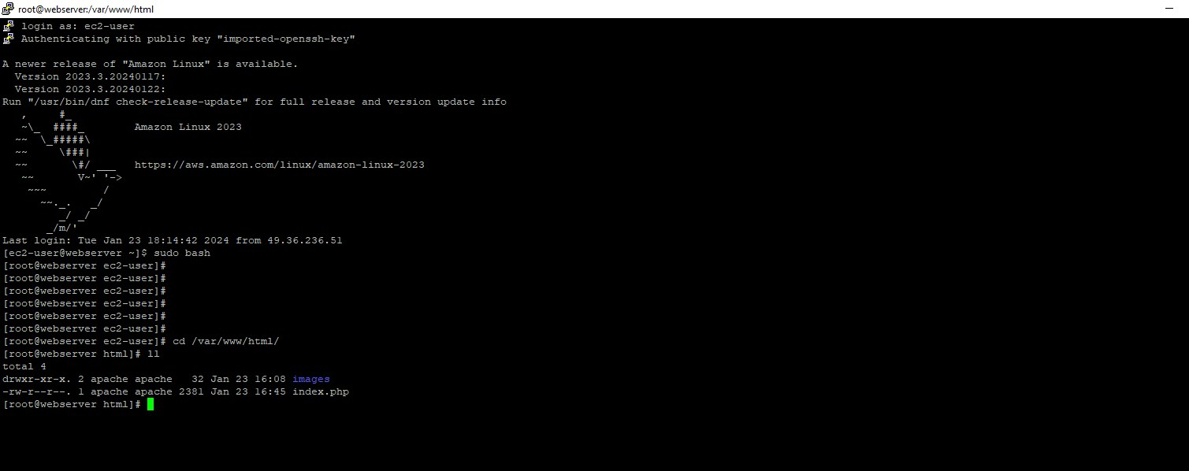
Original dimensions: 1509 × 598 px

Screenshot 06 — word/media/image10.png
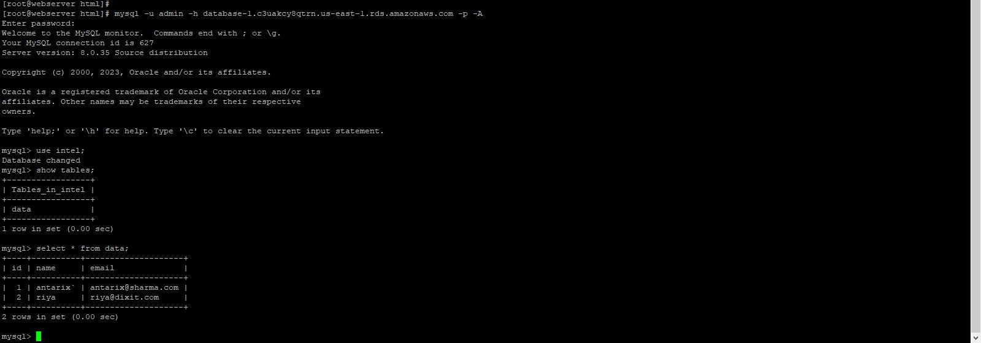
Original dimensions: 1600 × 561 px

Screenshot 07 — word/media/image5.png
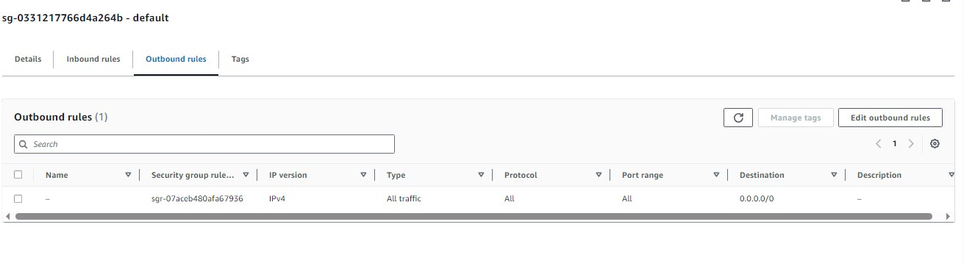
Original dimensions: 1326 × 362 px

Screenshot 08 — word/media/image4.png
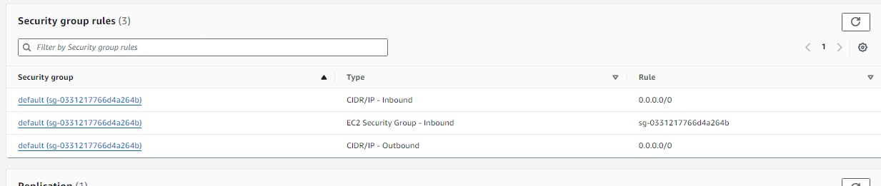
Original dimensions: 1233 × 261 px

Screenshot 09 — word/media/image3.png
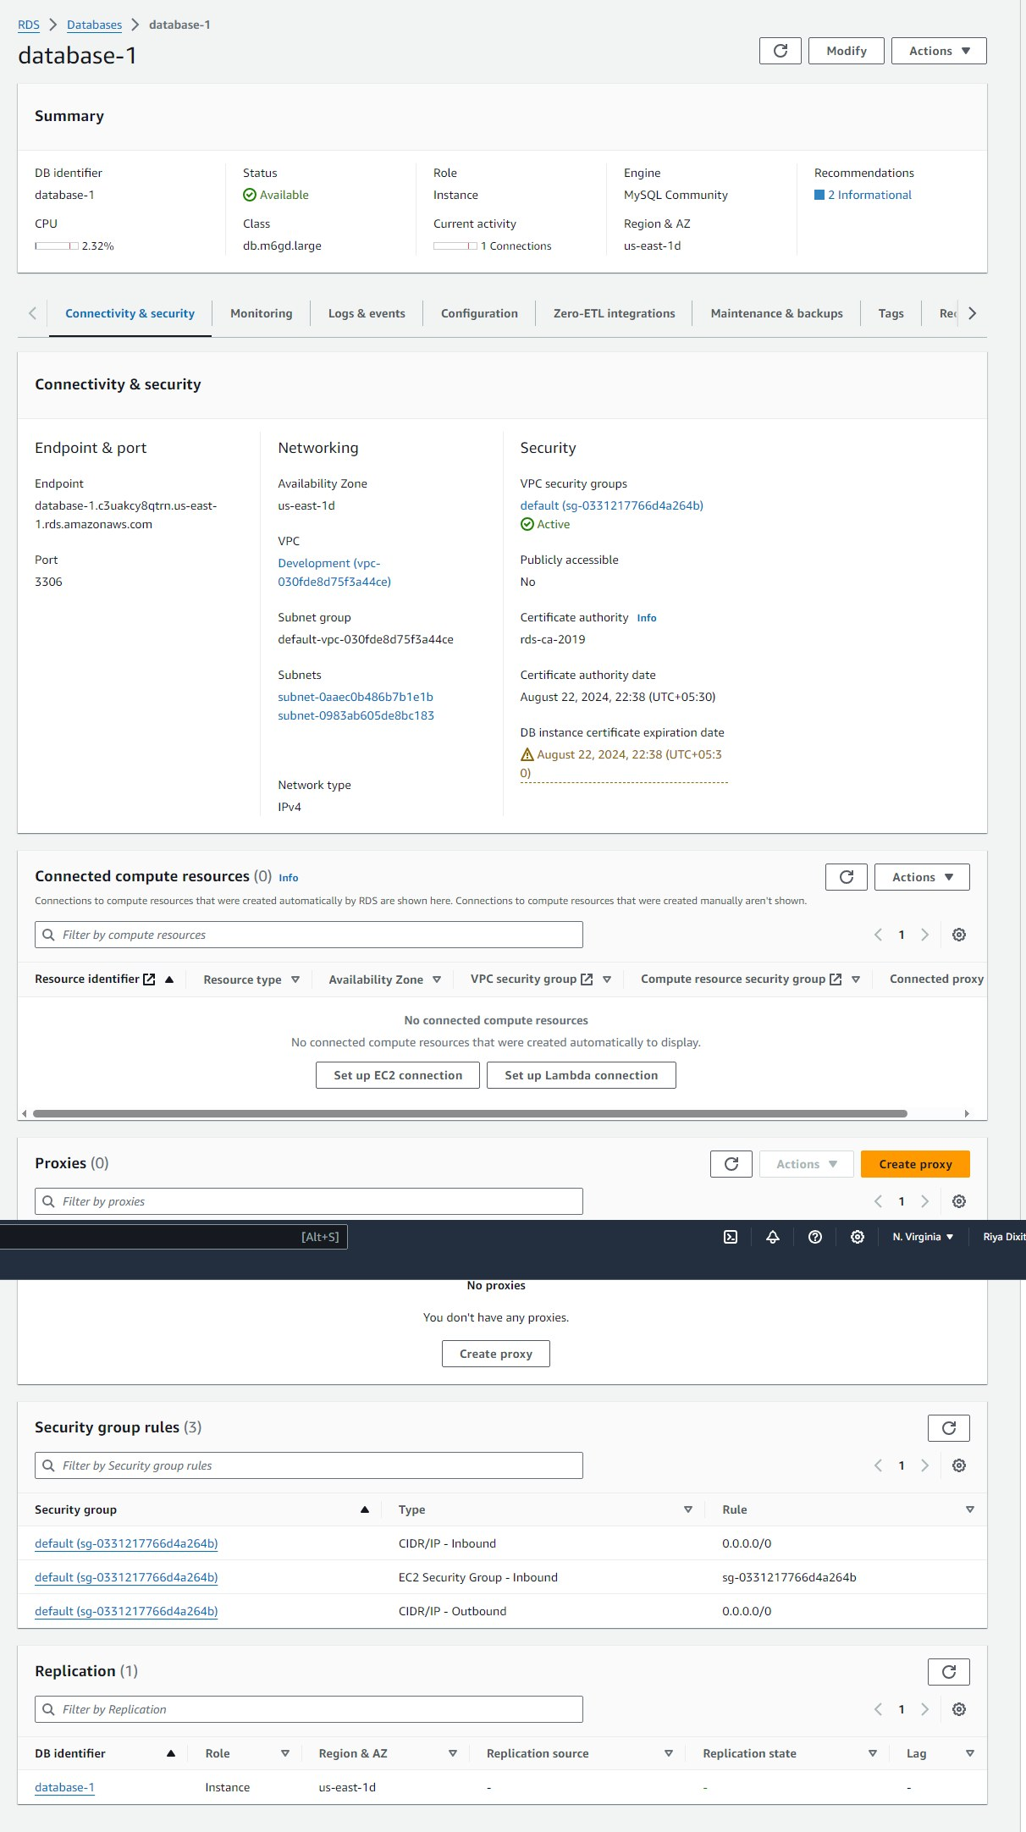
Original dimensions: 1212 × 2164 px

Screenshot 10 — word/media/image12.png
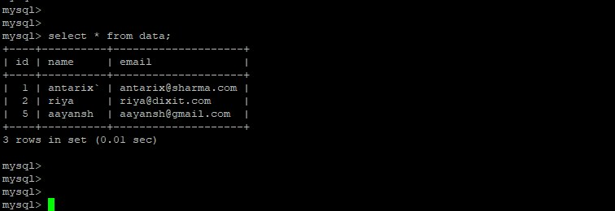
Original dimensions: 756 × 260 px

Screenshot 11 — word/media/image2.png
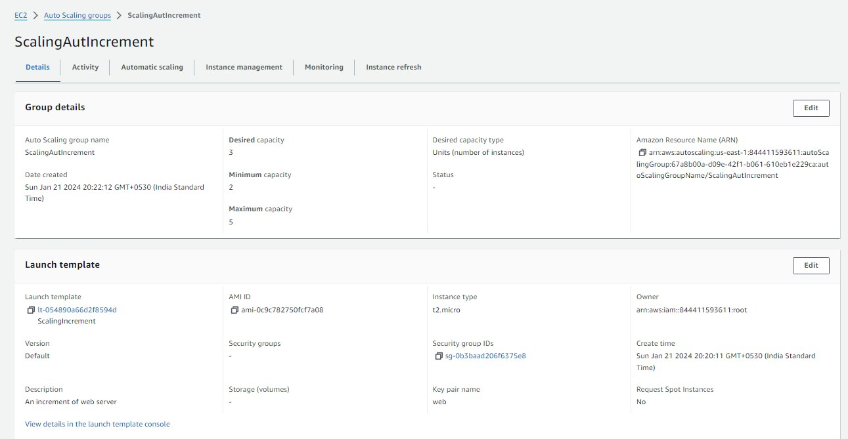
Original dimensions: 1291 × 669 px

Screenshot 12 — word/media/image1.png
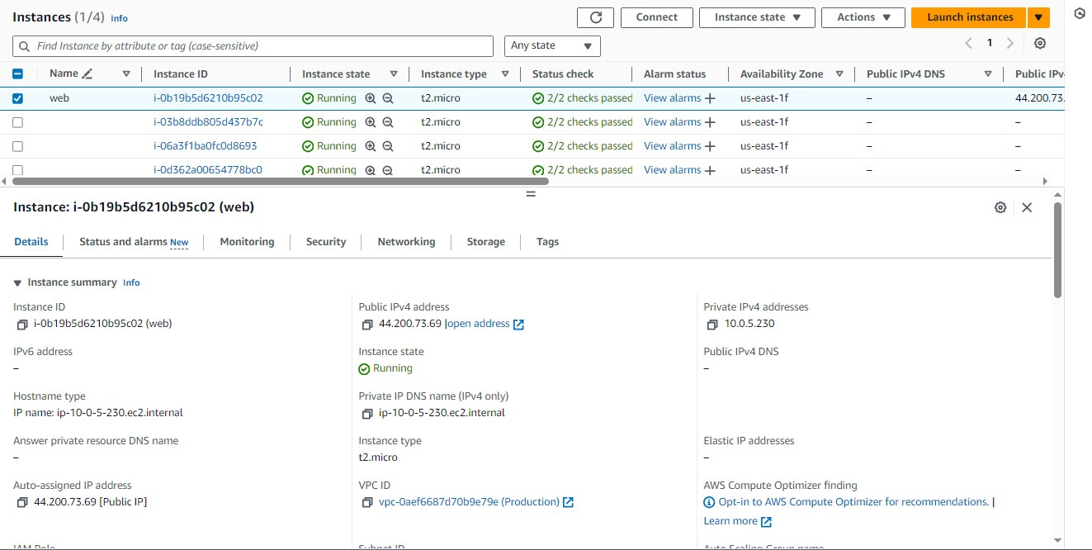
Original dimensions: 1323 × 666 px

kubernetes_assignment.zip
Source Word document: kubernetes_assignment/assignment_1.docx
Embedded image count extracted: 3

Screenshot 01 — word/media/image3.png
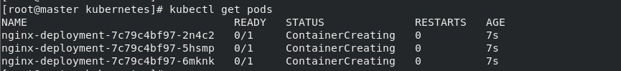
Original dimensions: 865 × 99 px

Screenshot 02 — word/media/image1.png
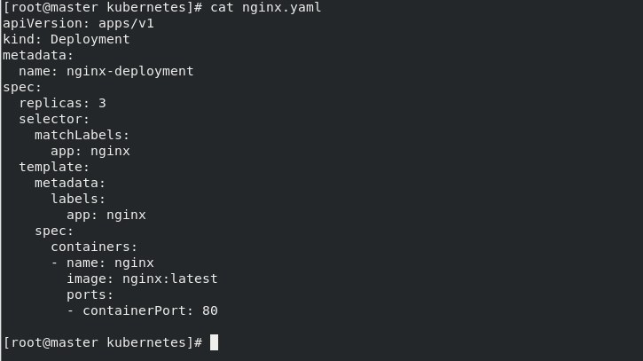
Original dimensions: 725 × 407 px

Screenshot 03 — word/media/image5.png
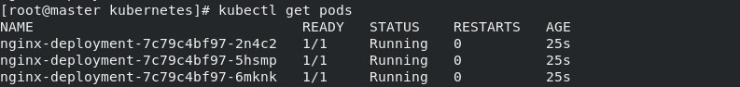
Original dimensions: 793 × 94 px

kubernetes_assignment.zip
Source Word document: kubernetes_assignment/assignment_2.docx
Embedded image count extracted: 4

Screenshot 01 — word/media/image5.png
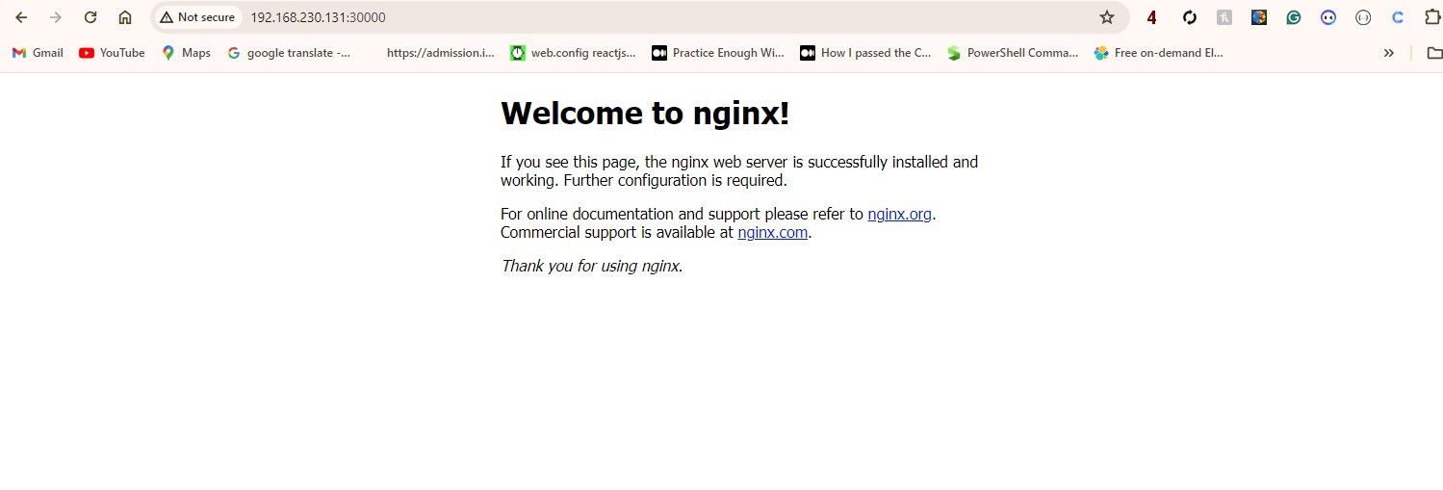
Original dimensions: 1499 × 509 px

Screenshot 02 — word/media/image4.png
Original dimensions: 1231 × 99 px

Screenshot 03 — word/media/image1.png
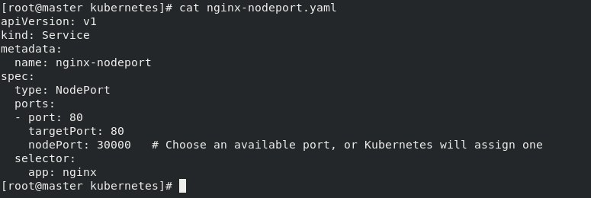
Original dimensions: 775 × 260 px

Screenshot 04 — word/media/image6.png
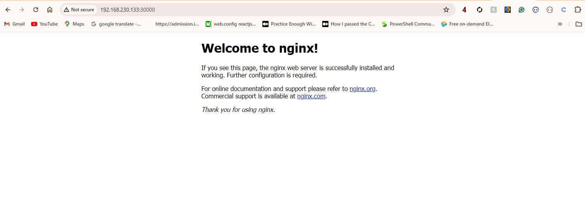
Original dimensions: 1505 × 576 px

kubernetes_assignment.zip
Source Word document: kubernetes_assignment/assignment_3.docx
Embedded image count extracted: 3

Screenshot 01 — word/media/image3.png
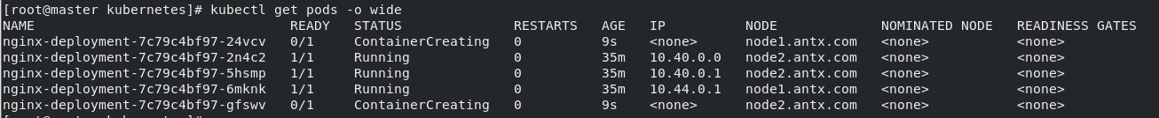
Original dimensions: 1306 × 134 px

Screenshot 02 — word/media/image1.png
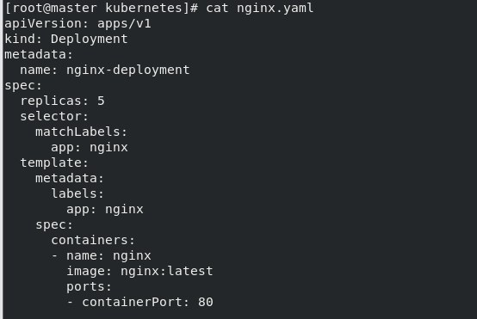
Original dimensions: 554 × 371 px

Screenshot 03 — word/media/image5.png
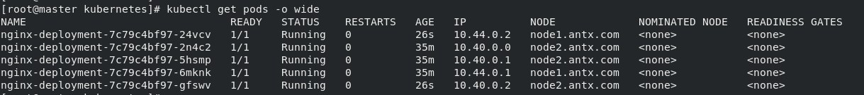
Original dimensions: 1219 × 135 px

kubernetes_assignment.zip
Source Word document: kubernetes_assignment/assignment_4.docx
Embedded image count extracted: 2

Screenshot 01 — word/media/image3.png
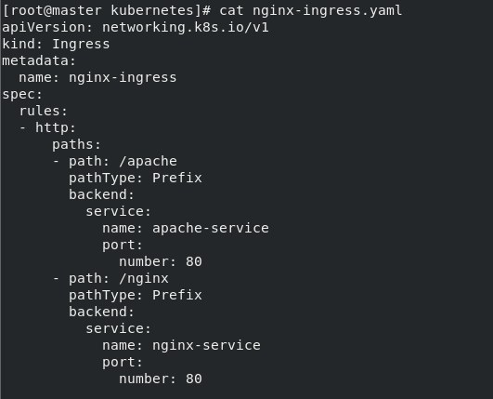
Original dimensions: 531 × 429 px

Screenshot 02 — word/media/image1.png
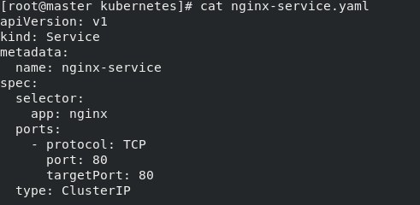
Original dimensions: 491 × 240 px

kubernetes_assignment.zip
Source Word document: kubernetes_assignment/assignment_5.docx
Embedded image count extracted: 4

Screenshot 01 — word/media/image3.png
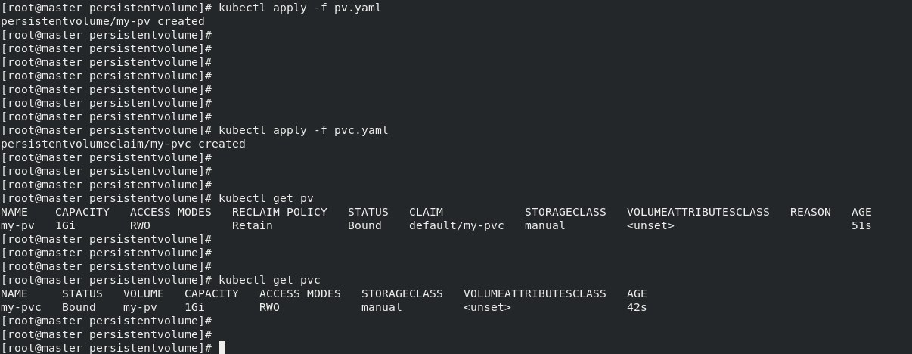
Original dimensions: 1206 × 468 px

Screenshot 02 — word/media/image2.png
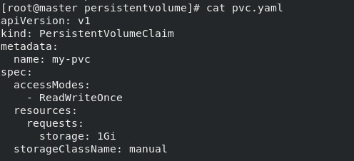
Original dimensions: 496 × 226 px

Screenshot 03 — word/media/image1.png
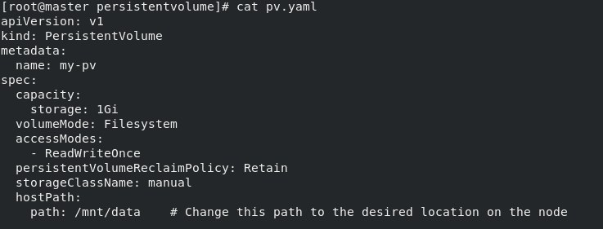
Original dimensions: 737 × 281 px

Screenshot 04 — word/media/image6.png
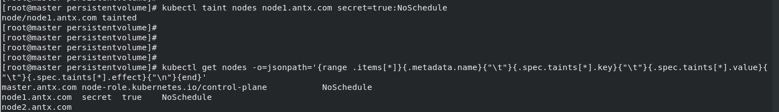
Original dimensions: 1400 × 203 px

kubernetes_assignment.zip
Source Word document: kubernetes_assignment/assignment_casestudy.docx
Embedded image count extracted: 6

Screenshot 01 — word/media/image8.png
Original dimensions: 680 × 71 px

Screenshot 02 — word/media/image6.png
Original dimensions: 1399 × 618 px

Screenshot 03 — word/media/image5.png
Original dimensions: 636 × 91 px

Screenshot 04 — word/media/image3.png
Original dimensions: 477 × 427 px

Screenshot 05 — word/media/image2.png
Original dimensions: 367 × 124 px

Screenshot 06 — word/media/image1.png
Original dimensions: 512 × 363 px

Module-4-Assignments-1.zip
No Word documents found in this ZIP. Contains: Module-4-Assignment-1.pdf, Module-4-Assignment-2.pdf, Module-4-Assignment-3.pdf, Module-4-Assignment-4.pdf, Module-4-Assignment-5.pdf

Capstone-Project01_assignment(1).zip
Source Word document: Capstone-Project01_assignment.docx
Embedded image count extracted: 15

Screenshot 01 — word/media/image10.png
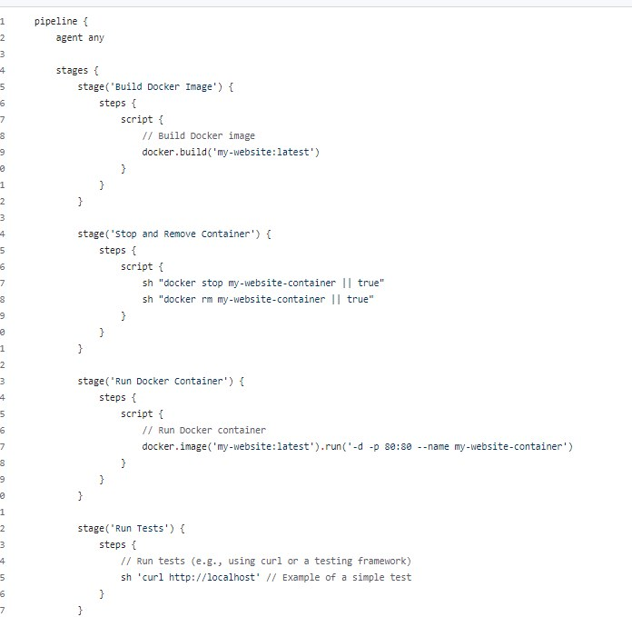
Original dimensions: 696 × 679 px

Screenshot 02 — word/media/image11.png
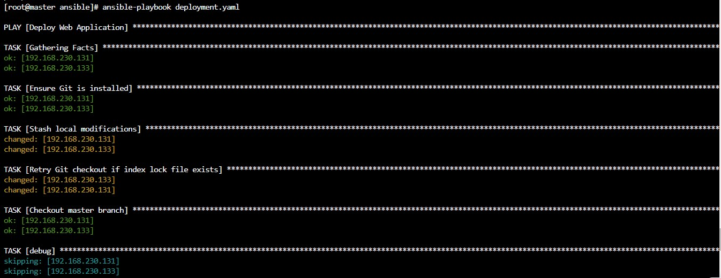
Original dimensions: 1346 × 520 px

Screenshot 03 — word/media/image12.png
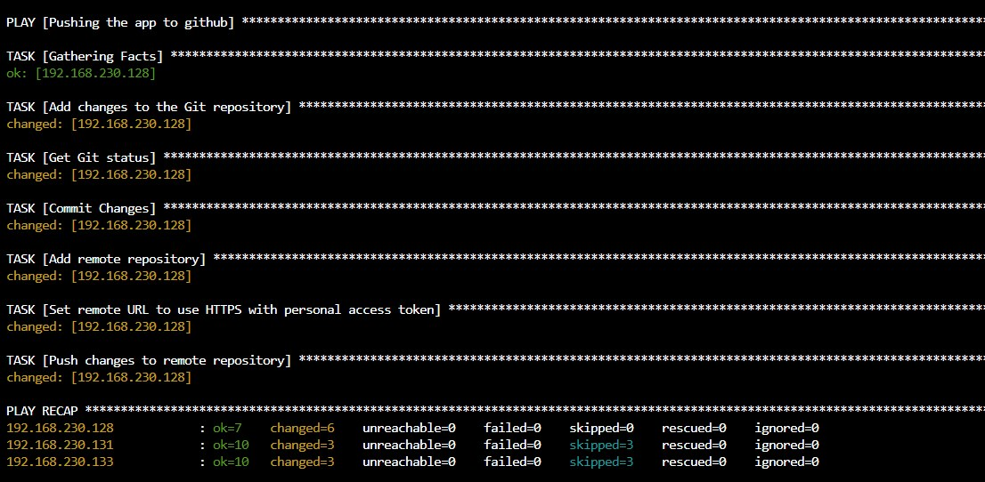
Original dimensions: 1106 × 542 px

Screenshot 04 — word/media/image13.png
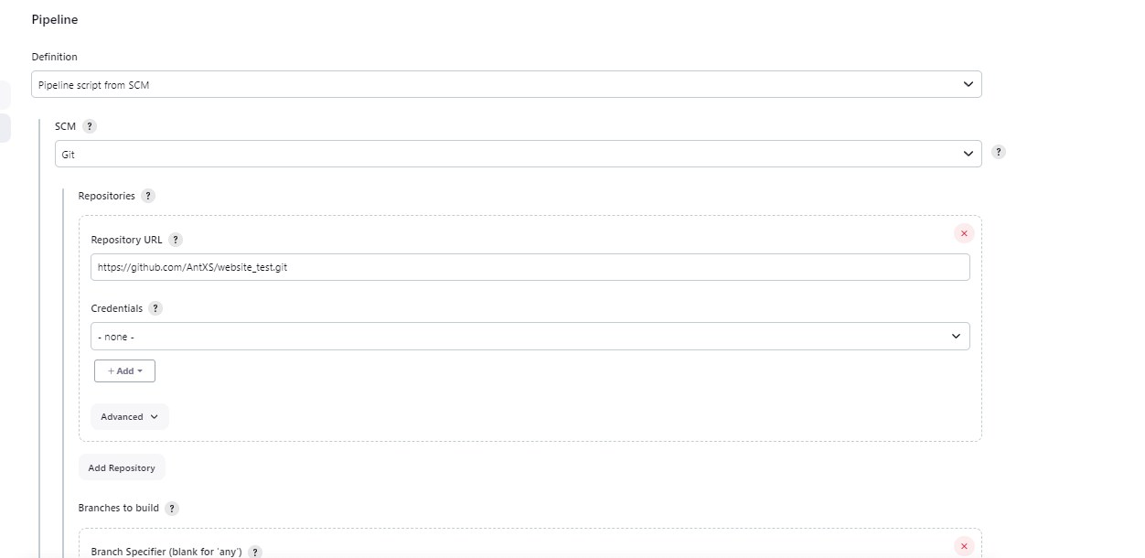
Original dimensions: 1252 × 610 px

Screenshot 05 — word/media/image14.png
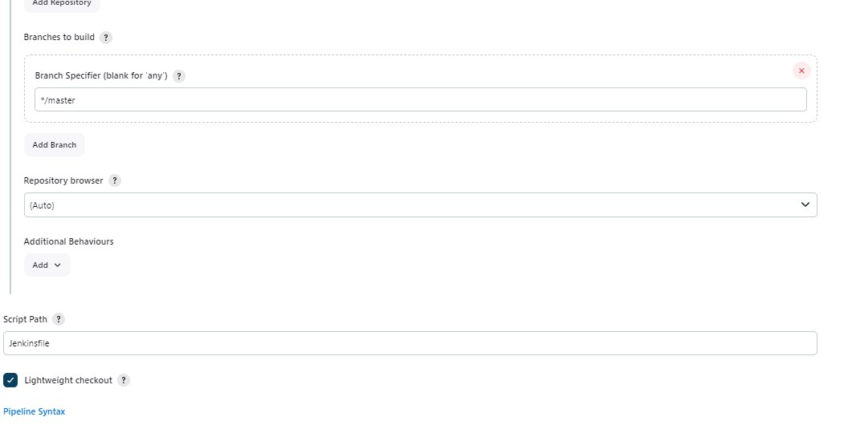
Original dimensions: 1066 × 530 px

Screenshot 06 — word/media/image15.png
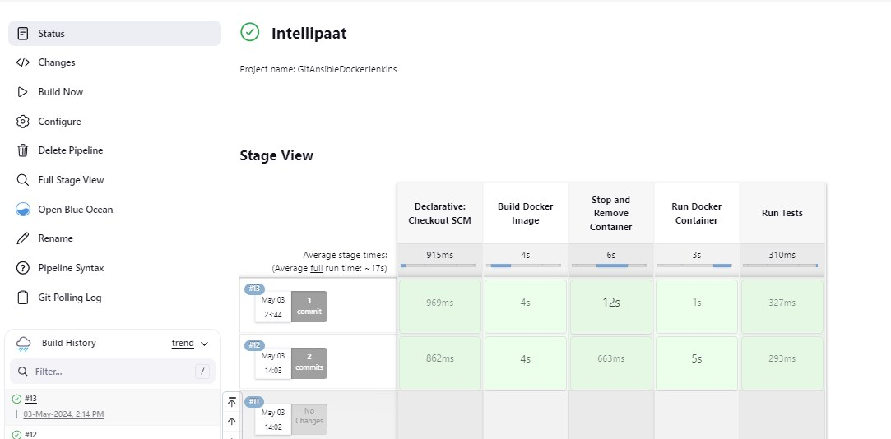
Original dimensions: 1083 × 534 px

Screenshot 07 — word/media/image9.png
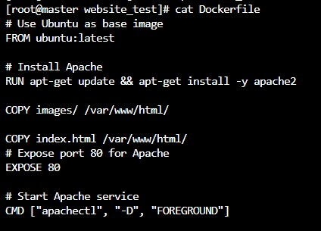
Original dimensions: 424 × 305 px

Screenshot 08 — word/media/image8.png
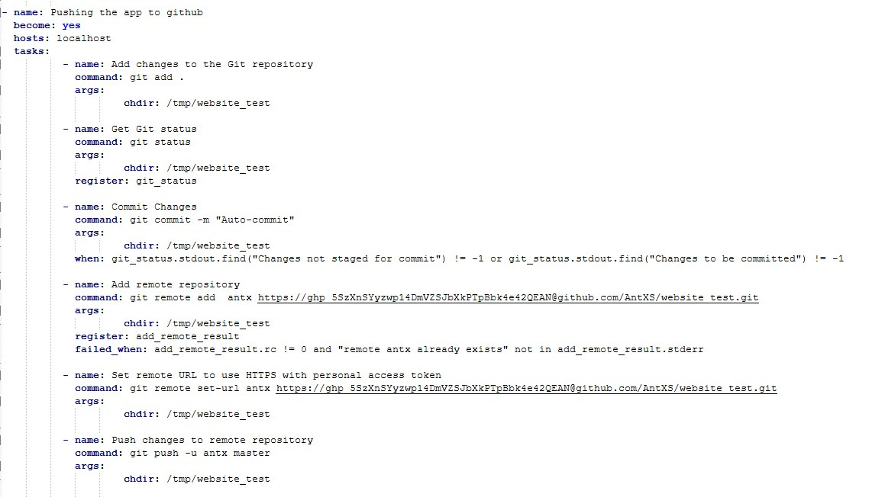
Original dimensions: 1142 × 652 px

Screenshot 09 — word/media/image7.png
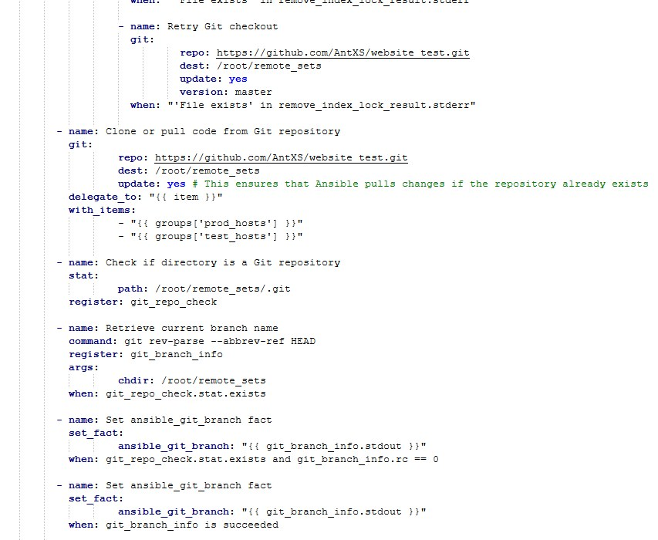
Original dimensions: 853 × 700 px

Screenshot 10 — word/media/image1.png
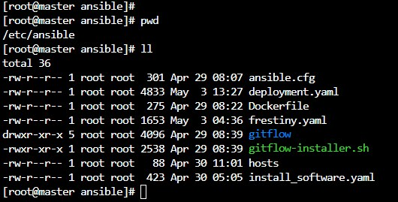
Original dimensions: 530 × 269 px

Screenshot 11 — word/media/image2.png
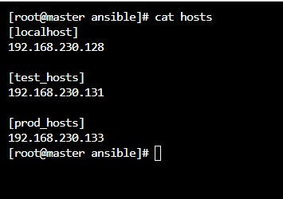
Original dimensions: 355 × 250 px

Screenshot 12 — word/media/image3.png
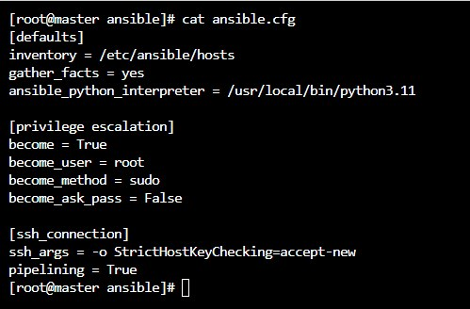
Original dimensions: 499 × 328 px

Screenshot 13 — word/media/image5.png
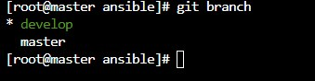
Original dimensions: 339 × 88 px

Screenshot 14 — word/media/image6.png
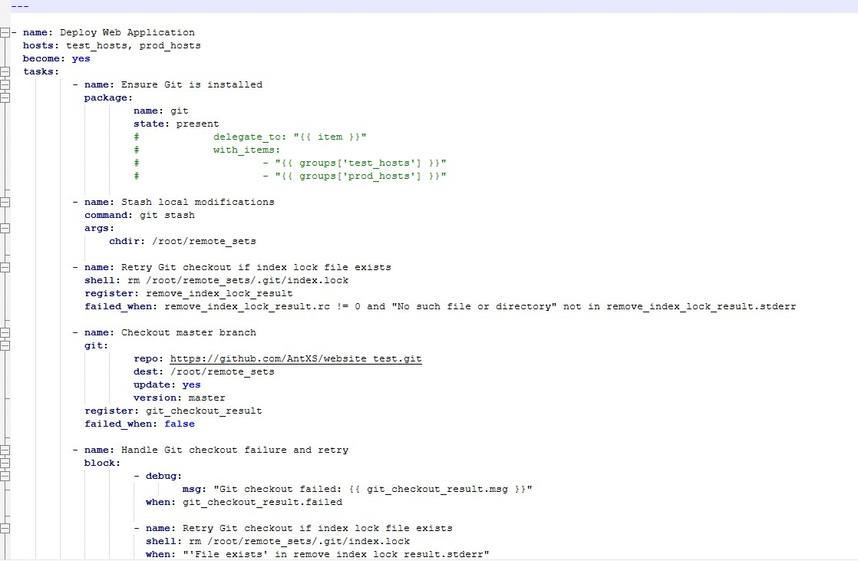
Original dimensions: 1118 × 731 px

Screenshot 15 — word/media/image16.png
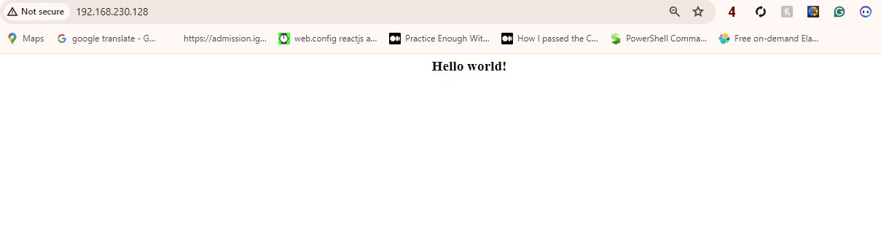
Original dimensions: 1209 × 330 px

Capstone-Project02_assignment(1).zip
Source Word document: Capstone-Project02_assignment.docx
Embedded image count extracted: 29

Screenshot 01 — word/media/image21.png
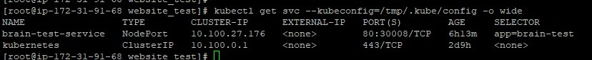
Original dimensions: 828 × 84 px

Screenshot 02 — word/media/image20.png
Original dimensions: 1451 × 74 px

Screenshot 03 — word/media/image19.png
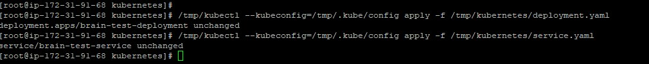
Original dimensions: 1010 × 101 px

Screenshot 04 — word/media/image18.png
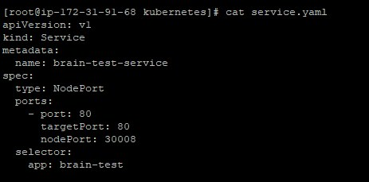
Original dimensions: 463 × 229 px

Screenshot 05 — word/media/image17.png
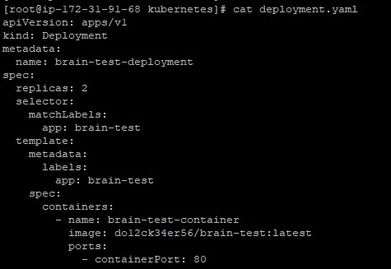
Original dimensions: 475 × 327 px

Screenshot 06 — word/media/image22.png
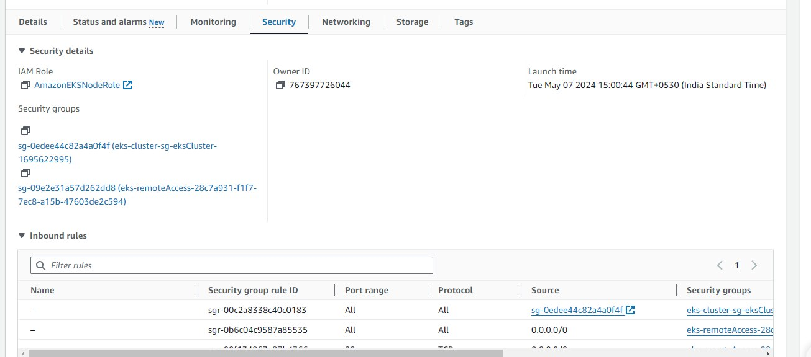
Original dimensions: 1305 × 576 px

Screenshot 07 — word/media/image23.png
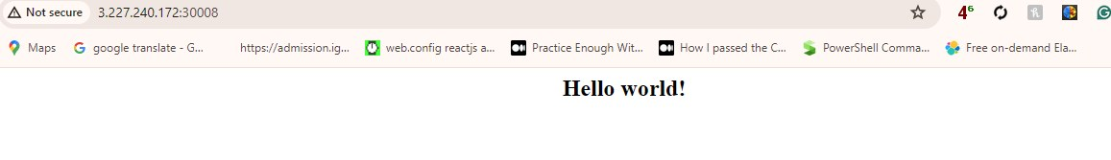
Original dimensions: 1157 × 167 px

Screenshot 08 — word/media/image24.png
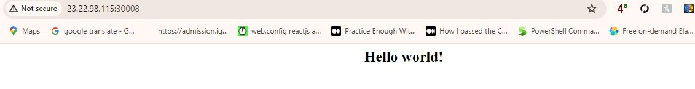
Original dimensions: 1131 × 146 px

Screenshot 09 — word/media/image29.png
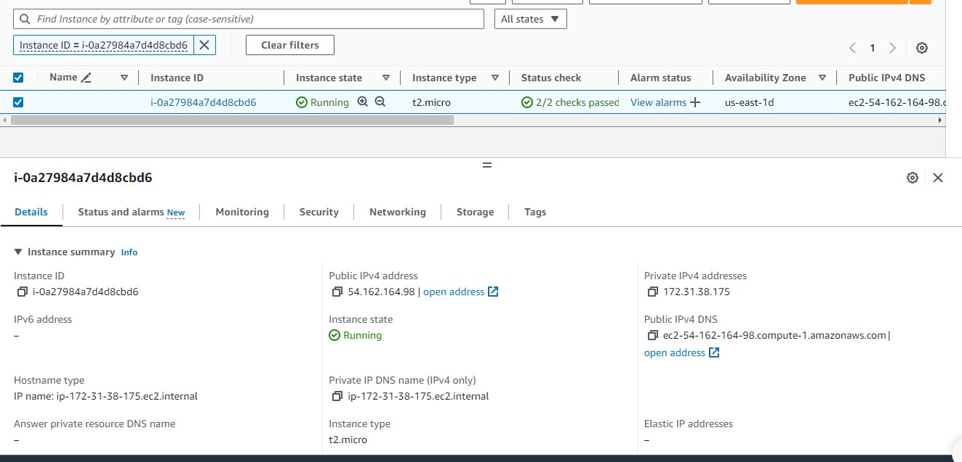
Original dimensions: 1323 × 637 px

Screenshot 10 — word/media/image28.png
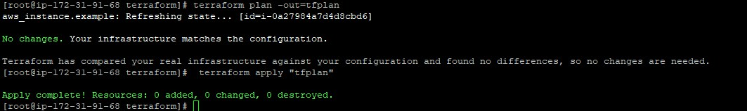
Original dimensions: 1063 × 158 px

Screenshot 11 — word/media/image27.png
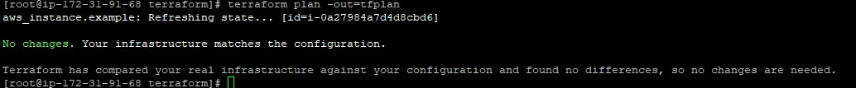
Original dimensions: 1034 × 107 px

Screenshot 12 — word/media/image26.png
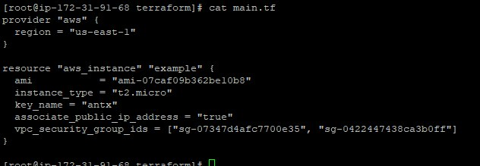
Original dimensions: 632 × 219 px

Screenshot 13 — word/media/image25.png
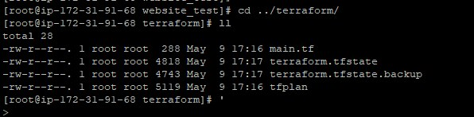
Original dimensions: 596 × 147 px

Screenshot 14 — word/media/image16.png
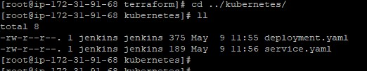
Original dimensions: 522 × 102 px

Screenshot 15 — word/media/image15.png
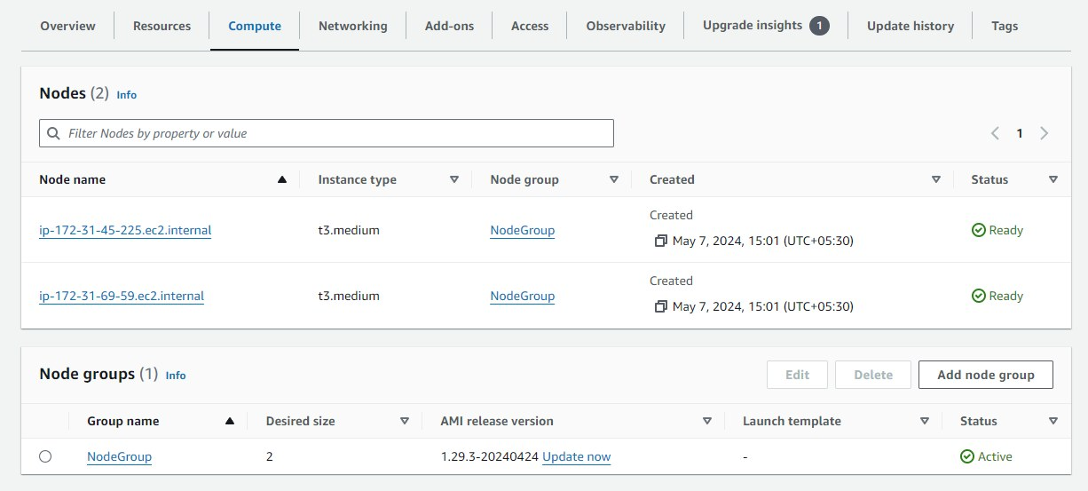
Original dimensions: 1226 × 553 px

Screenshot 16 — word/media/image14.png
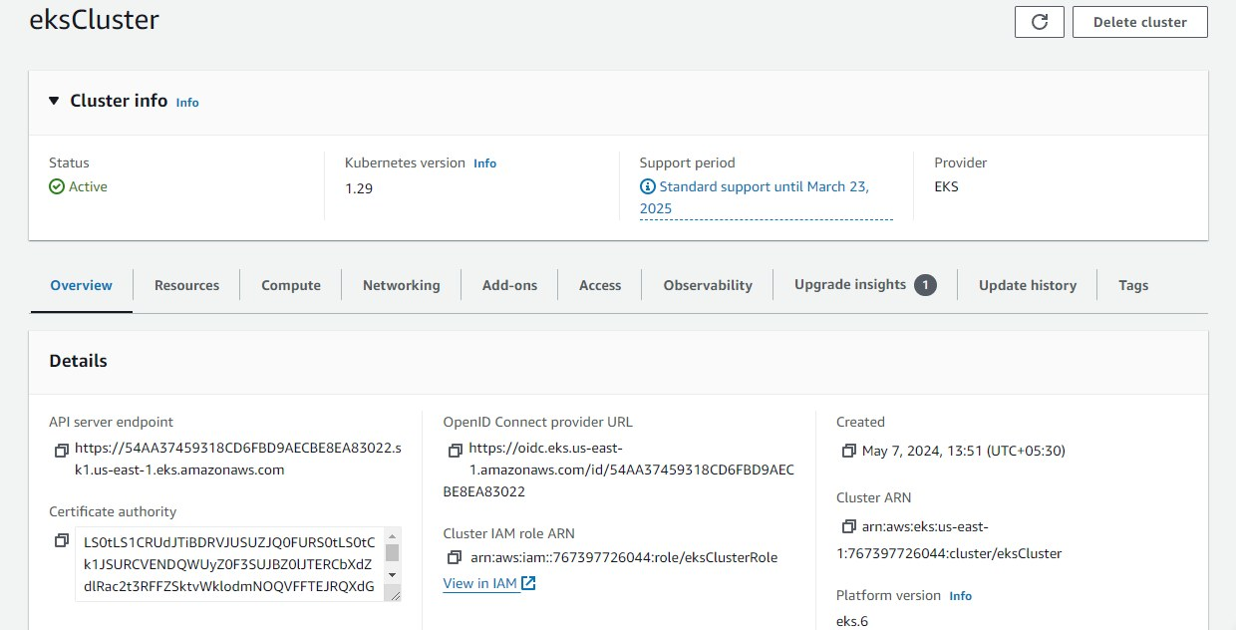
Original dimensions: 1240 × 632 px

Screenshot 17 — word/media/image5.png
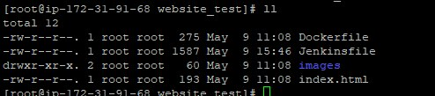
Original dimensions: 494 × 109 px

Screenshot 18 — word/media/image4.png
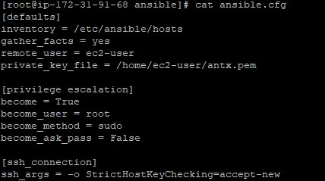
Original dimensions: 428 × 239 px

Screenshot 19 — word/media/image3.png
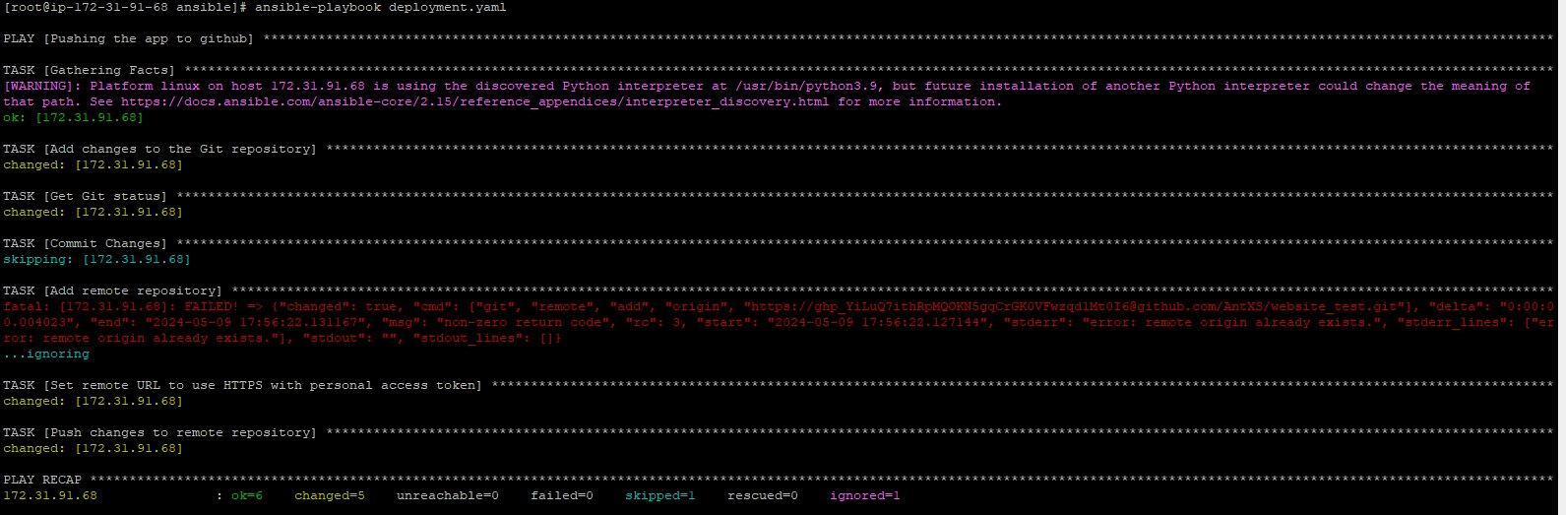
Original dimensions: 1591 × 523 px

Screenshot 20 — word/media/image2.png
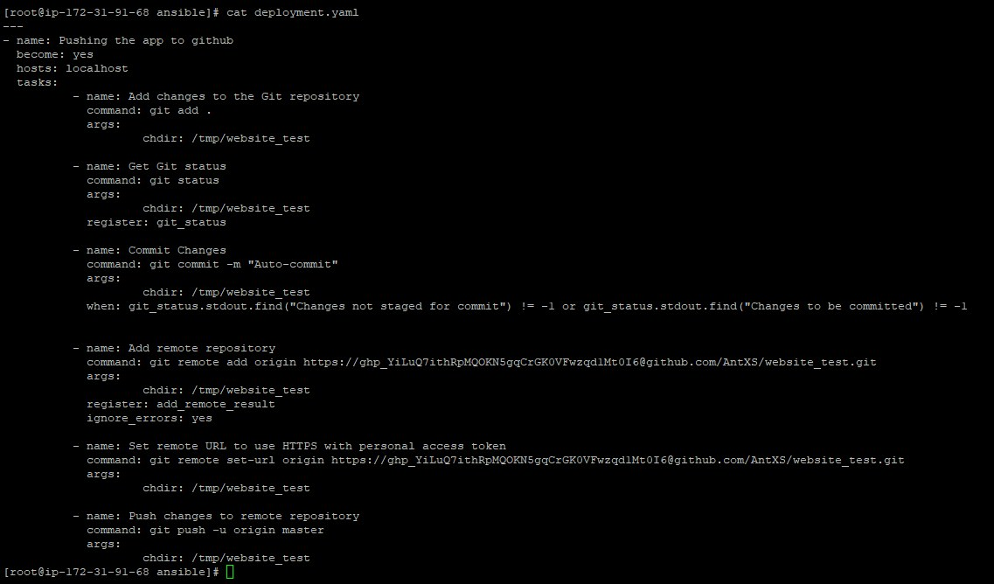
Original dimensions: 1137 × 668 px

Screenshot 21 — word/media/image6.png
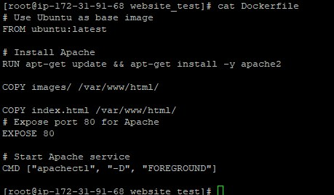
Original dimensions: 459 × 269 px

Screenshot 22 — word/media/image7.png
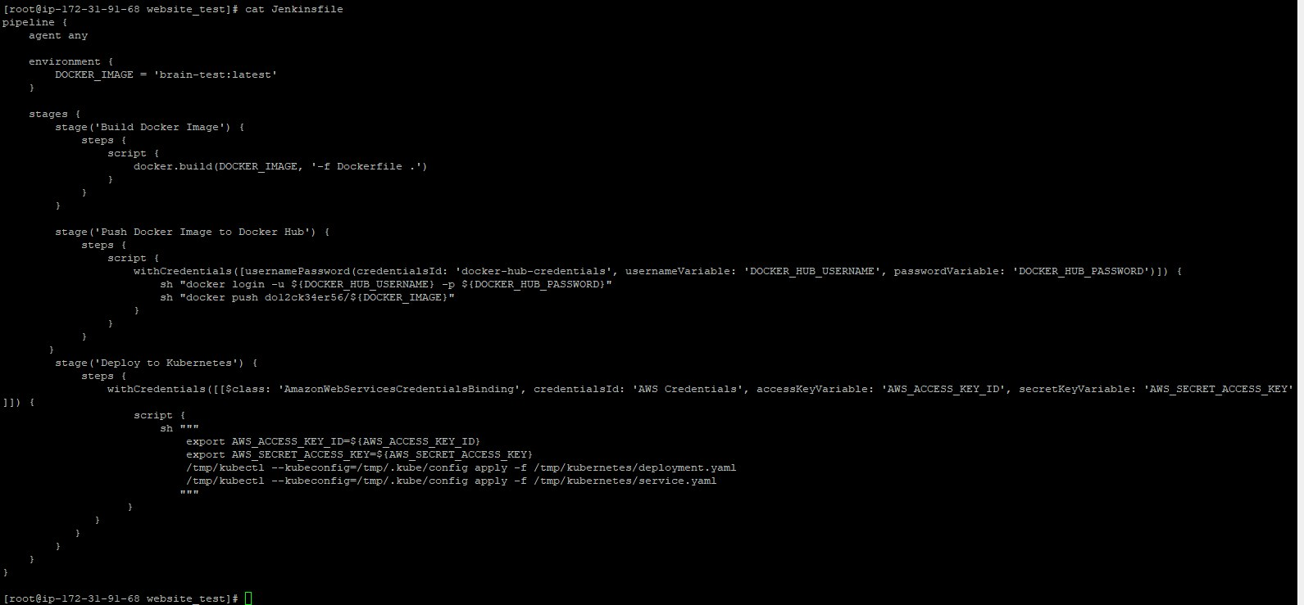
Original dimensions: 1591 × 739 px

Screenshot 23 — word/media/image8.png
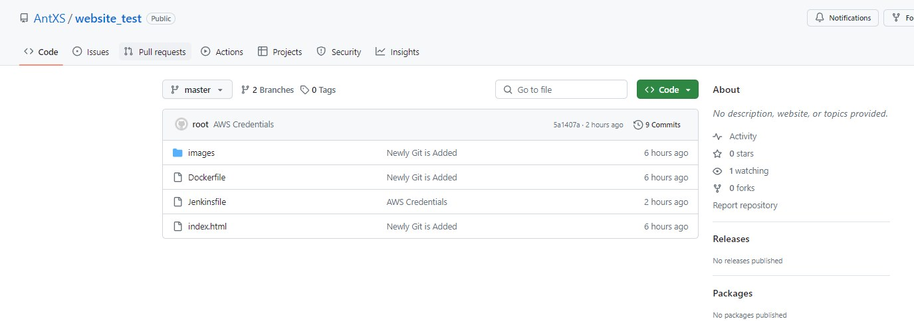
Original dimensions: 1375 × 484 px

Screenshot 24 — word/media/image13.png
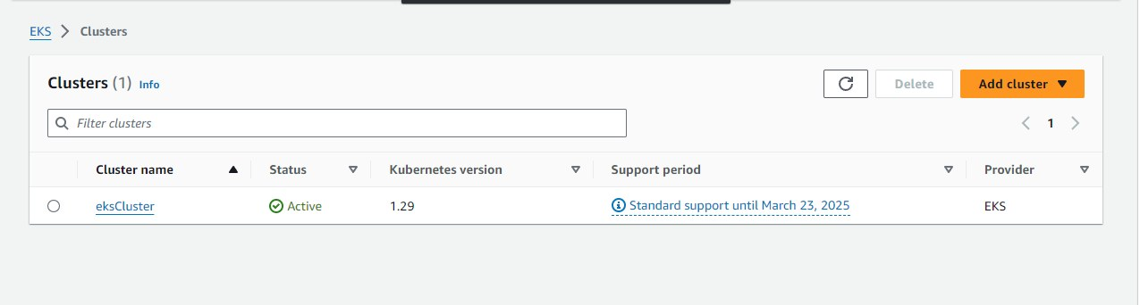
Original dimensions: 1275 × 342 px

Screenshot 25 — word/media/image12.png
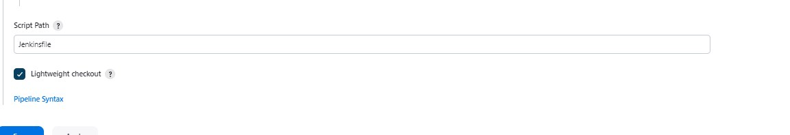
Original dimensions: 1152 × 198 px

Screenshot 26 — word/media/image11.png
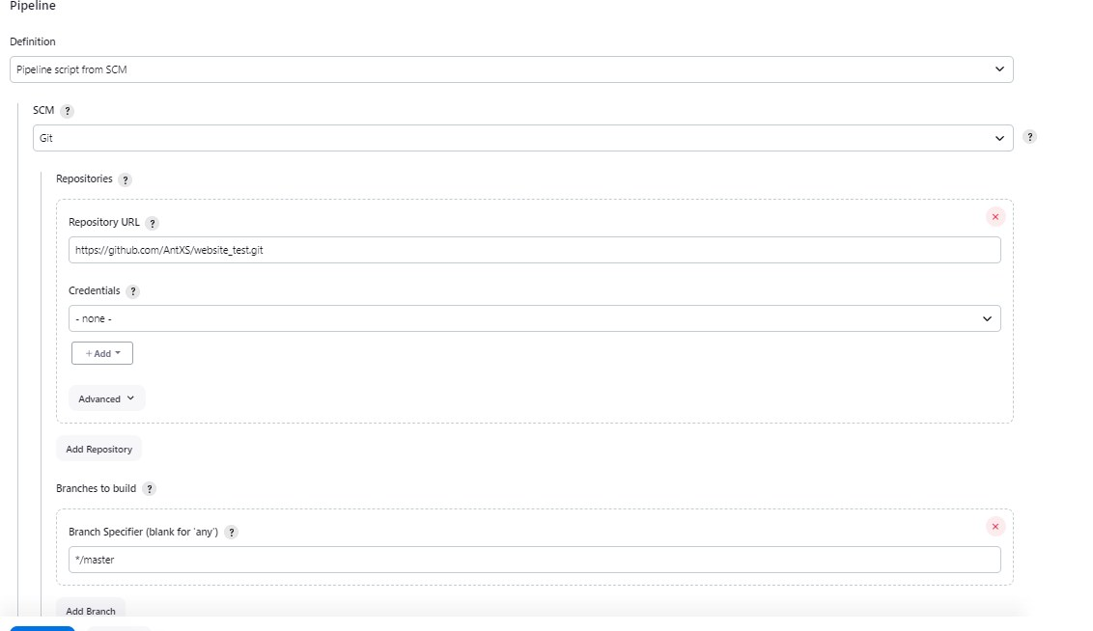
Original dimensions: 1132 × 654 px

Screenshot 27 — word/media/image10.png
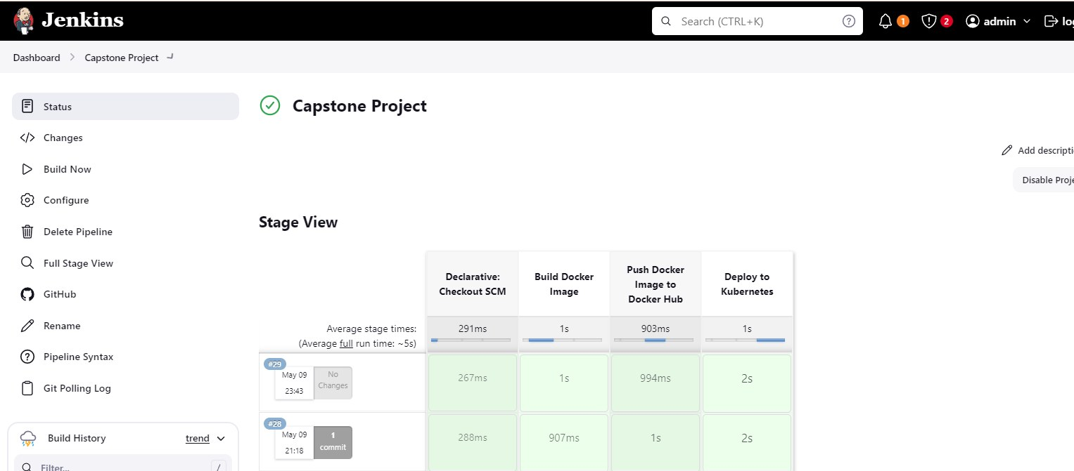
Original dimensions: 1527 × 671 px

Screenshot 28 — word/media/image9.png
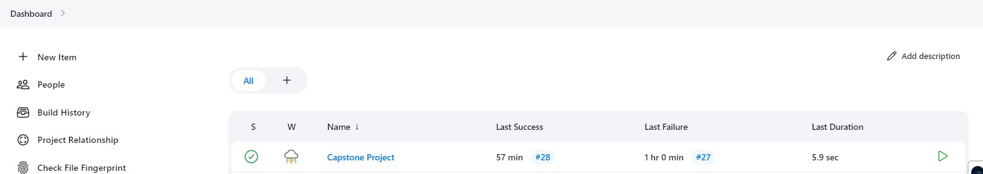
Original dimensions: 1576 × 280 px

Screenshot 29 — word/media/image30.png
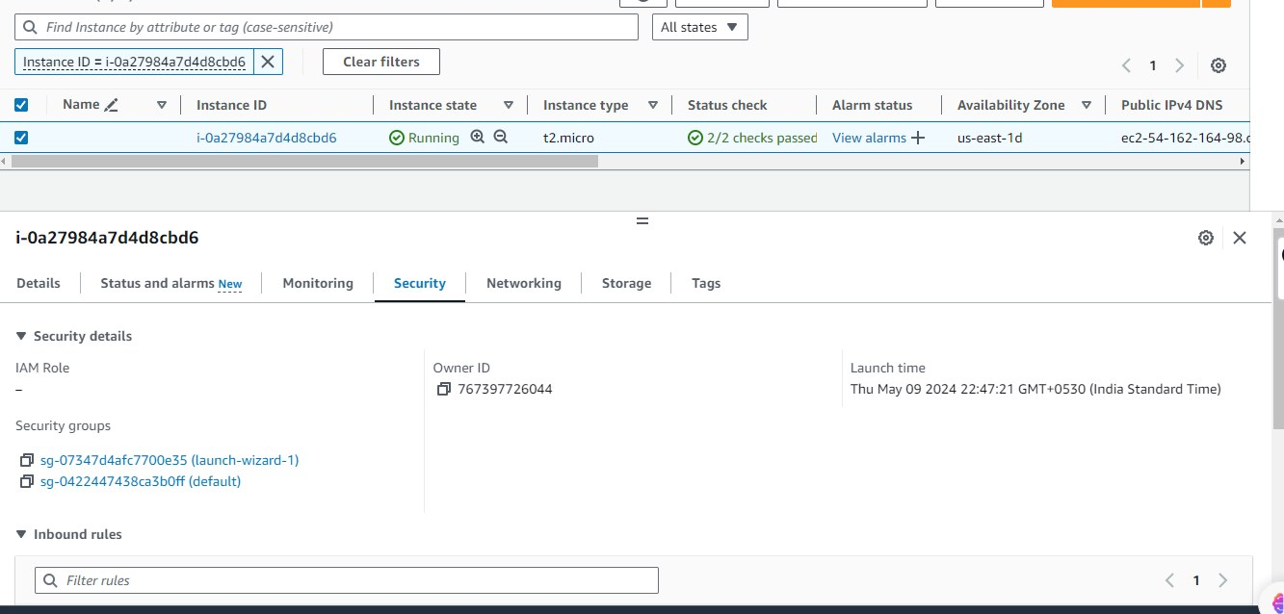
Original dimensions: 1333 × 638 px

AWS-DevOps(1).zip
Source Word document: AWS-DevOps.docx
Embedded image count extracted: 45

Screenshot 01 — word/media/image44.png
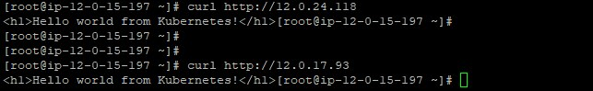
Original dimensions: 643 × 99 px

Screenshot 02 — word/media/image31.png
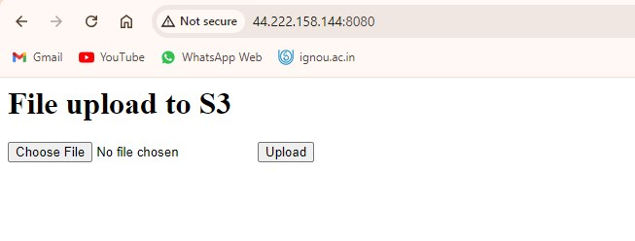
Original dimensions: 653 × 248 px

Screenshot 03 — word/media/image30.png
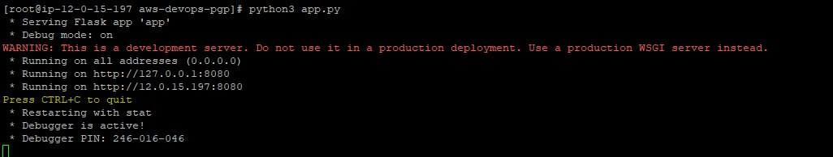
Original dimensions: 1026 × 194 px

Screenshot 04 — word/media/image29.png
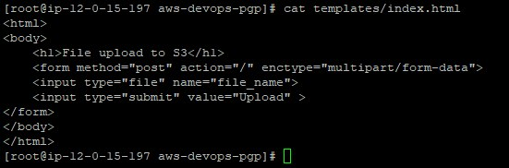
Original dimensions: 551 × 182 px

Screenshot 05 — word/media/image28.png
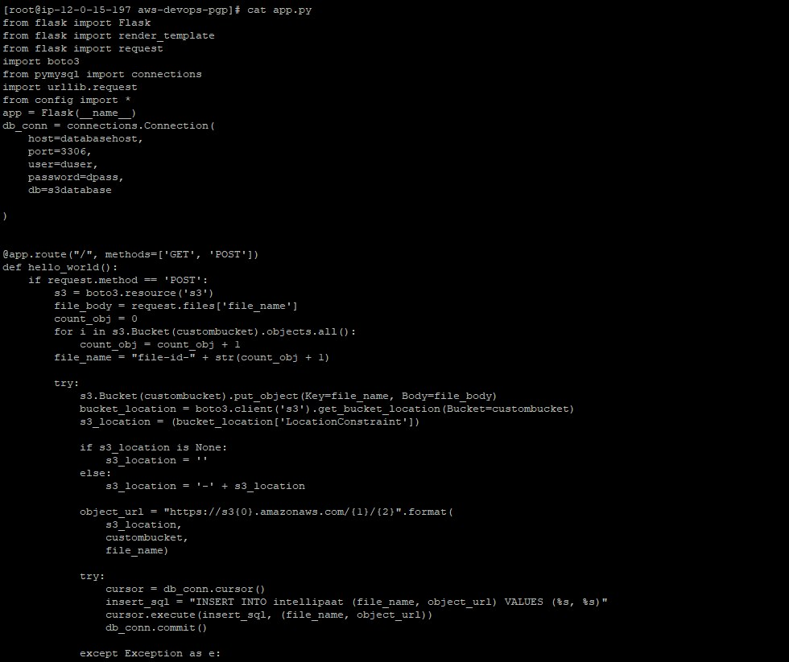
Original dimensions: 980 × 823 px

Screenshot 06 — word/media/image27.png
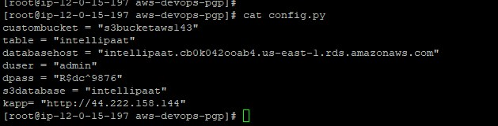
Original dimensions: 629 × 160 px

Screenshot 07 — word/media/image26.png
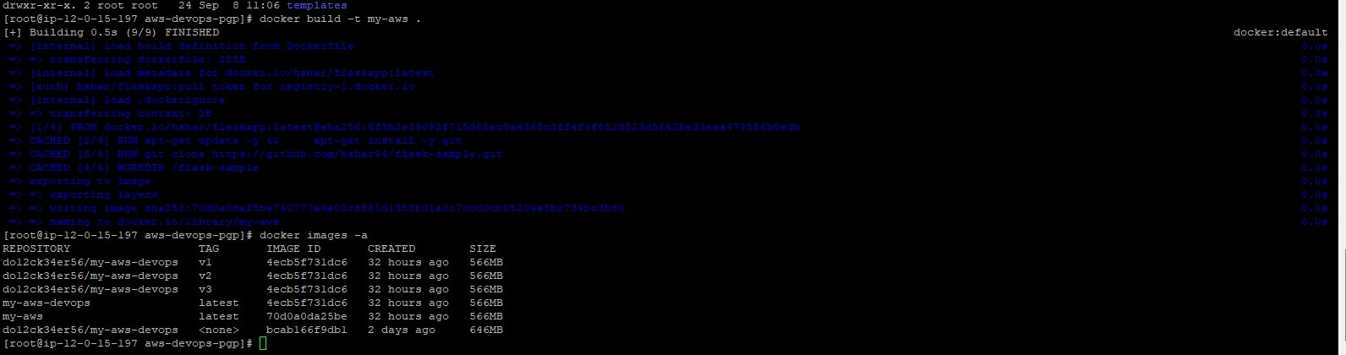
Original dimensions: 1592 × 420 px

Screenshot 08 — word/media/image25.png
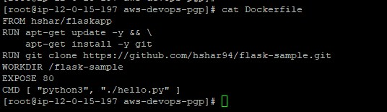
Original dimensions: 536 × 156 px

Screenshot 09 — word/media/image24.png
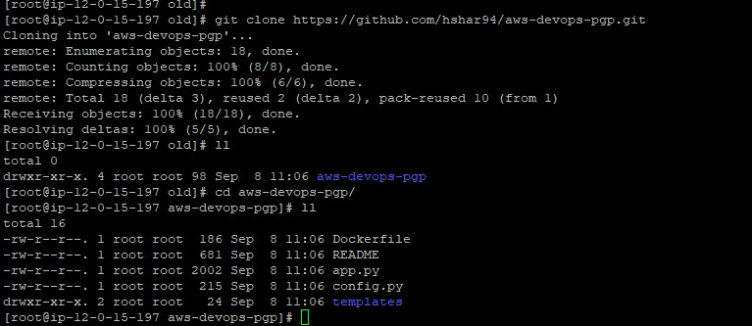
Original dimensions: 767 × 333 px

Screenshot 10 — word/media/image23.png
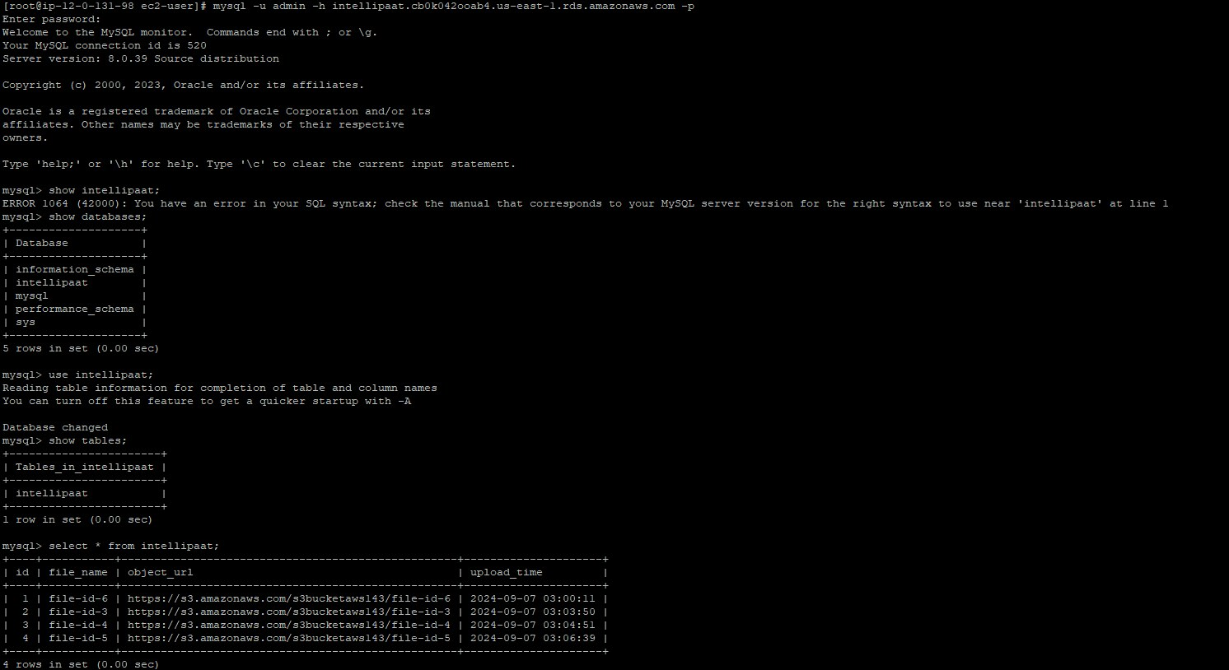
Original dimensions: 1492 × 814 px

Screenshot 11 — word/media/image32.png
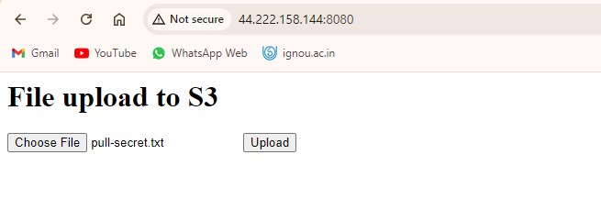
Original dimensions: 655 × 241 px

Screenshot 12 — word/media/image33.png
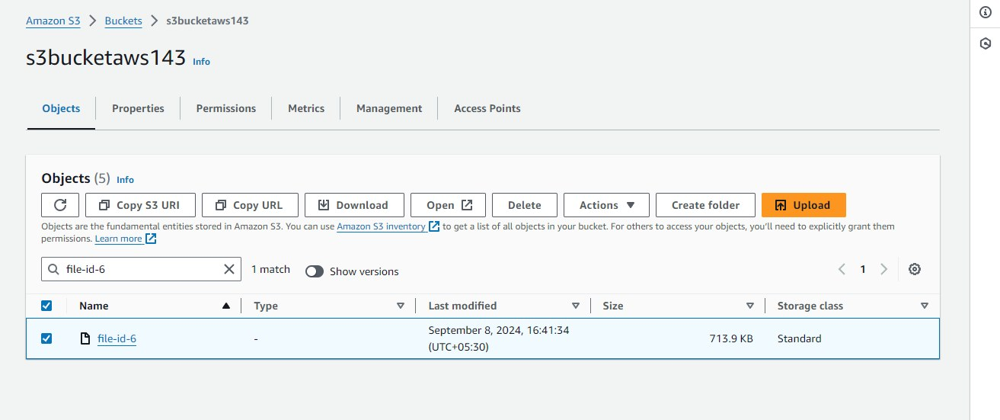
Original dimensions: 1313 × 551 px

Screenshot 13 — word/media/image34.png
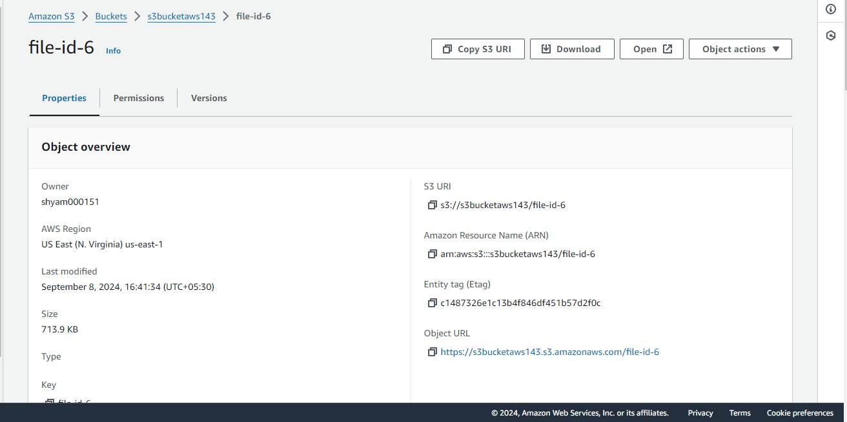
Original dimensions: 1312 × 655 px

Screenshot 14 — word/media/image43.png
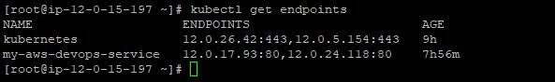
Original dimensions: 593 × 88 px

Screenshot 15 — word/media/image42.png
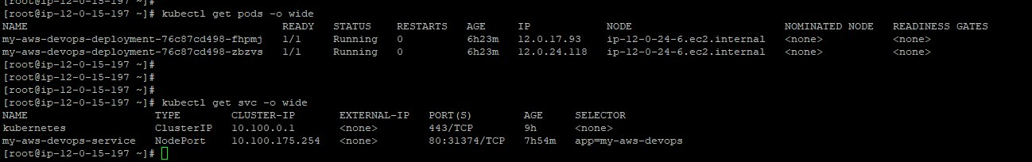
Original dimensions: 1298 × 204 px

Screenshot 16 — word/media/image41.png
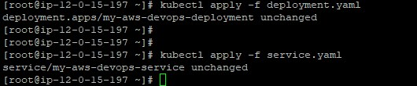
Original dimensions: 530 × 110 px

Screenshot 17 — word/media/image40.png
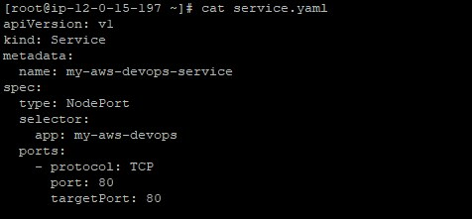
Original dimensions: 476 × 221 px

Screenshot 18 — word/media/image39.png
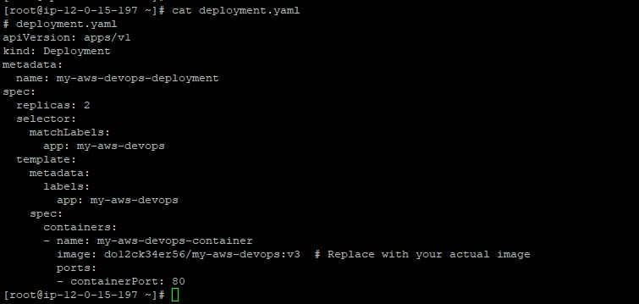
Original dimensions: 755 × 359 px

Screenshot 19 — word/media/image38.png
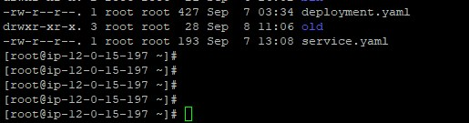
Original dimensions: 515 × 135 px

Screenshot 20 — word/media/image37.png
Original dimensions: 1456 × 89 px

Screenshot 21 — word/media/image36.png
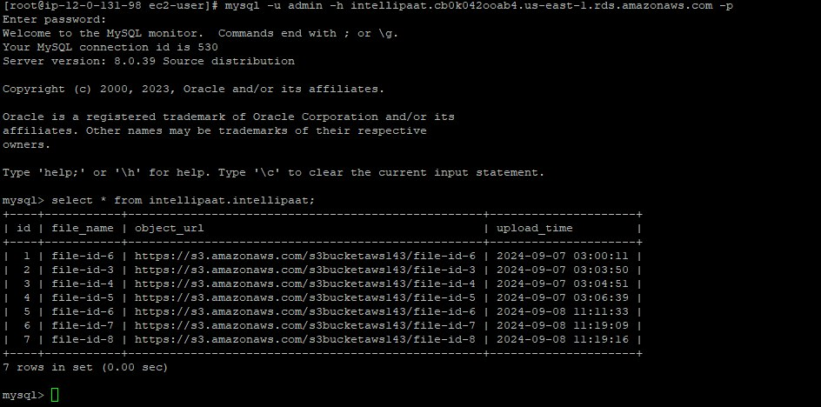
Original dimensions: 944 × 468 px

Screenshot 22 — word/media/image35.png
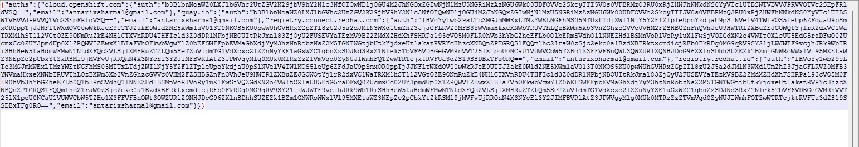
Original dimensions: 1542 × 265 px

Screenshot 23 — word/media/image22.png
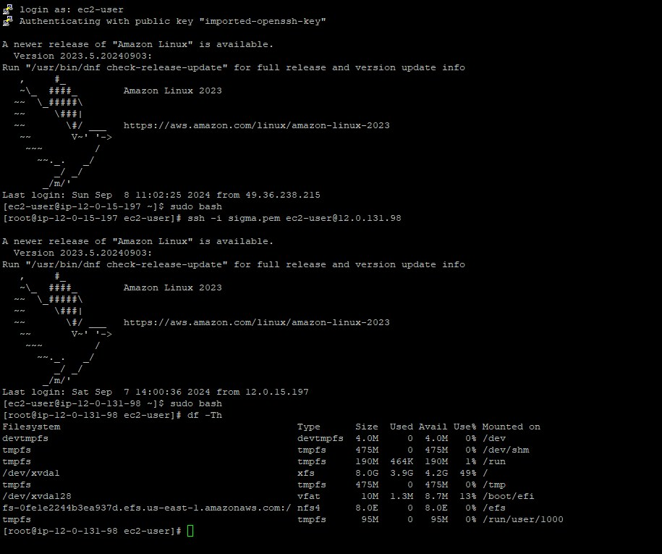
Original dimensions: 915 × 765 px

Screenshot 24 — word/media/image21.png
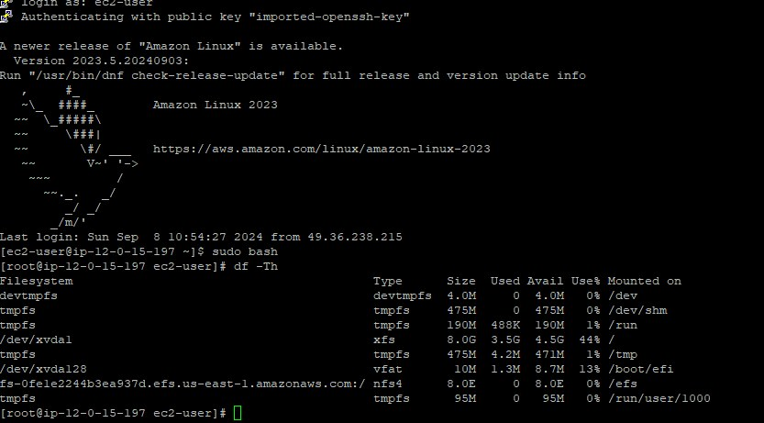
Original dimensions: 833 × 461 px

Screenshot 25 — word/media/image20.png
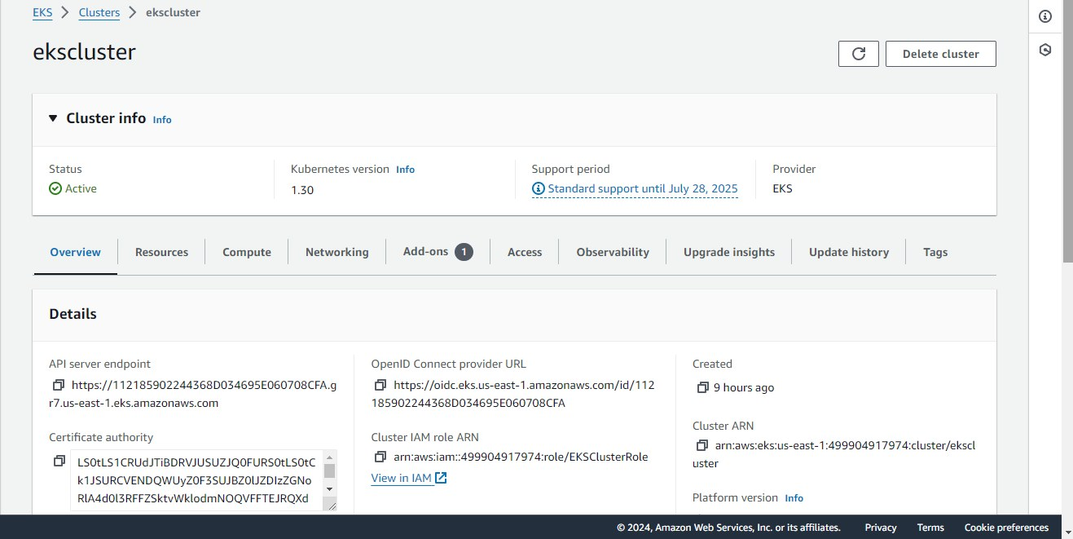
Original dimensions: 1317 × 661 px

Screenshot 26 — word/media/image8.png
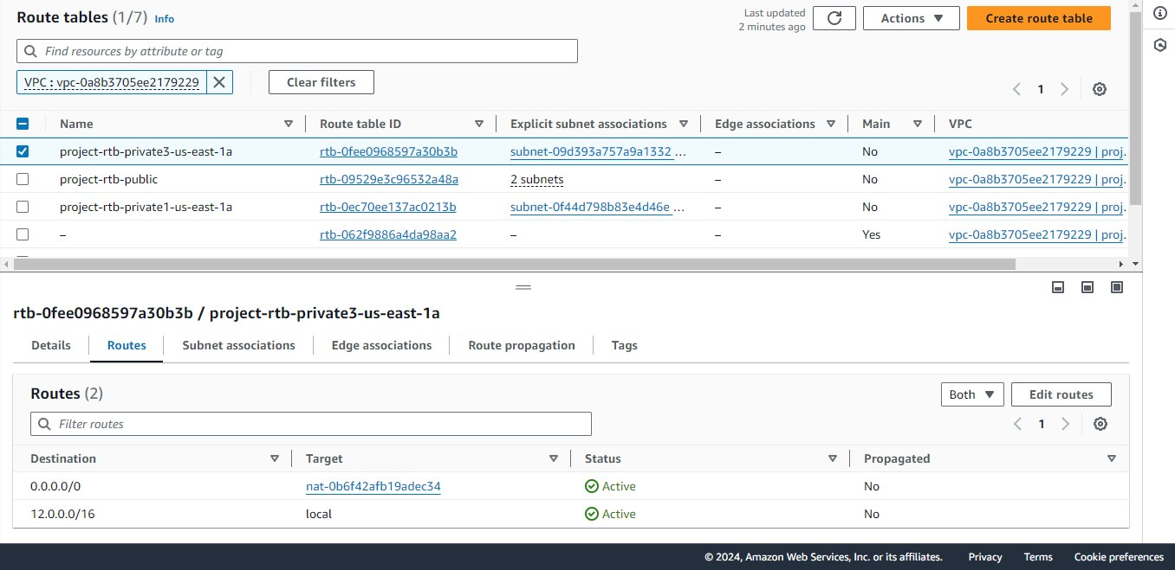
Original dimensions: 1356 × 659 px

Screenshot 27 — word/media/image7.png
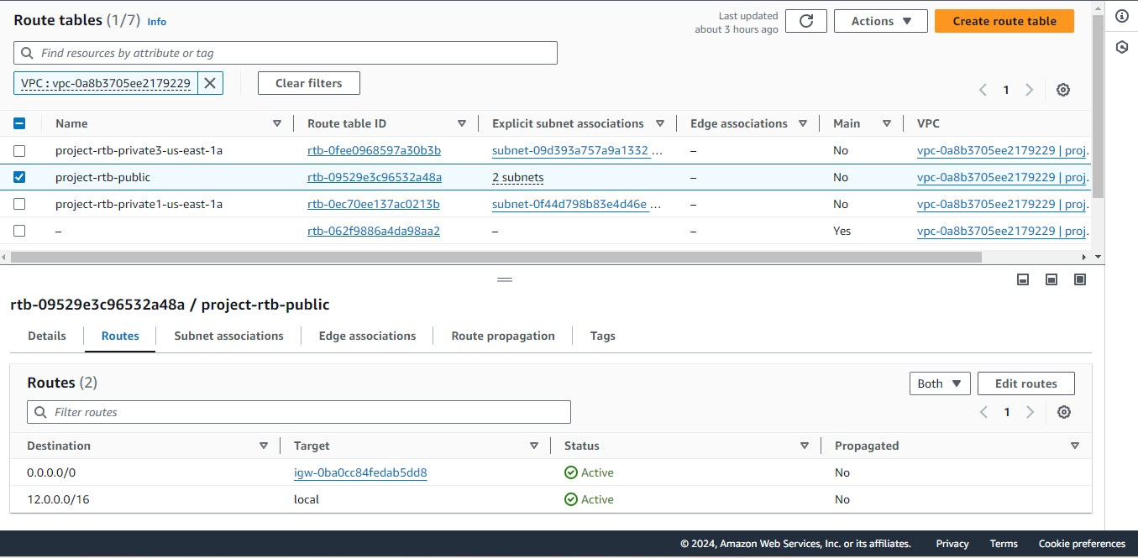
Original dimensions: 1355 × 665 px

Screenshot 28 — word/media/image6.png
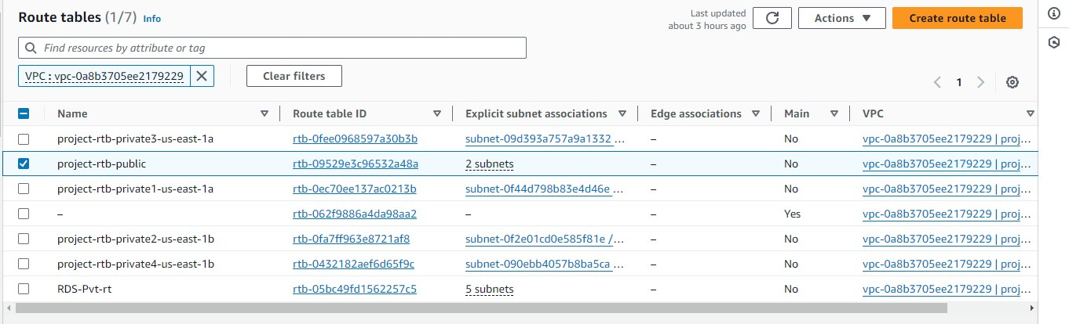
Original dimensions: 1362 × 414 px

Screenshot 29 — word/media/image5.png
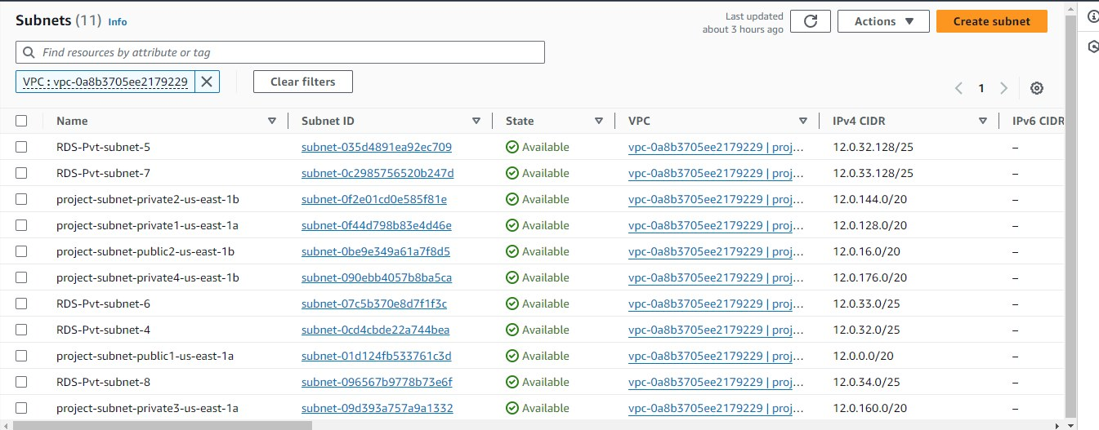
Original dimensions: 1345 × 527 px

Screenshot 30 — word/media/image4.png
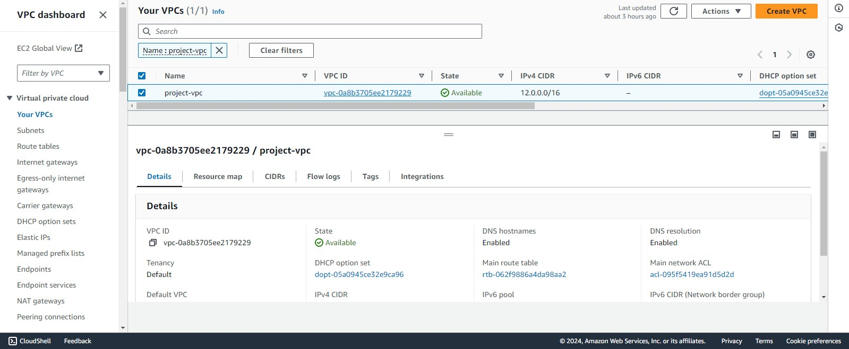
Original dimensions: 1599 × 659 px

Screenshot 31 — word/media/image3.png
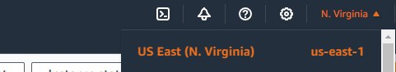
Original dimensions: 481 × 88 px

Screenshot 32 — word/media/image2.png
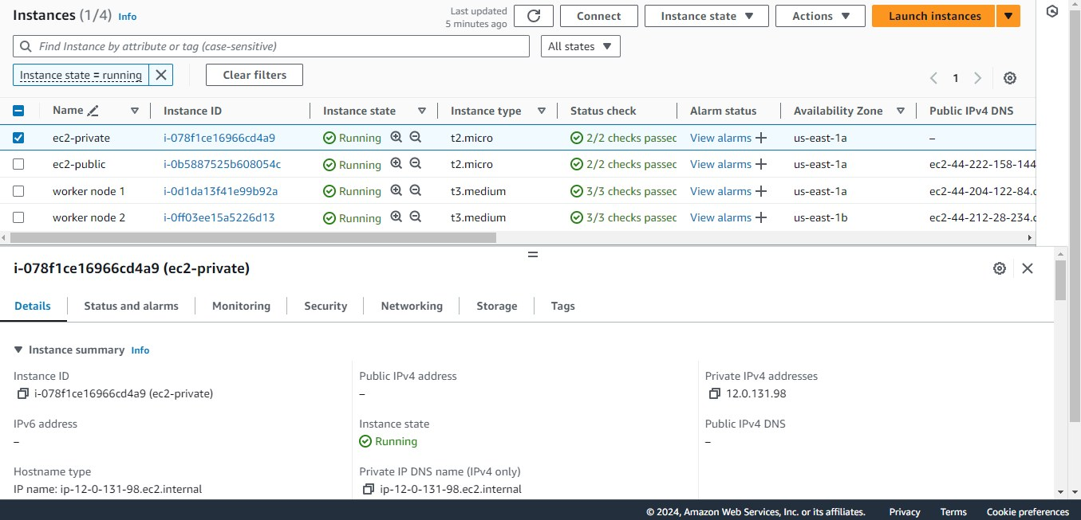
Original dimensions: 1355 × 653 px

Screenshot 33 — word/media/image1.png
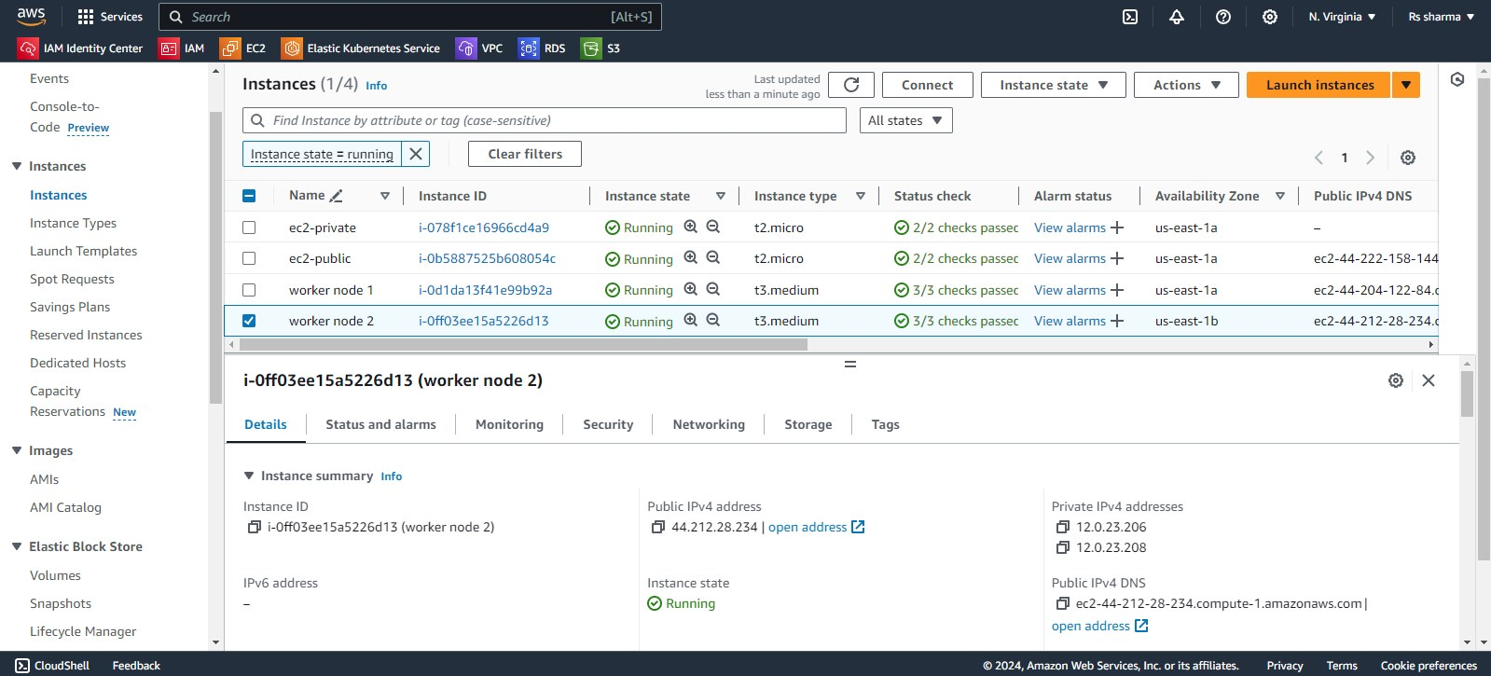
Original dimensions: 1599 × 725 px

Screenshot 34 — word/media/image45.png
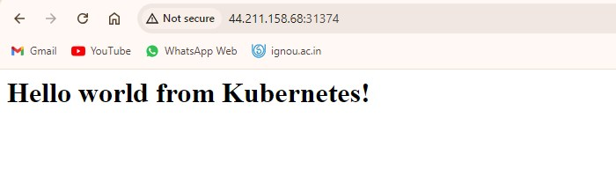
Original dimensions: 700 × 192 px

Screenshot 35 — word/media/image9.png
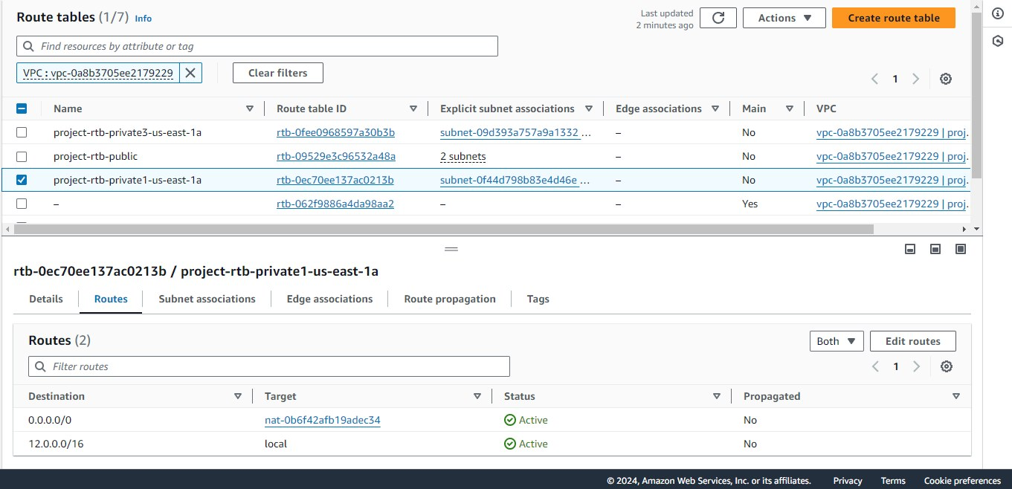
Original dimensions: 1361 × 658 px

Screenshot 36 — word/media/image11.png
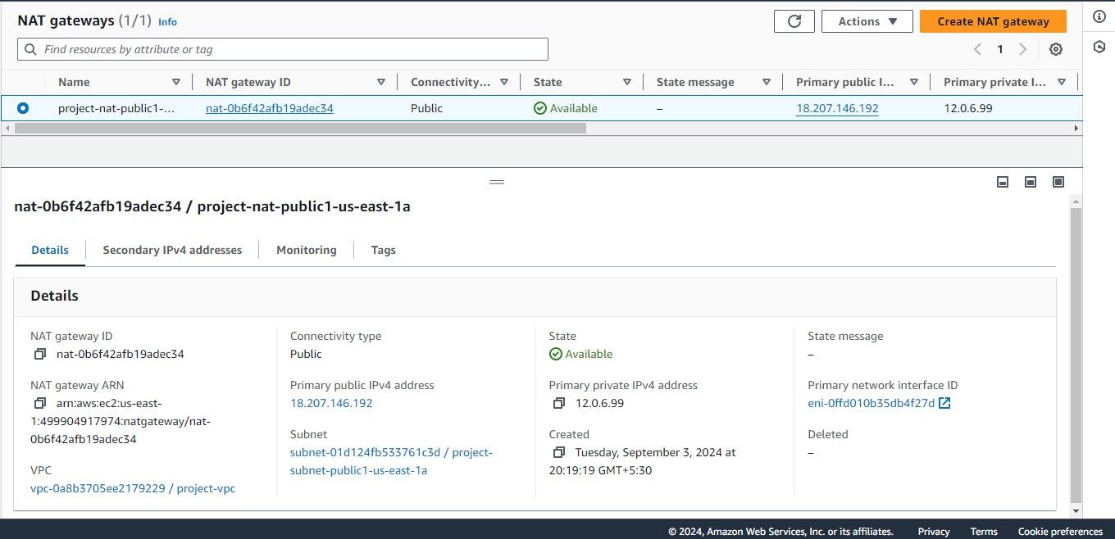
Original dimensions: 1360 × 658 px

Screenshot 37 — word/media/image19.png
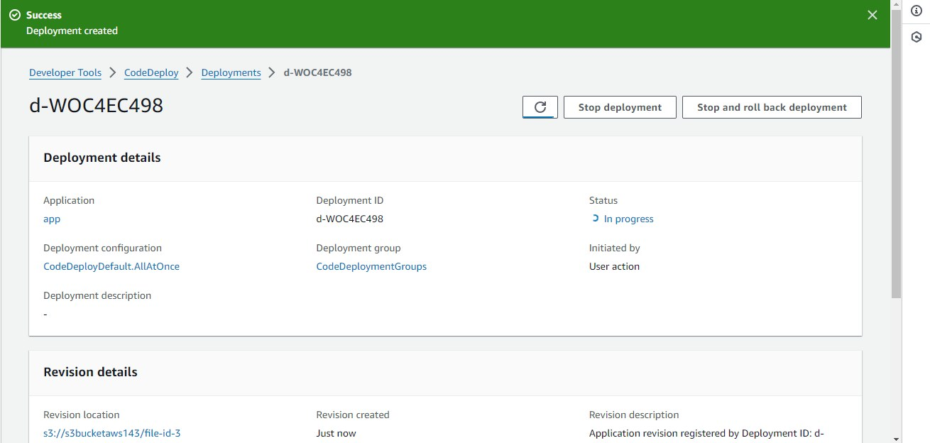
Original dimensions: 1310 × 624 px

Screenshot 38 — word/media/image18.png
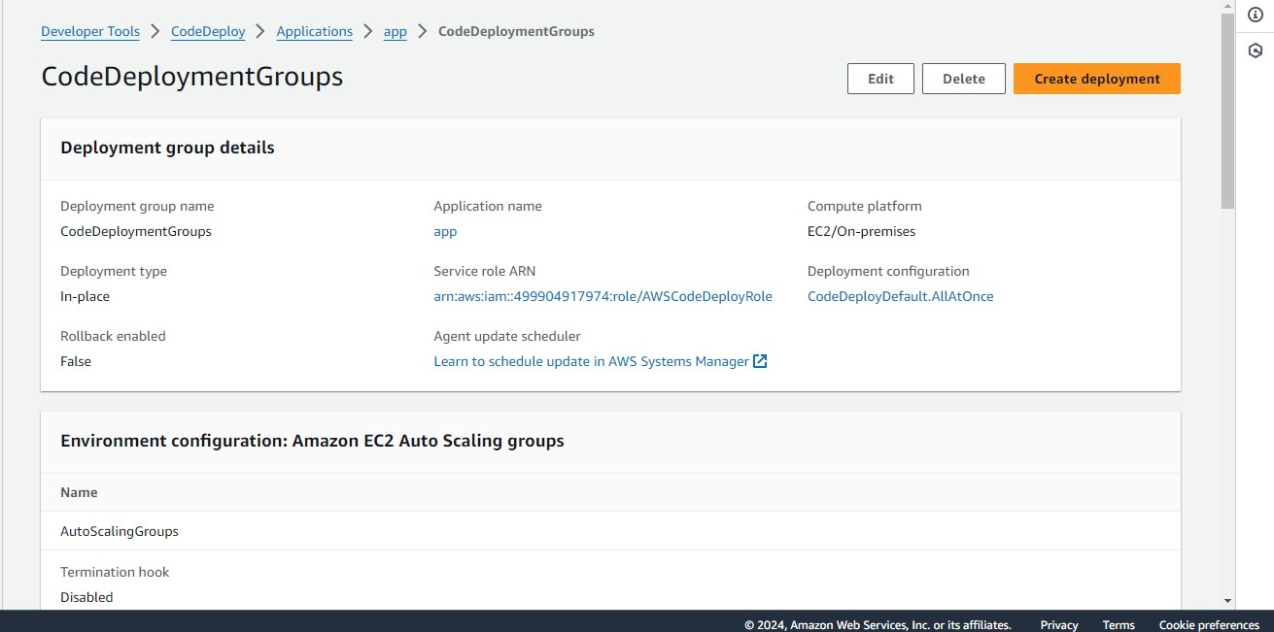
Original dimensions: 1311 × 651 px

Screenshot 39 — word/media/image17.png
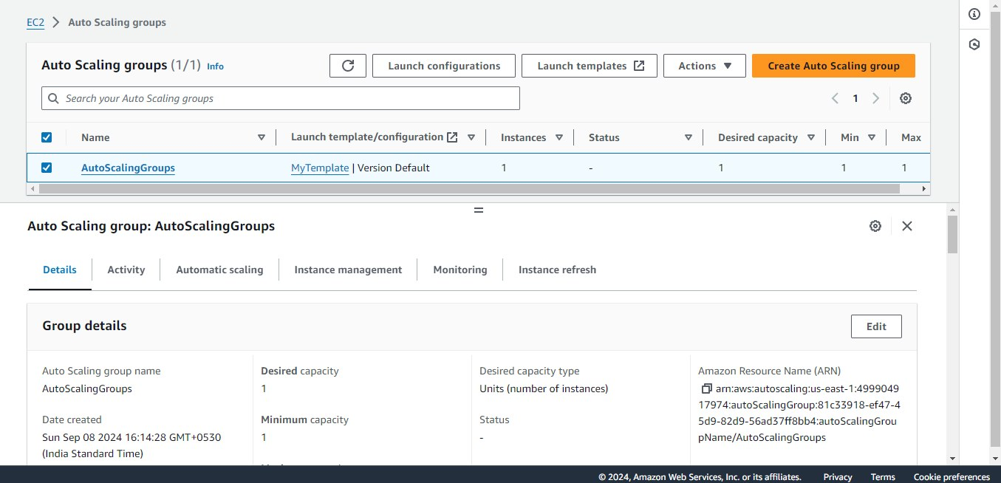
Original dimensions: 1355 × 654 px

Screenshot 40 — word/media/image10.png
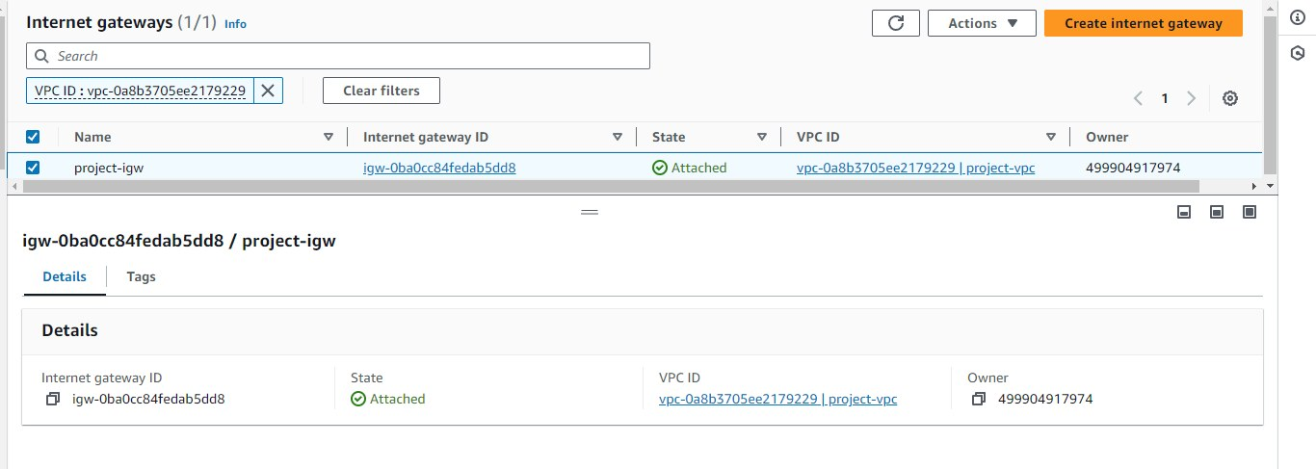
Original dimensions: 1366 × 487 px

Screenshot 41 — word/media/image16.png
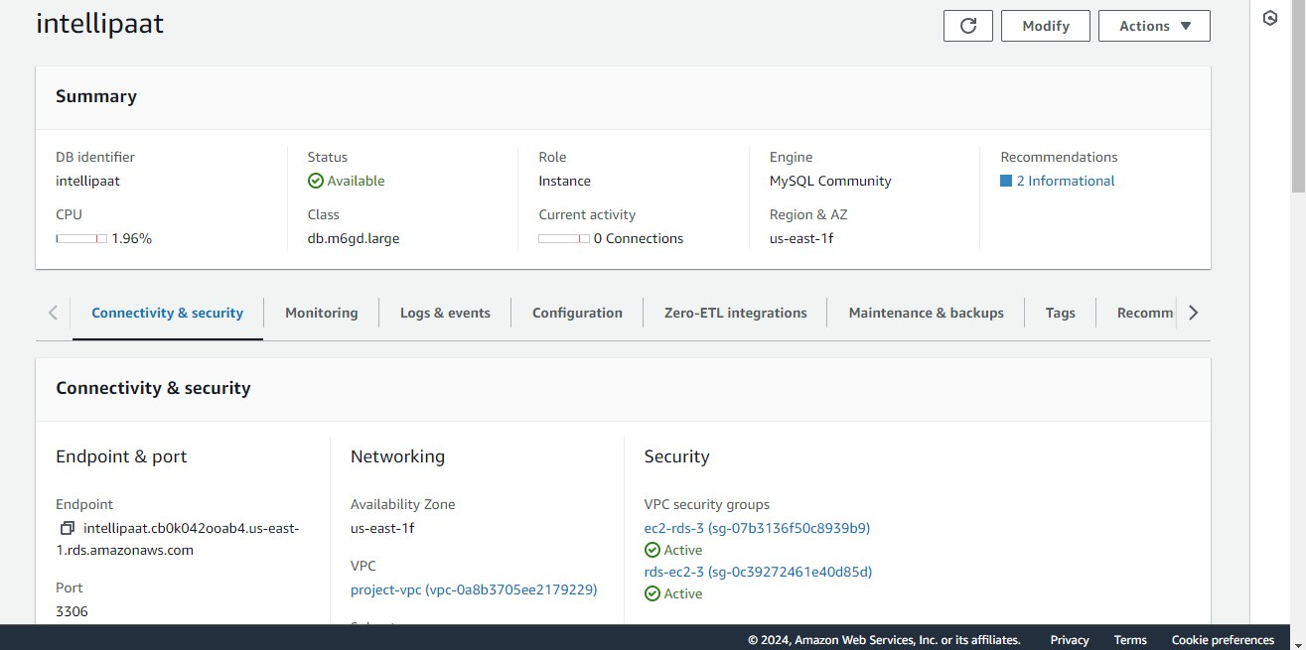
Original dimensions: 1315 × 655 px

Screenshot 42 — word/media/image14.png
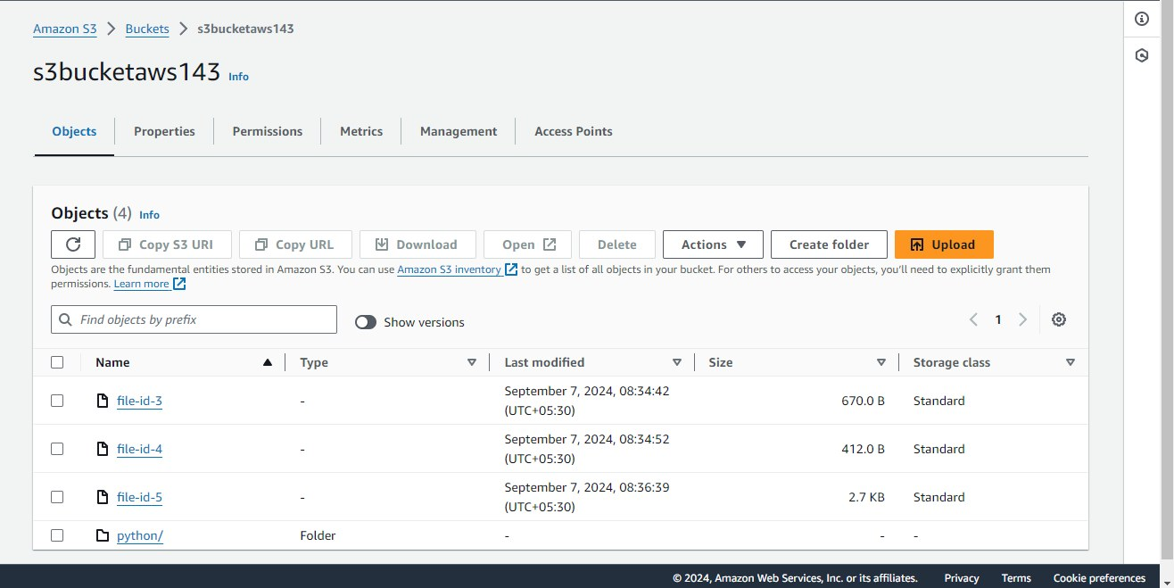
Original dimensions: 1316 × 659 px

Screenshot 43 — word/media/image15.png
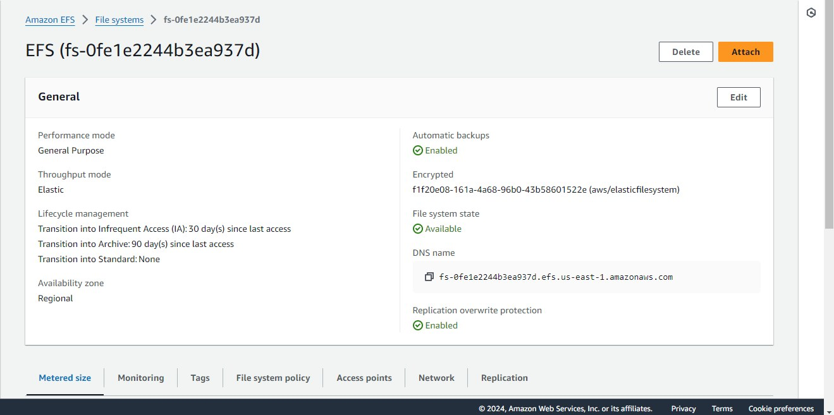
Original dimensions: 1319 × 657 px

Screenshot 44 — word/media/image12.png
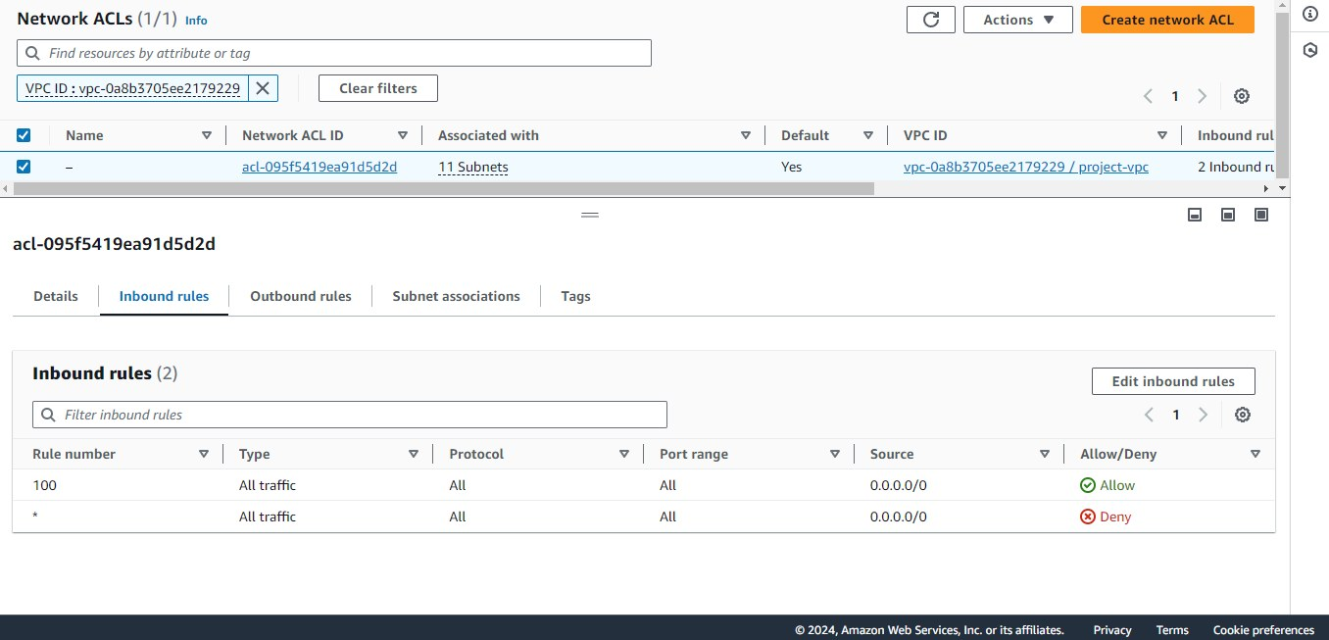
Original dimensions: 1356 × 653 px

Screenshot 45 — word/media/image13.png
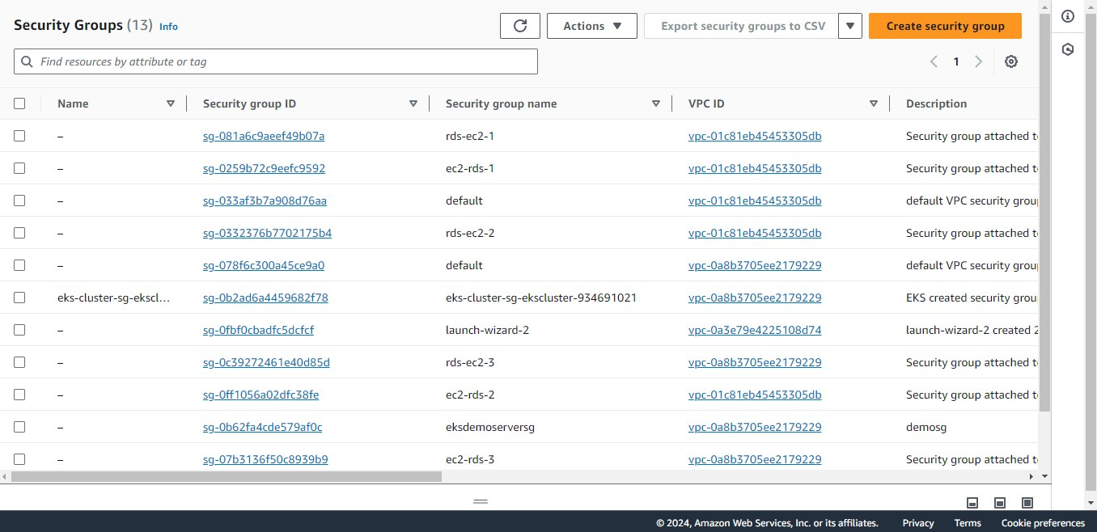
Original dimensions: 1356 × 658 px

DevOps-F-Project(1).zip
Source Word document: DevOps-F-Project.docx
Embedded image count extracted: 22

Screenshot 01 — word/media/image18.png
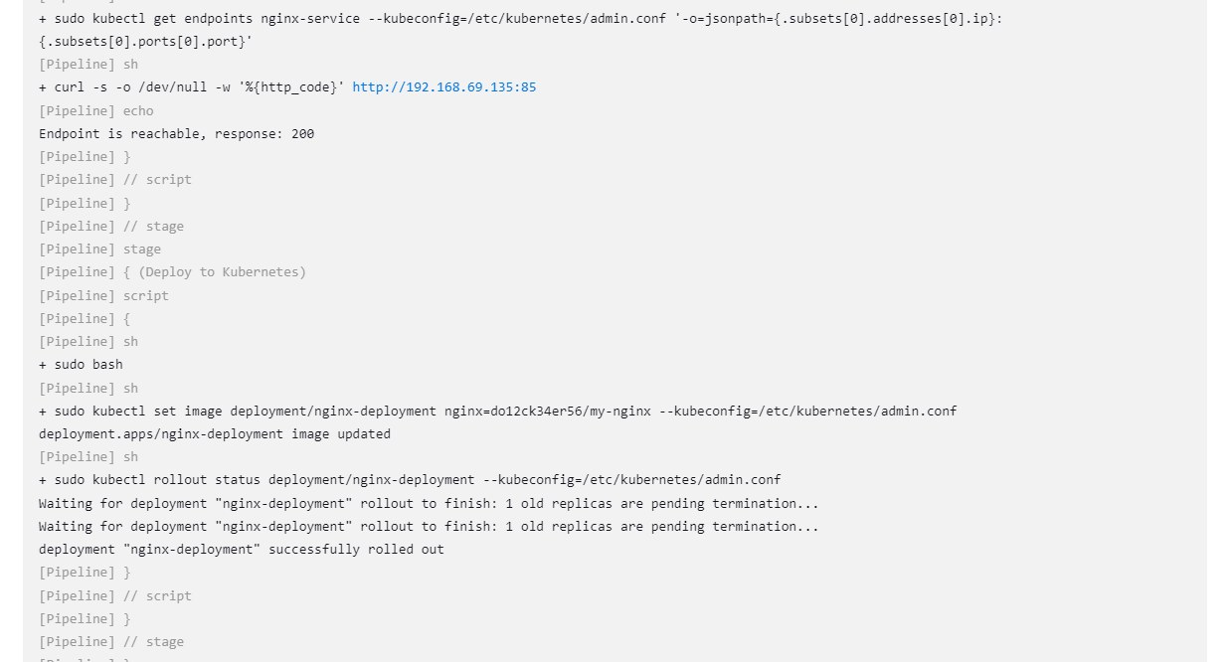
Original dimensions: 1237 × 666 px

Screenshot 02 — word/media/image17.png
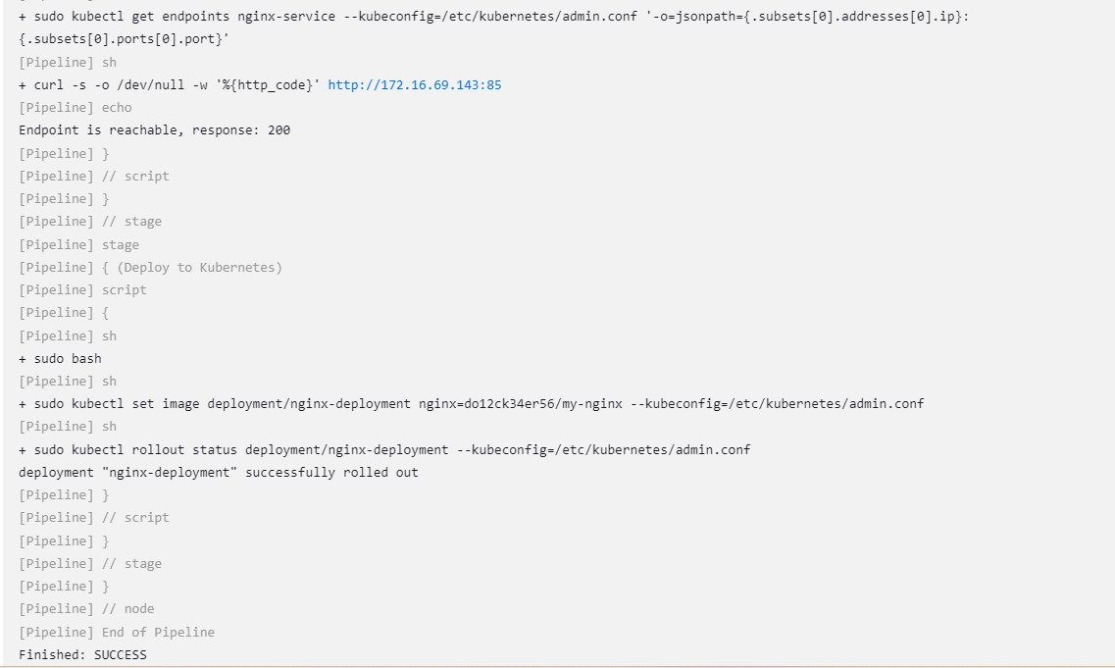
Original dimensions: 1137 × 681 px

Screenshot 03 — word/media/image16.png
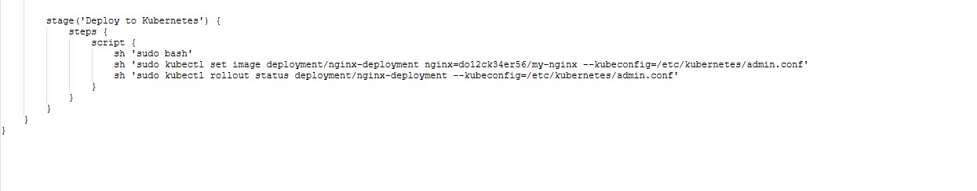
Original dimensions: 1245 × 244 px

Screenshot 04 — word/media/image15.png
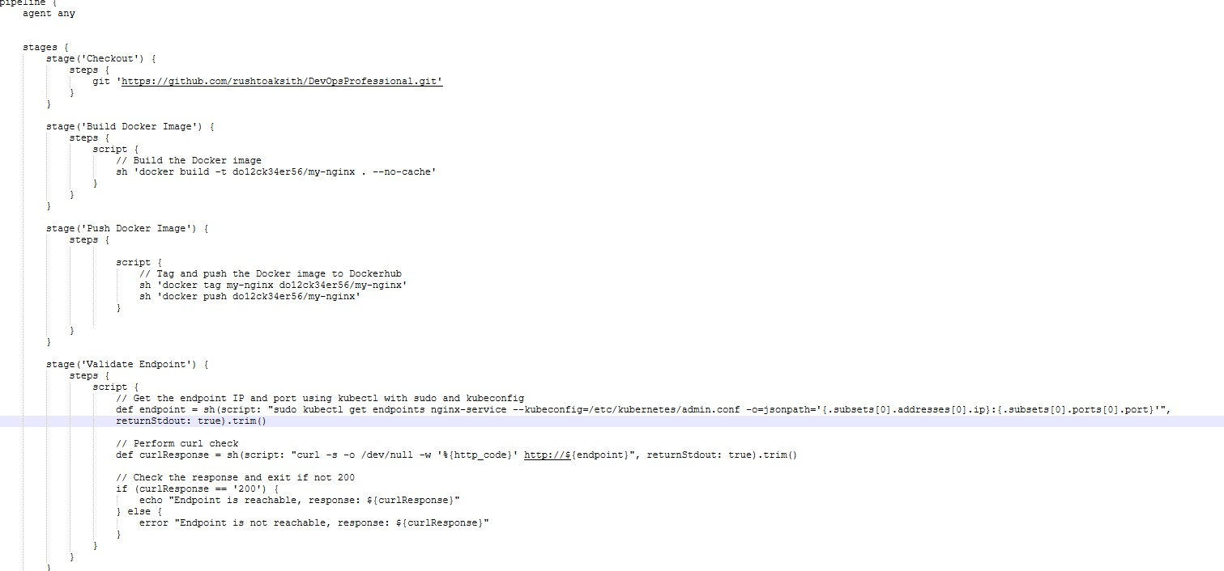
Original dimensions: 1511 × 706 px

Screenshot 05 — word/media/image19.png
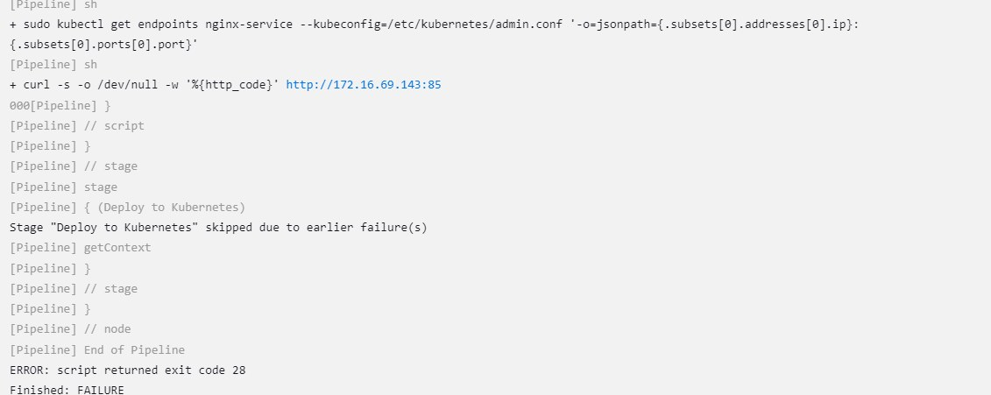
Original dimensions: 1131 × 451 px

Screenshot 06 — word/media/image21.png
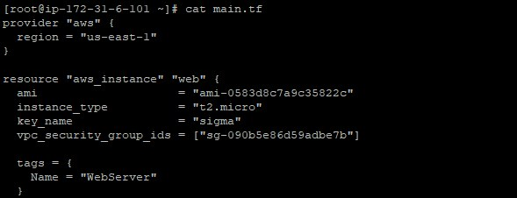
Original dimensions: 589 × 226 px

Screenshot 07 — word/media/image25.png
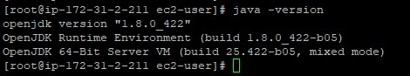
Original dimensions: 470 × 87 px

Screenshot 08 — word/media/image23.png
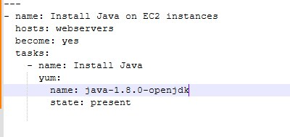
Original dimensions: 400 × 189 px

Screenshot 09 — word/media/image22.png
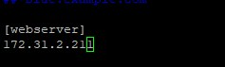
Original dimensions: 237 × 71 px

Screenshot 10 — word/media/image14.png
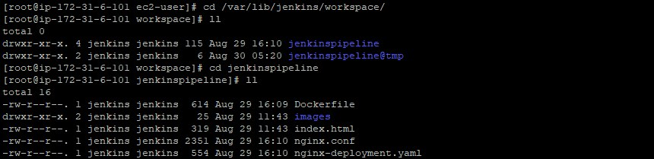
Original dimensions: 860 × 209 px

Screenshot 11 — word/media/image13.png
Original dimensions: 1175 × 115 px

Screenshot 12 — word/media/image12.png
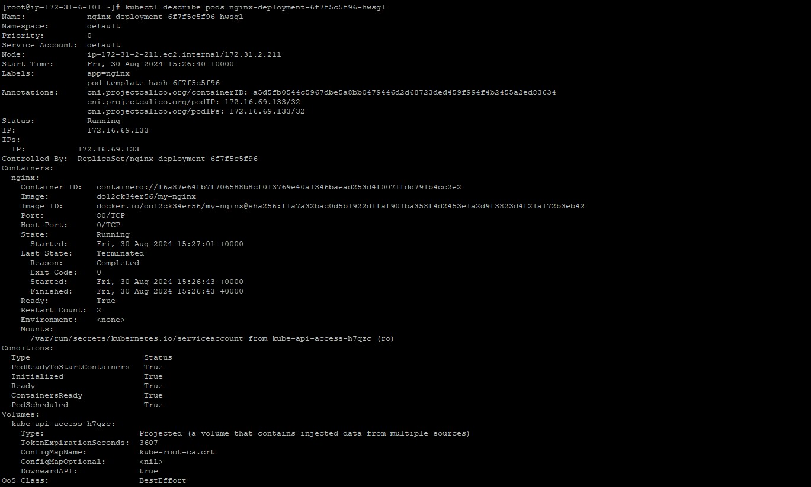
Original dimensions: 1369 × 823 px

Screenshot 13 — word/media/image4.png
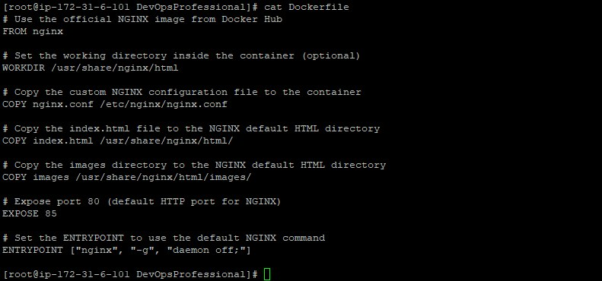
Original dimensions: 791 × 370 px

Screenshot 14 — word/media/image3.png
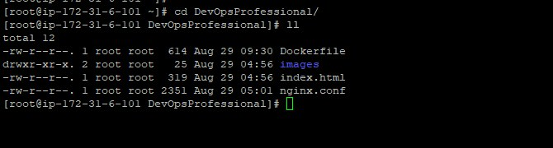
Original dimensions: 670 × 180 px

Screenshot 15 — word/media/image1.png
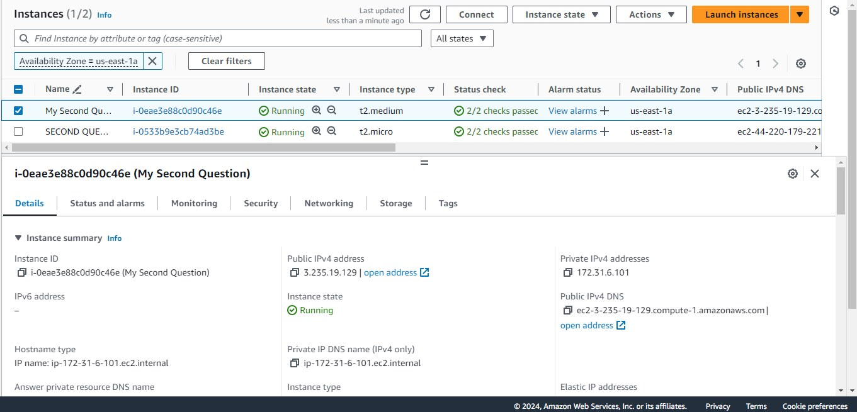
Original dimensions: 1361 × 655 px

Screenshot 16 — word/media/image5.png
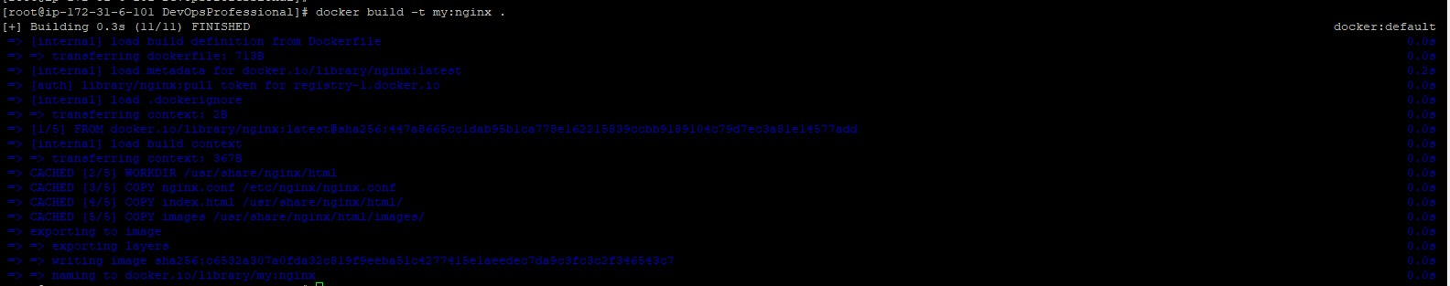
Original dimensions: 1584 × 313 px

Screenshot 17 — word/media/image6.png
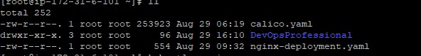
Original dimensions: 592 × 80 px

Screenshot 18 — word/media/image7.png
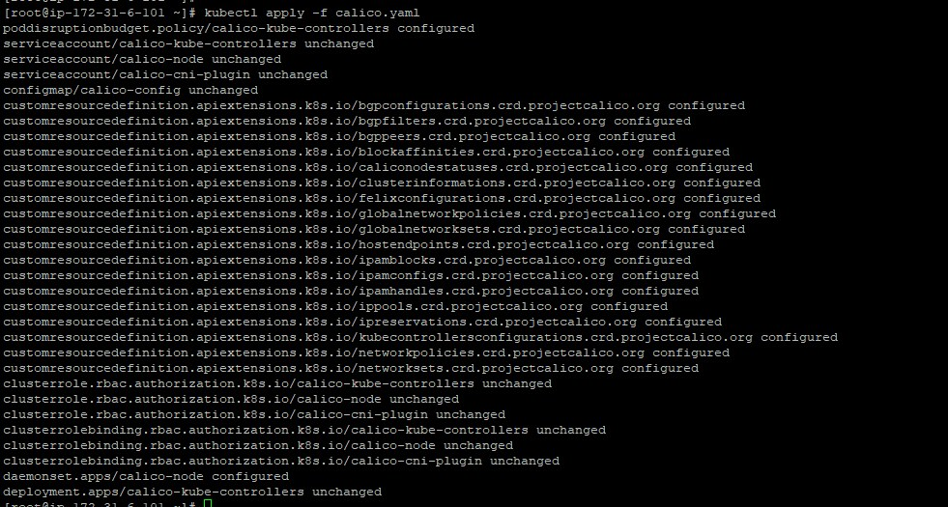
Original dimensions: 981 × 525 px

Screenshot 19 — word/media/image11.png
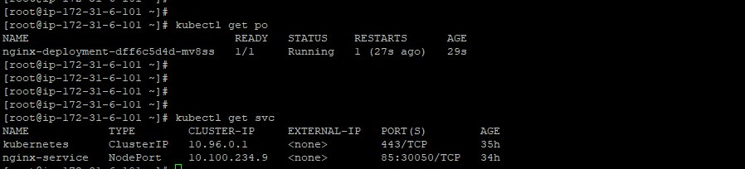
Original dimensions: 898 × 204 px

Screenshot 20 — word/media/image9.png
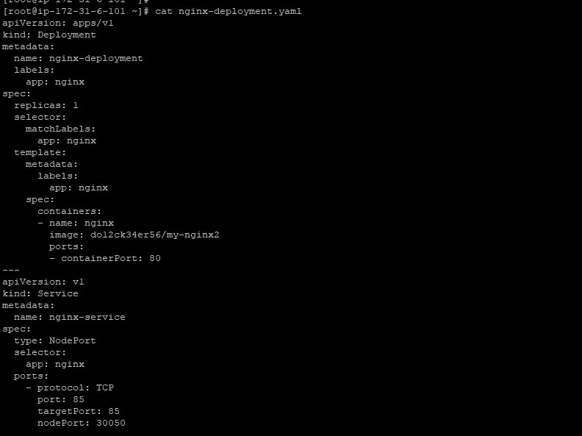
Original dimensions: 792 × 593 px

Screenshot 21 — word/media/image8.png
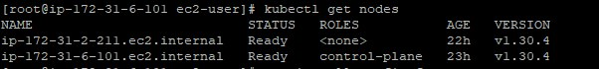
Original dimensions: 602 × 70 px

Screenshot 22 — word/media/image26.png
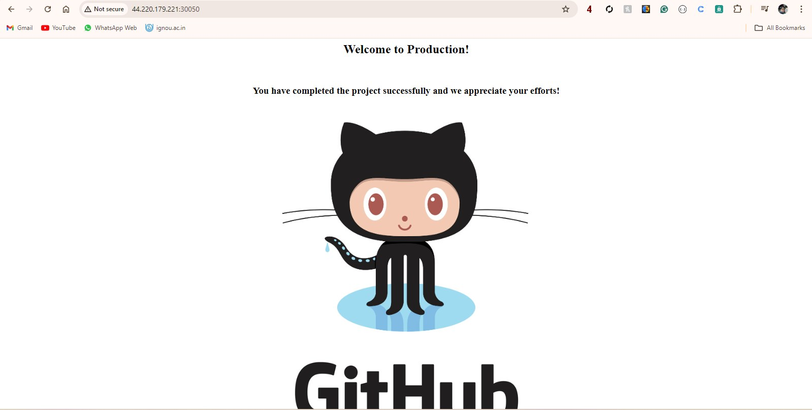
Original dimensions: 1599 × 809 px

How to use this inventory
- Use the source ZIP/document heading to trace each screenshot back to its original file.
- Select only screenshots that directly support the named project and its outcome.
- Do not treat image order as proof of project sequence or success.
- Redact credentials, account IDs, internal hostnames, sensitive IPs, and employer/client details before publishing.
- Training assignments and capstone work should be labelled honestly; do not describe them as paid client projects.

