Software Requirements Specification Template

**CS 258 Software Engineering**

**January 2018**

The following annotated template shall be used to complete the Software Requirements Specification (SRS) assignment of CS 258.

**Template Usage:**

Text contained within angle brackets (‘<’, ‘>’) shall be replaced by your project-specific information and/or details. For example, <Project Name> will be replaced with either ‘Smart Home’ or ‘Sensor Network’.

Italicized text is included to briefly annotate the purpose of each section within this template. This text should not appear in the final version of your submitted SRS.

This cover page is not a part of the final template and should be removed before your SRS is submitted.

**Acknowledgements:**

Sections of this document are based on the IEEE Guide to Software Requirements Specification (ANSI/IEEE Std. 830-1984). The SRS templates of Dr. Orest Pilskalns (WSU, Vancouver) and Jack Hagemeister (WSU, Pullman) have also been used as guides in developing this.

Development of a Game on Landslide disasters in North-eastern states of India

Software Requirements Specification

1.0

25th January 2018

160001004 - Amit Meena

160001011 - Ashutosh Bang

160001023 - Joshi Niranjan Suhas

160001033 - Mahesh Kumar

160001034 - Anish Sri Chandra

# Revision History

|  |  |  |  |
| --- | --- | --- | --- |
| Date | Description | Author | Comments |
| <date> | <Version 1> | <Your Name> | <First Revision> |
|  |  |  |  |
|  |  |  |  |
|  |  |  |  |

# Document Approval

The following Software Requirements Specification has been accepted and approved by the following:

|  |  |  |  |
| --- | --- | --- | --- |
| Signature | Printed Name | Title | Date |
|  | <Your Name> |  |  |
|  |  |  |  |
|  |  |  |  |

**Table of Contents**

Revision History ii

Document Approval ii

1. Introduction i

1.1 Purpose i

1.2 Scope i

1.3 Definitions, Acronyms, and Abbreviations i

1.4 References i

1.5 Overview i

2. General Description ii

2.1 Product Perspective ii

2.2 Product Functions ii

2.3 User Characteristics ii

2.4 General Constraints ii

2.5 Assumptions and Dependencies ii

3. Specific Requirements ii

3.1 External Interface Requirements iii

3.1.1 User Interfaces iii

3.1.2 Hardware Interfaces iii

3.1.3 Software Interfaces iii

3.1.4 Communications Interfaces iii

3.2 Functional Requirements iii

3.2.1 <Functional Requirement or Feature #1> iii

3.2.2 <Functional Requirement or Feature #2> iii

3.3 Classes / Objects iii

3.3.1 <Class / Object #1> iii

3.3.2 <Class / Object #2> iii

3.4 Non-Functional Requirements iii

3.4.1 Performance iv

3.4.2 Reliability iv

3.4.3 Availability iv

3.4.4 Security iv

3.4.5 Maintainability iv

3.4.6 Portability iv

3.5 Inverse Requirements iv

3.6 Design Constraints iv

3.7 Logical Database Requirements iv

3.8 Other Requirements iv

A. Appendices iv

A.1 Appendix 1 iv

A.2 Appendix 2 iv

# 1. Introduction

This document lays out a project plan for the development of “Salvos”, an open source repository. This is a game for awareness on landslides.

## 1.1 Purpose

The purpose of this document is to describe the purpose and functionality of the software product requested by Dr. Neelima Satyam of The Department of Civil Engineering, IIT Indore. The SRS will include the details of the project's requirements, interface, design issues, and components. The intended readers of this document are the current and future developers working on the project and proposer of this project.

## 1.2 Scope

The “Salvos” project is a learning tool created to help improve the awareness among the children of age group between 6 to 10. The product will be an interactive multi-platform game. The Application will be released both as a native Windows desktop application and an android based app. At the end of the game, students will be given feedback based on their game scores. The game will focus on both prevention and survival during the landslide.

## 1.3 Definitions, Acronyms, and Abbreviations

This subsection should provide the definitions of all terms, acronyms, and abbreviations required to properly interpret the SRS. This information may be provided by reference to one or more appendixes in the SRS or by reference to other documents.

|  |  |
| --- | --- |
| OS | Operating System |
| CPU | Central Processing Unit |
|  |  |
|  |  |
|  |  |

## 1.4 References

* Dr. Neelima Satyam, Department of Civil Engineering, IIT Indore
* Dr. Abhishek Srivastav, Department of Computer Science & Engineering, IIT Indore
* **Overview of Game Design:** <https://github.com/maheshcool/Group-H-Project-4/blob/master/Documentation/Game_design.md>
* **Literature on Landslides:** https://github.com/maheshcool/Group-H-Project-4/blob/master/Documentation/literature.md

## 1.5 Overview

# This document is designed to provide information to both the client and the technical designers of the software. Section one is a brief overview of the product, including definitions and references. The definitions section is intended to assist the technical designers as well as the client in clarifying the terms used throughout the document. Section two is a general description of the product requirements from a user's perspective. This section includes information such as functional and data requirements, general constraints, and assumptions. Section three is a detailed requirements specification targeted to technical designers. Specific requirements and expectations regarding the components of the product are given in this portion of the SRS document.

# 2. General Description

## 2.1 Product Perspective

**Desktop:**

* OS: Windows XP SP2+.
* Graphics card: DX9 (shader model 3.0) or DX11 with feature level 9.3 capabilities.
* CPU: SSE2 instruction set support.

**Android:**

* OS 4.1 or later; ARMv7 CPU with NEON support or Atom CPU; OpenGL ES 2.0 or later.

The program requires an internet connection only for downloading the application.

The game can run offline.

## 2.2 Product Functions

## Player has to start as per the game storyline.

## As he passses moves ahead in the game, it is quite essential for him/her to pass maximum modules to satisfy the aim of the game (maximize score and health and minimize distractions).

## Game score, health, distraction and time must be displayed all the time at the top of the game.

## The Environment of the game must be an attractive setting in the lap of nature.

## 2.3 User Characteristics

## The target clients for our software are the children of the age group in between 6 to 10. These students are in the process of learning how to tackle the problem of landslides both during the disaster and pre-disaster stages. Moreover, these students (as well as the teacher) are assumed to have basic computer and Internet skills that will enable them to use this software. For the mobile app, they are assumed to know how to operate a mobile phone. The game will request the user to enter his/her username and a character will be assigned to them. The game will be played using this character.

**2.3 Overview of Functional Requirements**

The "Salvos" game will have the following functional components:

1. An introductory movie to set up the storyline.

2. The main menu, including a brief help and settings section

3. A series of missions (testing survival skills and awareness) that sequentially form a storyline related to the introduction.

The missions will be in the form of a path where the next mission is unlocked only after the completion of the previous mission

4. The user’s score is calculated at the end of every mission and is in the form of stars. The user can get a maximum of 3 stars.

At any time during the game, the user has an option to quit the game.

In between or at the end of each mission, the user has an option to retry the game.

## 2.4 General Constraints

This program will run offline on any computer or a mobile phone that satisfies the above-mentioned requirements.

## 2.5 Assumptions and Dependencies

It is assumed that the player is age group in between 6 to 10 without any prior knowledge on landslides. He/she should know how to operate a computer. It is assumed that the game is properly installed on the device. The device must satisfy the above-mentioned requirements.

**2.6 Flowchart for Game flow**

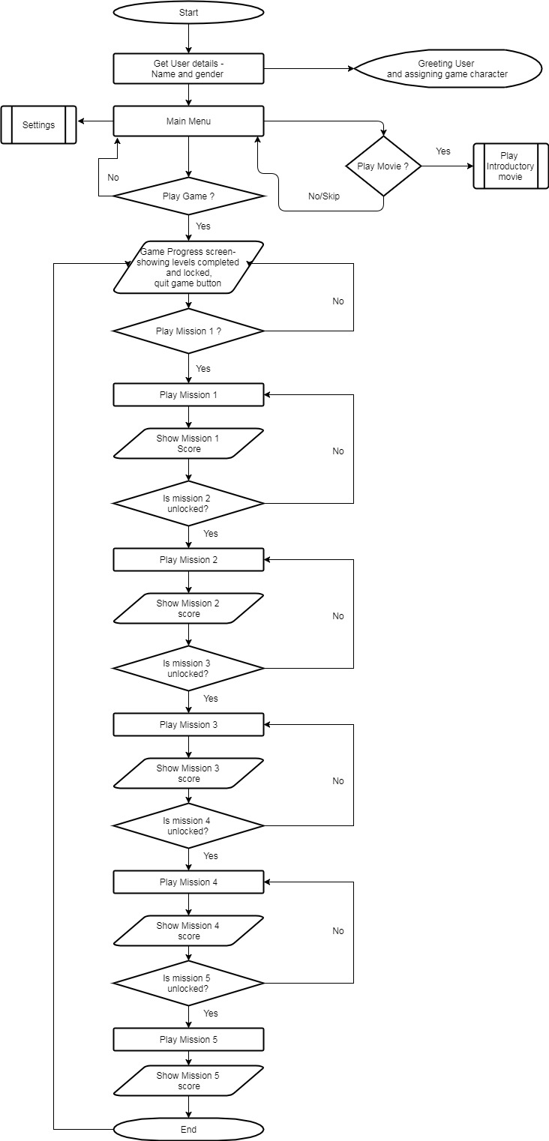

**2.7 Game Design**

## Main Screen:

* Play game
* Informative video (optional)
* Settings
  + Volume controls
  + Music controls

## Quit button

## In Game:

* 5 Missions:
  + 3 missions for pre-disaster stage
  + 2 missions for during disaster stage
* Path for levels.
* Further levels unlocked.
* Score will be form of stars. Stars will be decided based time taken and actions.
* Tutorial after each mission.

## If wrong action taken-mission failed. Give Hints.

### Mission 1: Planting the trees

* 3D mission
* Mountainous terrain-6 with different slopes
* First show two mountains, then walk, then next set.
* User must choose which is the best mountain to plant trees, the one which is more prone to landslides.
* Drag and drop for planting the trees.
* Different type of trees- based on type of root system.
* Scoring criteria:
  + Three pairs one star for each pair
  + Next level unlocked only by gaining three stars.
  + More score awarded for fibrous root.

## Hint will be same after every play. "Steep terrain are more prone to landslides."

### Mission 2: Redirection of water flow

* Top view of terrain
* Splitting of stream
* Multiple places
* Obstacles like other mountains and houses
* Scoring criteria:

## Based on time

### Mission 3: Land use zoning

* 2D mission
* User will be given houses- hospital, school, etc., roads, walls. He needs to use them all.
* Plan the town accordingly.
* Terrain will be divided in a grid.
* Each object will require certain number of blocks.
* Scoring criteria:
  + Lesser the overlapping more the score.

## Positioning

### Mission 4: Evacuation

* 3D mission
* Landslide is happening
* User in the house
* Many rooms
* Doors jammed
* One window safe for jumping otherwise mission failed.
* Money bags and 1 health kit.
* Call emergency services.
* Scoring criteria:
  + Based on time

## More star if no money bags are taken.

### Mission 5: Rescue camp

* 3D mission
* Include first aid
* Prioritization according health status
* Functionalities:
  + Walking
  + Saving
  + Navigation to survivors
* Scoring criteria:

## Based on time and number of people rescued.

# 3. Specific Requirements

## 3.1 External Interface Requirements

**3.1.1 User Interfaces**

We will have to provide a 3d video interface to the user so that he can get himself more and more

into the game. A first player controller, hence, would be the best suited for the game.

**3.1.2 Hardware and Software Interfaces**

In order to play the game, we will facilitate the users to use their keyboards, touchpad, mouse or

joystick to input the commands and real-time effects of the input will be reflected in the game.

The user should have a good graphics card installed on his/her machine. Basically, mouse shall be used to change rotate the screen and arrow keys to move in the respective directions.

## 3.2 Functional Requirements

**3.2.1 Template for Describing Functional Requirements**

This section describes the template that is used to describe each of the functional components of the "Salvos" game specified in section 2.3.

|  |  |
| --- | --- |
| Purpose | A description of the functional requirement and its reason(s). |
| Inputs | Which inputs; in what form/format will input arrive; from what sources input will be derived, legal domains of each input element. |
| Processing | Describes the outcome rather than the implementation; includes any validity checks on the data, the exact timing of each operation (if needed), how to handle unexpected or abnormal situations. |
| Outputs | The form, shape, destination, and volume of the output; output timing; range of parameters in the output; a unit measure of the output; process by which the output is stored or destroyed; process for handling error messages produced as output. |

**3.2.2 Introductory Movie**

|  |  |
| --- | --- |
| Purpose | A short movie to set up the storyline of the game and provide information to help the user about landslides |
| Inputs | If the user clicks the introductory movie button, the movie will start. If the user clicks the SKIP button while in this component, they will skip the movie and proceed to the main menu. |
| Processing | Upon entrance to the movie component, the introductory movie will begin playing. If the SKIP button is received, this component will terminate the movie and forward the user to the main menu component. Otherwise, the movie will continue to its completion and the user will be moved to the main menu. |
| Outputs | A movie is displayed on the screen. |

**3.2.3 Main Menu**

|  |  |
| --- | --- |
| Purpose | A menu that displays a brief section offering various options such as PLAY GAME, SETTINGS, QUIT, INTRODUCTORY MOVIE. |
| Inputs | The user can click on the corresponding button to perform that function |
| Processing | This component will wait until the user selects a button. At that time, the user will be forwarded to the game sequence component, depending on the button selected. |
| Outputs | This component will output the selection function. |

**3.2.4 Game Sequence**

|  |  |
| --- | --- |
| Purpose | A series of five missions, which sequentially form a storyline related to the introduction. |
| Inputs | The inputs are different for each mission. |
| Processing | This component will display a mission, and then wait until the user completes it. If the user completes the mission with 3 stars, the component will move to the next mission. The user will be given hints if he/she is unable to complete the missions. A RESTART option is also provided if the player fails the mission. After completing all 5 missions, they will be directed to the ending scene component. |
| Outputs | This component will output plot-based missions that are customizable by the game administrator and offer feedback to the user based on their performance on individual missions. |

**3.2.5 Ending Scene**

|  |  |
| --- | --- |
| Purpose | A screen offering a conclusion to the game's plot based on performance at certain critical points in the game sequence, where the user's score is displayed, and the user is given a chance to exit or return to the main menu or try again. |
| Inputs | The user can select either to end the game or return to the main menu or try again via clicks. |
| Processing | This component will wait until the user selects either to return to the main menu or to exit the game. After receiving the user's input, the component will act accordingly. |
| Outputs | The user's overall score is displayed, as well as a conclusion. |

**3.3 Non-Functional Requirements**

**3.3.1 Performance**

All the modules should be in a single game and should be followed by a single story or theme of

the game. The games should be as much interactive as look like a game environment, not a test.

Different tasks in the game should require the above-mentioned parameters.Responses should be

added by mouse or keyboard and a log file should be generated having the score information.

**3.3.2 Availability**

The game should be of distributable over PCs and Android devices. And, since we’re publishing it on the web it will be accessible and available for download.

**3.3.3 Security**

The game will be entirely offline. So, there are no threats from potential hackers.

**3.3.4 Maintainability**

Collaboration using version control systems like Git and storage of the code on the cloud of GitHub

and proper comments and description for every code will ensure that a new programmer who gets to work or improve this very piece of code faces minimal hurdles. A proper documentation

for every module shall be included.

**3.3.5 Portability**

All the laptop/PC machines that posses Windows XP SP2 or versions newer than that are capable to run this.

## 3.6 Design Constraints

## The outdated assets of unity in the unpaid version might be a constraint but it shall be compensated by making the modules more interactive and user-friendly to drag the player more into the story of the game.