|  |
| --- |
| BI.Talend Data Integration Exit Task |

Solution Description.

1. File DDL.sql. Scripts to create tables from SRC_, CLS_, DIM_ levels. Also we create here sequences.
2. Create connection as context, retrieve tables from schema.

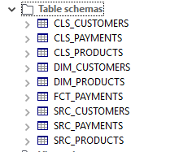

Pic.

1. Job ET_03. General flow.

We can run this flow to get all ETL flow.

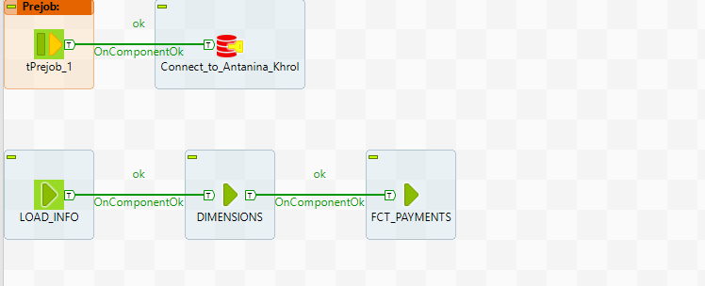

Pic.

1. Step Load info links to Job ET_01.

In this step we load data from Customers, Products files. Also the ability to load new incremental data from purchase_yyyymmdd.csv is foreseen.

The used filenames is written in table Filenames. There is the Primary key in this table. If it’s possible to make insert we work with this file. If it’s impossible, we put the filename in the table REJECT_FILENAME.

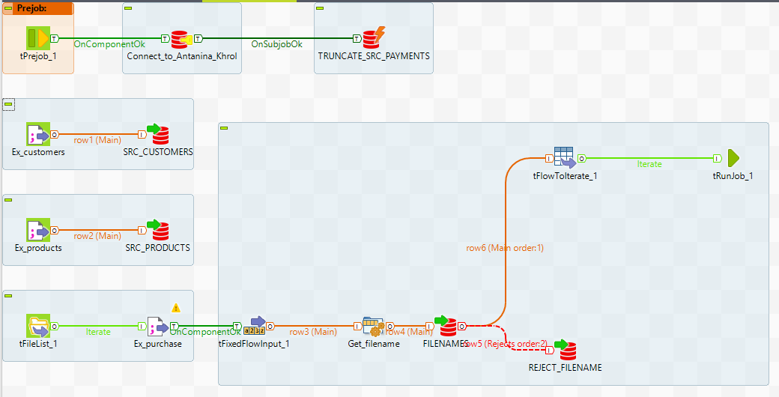

Pic.

1. The component RunJob goes to Job ET_02.

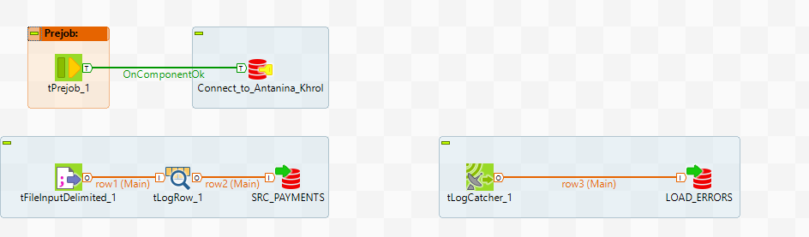

Pic.

In this step we write data from all files to SRC_PAYMENTS and log errors.

1. Block RunJob DIMENSIONS from the main flow goes to Job ET_05.

In this step we work with tables in CLS_ level. The main purpose is to create and insert the right ID_SURR. If the row already in dimension table – we get the ID_SURR from this table. If not, we create ID_SURR using sequence.

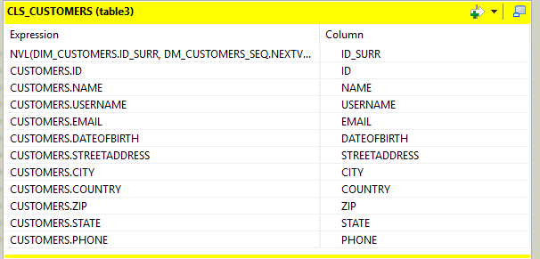

Pic.

After this step we merge info into DIM_ tables. ID_SURR is Primary key.

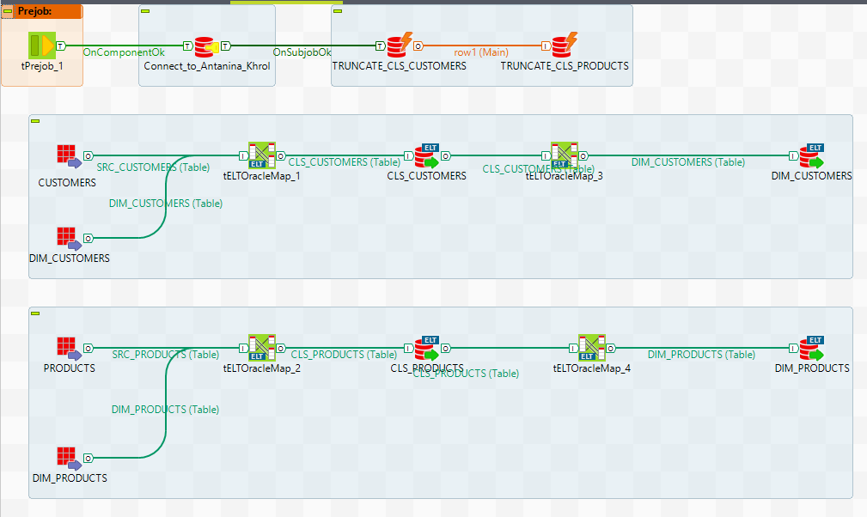

Pic.

1. Block RunJob FCT_PAYMENTS from the main flow goes to Job ET_06.

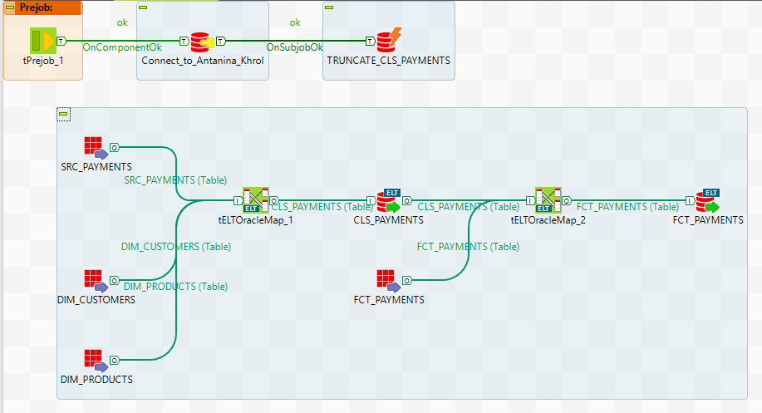

Pic.

The main purposes of this step are: 1. Create new column isInterState. 2. Find new id for table CLS_PAYMENTS (ID_SURR). 3. Find in table CLS_PAYMENTS data that is absent in table FCT_PAYMENTS.

For the last goal we make join for all columns

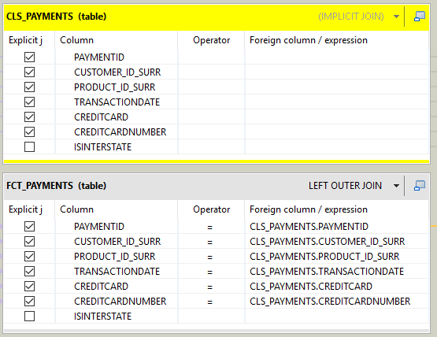

Pic.

and take row with Where clause.

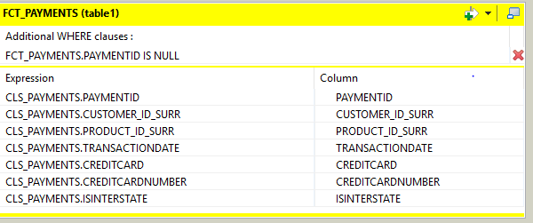

Pic.

1. So, the project consists of 5 Jobs

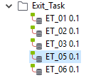

Pic.

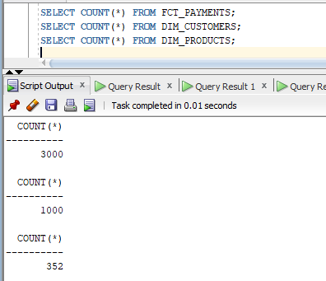

Pic.

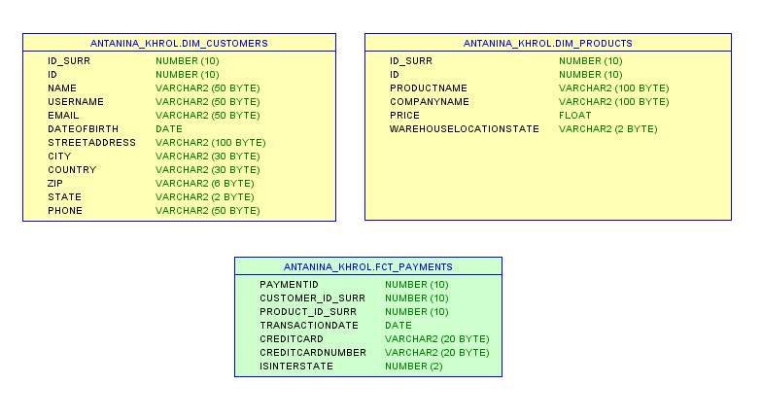

Pic.