**Solution Description.**

Task_03_4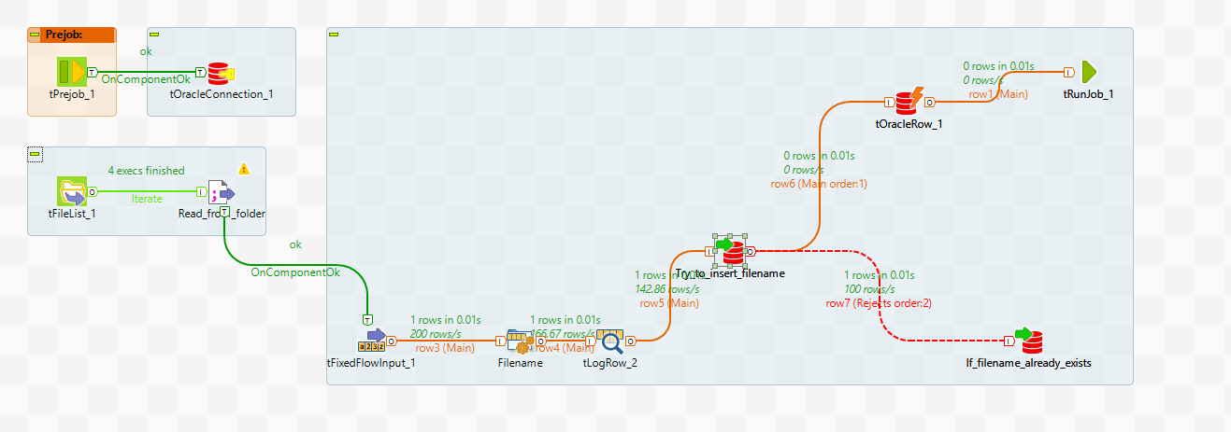

1. Read files from directory.

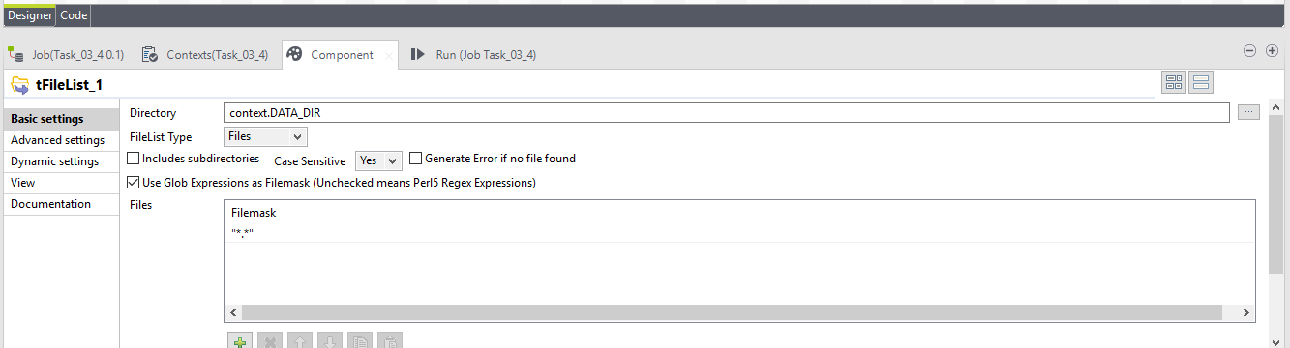

1. Saving filename into variable.

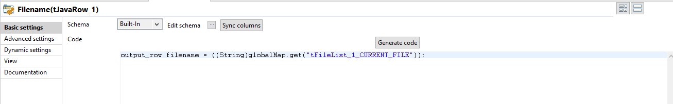

1. Insert filename into table **Filenames.** The table has constraints and we can’t insert the file name if it already in the table. In this case put this name into table **Reject**. Otherwise move to RunJob.
2. Send the name of file as parameter to the child job Task_03_3.

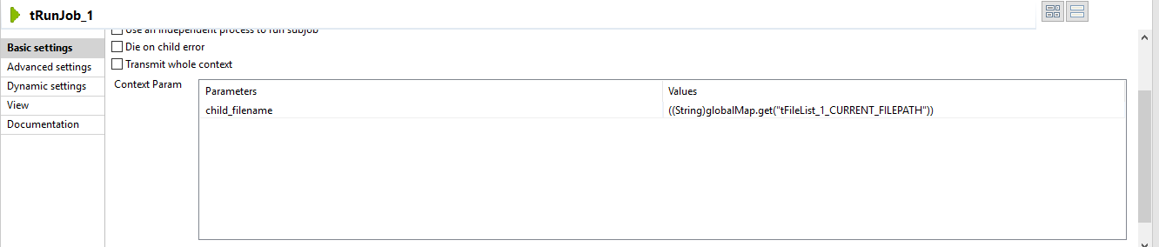

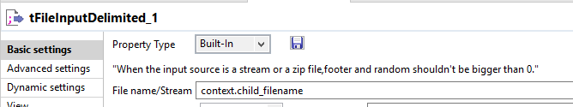

1. Insert data in table **Payments**.
2. If we can’t insert data into table **Payment** we find it by LogCacher and insert into table **Load_Errors.**

