Tic-Tac-Toe user documentation

1. How to install and start the game

The game is a complete compiled executable file, there is no needing in other materials or code. Just download the file and open it.

1. Overview

In the start, there will be 2 windows: the pygame standart window with the game itself, and cmd for I/O of errors. It is also a part of multiplayer system, so cmd is required for correct using of program.

On the start menu, the user can observe a white plane with a grey button “Start new game”. After pushing it, the user will be proceeded to the next menu, with 3 buttons, “Start new local game”, “Start new game as a host” and “Start new game as a client”.

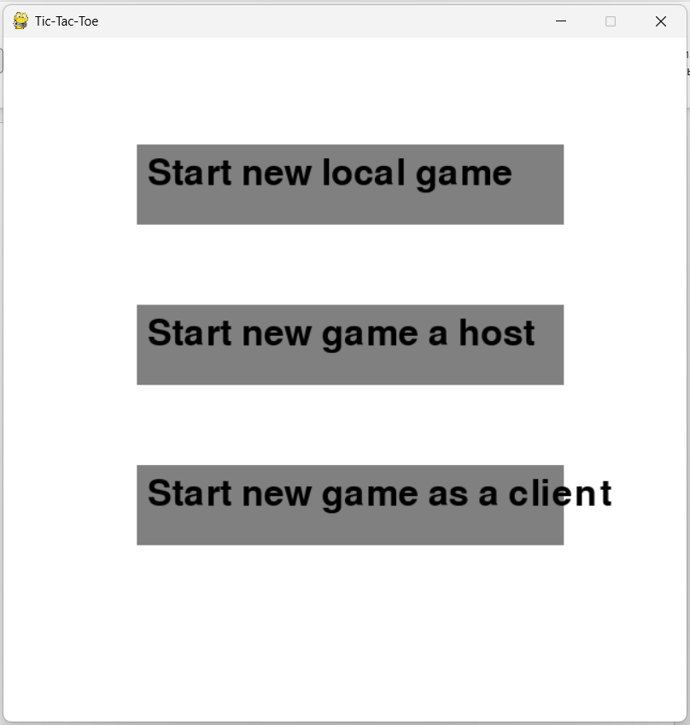

Next 3 paragraphs will be about each of the given modes of game.

1. 1. Local game

It’s a game against computer. The AI is absolutely correct itself, although, it can sometimes make determined misses in his game just to give a player chance to win the game.

After player has pushed “Start new local game” button, it’ll be redirected to the next menu, where the local game executes.



On the topward there is a plain text, which specifies whether machine or player now should make it’s turn. Every empty cell can be pressed by both player and enemy (therefore, it’s just a standard Tic-Tac-Toe game). After the player or computer has gained 3 same elements in the row, or whether there are no more empty cells for turn, the game ends. The winner will be showed on the screen for 2 seconds, and the game will redirect player to the first menu.

3.2. Host

This tic-tac-toe game is based on server-client system, and if two player are going to play the game together, one of them must became a host (therefore, create a server and also start a client), and another one just required to connect to the host. There could be used only IPv4, other possibilities like domain name or IPv6 are out of order. After the host activated, the player is redirected to the waiting menu. The game will start only after the client will join the host.

3.3. Client (please, first read the Host topic)

After the player pressed “Start new game as a client”, it’ll be redirected to the next menu, which will proceed next only after client will write valid IPv4 address of the host to the cmd. The game window will be blocked while waiting.

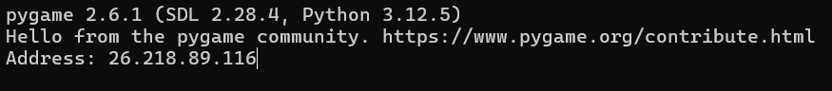

The example of the use is stated above. After reedeming of address, the client will be connected to the host stated by this address. (The client and host MUST be in one local network – such as wi-fi, or VPN).

3.4. Multiplayer session.

This part is the same for both 3.2 and 3.3. After client has connected to host, the game will start, and one of the player will randomly be picked to make a first move. (You can understand whether it’s your turn by looking into cmd). After the first-turn player will make a move, the second player will be able to make next move, and so on. The game ends in the same scenario, as in the local game.

After the end of game, server is able to restart it, to play once again. The first-turn player will be chosed randomly. Also, both client and server are able to go play the local game after the match ends.

1. Exceptions

If you played a multiplayer game, after that played a local one, it’s HIGHLY RECOMMENDED to restart the application. It’s due to the nature of sockets.

All other exceptions could be caused by network, and because it’s hard to predict them correctly, play the multiplayer mode with caution!

Don’t panic if the first move of the computer in the local game is a bit timetaking – it’s due to the algorithm it uses.