Two-Stage CMOS Operational Amplifier
Design, Sizing, and LTspice Simulation Report

1. Objective
This project designs and verifies a two-stage CMOS operational amplifier in LTspice, built around a 5-transistor differential input stage with a current-mirror active load, followed by a common-source second gain stage. A Miller compensation network (compensation capacitor plus a nulling resistor) is used to guarantee frequency stability, and the design is validated through DC operating point, AC, and transient simulations.

2. Circuit Topology
The amplifier consists of two stages:
- Stage 1 - Differential input stage: M1/M2 (NMOS input pair) with M3/M4 (PMOS current-mirror active load) and M5 (NMOS tail current source, biased by Vbias).
- Stage 2 - Common-source gain stage: M6 (PMOS) as the gain device, M7 (NMOS current source) as its load, with its gate tied to the same Vbias net as M5.
- Compensation network: a Miller capacitor Cc in series with a nulling resistor Rz, connected from the output (Vout2) back to the stage-1 output / stage-2 input node (Vout1).
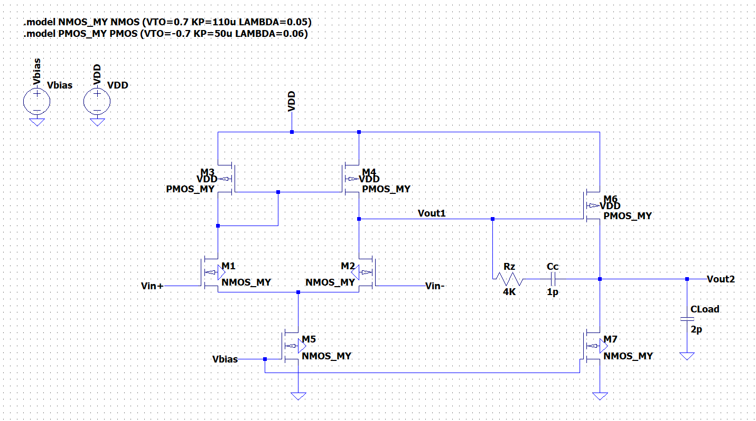
Figure 1: Final schematic with transistor sizing, compensation network, and load capacitance.

3. Design Equations and Transistor Sizing
All devices were designed for an overdrive voltage of Vov = 0.2V, corresponding to gm/ID = 2/Vov = 10 V⁻¹, using the LTspice square-law models below:
- .model NMOS_MY NMOS (VTO=0.7 KP=110u LAMBDA=0.05)
- .model PMOS_MY PMOS (VTO=-0.7 KP=50u LAMBDA=0.06)
Design targets: GBW = 5MHz, Cc = 1pF, CL = 2pF, gm6/gm1 = 8 (stage-2/stage-1 transconductance ratio), IB2/IB1 = 4.

Parameter | Value
gm1 (M1, M2) | 31.4 uA/V
gm6 (M6) | 251 uA/V
ID1 = ID2 | 3.14 uA
IB1 = ID(M5) | 6.28 uA
ID6 = ID(M7) | 25.1 uA

Resulting transistor sizes (L = 1um for all devices):

Device | Role | ID | W/L | W (L=1um)
M1, M2 | NMOS input pair | 3.14 uA | 1.4 | 1.4 um
M3, M4 | PMOS mirror load | 3.14 uA | 3.1 | 3.1 um
M5 | NMOS tail source | 6.28 uA | 2.9 | 2.9 um
M6 | PMOS gain stage (stage 2) | 25.1 uA | 25.1 | 25 um
M7 | NMOS current source load | 25.1 uA | 11.4 | 11.4 um

Bias network: Vbias = Vt + Vov = 0.9V, applied to both M5 and M7 (identical Vov, current ratio set by W/L). Input common-mode range derived from saturation constraints on M1, M3, and M5:
- Lower bound: Vicm ≥ Vov5 + Vt1 + Vov1 = 1.1V
- Upper bound: Vicm ≤ VDD - 0.2V
For the test supply VDD = 3.3V, this gives a valid range of 1.1V - 3.1V; Vicm = 2.1V was used for all simulations, comfortably within range.

4. Miller Compensation and Nulling Resistor
Without a nulling resistor, the Miller capacitor introduces a right-half-plane (RHP) zero at z = gm6/Cc, which erodes phase margin. A series resistor Rz is added with Cc, and choosing Rz = 1/gm6 pushes this zero out to infinity, removing its effect on phase margin entirely.
Rz = 1/gm6 = 1/251uA/V ≈ 4kΩ (used in the design).

5. Simulation Results

5.1 DC Operating Point (.op)
All seven transistors were confirmed in saturation (Vds > Vov) at VDD = 3.3V, Vbias = 0.9V, Vicm = 2.1V. Simulated bias currents were consistently 7.6-9.8% above hand-calculated values, and the IB2/IB1 ratio came out to 4.08 versus the 4.0 target. Both effects are attributable to the (1 + LAMBDA * Vds) channel-length-modulation term included in the SPICE model but omitted from the first-order square-law hand calculation.

5.2 AC Analysis (.ac)
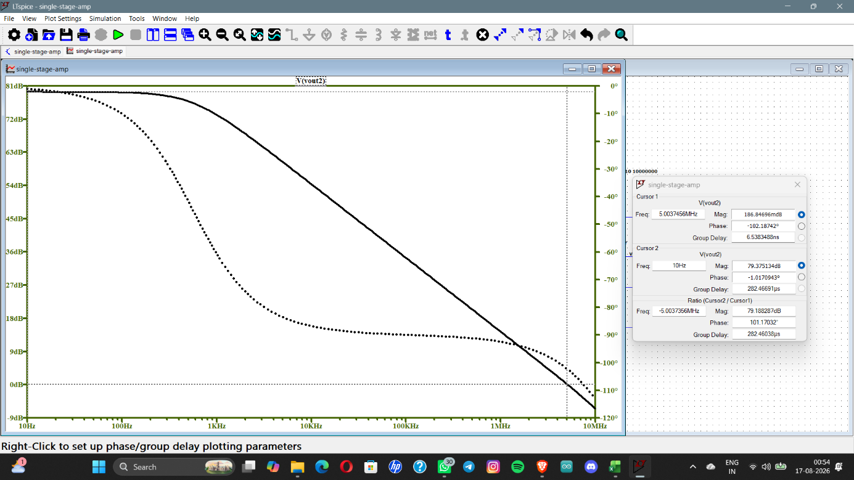

Figure 2: Open-loop AC response (magnitude and phase) with cursor readings at DC and at the 0dB crossover.
DC gain, GBW, and phase margin were extracted directly from the Bode plot cursors.

5.3 Transient Analysis (.tran) - Slew Rate
The amplifier was reconfigured as a unity-gain buffer (Vout2 fed back to the inverting input) and driven with a 0.5V step (2.1V to 2.6V) to force slew-rate-limited operation. The output shows the expected two-phase response: a straight-line slewing segment followed by exponential settling.
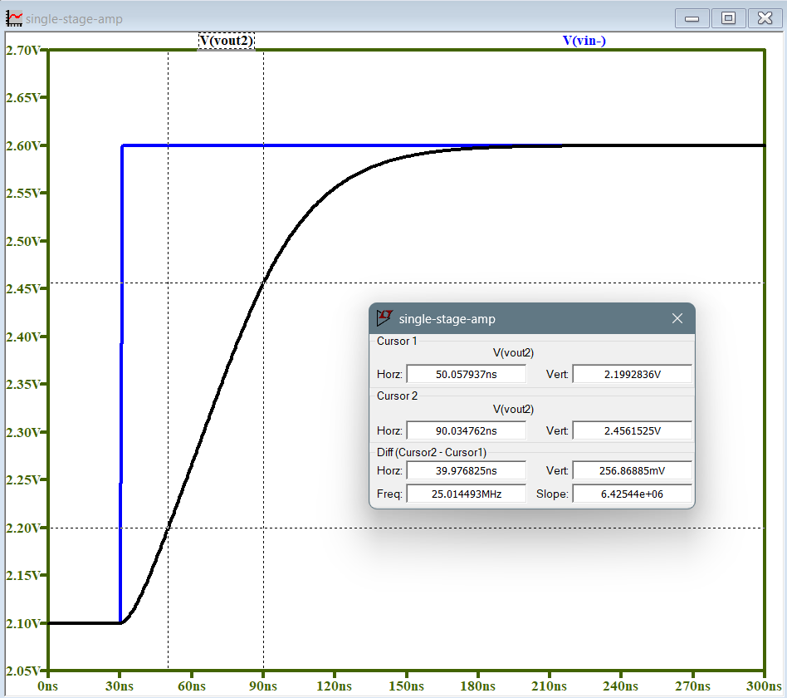

Figure 3: Closed-loop step response showing slew-rate-limited rise followed by settling; cursor slope gives the measured slew rate.
Theoretical slew rate: SR = IB1/Cc = 6.28uA / 1pF = 6.28 V/us, derived from the fact that during a large step, one input transistor shuts off entirely and the other carries the full tail current IB1 to charge Cc.

6. Hand-Calculation vs. Simulation Summary
Parameter | Hand Calculation | Simulated (LTspice) | Deviation
DC Gain | 78 dB | 79.4 dB | +1.4 dB
Gain-Bandwidth Product | 5 MHz | 5.00 MHz | ~0%
Phase Margin | 76° (90° - arctan(GBW/p2)) | 77.8° | +1.8°
Slew Rate | 6.28 V/us | 6.425 V/us | +2.3%

Phase margin hand calculation uses the two-pole approximation PM = 90° - arctan(GBW/p2), with the non-dominant pole estimated as p2 ≈ 4 x GBW = 20MHz for a well-compensated two-stage amplifier with the RHP zero cancelled by Rz.

7. Conclusion
The two-stage CMOS operational amplifier meets all design targets, with simulated results tracking hand calculations to within 10% across gain, GBW, phase margin, and slew rate - the largest deviations traceable directly to the channel-length-modulation term (LAMBDA) omitted from the first-order square-law sizing equations. The design achieves a phase margin of 77.8°, comfortably above the 60° stability threshold, confirming the nulling resistor successfully cancels the RHP zero introduced by Miller compensation.

