REPORT

**BENGALI NEWS ARTICLES SENTIMENT ANALYSIS**

ANTARA DAS [IIITD]

horizontal line

**INTRODUCTION**

Sentiment analysis, a vital domain within natural language processing (NLP), categorises the sentiments conveyed in a text by evaluating its polarity, which can be positive, negative, or neutral. This work is designed to predict the sentiment of a Bengali news article and analyse a collection of such predicted data. The system is expected to be efficiently implemented for real-time inference.

**PROBLEM STATEMENT**

The system will periodically query a designated directory containing Bengali (or any other low-resource regional Indian language) news articles at regular intervals to predict the sentiment of each new article added to the directory and store those predicted results in a designated output directory. The program should be capable of concurrently processing multiple articles in a multi-threaded manner. Analysing the predicted results through different data analysis and visualisation techniques is also required. The use of publicly available pre-trained models and libraries should be preferred to perform this task.

**TOOLS USED**

* Deep Learning Library (PyTorch, transformers)
* ML Libraries (NumPy, Pandas, scikit-learn)
* NLP Tools (BNLTK, BNLP, WordCloud)
* Data Visualization Libraries (matplotlib, seaborn, plotly)

**DATASET**

A dataset of Bengali news articles collected from the websites of two newspapers (Zeenews and Anandabazar) is publicly available [here](https://www.kaggle.com/datasets/csoham/classification-bengali-news-articles-indicnlp). This data contains 7411 news articles and the news title and category (e.g., sports, entertainment, national, etc.). In this work, this dataset is used for user inference or checking the desired system functionality and the analysis of the predictions.

A sample data file is given as follows:

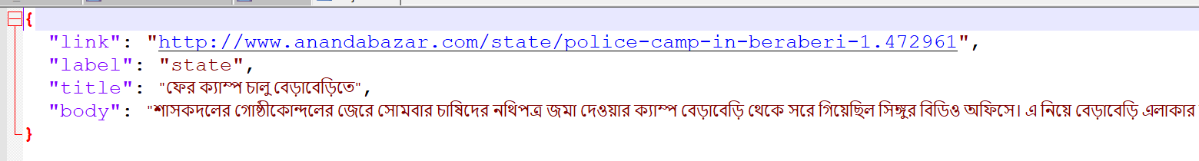

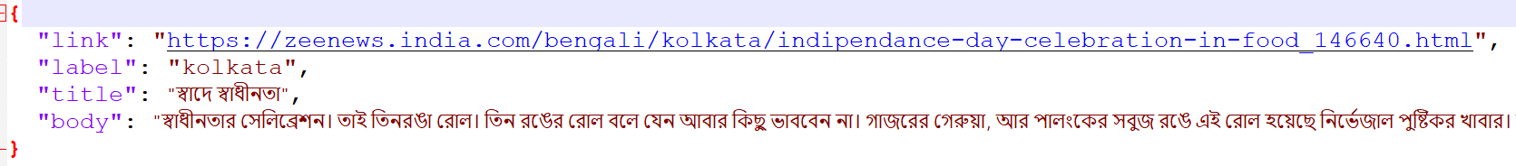

Due to the unavailability of any pre-trained model in the Bengali language, particularly for sentiment analysis, an existing BERT [model](https://huggingface.co/sagorsarker/bangla-bert-base), which was trained on a Bengali corpus for masked language modelling, was required to be finetuned. To perform this, a Bengali dataset with sentiment labels was required. However, the news articles dataset was not labelled on sentiments, and hence, there was a requirement to collect another dataset for this finetuning task. This sentiment classification dataset is collected from the data used in different related works[[1](https://aclanthology.org/2021.icon-main.58/), [2](https://aclanthology.org/2021.findings-emnlp.278/)]. All these data contain the user comments on popular news articles in an online Bengali news [**portal**](https://www.prothomalo.com/)**,** and each of them is labelled with its corresponding sentiments (Negative denotes 0, Positive denotes 1, and Neutral denotes 2).

**METHODOLOGY**

The first step involved here is data preparation. The sentiment-labelled datasets are combined together in a CSV file, and then they are preprocessed to remove stopwords, punctuations, URLs, emails, emojis, and digits, as these are irrelevant to the downstream task. Then, this dataset is divided into train and test splits containing 25000+ and 5000+ entries, respectively. The next task was to create individual JSON files for each news article from the collection of all articles.

Two popular LLMs are found in the Hugging Face [model](https://huggingface.co/sagorsarker/bangla-bert-base) collection, pre-trained on a huge Bengali corpus on masked language modelling. These two models are finetuned for this downstream task of sentiment classification by adding a linear layer on top of the last hidden layer of the model. Training is performed on these last two layers, freezing all the lower layers.

The last step was to design the code pipeline for user inference. This piece of code assumes the input file to be in JSON format, and the predicted output is stored as a JSON file with the same filename as the input file. It is also assumed that the system can support a maximum of five threads simultaneously to execute this task. A scheduler periodically checks if a new file is added to the directory containing all news articles every X minutes (user-defined parameter) and processes them in the multi-threaded code pipeline to generate the prediction files. The texts are preprocessed to remove unnecessary characters or stopwords before passing them to the model for inference. Also, an entire news article is divided into multiple sentences using a sentence tokenizer to ensure that those lengthy news articles do not surpass the maximum token length allowed for the model. The final prediction scores are an aggregation of scores of all sentences, and the class with the maximum score is determined as the predicted class. The output file contains the predicted sentiment, the predicted values of all possible sentiments (classes), the date and timestamp of the file generation, and the news category.

**RESULT AND ANALYSIS**

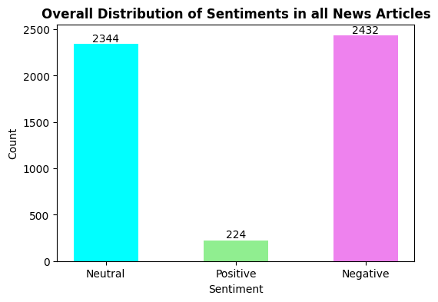

A sample of 5000 predicted files is used for the analysis. From the overall distribution given above, it’s clear that positive sentiments are rarely present in the news. This could also indicate that the model is biased towards the neutral and negative classes. However, this is highly unlikely because the train and test dataset was well balanced over all classes. The label-wise test performance metrics did not vary significantly, as shown below.

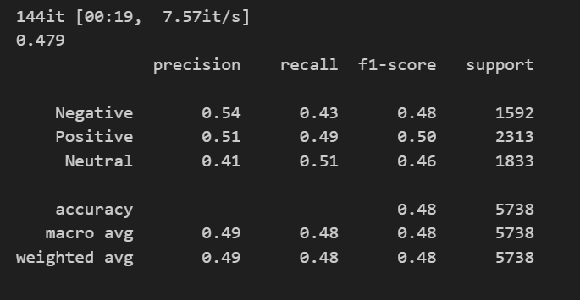

This observation about the two datasets is also confirmed by the visualisation of the two datasets using word clouds, in which the most frequently occurring words are highlighted in an image. In the word cloud of the news articles, positive words are not observed, whereas negative words are present (e.g., complain, murder, demand, against, etc.) in large fonts.



However, in the word cloud of the training dataset, positive (e.g., good, beautiful, opportunity, hope, thanks, peace, etc.) and a few negative words (e.g., bad, problem, etc.) are visible.



In the original dataset of news articles, those are tagged with different categories like state, sports, national, entertainment, etc. So, the category-wise analysis of the sentiments of news articles is given in the following pie and funnel charts:

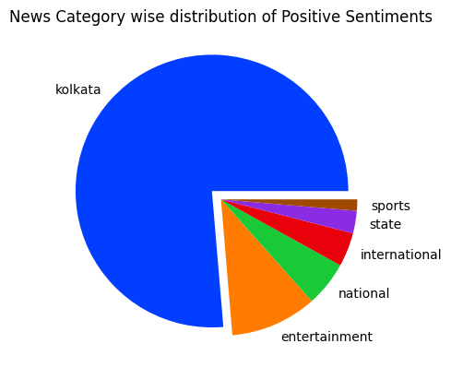

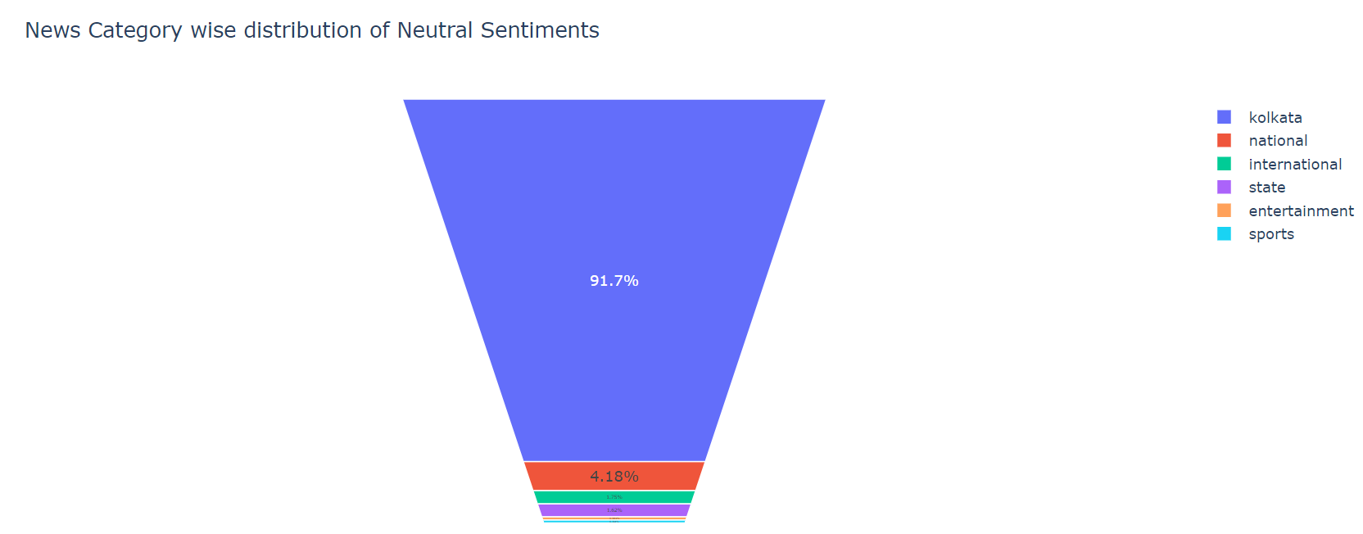

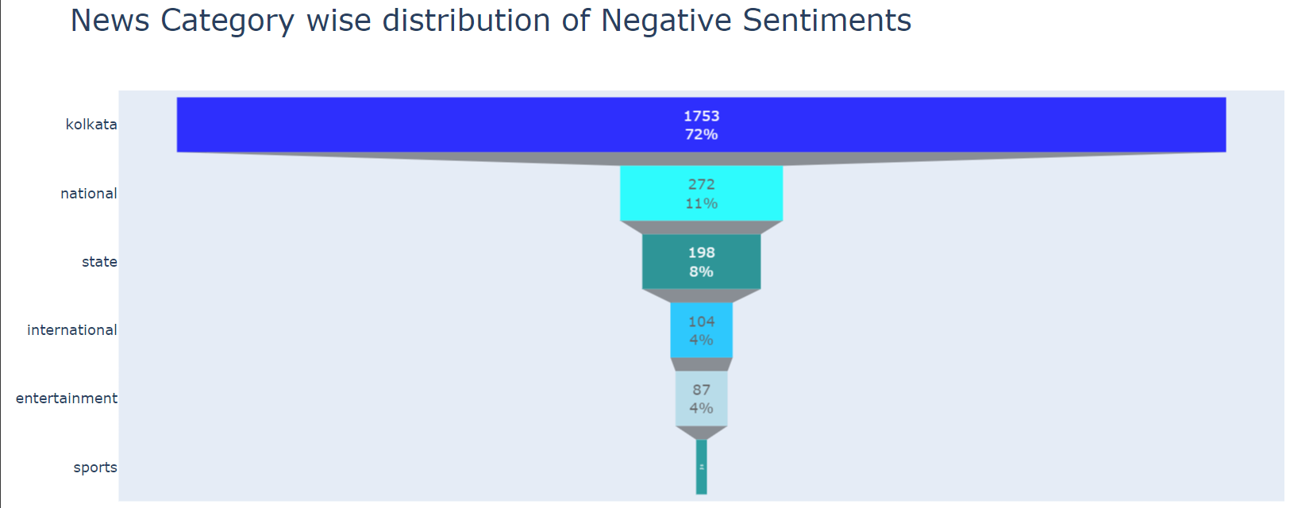

A month-wise trend graph of the sentiments is plotted as follows:

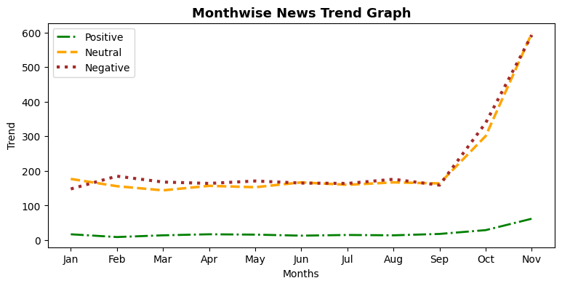

The distribution of the range of predicted scores for each sentiment class is given in the scatter plots below:

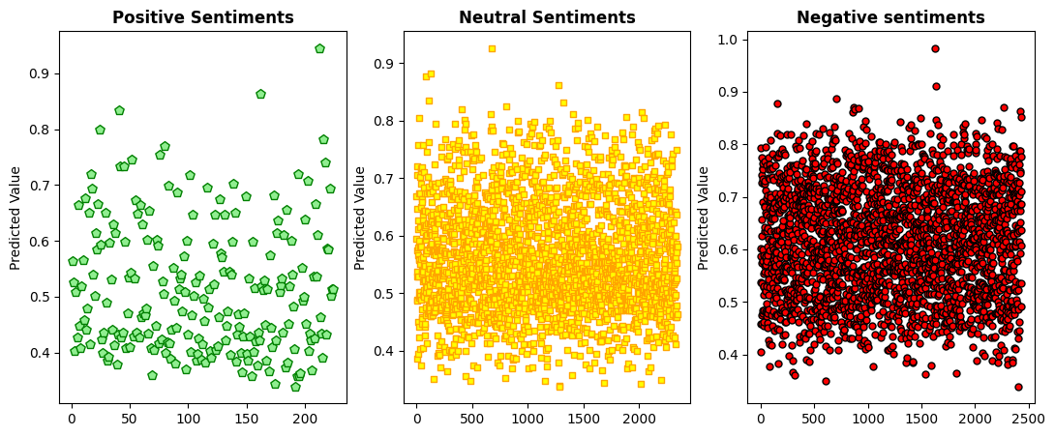

**REFERENCES**

1. <https://aclanthology.org/2021.icon-main.58/>
2. <https://aclanthology.org/2021.findings-emnlp.278/>
3. [প্রথম আলো | বাংলা নিউজ পেপার (prothomalo.com)](https://www.prothomalo.com/)
4. <https://huggingface.co/csebuetnlp/banglabert>
5. <https://huggingface.co/sagorsarker/bangla-bert-base>
6. <https://www.kaggle.com/datasets/csoham/classification-bengali-news-articles-indicnlp>