Test to characterize the timing of serial responses and output response.

The PS is connected to an Arduino running this code:

#include <Stream.h>
#include <RCTech_PS_Comm.h>

DPS_powerSupply supply1;

void setup() {
Serial1.begin(19200);
delay(1000);

supply1.initDPS(Serial1, 0x01);
delay(100);
supply1.setDPS_outputOn(true);
delay(3000);
supply1.setDPS_voltageamperage(600,400);
delay(350);
supply1.setDPS_voltageamperage(2400,1600);
}

void loop() {
delay(10);
}

When the power supply is sent a command, the response time varies from about 250ms to 500ms. The output does not change until about 50ms after the response is transmitted.

This first scope capture illustrates two commands being sent to the power supply sequentially. The yellow trace is the RX line of the power supply, the blue trace is the TX line of the power supply, and the pink trace is the voltage of the power supplies output. In this capture, the power supply recieves the command to set voltage to 6.00V, transmits the acknowledgment response about 275ms later, starts to change the output voltage about 75 ms after that, receives another command to set the output voltage back to 24.00V shortly after that, transmits another acknowledgment response about 350ms later this time, and finally, changes the output voltage about 75ms later again.
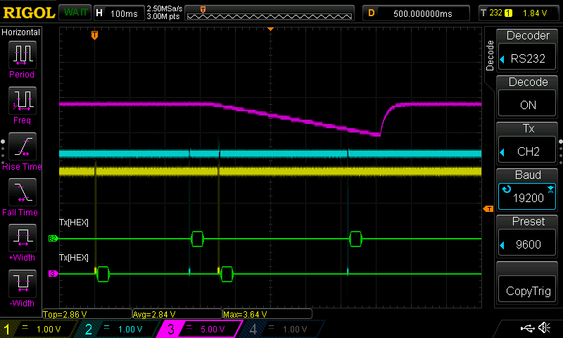
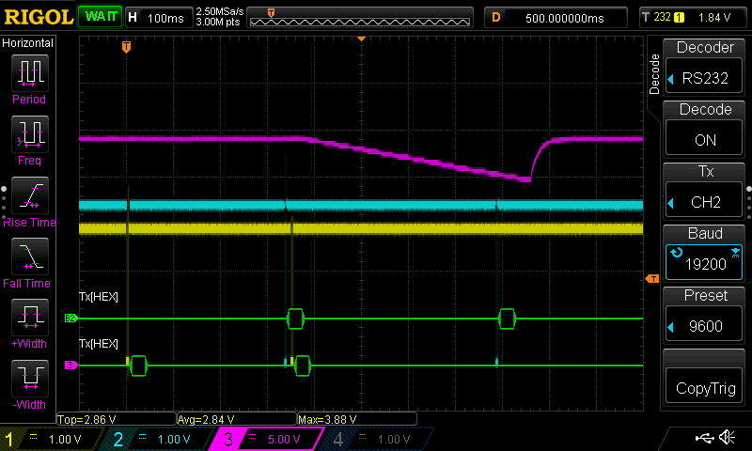
The next scope capture shows another response to the same code. In this case, the first acknowledgment response is a little bit delayed from the first one, but still before the second command is received. The timing of the supply output responses following the acknowledgments are about the same.

Finally, here is a scope capture with the same code again where the first response was not transmitted by the supply before a second command was received. In this case, the supply ignores the first command and sends an acknowledgment response (and sets the output state) only in response to the second command.
