# Antares-Xpansion



This package works along with RTE's adequacy software ANTARES: <https://antares.rte-france.com/>

**Antares-Xpansion** is the package which optimizes the installed capacities of an ANTARES study.

Typical uses of the package are for:

* **long-term scenario building**: build an economically consistent long-term generation mix
* **transmission expansion planning** : compute the network development which maximizes social welfare

The investment decisions are optimized by running ANTARES' simulations iteratively. At each iteration, the installed capacity of the investments are updated, and the simulations are repeated until the total costs have converged to a minimum. The total cost evaluated in this problem are the sum of the **expected operation cost during one year** and the **investment annuity**.

**Antares-Xpansion** is currently under development. Feel free to submit any issue.

## Optimal dimensioning of generation and transport capacities: the optimization problem solved by Antares-Xpansion

The cost function that **Antares-Xpansion** minimizes is as follows:

*Min (expected operating costs for one year + a fixed cost annuity)*

In which the expected operating costs for one year, calculated by ANTARES, includes the variable costs of thermal generation (fuel and CO2 costs), penalties in case of unsupplied energy, line transit costs (if any), and, if the expansion-accurate mode is used, the start-up costs of the thermal generation units. The production costs are calculated over the entire geographical perimeter of the ANTARES study, and in expectation over the probabilistic scenarios defined in the study. The expected operating costs for one year include the fixed operating and maintenance costs of the generation and transit costs and, in the case of new units, the fixed cost annuity.

In the case of a problem with a single investment variable, the above cost function can be represented by the graph in ***Figure 1***.

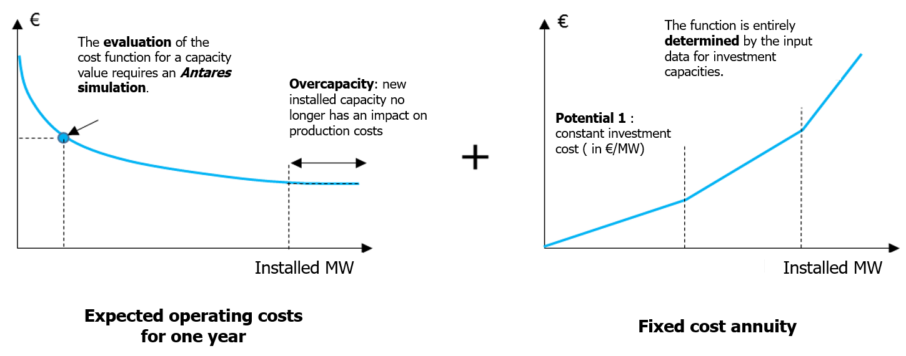

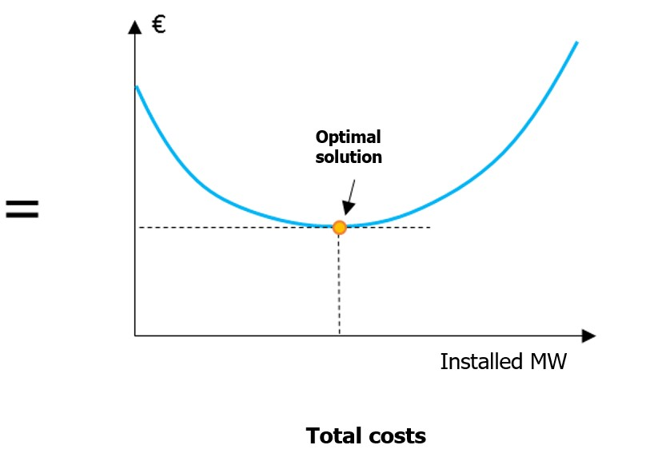

**Figure 1** – Objective function of the **Antares-Xpansion** optimization problem for one candidate

The expected operating costs for one year decreases as installed capacity increases. New generation or transmission capacity indeed reduces the variable operating costs of the power system by substituting "expensive" generation (or penalty in case of unsupplied energy) with generation from a more low cost source. The marginal contribution of the investment on this component of the cost function is decreasing: the first MW installed take the most interesting economic potential and have a greater impact on generation costs than the "last" MW installed, which have a lower economic utility, or even none in the case of overcapacity.

In **Antares-Xpansion**, fixed cost annuities are considered piecewise linear. Different potentials are defined, each of which is characterized by a fixed cost annuity in €/MW installed, and corresponds to one of the slopes of the function. A particular case of this commonly used representation of fixed cost annuities is a fully linear function, and therefore characterized by a single fixed cost (in €/MW installed).

The final cost result - which will be called the total cost later in this document - is a convex function. It therefore has a minimum solution plateau (see ***Figure 2***) which in most applications on real data sets is reduced to a single point (see ***Figure 1***), but it can be more than one point of equal value. **Antares-Xpansion** determines this point which minimizes the total cost, or any point of the minimum plateau in the case of a so-called degenerate problem. This is the optimal solution to the cost minimization problem.

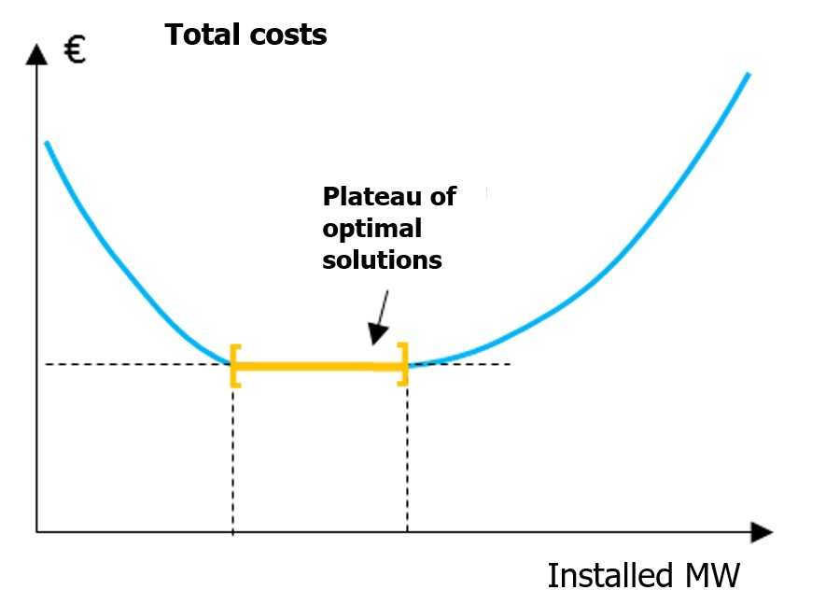

**Figure 2** – Generic case (but uncommon in practical **Antares-Xpansion** cases) with a set of optimal solutions (a plateau).

The investment variables are the installed capacities (in MW) of the generation and/or transmission assets defined at the input of **Antares-Xpansion** as candidates for investment.

The cases shown in ***Figure 1*** and ***Figure 2*** contain only one investment variable. The search for the optimal solution is then carried out over the interval [0, available potential], bounded on the left by zero and on the right by the maximum available potential of the investment under consideration. The available potential is one of the input data of **Antares-Xpansion**.

In the more general case with several investment candidates, **Antares-Xpansion** determines one optimal investment combination, that is, one combination of the capacities of the n investment candidates that minimizes the cost function.

The search for this optimal combination is done "at the same time" on the capacities of all investment candidates, and not candidate by candidate. In doing this, the **Antares-Xpansion** algorithm is able to identify and take into account the impact of synergies between structures - for example an A-B line which only becomes interesting once the B-C line is built - or of competitions - for example an A-B-C corridor parallel to another A-D-C corridor.

The definition of the investment variables in **Antares-Xpansion** is detailed later in this note. For example, it may include:

* Investable capacity values limited to a finite set rather than a whole interval. This allows for example to make the hypothesis that the investment is made in unit steps of 200 MW and to constrain the search for **Antares-Xpansion** to the discrete set {0 MW, 200 MW, 400 MW, 600 MW…}. Or to adopt an all-or-nothing approach in which only two choices are possible: not to invest or to invest up to an imposed unit capacity. Note that **Antares-Xpansion** can manage a mix of continuous investment variables, i.e. valid over the whole interval [0, maximum potential], and discrete variables, valid only over a finite set of values (see later).
* Linear constraints between investable capacities. Linear constraints between variables can be defined in investment problems. For example, they may require the sum of the capacities of two investment candidates to be greater or less than a given limit.

The resolution method used by **Antares-Xpansion** - called Benders decomposition - is an iterative method, which for each iteration:

* performs an ANTARES simulation to evaluate the expected annual production costs of a combination of investments,
* determines a new investment combination by solving a "master problem" in which the cost function is approximated by its derivatives into the previously tested investment combinations. These derivatives are also called Bender cuts.

This method has been shown to converge towards the optimal solution to the minimization problem presented in the previous sections. The Benders decomposition algorithm is also commonly used in the solution of large stochastic problems. The number of iterations needed to reach the optimum depends strongly on the structure of the problem and the variants/algorithmic parameters used. At first order of magnitude, it increases strongly with the number of defined investment variables.

|  |  |
| --- | --- |
| **Number of investment candidates** | **Order of magnitude of the number of iterations** |
| 5 | 10 |
| 10 | 40 |
| 25 | 100 |
| 50 | 300 |
| 100 | 800 |

**Table 1 -** Order of magnitude of the number of iterations required to reach the optimum with **Antares-Xpansion** v0.12. Note that the number of iterations is also highly dependent on the structure of the ANTARES study and investment candidates, as well as the algorithmic parameters of **Antares-Xpansion**.

Each iteration of the **Antares-Xpansion** algorithm includes an ANTARES simulation. However, the simulation of "operational" studies of several tens of nodes and with several hundred Monte-Carlo scenarios (TYNDP, Generation adequacy report on the electricity supply-demand, etc.) requires a significant amount of computing time, sometimes several hours. The search for the optimal solution to the problem solved by **Antares-Xpansion** can therefore be relatively long, and in some cases requires simplifying the problem being solved.

## User Guide: How to use Antares-Xpansion?

### The user/expansion/ folder of the ANTARES study

The **Antares-Xpansion** package is based on the ANTARES software and its data format.

**Antares-Xpansion** is based on an already existing ANTARES study. Some of the capacities of this study, usually fixed as input in the ANTARES paradigm, will be optimized by the investment optimization module of the **Antares-Xpansion** package.

In order to run the investment optimization module, the ANTARES dataset must be enriched with - at least - two new files:

* a ***candidates.ini*** file which contains the definition of investment candidates (which capacities of the ANTARES study are expandable? at what cost? with what limits? etc.);
* a ***settings.ini*** file which contains the settings of the **Antares-Xpansion** algorithm.

These two files must be located in the **user/expansion/** directory of the ANTARES study (see ***Figure 3***). To date, the data they contain are neither visible nor modifiable in the ANTARES man-machine interface. These two files must therefore be built "by hand".

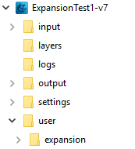

**Figure 3** – Enrichment of the ANTARES dataset with the addition of the user/expansion/ directory, which contains the data required for successful use of **Antares-Xpansion**.

### Definition of investment candidates in the ANTARES study

The user of the package defines investment candidates. **Candidate capacities for investment are necessarily links from an ANTARES study**. During the iterative process described later, the hourly capacities (direct and indirect) of the investment candidate links will be modified until the Benders decomposition converges towards the optimum or one of the shutoff parameter is reached.

Investment candidates can also be generation assets, or even flexibilities, by adopting a virtual node logic as described below.

|  |  |  |
| --- | --- | --- |
|  |  |  |
| **(a)** | **(b)** | **(c)** |

***Figure 4*** *- Configuration of the ANTARES study for an investment in* ***(a)*** *transmission capacity (new line or grid reinforcement),* ***(b)*** *generation units and* ***(c)*** *storage.*

Investment in transmission capacity between two areas: the ANTARES link candidate for investment, shown in red in **Figure 4 (a)**, is directly the interconnection for which the interest in increasing capacity is being studied.

* In the case of the construction of a new line, a link must be added in the ANTARES study between the two areas concerned.
* In the case of a grid reinforcement between two already interconnected areas, the link between these two areas already existed in the ANTARES study. The parameter already-installed-capacity is then used in the definition of the investment candidate to specify the capacity value of the grid structures already present between the two zones. In this way, **Antares-Xpansion** will assess the economic interest of increasing this capacity beyond what is already installed.

Investment in thermal generation capacity: The generation capacity subject to expansion, physically located for the example in **Figure 4 (b)** in *area1*, must be moved to a virtual node (here *invest_semibase*) connected to the physical node *area1*. The ANTARES link of the investment candidate is the link between these two nodes.

The generation unit of the investment candidate must be defined, with its technical and economic parameters, by a thermal cluster:

* located in the virtual node (here *invest_semibase*),
* created before executing the benders decomposition,
* which has a *market bid* equal to its *marginal cost*, which is equal to the variable operating cost (in €/MWh) of the generation unit,
* which has an hourly availability time series **always higher than the potential** (max-investment) of the investment candidate (if the hourly availability time series of thermal generation are "*ready-made*” in ANTARES, then the values of the time series must be filled in such a way that they **are always higher** than the candidate's potential. If the times series of thermal generation are “*stochastic*” i.e. generated by ANTARES, then the parameters for the generation of series must be defined in such a way that the availability is always higher than the potential (*number of units* * *nominal capacity* > *potential*, no outages rate).

Other cluster parameters (*pmin*, *start-up costs*, etc.) can also be defined. However, they will only be taken into account by **Antares-Xpansion** if the expansion-accurate mode is used (see later).

Investment in renewable generation capacity: As in the case of thermal generation, the renewable generation capacity subject to expansion, physically located for the example in **Figure 4 (b)** in *area1*, must be moved to a virtual node connected to the physical *area1* node. The investment candidate's ANTARES link is the link between these two nodes.

For the type of renewable production concerned (wind or solar), a production time-series (ANTARES wind or solar tab) must be defined in the virtual node. The production time-series must be deterministic, constant, and **higher than the potential** (max-investment) of the investment candidate. The parameter link-profile will then be used (see later) to define the hourly load factor. It should be noted that this profile is necessarily deterministic and that the new renewable generation capacities cannot have differentiated production time-series for each Monte-Carlo year.

Investment in flexibility: The modeling of flexibilities, such as Pumped storage, is generally based in ANTARES on a set of virtual nodes/links and coupling constraints. To make flexibility an investment candidate, a link must be identified in the ANTARES modelling whose transmission capacity corresponds to the capacity of the flexibility (at its maximum power for example, the size of a stock, etc.). For example, in the case of the Pumped storage in **Figure 4 (c)**, the capacity of the Pumped storage (equal to its pump and turbine capacity) is defined by the maximum possible flow on the link between *area2* and *hub*: it is by this link that the investment in this flexibility will be characterized. The classical binding constraints must be added in the ANTARES simulation to represents the storage (for example: with a negative ROW Balance in psp-in and a positive ROW Balance in psp-out and the following constraint).



In the 4 cases presented above, the link used to define investment candidates (in red in **Figure 4**):

* must have the parameter *« transmission capacities = use transmission capacities* », and not « *set to null* » or « *set to infinite* »,
* may have a *hurdle cost*, which will then be well taken into account in the economic optimization of **Antares-Xpansion**,
* may be subject to binding constraints - provided that the ANTARES version used is at least v6.1.3 - which will be well taken into account in the simulations of system operation. These constraints can possibly be constructed by the Kirchhoff constraint generator and the information given in the impedances, loop flow and phase shift columns of the link.

The direct and indirect transmission capacities of the link will be modified by **Antares-Xpansion**. The values initially entered in the *Trans.* *Capacity Direct* and *Trans. Capacity Indirect* columns do not matter since they will be overwritten when the expansion problem is solved. Note that the capacities of existing structures must be filled in with the already-installed-capacity parameter in the *candidates.ini* file (see later) and not in the definition of the links in the ANTARES study.

### Definition of investment candidates in the *candidates.ini* file

Not all links in the ANTARES study are by default investment candidates. The selection of expansion capacities is left to the user and is defined in the *candidates.ini* file. Each investment candidate is characterized with the following properties:

* **name**: name of the investment candidate (warnings : must not contains spaces)
* **link**: link whose capacity will be invested
* **annual cost per MW**: investment cost, per year and per MW
* **unit size**: size, in MW, of an investment unit (e.g. one group of 300 MW)
* **maximum units**: maximum number of units which can be built
* **has link profile**: True if candidate has a capacity profile

The *candidates.ini* file must respect the following syntax:

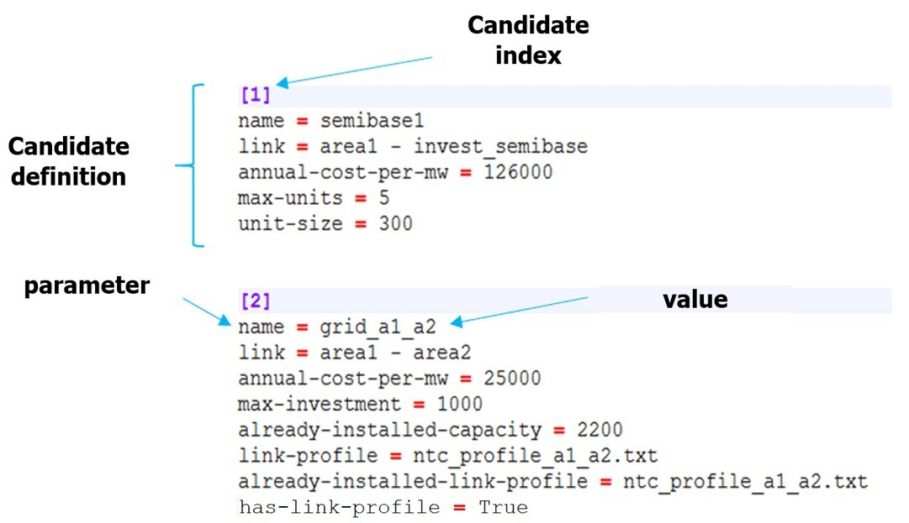

**Figure 5** – Example of a candidates.ini file

Concretely, the investment decision will affect only the capacity of the ANTARES' links. Investing in interconnections can be made directly with the package, while investing in generation capacity or storage capacity can be made using the so-called concept of "virtual nodes" with ANTARES. The definition of all the investment candidates is given in a new input file, located in the user folder of the study: ./user/expansion/candidates.ini.

The parameters that characterize the candidates are as follows:

**name (mandatory parameter)**

The value to be entered is a string. It specifies the name of the investment applicant. This name is reused in the logs and outputs of **Antares-Xpansion**.

Warnings: This field must not contain spaces!

**link (mandatory parameter)**

The value to be entered is a string. It defines the link of the ANTARES study candidate for investment, whose capacities (direct and indirect) will be modified by **Antares-Xpansion**. The syntax of the link name includes the names of the two ANTARES nodes that the link connects, separated by "-", for example:

origin_area – destination_area

Note that node names that include spaces or dashes are not compatible with **Antares-Xpansion**. The origin area corresponds to the first in the spelling order. The same link may contain several investment candidates (see section later).

**annual-cost-per-mw (mandatory parameter)**

The value to be filled in is numeric (the decimal separator is the point). It defines the investment candidate's fixed cost annuity (in €/MW/year). Depending on the type of candidate (see section 2.3.3), the fixed cost annuity can include:

* fixed operation and maintenance costs
* an investment cost annuity

**max-investment**

The value to be entered is numerical. It represents the candidate's potential, i.e. the maximum capacity (in MW) that can be invested in this candidate. If the candidate has this parameter, the set of values that its capacity can take is the interval [0, max-investment].

The definition of an investment candidate must necessarily include either (i) a maximum potential in MW (max-investment) or (ii) a unit size in MW (unit-size) and a maximum potential in number of units (max-units).

**unit-size**

The value to be entered is numerical. It defines the nominal capacity (in MW) of the investment candidate's installable units.

**max-units**

The value to be entered is an integer. It corresponds to the candidate's potential in terms of number of installable units. If the candidate has the max-units and unit-size parameters, then the set of values that its capacity can take is the finite set of the first multiples of unit-size:

{0, unit-size, 2 x unit-size, … , max-units * unit-size}

**already-installed-capacity**

The value to be entered is numerical. It corresponds to a capacity already installed on the investment candidate's link. If **Antares-Xpansion** considers the investment in this investment candidate to be economically relevant, the new capacity invested will be added to the already installed capacity. The transmission capacities initially indicated in the ANTARES study are not considered in the already-installed-capacity parameter and will be overwritten by **Antares-Xpansion**.

**has-link-profile**

The value to be entered is True if the candidate has a link profile.

**link-profile**

The value to be filled is a string specifying the name of a file. This file must be located in the *user/expansion/capa/* directory of the ANTARES study. It must contain one or two columns of 8760 numerical values (the decimal separator is the point). The link-profile makes the link between the capacity invested and the capacity actually available, in the direct and indirect directions of the ANTARES link for the 8760 hours of the year. The link-profile can for example be used to represent the maintenance of a generation asset via a seasonalized power outage, or the average load factor of intermittent renewable generation, defined at hourly intervals. It should be noted that the link-profile is deterministic: the same profile will be used by **Antares-Xpansion** for all Monte-Carlo years of the ANTARES study and all capacity tested.

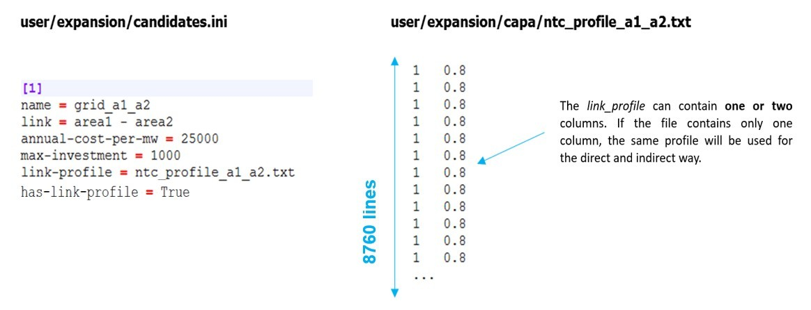

**Figure 6** – Example of a file containing a load factor profile in the **Antares-Xpansion** format

**already-installed-link-profile**

The value to be filled is a string specifying the name of a file. This file must be located in the *user/expansion/capa/* directory of the ANTARES study and have the same format as a link-profile (see ***Figure 6***). The already-installed-link-profile makes the link between the capacity invested and the hourly capacity actually available, in the direct and indirect way of the Antares link for the 8760 hours of the year. It should be noted that the same file can be used for link-profile and already-installed-link-profile of one or more candidates.

### Examples of candidates

An example with two investments candidates, one in semi-base generation and one in network capacity, is given below.

[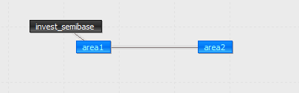](https://github.com/rte-antares-rpackage/antaresXpansion/blob/master/vignettes/example2nodes.png)

The invested semi-base generation in *area 1* is shifted in the "virtual node" *invest_semibase*. Within the optimization process, the capacity of the link between area 1 and *invest_semibase* will be updated with the new invested capacity.

The candidates.ini file for this example will be the following one. This file has to be saved in the folder ./user/expansion/:

[1]

name = semibase

link = area1 - invest_semibase

annual-cost-per-mw = 126000

unit-size = 200

max-units = 5

already_installed_capacity = 200

[2]

name = grid

link = area1 - area2

annual-cost-per-mw = 3000

unit-size = 500

max-units = 4

Another example with solar generation in a virtual node:

[1]

name = solar_power

link = area1 - pv1

annual-cost-per-mw = 100000

max-investment = 10000

has-link-profile = True

link-profile = pv1.txt

Where pv1.txt is a text file, located in the ./user/expansion/capa/ folder of the study, and which contains the load factor time series of the candidate (one column of 8760 values between 0 and 1, or two columns if there is a direct and indirect profile on the link). When x MW of the candidate *solar_power* will be invested, the actual time series of available power will be equal to the product of x and the time series pv1.txt.

### Link between invested capacity and capacity of the Antares

The parameter link-profile, already-installed-capacity and already-installed-link-profile are used to define the link between:

* the capacity installed by **Antares-Xpansion**, and
* the capacity actually available in the ANTARES study, hour by hour and in both directions of the link concerned.
* Note that these parameters are only useful if the candidates are grid reinforcement.

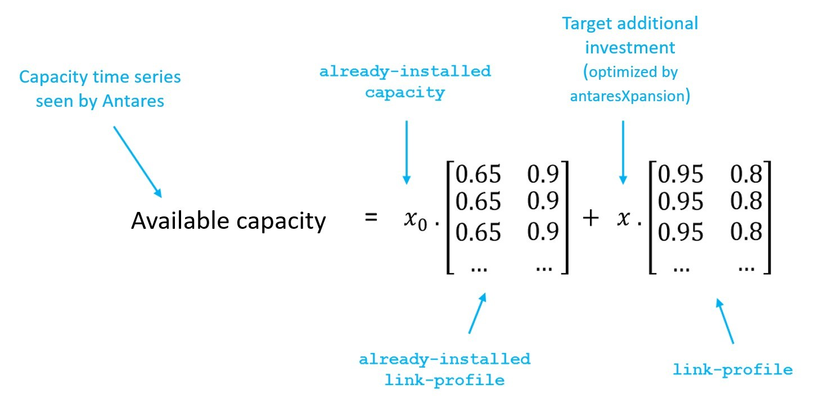

**Figure 7** – Link between the capacity invested by **Antares-Xpansion**, and the capacity available in the ANTARES study

Note that by default, the parameters link-profile and already-installed-link-profile contain only 1's, thus assuming "perfect" availability of the invested capacity.

The parameter link-profile is conventionally used for:

* Take into account an NTC profile on an interconnection, possibly seasonalized and having a different impact on the direct and indirect directions of the link,
* Represent the maintenance of a thermal generation asset by considering a deterministic reduction of its power, possibly different according to the season (see **Figure 8**),
* Model renewable generation by multiplying the invested capacities by a (deterministic) load factor chronicle (e.g. an average chronicle or the chronicle of a given Monte-Carlo year).

The investment problem, at this stage of development, makes it possible to manage the fact of investing in a capacity, whose availability varies during the year with an average availability over all Monte-Carlo years via the link_profile. However, it is not possible to manage an hourly availability per Monte-Carlo year, which would make it possible to represent more realistically the intermittency of RES from one year to another or the impact of outages and maintenance on an entire unit of thermal power plants (see **Figure 8**).

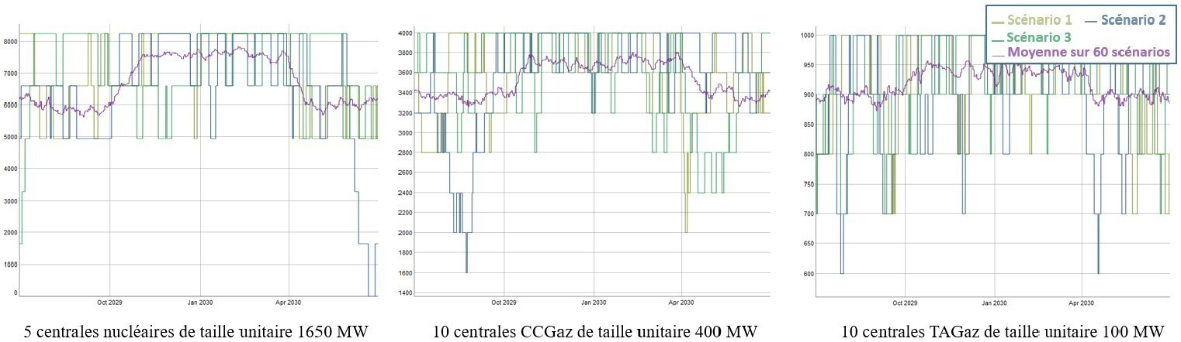

**Figure 8 –** Available hourly capacity of different types of power plants due to outages. **Antares-Xpansion** allows to take into account an average hourly availability (purple line) via the link_profile, which is still very different from the actual hourly availability over a year.

To validate the results, after having run the benders decomposition a first time with a deterministic average hourly availability curve, it is preferable to re-simulate these outages according to a stochastic process by relaunching an ANTARES simulation with the capacities obtained by antaresXpansion in order to obtain the real production program with outages and RES intermittencies varying according to the scenarios.

### Investment Candidates and Decommissioning Candidates

Investment candidates and decommissioning candidates are differentiated by their fixed cost annuities. In the case of decommissioning, there is no reconsideration of the investment cost, one only chooses whether or not to maintain operation and maintenance costs:

* The annuity of the investment candidates includes the sum of:
  + fixed annual operation and maintenance costs
  + annualized investment costs

In this configuration, **Antares-Xpansion** makes an economic choice between the sum of these costs and the reduction in variable operating costs (mainly fuel costs and penalties associated with loss of load) made possible by the new investment.

* The annuity for decommissioning candidates, on the other hand, only includes the fixed annual operation and maintenance costs. In this configuration, **Antares-Xpansion** makes an economic choice between the operation and maintenance costs of a generation or transmission asset, and the savings it makes on the variable costs of power system operation. The annualized investment costs are in this case considered as stranded and are not taken into account in this economic choice. The "potential" of this type of candidate (i.e. its max-investment or max-units x unit-size) corresponds to its decommissionable capacity, i.e. the candidate's already installed capacity that could be shut down if it is no longer profitable for the power system.

Candidates for decommissioning should be explicitly specified in **Antares-Xpansion** in the name. The generation units already installed in the ANTARES study, as well as the capacities covered by the already-installed-capacity parameter of the investment candidates are fixed and cannot be decommissioned by **Antares-Xpansion**.

By using the functionality presented in the last part, it is possible to make on the same link:

* A candidate for decommissioning: defined by a capacity already installed and by its fixed operation and maintenance costs.
* A candidate for investment: defined by an expandable capacity and a fixed annuity of costs including investment costs.

An example of a production process that can be decommissioned or expanded is given in the following figure.

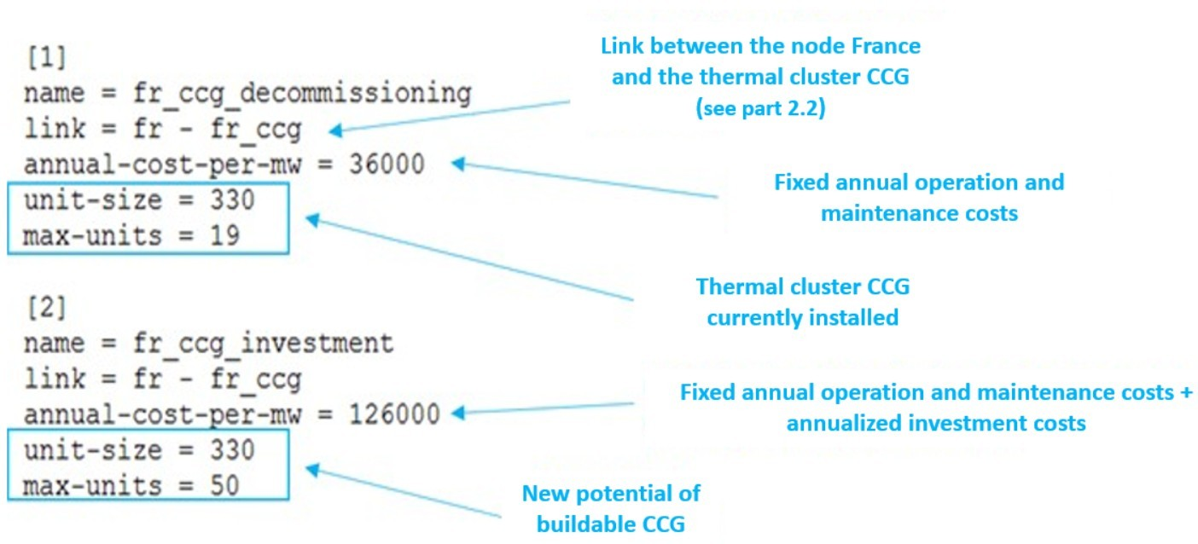

***Figure 9*** *- Candidates for investment and decommissioning on the same link from an ANTARES study*

Warnings : the hourly availability time series of thermal generation CCG in ANTARES should be higher than the sum of the availability currently installed with the new potential buildable (availability of CCG cluster in the virtual node *fr_ccg* > 330 x 19 + 330 x 50 with this example).

At the end, for the candidate for decommissioning, the result is inverse than for the investment candidate: if the result displayed in the console is: 300 x 19 MW invested, this means that no units are decommissioned, if the result displayed in the console is: 0 MW invested it means that all units have been decommissioned.

### Parameterization of the algorithm for solving the investment problem

The simulation options and algorithmic parameters for solving the investment problem must be entered in the settings.ini located in the folder ./user/expansion/ with the appropriate syntax is given below:

**uc_type = expansion_fast**

**master = integer**

**optimality_gap = 0**

**max_iteration = 100**

**additional-constraints = constraint.txt**

The various configurable parameters are detailed in the rest of this section. If a parameter is not filled in the settings.ini file by the user, it will take its default value.

**optimality-gap**

Possible values: numeric (ex: optimality_gap = 1e6) in euros. Default value: 1e-6.

The optimality-gap parameter is a stopping criterion of the **Antares-Xpansion** algorithm, expressed as a distance to the optimum of the optimization problem, defined in euros.

If the optimality_gap is zero, **Antares-Xpansion** will continue its search until the optimal solution to the investment optimization problem is found. If the optimality_gap is strictly positive, search will stop as soon as **Antares-Xpansion** finds a solution where the cost difference from the optimum is less than the optimality_gap.

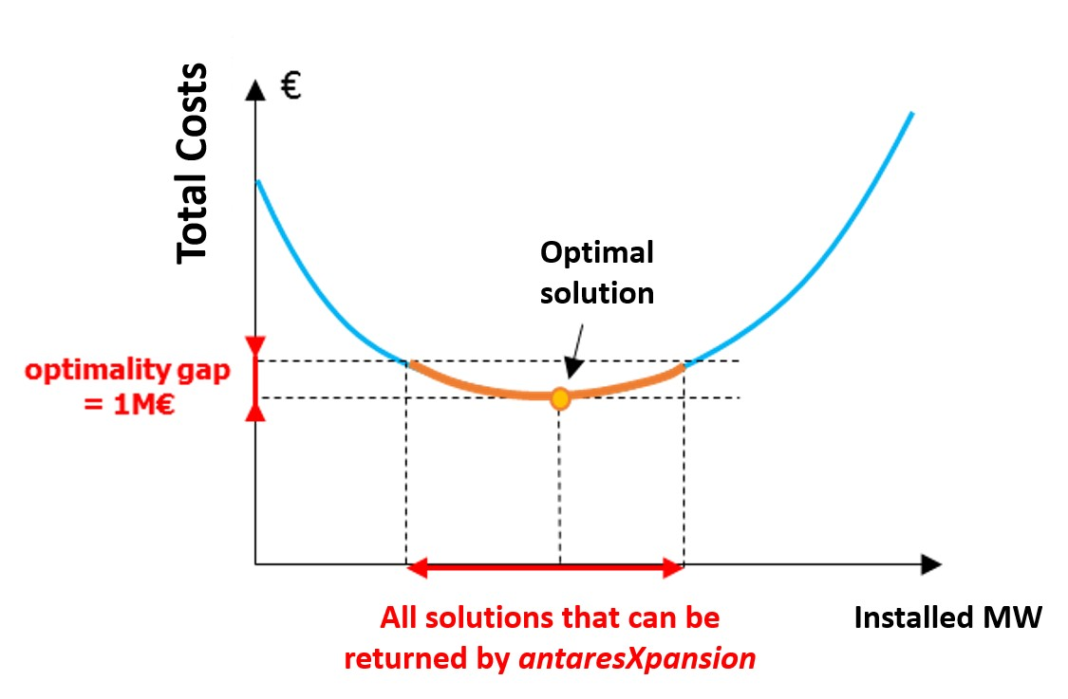

**Figure 10** – Illustration of the optimality-gap and the set of solutions that can be returned by the package when the gap is strictly positive.

The minus infinity (-Inf)value of the optimality_gap is theoretically equivalent to a null optimality_gap, except that it covers numerical errors which in practice can lead to an underestimation of the distance of a solution to the optimum. With this default value, **Antares-Xpansion** determines the investment combination that minimizes the cost function.

The interest of a strictly positive optimality_gap is that it speeds up research by stopping as soon as a "good" solution is found.

The interpretation of this stopping criterion is not always obvious. It certainly guarantees that a solution will be found whose cost is close to the optimum, but it does not provide any information on the distance (in MW) between the installed capacities of this solution and those of the optimum solution. However, if the cost function is relatively flat around the optimum, solutions whose costs are close may have significantly different installed capacities (see for example **Figure 8**).

**Which settings should I use the** optimality_gap**?**

* If I have to run several expansion optimizations of different variants of a study and compare them. In that case, if the optimal solutions are not returned by the package, the comparison of several variants can be tricky as the imprecision of the method might be in the same order of magnitude as the changes brought by the input variations. It is therefore advised to be as closed as possible from the optimum of the expansion problem. To do so, the following condition should necessarily be fulfilled:
  + set the optimality_gap to zero.

Note: even with the conditions mentioned above, the result might be slightly different from the optimum due to numeric approximations, this can be partly solved by putting to optimality gap to –Inf.

* If I'm building one consistent generation/transmission scenario. As the optimal solution is not more realistic than an approximate solution of the modelled expansion problem. The settings can be less constraining with:
  + an optimality_gap of a few million euros.

**uc_type**

Possible values: expansion_fast and expansion_accurate. By default: expansion_fast.

The uc-type (unit-commitment type) parameter specifies the simulation mode used by Antares to evaluate the operating costs of the electrical system:

* If uc_type = expansion_fast: the *fast* mode of ANTARES is used, deactivating the flexibility constraints of the thermal units (Pmin constraints and minimum up and down times), and not taking into account either the start-up costs or the impact of the day-ahead reserve.
* If uc_type = expansion_accurate: the *expansion* mode of ANTARES is used. This simulation mode corresponds to the *accurate* mode of ANTARES in which the unit-commitment variables are relaxed. The flexibility constraints of the thermal units as well as the start-up costs are taken into account.

**master**

Possible values: integer and relaxed. By default: integer.

The master parameter provides information on how integer variables are taken into account in the antaresXpansion master problem.

* If master = relaxed: the integer variables are relaxed, and the level constraints of the investment candidates (cf. max-units and unit-size) will not be necessarily respected.
* If master = integer: the problem of optimizing investments is solved by taking into account unit-size constraints of the candidates. However, to speed up the search for the optimal solution, these constraints are not taken into account during the first iterations of the Benders decomposition: they are relaxed until the relaxed-optimality-gap is reached.

For problems with several investment candidates with large max-units, the master = relaxed can accelerate the search for **Antares-Xpansion** very significantly.

**max-iteration**

Possible values: strictly positive integer or infinite. Default value: Inf.

Benders decomposition stop criterion defined in maximum number of iterations. Once this number of iterations is reached, the search for **Antares-Xpansion** ends, regardless of the quality of the solution found.

**Timelimit**

Possible values: strictly positive integer or infinite. Default value: Inf.

Benders decomposition stop criterion defined in maximum number of iterations. Once this number of iterations is reached, the search for **Antares-Xpansion** ends, regardless of the quality of the solution found.

**yearly-weights**

Value: string specifying the name of a file.

yearly-weights offers the possibility of assuming that the Monte Carlo years simulated in the ANTARES study are not equally probable. The most representative years may be given greater weight than those that are less representative. The yearly-weights points to a vector , with the number of Monte-Carlo years in the study, which is used to evaluate the expected production costs.

With the production cost of the -th Monte Carlo year.

The value to be filled is a string specifying the name of a file. This file must be located in the *user/expansion/* folder of the ANTARES study. It must contain a column with as many numerical values as there are Monte-Carlo years in the ANTARES study. The value of the -th row is the weight of the -th Monte Carlo year.

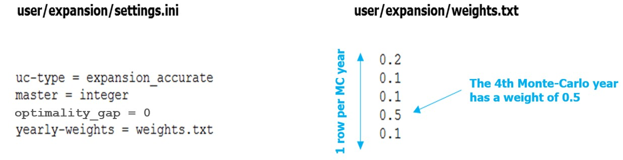

**Figure 11** – Example of a setting of Antares-Xpansion with Monte-Carlo years that are not equally-weighted.

If the yearly-weights parameter is not used, the Monte-Carlo years of the ANTARES study are considered to be equally-weighted.

The yearly-weights parameter **must be set in line with the ANTARES study playlist by the user**: years with zero weights must be removed from the ANTARES study playlist in order not to be simulated unnecessarily.

**additional-constraints**

Value: string specifying the name of a file.

The additional-constraint argument makes it possible to impose linear constraints between the invested capacities of investment candidates. The value of this parameter is the name of a file to be located in the user/expansion/ folder of the ANTARES study. This file must be written in a particular syntax and complements the master problem with new linear constraints between investment candidates. The format is inspired by Antares' binding constraints. An example of such a file is given in the following figure:

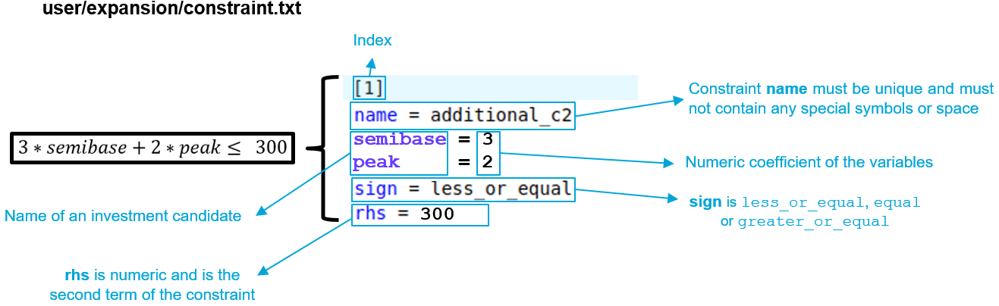

**Figure 12** – Example of an additional constraint file

* name : constraint name must be unique and must not contain any special symbols or space
* sign: direction of the equality : less_or_equal, equal or greater_or_equal
* rhs: numeric second term of the constraint

The user can also optionally use binary constraints to represent, for example, exclusion constraints. In the following figure, **Antares-Xpansion** cannot invest in semibase and peak at the same time, it can also invest in neither:

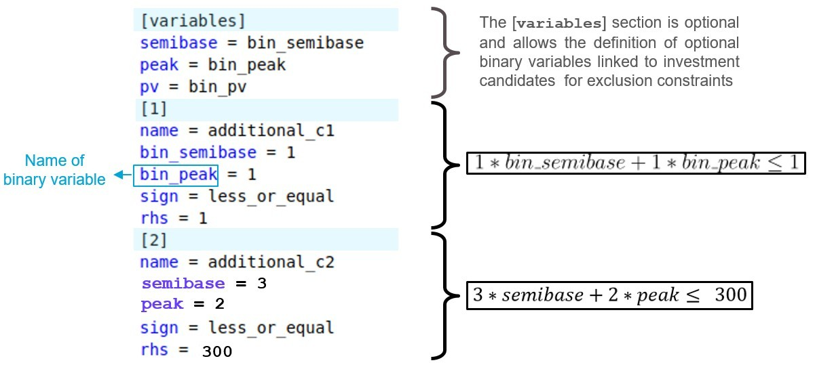

**Figure 13** – Example of an additional constraint file

The use of binary variables is not recommended as it greatly increases the calculation time.

## Launching an Antares-Xpansion optimization

First, create an ANTARES study with the description of the candidates and create the candidates.ini and settings.ini files as explained above and store them in the directory *study_path/user/expansion/*. Once the candidates.ini and settings.ini files are set up, investment optimization can be done with the package.

Antares-Xpansion does not include a human-machine interface.

1. 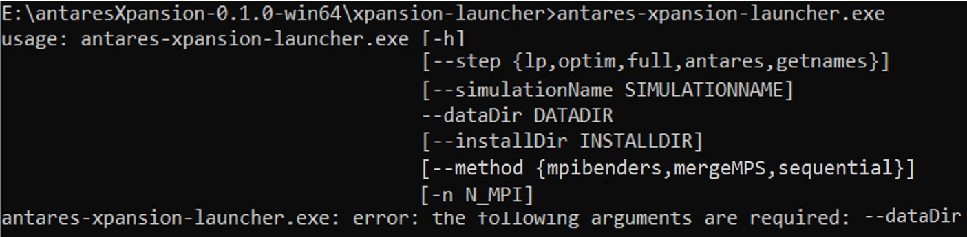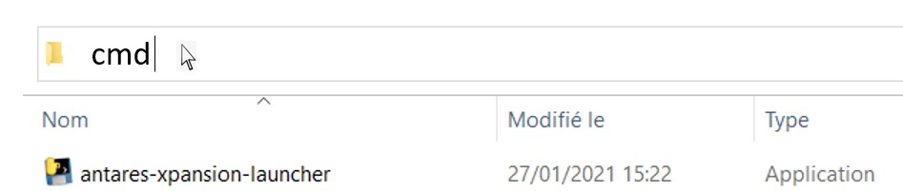Open a Command Prompt in the “*\antaresXpansion-x.y.z-win64* folder :

E:\antaresXpansion-x.y.z-win64\ >antares-xpansion-launcher.exe

usage: antares-xpansion-launcher.exe [-h]

[--step{lp,optim,full,antares,getnames,update}]

[--simulationName SIMULATIONNAME]

-i/--dataDir DATADIR

[--installDir INSTALLDIR] [--method {mpibenders,mergeMPS,sequential}]

[-n N_MPI]

antares-xpansion-launcher.exe: error: the following arguments are required: -i/--dataDir

Figure 14 -

**Figure 14** – Example of launch with Window

1. Run the antares-xpansion-launcher.exe and set the path to the Antares study with --*dataDir* parameter:

* antares-xpansion-launcher.exe --dataDir « D:\Users\franconmat\Documents\TP\example\xpansion-test-01 »

* The *--dataDir* parameter can also be replaced by *–i.*

Other non-mandatory parameters other than *--dataDir* are available: *--step , --method , --simulationName ,* *--installDir and –n* options.

**--step**

The python script does several operations one after the other. The --step option allows to execute only one step or all the steps (interaction between the different bricks).

|  |  |
| --- | --- |
| antares | Launch ANTARES one time to get the ANTARES problem |
| getnames | Launch getnamer one time to get the name of ANTARES variables |
| lp | Launch lpnamer one time to create the master problem of Antares-Xpansion |
| optim | Launch the resolution of Antares-Xpansion |
| full | Launch all steps in order (antares > getnames > lp > optim) |

Default value: full.

**--dataDir (-i)**

Indicate the ANTARES simulation path. The specified path must be an explicit path. Use quotes “” in case of a space in the path.

**--simulationName**

This option enables to give a name to an ANTARES simulation. It is necessary if you only run one of the following steps: getnames, lp, optim without restarting the antares step.

**--method (-m)**

This option enables to set the type of resolution to be used for **Antares-Xpansion**

|  |  |
| --- | --- |
| sequential | Launch Benders sequential decomposition |
| mpibenders | Launch the MPI version of the Benders decomposition if the user has MPI |
| mergeMPS | Not implemented. Launch frontal resolution without decomposition |

Defaut value: sequential

**Results and logs**

When the search for **Antares-Xpansion** ends, i.e. when the optimal investment combination has been found or a stop criterion has been reached - which can take several hours or even days in some cases - the package:

* 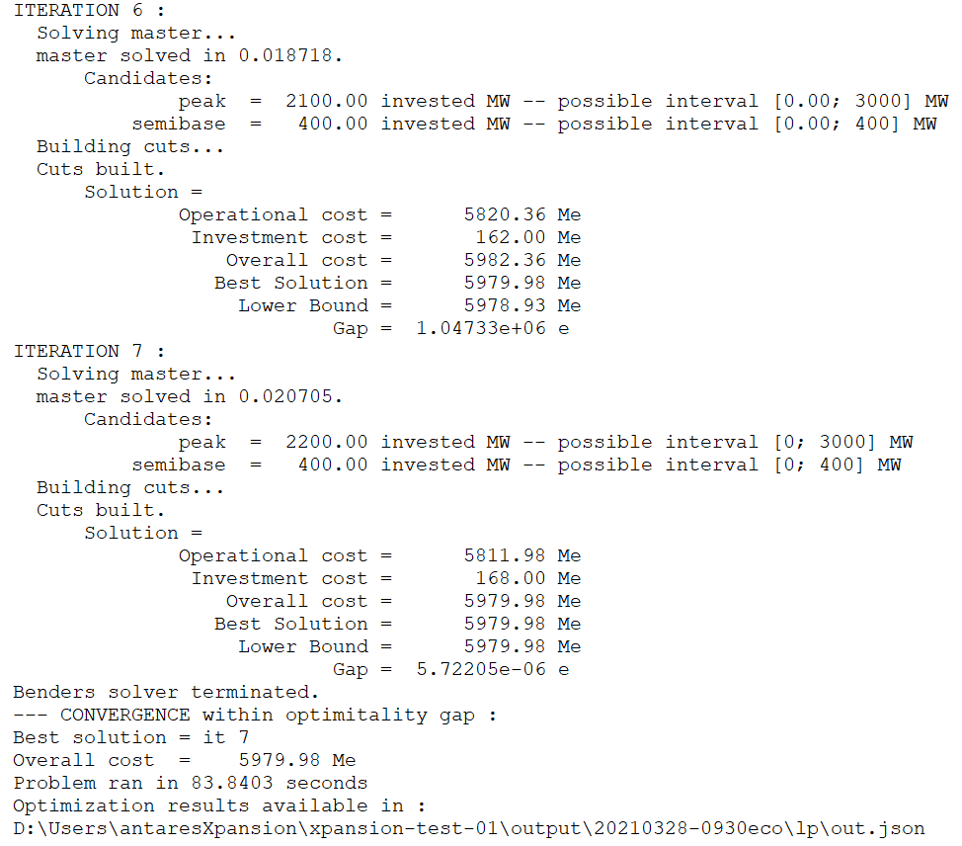Writes the outputs in the benderssequential.log text file and in the out.json text file, which are in the ANTARES study /output/simulation-name/lp/ folder. This report gives the parameters used in the settings.ini file for the **Antares-Xpansion** optimization, gives the capacities, the costs of the optimal solution and the time of resolution, as well as the path of the iterations of the Benders decomposition. The results are also displayed in the command prompt :

**Figure 15 -** The details of the iterations and the result are displayed in the command terminal

* Updates the ANTARES study by replacing the capacities of investment candidate links with their optimal value taking into account the link-profile, the already-installed-capacity and the already-installed-link-profile :

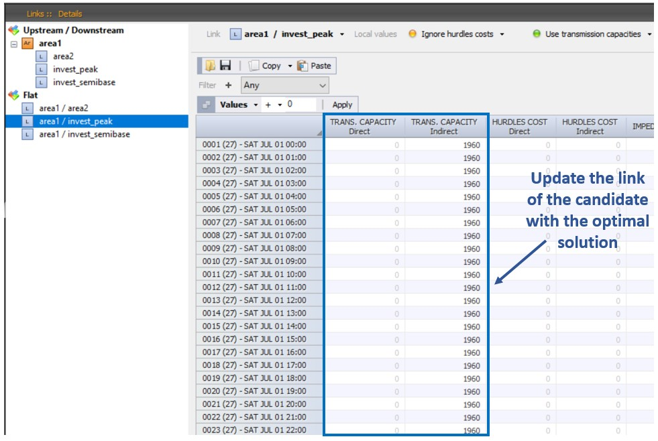

**Figure 16** –Example of update on the ANTARES study

The user can therefore relaunch the simulation corresponding to the last iteration. However, it is recommended to relaunch a real ANTARES post-**Antares-Xpansion** study for further analysis because **Antares-Xpansion** relaxes certain constraints (see link-profile and uc_type parameters) and the total costs could be a bit different.

**Errors**

Xpansion will not work if the initial ANTARES study is not running. The user must therefore check beforehand that the Antares simulations do not contain any errors.

Be careful to use the has-link-profile=True parameter in the case of a use of link-profile, to check the consistency between the names of the links in the candidates.ini file and in the Antares study and to use a unique index and name per candidate.

Sometimes Xpansion needs to be restarted.

In case of a problem, put an issue on Github:

<https://github.com/AntaresSimulatorTeam/antares-xpansion/>

end of document