Simulation Output Waveform
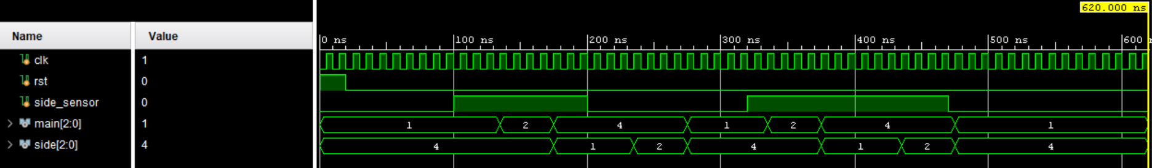
RTL Schematic
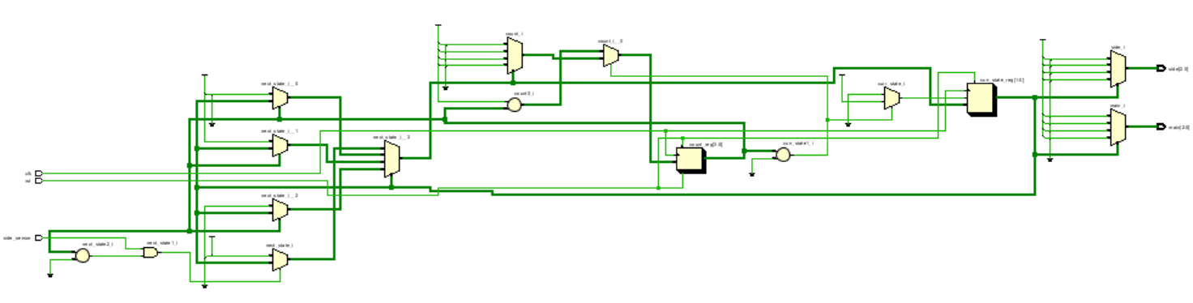
Synthesized Design
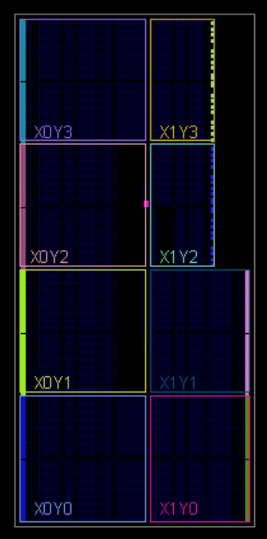
Output
TIME | Sensor | MAIN(RYG) | SIDE(RYG)
0 | 0 | 001 | 100
100000 | 1 | 001 | 100
135000 | 1 | 010 | 100
175000 | 1 | 100 | 001
200000 | 0 | 100 | 001
235000 | 0 | 100 | 010
275000 | 0 | 001 | 100
320000 | 1 | 001 | 100
335000 | 1 | 010 | 100
375000 | 1 | 100 | 001
435000 | 1 | 100 | 010
470000 | 0 | 100 | 010
475000 | 0 | 001 | 100

