Testing Spring Restful Webservices

You can test in postman by running your webservices and another way is to write unit testcases can test without running the webservices.

Advantage of writing unit testcases

* You don’t have to run your webservices everytime
* You create mock instances for the dependent instances ex: Mocking Services, DAO and etc
* You can test without interacting with the database

Create a simple project with H2 dependency

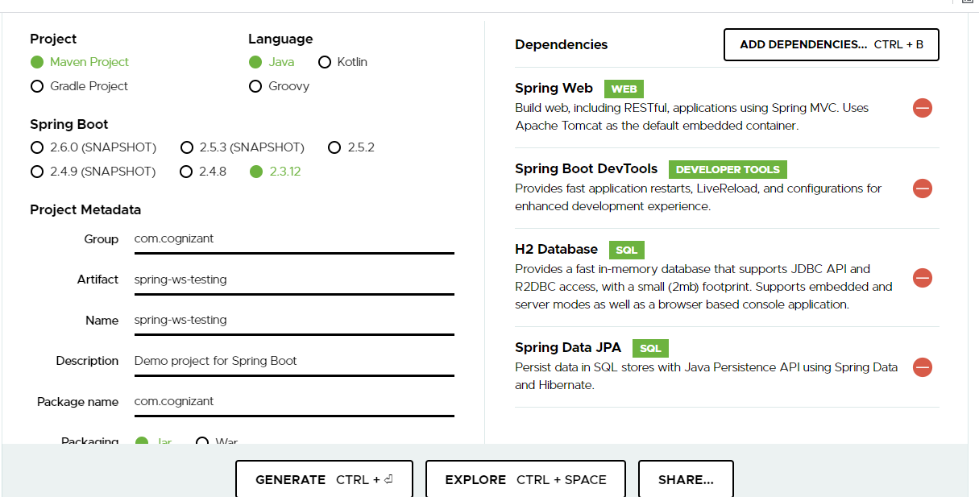

You can change .properties to .yml

Since we have H2 database library we can add the datasource informations in the yml file

application.yml

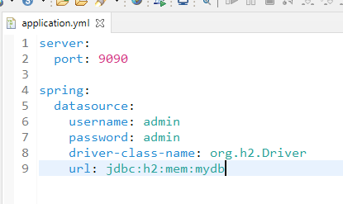

SpringWsTestingApplication.java

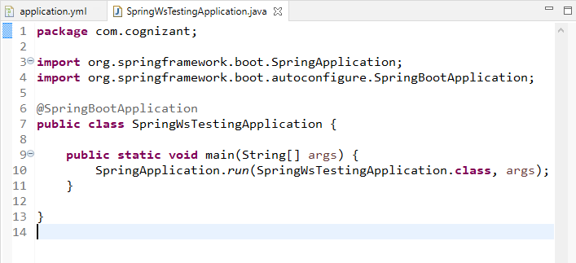

Create a RestApi.java that will have simple greetings for the input you pass

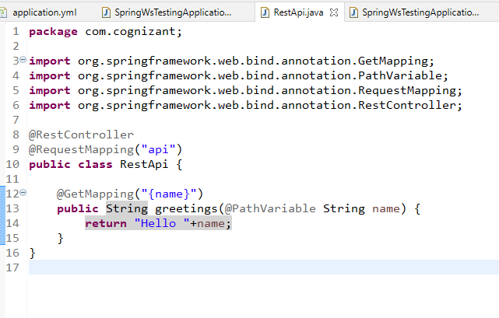

Now you can write test cases without launching the application you can assert the result from the greetings

Note: You need to write unit test cases inside the test folder

Write test cases in test package

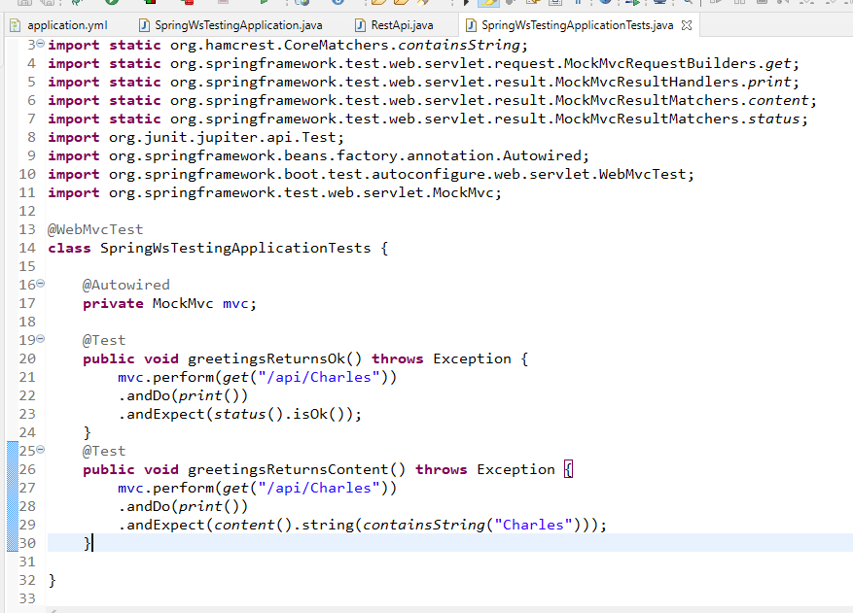

Output:

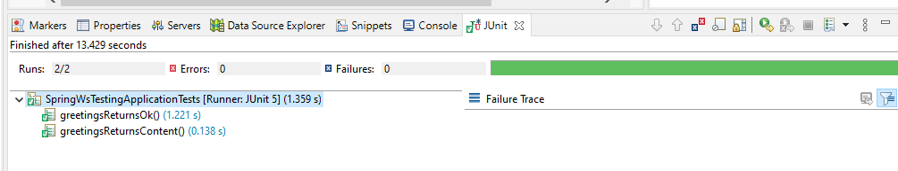

Create an MVC program that uses Service and DAO layer using H2 database

Firstly create an entity with some properties and use @Entity, @Id, @GeneratedValue

User.java

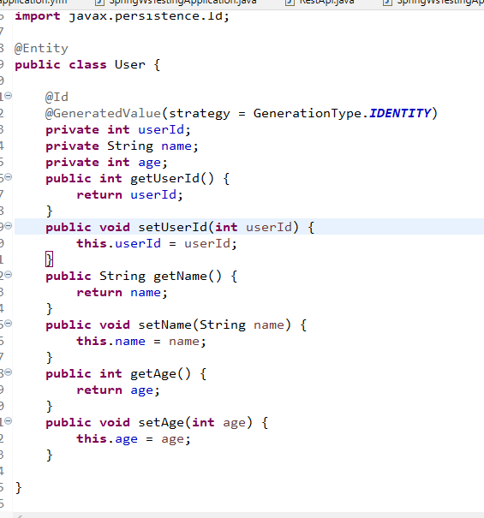

UserRepository.java

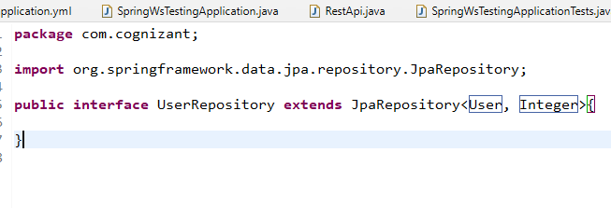

Now you can create Service layer

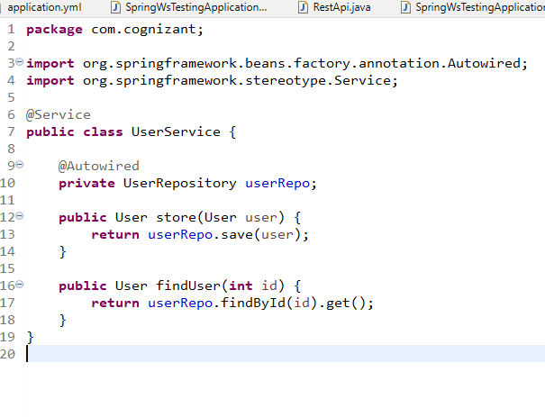

Controller can access service

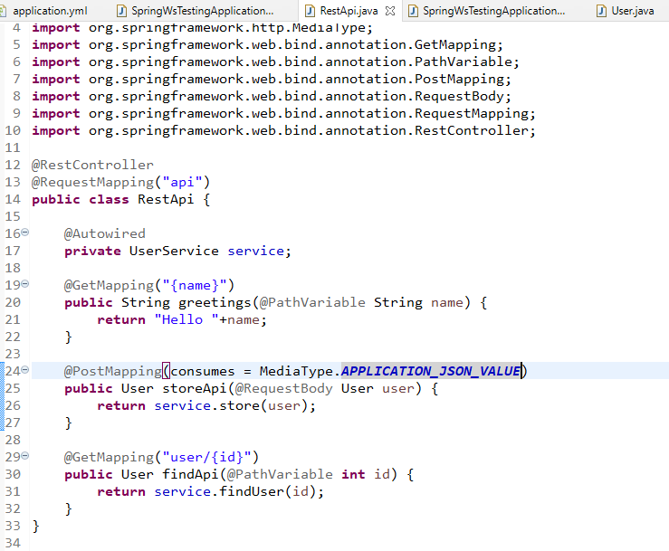

Now you write test cases for store and find

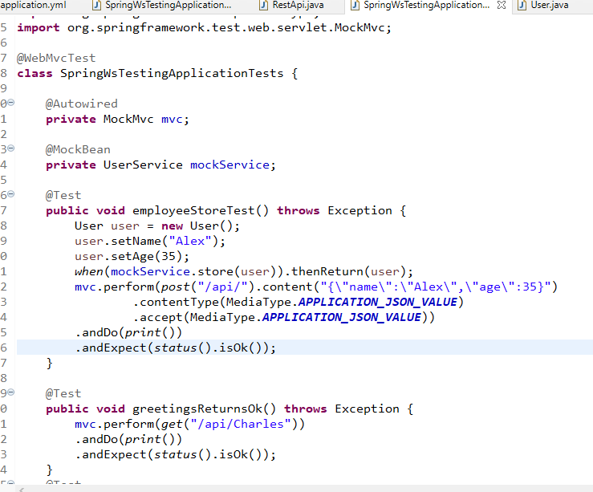

AWS stands for Amazon Web Services, it provides you the infrastructure required to start and launch the applications in any machine you want.

AWS charges as per the usage there are some free tier services.

Some of the important services are:

EC2: Elastic Cloud Computing

S3: Simple Storage Service

RDS: Relational Data Service

DynammoDB: For No-SQL database

EC2: It is a virtual machine that you can start from anywhere, you can choose free-tier OS.

How to connect to the virtual machine

There are 2 ways

1. Use SSH client or Git bash and follow the instructions provided in the

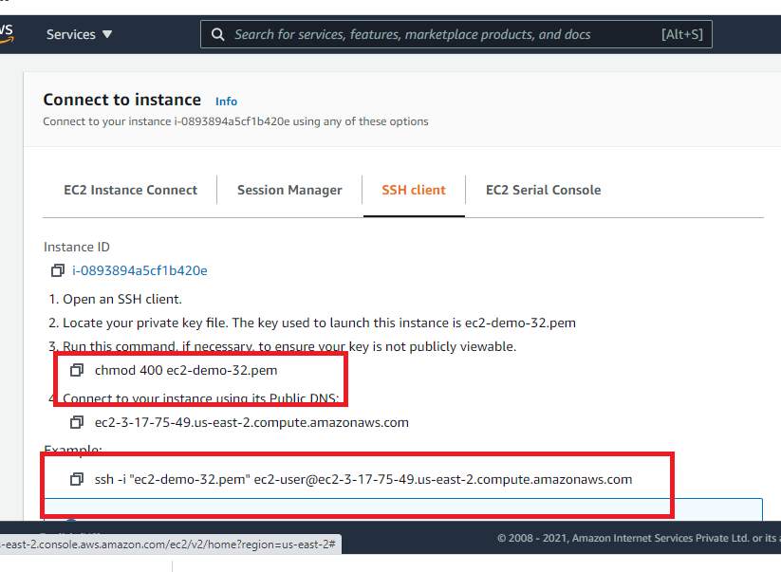

The above page you will get when you select your instance and click connect.

1. You can use Putty software, but you need to generate ppk file from pem file first

How to install softwares in EC2 instance

1. To install Git use *sudo yum install git -y*
2. To install Java use *sudo yum install java-1.8.0-devel*
3. To install http server use *sudo yum install httpd -y*
4. To install docker *sudo yum install docker*

How to run a simple restful webservices program on AWS

1. You need an executable jar
2. You need to get this jar in your aws machine
3. You need to open the TCP port in aws machine to accept the incoming request using security group inbound settings.

How to configure the security group

1. From AWS console go to EC2 dashboard & Click on your instance id

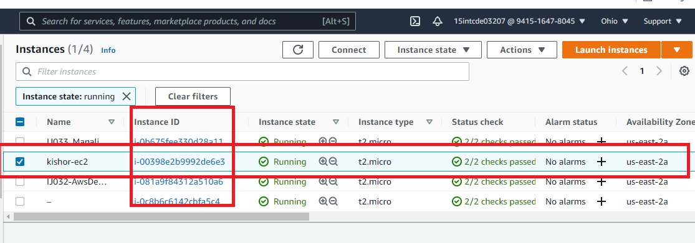

1. Go to the security group and edit the inbound rules

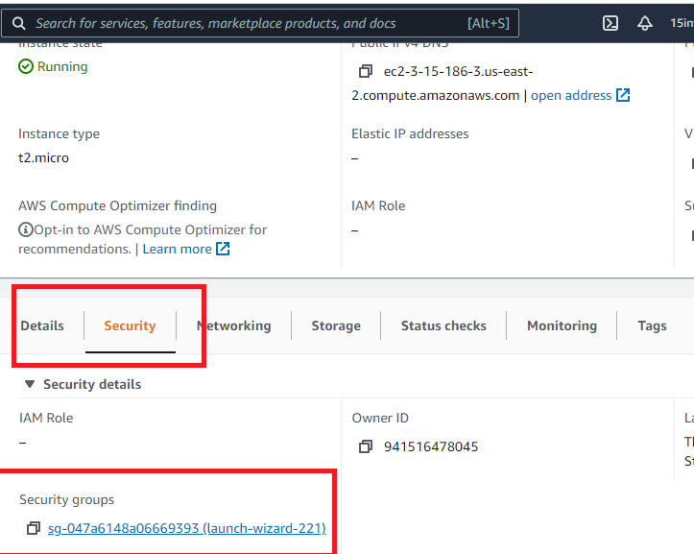

After you click on security groups you will see inbound rules

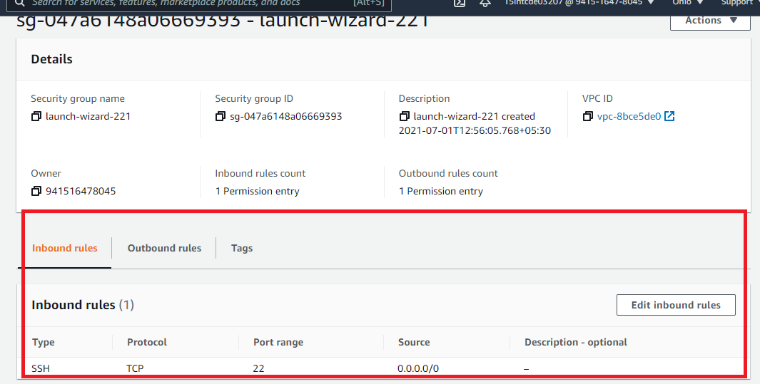

Now you can edit the inbound rules to accept TCP 9090 port and also open http protocol, when you edit you will see add rule button

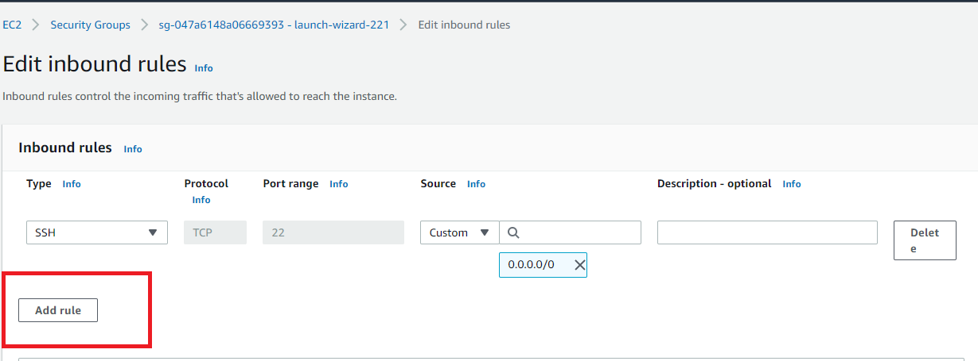

Now you can add inbound rules for Custom TCP & HTTP

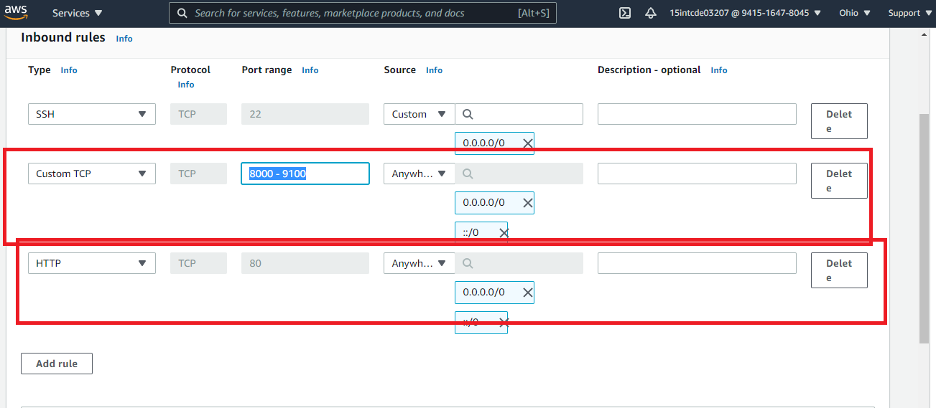

Note: Scroll down and save the rules

1. Once you pull the jar from git use *java -jar file.jar*

In the browser you can enter the ip address and port including the webservice url

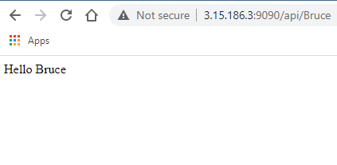

S3: Simple Storage Service

This service is used to upload any file/folders so that it can be accessible to group of users or public.

In simple storage service you will have a bucket that is a container for all your files/folders, this bucket must have an unique name.

RDS:

Relational Database Service

It is used to create the RDBMS database instance on the cloud and give access to the users.

You can choose any database some are free and some are not.

Steps to create mysql database on cloud

1. Select RDS
2. Create database with standard create option
3. Make public access and provide the credentials to be used to access
4. Use Free tier MySQL
5. Once you create the database instance you could able to see the end point and port number
6. Once you get the end point, you can open mysql-workbench and connect to the endpoint and enter the credentials
7. Then you can write the queries

DyammoDB:

It is a no-sql database, i.e., non-structured, you can keep the data in any structure in the table.

1st record can have id, name & salary

2nd record can have id, name, message, gender

3rd record can have id, itemName, itemsList