**Project Report**

In this project we have done a comparative analysis of iPhone XR Red 128 gb model reviews extracted from Amazon and Flipkart.

**Working Methodology**

For review extraction selenium and beautiful soup was used. Used browser of kora. Selenium to make a crawler which extracted reviews from amazon and Flipkart. I extracted 897 reviews for amazon from 150 pages and 1100 reviews for Flipkart from 150pages.

Then downloaded the files in excel format.1 for Amazon and 1 for Flipkart.

Then loaded Amazon, Flipkart excel sheet into my comparative analysis notebook. Then did data clustering(word similarity checking),Word Cloud for finding the most important words ,Count Vectorizer to find out which words or group of words was used the most ,Syntactic Analysis through Spacy to find important words, their qualifiers and entity relationships and Topic Modelling through Gensim .

Following sections are subdivided under Amazon and Flipkart

**Amazon**

Average Amazon Rating was found to be 4.29 from the ratings extracted

According to Amazon the most common words associated with iPhone are good, best, product, camera, battery, buy, great etc.

Also battery life, value money, media loaded, camera quality, good product, battery backup, nice product are the most mentioned points

**Wordcloud**

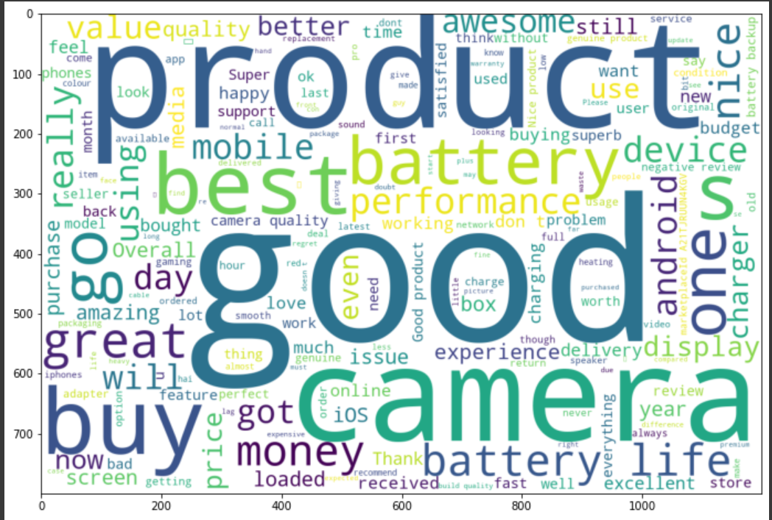

**Most Mentioned Words or Wordgroups**

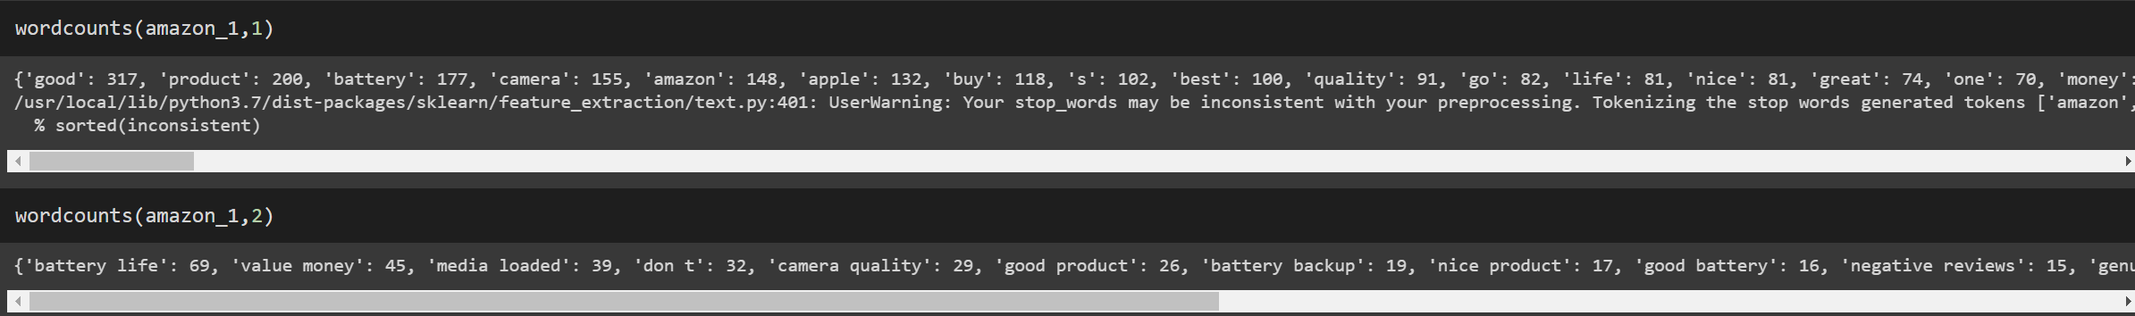

**Syntactic Analysis**

Here qualifiers were looked into.

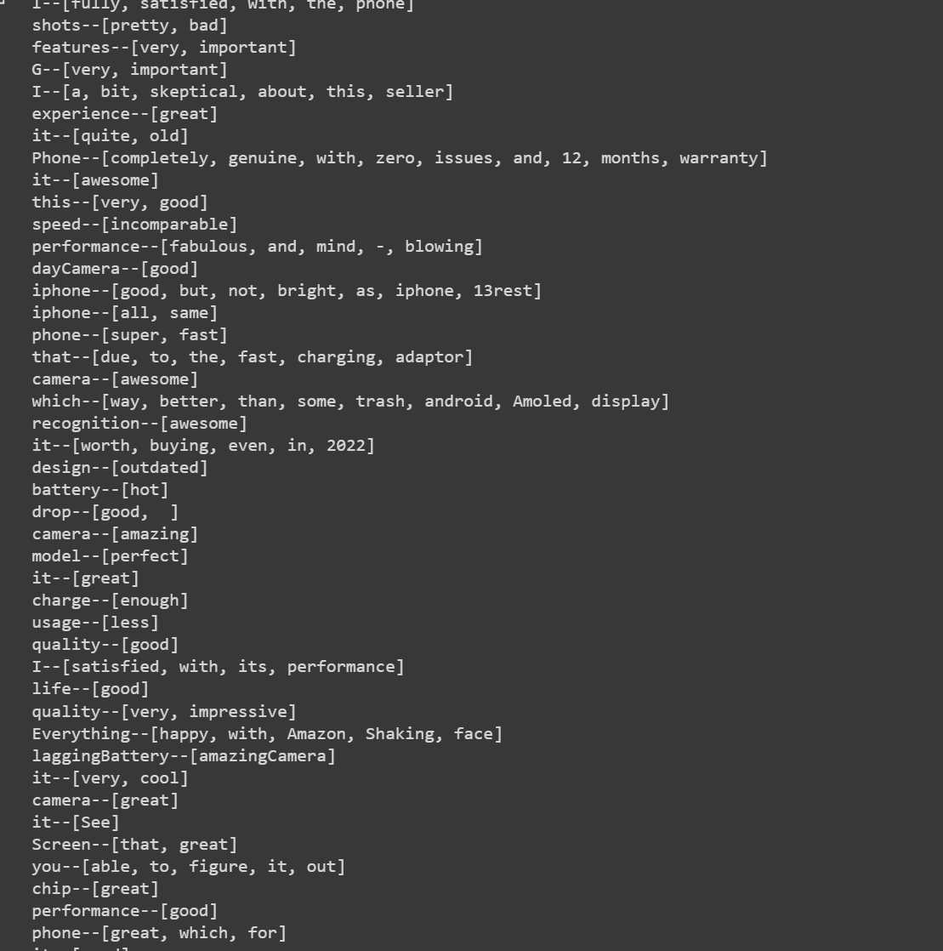

Also entity relations were found out

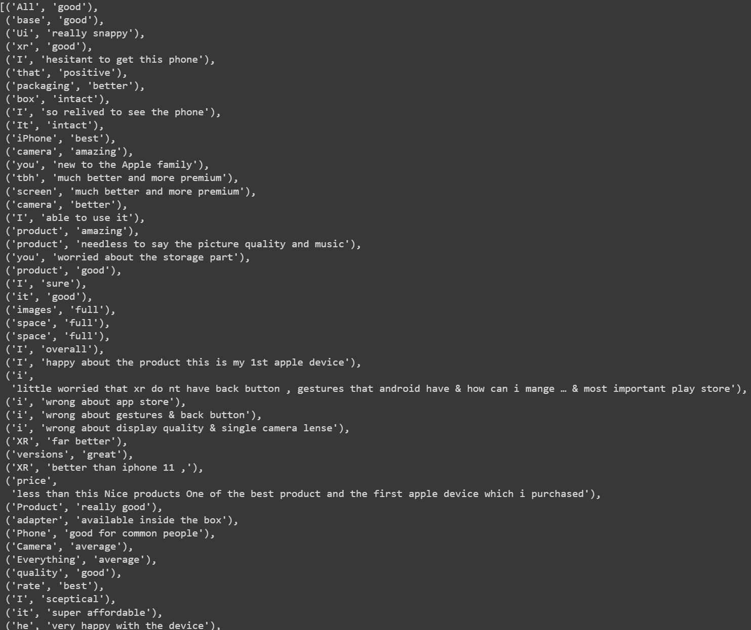

**Flipkart**

Average Flipkart Rating was found to be 4.57 from the ratings extracted

According to flipkart the most common words associated with iPhone are good, best, awesome, camera, product, performance, battery, product etc.

Also value money, battery backup, highly recommended, battery life, mind blowing, best market are some of the words associated with iPhone.

**Wordcloud**

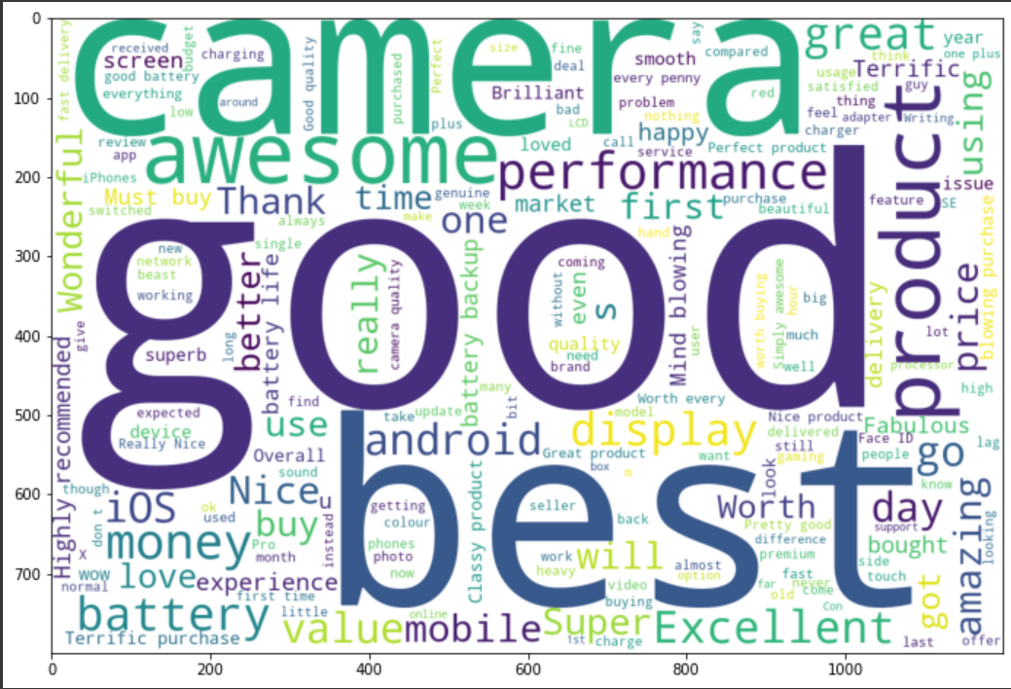

**Most Mentioned Words or Wordgroups**

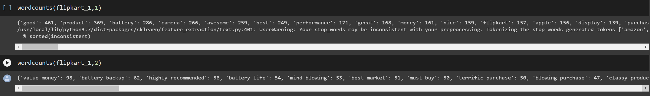

**Syntactic Analysis**

Here qualifiers were looked into.

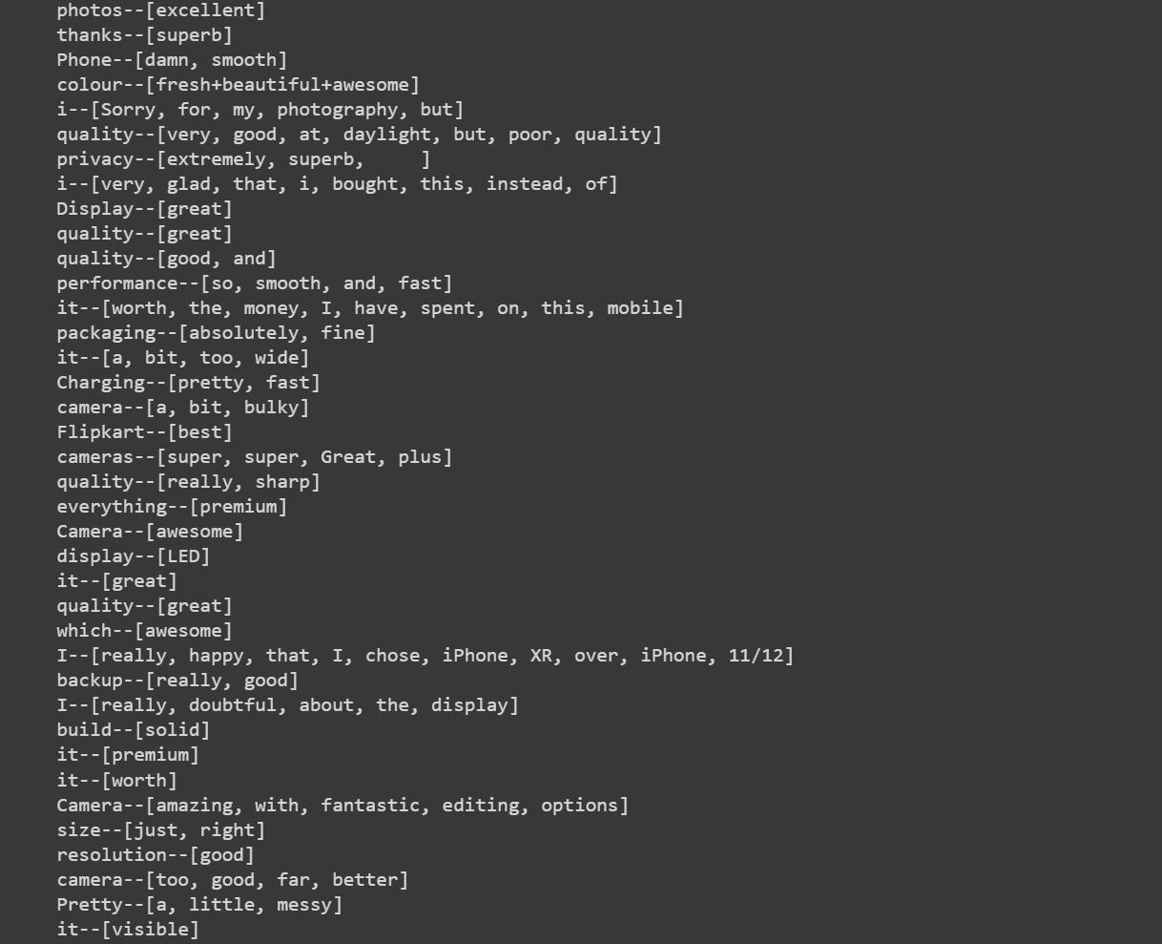

Also entity relations were found out

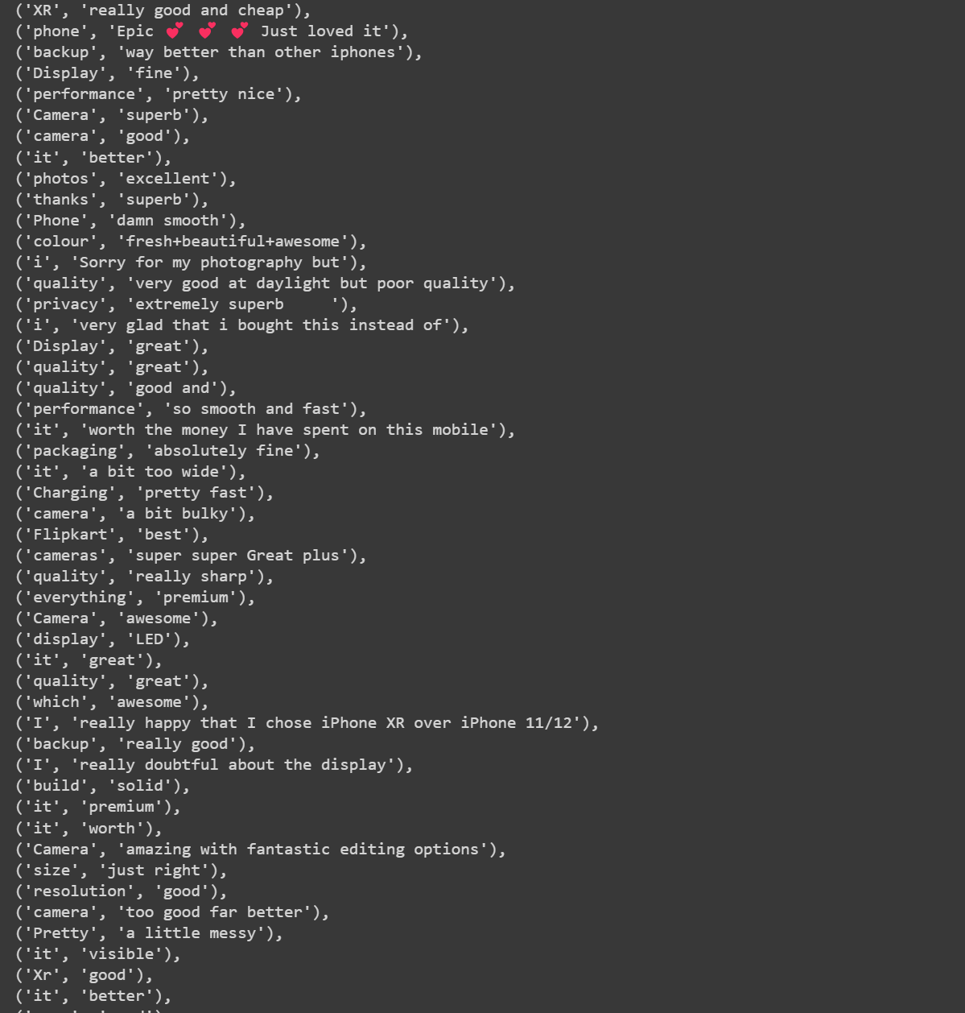

**Overall**

Based on comparative analysis done on both websites.Found complexity of using web crawling was much tougher on Flipkart than amazon because of website design. Also encountered issues like many popular phones not allowing physical of web crawler to see reviews beyond 30 pages though the phones have over 30 pages worth of reviews.

Also found that on Flipkart iPhone was rated higher that amazon iPhone by about 0.28.

After doing a thorough analysis of both the reports, not much difference was found in the reviews extracted from amazon and Flipkart with most qualifiers and entity relations pointing out that the iPhones had very good screen, amazing camera, good battery life and clean UI and worth the money paid for; which is exactly the qualities with which apple had marketed the product to be affordable yet holding up the Apple standards in hardware and software departments.

**Conclusion**

Good amount of information was found and now we have an idea about customer sentiments regarding iPhone on both Amazon and Flipkart and further related works may be done to delve deeper into understanding customer sentiments and compare the 2 website reviews.