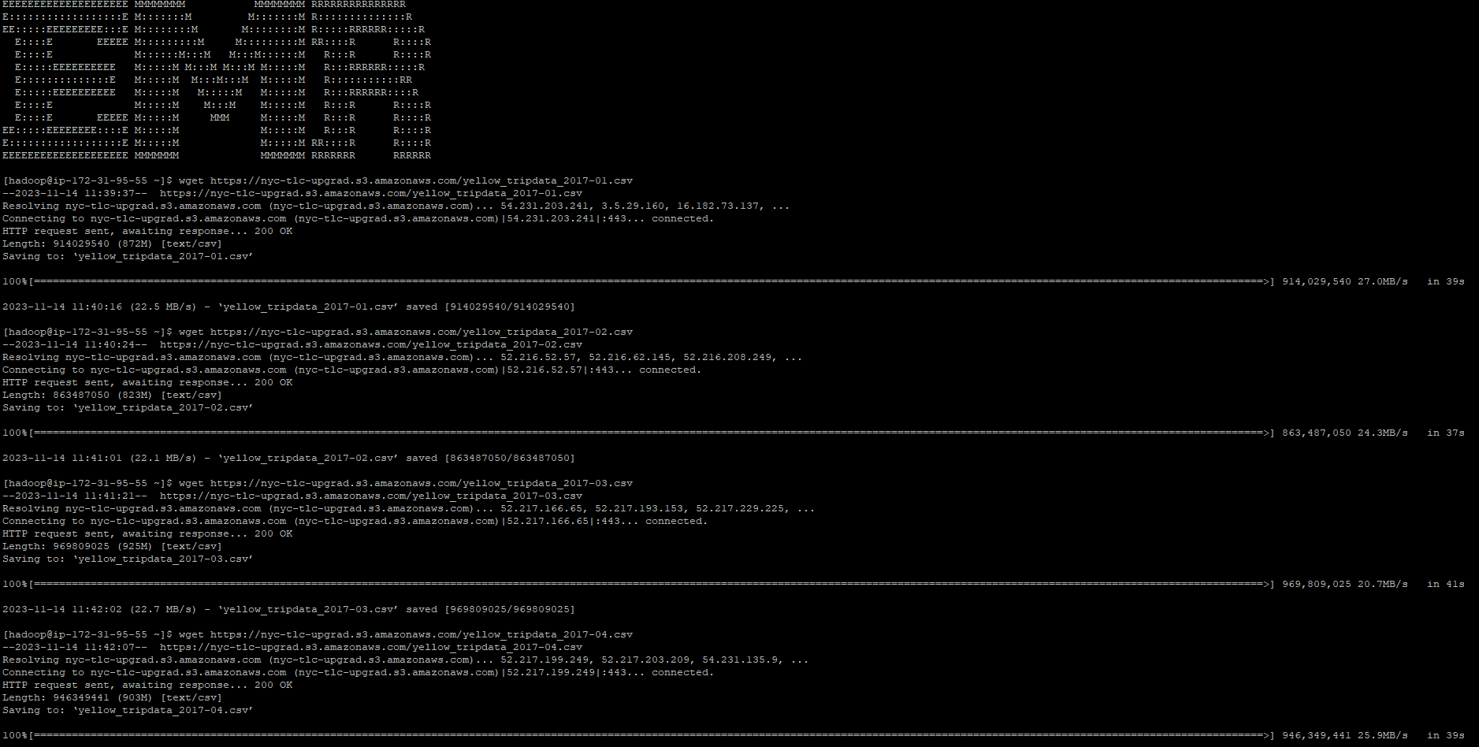

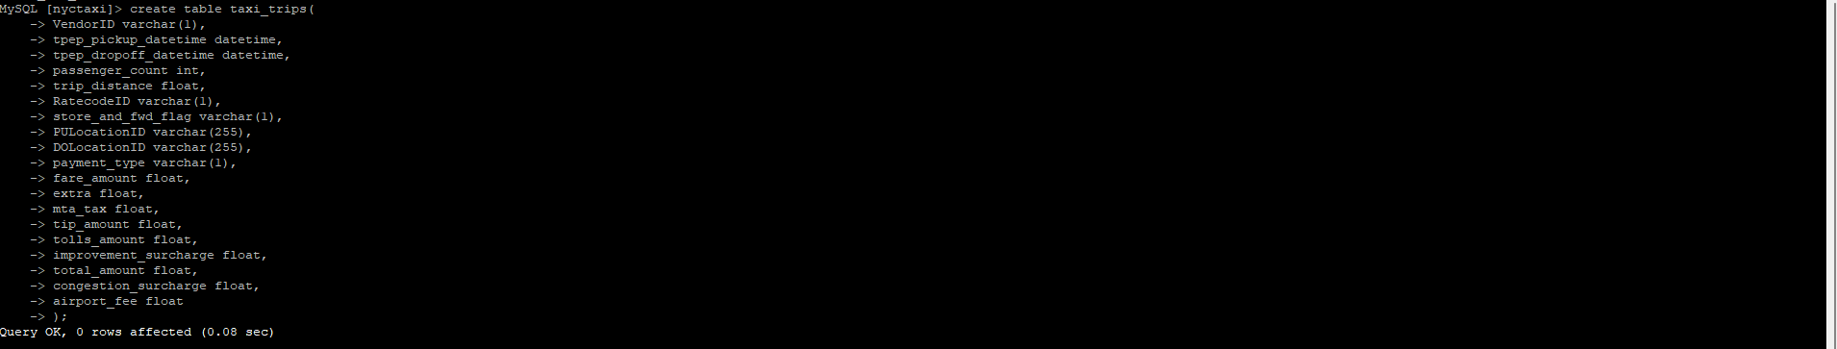

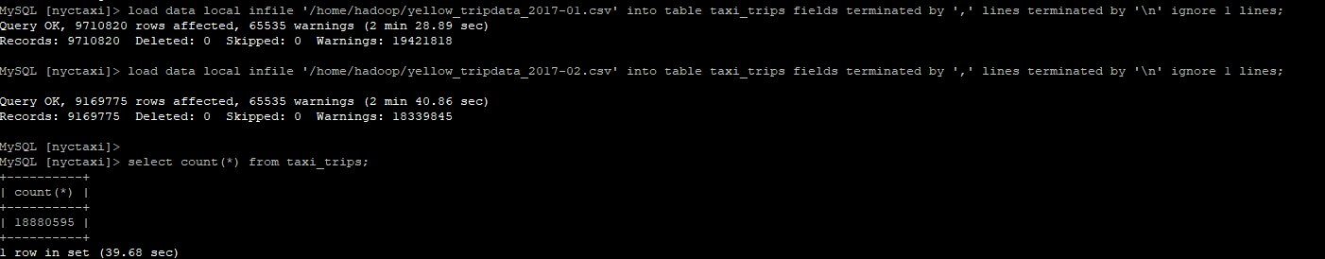

sqoop import --connect jdbc:mysql://database-1.czdhajbrjw1o.us-east-1.rds.amazonaws.com/nyctaxi --driver com.mysql.jdbc.Driver --username admin -P --table taxi_trips --hbase-table nyc_taxi_hbase --hbase-row-key VendorID,tpep_pickup_datetime,tpep_dropoff_datetime --column-family trip_data --split-by VendorID --m 1