Podcast Directory Database – Final Project Report

1. Introduction and Project Purpose
For my database project, I created a Podcast Directory database. The purpose of the database is to organize information about podcasts in a way that makes the information easy to store, connect, and retrieve. The system keeps track of podcasts, hosts, categories, episodes, listeners, and subscriptions.
I chose a Podcast Directory because it is a realistic example of a system that contains several related types of information. A podcast can belong to a category, have a host, and contain multiple episodes. Listeners can also subscribe to podcasts. This allowed me to practice designing tables, identifying primary and foreign keys, creating relationships, and using SQL queries to retrieve information from multiple tables.

2. Database Requirements and Design
I began the design process by deciding what information the Podcast Directory needed to store. I separated the information into six tables so that each table would have a clear purpose and unnecessary repetition could be reduced.
Table | Purpose
category | Stores podcast categories such as Entertainment, Sports, Technology, Business, and Education.
host | Stores information about podcast hosts, including name, email, and biography.
podcast | Stores the main podcast information and connects each podcast to a category and host.
episode | Stores individual episodes and connects each episode to its podcast.
listener | Stores listener information, including name, email, and date joined.
subscription | Connects listeners to the podcasts they subscribe to and stores the subscription date.

Each main table has a primary key that uniquely identifies its records. Foreign keys are used to connect related tables. For example, the podcast table contains category_id and host_id, while the episode table contains podcast_id. The subscription table uses listener_id and podcast_id to connect listeners and podcasts.

3. Relationships and ER Diagrams
The database contains several relationships. A category can be connected to multiple podcasts. A host can be connected to podcasts. A podcast can contain multiple episodes. The listener and podcast relationship is many-to-many because one listener can subscribe to multiple podcasts and one podcast can have multiple listeners. I resolved this relationship by using the subscription table as an associative table.
I represented the database relationships in two ways. I created a hand-drawn Chen-style ER diagram for the conceptual design and created a UML/EER diagram in MySQL Workbench for the database implementation.
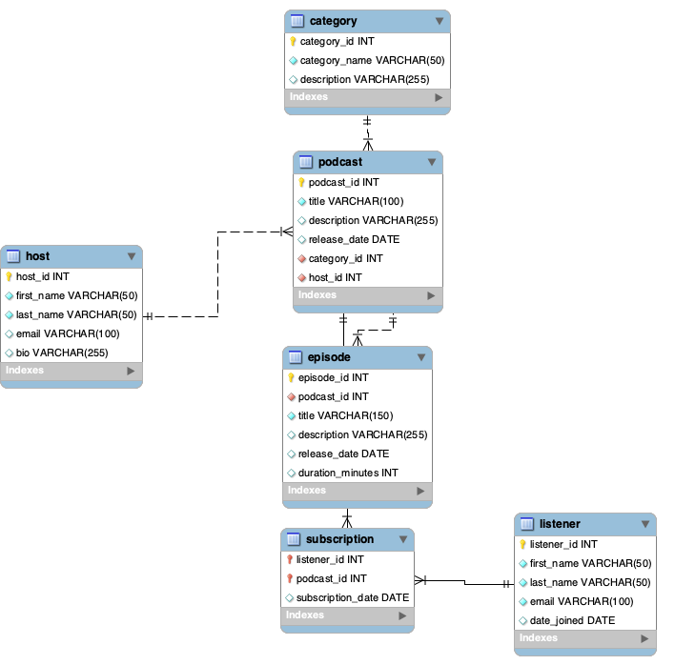
Figure 1. Podcast Directory UML/EER diagram created in MySQL Workbench.

4. Database Implementation and SQL
After completing the design, I created the database in MySQL Workbench. I used the model to define the tables and relationships and saved the completed Workbench model as a .mwb file. I also saved the SQL script used for the database.
I inserted sample data into the database and used SELECT statements to check the records. I then used JOIN queries to retrieve related information from multiple tables. For example, the following type of query connects a podcast with its category and host:
SELECT
podcast.title AS podcast_title,
category.category_name,
host.first_name,
host.last_name
FROM podcast
JOIN category
ON podcast.category_id = category.category_id
JOIN host
ON podcast.host_id = host.host_id;
Another important part of the project was testing the subscription relationship. By joining subscription, listener, and podcast, the database can show which listener subscribed to which podcast and the date of the subscription.

5. Challenges and What I Learned
One of the main challenges I faced was understanding how the tables should connect to each other. The subscription table was especially important because I needed a way to allow listeners to subscribe to multiple podcasts while also allowing each podcast to have multiple listeners. Working through the ER diagrams helped me understand how an associative table solves a many-to-many relationship.
I also learned more about primary keys, foreign keys, relationship cardinality, and how MySQL Workbench represents relationships visually. Testing the database with sample data and JOIN queries helped me see how the design of the tables affects the SQL queries that can be written.
Another part of the project was organizing the project files in a public GitHub repository. This gave me practice keeping the SQL script, MySQL Workbench model, ER diagrams, README documentation, and final report together in one organized location.

