BASTIONS OF RETROCOMPUTING
A strategy game for the Sharp PC-1500, PC-1500A and Tandy PC-2
Instructions – version 2.4
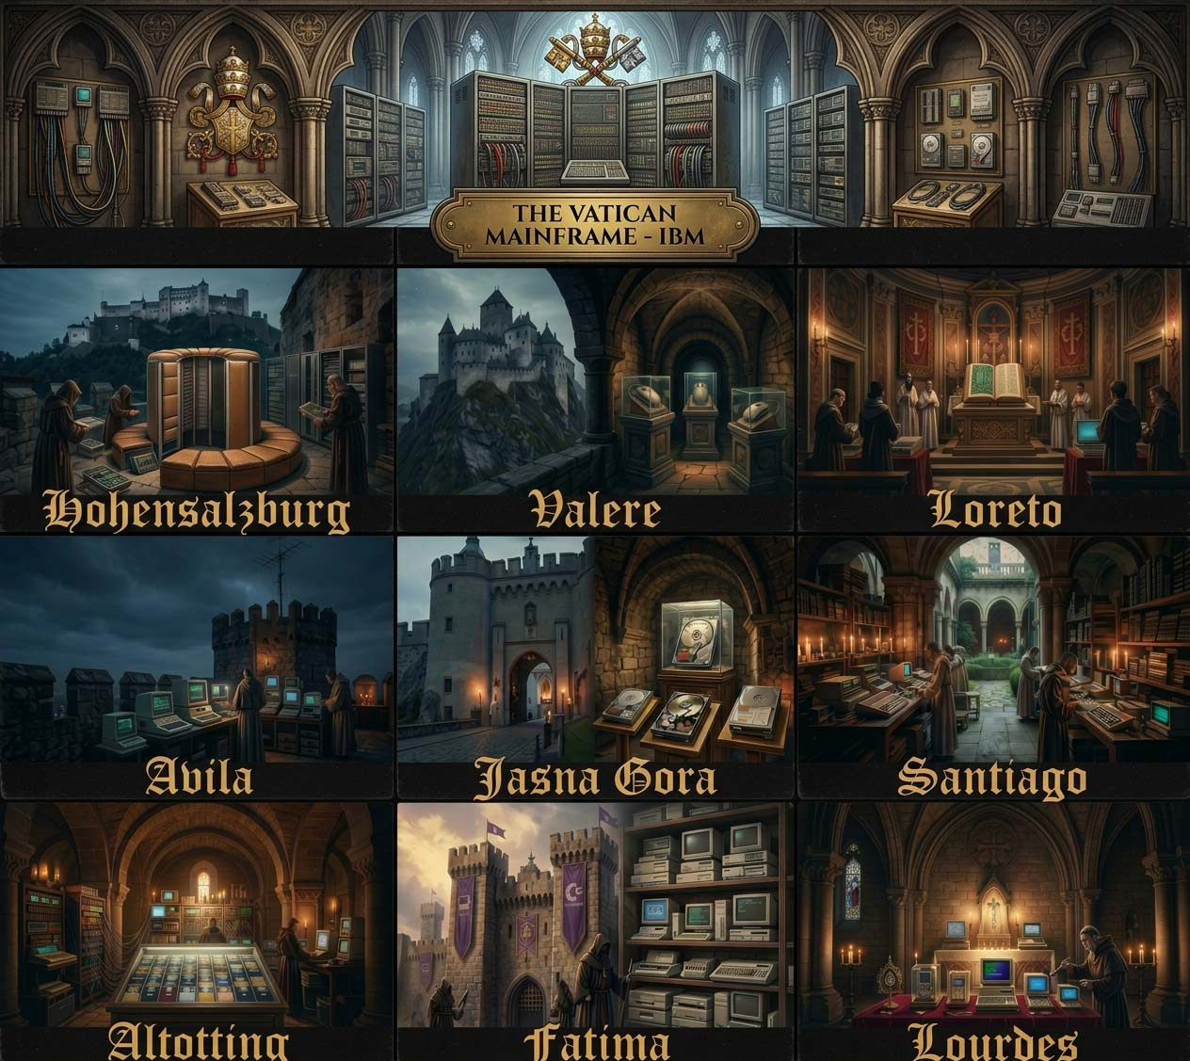

1. The game
The Cathodic Church (CC) – a fictional organisation with a profound interest in vintage computing – maintains ten places across Europe, called Bastions of Vintage IT, numbered 0 to 9: Lourdes (France), Fatima (Portugal), Altotting (Germany), Santiago de Compostela (Spain), Jasna Gora (Poland), Avila (Spain), Loreto (Italy), Valere (Switzerland), Hohensalzburg (Austria) and the Vatican. In these bastions of retro computing the CC keeps its vintage and NOS treasures: old hardware from IBM, HP, Apple, Commodore, Atari, Sharp, Casio, NEC and others. They are revered and heavily protected, and no outsider is let in. The security systems of every bastion are run by Tech Priests, who also guard its tokens and its retro stuff. You lead a team of Hackers, who attack with their own code and with the Daemons and Trojans they throw at the bastion. Tech Priests defect to you as new Hackers as you conquer bastions, and you can hire Gurus, the masters of Dependency Hell, and more Hackers and weapons. Conquer all ten places to win the war.
The first places are easy. Every next place is harder than the one before, and the last three, places 7, 8 and 9, are the richest places: they start with twice as many Tech Priests and more than twice as many tokens, but not with twice as much retro stuff, so what one of them gives you is not enough to conquer the next one. The richest of all is the Vatican (place 9). Every place also hides its own retro treasure, and every place is fearful of one kind of your forces: your Daemons, your Trojans, your Hackers or your Gurus. Once you hold Avila or a higher place, the Tech Priests strike back and your places may rise against you.

2. What you need
- A Sharp PC-1500A, or a PC-1500 or Tandy PC-2 with a RAM module (CE-151 or larger). The recording holds the program without its REM lines (5702 bytes); with its variables it needs about 5.9 KB of memory, so it does not fit into a PC-1500 or PC-2 without a module.
- To load the recording: the CE-150 printer/cassette interface (for the PC-2: the Radio Shack printer/cassette interface) and a computer, phone or player that can play WAV files.

3. Loading the game
- Switch off the computer, insert it into the CE-150 and connect the audio output of the computer or player to the EAR jack of the CE-150.
- Switch on, select PRO mode and type NEW0 [ENTER], then CLOAD [ENTER].
- Play bastions-v2.4.wav (name on the tape: BASTIONS, about 7 minutes). If the program does not load, try again with another volume.
- Select RUN mode and type RUN [ENTER].
You can also type in the listing bastions_of_retrocomputing-v2.4.txt. Leave out the REM lines: the recording does not contain them either, and with them the program would not leave enough memory for its variables on a PC-1500A. The place names and treasures in lines 970–986 contain small letters (SML key).

4. Start and main menu
After the title the game shows the main menu:
FIGHT/BUY/SELL/RESOUR/END?
Press one key, without ENTER:
Key | Action
F | Fight: attack a place (section 7)
B | Buy Hackers, Gurus, Daemons and Trojans (section 8)
S | Sell retro stuff, Daemons and Trojans (section 9)
R | Show your resources (section 10)
E | End the game (section 11)

Other keys are ignored. Numbers (the Hackers, Daemons and Trojans for a fight and what you buy or sell) are typed right after the question mark and confirmed with ENTER; any key other than a digit wipes the number, so you can type it again. A number that is too big gives a beep and the question again.

5. Your forces
At the start you have:
Resource | Start
Hackers | 12
Gurus | 2
Daemons | 20
Trojans | 6
Retro stuff | 0
Tokens | 270

Your people
- HACKERS (HACK on the display) are brilliant programmers who attack with their own code and methods: they write unholy code that finds every flaw in the Tech Priests’ systems and unleash malicious scripts, plagues of self-replicating worms and infinite loops. On top of that they throw the Daemons and Trojans you chose for the fight at the bastion. You decide how many of your Hackers take part in a fight; the others stay safe at home. Hackers stand in the front line: the Tech Priests strike them first. When a place is conquered, an eighth of its Tech Priests defect to you as new Hackers, and you can also hire them.
- GURUS fight in every fight, all of them, and stay with you until they are eliminated. They strike with a huge, carefully prepared Dependency Hell of links and corruption, which paralyses the Tech Priests’ systems and ends in crashes or a thermal infernal meltdown: a Guru who strikes eliminates 40 Tech Priests. Groups of Tech Priests hunt them, and a Guru who faces more than 10 Tech Priests at once may fall. Gurus are hired – but after a won fight some may also join you of their own accord (see You won).
Your people are Hackers + Gurus. When all of them are gone, the Cathodic Church (CC) wins.
Nobody gets hurt in this war. It is fought with code, not with swords. When a Hacker or a Guru is “eliminated”, the Tech Priests have defeated their solution, their code or their system: a patch closes the hole, a firewall swallows the worm, a Daemon is shut down. The defeated hero leaves the battlefield in one piece, for a long relaxation and a complete rewrite. Your people eliminate Tech Priests the same way: their systems crash, and they spend the rest of the war in the Cathodic Church’s retreat centre, waiting for the main spiritual help desk.

Weapons
- Daemon (DAEM on the display): a hostile system daemon – an endless loop, a merge conflict, a deadlock – that your Hackers unleash on the Tech Priests’ machines and that drives them into an infernal overheat. A Daemon that hits eliminates one Tech Priest.
- Trojan (TROJ on the display): a Trojan horse that your Hackers smuggle into the Tech Priests’ systems and that corrupts them from the inside. A Trojan that hits eliminates three Tech Priests.
Not every attack succeeds. You choose how many Hackers, Daemons and Trojans to take into each fight. The weapons are not used up one per Hacker: a sixth of the Daemons and of the Trojans you took is thrown in every round, as long as at least one of your Hackers is still fighting, so they last about six rounds. The weapons that were not thrown come back to you.

6. The places
At the start of the game the places hold:
Place | Name | Tech Priests | Retro stuff | Tokens
0 | Lourdes | 13 | 5 | 53
1 | Fatima | 22 | 9 | 40
2 | Altotting | 33 | 13 | 80
3 | Santiago de C. | 50 | 17 | 120
4 | Jasna Gora | 75 | 21 | 160
5 | Avila | 115 | 25 | 200
6 | Loreto | 182 | 29 | 240
7 | Valere | 588 | 33 | 651
8 | Hohensalzburg | 976 | 37 | 744
9 | Vatican | 1646 | 41 | 837
Places 7, 8 and 9 (shaded) are the richest places.
Fearful of. Every place is fearful of one kind of your forces, and the game tells you which: FEARFUL OF DAEMONS, FEARFUL OF TROJANS, FEARFUL OF HACKERS or FEARFUL OF GURUS. There, the hits of that kind count three times. The places fear them in a fixed order – Daemons, Trojans, Hackers, Gurus, Daemons … – but where the order starts is drawn anew in every game: once you know what one place fears, you know them all. A place fearful of Gurus is a special case: your Hackers and weapons are six times weaker there, and the Tech Priests strike the Hackers twice as hard – there you need Gurus. A place never has any of the kind it fears to give you: a place fearful of Daemons gives no Daemons, a place fearful of Trojans gives no Trojans. Plan your purchases for the next places.
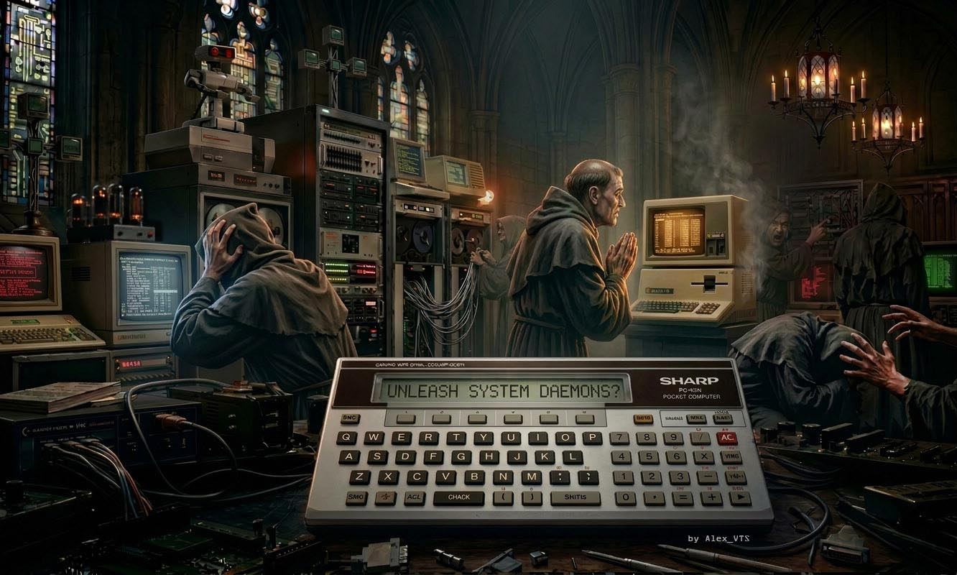

7. Fight
- Press F. The game asks WHICH PLACE 0-9 (L=LIST)?. Press the number of the place. L shows all places, e.g. 2 Altotting: 25 TP (Tech Priests still there) or 0 Lourdes: YOURS. Any other key returns to the main menu.
- The game shows the place, how many Tech Priests defend it, e.g. DEFENDED BY 50 PRIESTS, its retro stuff and tokens, and what it fears, e.g. FEARFUL OF DAEMONS. A place that you have conquered before and that broke free gives only half its tokens and half its retro stuff; the screen already shows the halved amounts. If the place is already yours, the game says so and asks for the place again.
- HACKERS (MAX 12) ?, DAEMONS (MAX 20) ? and TROJANS (MAX 6) ?: how many of your Hackers fight and how many Daemons and Trojans you take; the game shows how many you have. Type the number right after the question mark, as when buying, and press ENTER (ENTER alone: none). More than you have gives a beep and the question again. Your Gurus always fight. Without any Hackers and Gurus you cannot fight: NO FIGHTERS!.
- ENTER=FIGHT 3=RETREAT: press 3 to retreat (you get everything back) or ENTER to fight.

Rounds
The fight is played in rounds:
- Your side strikes first: the Hackers who fight attack with their own code (each Hacker one try), and a sixth of the Trojans and Daemons you took are thrown, as long as at least one Hacker still fights; then all your Gurus strike. The hits of the kind the place is fearful of count three times. The first strike is the weakest, because the Tech Priests are still behind their firewalls; from the second round on your attacks hit more often. However much you attack with, at most a sixth of the Tech Priests the place had at the start of the fight fall in one round: the others take cover, and what was used on them is lost. So the Tech Priests are eliminated step by step, in about five rounds.
- Then the Tech Priests who are still active strike back: the more of them, the more of your fighting Hackers they eliminate, and when no Hackers are left, the weapons are not thrown any more (NO HACKERS LEFT!). They also hunt your Gurus, in groups, and a Guru who faces more than 10 Tech Priests at once may fall.
- Every round screen shows e.g. ROUND2:CC 120 vs YOU 60: the Tech Priests still active and your fighters (Hackers and Gurus). Short messages tell you which of your forces struck – HACKERS launch worms!, Attack of Trojans!, Unleashing Daemons!, GURUS set Dependency Hell.
How your forces are used. Every round all your fighting Hackers attack and a sixth of the weapons you took is thrown, so a fight with weapons for six rounds needs your Hackers to stay alive for six rounds: take enough of them. Take Daemons and Trojans in proportion to the size of the bastion, more of the kind it fears; at a place fearful of Gurus bring your Gurus. The fight goes on until no Tech Priests or none of your fighters are left; once it has begun, only surrendering stops it (see Surrender below). Weapons that were not thrown and Hackers who survived come back to you when you win or surrender.

You won
The game shows e.g. YOU WON! (Lourdes), then what you got:
YOU GOT g TOKENS
r RETRO, d DAEM, t TROJ
  - You got all the tokens and all the retro stuff of the place (only half of them when you win back a place that broke free), and some Daemons and Trojans (more at the higher places) – but not the kind the place is fearful of.
LOST:mH jU
  - Your losses in this fight, e.g. LOST:7H 1U (H Hackers, U Gurus).
+y HACKERS JOIN YOU and, sometimes, +n GURUS JOIN YOU!
  - An eighth of the Tech Priests of the place defect to you as Hackers. With probability one half some Gurus join you too: the higher the place, the more of them (INT(place number ÷ 3) + 1).
AND ALSO YOU GOT:
  - Last, the retro treasure of the place, e.g. Casio FX-602P at Lourdes. Every place has its own treasure; it is a trophy and does not change your resources. You get it only the first time you conquer the place: when you win back a place that broke free, this screen is left out.

Surrender
From the second round on, while you have fewer fighters than the Tech Priests still active, S appears at the right end of the round screen, e.g. ROUND3:CC 120 vs YOU 45 S. Press S while that screen is on the display (hold the key until the screen changes) and you surrender: the game shows YOU SURRENDERED! and your losses in this fight, then the main menu comes back.
You keep the Hackers and Gurus you still have and the Daemons and Trojans that were not thrown; you get no tokens, no retro stuff and no new people. The place stays with the CC, but only with the Tech Priests still active: the ones you have eliminated do not come back, so your next attack on that place is easier. When you have as many fighters as the Tech Priests or more, there is no S: fight on!

You lost or are defeated
If all your fighting Hackers and Gurus fall, you are defeated: YOU WERE DEFEATED! and your losses are shown. The place keeps the Tech Priests it has left, and you keep the Hackers who stayed at home and the weapons that were not thrown. Only when you have no Hacker at home either, the game is over: NO ONE LEFT!, YOU LOST! and GAME OVER! Priests won!. Then the game shows the treasure of the last place you conquered, or lesson in humility.. if you have not conquered any.

A place breaks free
Once you have conquered Avila (place 5) or a higher place, the Tech Priests start to fight back. From time to time, on the way back to the main menu, one of your places breaks free, e.g. Loreto broke free!; it is never the place of your last fight. It gets back the Tech Priests it had at the start of the game. Winning it back gives half its tokens and half its retro stuff, but no treasure – a chance to collect a little more for the Vatican. To win the war, all ten places must be yours at the same time.

8. Buy
Press B. The game shows H)ACK G)URU D)AEM T)ROJ:
Key | Item | Price (tokens)
H | Hacker | 104
G | Guru | 520
D | Daemon | 10
T | Trojan | 30

The game shows the price and how many you can afford, e.g. PRICE 10 (MAX 27) ?. Type the number on the same line, right after the question mark, e.g. PRICE 10 (MAX 27) ? 12, and press ENTER (ENTER alone buys nothing). Any key other than a digit wipes the number, so you can type it again; more than you can afford gives a beep and the question again. If you cannot afford even one, the game beeps, shows NOT ENOUGH TOKENS for a second and the buy menu comes back at once. After a purchase the buy menu comes back too: buy something else or press any other key to return to the main menu.

9. Sell
Press S. The game first shows what you have to sell, e.g. RET 9 DAEM 12 TROJ 2 (retro stuff, Daemons, Trojans) and waits until you press any key. Then it asks SELL R)ETRO D)AEM T)ROJ?:
Key | Item | Price (tokens)
R | Retro stuff | 60 at the start
D | Daemon | 5
T | Trojan | 15

Press R, D or T; any other key returns to the main menu. The game shows the price of one piece and how many you have, e.g. PRICE 15 (MAX 2) ?. Type the number right after the question mark, as when buying, and press ENTER (ENTER alone sells nothing). Then it shows TOKENS NOW n and the sell menu comes back. Hackers and Gurus cannot be sold.
The price of retro stuff is 60 tokens at the start of the game. After every fight it rises by 0, 10 or 20 tokens (at random); every sale of retro stuff lowers it by 0 to 40 tokens, but never below 30. Over a game the price slowly rises for a player who sells now and then; whoever sells after every fight pushes it down. Daemons and Trojans sell for half of what they cost. If you have none of the chosen item, the game shows NOTHING TO SELL.

10. Resources
Press R. The game shows YOU HAVE: DAEMONS n, then TROJANS n, HACK n GURU n and last TOKENS n RETRO n, one screen at a time. Press any key to see the next screen; after the last one the main menu comes back.

11. End
Press E: the game shows Y=END. Press Y to end the game at once, without a message; any other key brings the main menu back.

12. Winning and losing
You win the war when all ten places are yours: ALL BASTIONS ARE YOURS! and YOU BEAT THE TECH PRIESTS!. You lose when none of your people are left: GAME OVER! Priests won!.

13. Tips
- Every element counts. Hackers carry the fight: they attack on their own and throw the weapons, and without them the Daemons and Trojans lie idle. Daemons are cheap, Trojans hit three times as hard, Gurus need nobody and fight again in every fight, and at places fearful of Gurus nothing else works. A player who leaves out Hackers, Gurus, Daemons or Trojans wins clearly less often.
- Your income is the tokens and the retro stuff of the conquered places, and the weapons they leave behind. Retro stuff gains value with every fight and loses some with every sale: keep it while you can, and when you sell, sell a lot at once.
- Save tokens and retro stuff from the first places for the rich places 7, 8 and 9: each of them is a big step up, and what one of them gives you is not enough for the next one. If you spend all your tokens on the same things every time, you will not get through Valere, Hohensalzburg and the Vatican.
- Gurus are expensive and mighty, and they fight again in every following fight. Without them you will hardly take the places fearful of Gurus. But they are no miracle workers – do not let them be outnumbered: when more than 10 Tech Priests per Guru are left, they fall fast.
- Look at what the place fears before you buy: take plenty of that kind – three times as strong – and fewer of the other weapons. A place fearful of Daemons or Trojans gives none of them back, so stock up on them elsewhere.
- Take as many Hackers as the weapons need: they must stay alive while the weapons are thrown, which takes about six rounds. In big places the Tech Priests eliminate your Hackers fast, so take a good part of them – but keep some at home, for they are the ones who survive a lost battle.
- A place that breaks free is not lost for good: win it back for half its tokens and retro stuff, a welcome extra before the Vatican.
- Hackers stand in the front line: they take the first blows of the Tech Priests, so a fight with few Hackers is over quickly.
- Hackers and Gurus cannot be sold. The Hackers you win by conquering places are your reserve of fighters; check your forces with R and the places with L before you attack.
- Changed your mind before the fight? Press 3 to retreat: you lose nothing.
- When a fight goes badly, press S in time (from the second round, while you have fewer fighters than the Tech Priests): you keep your fighters and your weapons that were not thrown, and the Tech Priests you have eliminated are gone for good. Then buy what you need and attack the same place again.

