BASTIONS OF RETROCOMPUTING
A strategy game for the Sharp PC-1600 (MODE 0, 4-line display)
Instructions – version 2.6 (PC-1600)
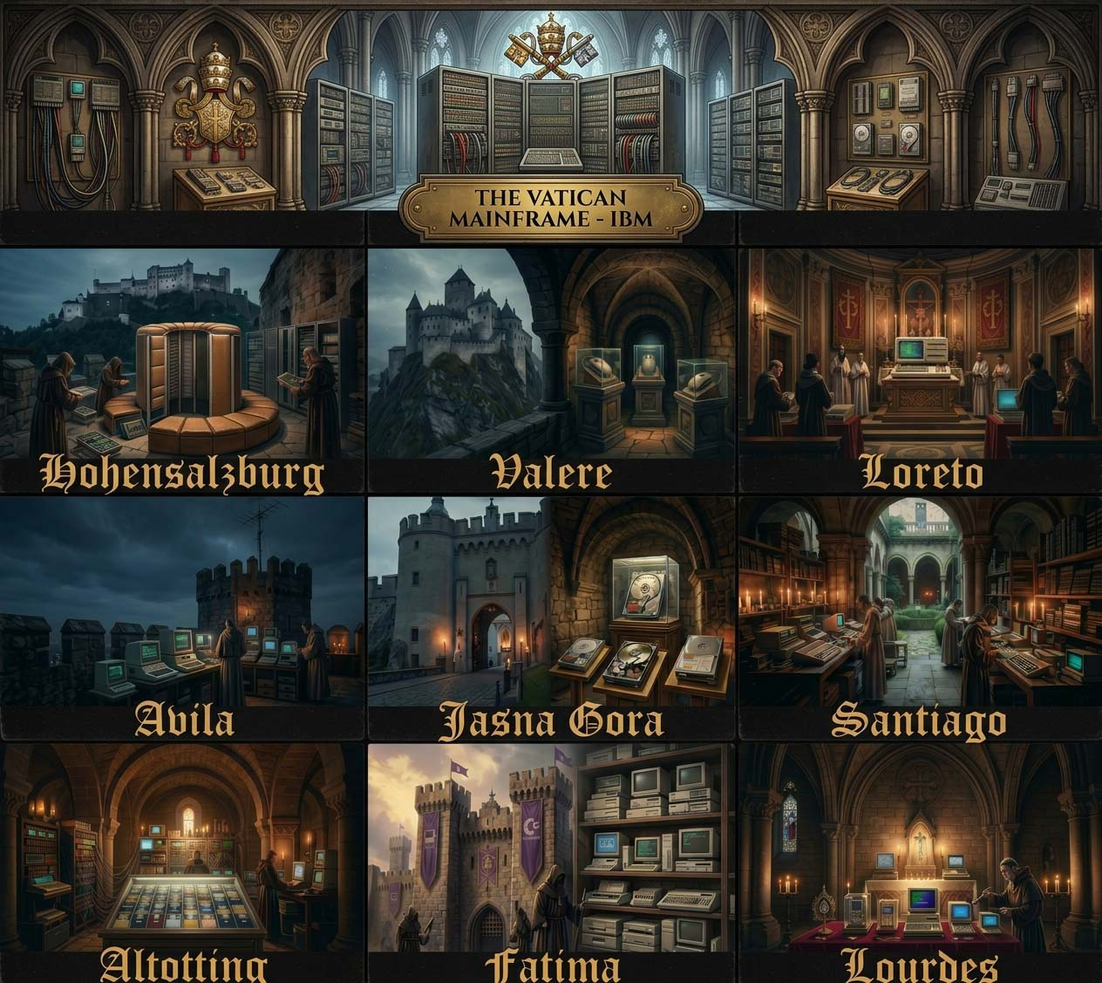

1. The game

The Cathodic Church (CC) – a fictional organisation with a profound interest in vintage computing – maintains ten places across Europe, called Bastions of Vintage IT, numbered 0 to 9: Lourdes (France), Fatima (Portugal), Altotting (Germany), Santiago de Compostela (Spain), Jasna Gora (Poland), Avila (Spain), Loreto (Italy), Valere (Switzerland), Hohensalzburg (Austria) and the Vatican. In these bastions of retro computing the CC keeps its vintage and NOS treasures: old hardware from IBM, HP, Apple, Commodore, Atari, Sharp, Casio, NEC and others. They are revered and heavily protected, and no outsider is let in. The security systems of every bastion are run by Tech Priests, who also guard its tokens and its retro stuff. You lead a team of Hackers, who attack with their own code and with the Daemons and Trojans they throw at the bastion. Tech Priests defect to you as new Hackers as you conquer bastions, and you can hire Gurus, the masters of Dependency Hell, and more Hackers and weapons. Conquer all ten places to win the war.
The first places are easy. Every next place is harder than the one before, and the last three, places 7, 8 and 9, are the richest places: they start with twice as many Tech Priests and more than twice as many tokens, but not with twice as much retro stuff, so what one of them gives you is not enough to conquer the next one. The richest of all is the Vatican (place 9). Every place also hides its own retro treasure, and every place is fearful of one kind of your forces: your Daemons, your Trojans, your Hackers or your Gurus. Once you have collected the tax (key T) for the first time, the Tech Priests strike back and your places may rise against you. Without the tax money the rich places 7, 8 and 9 are practically out of reach.

2. What you need
- A Sharp PC-1600 in its default mode, MODE 0 (4 lines of 26 characters). The program is about 17 KB of BASIC text.
- To load the recording: the CE-1600P interface (cassette connection) and a computer, phone or player that can play WAV files.

3. Loading the game
- Put the PC-1600 in the CE-1600P and connect the audio output of the computer or player to its EAR jack.
- Switch on the PC-1600 in the default MODE 0 and type LOAD "CAS:" [ENTER] (or LOAD "CAS:BASTIONS").
- Play bastions-v2.6-pc1600.wav (name on the tape: BASTIONS, about 10 minutes). If the program does not load, try again with another volume.
- Type RUN [ENTER] (still in MODE 0).
You can also type in the listing bastions_of_retrocomputing-v2.6-pc1600.txt. The place names and treasures in the DATA lines contain small letters.
Through the serial port (RS-232C): connect the PC-1600 to a computer with a serial cable and open a terminal program on the computer. Set the port of the PC-1600 with SETCOM (e.g. 9600 baud, 8 bits, no parity, 1 stop bit, X-ON/OFF; see SETCOM in the PC-1600 manual) and the same settings in the terminal. In MODE 0 type LOAD "COM1:" [ENTER] and send the listing bastions_of_retrocomputing-v2.6-pc1600.txt from the terminal as a plain text file (CR line ends, X-ON/OFF flow control, a short pause after every line if the terminal can do it). When the transfer is finished, type RUN.

4. Start and main menu
After the title the game shows the main menu:
FIGHT/BUY/SELL/TAX/RS/END?
Press one key, without ENTER:
Key | Action
F | Fight: attack a place (section 7)
B | Buy Hackers, Gurus, Daemons and Trojans (section 8)
S | Sell retro stuff, Daemons and Trojans (section 9)
T | Tax: collect the tax money (section 7)
R | Show your resources, RS on the menu (section 10)
E | End the game (section 11)

Other keys are ignored. Numbers (the Hackers, Daemons and Trojans for a fight and what you buy or sell) are typed right after the question mark and confirmed with ENTER; any key other than a digit wipes the number, so you can type it again. A number that is too big gives a beep and the question again.

The display
Line 1: your tokens (Tnnn) on the left, your retro stuff (Rnnn) on the right and in the middle the mode: MAIN MENU, FIGHT, BUY, SELL, RESOURCES or TAX. From FIGHTING! until the fight is decided the middle shows the place and the Tech Priests still active, e.g. Fatima - 12P. The title screen shows no resources.
Lines 2 and 3: the game – messages and questions. The important messages (FIGHTING!, the attacks, YOU WON!, …) are centred.
Line 4: your Hackers, Gurus, Daemons and Trojans in fixed fields: Hnn Gnn Dnn Tnn. A field that grows (a purchase, loot, new fighters) blinks for a moment. In a fight, from FIGHTING! on, line 4 shows only the forces you took into it, in brackets and small letters, (hnn gnn dnn tnn), and counts them down after every attack. The list of places (L) uses line 4 too.

5. Your forces
At the start you have:
Resource | Start
Hackers | 12
Gurus | 2
Daemons | 20
Trojans | 6
Retro stuff | 0
Tokens | 476

Your people
Your people are Hackers + Gurus. When all of them are gone, the Cathodic Church (CC) wins.
- HACKERS (H in line 4) are brilliant programmers who attack with their own code and methods: they write unholy code that finds every flaw in the Tech Priests’ systems and unleash malicious scripts, plagues of self-replicating worms and infinite loops. On top of that they throw the Daemons and Trojans you chose for the fight at the bastion. You decide how many of your Hackers take part in a fight; the others stay safe at home. Hackers stand in the front line: the Tech Priests strike them first. When a place is conquered, a sixteenth of its Tech Priests defect to you as new Hackers – not many, so look after your Hackers and hire more.
- GURUS fight in every fight, all of them, and stay with you until they are eliminated. They create a Dependency Hell that tangles the Tech Priests’ systems in conflicting library versions, circular and unresolvable dependencies, broken links and corrupted files and data, so that nothing can be built, updated or started any more – and it all ends in cascading failures, and a filnal meltdowdown. A Guru who strikes eliminates as much as 40 Tech Priests! Groups of Tech Priests hunt them, and a Guru who faces more than 10 Tech Priests at once may fall. Gurus are hired – but after a won fight some may also join you of their own accord (see You won).
Nobody gets hurt in this war. It is fought with code, not with swords. When a Hacker or a Guru is “eliminated”, the Tech Priests have defeated their solution, their code or their system: a patch closes the hole, a firewall swallows the worm, a Daemon is shut down. The defeated hero leaves the battlefield in one piece, for a long relaxation and a complete rewrite. Your people eliminate Tech Priests the same way: their systems crash, and they spend the rest of the war in the Cathodic Church’s retreat centre, waiting for the main spiritual help desk.

Weapons
- Daemon (D in line 4): a hostile system daemon – an unholy vicious code that enables an endless loop, a merge conflict, a deadlock – that your Hackers unleash on the Tech Priests’ machines and that drives them into an infernal overheat. A Daemon that hits eliminates one Tech Priest.
- Trojan (T in line 4): a Trojan horse that your Hackers smuggle into the Tech Priests’ systems and that corrupts them from the inside. A Trojan that hits eliminates three Tech Priests.
Not every attack succeeds. You choose how many Hackers, Daemons and Trojans to take into each fight. The weapons are not used up one per Hacker: a sixth of the Daemons and of the Trojans you took is thrown in every round, as long as at least one of your Hackers is still fighting, so they last about six rounds. The weapons that were not thrown come back to you.

6. The places
At the start of the game the places hold:
Place | Name | Tech Priests | Retro stuff | Tokens
0 | Lourdes | 13 | 5 | 57
1 | Fatima | 22 | 9 | 43
2 | Altotting | 33 | 13 | 86
3 | Santiago | 50 | 17 | 129
4 | Jasna Gora | 75 | 21 | 172
5 | Avila | 115 | 25 | 215
6 | Loreto | 182 | 29 | 258
7 | Valere | 588 | 33 | 700
8 | Hohensalzburg | 976 | 37 | 800
9 | Vatican | 1646 | 41 | 900
Places 7, 8 and 9 (shaded) are the richest places.
Fearful of. Every place is fearful of one kind of your forces, and the game tells you which: FEARFUL OF DAEMONS, FEARFUL OF TROJANS, FEARFUL OF HACKERS or FEARFUL OF GURUS. There, the hits of that kind count three times – but all your other kinds are weaker there: where the place fears Daemons, the others are six times weaker; where it fears Trojans, two times; where it fears Hackers, three times; where it fears Gurus, six times (and the Tech Priests strike the Hackers twice as hard). So plan for what the place fears. The places fear them in a fixed order – Daemons, Trojans, Hackers, Gurus, Daemons … – but where the order starts is drawn anew in every game: once you know what one place fears, you know them all. A place never has any of the kind it fears to give you: a place fearful of Daemons gives no Daemons, a place fearful of Trojans gives no Trojans. At least one Tech Priest falls in every round.
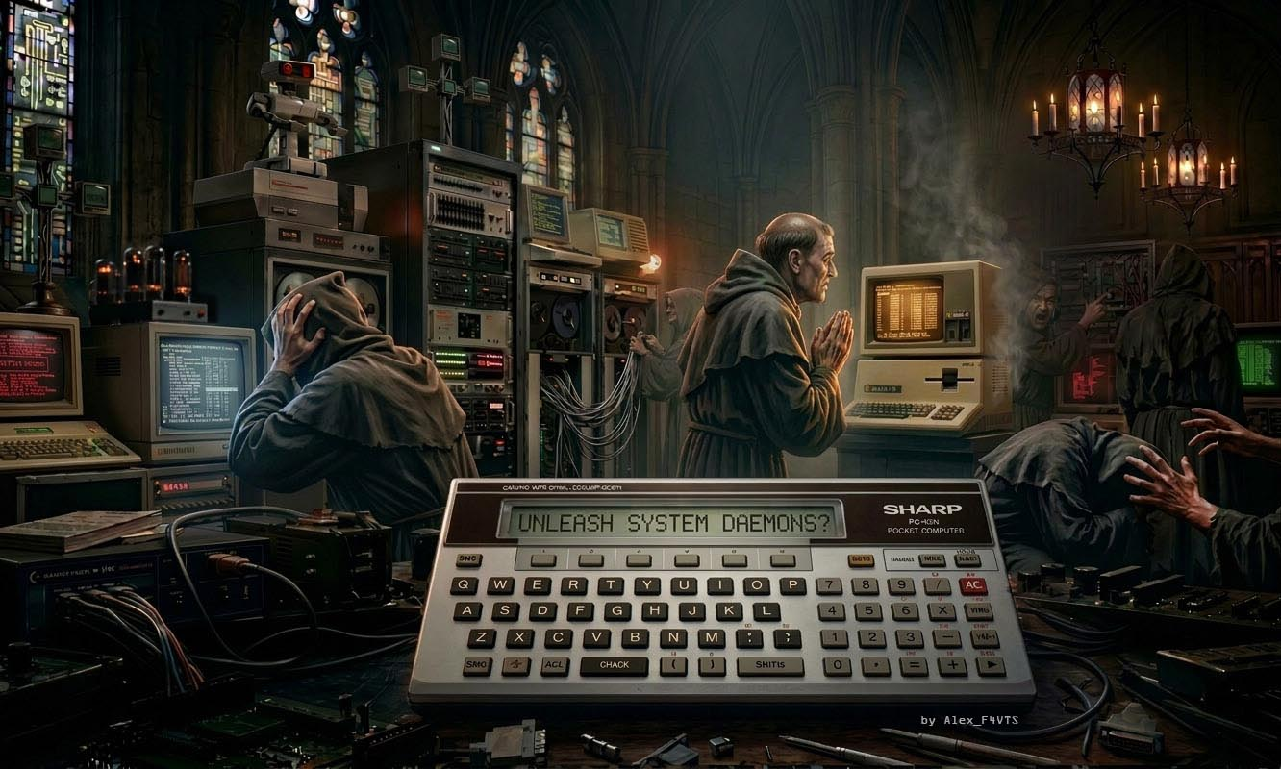

7. Fight
- Press F. The game asks WHICH PLACE 0-9 (L=LIST)?. Press the number of the place. L shows all places, three on a screen, e.g. 2 Altotting: 25 TP (Tech Priests still there) or 0 Lourdes: YOURS. Any other key returns to the main menu.
- The game shows the place, how many Tech Priests defend it, e.g. DEFENDED BY 50 PRIESTS, its retro stuff and tokens, and what it fears, e.g. FEARFUL OF DAEMONS. A place that you have conquered before and that broke free gives only half its tokens and half its retro stuff; the screen already shows the halved amounts. If the place is already yours, the game says so and asks for the place again.
- HACKERS ?, DAEMONS ? and TROJANS ?: how many of your Hackers fight and how many Daemons and Trojans you take; what you have is in line 4. Type the number right after the question mark, as when buying, and press ENTER (ENTER alone: none). More than you have gives a beep and the question again. Your Gurus always fight. Without any Hackers and Gurus you cannot fight: the game beeps and the menu comes back.
- ENTER=FIGHT 3=RETREAT: press 3 to retreat (you get everything back) or ENTER to fight.

Rounds
The fight is played in rounds:
- Your side strikes first: the Hackers who fight attack with their own code (each Hacker one try), and a sixth of the Trojans and Daemons you took are thrown, as long as at least one Hacker still fights; then all your Gurus strike. The hits of the kind the place is fearful of count three times, and the other kinds are weakened (see Fearful of). The first strike is the weakest, because the Tech Priests are still behind their firewalls; from the second round on your attacks hit more often. However much you attack with, at most a sixth of the Tech Priests the place had at the start of the fight fall in one round, and at least one: the others take cover, and what was used on them is lost. So the Tech Priests are eliminated step by step, in about five rounds. The fight ends at once when an attack brings the Tech Priests to 0: the remaining weapons are not used.
- Then the Tech Priests who are still active strike back: the more of them, the more of your fighting Hackers they eliminate, and when no Hackers are left, the weapons are not thrown any more (NO HACKERS LEFT!). They also hunt your Gurus, in groups, and a Guru who faces more than 10 Tech Priests at once may fall.
- Every round screen shows e.g. ROUND 2: CC 120 PRIESTS and YOU: 60 FIGHTERS: the Tech Priests still active and your fighters (Hackers and Gurus). Short messages tell you which of your forces struck – HACKERS launch worms!, Attacking with Trojans!, Unleashing Daemons!, GURUS breed a Dependency Hell !. The weapons thrown are taken off line 4 after the message. When you can surrender or reinforce, line 3 says so, e.g. YOU: 60 R=REINFORCE, YOU: 45 S=SURRENDER or YOU: 45 R=REINF S=SURR.
How your forces are used. Every round all your fighting Hackers attack and a sixth of the weapons you took is thrown, so a fight with weapons for six rounds needs your Hackers to stay alive for six rounds: take enough of them. Take Daemons and Trojans in proportion to the size of the bastion, more of the kind it fears; at a place fearful of Gurus bring your Gurus. The fight goes on until no Tech Priests or none of your fighters are left; once it has begun, only surrendering stops it (see Surrender below). Weapons that were not thrown and Hackers who survived come back to you when you win or surrender.

You won
The game shows e.g. YOU WON! (Lourdes), then what you got:
GOT g TOKENS
r RETRO, d DAEM, t TROJ
  - You got all the tokens and all the retro stuff of the place (only half of them when you win back a place that broke free), and some Daemons and Trojans (more at the higher places) – but not the kind the place is fearful of.
LOST: nnn HACKERS mm GURUS
  - Your losses in this fight, e.g. LOST: 7 HACKERS 1 GURUS.
+y HACKERS JOIN YOU and, sometimes, +n GURUS JOIN YOU!
  - A sixteenth of the Tech Priests of the place defect to you as Hackers. With probability one half some Gurus join you too: the higher the place, the more of them (INT(place number ÷ 3) + 1).
AND ALSO YOU GOT:
  - Last, the retro treasure of the place, e.g. Casio FX-602P at Lourdes. Every place has its own treasure; it is a trophy and does not change your resources. You get it only the first time you conquer the place: when you win back a place that broke free, this screen is left out.

Surrender
From the second round on, while you have fewer fighters than the Tech Priests still active, S=SURRENDER appears in line 3 of the round screen, e.g. YOU: 45 S=SURRENDER. Press S while that screen is on the display (hold the key until the screen changes) and you surrender: the game shows YOU SURRENDERED! and your losses in this fight, then the main menu comes back.
You keep the Hackers and Gurus you still have and the Daemons and Trojans that were not thrown; you get no tokens, no retro stuff and no new people. The place stays with the CC, but only with the Tech Priests still active: the ones you have eliminated do not come back, so your next attack on that place is easier. When you have as many fighters as the Tech Priests or more, there is no S: fight on!

Reinforcements (key R)
When you have fewer fighters than the Tech Priests still active and still have Hackers, Daemons or Trojans at home (not thrown into the fight), R=REINFORCE appears in line 3 of the round screen (R=REINF when S=SURR is shown too). Press R while that screen is on the display (hold the key until the screen changes). It works from the first round on; without anything at home there is no R.
The game moves Hackers from home to the fight, as many as there are Tech Priests (or all you have), and with them 2 Daemons per Hacker and 1 Trojan per 2 Hackers (or what is available). The Daemons and Trojans moved are thrown from then on like the ones you took at the start, a sixth of them per round. The screen REINFORCEMENTS! shows e.g. +12 H +24 D +6 T and line 4 counts the new forces. If you have no Hackers at home, the weapons are moved according to the number of your fighters. If you press S and R together, S wins.

You lose
The fight goes on to the last of your fighters, unless you surrender. If all your fighting Hackers and Gurus fall, the game is over, even if some Hackers stayed at home: with no one left to lead the fight, the commander is finished too. You see NO ONE LEFT!, YOU LOST! and GAME OVER! Priests won!. Then the game shows the treasure of the last place you conquered, or lesson in humility.. if you have not conquered any. The only way to leave a lost fight alive is to surrender (S).

Tax (key T)
The Tech Priests pay a tax on the places you have conquered – only on those, not on all places. The tax money waits for you until you press T in the main menu: the game then pays out everything collected so far and shows e.g. GOT 345 TOKENS for about two and a half seconds. You can press T as often as you like; every time you get what has been collected since the last time, and nothing if you have conquered no new places meanwhile. The tax is the main source of the tokens you need for places 7, 8 and 9. The first time you press T has a price: from then on the Tech Priests strike back (see the next section).

A place breaks free
Once you have collected the tax for the first time, the Tech Priests start to fight back. From time to time, on the way back to the main menu, one of your places breaks free, e.g. Loreto broke free!; it is never the place of your last fight. It gets back the Tech Priests it had at the start of the game. Winning it back gives half its tokens and half its retro stuff, but no treasure – a chance to collect a little more for the Vatican. To win the war, all ten places must be yours at the same time. Until the first tax, no place ever breaks free.

8. Buy
Press B. The game shows H)ACK G)URU D)AEM T)ROJ:
Key | Item | Price (tokens)
H | Hacker | 104
G | Guru | 520
D | Daemon | 10
T | Trojan | 30

The game shows the price of one piece, e.g. Price 10, HOW MUCH?. Type the number on the same line, right after the question mark, e.g. Price 10, HOW MUCH? 12, and press ENTER (ENTER alone buys nothing). Any key other than a digit wipes the number, so you can type it again; more than you can afford gives a beep and the question again. If you cannot afford even one, the game beeps, shows NOT ENOUGH TOKENS for a second and the buy menu comes back at once. After a purchase the game shows BOUGHT n, the bought field in line 4 blinks and the buy menu comes back: buy something else or press any other key to return to the main menu.

9. Sell
Press S. The game asks SELL R)ETRO D)AEM T)ROJ? (what you can sell is in line 4, the retro stuff in line 1):
Key | Item | Price (tokens)
R | Retro stuff | 60 at the start
D | Daemon | 5
T | Trojan | 15

Press R, D or T; any other key returns to the main menu. The game shows the price of one piece, e.g. Price 15, HOW MUCH?. Type the number right after the question mark, as when buying, and press ENTER (ENTER alone sells nothing). Then it shows TOKENS NOW n and the sell menu comes back. Hackers and Gurus cannot be sold.
The price of retro stuff is 60 tokens at the start of the game. After every fight it rises by 0, 10 or 20 tokens (at random); every sale of retro stuff lowers it by 0 to 40 tokens, but never below 35. Over a game the price slowly rises for a player who sells now and then; whoever sells after every fight pushes it down. Daemons and Trojans sell for half of what they cost. If you have none of the chosen item, the game shows NOTHING TO SELL.

10. Resources
Press R. The game shows HACKERS n GURUS n and DAEMONS n TROJANS n (line 1: RESOURCES). Press any key and the main menu comes back. Tokens and retro stuff are always in line 1.

11. End
Press E: the game shows Y=END and ENTER=Continue playing. Press Y to end the game: the screen is cleared and THANKS FOR PLAYING is shown. Any other key brings the main menu back.

12. Winning and losing
You win the war when all ten places are yours: ALL BASTIONS ARE YOURS! and YOU BEAT THE TECH PRIESTS!. You lose when all your fighters fall and you did not surrender: NO ONE LEFT!, YOU LOST!, GAME OVER! Priests won!.

13. Tips
- Every element counts. Hackers carry the fight: they attack on their own and throw the weapons, and without them the Daemons and Trojans lie idle – and new Hackers are scarce, so do not waste them. Daemons are cheap, Trojans hit three times as hard, Gurus need nobody and fight again in every fight. Whatever a place fears, the other kinds are weaker there, so a player who leaves out Hackers, Gurus, Daemons or Trojans wins clearly less often.
- Your income is the tokens and the retro stuff of the conquered places, and the weapons they leave behind. Retro stuff gains value with every fight and loses some with every sale: keep it while you can, and when you sell, sell a lot at once.
- Save tokens and retro stuff from the first places for the rich places 7, 8 and 9: each of them is a big step up, and what one of them gives you is not enough for the next one. If you spend all your tokens on the same things every time, you will not get through Valere, Hohensalzburg and the Vatican.
- Retro stuff is cheap and the first places give little: without the tax money you will not afford the forces for places 7, 8 and 9. Press T when you need the tokens, but remember that it lets your places rise against you – the later the first T, the fewer risings, the less money meanwhile.
- Gurus are expensive and mighty, and they fight again in every following fight. Without them you will hardly take the places fearful of Gurus. But they are no miracle workers – do not let them be outnumbered: when more than 10 Tech Priests per Guru are left, they fall fast.
- Look at what the place fears before you buy: take plenty of that kind – three times as strong, and the others are weaker. A place fearful of Daemons or Trojans gives none of them back, so stock up on them elsewhere.
- Take as many Hackers as the weapons need: they must stay alive while the weapons are thrown, which takes about six rounds. In big places the Tech Priests eliminate your Hackers fast, so take a good part of them – but remember that when all your fighters fall the game is over, so surrender in time (S) while you can still save your people.
- A place that breaks free is not lost for good: win it back for half its tokens and retro stuff, a welcome extra before the Vatican.
- Hackers stand in the front line: they take the first blows of the Tech Priests, so a fight with few Hackers is over quickly.
- Hackers and Gurus cannot be sold. The Hackers you win by conquering places are your reserve of fighters; check your forces with R and the places with L before you attack.
- Changed your mind before the fight? Press 3 to retreat: you lose nothing.
- When a fight goes badly, press S in time (from the second round, while you have fewer fighters than the Tech Priests): you keep your fighters and your weapons that were not thrown, and the Tech Priests you have eliminated are gone for good. Then buy what you need and attack the same place again.
- Keep some Hackers, Daemons and Trojans at home: when a fight goes badly, R=REINFORCE brings them in, and the Tech Priests may be beaten before you have to surrender.

