Ante Zovko

1. Does the existence of RAD tools further or hinder the goal of creating the best possible user interface for the large number of programmers.

RAD tool stands for Rapid Application Development. As the name implies, it allows the user the develop applications fast and efficient. After using both Java SWING and RAD tools such as Java FX, Window Builder and Android Studio, I have to say that RAD tools greatly further the goal of creating the best possible user interface. The most important aspect of RAD tools is that they save time. They are very easy to use, and the drag/drop functionality allows the programmer to be in full control when designing the user interface. RAD tools also do not require any coding knowledge and because of that a programmer can have a graphical designer work on the user interface while he works on the logic. Finally, software developed with RAD tools tends to be easier to read and maintain because the programmer is provided with templates and patterns.

Ante Zovko

1. In the front of the room. There are some pictures showing the cockpit of a Cessna Plane. Evaluate the design of the aircraft from a user interface perspective.

The cockpit looks very complex which shows that it the interface is designed specifically for experts that know what they are doing, it is not beginner friendly. When the pilot is sitting, in front of him are the primary flight instruments that show crucial information about the aircraft which is good user interface design since the pilot does not have to move his eyes a lot to see all the necessary information. The instruments are not labeled well so the pilot needs to know what he is looking for. The steering wheel of the plane is well designed for maneuvering and grip and it is easy to use because the plane will turn where the pilot turns the wheel. The screen real estate is not used well, it is very crammed and crowded. Some models also have a head-up display that displays all the vital information which is great design because the pilot does not have to look away, everything is in one place and it is more interactive. The layout of the instruments is based on importance, so the most important ones are near the middle and the less important ones are spread out which is good design. I would also add some more labels to clarify what each thing is. Overall, the cockpit looks complicated to beginners and non-experts, but it works well for experienced and trained people.

Ante Zovko

1. What connections are there between text command abbreviations and menu shortcuts? In particular, do the guidelines for creating and/or using them differ, and if so how?

Everyone can agree that both should be available whenever possible as they significantly improve speed and efficiency. The text command abbreviation can be multiple letters (“colo” for the command “color”) while shortcuts are mostly two or three keys on the keyboard (ctrl + P, ctrl + alt + S). The menu shortcuts have established standard conventions (like using ctrl + C for copy) that everyone should use, while text command abbreviations don’t have many established conventions so it can be just the first couple of letters of the command. Menu shortcuts should not have any duplicates, each one must be unique, while text command abbreviations can have duplicates like entering “co” when the options are copy and color. If that happens the user should get notified that he needs to be more specific. Another difference is that shortcuts should be applied to the more important commands only while text command abbreviations can exist for every command that is available. A similarity is that they have to make sense and should be easy for the user to figure out on their own. A final difference is that keyboard shortcuts tied to the command does not have to start with the same letter (Ctrl + X for Cut) but for text command abbreviation they should always start with the same letters as the command (“st” for stop, “col” for color).

Ante Zovko

1. Microsoft was recently sued by the anti-trust division of the Justice department. Regardless of how one views the lawsuit, it is undeniable that Microsoft has a dominant position in the office software market. How has Microsoft’s market position hindered or helped the cause of creating better user interfaces for the computing community?

I think that Microsoft’s market position has both helped and hindered the creation of user interfaces.

It has helped it tremendously by being at the forefront of pushing for a GUI based operating system as opposed to a terminal based one in the 1980s. With their research and dedication, they have set standards, norms and conventions for GUI design we still use today. Their focus on the UX (User Experience) has helped other GUI designers see what people like and what to avoid while designing a GUI.

Microsoft’s position has also hindered the cause of creating a better user interface by almost having a monopoly over desktop computers. There might be better ways to design certain aspects of GUIs but because Microsoft decided to take a different approach, people got used to that and are reluctant to switch. They have also hired the best GUI designers on the market which has reduced quality and diversity in the GUI design market.

All in all, I think that they have done more good than harm in the cause of creating a better user interface.

Ante Zovko

1. You have been invited to give the keynote address for the user interface track of the WWW 19 conference on uses of the World Wide Web. Your talk will be presented using PowerPoint. Show your conclusions (final) slide.

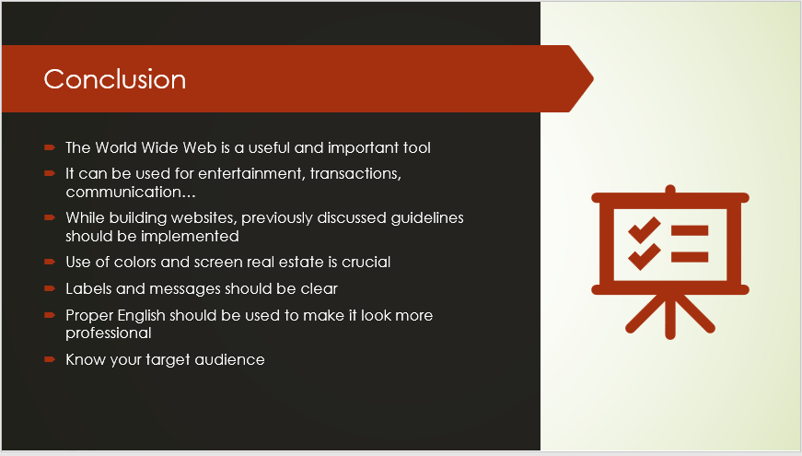

My talk was about the user interface aspect of the World Wide Web and how it is used.

My final remarks would be just everything I talked about tied together including the uses

of the WWW and general takeaways about the GUI design.

It is meant to help the listeners focus on what they should be paying attention to while designing websites.

Ante Zovko

The stakeholders are the users of the program and the company that made the software including the president and the developers.

Violations:

1.2 Avoid Harm (They are failing to minimize negative consequences and because of that the users were penalized by the IRS)

1.3 Be honest and trustworthy (While they put the disclaimer on the disc, they are not being trustworthy by releasing a program with bugs)

2.1 Strive to achieve high quality in both the processes and products of professional work.

(It is not high-quality work if it has bugs)

2.2 Maintain high standards of professional competence, conduct, and ethical practice.

(It is not a high standard of ethical practice if they released the product knowing it would cause problems for the users)

2.7 Foster public awareness and understanding of computing, related technologies, and their consequences (They failed to specifically say that they have bugs in their software to the general public)

3.1 Ensure that the public good is the central concern during all professional computing work.

(It is not central; the main concern was capturing the largest market share)

3.2 Articulate, encourage acceptance of, and evaluate fulfillment of social responsibilities by members of the organization or group.

(The company president failed to focus on social responsibilities by releasing the software with bugs)

3.4 Articulate, apply, and support policies and processes that reflect the principles of the Code.

(The president is failing to support the principles of the Code)

3.7 Recognize and take special care of systems that become integrated into the infrastructure of society.

(Taxes are a big part of society and he failed to take special care of that software)

4.1 Uphold, promote, and respect the principles of the Code.

(They are not promoting the principles of the Code)