# Running From Command Line

You can invoke this plug-in by changing startcmd.bat file.

Before running command-line, you must install com.antennahouse.wml plug-in into your DITA-OT.

1. Add your Saxon PE/EE .jar file path at the top of CLASSPATH setting batch file instead of Saxon HE.

@echo off  
REM Generated file, do not edit manually  
echo "NOTE: The startcmd.bat has been deprecated, use the dita.bat command instead."  
pause  
  
REM Get the absolute path of DITAOT's home directory  
set DITA_DIR=%~dp0  
  
REM Set environment variables  
set ANT_OPTS=-Xmx512m %ANT_OPTS%  
set ANT_OPTS=%ANT_OPTS% -Djavax.xml.transform.TransformerFactory=net.sf.saxon.TransformerFactoryImpl  
set ANT_HOME=%DITA_DIR%  
set PATH=%DITA_DIR%\bin;%PATH%  
set CLASSPATH=%DITA_DIR%lib;%CLASSPATH%  
REM Add my Saxon PE to CLASSPATH  
set CLASSPATH=D:\My_Documents\Java\SaxonPE9-8-0-12J\saxon9pe.jar;%CLASSPATH%  
REM Remove SaxonHE from CLASSPATH setting  
REM set CLASSPATH=%DITA_DIR%lib\Saxon-HE-9.8.0-12.jar;%CLASSPATH%  
set CLASSPATH=%DITA_DIR%lib\ant-apache-resolver-1.10.3.jar;%CLASSPATH%  
set CLASSPATH=%DITA_DIR%lib\ant-launcher.jar;%CLASSPATH%  
set CLASSPATH=%DITA_DIR%lib\ant.jar;%CLASSPATH%  
...

1. Open command window by clicking startcmd.bat.
2. Input ant command to invoke DITA-OT specifying "ah.wml" as transtype.

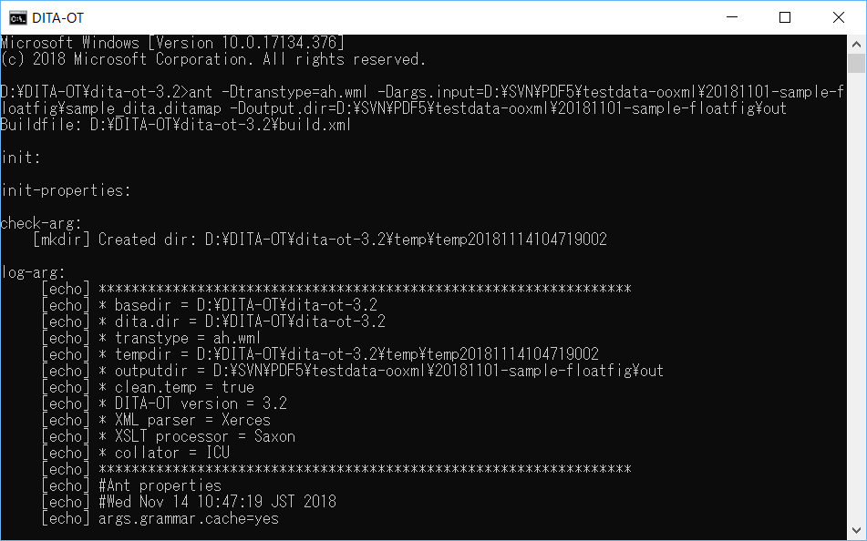

If the build process finished normally, the .docx file will be generated in the output folder.

# Running From oXygen DITA-OT Transformation Scenario

You can invoke this plug-in by adding DITA-OT transformation scenario in oXygen XML Editor.

Before adding scenario, you must install com.antennahouse.wml plug-in into your external DITA-OT. Also you must setup your new oXygen project for publication.

1. Open your main map or bookmap in oXygen.
2. From **[‍Document‍]** menu select **[‍Transformation‍]** > **[‍Configure Transformation Scenario(s)‍]** .
3. In the "Configure Transformation Scenario(s)" dialog, select **[‍New‍]** > **[‍DITA-OT Transformation‍]** .

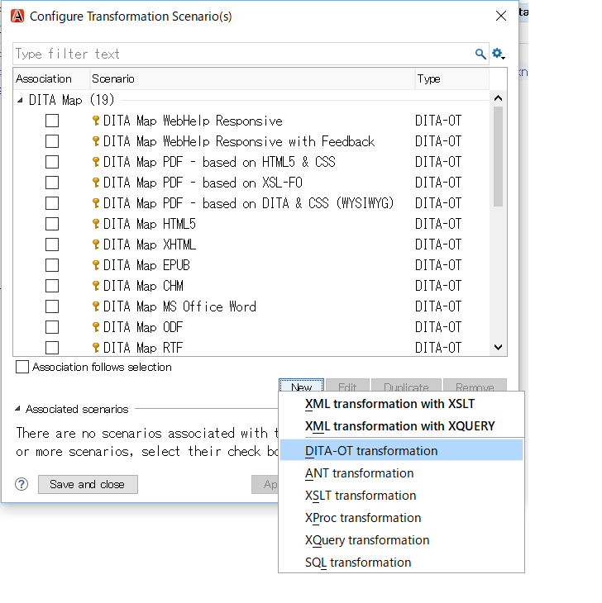

1. Select "Word RTF" in the "DITA Transformation Dialog".

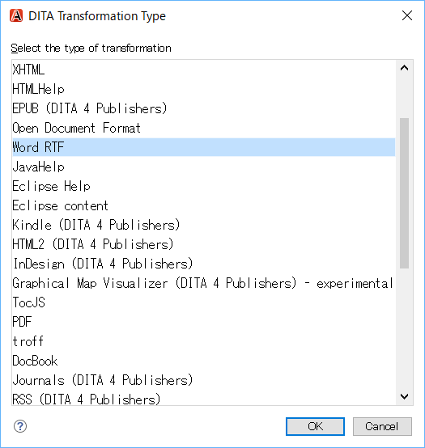

1. Input DITA-OT parameters in the Parameters tab.
   1. Specify your external DITA-OT folder as "dita.dir" parameter.
   2. Specify "ah.wml" as "transtype".

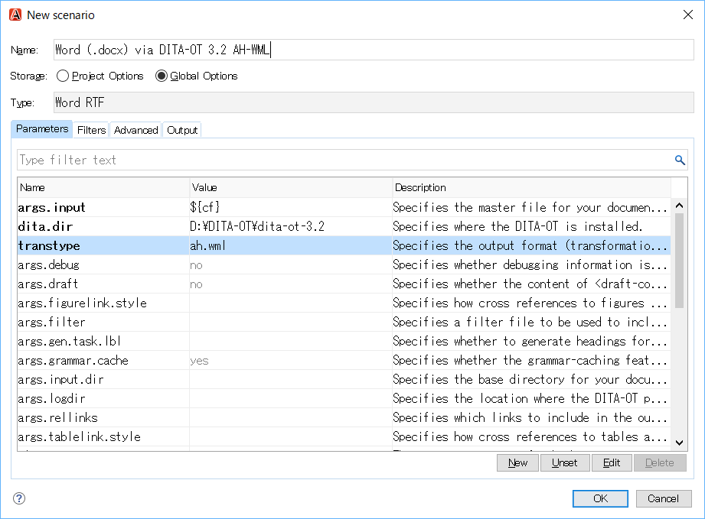

1. Setup output folder as you like.

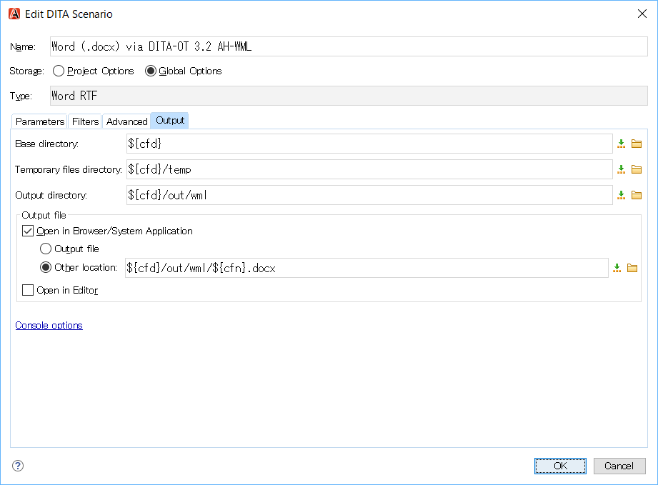

1. In the **[‍Advanced‍]** tab, click **[‍Libraries‍]** button.

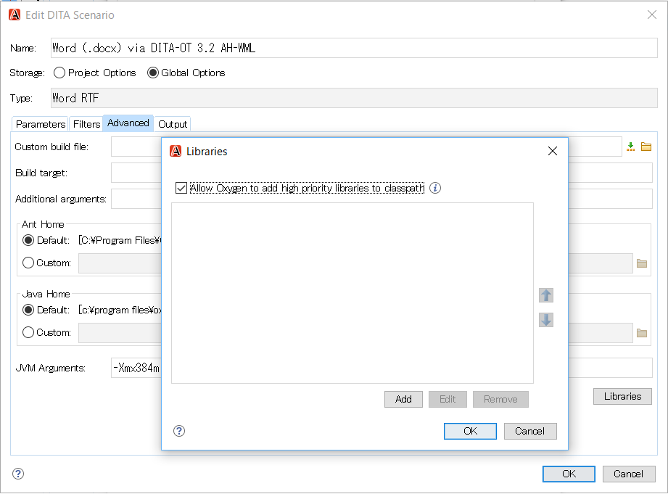

1. Confirm **[‍Allow Oxygen to add high priority libraries to classpath‍]** is checked.
2. Close dialog and invoke this scenario.

If the build process finished normally, the .docx file will be generated in the output folder and oXygen automatically opens the .docx file by launching Word.