1. **Login to**[**https://aac.amd.com/**](https://aac.amd.com/)**.**

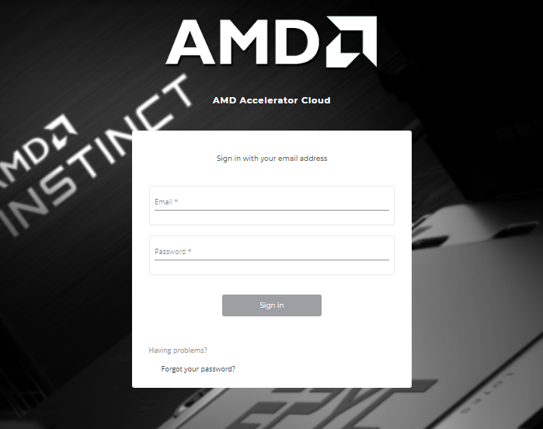

**2.Go to workloads, Select new workload.**

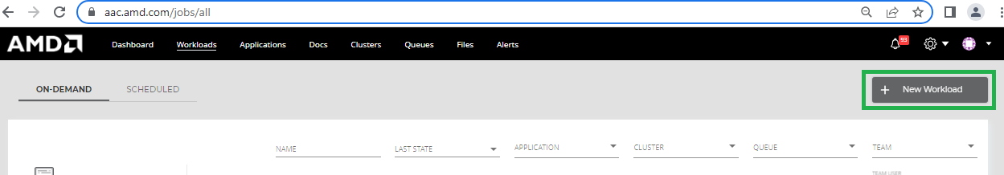

**2. Select the desired TensorFlow version with desired container type as docker**

**Note**: In this case, we have selected TensorFlow 2-10 ROCm 5-4-1 version and container as docker.

3.Click on Next, available in top-right corner

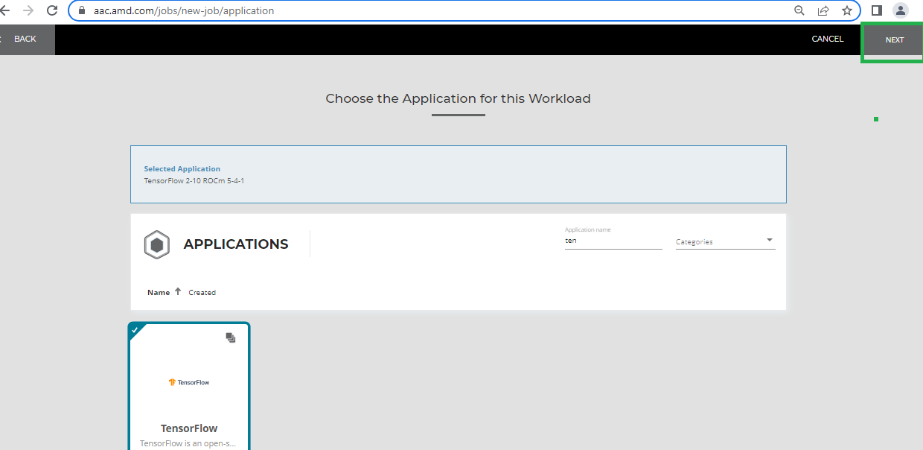

4. **Click Next to continue**

5. Select Number of GPU’s as 8 and Click on Next

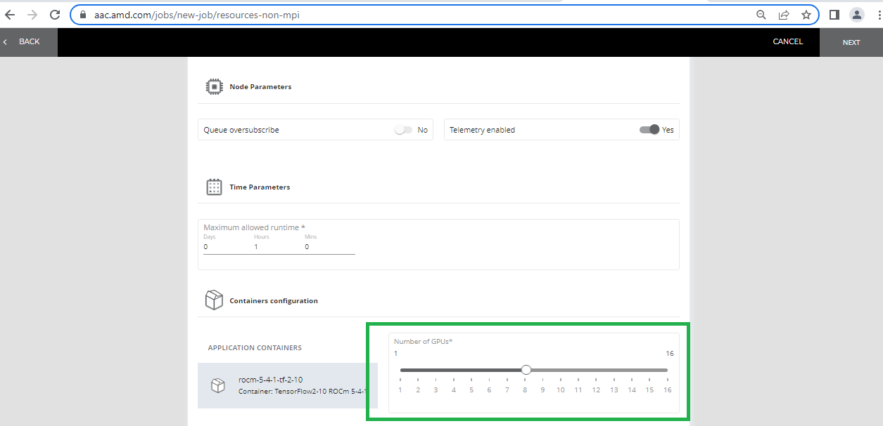

6. Select the desired queue. Click Next.

Note: Here, we selected queue as CirraScale:1CN128C8G1H_4RoCE_MI250_Ubuntu22 (gpu:mi250:8(S:0-1))

7.Review workload and Click on Run Workload.

