

**LAIG – TP3**

**User Manual Lear**

**Class 6**

**Group 3**

Francisco Tomé Macedo Martins Santos Moreira - 201607929

Antero Campos Gandra - 201607926

* **Running the Game**
  1. Open Sicstus and consult the file ‘server.pl’ in the prolog folder provided.
  2. Execute the predicate ‘server.’ inside Sicstus.
  3. Run a server.
  4. Open a browser and navigate to the game folder.
* **The Rules**

Each player takes a turn placing one of their pieces in an 8 by 8 square board. This piece must be placed at an empty square. If the player places a piece in an horizontal or vertical line with another piece of his and these 2 pieces don’t have any empty square between them then this player will capture all the opponent pieces making them flip and become their own pieces. Note that players can only capture a line if they only have 1 piece already there, if they have 2 or more pieces in that line than they can’t capture it. Players must always place new pieces, they can’t move pieces already in the board.

**Example:**

X_OO _XOO _OOOX _XXOOO

In the first 3 examples a player ‘X’ playing in the empty spot ‘_’ will capture the ‘O’ pieces of that line. However in the last example this doesn’t happen because ‘X’ already has 2 pieces on that line.

The game ends when all the board is filled and the winner will be the player with more pieces on the board.

* **Playing**

To play simply click on a piece from your side, hold the mouse and drag it over an empty tile of the board and release. The piece will follow the mouse hovering over it with a shadow below to indicate where it will be placed.

The GUI indicates the current amount of points for each player and the winner in the end.

It also has the option to undo the last play.

* **GUI**

The GUI provides with several options regarding game mode, playing, the scenario and the status of the game.

* + Settings
    - 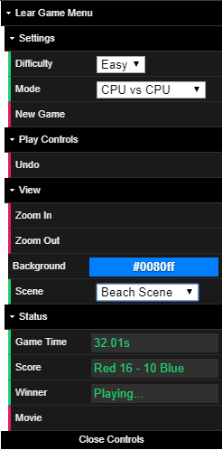Difficulty: Select difficulty of the CPU players (Easy; Hard)
    - Mode: Select game mode (Player vs Player; Player vs CPU; CPU vs CPU)
    - New Game: Repositions the pieces and starts a new game with the new settings
  + Play Controls
    - Undo: Undo the last Player play. In Player vs Player this is the last play. In Player vs CPU this is the last 2 plays.
  + View
    - Zoom in: Zoom in on the board
    - Zoom out: Zoom out on the board
    - Background: Pick the background colour
    - Scene: Pick the scene to play the game (Empty Scene; Beach Scene; Volcano Scene; Casino Scene)
  + Status
    - Game Time: Current game time in seconds
    - Score: Score of the game so far
    - Winner: Winner of the game
    - Movie: Plays the movie of the game. It can be played at any point of the game to see every play until that point. Once the movie is done the players can keep playing. For CPU vs CPU mode the movie can only be played at the end.