Student name: \_\_\_\_\_\_\_\_\_\_\_\_Antti Kurri\_\_\_\_\_\_\_\_\_\_\_\_\_\_\_\_\_\_

Student ID: \_\_\_\_\_\_\_\_\_\_\_\_\_\_\_\_\_\_\_\_\_\_\_

Score: \_\_\_\_\_\_ /80 (Please do not fill this field)

|  |
| --- |
| **Note:**  You are allowed to use class materials and all online materials. |

**Project: Your personal website**

**Time: 5 hours**

**C:\Users\feftekhari\Downloads\sitemap_color.png Step 1: Create Pages and folders (5 points)**

Create your personal website pages:

|  |  |  |
| --- | --- | --- |
| **#** | **Page** | **Description** |
| 1 | Home (About) | Your picture, description |
| 2 | Skills | Listing your skills with a related picture – A link for download your CV in both DOC & PDF format |
| 3 | Projects | Listing the projects you have done with brief description and screenshot (at least 3 projects, if you do not have enough use your imagination!) |
| 4 | Gallery | Your favorite photos with brief description |
| 5 | Contact | Your contact information + your social network links |
| 6 | ??? | One page as you suggest |

Folders

|  |  |  |
| --- | --- | --- |
| **#** | **Folder** | **Description** |
| 1 | Root | Your pages |
| 2 | /Images | Placing your images and creating sub-folders to group related ones |
| 3 | /Styles | Placing your CSS files |
| 4 | /JS | Placing your JavaScript files |

** Step 2: Pages HTML structures (25 points)**

Considering the material of the course, taking care of the following points:

* HTML structure
* Proper definition and use of elements (such as headings, paragraphs, and etc.)
* Page titles and meta tags
* Proper commenting
* Proper indentation

 **Step 3: Styling pages using CSS (15 points)**

Using CSS to apply style on your pages and HTML elements inside of the pages.

Minimum requirements:

* Pages background and related rules
* Styling text for the content
* Styling links (definition for normal, visited, hover, and active)
* Proper commenting
* Proper indentation
* Styling form elements

** Step 4: Adding functionality using JavaScript (30 points)**

Using JavaScript for the following tasks:

|  |  |  |
| --- | --- | --- |
| **#** | **Page** | **Description** |
| 1 | Home (About) | Show current date and time at the bottom |
| 2 | Skills | Add a text box and a button to add a skill to the first of the list and remove the last one (Have a proper object with related properties such as skill name, photo ID, and etc.) |
| 3 | Projects | Add the following JavaScript events and react to them accordingly by showing a message or changing something in your page:   * Load * Scroll * Mouse over your first project |
| 4 | Gallery | Using this article:  <http://themarklee.com/2013/12/26/simple-diy-responsive-slideshow-made-html5-css3-javascript/>  Create a native JavaScript slide show for your photos (NOT using jQuery) |
| 5 | Contact | Add contact me form including the following fields:   * First name (Text box) (Validation: no blank – less than 25 character) * Last name (Text box) (Validation: no blank – less than 25 character) * Gender (Dropdown box) (Validation: no blank) * Age (Text box) (Validation: no blank – older than 18 – blow than 100) * Email address (Text box) (Validation: no blank – proper email – less than 50 character) * Website address (Text box) (Validation: no blank – proper URL – less than 50 character) * Comment (Text box) (Validation: no blank – proper URL – less than 255 character) * Reset button – To reset the entered information   After submit, you need to validate all the information, and finally show at the bottom of the page. |
| 6 | ??? | Surprise me! |

**C:\Users\Farhad\Downloads\bookmark.png Step 5: Documenting your progress (5 points)**

Document your progress, describe your pages, elements, styles, and functionalities by using screenshots, and your code. And finally describe how it went!



Navigation bar was done from an example from w3school.

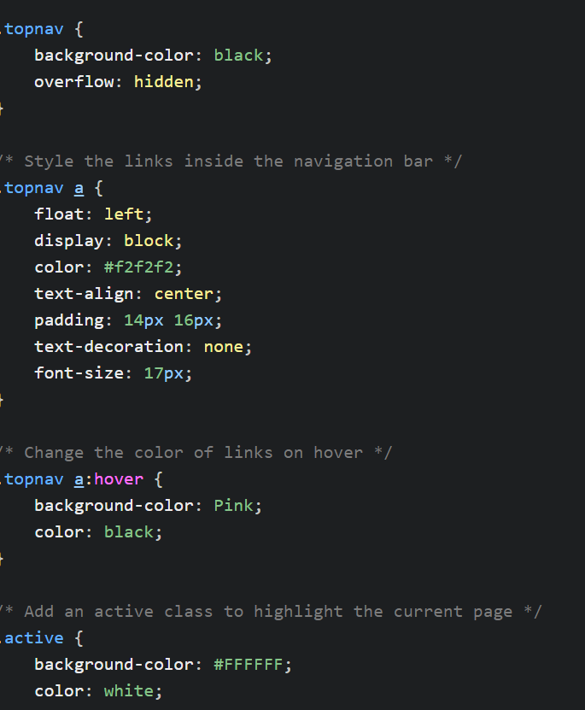

Here is some stylesheet from the navbar.

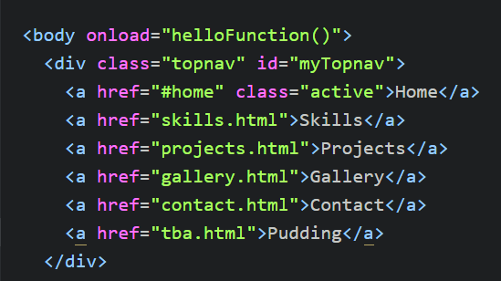

And here is html part. Class active was given to the page you were currently on

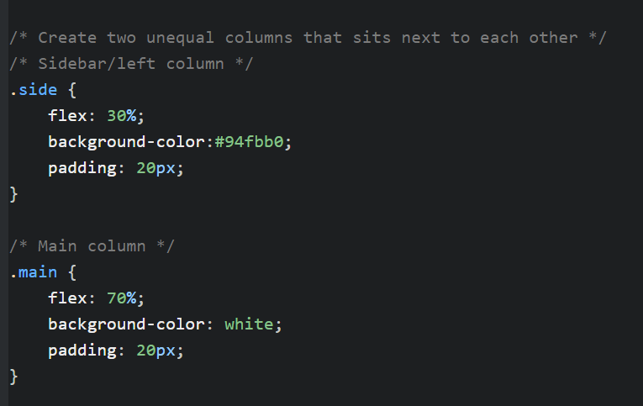

Here is how I divided the home page to two different columns to create more pleasant page

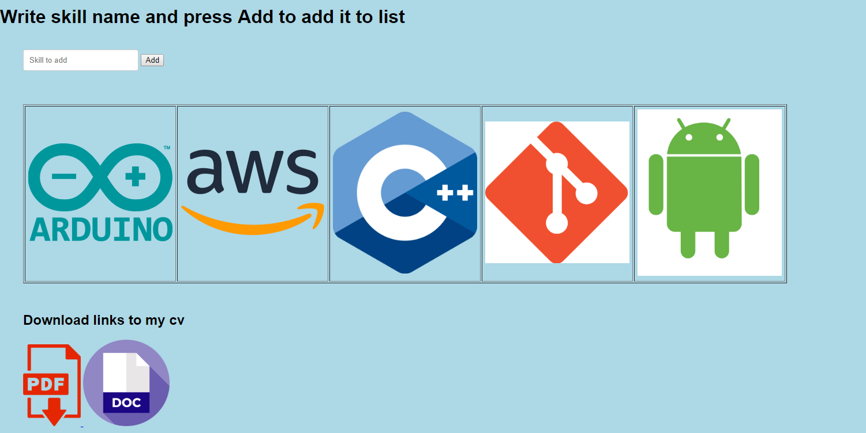

Here is the screen from skills. You can add skills to the table as instructed on the instructions and the download link to cv

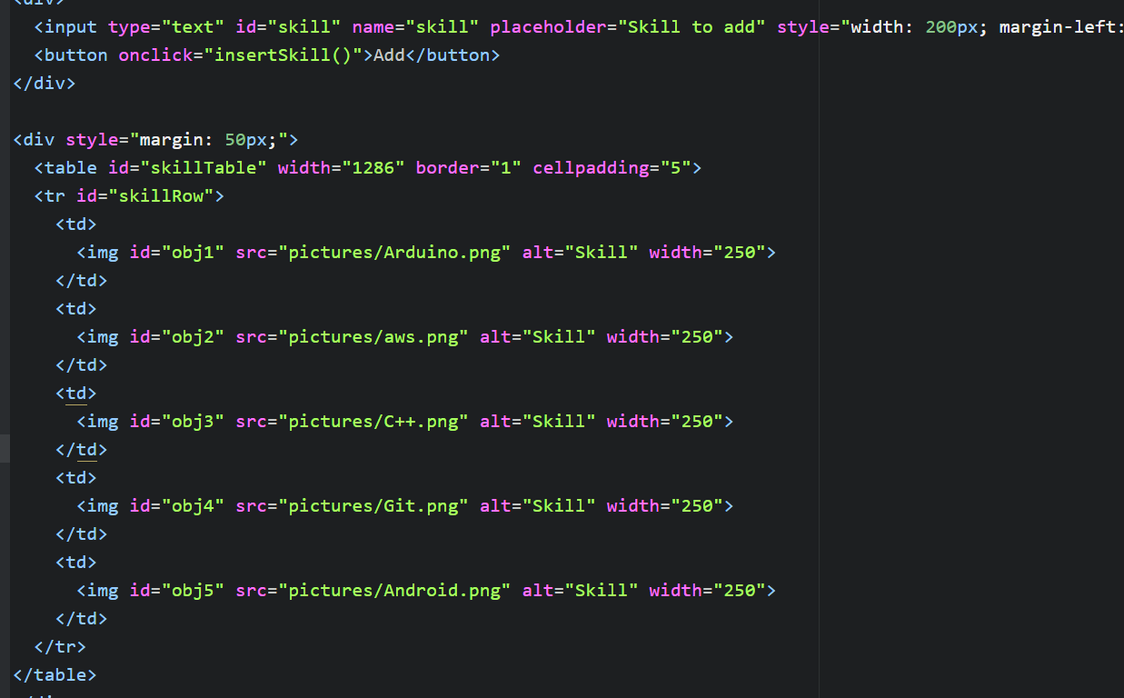

Table in html and on button click it calls the function

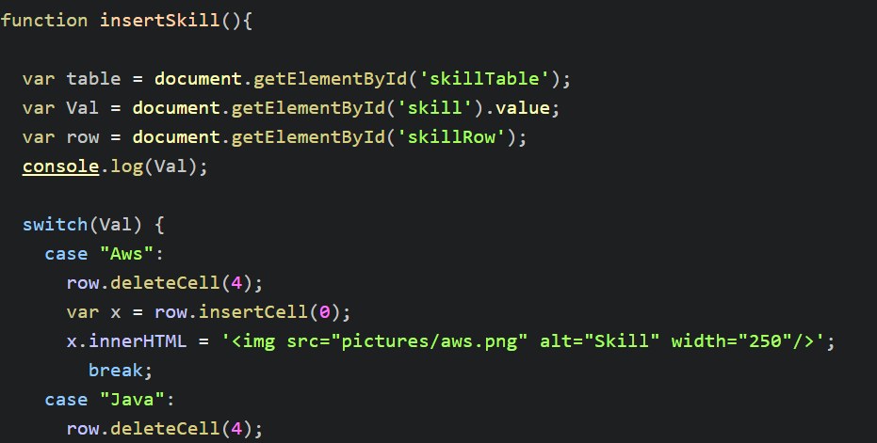

The function deletes last cell and adds new cell with picture to the front

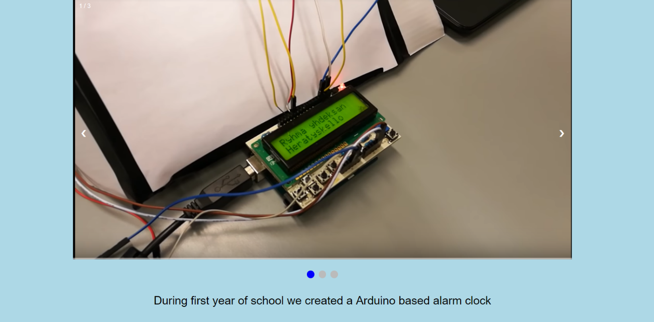

In projects I have a little image scroller and description about the project.





At the bottom of the page is a text which changes when hovered the project is hovered. Also Onscroll the site plays sound

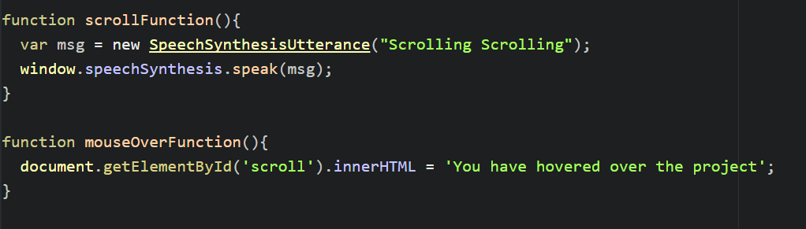

Here are the simple js functions

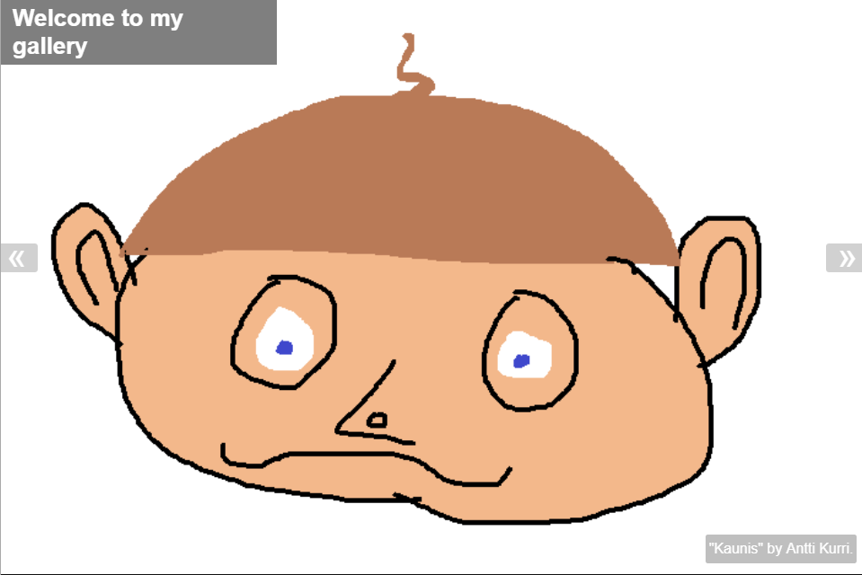

Here is the gallery made with the example from link in the instructions.

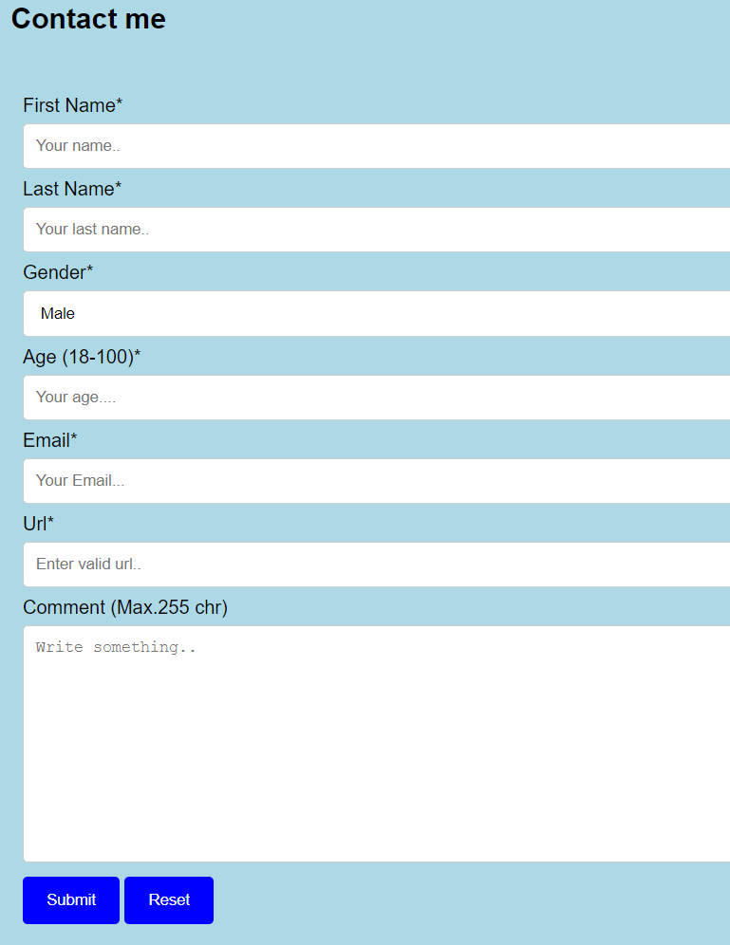

Here is the contact me form

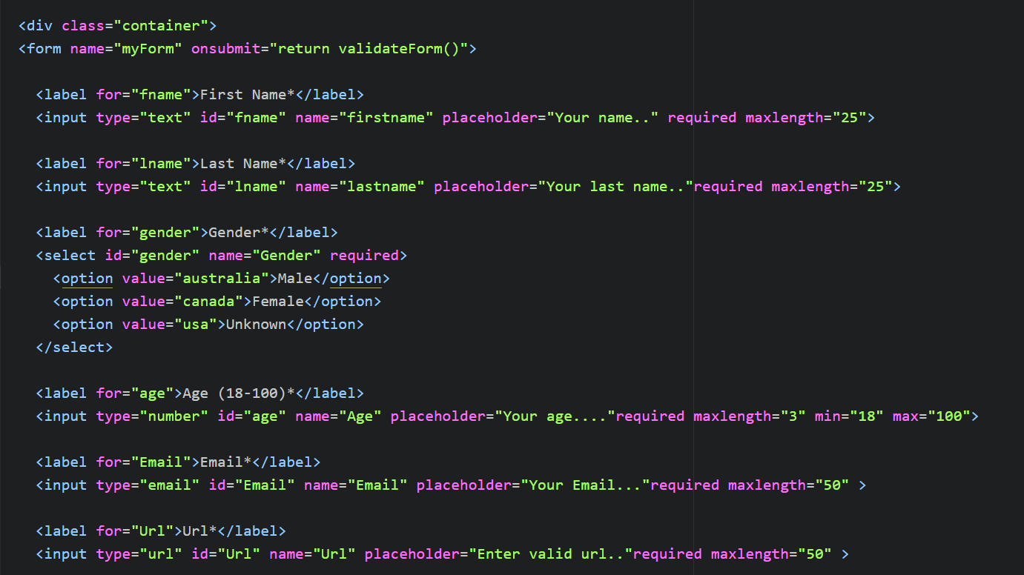

Here is a snippet on html of how the form and requirements for different inputs were created.

And the onsubmit function is called in the form

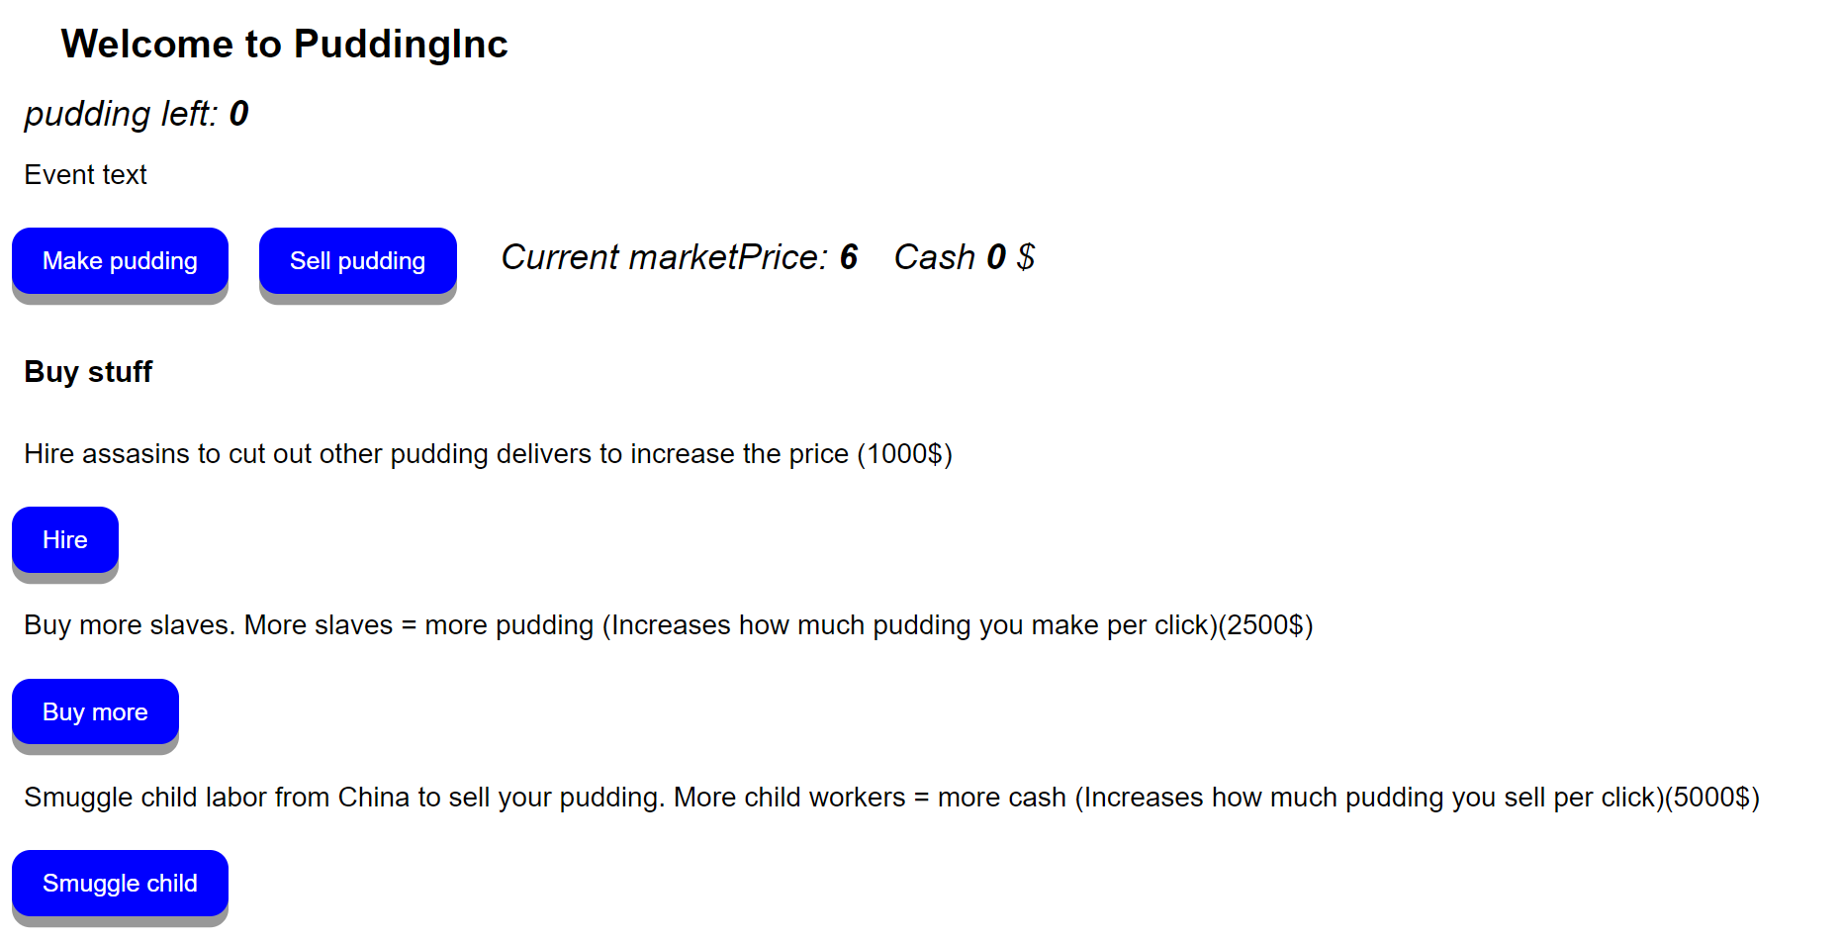

And here is the final page I made a small game called puddingInc where you make and sell pudding and try take over the worlds pudding industry.

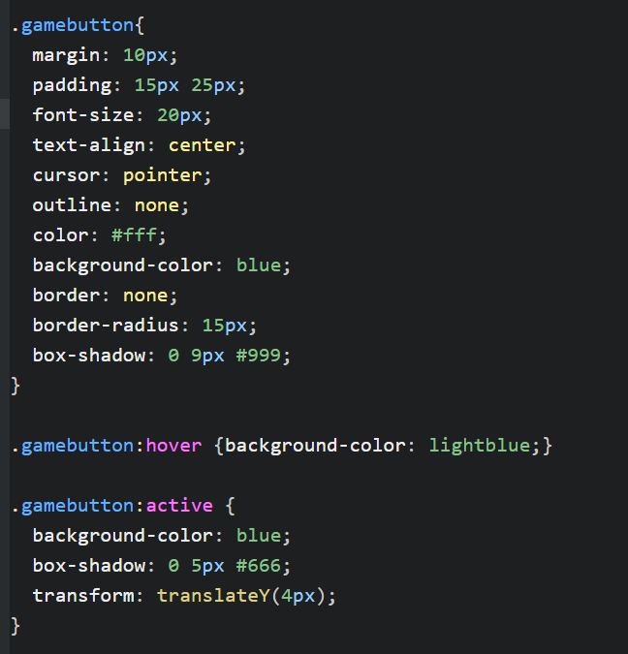

Here is how the games buttons style was made

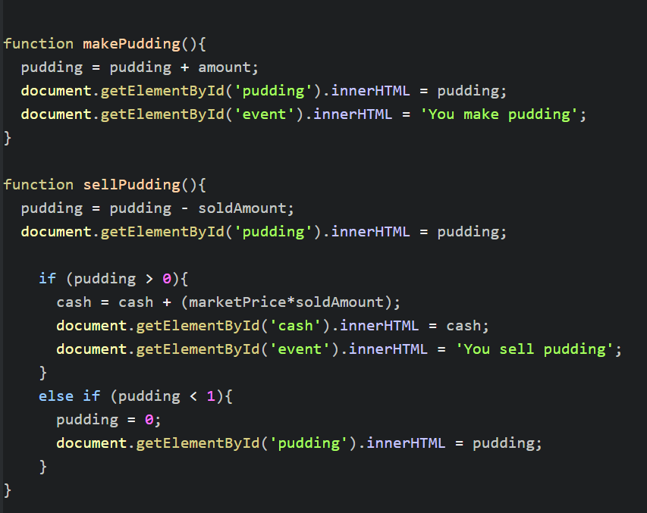

Here is some basic example functions on the game which are making and selling pudding

**You need to return this document for your final assessment.**

**Good luck!** ☺ **Farhad Eftekhari**

Copyright © 2017 by TechClass Oy

All rights reserved. No part of this publication may be reproduced, distributed, or transmitted in any form or by any means, including photocopying, recording, or other electronic or mechanical methods, without the prior written permission of the publisher, except in the case of brief quotations embodied in critical reviews and certain other noncommercial uses permitted by copyright law. For permission requests, write to the publisher, addressed “Attention: Permissions Coordinator,” at the email address below.

TechClass Oy  
www.techclass.co  
info@techclass.co

