## 

## Check the docker VM

1. Go to a windows command shell and check that there is a valid docker VM available

docker-machine ls

There should be a VM named docker-vm1 in the list.

1. Start the docker-vm1, if not started already

docker-machine start docker-vm1

1. Set the docker environment in the current shell

docker-machine env docker-vm1

@FOR /f "tokens=*" %i IN ('docker-machine env docker-vm1') DO @%i

## Clone mschassis

1. Clone the following repository

<https://github.ibm.com/kapil-raina/mschassis.git>

## Install RabbitMQ

Start RabbitMQ (in the same windows shell as above)

1. On the same command shell as above go to this location

/mschassis/docker

1. Run the following :

startchassis -s rabbitmq

1. After installation is successful , check the containers

docker ps

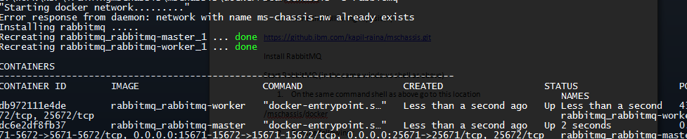

1. RabbitMQ Http port is mapped to 15672. Check the RabbitMQ console by going to http://<docker-host>:15672

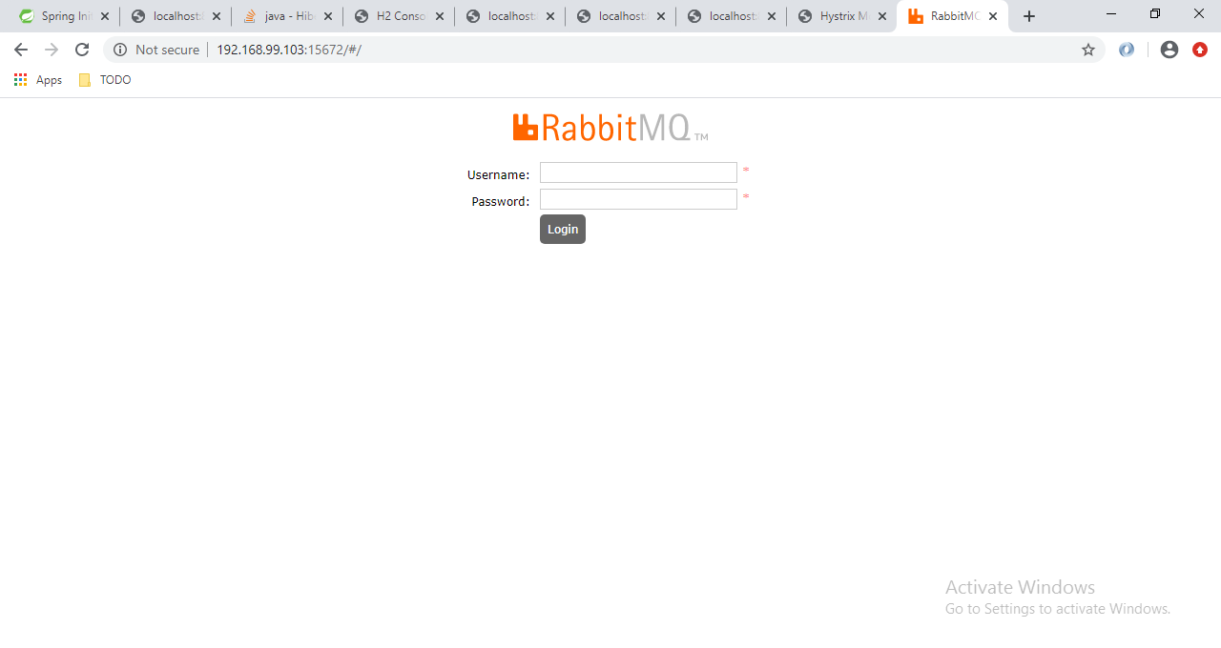

1. Login with guest/guest credentials
2. Create a new exchange “ex.webaudit” of type direct.

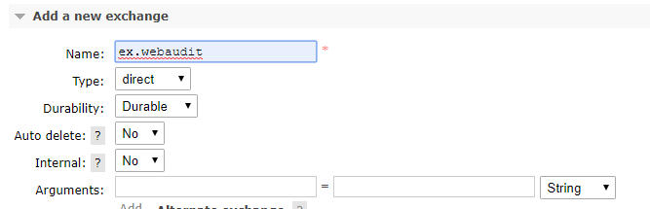

1. Create a new queue “q.audit”

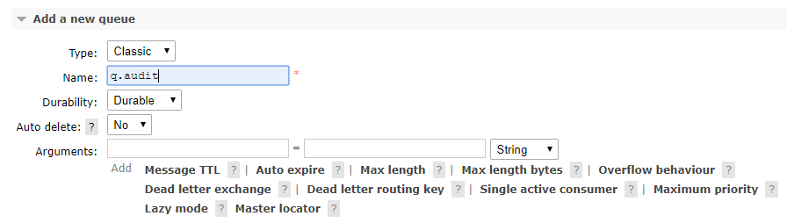

1. Bind this exchange to this queue using routing key “rkwebauditshim1”

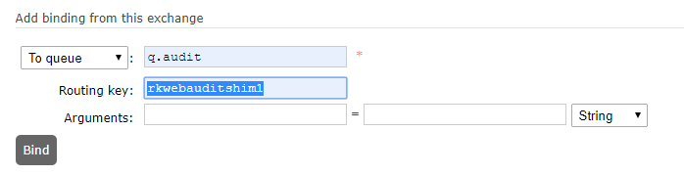

## Install Zipkin

1. Execute the following at the same location(mschassis/docker):

startchassis -s zipkin

1. Zipkin is stared mapped to port 9411. Go to http://<Docker-Host>:9411

