What is traceroute?

Traceroute is a command used to know the path of data packets sent by a local network user as they travel all over the internet, until they reach a destination. Think about the internet as a big set of networks that are interconnected with the use of multiple routers that track the packet traffic between computers and servers all over the world. With this in mind, it’s pretty clear that a packet does not travel from a point to another directly, passing through different networks and, implicitly, different routers.

Traceroute command is more complex than the ping one – while *ping* only pings the final destination, traceroute not only pings the final destination, but it also pings each router on its way to the final destination; the computer sends three data packets to all routers they pass, and they send back these packets, allowing to obtain DNS domains and measure the round trip time that these took to and from each router. Note that traceroute is based on TTL mechanism: data packets are sent with a related value, and this value is decremented when they reach a router, reaching zero when they discover a new “checkpoint” (a new router).

With all of this said, traceroute can be a great tool to help discover network issues when it is not possible to establish a communication with a given IP address or domain.

Traceroute command executions

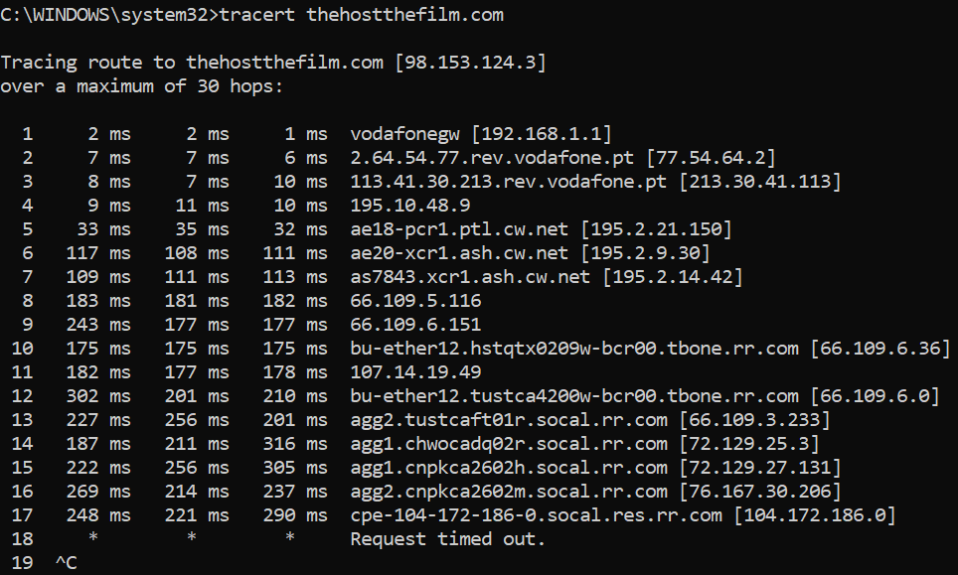

Fig.1 – Example of usage of the tracert command within Anthony’s network

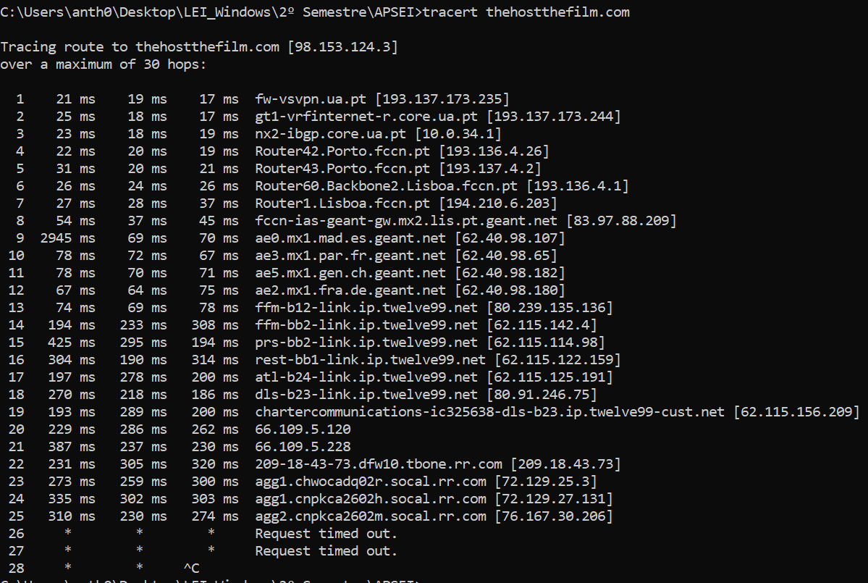

Fig. 2 – Example of usage of the tracert command within the UA network

Traceroute result interpretations

As shown by the screenshots above, the location of an user interferes with the traceroute results, for instance, by changing the initial IPs and domains. This happens because the user was in different networks, so the path that each data packet chose to reach its destination has changed.

Both inside and outside the network of the unniversity, it was never possible to complete the traceroute research - the last hops always have the “request timed out” message and there is no hop with the IP that’s used as parameter for the traceroute command. Most of the time, the last shown IP is 76.167.30.206 (check the screenshot above), but sometimes there is a new one – 104.172.186.0. Pay attention because we’ll come back to this later.

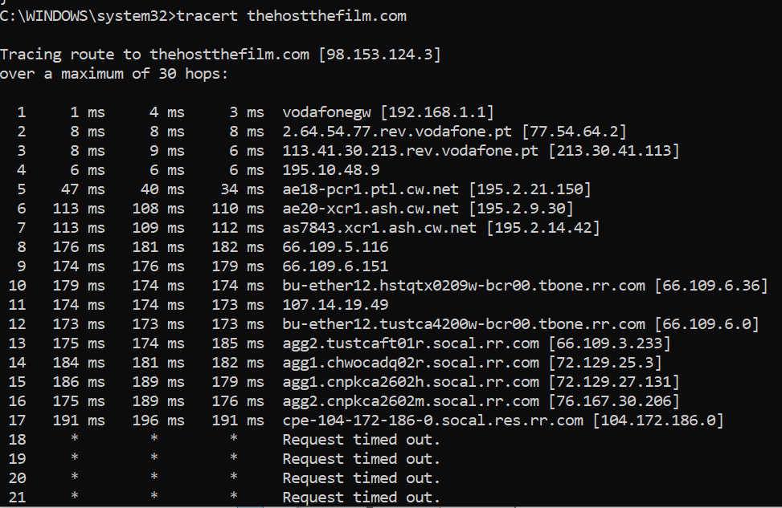

Fig.3 – Traceroute with a new last shown IP.

To help the process of interpeting the results obtained while testing the traceroute command, an IP geolocation API was used – ipinfo.io. Using the curl command together with ipconfig and the IP to be analyzed, it was possible to retrieve a json with additional information related to that IP:

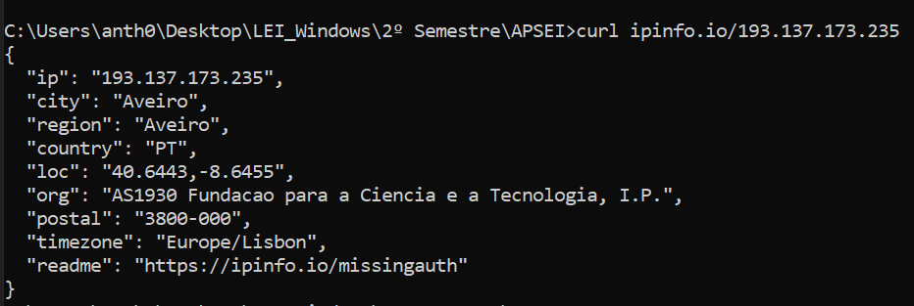

Fig.2 – Example of usage of the IP geolocation API ipinfo.io

With this in mind, a python program was made to help obtain all the jsons for each of the IPs obtained when executing the tracert command – this program accepts as an argument the name of a file where the output of a traceroute command is saved, and it filters the document to obtain all the IPs and perform the curl with each one, obtaining the multiple json outputs in a results file:

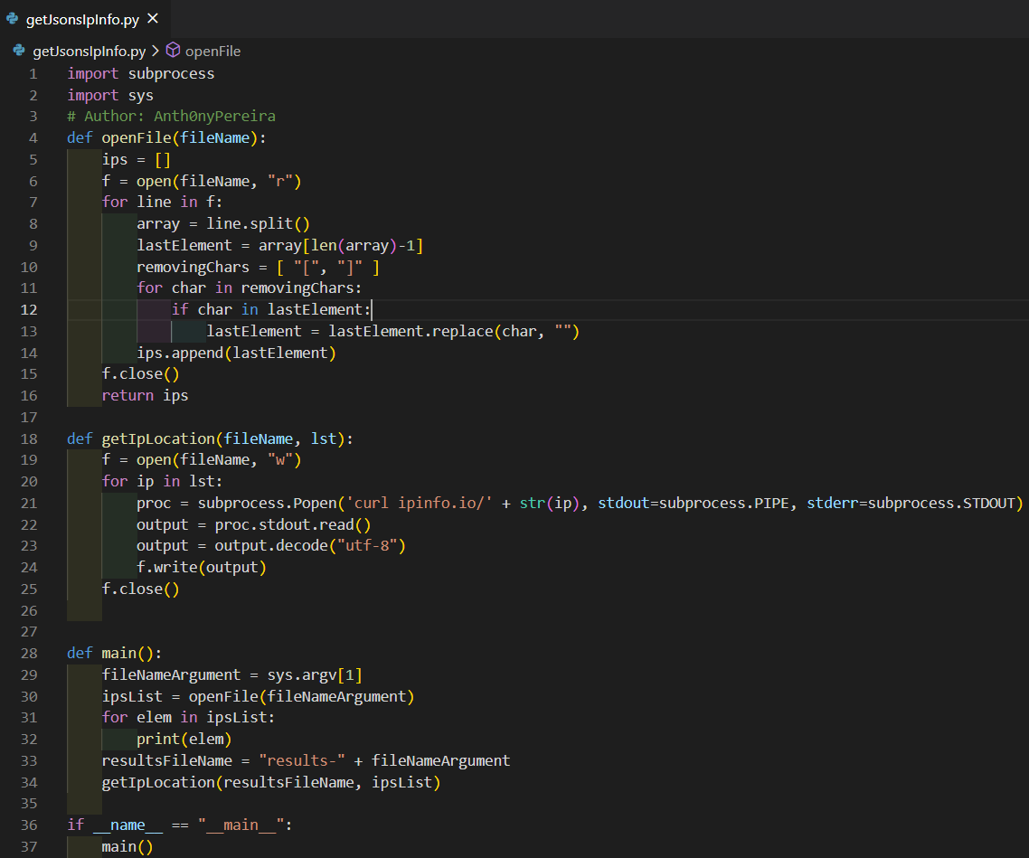

Fig.3 – Python program to obtain a sequence of JSONs using an IP geolocation API

With the results that were achieved, two diagrams were made for helping to visualize the way that these data packets perform during the traceroute command (CN means “changed network”):

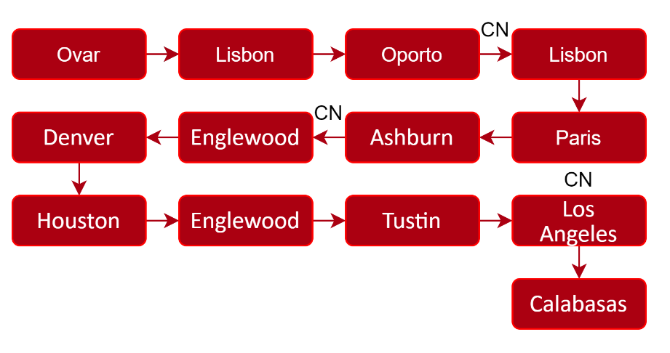

Diag.1 – Path traced with VPN switched off

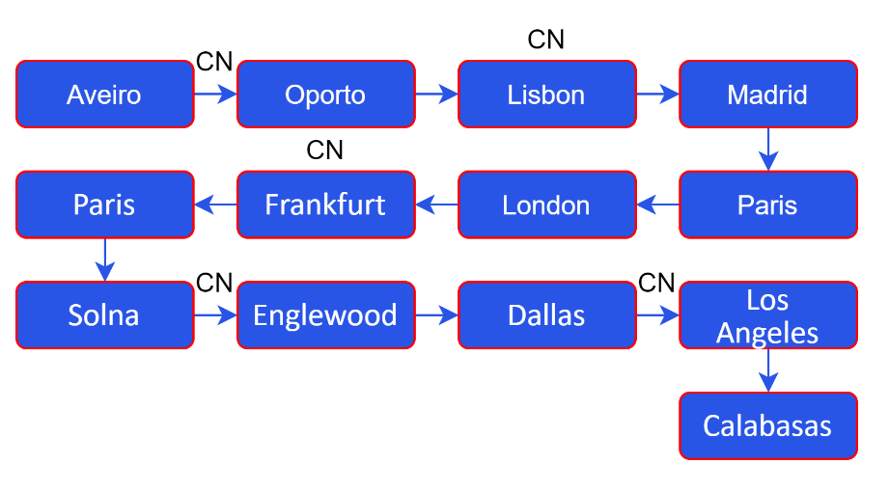

Diag.2 – Path traced with VPN switched on

Some cities are out of place or have changed (check Tustin and Dallas, for example), so, it’s reliable to say (again) that the path changed in these two different situations. Checking the two tables (see the appendix), it can be observed that even the networks (organizations) have changed too, even after the UA network. So, we can assume that the tracert path is not always the same and that it’s dependent on the location where the user is, leading to a possible mid-different path/networks – not only the user’s network can (obviously) change, everything can change.

Now that the location of the IPs were recorded, let’s go back a little bit and check the location of both IPs 76.167.30.206 and 104.172.186.0:

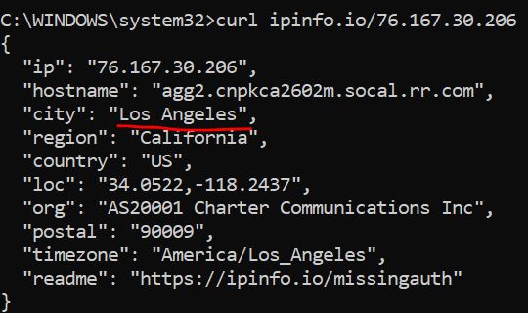 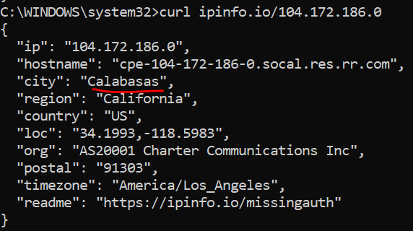

Figs. 4 & 5 – Results of the consultation of the geolocation API for two specific IPs

The target IP 98.153.124.3 was also inspected:

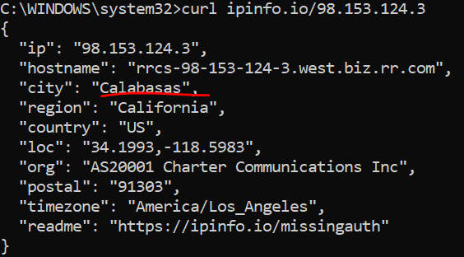

Fig.6 – Result of the consultation of the geolocation API for the target IP

All three IPs are from the same organization and region – California. 104.172.186.0 and 98.153.124.3 (the IP that sometimes appears in the trace and the initial IP, respectively) are from the same city – Calabasas!

Now, let’s check the distance between Los Angeles and Calabasas:

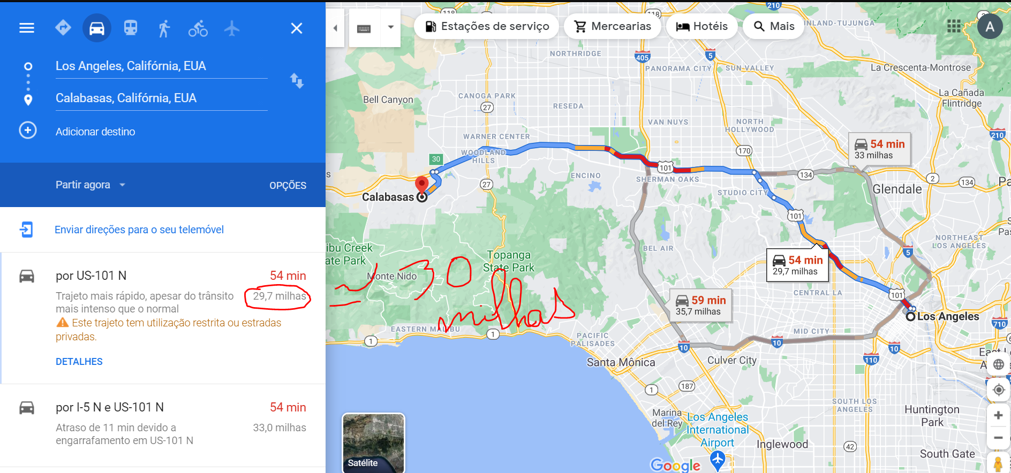

Fig. 7 – Distance between Los Angeles and Calabasas, using Google Maps

Time to make a conversion:

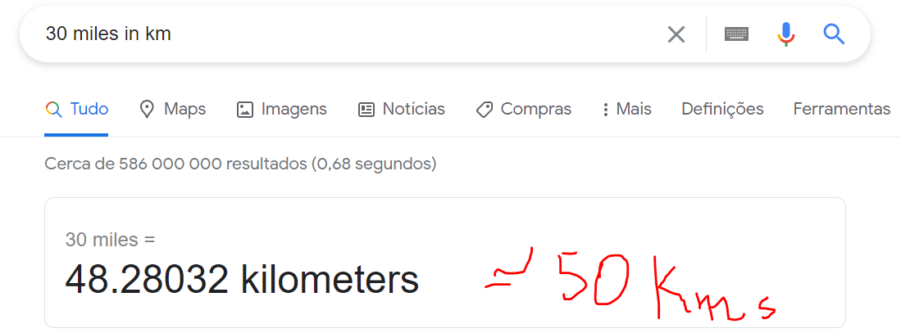

Fig.8 – Conversion between miles and kilometers, using Google

With all of this shown, it can be deduced that the server where the website that is being targeted by traceroute is located is probably denying any interaction with the user, that is, it is not responding with the traceroute packages that were sent to it. Both possible last IPs are close to the real location of the server - either they are from the same city or are 50 km apart from each other - so it’s safe to discard the possibility of 98.153.124.3 being too far away from 76.167.30.206 that they are not able to connect to each other. Another thing is that all three IPs are from the same network, so, we can surely say that the problem is not that it’s not possible to move from a previous network to the last one. We can prove this by executing the ping command, that shows that there is na established connection:

(insert ping command output that is working)

A quick search was performed and a curious result was gotten:

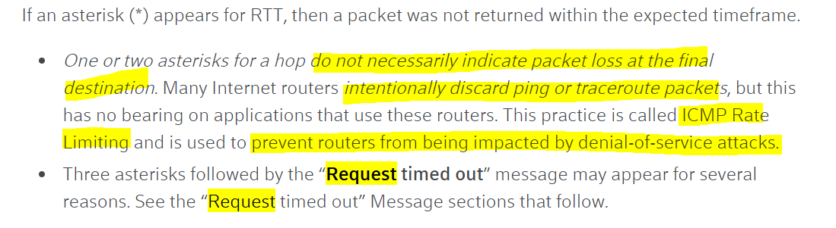

Fig.9 – Paragraph from the website Xfinity.com

It seems that some routers can “intentionally discard traceroute packets” because of security reasons, such as preventing DoS attacks. This could be what’s happening in this case.

Another reason that sustains this assumption is the fact that the website seems forgotten by everyone:

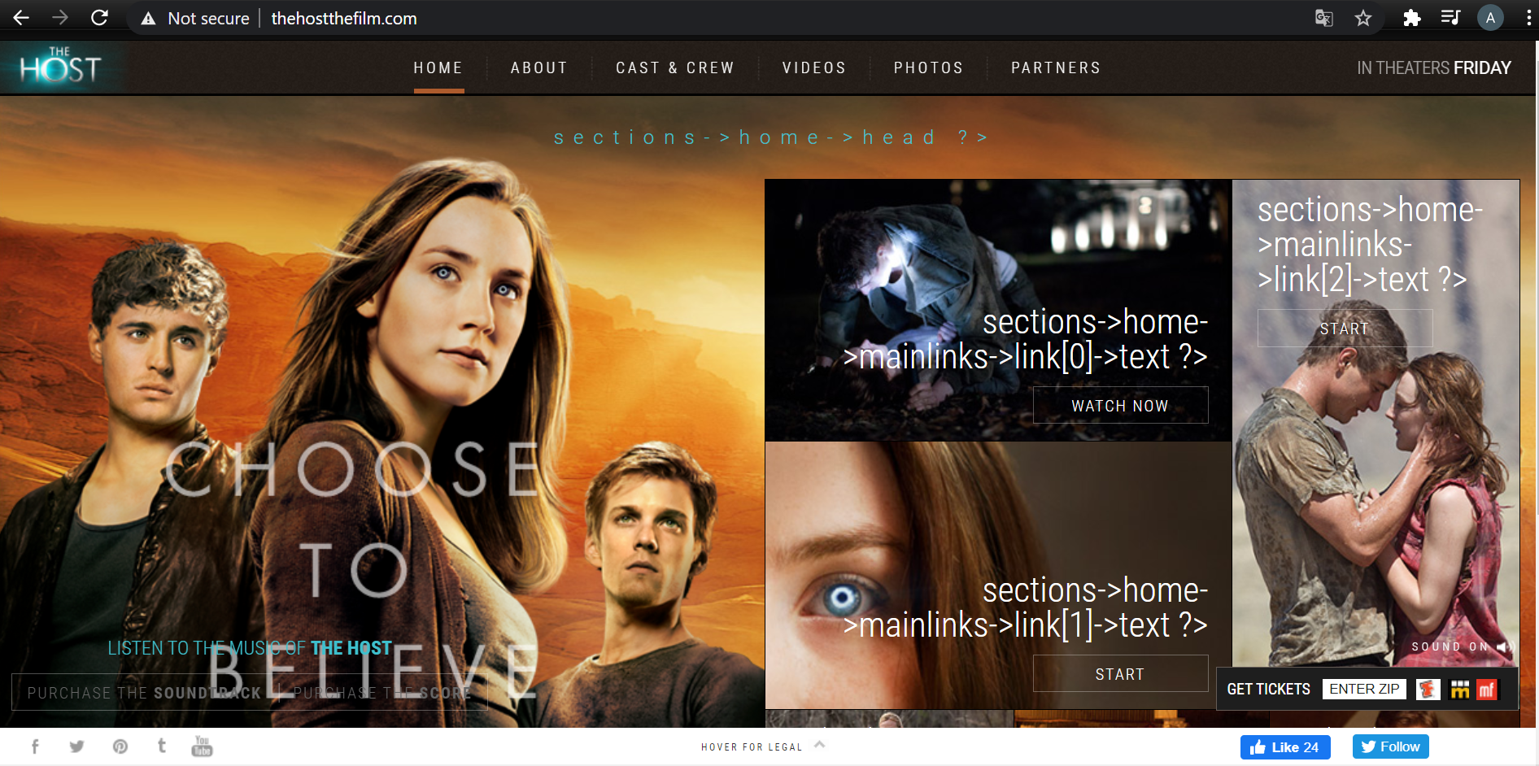

Fig.10 – Homepage of the website The Host, a movie from the year 2013

As we can clearly see from the screenshot taken, some things seem misconfigured (some raw code appears) and even if we check some features that it offers (or that it once offered), we can see that there are some bugs or some features that no longer exist. Thus, it’s possible to assume that this website is no longer maintained – which can lead to security problems. So, the owners could probably block some ways to communicate with the internet – to protect what’s left.

<https://www.netnod.se/ix/what-is-an-ixp-and-what-is-peering>

<https://www.xfinity.com/support/articles/run-traceroute-command>

Implicações sociais de uma conexão web

É óbvio que a capacidade de se ligar a um grande universo de redes que se interligam entre si, à qual chamamos de Internet, permitiu que nos tornássemos menos sós em termos de individualidade – é mais fácil comunicar com um familiar que está longe, pode-se observar em tempo real uma cerimónia num país a milhares de quilómetros de distância sem termos de estar lá presentes fisicamente, pode-se saber de notícias e acontecimentos de países do outro lado do mundo. Estamos cada vez mais a tornarmo-nos numa “aldeia global” – conceito introduzido pelo canadense Herbert Marshall McLuhan que procura explicar a relação entre as novas tecnologias de comunicação e a ideia de que, encurtando a distância entre todos os seres humanos que habitam o planeta Terra a nível metafórico, nos encontramos todos numa aldeia na qual nos conhecemos a todos e sabemos de tudo o que se passa no mundo inteiro.

It’s clear that the ability to connect to a large universe of interconnected networks, which we call the Internet, has allowed us to feel “less alone” - it is easier to communicate with a family member who is far away, you’re able to watch in real time a ceremony in a country thousands of kilometers away without having to be there physically and can learn about news or events from countries on the other side of the world. We are increasingly becoming a “global village” - a concept introduced by canadian Herbert Marshall McLuhan that seeks to explain the relationship between new communication technologies and the idea that by shortening figuratively the distance between all human beings that inhabit, we are all in a village in which we know each other and know everything that goes on all over the world.

O acesso à internet também permitiu que, e nomeadamente recorrendo às redes sociais ou blogs, as figuras públicas mostrassem a sua figura de autoridade para além da televisão, ou permitissem tornar-se figuras públicas através da sua presença assídua nessas mesmas redes sociais e/ou blogs: recordemos Kim Kardashian, que após ter participado num reality show acerca da sua família, começou a publicar nas suas redes sociais vivências da sua vida pessoal, aproveitando para publicitar marcas próprias de perfumes, maquilhagem, parcerias para com revistas e marcas de roupa, etc. Além disso, falemos do caso de Ana Garcia Martins, mais conhecida por “A Pipoca Mais Doce”, proprietária de um blog com o mesmo nome, criado em 2004, sendo então pioneira neste tipo de tecnologias, o que a tornou famosa ao possuir o blog mais visitado de sempre em Portugal. Um exemplo mais mediático – Justin Bieber, cantor, compositor e ator bastante aclamado na atualidade, começou por postar vídeos no Youtube de covers seus em 2007, quando foi encontrado por Scooter Braun, tornando-se seu agente, e assinou um contrato profissional com a Island Records dois anos mais tarde, iniciando-se assim a sua carreira artística. Para terminar este tópico, mais um exemplo: Mário Daniel, o famoso ilusionista português que inclusive foi apresentador do programa de televisão da SIC, “Minutos Mágicos”, é uma presença recorrente no Facebook, no qual ele partilha artigos e expõe a sua opinião acerca da covid-19 – algo que é importante, isto deveria ser considerado serviço público…

The access to the internet also allowed public figures to show their authority beyond television, using social media or blogs, or to become public figures through their constant presence in these same social networks and / or blogs: let’s remember Kim Kardashian, who after having participated in a reality show about her family, started to publish her personal life experiences on her social networks, taking the opportunity to advertise her own brands of perfumes, makeup, partnerships with magazines and clothing brands, etc. Now, let’s talk about Ana Garcia Martins, better known as “A Pipoca Mais Doce”, owner of a blog with the same name that was created in 2004 and a pioneer in this type of technologies, which made her famous by having the most visited blog ever in Portugal. A better known example - Justin Bieber, singer, composer and actor quite acclaimed nowadays that started posting covers on Youtube in 2007 and then he was found by Scooter Braun, becoming his agent, and signed a professional contract with Island Records two years later, beginning his artistic career. To finish this topic, another example: Mário Daniel, the famous Portuguese illusionist who was also presenter on the SIC television program, “Minutos Mágicos”, is a recurring presence on Facebook, in which he shares articles and gives his opinion about covid-19 - recommending what people should and shouldn't do.

No entanto, o acesso à internet também criou ainda mais desigualdades sociais, pois nem toda a gente tem a chance de aceder a este serviço de igual forma – nos países de terceiro mundo, esta ainda não é uma realidade muito comum. Assim, pode-se concluir que esta desigualdade social também está relacionada com as desigualdades económicas existentes, no país e no mundo. Se não existem recursos para acabar com a fome em África, se não existem recursos para acabar com todos os sem-abrigo que deambulam nas cidades e subúrbios de Porto e Lisboa, como seria possível garantir o acesso igualitário à internet?

However, the access to the internet has also created even more social inequalities, as not everyone has the chance to access this service equally - in third world countries, this is still not a very common reality. Thus, it can be said that this social inequality is also related to the existing economic inequalities, in the country and in the world. If there are no resources to end hunger in Africa, if there are no resources to end all homeless people who roam the cities and suburbs of Oporto and Lisbon, how would it be possible to guarantee equal access to the internet?

Outra implicação negativa inerente à possibilidade de uma conexão web é a rapidez de propagação de notícias – para o bem e para o mal. Vivemos numa era em que é cada vez mais comum a visualização de fake news sobre temas atuais que ainda não são consensuais (infelizmente) e que incitam ao ódio. É o caso de temas relacionados com a comunidade LGBTQ+ e da própria covid-19. A internet também facilita a propagação de notícias catastróficas, como acidentes, homicídios, bombardeamentos, guerras, promovendo um sentimento de insegurança na população em geral e criando a ideia de que o mundo fora outrora mais seguro. A minha avó tem o hábito de dizer que “no tempo de Salazar é que era bom – podia-se deixar a porta de casa por trancar que não acontecia nada”. Essa visão pode ser um pouco distorcida da realidade – é provável que a taxa de incidentes não tenha sofrido grandes alterações ao longo do tempo, mas tendo em conta ser-nos possível saber mais rapidamente e num número de vezes superior o que acontece de mal no país e no mundo, isso pode criar uma falsa sensação de insegurança e pânico.

Another negative implication inherent in the possibility of a web is how quick online news are spread. We live in an era in which it’s increasingly common to view fake news on current topics that are not yet consensual (unfortunately) and that incite to violence and hatred. This is the case with issues related to the LGBTQ + community and covid-19. The internet also promotes the spread of catastrophic news, such as accidents, homicides, bombings, wars, promoting a feeling of insecurity and creating the idea that the world was once safer. My grandmother says that "when I was little, we could leave the door open that no one would bother us". This thought may be slightly distorted from reality – it’s possible that the rate of incidents has not changed significantly over time, but taking into account that it’s possible for us to know more quickly and more often what’s happening in the world, this can create a false sense of insecurity and panic.

- figuras públicas e redes sociais

- fake news

- acentuar das desigualdades

- ideia de mundo mais perigoso

Implicações económicas

- teletrabalho

- serviços de streaming

- lojas online

A existência de

Social and economic implications of a web connection

Social implications

- acesso à internet diferenciado

-

Table