Chapter 3
7. What sort of information does the man command provide?
Answer: the man command provide detailed information about command usage and options.

8. What is the general format of a UNIX command?
Answer: the command line format:

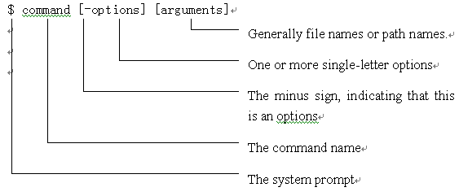
13. Name the different types if UNIX shells. What are the prompt signs for UNIX shells?
Answer: Bourne Shell(the sign is $), Korn Shell(the sign is $), C Shell(the sign is %), Bourne Again Shell(the sign is $).

14. What are the shell commands?
Answer: shell commands are part of the shell program, these built-in commands are recognized by the shell and are executed internally.

15. What are the utility programs?
Answer: utility programs s are executable programs that the shell locates and executes.

