Chapter 14
8.
The at command. Example: at 1530 Wed ; sort bigfile

10.
The tar command is used to archive files or transport files from one system to another. It copies a set of files into a single file that can be save on any disk media.

11.
The tarfile is a file created when the tar command is used.

13.
tar -t save.tar

Terminal Session
Chapter 12
6.
＃accept numbers passed from arguments on the command line,and sums them to display the #result.
if [ $# = 0 ]
then
echo "Error! Please specify at least one number as arguments on command line."
exit 0
fi
sum=
msg=
n=
for i in $@
do
let n=n+1
let sum=sum+i
if [ $n -le 1 ]
then
msg=$i
else
msg=$msg+$i
fi
done
echo “$msg = $sum”

9
#Accept three numbers from from arguments on the command line and shows the largest one of #them
if test $# = 3
then
if test "$1" -gt "$2" -a "$1" -gt "$3"
then
echo "The largest number is: $1"
elif test "$2" -gt "$1" -a "$2" -gt "$3"
then
echo "The largest number is: $2"
else
echo "The largest number is: $3"
fi
else
echo “Error! Please specify three numbers as arguments on command line.”
exit 0
fi
echo "Done! "

Chapter 12
10
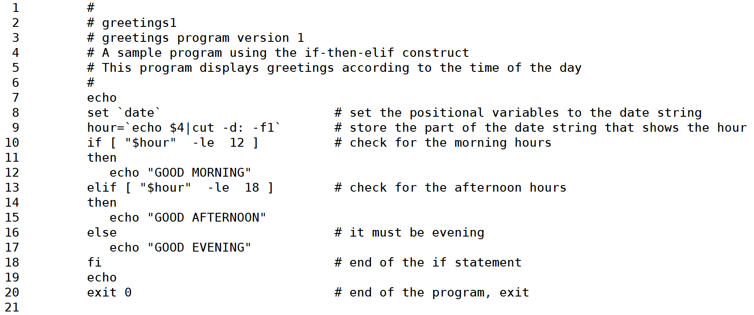
Chapter 13
10 see textbook p425 figure 13.7

