**Pais-Saclay University**

**Evry-Val-d’Essonne University**

**Quantitative Finance**



SABR calibration in Python

**Modeling of the yield curve**

Supervised by : Thomas LIM and Stephane KAMTA

Realized by: Zakaria Ben yechou and Antonio Antona

Academic year 2022/2023

**SABR calibration with swaption**

The objective of this project is to study the SABR model and to process an example of calibration of the model on real market data. This study consists in visualizing the curve of the volatility of the swaptions which allow us to predict the volatility at any strike. We will use the "Market-data.xlsx" database for the calibration of the SABR model.

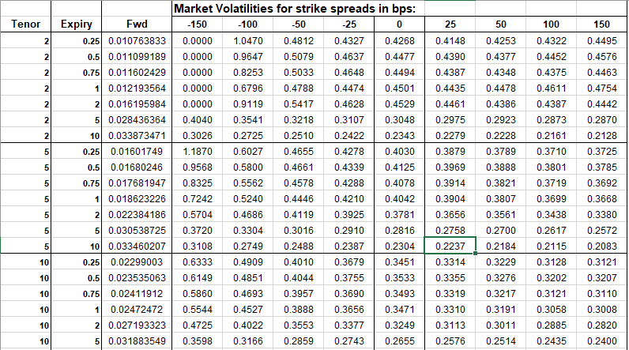

Figure 1 – Market data

Figure 1 includes the swaption volatilities quoted by tenor (2y, 5y, 10y, 15y, 30y), and expiry (3m ,6m, 9m, 1y, 2y, 5y, 10y).

**Calibration of the model:**

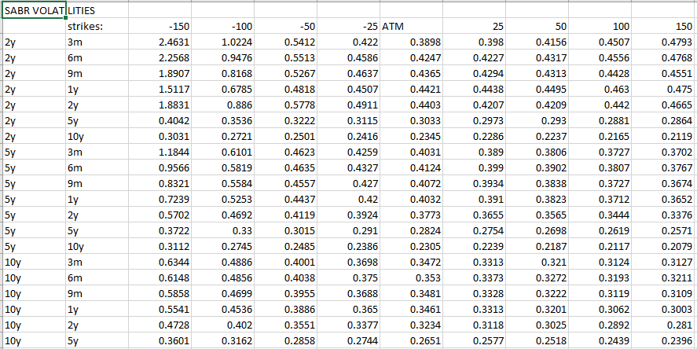The minimization problem to be solved by SABR model calibration is matching the market implied volatility with the SABR volatility evaluated for a given strike set and current forward rate for each maturity and each tenor. the results of the parameters of the SABR model are shown in the excel file "parameters", as well as the volatilities calculated by the model are shown in the file "outvol".

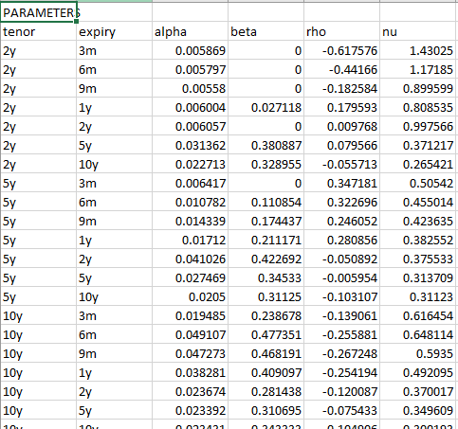Figure 2 – SABR volatilities

Figure 3 – SABR parameters

The 3D plot of the Swaption volatility surface and the fitted volatility surface (SABR) for 2 years and 10 years tenor are showed in the figures bellow.

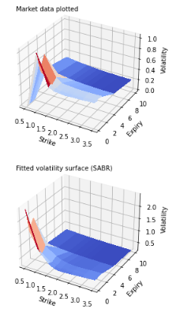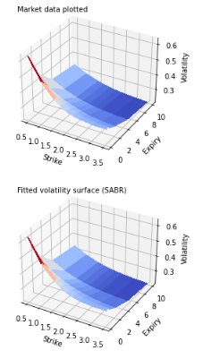

Figure 4 – Swaption volatility surface and Figure 5– Swaption volatility surface and

Swaption volatility surface SABR: tenor 2 years Swaption volatility surface SABR: tenor 2 years

Let us now examine more closely the goodness of fit of SABR model. To do so, we plot the volatility smile for four different expiry time: 3 and 6 mounts, 5 and 10 years, for tenors 2 years and 10 years.

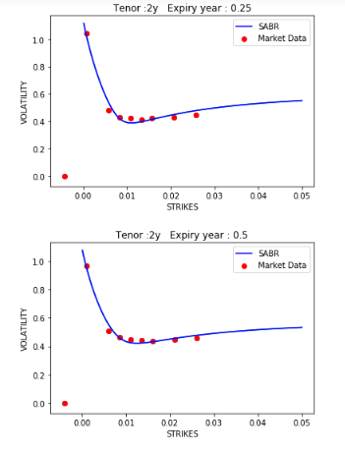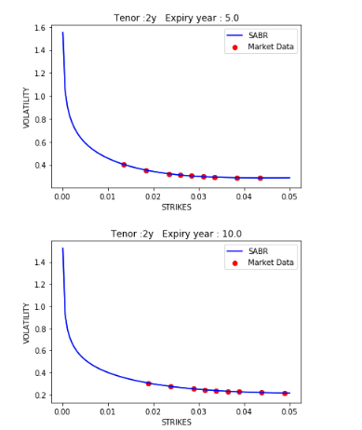Tenor : 2 years

Figure 6– 3 and 6 months Swaption Figure 7 – 5 and 10 years Swaption

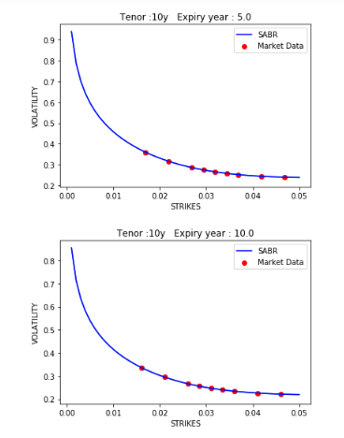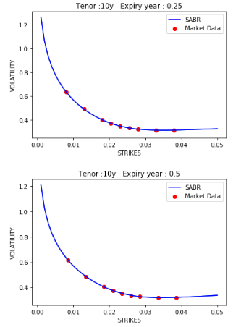Tenor : 10 years

Figure 8 – 3 and 6 months Swaption Figure 9 – 5 and 10 years Swaption

Conclusion :

— Clearly, as seen in the figures, the SABR parameters capture fairly well the left side of the volatility where the expiry time is relatively small.

— It seems the SABR fitted volatility smile does not quite match with the market implied volatility for small tenor and small expiry, due to the shift function applied for negative rates.

— The variation on the instantaneous volatility α is small especially at the large expiry part due to the flatness of the volatility surface.

— Using the SABR function and the parameters, we can predict the value of the swaption volatility at any strike for a tenor/expiry case.

Python CODE :

— The file SMILES.ipynb shows the code of the Smiles plots.

— The files 2y tenor.ipynb, 5y tenor.ipynb, 10y tenor.ipynb, 15y tenor.ipynb, 30y tenor.ipynb shows the 3D plots of the volatility surface for differents tenor.