pitches

How do pitch metrics (velocity and spin rate) influence effectiveness?
To quantify the effectiveness of each pitching group, we analyzed every pitch in the dataset and focused on outcomes that represent successful results for the pitcher: specifically, in-play outs (including groundouts, flyouts, and other standard outs) and strikeouts. For each pitch group, we divided the data into velocity bins of 3 mph (ranging from 75–110 mph) and spin rate bins of 300 rpm (ranging from 1200–4200 rpm). Within each bin, we calculated the total number of pitches and determined the percentage of those pitches that resulted in an out. The most effective velocity or spin rate for a given pitch group was defined as the bin that produced the highest percentage of outs, while also ensuring that only bins with a sufficient number of pitches (≥20) were considered to avoid statistical noise. This method allowed us to identify the pitch characteristics — both in terms of speed and spin — that were most likely to produce an out, thereby providing a quantitative measure of effectiveness for each pitch group.

visualizing and trimming our data
library(dplyr)
Warning: package 'dplyr' was built under R version 4.4.3
Attaching package: 'dplyr'
The following objects are masked from 'package:stats':
filter, lag
The following objects are masked from 'package:base':
intersect, setdiff, setequal, union
library(ggplot2)
Warning: package 'ggplot2' was built under R version 4.4.3
library(tidyr)
Warning: package 'tidyr' was built under R version 4.4.3
library(readr)
Warning: package 'readr' was built under R version 4.4.3
library(scales)
Warning: package 'scales' was built under R version 4.4.3
Attaching package: 'scales'
The following object is masked from 'package:readr':
col_factor
library(forcats)
Warning: package 'forcats' was built under R version 4.4.3
library(readr)
pitches_csv <- read_csv("pitches.csv (1).zip")
Rows: 2867154 Columns: 40
── Column specification ────────────────────────────────────────────────────────
Delimiter: ","
chr (3): code, type, pitch_type
dbl (37): px, pz, start_speed, end_speed, spin_rate, spin_dir, break_angle, ...
ℹ Use `spec()` to retrieve the full column specification for this data.
ℹ Specify the column types or set `show_col_types = FALSE` to quiet this message.
atbats_csv <- read_csv("atbats.csv.zip")
Rows: 740389 Columns: 11
── Column specification ────────────────────────────────────────────────────────
Delimiter: ","
chr (3): event, p_throws, stand
dbl (7): ab_id, batter_id, g_id, inning, o, p_score, pitcher_id
lgl (1): top
ℹ Use `spec()` to retrieve the full column specification for this data.
ℹ Specify the column types or set `show_col_types = FALSE` to quiet this message.
combined_data_sets <- pitches_csv |>
inner_join(atbats_csv, by = "ab_id")
#bargraph of all different pitches by count
ggplot(data = pitches_csv, aes(x = pitch_type)) +
geom_bar() + # Counts the number in each species
labs(title = "results by pitch",
x = "number thrown", # x-axis is the count
y = "type") + # y-axis is the species names
theme_minimal()
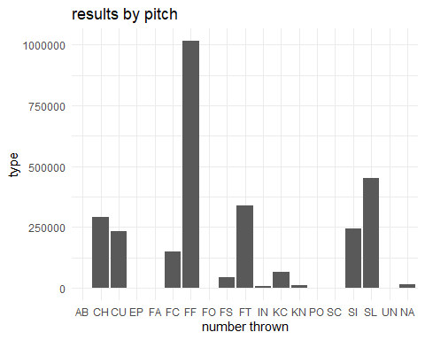
This is the complete data set with all pitches thrown over the course of 4 seasons (2015-2018), with over 2.8 million entries.
library(dplyr)
library(ggplot2)
library(scales) # for percent_format()
# 1. Create the pitch group column using the 2-letter codes
combined_data_sets <- combined_data_sets %>%
mutate(
pitch_group = case_when(
# Fastballs group: FF, FC, FT, SI
pitch_type %in% c("FF", "FC", "FT", "SI") ~ "Fastballs",
# Curveballs group: CU, KC
pitch_type %in% c("CU", "KC") ~ "Curveballs",
# Sliders group: SL
pitch_type == "SL" ~ "Sliders",
# Changeup/Splitter group: CH, FS
pitch_type %in% c("CH", "FS") ~ "Changeup/Splitter",
# Catch-all for anything else (IN, PO, KN, SC, EP, UN, etc.)
TRUE ~ "Other / Rare"
)
)
# 2. Summarize: count per group + calculate percentage
pitch_summary <- combined_data_sets %>%
count(pitch_group) %>%
mutate(
percentage = n / sum(n) * 100,
perc_label = sprintf("%.1f%%", percentage)
) %>%
# Order from highest to lowest percentage
mutate(pitch_group = forcats::fct_reorder(pitch_group, percentage, .desc = TRUE))
# 3. Create the bar chart
ggplot(pitch_summary, aes(x = pitch_group, y = percentage, fill = pitch_group)) +
# Draw the bars
geom_col() +
# Add percentage labels on top
geom_text(
aes(label = perc_label),
vjust = -0.4, # slightly above bar
size = 4.5,
fontface = "bold"
) +
# Format y-axis as percentages
scale_y_continuous(
labels = percent_format(scale = 1),
expand = expansion(mult = c(0, 0.12)) # room for labels
) +
# Titles and styling
labs(
title = "Percentage of Pitches by Pitch Group",
subtitle = paste("Total pitches:", format(sum(pitch_summary$n), big.mark = ",")),
x = NULL,
y = "Percentage of All Pitches (%)"
) +
scale_fill_viridis_d(option = "plasma", begin = 0.2, end = 0.9) +
theme_minimal(base_size = 14) +
theme(
legend.position = "none", # no legend needed
axis.text.x = element_text(angle = 0, hjust = 0.5),
plot.title = element_text(face = "bold")
)
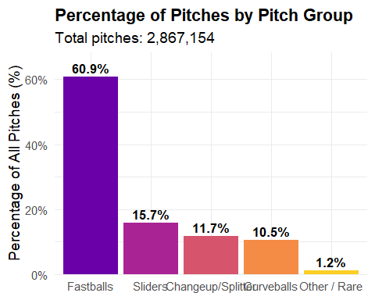
The bar chart visualizes the distribution of pitches across four main pitch groups — Fastballs, Curveballs, Sliders, and Changeup/Splitters — which were created by combining the individual pitch types based on their two-letter codes. Fastballs include “FF,” “FC,” “FT,” and “SI,” Curveballs include “CU” and “KC,” Sliders are “SL,” and Changeup/Splitters include “CH” and “FS.” This grouping simplifies the analysis by consolidating multiple pitch types with similar characteristics and roles into broader categories, making patterns easier to observe and interpret.
Each bar represents the percentage of total pitches that belong to that pitch group, with the height of the bar showing its relative frequency in the dataset and the text label displaying the exact percentage. The “Other / Rare” category includes uncommon or irregular pitch types (such as “IN,” “PO,” “KN,” “SC,” “EP,” “UN,” etc.) that occur very infrequently. These pitches are excluded from deeper analysis because they are too rare to provide meaningful statistical insight, and including them could add noise to the results. By focusing on the main four groups, we capture the vast majority of pitches and can more reliably study pitch effectiveness, velocity, spin rate, and outcomes.

Pitch Metrics - Initial Start Speed
combined_data_sets %>%
ggplot(aes(x = pitch_group, y = start_speed)) +
geom_boxplot() +
labs(
x = "Pitch Group",
y = "Speed (mph)",
title = "Speed by Pitch Group"
) +
theme(
axis.text.x = element_text(angle = 90, vjust = 0.5, hjust = 1)
)
Warning: Removed 14114 rows containing non-finite outside the scale range
(`stat_boxplot()`).
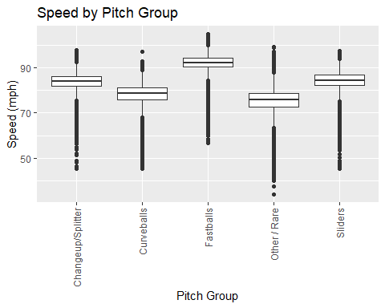
library(dplyr)
library(ggplot2)
library(tidyr)
# 1. Compute summary statistics safely
pitch_speed_stats <- combined_data_sets %>%
group_by(pitch_group) %>%
summarise(
n = sum(!is.na(start_speed)), # count only non-NA
min_mph = min(start_speed, na.rm = TRUE),
q1_mph = quantile(start_speed, 0.25, na.rm = TRUE),
median_mph = median(start_speed, na.rm = TRUE),
mean_mph = mean(start_speed, na.rm = TRUE),
q3_mph = quantile(start_speed, 0.75, na.rm = TRUE),
max_mph = max(start_speed, na.rm = TRUE),
.groups = "drop"
) %>%
mutate(across(where(is.numeric), ~round(., 1))) %>%
arrange(desc(median_mph))
# 2. Reshape to long format
pitch_long <- pitch_speed_stats %>%
pivot_longer(
cols = c(n, min_mph, q1_mph, median_mph, mean_mph, q3_mph, max_mph),
names_to = "statistic",
values_to = "value"
) %>%
mutate(
statistic = case_when(
statistic == "n" ~ "n",
statistic == "min_mph" ~ "Min",
statistic == "q1_mph" ~ "Q1",
statistic == "median_mph" ~ "Median",
statistic == "mean_mph" ~ "Mean",
statistic == "q3_mph" ~ "Q3",
statistic == "max_mph" ~ "Max"
)
)
# 3. Plot the table
ggplot() +
geom_tile(
data = pitch_long,
aes(x = statistic, y = pitch_group),
fill = "white",
color = "grey60",
linewidth = 0.4
) +
geom_text(
data = pitch_long,
aes(x = statistic, y = pitch_group, label = value),
size = 4.2,
fontface = "bold"
) +
scale_x_discrete(
position = "top",
limits = c("n", "Min", "Q1", "Median", "Mean", "Q3", "Max")
) +
labs(
title = "Pitch Speed Statistics by Group",
x = NULL,
y = NULL
) +
theme_minimal(base_size = 14) +
theme(
axis.text.x.top = element_text(face = "bold", size = 12),
axis.text.y = element_text(face = "bold", size = 12),
panel.grid = element_blank(),
axis.ticks = element_blank(),
panel.border = element_rect(color = "black", fill = NA, linewidth = 1),
plot.title = element_text(face = "bold", hjust = 0.5),
plot.subtitle = element_text(hjust = 0.5)
) +
coord_cartesian(xlim = c(0.5, 7.5))
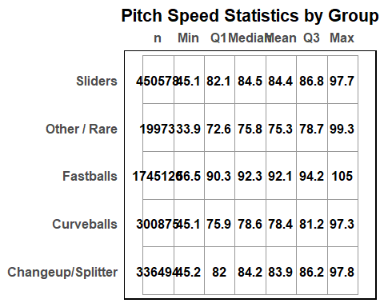

Pitch metrics - Spin Rate (active rate)
library(dplyr)
library(ggplot2)
combined_data_sets %>%
# Filter to remove outliers
filter(spin_rate >= 1200 & spin_rate <= 4200) %>%
ggplot(aes(x = pitch_group, y = spin_rate)) +
geom_boxplot() +
labs(
x = "Pitch Group",
y = "Spin Rate",
title = "Spin Rate by Pitch Group (Filtered)"
) +
theme(
axis.text.x = element_text(angle = 90, vjust = 0.5, hjust = 1) # vertical x labels
)
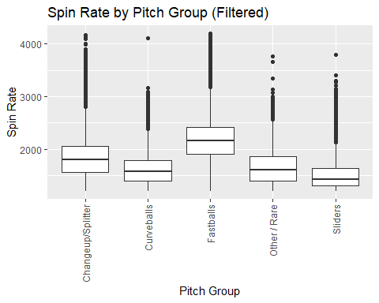
library(dplyr)
library(ggplot2)
library(tidyr)
# 1. Compute summary statistics safely for spin_rate, only within 1200-4200 rpm
spin_rate_stats <- combined_data_sets %>%
filter(spin_rate >= 1200 & spin_rate <= 4200) %>% # 🔹 filter range
group_by(pitch_group) %>%
summarise(
n = sum(!is.na(spin_rate)), # count only non-NA
min_rpm = min(spin_rate, na.rm = TRUE),
q1_rpm = quantile(spin_rate, 0.25, na.rm = TRUE),
median_rpm = median(spin_rate, na.rm = TRUE),
mean_rpm = mean(spin_rate, na.rm = TRUE),
q3_rpm = quantile(spin_rate, 0.75, na.rm = TRUE),
max_rpm = max(spin_rate, na.rm = TRUE),
.groups = "drop"
) %>%
mutate(across(where(is.numeric), ~round(., 1))) %>%
arrange(desc(median_rpm))
# 2. Reshape to long format
spin_long <- spin_rate_stats %>%
pivot_longer(
cols = c(n, min_rpm, q1_rpm, median_rpm, mean_rpm, q3_rpm, max_rpm),
names_to = "statistic",
values_to = "value"
) %>%
mutate(
statistic = case_when(
statistic == "n" ~ "n",
statistic == "min_rpm" ~ "Min",
statistic == "q1_rpm" ~ "Q1",
statistic == "median_rpm" ~ "Median",
statistic == "mean_rpm" ~ "Mean",
statistic == "q3_rpm" ~ "Q3",
statistic == "max_rpm" ~ "Max"
)
)
# 3. Plot the table for spin rate
ggplot() +
geom_tile(
data = spin_long,
aes(x = statistic, y = pitch_group),
fill = "white",
color = "grey60",
linewidth = 0.4
) +
geom_text(
data = spin_long,
aes(x = statistic, y = pitch_group, label = value),
size = 4.2,
fontface = "bold"
) +
scale_x_discrete(
position = "top",
limits = c("n", "Min", "Q1", "Median", "Mean", "Q3", "Max")
) +
labs(
title = "Spin Rate Statistics by Pitch Group (1200–4200 rpm)",
x = NULL,
y = NULL
) +
theme_minimal(base_size = 14) +
theme(
axis.text.x.top = element_text(face = "bold", size = 12),
axis.text.y = element_text(face = "bold", size = 12),
panel.grid = element_blank(),
axis.ticks = element_blank(),
panel.border = element_rect(color = "black", fill = NA, linewidth = 1),
plot.title = element_text(face = "bold", hjust = 0.5)
) +
coord_cartesian(xlim = c(0.5, 7.5))
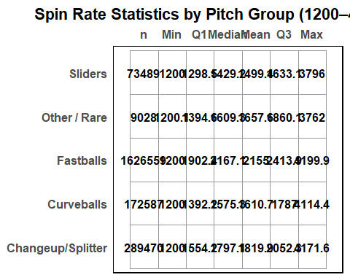

Events Data Sets
library(ggplot2)
ggplot(combined_data_sets, aes(x = event)) +
geom_bar() +
labs(
x = "Event",
y = "Count",
title = "Count of Events"
) +
theme_minimal() +
theme(
axis.text.x = element_text(angle = 90, vjust = 0.5, hjust = 1)
)
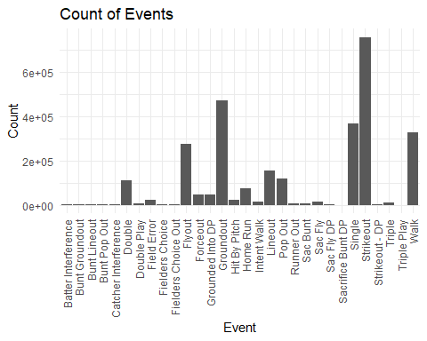
We have a similar problem with the events of the data set, as there are just far to many outcomes.
library(dplyr)
library(ggplot2)
library(scales)
# 1. Create the event group column
combined_data_sets <- combined_data_sets %>%
mutate(
event_group = case_when(
event %in% c(
"Bunt Groundout",
"Bunt Line Out",
"Bunt Pop Out",
"Double Play",
"Flyout",
"Forceout",
"Grounded Into A Double Play",
"Ground Out",
"Line Out",
"Popout"
) ~ "In-Play Outs",
event %in% c(
"Strikeout",
"Strikeout DP"
) ~ "Strikeouts",
event %in% c(
"Walk",
"Intentional Walk",
"Hit By Pitch",
"Catcher's Interference"
) ~ "Walks / HBP",
event %in% c(
"Single",
"Double",
"Triple",
"Home Run"
) ~ "Hits",
TRUE ~ "Other / Rare"
)
)
# 2. Summarize (excluding Other / Rare)
event_summary <- combined_data_sets %>%
filter(event_group != "Other / Rare") %>%
count(event_group) %>%
mutate(
percentage = n / sum(n) * 100,
perc_label = sprintf("%.1f%%", percentage)
) %>%
mutate(event_group = forcats::fct_reorder(event_group, percentage, .desc = TRUE))
# 3. Create the bar chart (no total shown)
ggplot(event_summary, aes(x = event_group, y = percentage, fill = event_group)) +
geom_col() +
geom_text(
aes(label = perc_label),
vjust = -0.4,
size = 4.5,
fontface = "bold"
) +
scale_y_continuous(
labels = percent_format(scale = 1),
expand = expansion(mult = c(0, 0.12))
) +
labs(
title = "Percentage of Plate Appearances by Event Group",
x = NULL,
y = "Percentage of All Events (%)"
) +
scale_fill_viridis_d(option = "plasma", begin = 0.2, end = 0.9) +
theme_minimal(base_size = 14) +
theme(
legend.position = "none",
axis.text.x = element_text(angle = 0, hjust = 0.5),
plot.title = element_text(face = "bold")
)
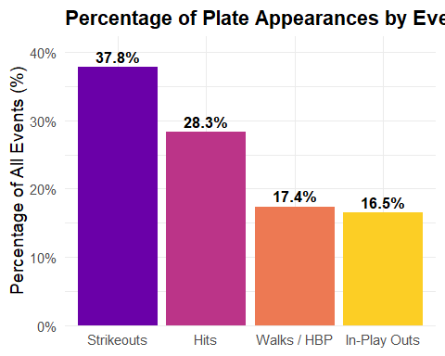

Pitches metrics vs outcome

Fastballs Velocity/Spin Rate x Outcome
library(dplyr)
library(ggplot2)
library(scales)
# 1. Filter Fastballs, speed range, and remove "Other / Rare"
fastballs <- combined_data_sets %>%
filter(
pitch_group == "Fastballs",
start_speed >= 65,
start_speed <= 110,
event_group != "Other / Rare"
)
# 2. Create 3 mph bins
fastballs <- fastballs %>%
mutate(
speed_bin = cut(
start_speed,
breaks = seq(65, 110, by = 3), # 🔹 3 mph bins
include.lowest = TRUE,
right = FALSE
)
)
# 3. Summarize counts per bin & event_group
bin_summary <- fastballs %>%
group_by(speed_bin, event_group) %>%
summarise(count = n(), .groups = "drop")
# 4. Plot stacked bar chart
ggplot(bin_summary, aes(x = speed_bin, y = count, fill = event_group)) +
geom_bar(stat = "identity", color = "black") +
scale_fill_viridis_d(option = "plasma", begin = 0.2, end = 0.9, name = "Event Group") +
labs(
x = "Pitch Speed (mph, 3 mph bins)",
y = "Count",
title = "Fastball Event Group Distribution by Speed Bin"
) +
theme_minimal(base_size = 14) +
theme(
axis.text.x = element_text(angle = 90, vjust = 0.5, hjust = 1),
plot.title = element_text(face = "bold"),
plot.subtitle = element_text(size = 12),
legend.position = "right"
)
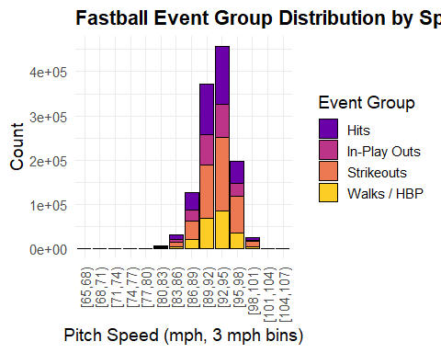

library(dplyr)
library(ggplot2)
library(tidyr)
library(scales)
# 1. Filter Fastballs, speed range, and remove "Other / Rare"
fastballs <- combined_data_sets %>%
filter(
pitch_group == "Fastballs",
start_speed >= 80,
start_speed <= 105,
event_group != "Other / Rare"
)
# 2. Create 3 mph bins
fastballs <- fastballs %>%
mutate(
speed_bin = cut(
start_speed,
breaks = seq(80, 105, by = 3),
include.lowest = TRUE,
right = FALSE
)
)
# 3. Count pitches per bin & event_group and compute percentages
table_data <- fastballs %>%
group_by(speed_bin, event_group) %>%
summarise(count = n(), .groups = "drop") %>%
group_by(speed_bin) %>%
mutate(perc = count / sum(count) * 100) %>%
ungroup()
# 4. Plot table-style heatmap
ggplot(table_data, aes(x = event_group, y = speed_bin, fill = perc)) +
geom_tile(color = "grey60") +
geom_text(aes(label = sprintf("%.1f%%", perc)), color = "black", fontface = "bold") +
scale_fill_viridis_c(option = "plasma", name = "% of Bin") +
labs(
x = "Event Group",
y = "Pitch Speed Bin (mph, 3 mph)",
title = "Percentage of Fastball Event Groups by Speed Bin"
) +
theme_minimal(base_size = 14) +
theme(
axis.text.x = element_text(angle = 45, hjust = 1, face = "bold"),
axis.text.y = element_text(face = "bold"),
plot.title = element_text(face = "bold", hjust = 0.5),
plot.subtitle = element_text(hjust = 0.5)
)
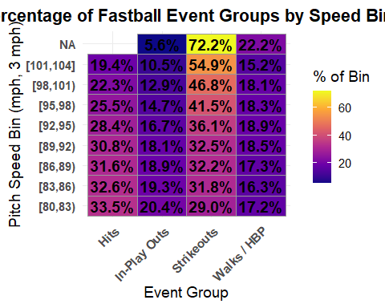
library(dplyr)
library(ggplot2)
library(scales)
# 1. Filter Fastballs, spin rate range, remove "Other / Rare"
fastballs <- combined_data_sets %>%
filter(
pitch_group == "Fastballs",
spin_rate >= 1200,
spin_rate <= 4200,
event_group != "Other / Rare"
)
# 2. Create 300 rpm bins
breaks <- seq(1200, 4200, by = 300)
fastballs <- fastballs %>%
mutate(
spin_bin = cut(
spin_rate,
breaks = breaks,
include.lowest = TRUE,
right = FALSE
)
)
# 3. Create custom bin labels like "1200-1500", "1500-1800", etc.
bin_labels <- paste(head(breaks, -1), tail(breaks, -1), sep = "-")
fastballs <- fastballs %>%
mutate(
spin_bin = factor(spin_bin, labels = bin_labels)
)
# 4. Summarize counts per bin & event_group
bin_summary <- fastballs %>%
group_by(spin_bin, event_group) %>%
summarise(count = n(), .groups = "drop")
# 5. Plot stacked bar chart with custom bin labels
ggplot(bin_summary, aes(x = spin_bin, y = count, fill = event_group)) +
geom_bar(stat = "identity", color = "black") +
scale_fill_viridis_d(option = "plasma", begin = 0.2, end = 0.9, name = "Event Group") +
labs(
x = "Spin Rate (rpm)",
y = "Count",
title = "Fastball Event Group Distribution by Spin Rate"
) +
theme_minimal(base_size = 14) +
theme(
axis.text.x = element_text(angle = 45, vjust = 1, hjust = 1, face = "bold"), # angled for readability
plot.title = element_text(face = "bold"),
plot.subtitle = element_text(size = 12),
legend.position = "right"
)
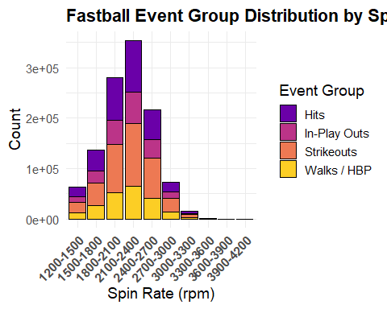
library(dplyr)
library(ggplot2)
library(tidyr)
library(scales)
# 1. Filter Fastballs, spin rate range, remove "Other / Rare"
fastballs <- combined_data_sets %>%
filter(
pitch_group == "Fastballs",
spin_rate >= 1200,
spin_rate <= 4200,
event_group != "Other / Rare"
)
# 2. Create 300 rpm bins
breaks <- seq(1200, 4200, by = 300)
fastballs <- fastballs %>%
mutate(
spin_bin = cut(
spin_rate,
breaks = breaks,
include.lowest = TRUE,
right = FALSE
)
)
# 3. Create custom bin labels like "1200-1500", "1500-1800", etc.
bin_labels <- paste(head(breaks, -1), tail(breaks, -1), sep = "-")
fastballs <- fastballs %>%
mutate(
spin_bin = factor(spin_bin, labels = bin_labels)
)
# 4. Count pitches per bin & event_group and compute percentage
table_data <- fastballs %>%
group_by(spin_bin, event_group) %>%
summarise(count = n(), .groups = "drop") %>%
group_by(spin_bin) %>%
mutate(perc = count / sum(count) * 100) %>%
ungroup()
# 5. Plot table-style heatmap
ggplot(table_data, aes(x = event_group, y = spin_bin, fill = perc)) +
geom_tile(color = "grey60") +
geom_text(aes(label = sprintf("%.1f%%", perc)), color = "black", fontface = "bold") +
scale_fill_viridis_c(option = "plasma", name = "% of Bin") +
labs(
x = "Event Group",
y = "Spin Rate Bin (rpm, 300 rpm)",
title = "Percentage of Fastball Event Groups by Spin Rate Bin"
) +
theme_minimal(base_size = 14) +
theme(
axis.text.x = element_text(angle = 45, hjust = 1, face = "bold"),
axis.text.y = element_text(face = "bold"),
plot.title = element_text(face = "bold", hjust = 0.5),
plot.subtitle = element_text(hjust = 0.5)
)
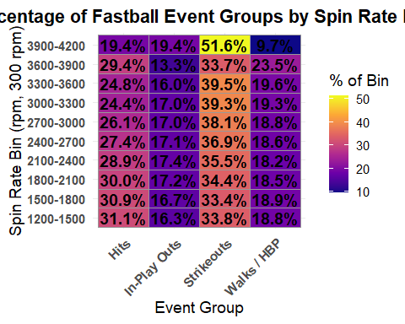

Curveball Velocity/Spinrate x Outcomes
library(dplyr)
library(ggplot2)
library(scales)
# 1. Filter Curveballs, speed range, remove "Other / Rare"
curveballs <- combined_data_sets %>%
filter(
pitch_group == "Curveballs",
start_speed >= 55,
start_speed <= 100,
event_group != "Other / Rare"
)
# 2. Create 4 mph bins
curveballs <- curveballs %>%
mutate(
speed_bin = cut(
start_speed,
breaks = seq(55, 100, by = 4), # 4 mph bins
include.lowest = TRUE,
right = FALSE
)
)
# 3. Summarize counts per bin & event_group
bin_summary <- curveballs %>%
group_by(speed_bin, event_group) %>%
summarise(count = n(), .groups = "drop")
# 4. Plot stacked bar chart
ggplot(bin_summary, aes(x = speed_bin, y = count, fill = event_group)) +
geom_bar(stat = "identity", color = "black") +
scale_fill_viridis_d(option = "plasma", begin = 0.2, end = 0.9, name = "Event Group") +
labs(
x = "Pitch Speed (mph, 4 mph bins)",
y = "Count",
title = "Curveball Event Group Distribution by Speed Bin",
subtitle = "Bars stacked by event_group showing proportion in each bin (Other / Rare removed)"
) +
theme_minimal(base_size = 14) +
theme(
axis.text.x = element_text(angle = 90, vjust = 0.5, hjust = 1),
plot.title = element_text(face = "bold"),
plot.subtitle = element_text(size = 12),
legend.position = "right"
)
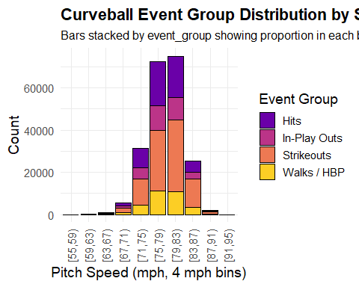
library(dplyr)
library(ggplot2)
library(tidyr)
library(scales)
# 1. Filter Curveballs, speed range, remove "Other / Rare"
curveballs <- combined_data_sets %>%
filter(
pitch_group == "Curveballs",
start_speed >= 55,
start_speed <= 100,
event_group != "Other / Rare"
)
# 2. Define breaks so the last bin includes 100
breaks <- seq(55, 104, by = 4) # 55, 59, 63, ..., 101 → last bin includes 100
# 3. Create bin labels (length = length(breaks)-1)
bin_labels <- paste(head(breaks, -1), tail(breaks, -1), sep = "-")
# 4. Create the bins and assign labels
curveballs <- curveballs %>%
mutate(
speed_bin = cut(
start_speed,
breaks = breaks,
include.lowest = TRUE,
right = FALSE,
labels = bin_labels
)
)
# 5. Count pitches per bin & event_group, compute percentages
table_data <- curveballs %>%
group_by(speed_bin, event_group) %>%
summarise(count = n(), .groups = "drop") %>%
group_by(speed_bin) %>%
mutate(perc = count / sum(count) * 100) %>%
ungroup()
# 6. Plot table-style heatmap
ggplot(table_data, aes(x = event_group, y = speed_bin, fill = perc)) +
geom_tile(color = "grey60") +
geom_text(aes(label = sprintf("%.1f%%", perc)), color = "black", fontface = "bold") +
scale_fill_viridis_c(option = "plasma", name = "% of Bin") +
labs(
x = "Event Group",
y = "Pitch Speed Bin (mph, 4 mph)",
title = "Percentage of Curveball Event Groups by Speed Bin",
subtitle = "Percent of pitches in each 4 mph bin belonging to each outcome (Other / Rare removed)"
) +
theme_minimal(base_size = 14) +
theme(
axis.text.x = element_text(angle = 45, hjust = 1, face = "bold"),
axis.text.y = element_text(face = "bold"),
plot.title = element_text(face = "bold", hjust = 0.5),
plot.subtitle = element_text(hjust = 0.5)
)
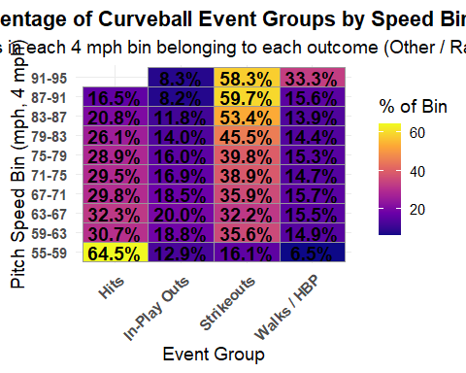
library(dplyr)
library(ggplot2)
library(scales)
# 1. Filter Curveballs, spin rate range, remove "Other / Rare"
curveballs <- combined_data_sets %>%
filter(
pitch_group == "Curveballs",
spin_rate >= 1200,
spin_rate <= 4200,
event_group != "Other / Rare"
)
# 2. Create 300 rpm bins
breaks <- seq(1200, 4200, by = 300)
bin_labels <- paste(head(breaks, -1), tail(breaks, -1), sep = "-")
curveballs <- curveballs %>%
mutate(
spin_bin = cut(
spin_rate,
breaks = breaks,
include.lowest = TRUE,
right = FALSE,
labels = bin_labels
)
)
# 3. Summarize counts per bin & event_group
bin_summary <- curveballs %>%
group_by(spin_bin, event_group) %>%
summarise(count = n(), .groups = "drop")
# 4. Plot stacked bar chart
ggplot(bin_summary, aes(x = spin_bin, y = count, fill = event_group)) +
geom_bar(stat = "identity", color = "black") +
scale_fill_viridis_d(option = "plasma", begin = 0.2, end = 0.9, name = "Event Group") +
labs(
x = "Spin Rate (rpm, 300 rpm bins)",
y = "Count",
title = "Curveball Event Group Distribution by Spin Rate",
subtitle = "Bars stacked by event_group showing proportion in each bin (Other / Rare removed)"
) +
theme_minimal(base_size = 14) +
theme(
axis.text.x = element_text(angle = 45, hjust = 1, face = "bold"),
plot.title = element_text(face = "bold"),
plot.subtitle = element_text(size = 12),
legend.position = "right"
)
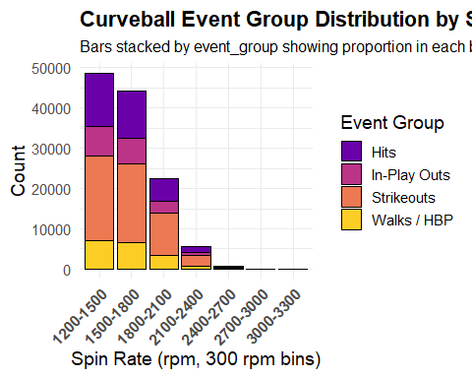
library(dplyr)
library(ggplot2)
library(tidyr)
library(scales)
# 1. Filter Curveballs, spin rate range, remove "Other / Rare"
curveballs <- combined_data_sets %>%
filter(
pitch_group == "Curveballs",
spin_rate >= 1200,
spin_rate <= 4200,
event_group != "Other / Rare"
)
# 2. Create 300 rpm bins
breaks <- seq(1200, 4200, by = 300)
bin_labels <- paste(head(breaks, -1), tail(breaks, -1), sep = "-")
curveballs <- curveballs %>%
mutate(
spin_bin = cut(
spin_rate,
breaks = breaks,
include.lowest = TRUE,
right = FALSE,
labels = bin_labels
)
)
# 3. Count pitches per bin & event_group, compute percentage
table_data <- curveballs %>%
group_by(spin_bin, event_group) %>%
summarise(count = n(), .groups = "drop") %>%
group_by(spin_bin) %>%
mutate(perc = count / sum(count) * 100) %>%
ungroup()
# 4. Plot table-style heatmap
ggplot(table_data, aes(x = event_group, y = spin_bin, fill = perc)) +
geom_tile(color = "grey60") +
geom_text(aes(label = sprintf("%.1f%%", perc)), color = "black", fontface = "bold") +
scale_fill_viridis_c(option = "plasma", name = "% of Bin") +
labs(
x = "Event Group",
y = "Spin Rate Bin (rpm, 300 rpm)",
title = "Percentage of Curveball Event Groups by Spin Rate Bin"
) +
theme_minimal(base_size = 14) +
theme(
axis.text.x = element_text(angle = 45, hjust = 1, face = "bold"),
axis.text.y = element_text(face = "bold"),
plot.title = element_text(face = "bold", hjust = 0.5),
plot.subtitle = element_text(hjust = 0.5)
)
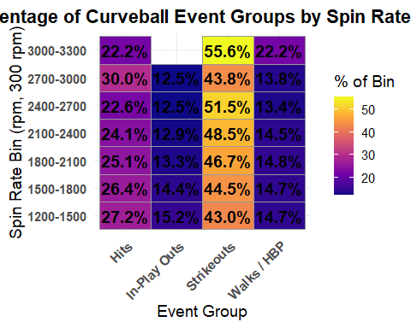

Sliders Velocity/Spinrate x Outcome
library(dplyr)
library(ggplot2)
library(scales)
# Filter Sliders, speed range, remove "Other / Rare"
sliders <- combined_data_sets %>%
filter(
pitch_group == "Sliders",
start_speed >= 55, # sliders tend to be slower
start_speed <= 100,
event_group != "Other / Rare"
)
# Create 4 mph bins
breaks_speed <- seq(55, 100, by = 4)
bin_labels_speed <- paste(head(breaks_speed, -1), tail(breaks_speed, -1), sep = "-")
sliders <- sliders %>%
mutate(
speed_bin = cut(
start_speed,
breaks = breaks_speed,
include.lowest = TRUE,
right = FALSE,
labels = bin_labels_speed
)
)
# Summarize counts per bin & event_group
speed_summary <- sliders %>%
group_by(speed_bin, event_group) %>%
summarise(count = n(), .groups = "drop")
# Plot stacked bar chart for pitch speed
ggplot(speed_summary, aes(x = speed_bin, y = count, fill = event_group)) +
geom_bar(stat = "identity", color = "black") +
scale_fill_viridis_d(option = "plasma", begin = 0.2, end = 0.9, name = "Event Group") +
labs(
x = "Pitch Speed (mph, 4 mph bins)",
y = "Count",
title = "Slider Event Group Distribution by Pitch Speed"
) +
theme_minimal(base_size = 14) +
theme(
axis.text.x = element_text(angle = 45, hjust = 1, face = "bold"),
plot.title = element_text(face = "bold"),
plot.subtitle = element_text(size = 12),
legend.position = "right"
)
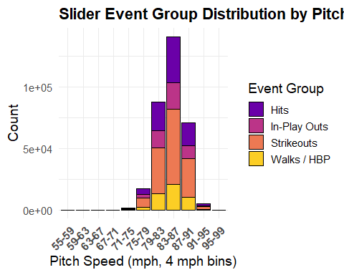
# Count pitches per speed bin & event_group, compute percentages
speed_table <- sliders %>%
group_by(speed_bin, event_group) %>%
summarise(count = n(), .groups = "drop") %>%
group_by(speed_bin) %>%
mutate(perc = count / sum(count) * 100) %>%
ungroup()
# Plot table-style heatmap
ggplot(speed_table, aes(x = event_group, y = speed_bin, fill = perc)) +
geom_tile(color = "grey60") +
geom_text(aes(label = sprintf("%.1f%%", perc)), color = "black", fontface = "bold") +
scale_fill_viridis_c(option = "plasma", name = "% of Bin") +
labs(
x = "Event Group",
y = "Pitch Speed Bin (mph, 4 mph)",
title = "Percentage of Slider Event Groups by Pitch Speed Bin"
) +
theme_minimal(base_size = 14) +
theme(
axis.text.x = element_text(angle = 45, hjust = 1, face = "bold"),
axis.text.y = element_text(face = "bold"),
plot.title = element_text(face = "bold", hjust = 0.5),
plot.subtitle = element_text(hjust = 0.5)
)
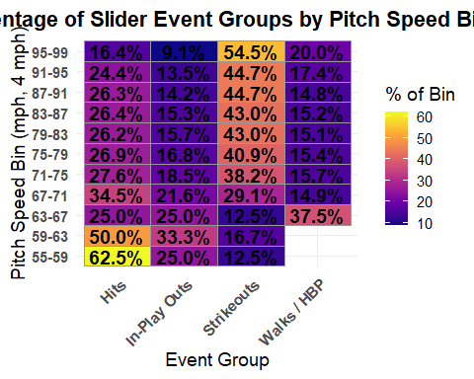
# Filter spin rate range 1200–4200 rpm
sliders_spin <- sliders %>%
filter(spin_rate >= 1200, spin_rate <= 4200)
# Create 300 rpm bins
breaks_spin <- seq(1200, 4200, by = 300)
bin_labels_spin <- paste(head(breaks_spin, -1), tail(breaks_spin, -1), sep = "-")
sliders_spin <- sliders_spin %>%
mutate(
spin_bin = cut(
spin_rate,
breaks = breaks_spin,
include.lowest = TRUE,
right = FALSE,
labels = bin_labels_spin
)
)
# Summarize counts per bin & event_group
spin_summary <- sliders_spin %>%
group_by(spin_bin, event_group) %>%
summarise(count = n(), .groups = "drop")
# Plot stacked bar chart for spin rate
ggplot(spin_summary, aes(x = spin_bin, y = count, fill = event_group)) +
geom_bar(stat = "identity", color = "black") +
scale_fill_viridis_d(option = "plasma", begin = 0.2, end = 0.9, name = "Event Group") +
labs(
x = "Spin Rate (rpm, 300 rpm bins)",
y = "Count",
title = "Slider Event Group Distribution by Spin Rate"
) +
theme_minimal(base_size = 14) +
theme(
axis.text.x = element_text(angle = 45, hjust = 1, face = "bold"),
plot.title = element_text(face = "bold"),
plot.subtitle = element_text(size = 12),
legend.position = "right"
)
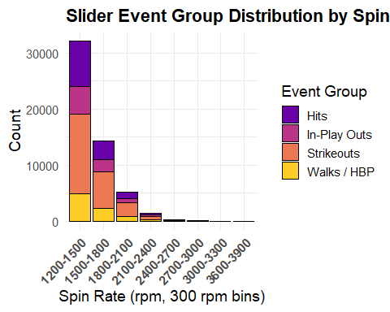
# Count pitches per spin bin & event_group, compute percentages
spin_table <- sliders_spin %>%
group_by(spin_bin, event_group) %>%
summarise(count = n(), .groups = "drop") %>%
group_by(spin_bin) %>%
mutate(perc = count / sum(count) * 100) %>%
ungroup()
# Plot table-style heatmap
ggplot(spin_table, aes(x = event_group, y = spin_bin, fill = perc)) +
geom_tile(color = "grey60") +
geom_text(aes(label = sprintf("%.1f%%", perc)), color = "black", fontface = "bold") +
scale_fill_viridis_c(option = "plasma", name = "% of Bin") +
labs(
x = "Event Group",
y = "Spin Rate Bin (rpm, 300 rpm)",
title = "Percentage of Slider Event Groups by Spin Rate Bin"
) +
theme_minimal(base_size = 14) +
theme(
axis.text.x = element_text(angle = 45, hjust = 1, face = "bold"),
axis.text.y = element_text(face = "bold"),
plot.title = element_text(face = "bold", hjust = 0.5),
plot.subtitle = element_text(hjust = 0.5)
)
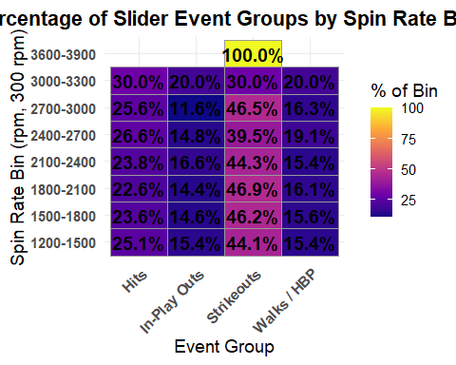

Changeups Velocity/Spin Rate x Outcome
library(dplyr)
library(ggplot2)
library(scales)
# Filter Changeups, speed range, remove "Other / Rare"
changeups <- combined_data_sets %>%
filter(
pitch_group == "Changeup/Splitter",
start_speed >= 55, # changeups are slower pitches
start_speed <= 100,
event_group != "Other / Rare"
)
# Create 4 mph bins
breaks_speed <- seq(55, 100, by = 4)
bin_labels_speed <- paste(head(breaks_speed, -1), tail(breaks_speed, -1), sep = "-")
changeups <- changeups %>%
mutate(
speed_bin = cut(
start_speed,
breaks = breaks_speed,
include.lowest = TRUE,
right = FALSE,
labels = bin_labels_speed
)
)
# Summarize counts per bin & event_group
speed_summary <- changeups %>%
group_by(speed_bin, event_group) %>%
summarise(count = n(), .groups = "drop")
# Plot stacked bar chart for pitch speed
ggplot(speed_summary, aes(x = speed_bin, y = count, fill = event_group)) +
geom_bar(stat = "identity", color = "black") +
scale_fill_viridis_d(option = "plasma", begin = 0.2, end = 0.9, name = "Event Group") +
labs(
x = "Pitch Speed (mph, 4 mph bins)",
y = "Count",
title = "Changeup Event Group Distribution by Pitch Speed"
) +
theme_minimal(base_size = 14) +
theme(
axis.text.x = element_text(angle = 45, hjust = 1, face = "bold"),
plot.title = element_text(face = "bold"),
plot.subtitle = element_text(size = 12),
legend.position = "right"
)
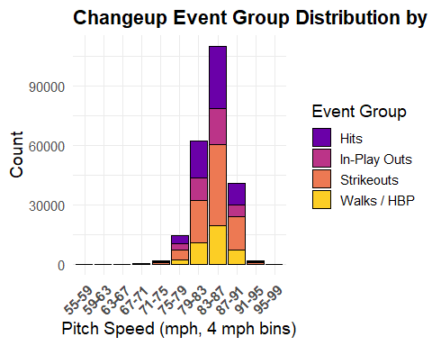
# Count pitches per speed bin & event_group, compute percentages
speed_table <- changeups %>%
group_by(speed_bin, event_group) %>%
summarise(count = n(), .groups = "drop") %>%
group_by(speed_bin) %>%
mutate(perc = count / sum(count) * 100) %>%
ungroup()
# Plot table-style heatmap
ggplot(speed_table, aes(x = event_group, y = speed_bin, fill = perc)) +
geom_tile(color = "grey60") +
geom_text(aes(label = sprintf("%.1f%%", perc)), color = "black", fontface = "bold") +
scale_fill_viridis_c(option = "plasma", name = "% of Bin") +
labs(
x = "Event Group",
y = "Pitch Speed Bin (mph, 4 mph)",
title = "Percentage of Changeup Event Groups by Pitch Speed Bin"
) +
theme_minimal(base_size = 14) +
theme(
axis.text.x = element_text(angle = 45, hjust = 1, face = "bold"),
axis.text.y = element_text(face = "bold"),
plot.title = element_text(face = "bold", hjust = 0.5),
plot.subtitle = element_text(hjust = 0.5)
)
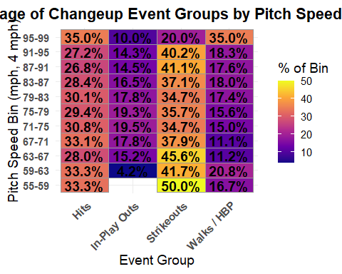
# Filter spin rate range 1200–4200 rpm
changeups_spin <- changeups %>%
filter(spin_rate >= 1200, spin_rate <= 4200)
# Create 300 rpm bins
breaks_spin <- seq(1200, 4200, by = 300)
bin_labels_spin <- paste(head(breaks_spin, -1), tail(breaks_spin, -1), sep = "-")
changeups_spin <- changeups_spin %>%
mutate(
spin_bin = cut(
spin_rate,
breaks = breaks_spin,
include.lowest = TRUE,
right = FALSE,
labels = bin_labels_spin
)
)
# Summarize counts per bin & event_group
spin_summary <- changeups_spin %>%
group_by(spin_bin, event_group) %>%
summarise(count = n(), .groups = "drop")
# Plot stacked bar chart for spin rate
ggplot(spin_summary, aes(x = spin_bin, y = count, fill = event_group)) +
geom_bar(stat = "identity", color = "black") +
scale_fill_viridis_d(option = "plasma", begin = 0.2, end = 0.9, name = "Event Group") +
labs(
x = "Spin Rate (rpm, 300 rpm bins)",
y = "Count",
title = "Changeup Event Group Distribution by Spin Rate"
) +
theme_minimal(base_size = 14) +
theme(
axis.text.x = element_text(angle = 45, hjust = 1, face = "bold"),
plot.title = element_text(face = "bold"),
plot.subtitle = element_text(size = 12),
legend.position = "right"
)
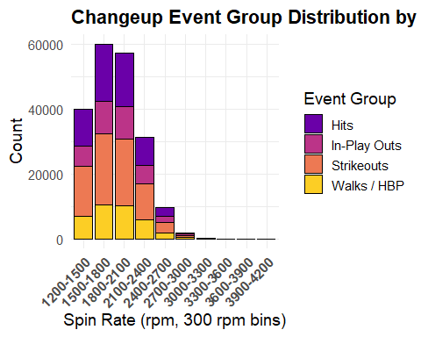
# Count pitches per spin bin & event_group, compute percentages
spin_table <- changeups_spin %>%
group_by(spin_bin, event_group) %>%
summarise(count = n(), .groups = "drop") %>%
group_by(spin_bin) %>%
mutate(perc = count / sum(count) * 100) %>%
ungroup()
# Plot table-style heatmap
ggplot(spin_table, aes(x = event_group, y = spin_bin, fill = perc)) +
geom_tile(color = "grey60") +
geom_text(aes(label = sprintf("%.1f%%", perc)), color = "black", fontface = "bold") +
scale_fill_viridis_c(option = "plasma", name = "% of Bin") +
labs(
x = "Event Group",
y = "Spin Rate Bin (rpm, 300 rpm)",
title = "Percentage of Changeup Event Groups by Spin Rate Bin"
) +
theme_minimal(base_size = 14) +
theme(
axis.text.x = element_text(angle = 45, hjust = 1, face = "bold"),
axis.text.y = element_text(face = "bold"),
plot.title = element_text(face = "bold", hjust = 0.5),
plot.subtitle = element_text(hjust = 0.5)
)
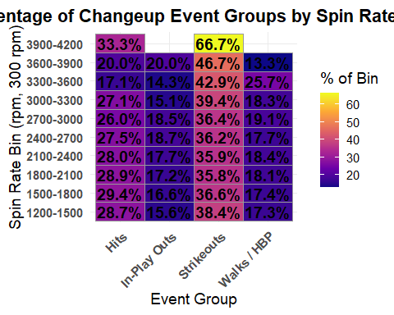

analizing effectiveness
How do we analyze the effectiveness of a pitch?
insert pitching histograms that reflect percentages by haveing the velo/spin on the xaxis and the y be the percentages in the bins and then have it color coded based on each pitch
library(dplyr)
library(knitr)
Warning: package 'knitr' was built under R version 4.4.3
best_bins <- combined_data_sets %>%
mutate(
speed_bin = cut(
start_speed,
breaks = seq(75, 106, by = 3),
labels = paste0(seq(75, 103, by = 3), "–", seq(78, 106, by = 3)),
right = FALSE,
include.lowest = TRUE
),
is_success = event_group %in% c("Strikeouts", "In-Play Outs")
) %>%
filter(
!is.na(speed_bin),
pitch_group %in% c("Fastballs", "Curveballs", "Sliders", "Changeup/Splitter")
) %>%
group_by(pitch_group, speed_bin) %>%
summarise(
n_pitches = n(),
n_success = sum(is_success),
success_pct = n_success / n_pitches * 100,
.groups = "drop"
) %>%
mutate(success_pct = round(success_pct, 1)) %>%
group_by(pitch_group) %>%
slice_max(success_pct, n = 1, with_ties = FALSE) %>%
ungroup() %>%
arrange(desc(success_pct)) %>%
select(
`Pitch Group` = pitch_group,
`Best Velocity Bin (mph)` = speed_bin,
`% Success` = success_pct,
`Pitches in Bin` = n_pitches,
`Effective Pitches in Bin` = n_success
)
kable(best_bins,
digits = c(0, 0, 1, 0, 0),
align = "lcccc",
caption = "Most Effective Velocity Bin (75–105 mph, 3 mph increments)")
Most Effective Velocity Bin (75–105 mph, 3 mph increments)
Pitch Group | Best Velocity Bin (mph) | % Success | Pitches in Bin | Effective Pitches in Bin
Sliders | 96–99 | 60.0 | 25 | 15
Curveballs | 87–90 | 54.3 | 2327 | 1263
Fastballs | 102–105 | 54.3 | 505 | 274
Changeup/Splitter | 90–93 | 39.8 | 7325 | 2919

library(dplyr)
library(knitr)
best_spin_bins <- combined_data_sets %>%
mutate(
spin_bin = cut(
spin_rate,
breaks = seq(1200, 4201, by = 300),
labels = paste0(seq(1200, 3900, by = 300), "–", seq(1500, 4200, by = 300)),
right = FALSE,
include.lowest = TRUE
),
is_success = event_group %in% c("Strikeouts", "In-Play Outs")
) %>%
filter(
!is.na(spin_bin),
pitch_group %in% c("Fastballs", "Curveballs", "Sliders", "Changeup/Splitter")
) %>%
group_by(pitch_group, spin_bin) %>%
summarise(
n_pitches = n(),
n_success = sum(is_success),
success_pct = n_success / n_pitches * 100,
.groups = "drop"
) %>%
mutate(success_pct = round(success_pct, 1)) %>%
group_by(pitch_group) %>%
slice_max(success_pct, n = 1, with_ties = FALSE) %>%
ungroup() %>%
arrange(desc(success_pct)) %>%
select(
`Pitch Group` = pitch_group,
`Best Spin Rate Bin (rpm)` = spin_bin,
`% Success (K + In-Play Out)` = success_pct,
`Pitches in Bin` = n_pitches,
`Effective Pitches in Bin` = n_success
)
kable(best_spin_bins,
digits = c(0, 0, 1, 0, 0),
align = "lcccc",
caption = "Most Effective Spin Rate Bin (1200–4200 rpm, 300 rpm increments)")
Most Effective Spin Rate Bin (1200–4200 rpm, 300 rpm increments)
Pitch Group | Best Spin Rate Bin (rpm) | % Success (K + In-Play Out) | Pitches in Bin | Effective Pitches in Bin
Sliders | 3600–3900 | 100.0 | 1 | 1
Curveballs | 3000–3300 | 55.6 | 9 | 5
Fastballs | 3900–4200 | 50.6 | 87 | 44
Changeup/Splitter | 3600–3900 | 47.6 | 21 | 10

Conclusions
The combined data from all pitch types shows a clear pattern: pitches that deviate above the average in velocity or spin rate tend to be more effective, often resulting in more strikeouts and fewer in-play balls.
1. Fastballs
Looking at the pitch speed bar chart and table for fastballs, the highest velocity bins (e.g., 95–99 mph and 99–103 mph) correspond to a higher proportion of strikeouts in the event group distribution. Similarly, the spin rate table and chart show that fastballs in the upper spin rate bins (e.g., 2500–2800 rpm) tend to generate more swings and misses. The combination of high speed and high spin makes fastballs particularly difficult to hit, emphasizing the advantage of above-average metrics.
2. Curveballs
Curveballs exhibit a similar pattern. High-velocity curveballs, relative to the group, correspond with more strikeouts and fewer balls in play. Additionally, bins with higher spin rates correlate with sharper break and more swings and misses. The heatmap table of curveball spin rates highlights that pitches in the upper spin bins are dominated by strikeouts, demonstrating the importance of spin in breaking ball effectiveness.
3. Sliders
For sliders, the velocity bar chart shows that pitches above the median velocity (e.g., 85–89 mph and 89–93 mph bins) have a higher proportion of strikeouts. The spin rate chart similarly demonstrates that higher-spin sliders (e.g., 2700–3000 rpm) lead to more strikeouts and fewer in-play balls. The combination of speed and spin deviation from the average enhances pitch deception and difficulty for hitters.
4. Changeups
Changeups tend to be effective when thrown slower than fastballs but with higher spin relative to other changeups. The tables and charts indicate that bins with moderate velocities but elevated spin rates (e.g., 65–69 mph with 2000–2300 rpm) often result in weak contact or strikeouts, showing that variation from the pitch type average can also be strategically advantageous.
5. Overall Trends
Across all pitch types:
- High velocity above the group median reduces the hitters reaction time
- High spin rates above the group median enhance pitch movement, making them harder to hit.
- Event group distributions (strikeouts, walks/hbp, in-play outs, hits) clearly show that binswith above average speed and spin are associated with more strikeouts and fewer hits.
- Heatmap tables demonstrate that the percentage of strikeouts increase in the upper bins, while balls in play and hits decrease.
Conclusion:
The visualizations and tables confirm that pitch effectiveness is strongly influenced by deviations from average velocity and spin rates. Pitches combining high velocity and high spin consistently produce better outcomes, particularly for strikeouts. Strategic use of deviations from the group average—whether faster, slower, or higher spin—can further enhance effectiveness depending on pitch type.
histograms 4 3 things at once speed spin outcome of pitch

