Test case 1. Reset the test data POST

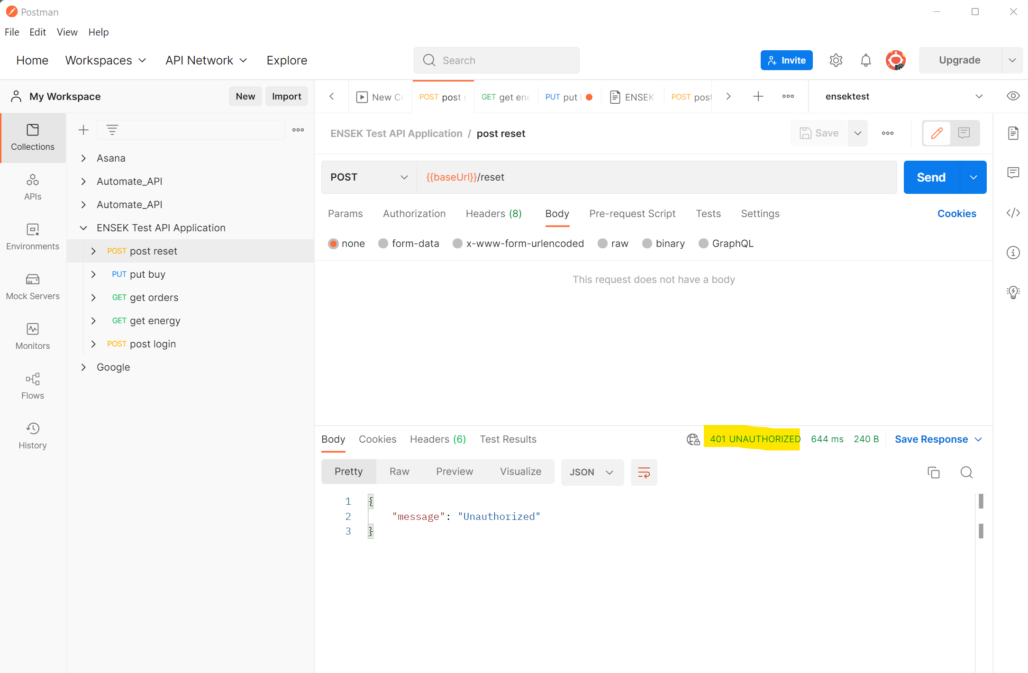

GET energy initial in stock

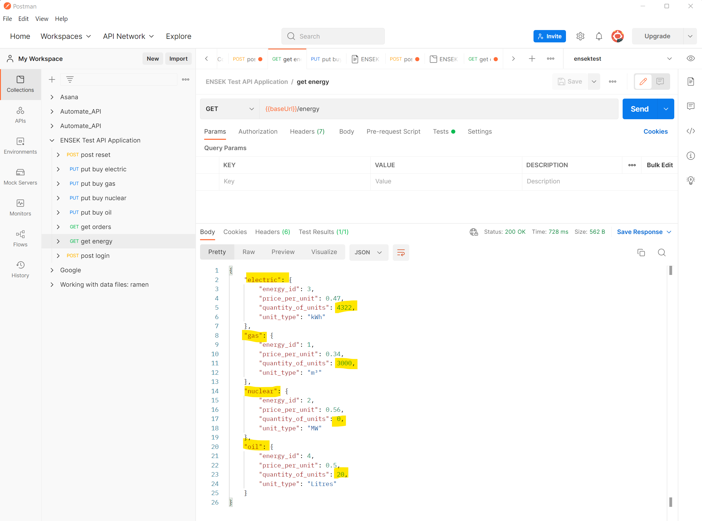

Electric quantity in stock = 4322

Gas quantity in stock = 3000

Nuclear quantity in stock = 0

Oil quantity in stock = 20

Test case 2. Buy a quantity of Electric

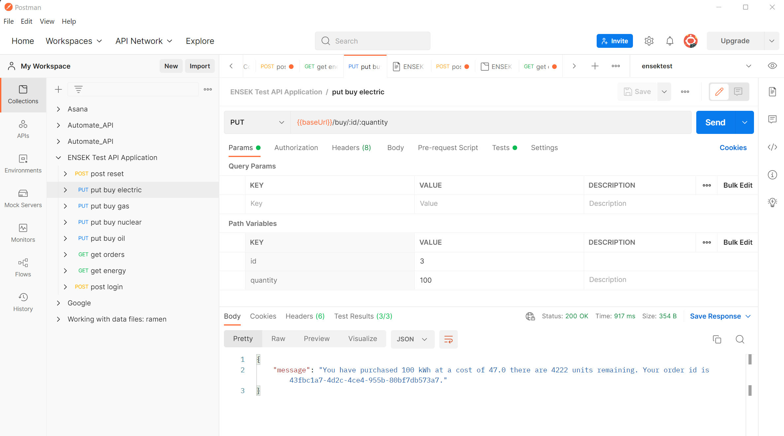

Electric quantity reamining should be 4222

Test case 3 Buy a quantity of Gas

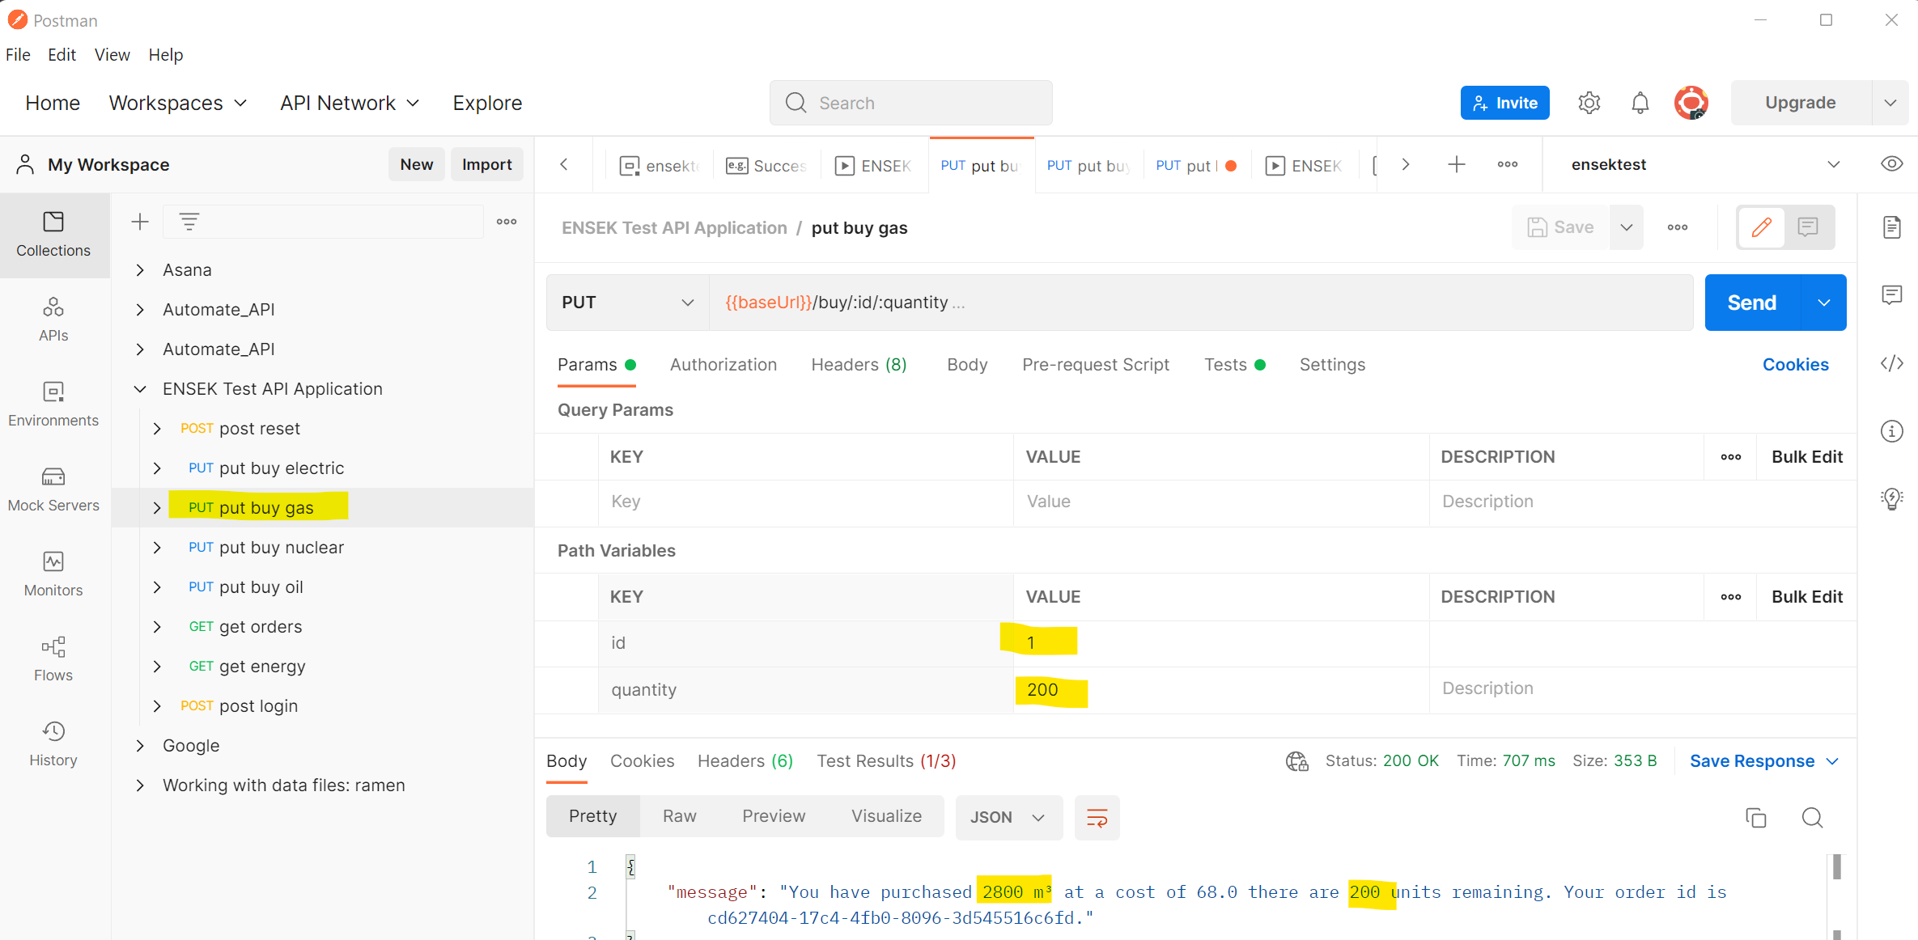

Quantity of Gas purchased is 200, remaining should be 3000-200 = 2800

Test failed as quantity purchased and units remainingnot as expected.

Test case 4. Buy a quantity of Nuclear

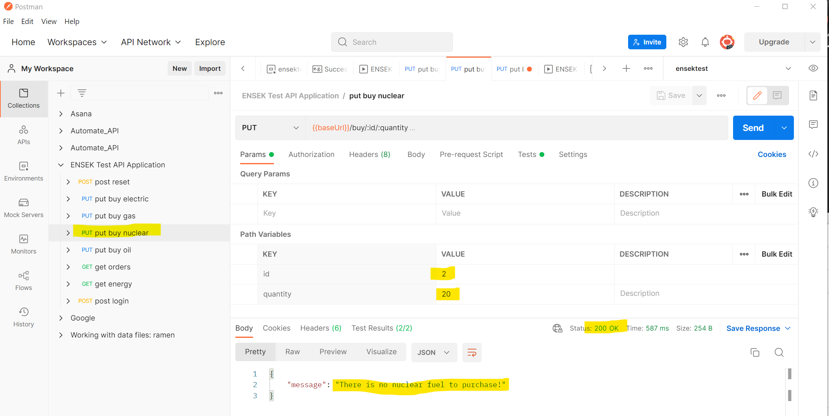

Pass as quantity of Nuclear in stock is zero

Test case 5. Buy a quantity of Oil

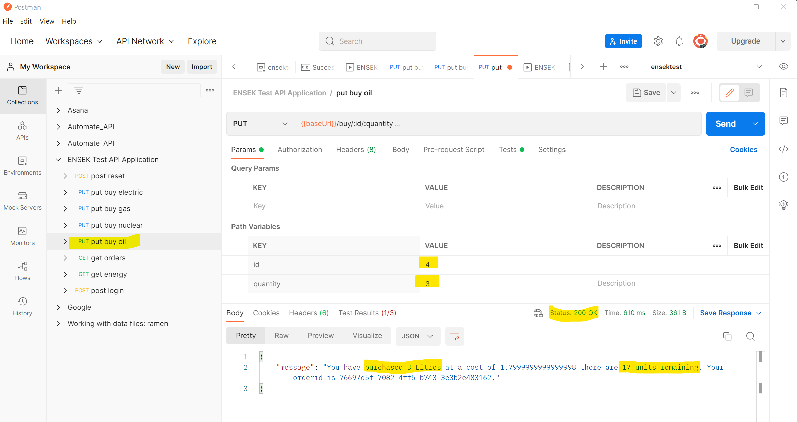

Purchased 3 litres out of 20, remaining should be 17 units

GET all orders

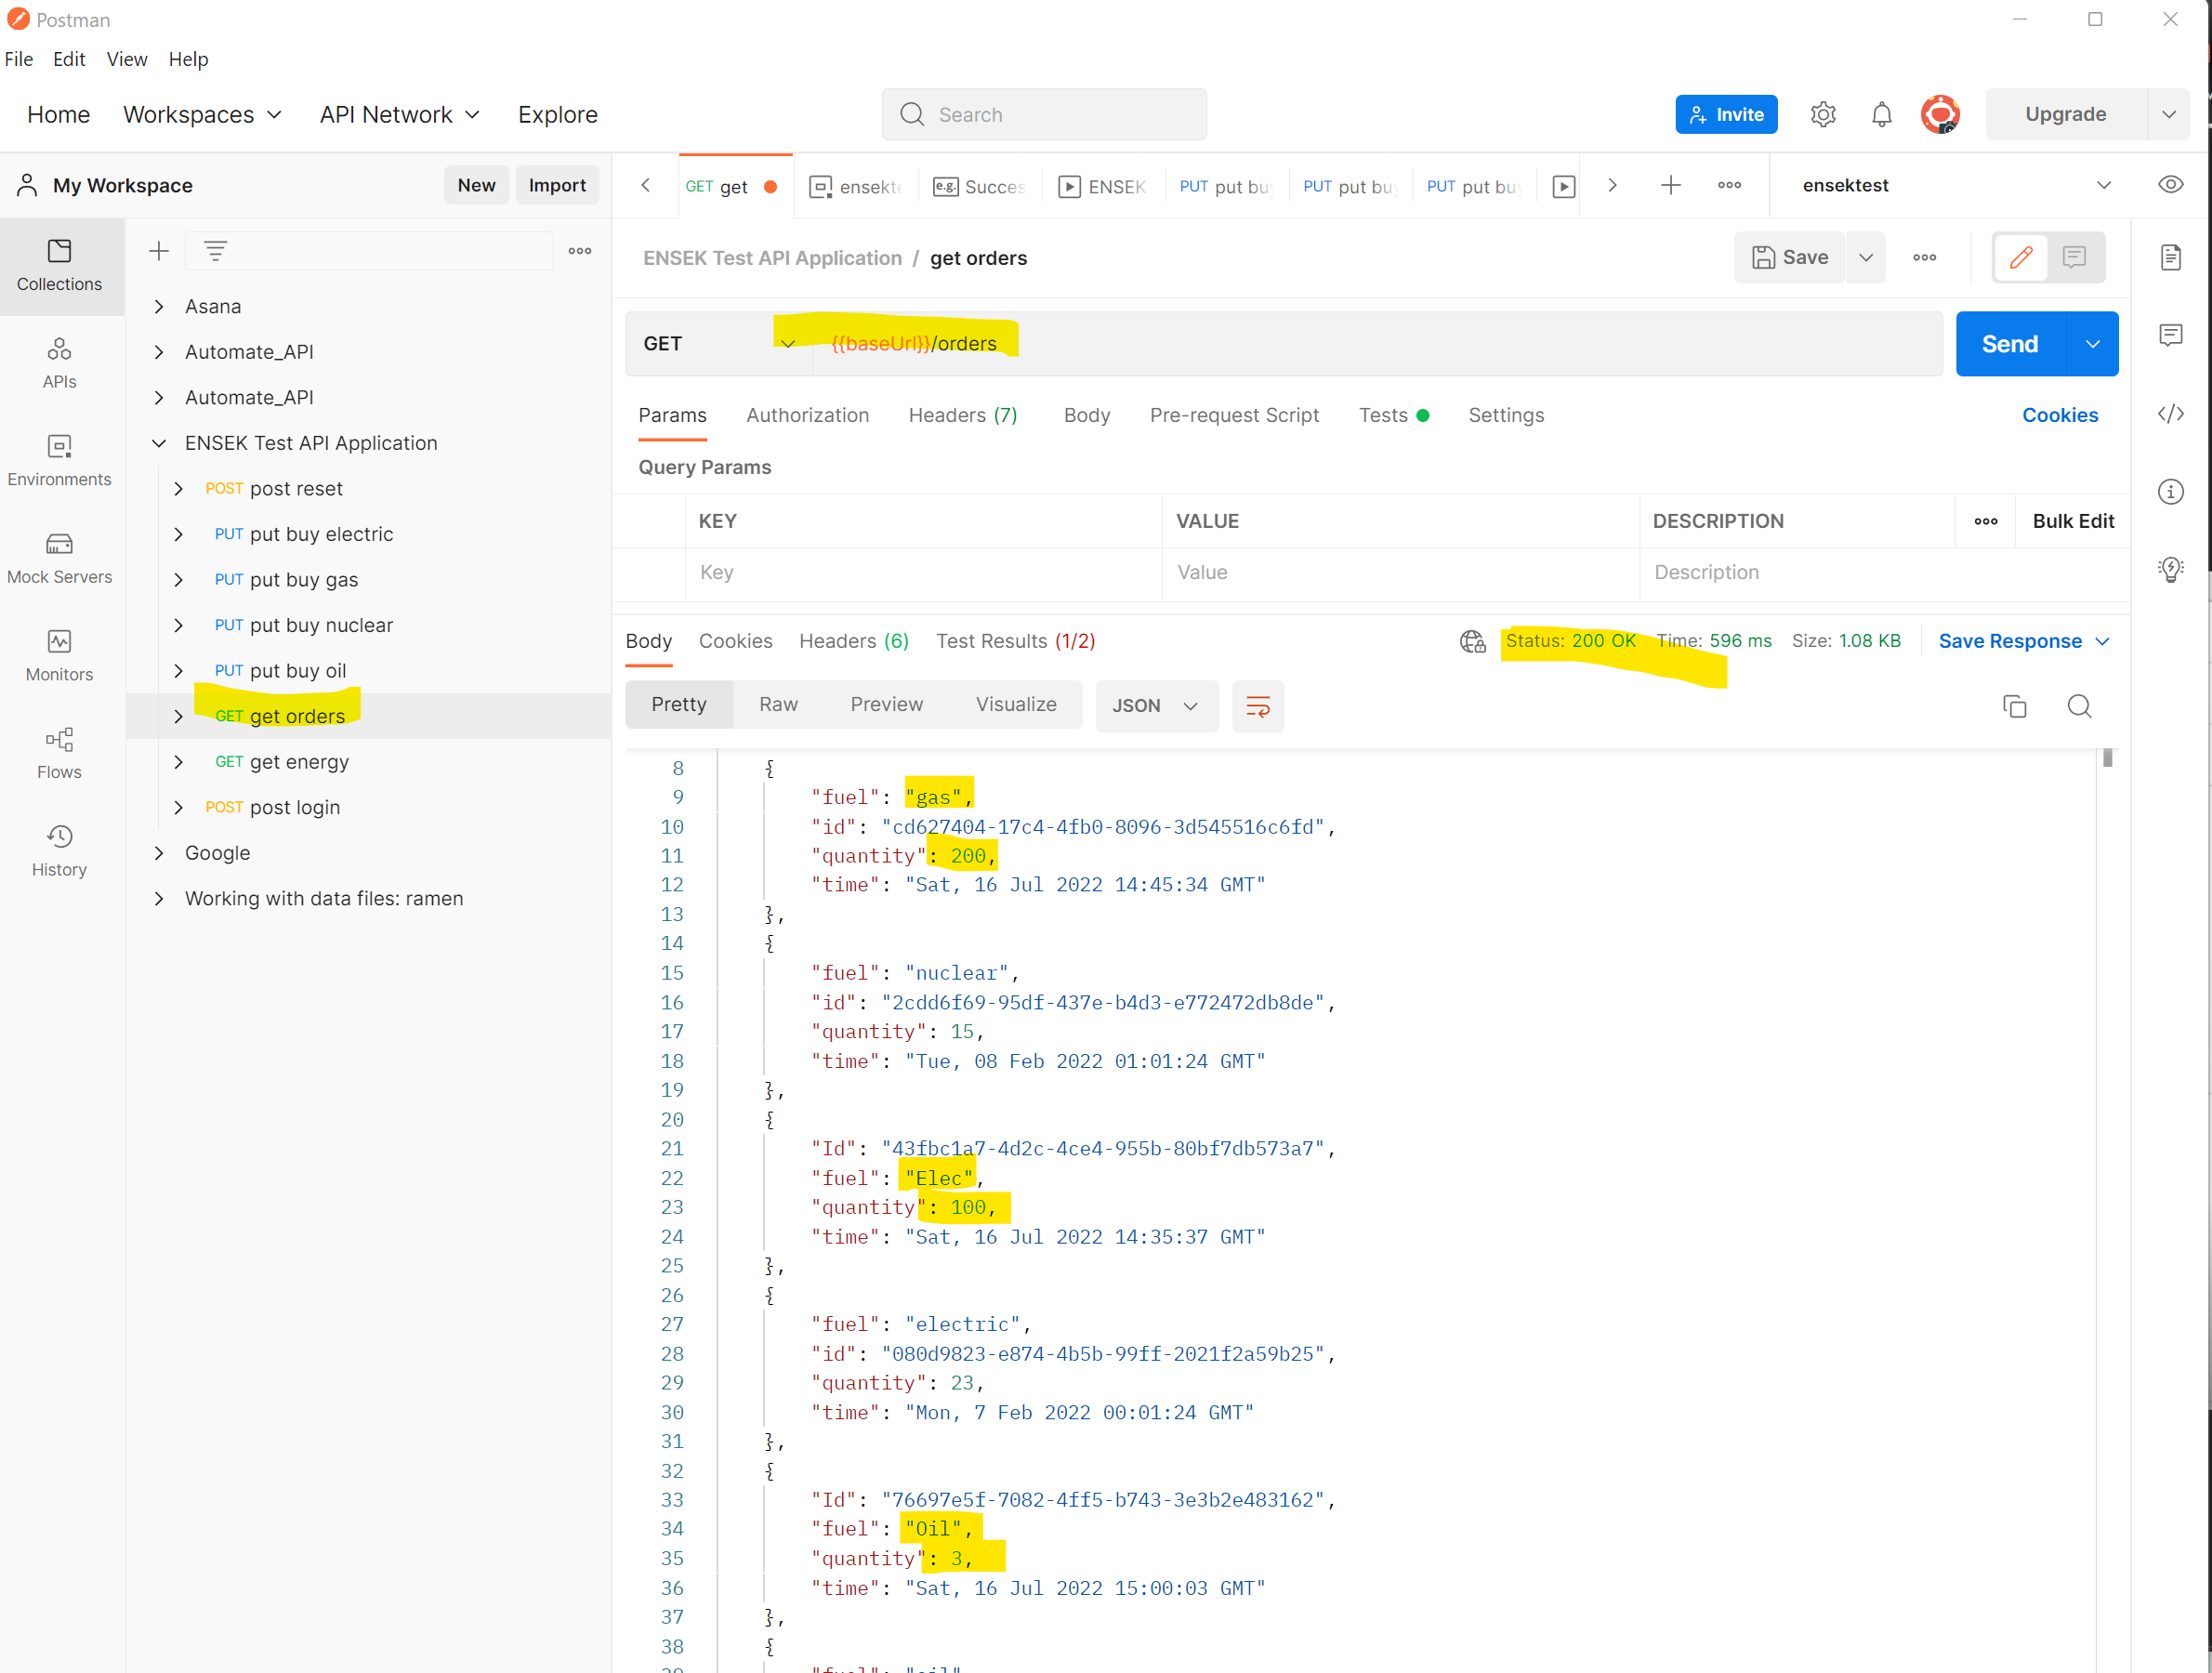

POST login

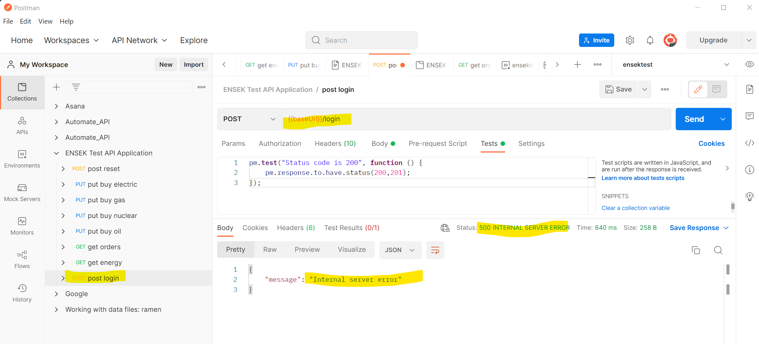

GET Energy after all purchases

