CEP146NDD - Lab 9
By: Anthony Garcia
Partner: Joshua Ignacio
049420144

Part 1 - Spot The Problem

Prompt | Problem | Revised Prompt
"Fix my laptop." | Too vague | My laptop is having symptoms where it is only showing a black screen at times. What do you think the problems are and how to fix it.
"Who will win the Stanley Cup next season?" | Assuming the AI knows your context | Which team is more likely to win the next Stanley Cup based on current performance and win rates. Use current statistics only.
"Why won't it open?" | Too vague | I'm trying to open the hood of my Honda Civic but it won’t open. What could be the issue?
"Tell me about healthy breakfasts." (The person wanted a quick list to take shopping, but got a long essay.) | Output format not specified | What are some common healthy meals that I can easily afford as a student?.
e) "Plan my 7-day trip to Japan, make a full budget, write a packing list, teach me basic Japanese phrases, and write a 1,000-word history of Tokyo." | Overloading with information. | I am planning a 7 day trip to japan. Give me common Japanese phrases, a basic history of Japan, and give travelling advice with a budget of $1000.

Part 2 - Prompt Makeover

Scenario: A study schedule for 3 midterms next week.

Version 1
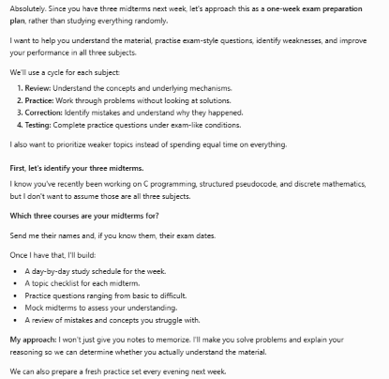

Version 2
Context
Create a study schedule over the next 7 days starting from 12pm to 6 pm. I have three midterms to study from.

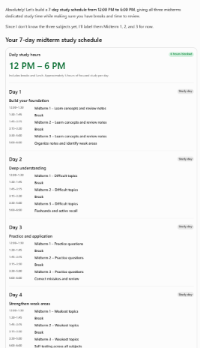
Task & Format
Create a study schedule for me to help me prepare in a calendar format.

Example
For Example:
Monday
- C (1 hr of pointers)
- Linux (1 hr of Bash Scripting)
- Math (1 hr of Propositional Logic)

Constraints
I have 3.5 hours of available study time per day.
Do not list what times I should spend studying.
List how long I should spend on each topic.
List what content I should cover for a particular day.

Partner Critiques
Check | ✓ / ✗
Context: Does it explain who they are or what situation they are in? | No
Task: Is the action clear? | No
Format: Does it say how the answer should look? | Yes
Example: Does it give a sample? | Yes
Constraints: Does it set limits (length, tone, what to avoid)? | Yes
Technique: Is the named technique used correctly? | No
Partner Suggestion for Version 2: Include more context for a stronger response. Give an example of a format.

Part 4: Prompt Chaining Together
Task: Prepare for your first job interview
Write a chain of 3 prompts, where each builds on the answer before it. Run them in the same chat.
1) I’m preparing for a job interview for a Senior Dev position at Nintendo. Help me identify how I can prepare for this interview. Organize your response using headings and bullet points.
For example:
Thing to do in order to prepare #1
- How it’ll help me
- Description
Keep the information relevant to the job. Be concise. Do not make up company information and fact-check.
2) Using the information you’ve researched in your response. Create a list of 20 mock interview questions to help me prepare.
Output a numbered list and include an example of a strong answer below.
For example:
1) Question 1
Example…
2) Question 2
Example…
3) Question 3
Example…
Keep the questions realistic and relevant to the job.
3) Act as an interviewer at Nintendo recruiting for the Senior Dev position.
Conduct a realistic interview with me using the interview questions listed above. Ask me one question at a time and evaluate my responses.
For example:
- <Dialogue and/or Response evaluation>
- <Interview question>
Make half of the interview a personal evaluation. Make the other half a technical evaluation. Ensure your dialogue is professional and realistic. Also give a couple of questions to ask the interviewer based on the company operations.

Prompt 1 Response
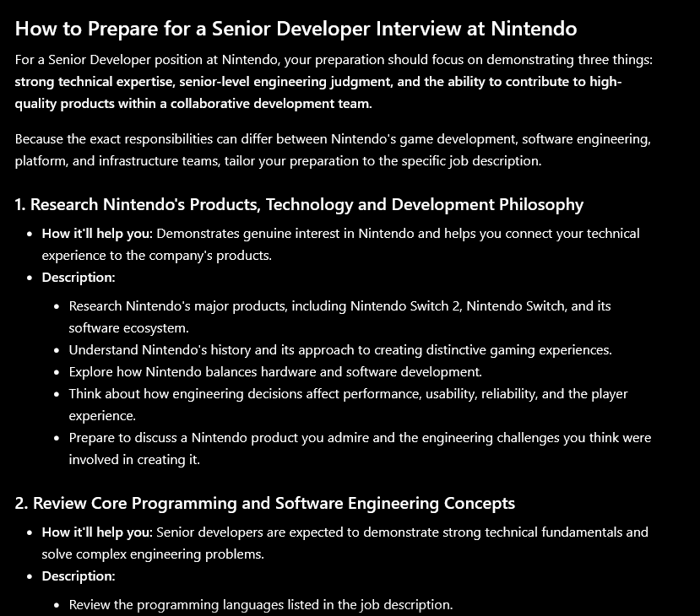

Prompt 2 Response
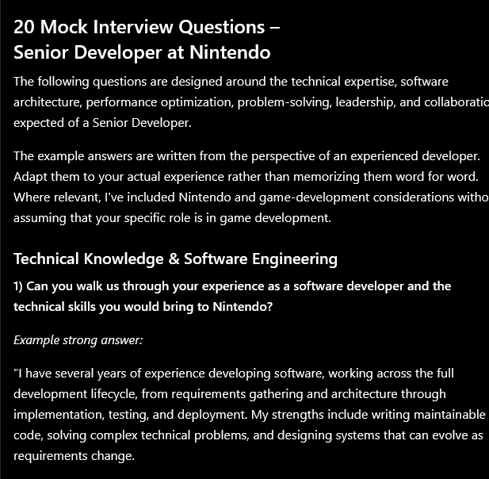

Prompt 3 Response
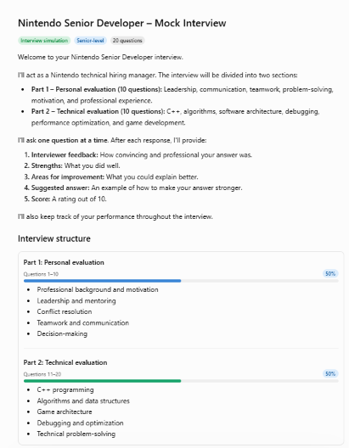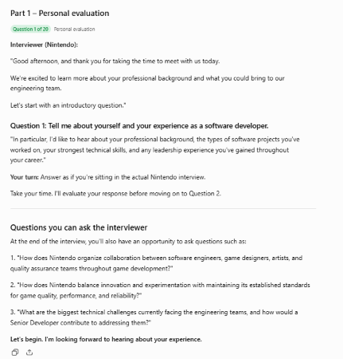

Reflection Question
What did your partner's feedback teach you about your prompt?
They suggested giving more context to my prompt. It needs more context such as including program and course details in the prompt. It also needs a more realistic constraints to keep the responses more realistic.

Give one example of something you should not trust an AI to answer correctly, and explain why.
AI should never be trusted to answer technical question on niche topics as they lack the training data and information to answer correctly.

