MAXBrowse

Overview
MAXBrowse is a server-browser for a number of games, and the primary goal of the browser is to be both easy to use and powerful, but without adding a large number of options and complex configuration screens.
MAXBrowse supports primarily idTech engine games:
idTech 4 games - Doom 3, Quake 4, Prey, Enemy Territory – Quake Wars
idTech 3 games - Quake 3, Wolfenstein : Enemy Territory, Warsow
idTech 2 games - Quake 2
Additional games that derive from idTech 2-4 engines can perhaps easily be supported by just configuration changes to the SupportedGames.xml file that sits alongside the executable.
The main MAXBrowse window is made up of 4 panes:
- Server List
- Filter Tree
- Server Info
- Players
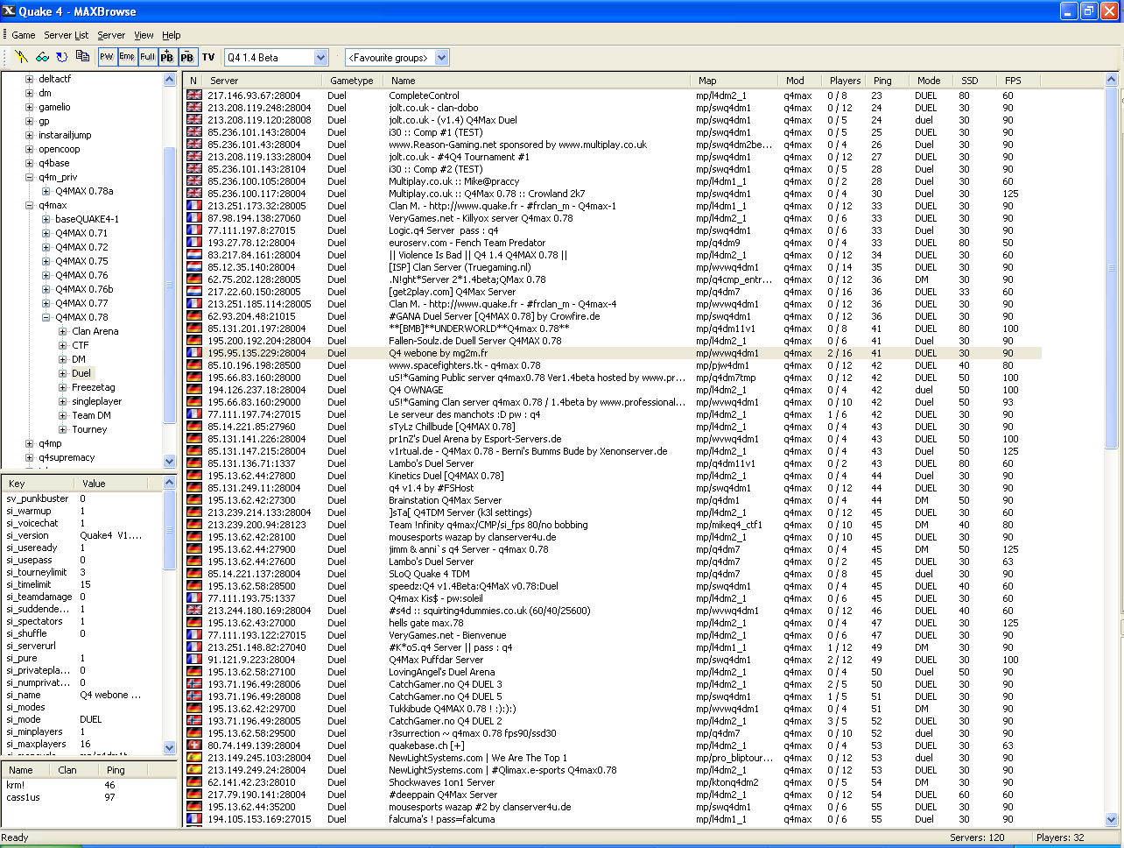
Server List
Players
Filter Tree
Server Info
The server list, displayed on the right hand side, is the list of all servers which match the current filters. When a server is selected in this list, the Players and Server Info panes (bottom left) are populated with information about the server. Additionally, you can connect to the server, view details of the server and more through the menus.
The filter tree, displayed in the top left, allows you to navigate through the servers to filter the servers to those you are most interested in. By default, this is grouped by mod, then by gametype, and then finally by map. Clicking on any item within the tree will filter it to show only those appropriate to your selection – so clicking at the top will show all servers, while clicking on a mod will only show servers for that mod.
In addition to the filter tree there are a number of standard filters for showing / hiding servers with Punkbuster, passwords, which are available via the menu and toolbar.

Configuring Games
When you first launch MAXBrowse it will automatically detect the games that have been installed via the installers, however if you have manually installed the games, or installed through another method (eg using Steam), you may need to configure the games. This is done through the “Configure Games” menu item under the “Game” menu.
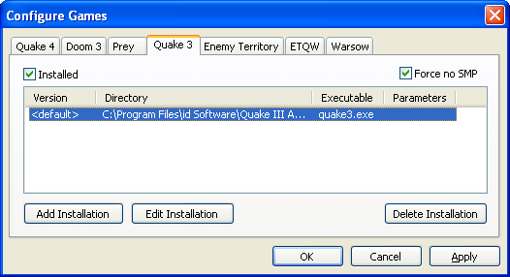
When configuring a game, simply check the tickbox to indicate that the game is installed, highlight the “default” version, and select “Edit Installation”. Locate the executable to launch. There is no need to set the “additional parameters” field for fs_game or password, as these will automatically be set by MAXBrowse, however you can use this to execute a config or set any other parameters you choose.
If you have multiple versions of the game installed then you can add multiple installations, and MAXBrowse will automatically pick the version based upon the version the server is running. Note that to do this, you must have queried the master server list at least once, to have obtained a list of versions.
Once the game has been configured, the menu item for this game will become enabled under the “Game” menu. Selecting the game will switch to displaying servers for this game.
The first time you select a game, it will automatically query the master server to obtain a list of servers.
The “Force no SMP” option defaults to selected for Quake 3. This option is the same as selecting the application to run on one CPU through Task Manager, or via an external program such as arQon’s “nosmp.exe”. This may be required for Q3 engine games with modern graphics card drivers, if they error due to threaded optimizations in the device drivers.

Server Lists
Once you have a list of servers, you can refresh them, or look for new servers whenever you choose. When refreshing servers, you can:
- Check for new servers – this will check the master server for new servers, and only query these new servers
- Refresh all servers – this will check the master server, and then query all servers – both those you had in your server list before, and the new servers
- Refresh visible servers – this will refresh only the servers currently visible in the server list
- Refresh selected servers – this will only refresh the servers that are currently highlighted in the server list.

Additionally, you may manually add a server, by specifying the IP / hostname, and port number. Generally this should not be necessary, because most servers should be automatically found via the master server.
MAXBrowse will always remember a server, even if it drops out of the master server list. This may mean that servers which are taken down cause your lists to grow. When you wish to remove all of the unresponsive servers, you can select “Delete Old Servers” to remove any server which is currently marked as unresponsive. It will not automatically remove any server which has been marked as a favourite. If the server is still reporting to the master server even though it is unresponsive it will be re-added when the master server is next queried, so there should be no harm in selecting this option periodically.

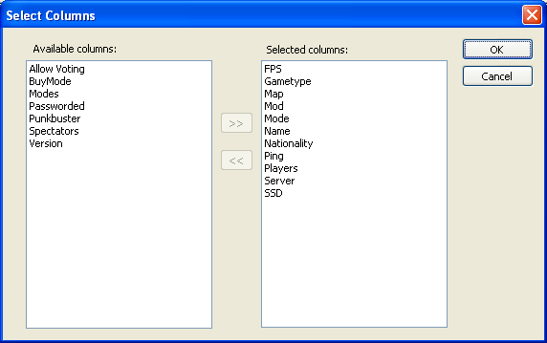
Server List Display
The display of the servers in the Server List pane is customizable. You can resize the columns by dragging the separators between them, and re-order them by clicking and dragging on the headers themselves.
Additional columns can be selected using the “Select Columns” menu option in the “View” menu. Columns may be moved between the “available” and “selected” lists by clicking the arrow buttons – only those in the “Selected” list will be displayed in the main window.
The servers may be sorted, or reverse sorted by any column, by clicking on the column header – for example, commonly users sort by either ping, or by the number of players.
These layout settings, and also the positions of the pane separators are automatically stored for the next time you launch the application. They are stored on a per-game basis, so each game you play may have a different display.
Within the view, you can highlight multiple servers at once using the standard ctrl and shift key combinations – which can be useful for refreshing servers you’re interested in, for example.
There are times when you may be searching for a specific server. If this is the case, then the “Find server” menu item allows you to search for a server. This will search all servers currently displayed for the text entered – by default searching all of the columns displayed, and will automatically highlight any of those that match. For example, searching for “SN.Q4Pickup” will highlight all 3 servers with this IRC channel name in the server name, and they can then easily be either refreshed, or added to a favourites group, for example.

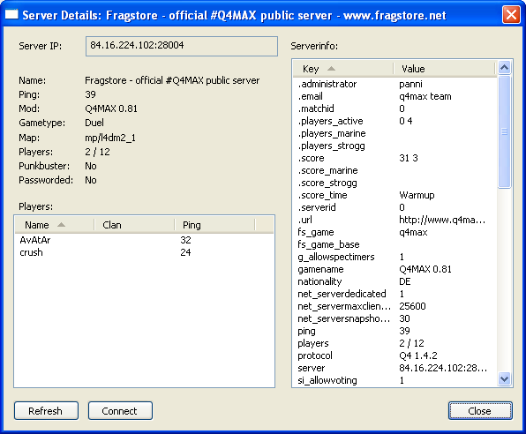
Server Options
Once you have located a server that you like, the right-click menu in the list gives a number of options, ranging from copy + paste of just the server IP (and port), through to connecting. You can connect to it through the “Connect” menu item. If the server has a password, you can select “Set Password”, and enter the password. This will then be remembered, and automatically used whenever you connect to the server.
Alternatively, if you are organizing a game with friends, you can either copy the server address (IP:port), or the full details of the server into the Windows clipboard.
You can also view the server details which shows the full details of the server in a window of its own, from which you can refresh the server and easily see all of its properties.

Filter Tree
The filter tree allows an easy way to navigate through the servers. The default structure is to filter by mod, then by mod version, then gametype, and then finally by map. This generally makes it very easy for example to locate a q4max 0.81 Duel server, by selecting Q4Max, then the version number, and then the duel gametype. Within this, you could then choose if you want a specific map, or just select from any of the Duel servers.
Although this default structure is believed to be ideal for many players, you may choose to change this. For example, if you prefer to play only on servers running high values of si_fps, then you might choose to group the servers by si_fps at the top of the tree. This would then let you see the servers grouped by this setting.
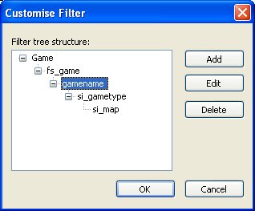
To configure the tree structure, select “Edit tree structure” in the “View” menu. This will display a dialog which allows you to add and delete items into the tree structure. You can structure by any serverinfo data - simply edit the tree so that the labels displayed in this dialog match the names displayed in the “Key” column in the server info pane when querying a server – which in general is the same name as the cvars within the game – eg “fs_game” and “si_gametype” in Quake 4.
If servers do not have a value for a particular setting, they will be grouped underneath “<Unknown>”. With the default structure, any server which has never been successfully queried will be displayed under “<Unknown>” for all properties, because the mod it is running has not been identified.
As with the server list display, the filter tree structure is automatically remembered for each game, so you can configure a different structure for different games if you choose.

Standard Filters
In addition to the filter tree, the toolbar and View menu has a number of standard filters. These allow you to apply additional filters on top of that selected via the filter tree. These standard filters are:
- Show Empty – when not selected, empty servers will not be displayed
- Show Fill – when not selected, full servers will not be displayed.
- Show Passworded – when not selected, servers with passwords will not be displayed.
- Show with PB – when not selected, servers with Punkbuster enabled will not be shown.
- Show without PB – when not selected, servers without Punkbuster enabled will not be shown.
- Show TV Servers – when selected, will only show TV servers. When not selected, will not show TV servers. Note that Q3 and Warsow TV servers do not report to the master server, and so do not automatically show. If you add the server IPs manually they will be remembered and filtered by the TV filter, however.
- Version filter - the toolbar shows a dropdown list of all the versions of the game, and allows you to filter to just a specific version.

Favourite Servers
A final method of filtering is to configure favourites groups. This is done by selecting servers in the server list, and choosing the “Add to favourites” menu item. This will then allow you to enter a name for the favourites group (or select an existing one if you have already created a favourites group).
Once you have added some servers into favourites groups, the group names will be displayed in a dropdown list on the toolbar. This allows you to filter to just the servers within the selected favourites group. All the other filters still apply though, so for example if your version number is set to “Q4 1.3” then it will still only show Q4 1.3 servers.
To remove a server from a favourites group, simply switch to that favourites group, select the servers to remove, and select “Remove from favourites”. When the last servers have been removed from a favourites group, the group itself will disappear from the list.

IP Country Mappings
The original MAXBrowse releases supported mapping the IP address to a country, using the GeoCountryLite database from https://www.maxmind.com/ - however they have now retired the original format as used by MAXBrowse, in preference for the new GeoLite2 format.
Additionally, their licence terms have been updated in response to GDPR and other similar legislation that requires the database to be constantly updated, and puts restrictions on re-distributing the data because of this requirement.
Therefore, at this time I do not intend to update to this dataset, and have taken the decision not to include the original data with this release. The software still supports loading the old format of data so if you place the old IPData.dat file alongside MAXBrowse it will use it.

Licensing
MAXBrowse 1.3 is made available under the GPL v3 license. See the included license text – the source code can be found on github at https://github.com/Anthony-Jacques/MAXBrowse/

Credits
Software Development: AnthonyJ - Anthony Jacques – AnthonyJacques@sky.com
Flag icons: Zarkof / ESR
MAX icon: fnatic|Alba
Thanks to the Q4Max team and testers, and numerous other testers for their feedback, and to id Software, who’s games are at the base of all of the supported games.
All trademarks are acknowledged as belonging to their respective owners.

